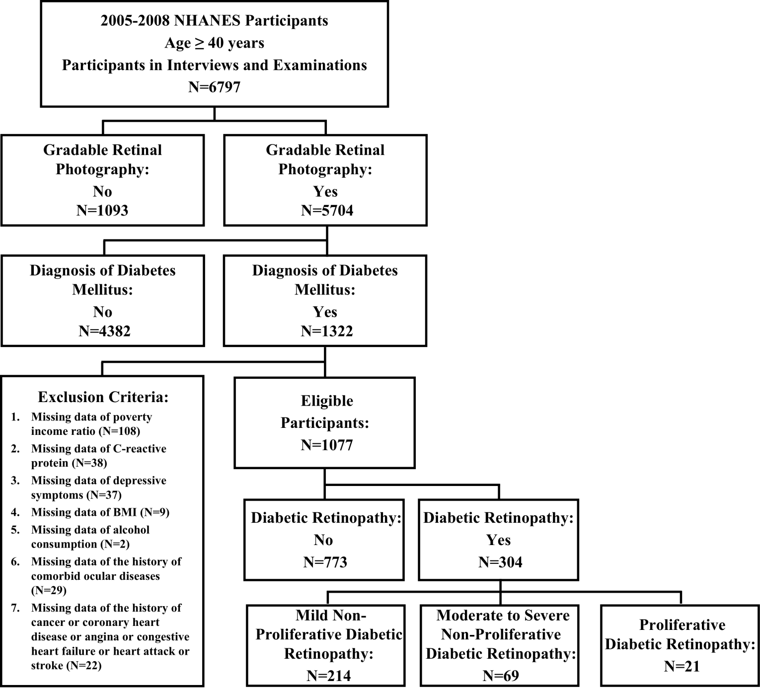
Figure S1. Schematic Showing Inclusion Criteria for Study Participants. Schematic showing study participants included for the present analysis from the 2005-2008 National Health and Nutrition Examination Survey(NHANES). A total of 1077 participants were included.
Table S1. Demographic, Health Behavior, and General Health Characteristics of Participants by Diabetic Retinopathy Status after PSM ª
Characteristic | Study Participants after PSM
Characteristic | All (n = 608)  N = 543,326.5 | No Diabetic Retinopathy (n = 304)  N = 277,206.9 | Diabetic Retinopathy (n = 304)  N = 266,119.6 | P value
Age, No. (%), y |  |  |  | 0.98
40-49 | 65 (10.69) | 30 (16.53) | 35 (16.44)
50-59 | 125 (20.56) | 61 (26.57) | 64 (26.16)
60-69 | 217 (35.69) | 109 (27.87) | 108 (27.16)
70-79 | 150 (24.67) | 78 (22.26) | 72 (21.98)
≥80 | 51 (8.39) | 26 (6.77) | 25 (8.26)
Sex, No. (%) |  |  |  | 0.26
Male | 348 (57.24) | 176 (54.23) | 172 (57.88)
Female | 260 (42.76) | 128 (45.77) | 132 (42.12)
Race/Ethnicity, No. (%) |  |  |  | 0.46
Non-Hispanic White | 254 (41.78) | 135 (67.41) | 119 (67.01)
Non-Hispanic Black | 186 (30.59) | 89 (16.52) | 97 (19.23)
Mexican American | 117 (19.24) | 57 (7.08) | 60 (8.05)
Other | 51 (8.39) | 23 (8.99) | 28 (5.71)
Marital status, No. (%) |  |  |  | 0.55
Unmarried or other | 231 (37.99) | 111 (32.22) | 120 (34.71)
Married or living with a partner | 377 (62.01) | 193 (67.78) | 184 (65.29)
Educational attainment, No. (%) |  |  |  | 0.99
< High school | 269 (44.24) | 134 (31.49) | 135 (31.43)
≥High school | 339 (55.76) | 170 (68.51) | 169 (68.57)
Poverty income ratio, No. (%) |  |  |  | 0.42
Below poverty line (<1.00) | 113 (18.59) | 56 (10.56) | 57 (12.43)
At or above poverty line (≥1.00) | 495 (81.41) | 248 (89.44) | 247 (87.57)
Alcohol consumption, No. (%) |  |  |  | 0.7
Never | 110 (18.09) | 53 (17.75) | 57 (19.55)
Former | 238 (39.14) | 116 (38.81) | 122 (36.40)
Mild | 175 (28.78) | 96 (30.52) | 79 (31.49)
Moderate | 44 (7.24) | 20 (9.11) | 24 (6.53)
Heavy | 41 (6.74) | 19 (3.82) | 22 (6.03)
BMI, No. (%) |  |  |  | 0.5
18.5-30.0 | 283 (46.55) | 138 (45.33) | 145 (40.51)
<18.5 | 2 (0.33) | 1 (0.33) | 1 (0.13)
≥30.0 | 323 (53.12) | 165 (54.34) | 158 (59.36)
High C-reactive protein level, No. (%) |  |  |  | 0.5
No | 524 (86.18) | 265 (82.81) | 259 (85.05)
Yes | 84 (13.82) | 39 (17.19) | 45 (14.95)
Hypertension, No. (%) |  |  |  | 0.67
No | 154 (25.33) | 89 (30.19) | 65 (27.74)
Yes | 454 (74.67) | 215 (69.81) | 239 (72.26)
Hyperlipidemia, No. (%) |  |  |  | 0.85
No | 75 (12.34) | 39 (10.94) | 36 (11.50)
Yes | 533 (87.66) | 265 (89.06) | 268 (88.50)
Depressive symptoms, No. (%) |  |  |  | 0.54
No | 557 (91.61) | 277 (90.53) | 280 (91.86)
Yes | 51 (8.39) | 27 (9.47) | 24 (8.14)
Difficulty walking, No. (%) |  |  |  | 0.99
No | 492 (80.92) | 247 (79.92) | 245 (79.96)
Yes | 116 (19.08) | 57 (20.08) | 59 (20.04)
Health status, No. (%) |  |  |  | 0.78
Poor to fair | 277 (45.56) | 129 (38.04) | 148 (39.34)
Good to excellent | 331 (54.44) | 175 (61.96) | 156 (60.66)
History of congestive heart failure, No. (%) |  |  |  | 0.43
No | 525 (86.35) | 268 (87.80) | 257 (85.11)
Yes | 83 (13.65) | 36 (12.20) | 47 (14.89)
History of coronary heart disease, No. (%) |  |  |  | 0.76
No | 538 (88.49) | 273 (87.10) | 265 (86.02)
Yes | 70 (11.51) | 31 (12.90) | 39 (13.98)
History of angina, No. (%) |  |  |  | 0.9
No | 563 (92.6) | 284 (91.15) | 279 (91.58)
Yes | 45 (7.4) | 20 (8.85) | 25 (8.42)
History of heart attack, No. (%) |  |  |  | 0.71
No | 535 (87.99) | 274 (88.82) | 261 (87.67)
Yes | 73 (12.01) | 30 (11.18) | 43 (12.33)
History of stroke, No. (%) |  |  |  | 0.84
No | 537 (88.32) | 273 (87.54) | 264 (86.74)
Yes | 71 (11.68) | 31 (12.46) | 40 (13.26)
History of cancer, No. (%) |  |  |  | 0.84
No | 524 (86.18) | 261 (86.44) | 263 (87.13)
Yes | 84 (13.82) | 43 (13.56) | 41 (12.87)
History of comorbid ocular diseases, No. (%) |  |  |  | 0.54
No | 364 (59.87) | 184 (64.19) | 180 (60.95)
Yes | 244 (40.13) | 120 (35.81) | 124 (39.05)

Abbreviations: NPDR, Non-proliferative diabetic retinopathy; PDR, proliferative diabetic retinopathy; PSM, Propensity score matching; BMI, body mass index (calculated as weight in kilograms divided by height in meters squared).
ª All proportions, means, and SEs are weighted estimates of the US population characteristics, taking into account the complex sampling design of the National Health and Nutrition Examination Survey.

Table S2. Demographic, Health-Related Behaviors and General Health Characteristics of Participants Included and Excluded in the Analyses ª

Characteristic | No. of Excluded  Subjects (n = 245) | No. of Included  Subjects (n = 1077) | P value ^{b}
Age, No. (%), y |  |  | < 0.0001
40-49 | 23 (14.02) | 136 (18.52)
50-59 | 37 (17.04) | 255 (29.81)
60-69 | 83 (27.31) | 365 (27.26)
70-79 | 64 (26.71) | 240 (18.35)
≥80 | 38 (14.92) | 81 (6.06)
Sex, No. (%) |  |  | 0.004
Male | 106 (36.38) | 559 (50.76)
Female | 139 (63.62) | 518 (49.24)
Race/Ethnicity, No. (%) |  |  | 0.001
Non-Hispanic White | 79 (53.82) | 484 (70.73)
Non-Hispanic Black | 77 (21.53) | 283 (14.23)
Mexican American | 56 (10.38) | 200 ( 7.23)
Other | 33 (14.28) | 110 ( 7.81)
Marital status, No. (%) |  |  | 0.52
Unmarried or other | 96 (35.32) | 413 (32.76)
Married or living with a partner | 149 (64.68) | 664 (67.24)
Educational attainment, No. (%) |  |  | 0.05
< High school | 112 (34.23) | 414 (25.08)
≥High school | 133 (65.77) | 663 (74.92)
Poverty income ratio, No. (%) |  |  | 0.001
Below poverty line (<1.00) | 37 (22.90) | 209 (11.70)
At or above poverty line (≥1.00) | 100 (77.10) | 868 (88.30)
Alcohol consumption, No. (%) |  |  | 0.11
Never | 45 (23.37) | 185 (16.72)
Former | 79 (34.70) | 382 (32.03)
Mild | 44 (23.20) | 306 (31.10)
Moderate | 19 ( 8.04) | 109 (12.58)
Heavy | 19 (10.70) | 95 ( 7.57)
BMI, No. (%) |  |  | 0.02
18.5-30.0 | 103 (49.86) | 465 (38.74)
<18.5 | 1 (1.76) | 5 (0.25)
≥30.0 | 125 (48.38) | 607 (61.00)
High C-reactive protein level, No. (%) |  |  | 0.44
No | 168 (83.85) | 884 (80.55)
Yes | 34 (16.15) | 193 (19.45)
Hypertension, No. (%) |  |  | 0.75
No | 63 (29.70) | 279 (28.08)
Yes | 182 (70.30) | 798 (71.92)
Hyperlipidemia, No. (%) |  |  | 0.07
No | 43 (17.09) | 128 (11.26)
Yes | 202 (82.91) | 949 (88.74)
Depressive symptoms, No. (%) |  |  | 0.09
No | 163 (85.43) | 963 (89.91)
Yes | 31 (14.57) | 114 (10.09)
Difficulty walking, No. (%) |  |  | 0.002
No | 173 (71.60) | 900 (84.21)
Yes | 72 (28.40) | 177 (15.79)
Health status, No. (%) |  |  | 0.01
Poor to fair | 135 (48.87) | 463 (35.32)
Good to excellent | 110 (51.13) | 614 (64.68)
History of congestive heart failure, No. (%) |  |  | 0.01
No | 200 (86.25) | 982 (92.03)
Yes | 35 (13.75) | 95 (7.97)
History of coronary heart disease, No. (%) |  |  | 0.92
No | 206 (88.85) | 963 (88.61)
Yes | 31 (11.15) | 114 (11.39)
History of angina, No. (%) |  |  | 0.04
No | 206 (87.24) | 1006 (93.29)
Yes | 29 (12.76) | 71 (6.71)
History of heart attack, No. (%) |  |  | 0.01
No | 195 (81.88) | 962 (89.66)
Yes | 48 (18.12) | 115 (10.34)
History of stroke, No. (%) |  |  | 0.001
No | 194 (80.77) | 975 (90.78)
Yes | 46 (19.23) | 102 ( 9.22)
History of cancer, No. (%) |  |  | 0.09
No | 209 (80.86) | 927 (85.70)
Yes | 34 (19.14) | 150 (14.30)
History of comorbid ocular diseases, No. (%) |  |  | 0.15
No | 128 (63.26) | 718 (69.86)
Yes | 82 (36.74) | 359 (30.14)
Mortality leading |  |  | 0.003
Cancer-Specific | 17 (5.05) | 77 (5.77)
CVD-Specific | 42 (17.02) | 140 (11.66)
DM-Specific | 11 (3.39) | 35 (3.07)
Other | 46 (20.71) | 127 (10.56)
No | 129 (53.82) | 698 (68.93)
Mortality status |  |  | 0.004
Assumed alive | 129 (53.82) | 698 (68.93)
Assumed deceased | 116 (46.18) | 379 (31.07)
DR status
None | 164 (70.55) | 773 (75.29)
Any DR | 81 (29.45) | 304 (24.71) | 0.22
Mild NPDR | 45 (18.21) | 214 (18.11) | 0.06
Moderate to Severe NPDR | 26 (7.90) | 69 (5.39) | 0.06
PDR | 10 (3.33) | 21 (1.21) | 0.06

Abbreviations: NPDR, Non-proliferative diabetic retinopathy; PDR, proliferative diabetic retinopathy; BMI, body mass index (calculated as weight in kilograms divided by height in meters squared).
ª Mortality was assessed through December 31, 2020. All proportions, means, and SEs are weighted estimates of the US population characteristics, taking into account the complex sampling design of the National Health and Nutrition Examination Survey.
^{b} All P values were calculated using the unpaired t test for continuous variables and the design-adjusted Rao-Scott Pearson χ² test for categorical variables. Comparisons were between each group with retinopathy and the group with no retinopathy and were unadjusted.
* P<0.05; ** P<0.01; *** P<0.001; **** P<0.0001.

