Fig. S1. Heterogenous effects on household water consumption

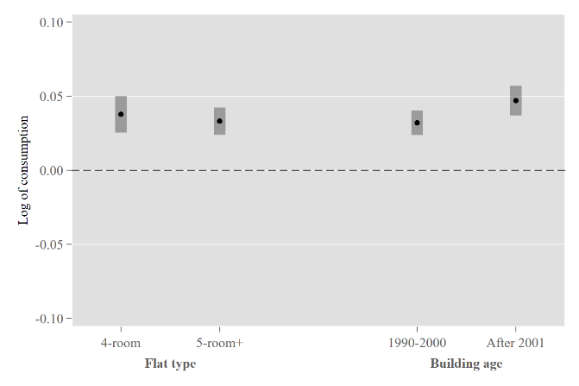 | 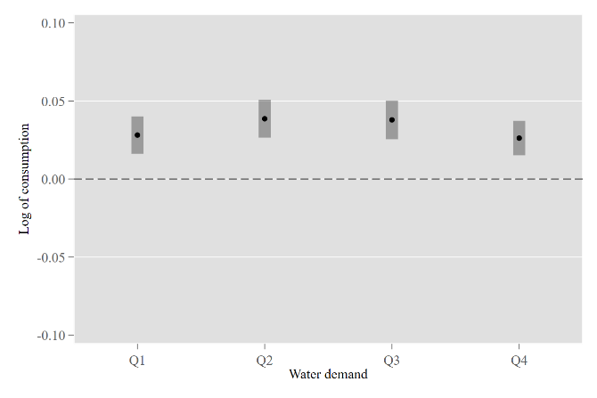
- Flat type and building age | - Baseline utility consumption

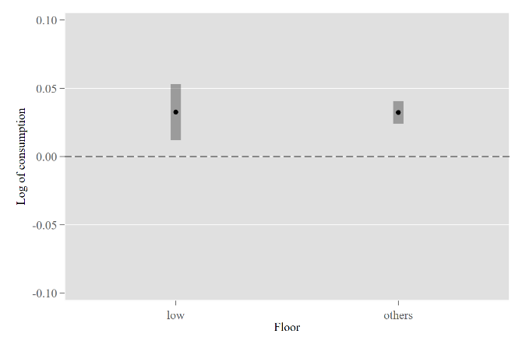 | 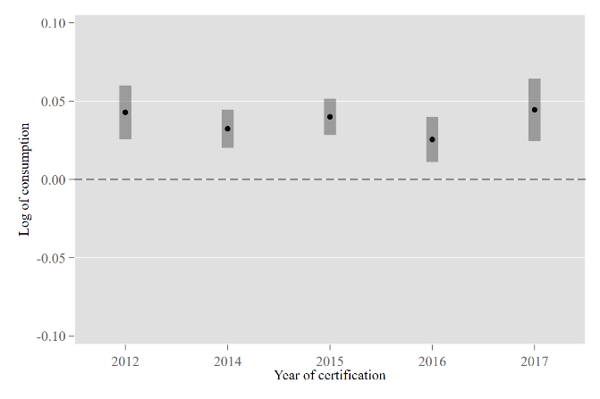
- Floor | - Year of Certification

Notes: The figures show the coefficients and corresponding 95% confidence intervals (error bars) for the effect of green building certification on monthly household water consumption by flat type and building age (Sub-figure (a)), baseline water consumption quartile (Sub-figure (b)), floor (Sub-figure (c)), and year of certification (Sub-figure (d)) by estimating Equation (2) in Methods using the household level sample of 53,407,060 observations.

Fig. S2. Heterogenous effects on household electricity consumption

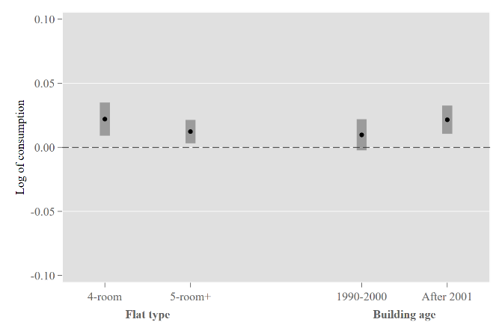 | 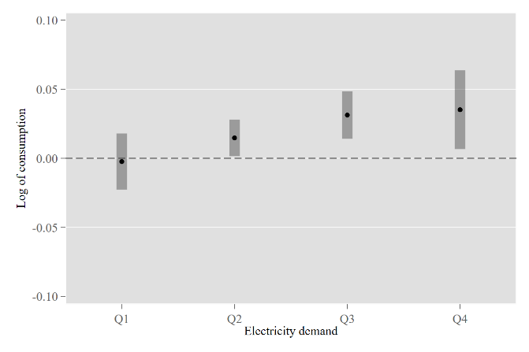
- Flat type and building age | - Baseline utility consumption

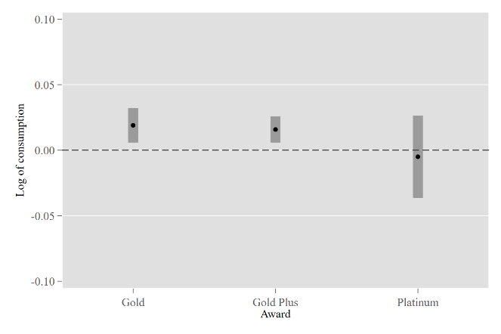 | 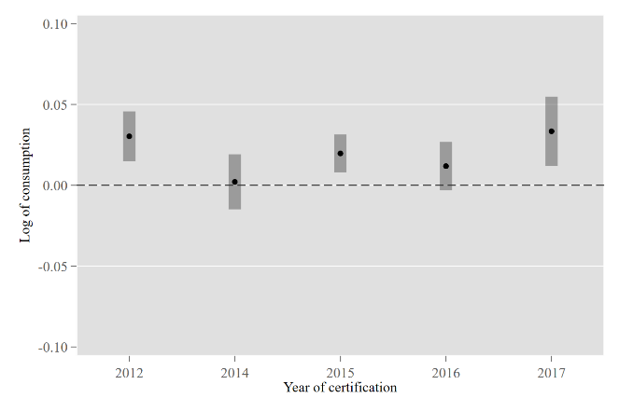
- Award level | - Year of certification

Notes: The figures show the coefficients and corresponding 95% confidence intervals (error bars) for the effect of green building certification on monthly household electricity consumption by flat type and building age (Sub-figure (a)), baseline electricity consumption quartile (Sub-figure (b)), award category (Sub-figure (c)), and award year (Sub-figure (d)) by estimating Equation (2) in Methods using the block-flat type level sample of 1,336,245 observations.

Fig. S3. Event study on electricity consumption

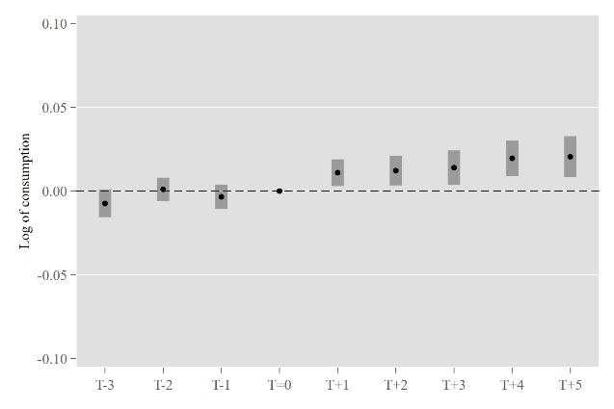
Notes: The figure shows the coefficients and corresponding 95% confidence intervals (error bars) for the differences in household electricity consumption between the certified and non-certified buildings each year before and after the time of certification (T=0), by estimating equation (3) using the block-flat type level sample with 1,336,245 observations.

Fig. S4. Event study on resale property value

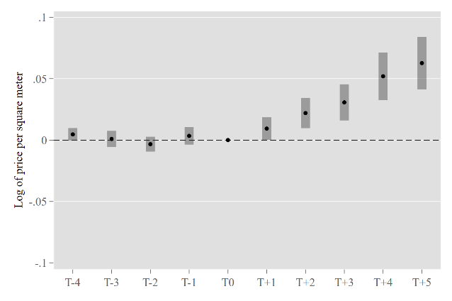
Notes: The figure shows the coefficients and corresponding 95% confidence intervals (error bars) for the differences in per square meter resale property value between the certified and non-certified buildings each year before and after the time of certification (T=0), by estimating equation (7) using 177,135 resale transactions of public-housing flats.

Fig. S5. Event study on water consumption for existing non-residential buildings

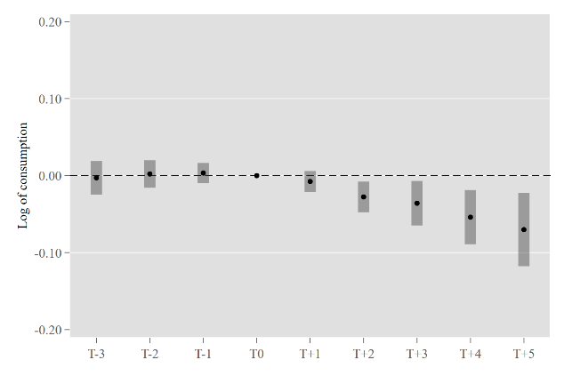
Notes: The figure shows the coefficients and corresponding 95% confidence intervals (error bars) for the differences in water consumption between the certified and non-certified buildings each year before and after the time of certification (T=0), by estimating equation (3) using the account level non-residential sample with 3,267,939 observations.

Table S1. Robustness checks for the effect of Green Mark certification on water consumption of existing residential buildings
 | (1) | (2) | (3) | (4) | (5) | (6)
 | Baseline | Extreme | Building age | Balanced panel | Location | Weather control
Panel A: Household
Post Certification | 0.033*** | 0.032*** | 0.036*** | 0.033*** | 0.034*** | 0.033***
 | (0.004) | (0.004) | (0.005) | (0.004) | (0.004) | (0.004)
N | 53,407,060 | 54,260,336 | 77,208,963 | 35,176,179 | 12,619,614 | 53,407,060
Panel B: Common area
Post Certification | -0.112*** | -0.163*** | -0.164*** | -0.110** | -0.181*** | -0.112***
 | (0.021) | (0.022) | (0019) | (0.021) | (0.022) | (0.021)
N | 305,380 | 322,591 | 435,996 | 274,084 | 94,907 | 305,380
Weather control | No | No | No | No | No | Yes
Account FE | Yes | Yes | Yes | Yes | Yes | Yes
Year-month FE | Yes | Yes | Yes | Yes | Yes | Yes
Group year-month FE | No | No | No | No | No | No
Notes: This table presents the robustness checks on the effect of green building certification on household (Panel A) and common area (Panel B) water consumption for certified buildings, relative to non-certified buildings. The dependent variable is the natural logarithm of monthly water consumption. Column (1) shows the estimates using baseline sample. Columns (2)-(4) alter sample restrictions by including the top and bottom 1% observations in water consumption, including buildings of all ages, and using a fully balanced sample, respectively. Column (5) restricts the control group to never-certified buildings located in the same postal section. Column (6) alters model specification by including block-level weather controls. All models include account fixed effects and year-month fixed effects. The standard errors shown in parentheses are clustered by block. * p < 0.1, ** p < 0.05, *** p < 0.01.

Table S2. Effect of Green Mark Certification on block-flat type level household utility consumption of existing residential buildings

 | (1) | (2) | (3)
 | Monthly | Annual
 | Monthly | Weighted | Standard
Panel A: Water
Post Certification | 0.019*** | 0.011*** | 0.018***
 | (0.005) | (0.005) | (0.005)
Panel B: Electricity
Post Certification | 0.015*** | 0.011*** | 0.014***
 | (0.004) | (0.004) | (0.004)
Block-flat type FE | Yes | Yes | Yes
Year FE | No | Yes | Yes
Year-month FE | Yes | No | No
N | 1,336,245 | 113,611 | 113,611

Notes: This table presents the estimates on the effect of green building certification on household electricity consumption of existing residential buildings, relative to their never-certified counterparts, using Equation (1) in Methods. The dependent variable is log of block-flat type level monthly water consumption for columns (1) and log of block-flat type level annual mean monthly water consumption for columns (2) and (3). Columns (1) and (3) show the effects estimated using standard staggered difference-in-differences method, while column (2) uses the weighted estimation method proposed in Callaway and Sant’Anna (2022). All models control for block-flat type fixed effects and time fixed effects. The standard errors shown in parentheses are clustered by block. * p < 0.1, ** p < 0.05, *** p < 0.01.

Table S3. Robustness checks on the effect of Green Mark certification on electricity use of existing residential buildings
 | (1) | (2) | (3) | (4) | (5) | (6)
 | Baseline | Extreme | Building age | Balanced panel | Location | Weather control
Post Certification | 0.011*** | 0.012** | 0.012*** | 0.012*** | 0.012*** | 0.011***
 | (0.004) | (0.004) | (0.004) | (0.004) | (0.004) | (0.004)
Weather control | No | No | No | No | No | Yes
Block-flat type FE | Yes | Yes | Yes | Yes | Yes | Yes
Year FE | Yes | Yes | Yes | Yes | Yes | Yes
N | 113,611 | 120,757 | 152,697 | 109,880 | 21,201 | 113,611

Notes: This table presents the robustness checks on the effect of green building certification on household electricity consumption for certified buildings, relative to non-certified buildings, using Equation (1) in Methods. The dependent variable is the natural logarithm of monthly electricity consumption for all households of the same flat type in a block. Column (1) shows the estimates using baseline sample. Columns (2)-(4) alter sample restrictions by including the top and bottom 1% observations in water consumption, including buildings of all ages, and using a fully balanced sample, respectively. Column (5) restricts the control group to never-certified buildings located in the same postal section. Column (6) alters model specification by including block-level weather controls. All models include block-flat type fixed effects and year-month fixed effects. The standard errors shown in parentheses are clustered by block. * p < 0.1, ** p < 0.05, *** p < 0.01.

Table S4. Effect of Green Mark Certification on resale property value

 | (1) | (2) | (3) | (4) | (5)
 | Baseline | Alternative sample |  | Alternative specification
 | Baseline | Building age | Location
Post Certification | 0.011*** | 0.011*** | 0.011*** | 0.013*** | 0.010**
 | (0.005) | (0.005) | (0.005) | (0.005) | (0.00)
Flat characteristics | Yes | Yes | Yes | No | Yes
Block FE | Yes | Yes | Yes | Yes | Yes
Group by year-month FE | Yes | Yes | Yes | Yes | No
Year-month FE | No | No | No | No | Yes
Group-year FE | No | No | No | No | Yes
N | 177,135 | 191,548 | 38,566 | 177,135 | 177,135

Notes: This table presents the estimates on the effect of green building certification on resale property value of existing residential buildings, relative to their never-certified counterparts, use Equation (6) in Methods. The dependent variable is log of price per square foot. Column (1) uses the baseline sample while columns (2) and (3) alter the sample by relaxing the restriction on building age and further restricts the control group to never-certified buildings within the same vicinity. Columns (4) and (5) alter the model specifications by excluding flat characteristics and including alternative time fixed effects. All models control for account fixed effects and time fixed effects. The standard errors shown in parentheses are clustered by block. * p < 0.1, ** p < 0.05, *** p < 0.01.

Table S5. Effect of Green Mark Certification on water consumption of existing non-residential buildings

 | (1) | (2) | (3)
 | Monthly | Annual
 | Monthly | Weighted | Standard
Post Certification | -0.036*** | -0.031*** | -0.040***
 | (0.011) | (0.010) | (0.011)
Account FE | Yes | Yes | Yes
Year FE | No | Yes | Yes
Year-month FE | Yes | No | No
N | 3,267,939 | 302,158 | 302,158

Notes: This table presents the estimates on the effect of green building certification on water consumption of existing non-residential buildings, relative to their never-certified counterparts, use Equation (1) in Methods. The dependent variable is log of account level monthly water consumption for column (1) and log of account level annual mean monthly water consumption for columns (2) and (3). Columns (1) and (3) show the effects estimated using standard staggered difference-in-differences method, while column (2) uses the weighted estimation method proposed in Callaway and Sant’Anna (2022). All models control for account fixed effects and time fixed effects. The standard errors shown in parentheses are clustered by account. * p < 0.1, ** p < 0.05, *** p < 0.01.

Table S6. Effect of Green Mark Certification on water and electricity of new residential buildings

 | (1) | (2)
 | Water | Electricity
Certification | -0.008 | -0.004
 | (0.009) | (0.007)
Flat type | Yes | Yes
Othe flat characteristics | Yes | No
Block characteristics | Yes | Yes
Year-month FE | Yes | Yes
N | 9,074,345 | 151,194

Notes: This table presents the estimates on the effect of green building certification on water and electricity consumption of new residential buildings, relative to their never-certified counterparts, use Equation (5) in Methods. The dependent variable is log of account level monthly water consumption for column (1) and log of block-flat type level monthly electricity consumption for column (2). Other flat characteristics include floor and if a unit locates at the topmost floor of a building; Block characteristics include postal district, distance to MRT, and year of complete. Both models control for flat type and year-month fixed effects. The standard errors shown in parentheses are clustered by block. * p < 0.1, ** p < 0.05, *** p < 0.01.

Tabel S7. Summary statistics for existing residential buildings

 | (1) |  | (2) |  | (3)
 | Certified |  | Non-certified |  | Normalized  Difference
 | Mean | SD | Mean | SD | Normalized  Difference
Panel A: Household water consumption
Mean water use before certification (m³) | 17.24 | 9.91 | 18.38 | 10.48 | 0.11
Mean water use after certification (m³) | 17.49 | 9.87
Observations | 1,835,832 |  | 51,564,641 |  | 53,400,47
Panel B: Household electricity consumption
Mean electricity use before certification (kwh) | 402.6 | 81.9 | 486.6 | 176.3 | 0.61
Mean electricity use after certification (kwh) | 424.8 | 100.5
Observations | 34,506 |  | 1,301,739 |  | 1,336,245
Panel C: Common area water consumption
Mean water use before certification (m³) | 108.3 | 79.9 | 86.51 | 74.8 | -0.28
Mean water use after certification (m³) | 108.2 | 75.6
Observations | 10,530 |  | 328,751 |  | 305,380
Panel D: Household characteristics
Year of construction
Before 2001 | 0.75 | 0.44 | 0.16 | 0.37 | -1.44
After 2001 | 0.25 | 0.44 | 0.84 | 0.37 | 1.44
Flat type
4-room or smaller | 0.60 | 0.49 | 0.46 | 0.50 | -0.29
5-room or larger | 0.40 | 0.49 | 0.54 | 0.50 | 0.29
Floor
Low floor | 0.12 | 0.32 | 0.16 | 0.37 | -0.13
High floor | 0.88 | 0.32 | 0.84 | 0.37 | 0.13
Observations | 1,835,832 |  | 51,564,641 |  | 53,400,47
Notes: This table provides the mean and standard deviation for account level monthly water consumption for household (Panel A) and common areas (Panel C); block-flat type mean monthly electricity consumption for household (Panel B); and household characteristics (Panel D) for treatment group (columns (1)) and control group (columns (2)), respectively. Normalized differences between the group means are provided in column (3).

Table S8. Summary statistics for other building categories

 | (1) |  | (2) |  | (3)
 | Certified |  | Non-certified |  | Normalized  Difference
 | Mean | SD | Mean | SD | Normalized  Difference
Panel A: Household water consumption for new residential buildings
Mean water use (m³) | 12.79 | 8.15 | 12.67 | 8.10 | -0.01
Observations | 2,651,261 |  | 6,423,084 |  | 9,074,345
Panel B: Household electricity consumption for new residential buildings
Mean electricity use (kwh) | 311.2 | 88.4 | 315 | 90.5 | 0.04
Observations | 45,094 |  | 106,100 |  | 151,194
Panel C: Account level water consumption for existing non-residential buildings
Mean water use before certification (m³) | 58.36 | 129.5 | 75.93 | 143.9 | 0.13
Mean water use after certification (m³) | 59.5 | 132.2
Observations | 153,016 |  | 3,114,923 |  | 3,267,939
Notes: This table provides the mean and standard deviation for account level monthly water consumption for new residential buildings (Panel A) and existing non-residential buildings (Panel C); block-flat type mean monthly electricity consumption for new residential buildings (Panel B) for treatment group (columns (1)) and control group (columns (2)), respectively. Normalized differences between the group means are provided in column (3).

