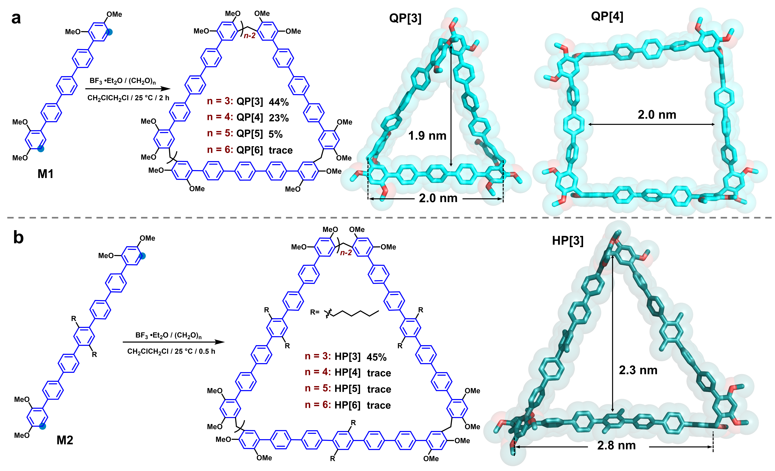
Scheme 1. (a) Synthesis of quinquephen[3-6]arenes (QP[3-6]), a single-crystal structure of QP[3], and an optimized structure of QP[4]. (b) Synthesis of heptaphen[3-6]arenes (HP[3-6]) and an optimized structure of HP[3]. The hydrogen atoms are omitted for the sake of clarity. The hexyls units in HP[3] were replaced by methyl units for clarity.
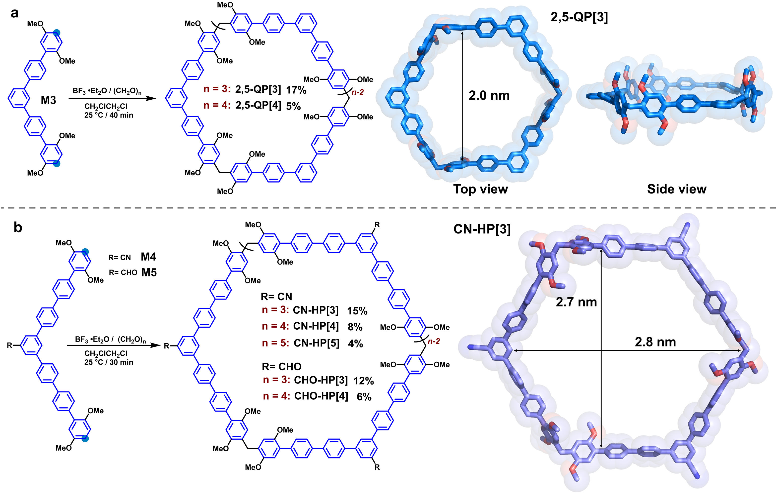
Scheme 2. (a) Synthesis of 2,5-dimethoxyquinquephen[3-4]arenes (2,5-QP[3-4]) and single-crystal structure of 2,5-QP[3]. Side view of the structure is also shown. (b) Synthesis of 2,5-dimethoxyheptaphen[n]arenes (CN-HP[3-5] and CHO-HP[3-4]) and optimized structure of CN-HP[3]. The hydrogen atoms are omitted for the sake of clarity.

