Supporting Information

Low-Entropy-Penalty Synthesis of Giant Macrocycles for Good Self-Assembly and Emission Enhancement
Xiao-Na Sun⁺,ª Ao Liu⁺,ª Kaidi Xu⁺,^{b} Zhe Zheng,ª Kai Xu,ª Ming Dong,ª Jian Li,^{b,c} Zhi-Yuan Zhang^{*, a} and Chunju Li^{*, a}
a. Tianjin Key Laboratory of Structure and Performance for Functional Molecules, College of Chemistry, Tianjin Normal University, Tianjin 300387 (P. R. China).
b. College of Science, Center for Supramolecular Chemistry and Catalysis, Shanghai University, Shanghai 200444 (P. R. China).
c. School of Chemistry and Chemical Engineering, Henan Normal University, P. R. China.

+. These authors contributed equally to this work.

Table of Contents
Section I. Materials/Methods/Instrumentation 2
Section II. Comparison of Traditional Method and Our Strategy 3-4
Section III. Synthetic Protocols of Giant Macrocycles. 4-61
Section IV. Assembly and Photophysical properties 61-68
Section V. References 69

Section I. Materials/Methods/Instrumentation
All reagents were commercially available and used without further purification, unless otherwise noted. Solvents were either employed as purchased or dried prior to use by standard laboratory procedures. Quaterphen[3]arenes (QT[3]) and terphen[3]arenes (TP[3]) were synthesized according to our previous work.¹
¹H NMR, ¹³C NMR and 2D NMR spectra were recorded using a Bruker Avance 400, 500 and 600 NMR spectrometer, and chemical shifts in organic solvents were reported in ppm relative to the signals of residual solvent as the internal standard. High-resolution mass spectra (HRMS) were determined on Thermo Scientific ExactiveTM LC/MS with ESI source, Agilent 6520 Accurate-Mass Q-TOF LC/MS System, Bruker solanX 70 FT-MS or Bruker Daltonics Inc. Ultrafle Xtreme MALDI-TOF. All single crystal X-ray diffraction data were determined by a Bruker D8 Venture single crystal X-ray CCD diffractometer at low temperature using graphite-monochromated Cu-Kα (λ = 1.54178 Å) or Mo-Kα (λ = 0.71073) radiations. The crystal structures were solved by direct methods and subsequent Fourier syntheses and refined by full-matrix least-squares method based on F² by the SHELXL^{2,3} in the Olex 2 software.⁴ Photoluminescence spectra and lifetime were obtained on FLS 1000. Fluorescence and phosphorescence quantum efficiencies were measured on HAMAMATSU C9920-02.
The geometry optimization of QP[4-6] and HP[3-6] were performed by using Mopac2016 program.^{5,6}

Section II. Comparison of Reported Method and Our Strategy

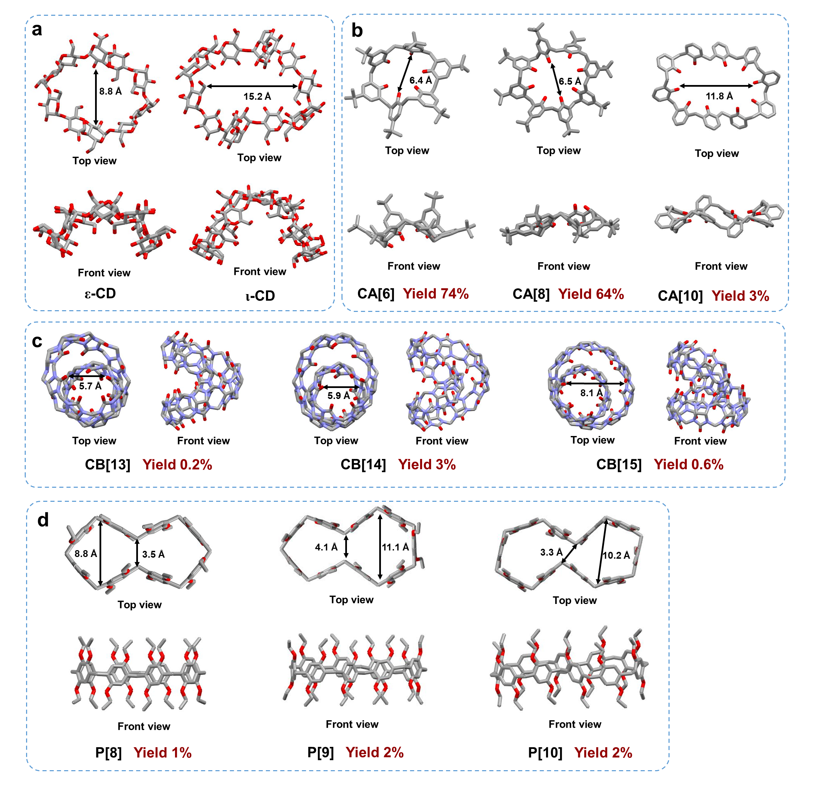
Figure S1. A conventional method of increasing monomer numbers for synthesizing macrocycles resulted twisted configurations and low yields. (a) Single-crystal structures of ε- and ι-cyclodextrins (ε-CD and ι-CD)⁷. (b) Single-crystal structures of calix[n]arenes (CA[6]⁸[Xing, 2021 #186][Xing, 2021 #186] CA[8]⁹, and CA[10]^{10,11}). (c) Single-crystal structures of cucurbit[n]urils (CB[13]¹², CB[14]¹³, and CB[15]¹²). (d) Single-crystal structures of pillar[n]arenes (P[8], P[9], and P[10])¹⁴.

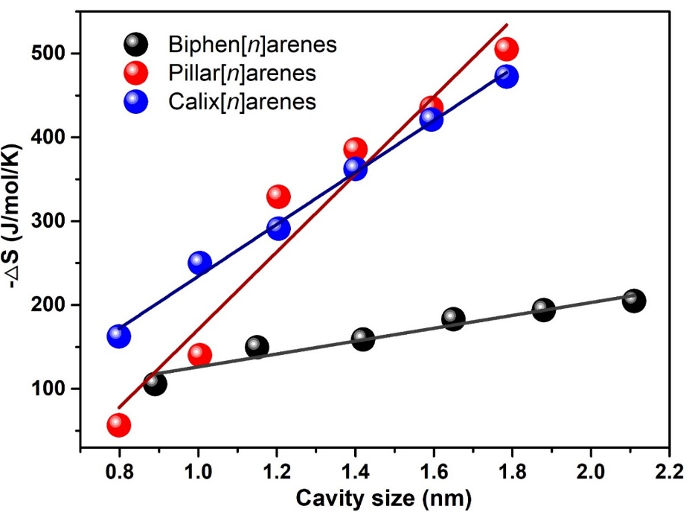
Figure S2. The calculated cyclization entropy penalty (-ΔS) of biphen[n]arenes, pillar[n]arenes, and calix[n]arenes as increasing cavity sizes.

Section III. Synthetic Protocols of Giant Macrocycles
1. Synthetic Protocols of QP[3-6] and HP[3-6]
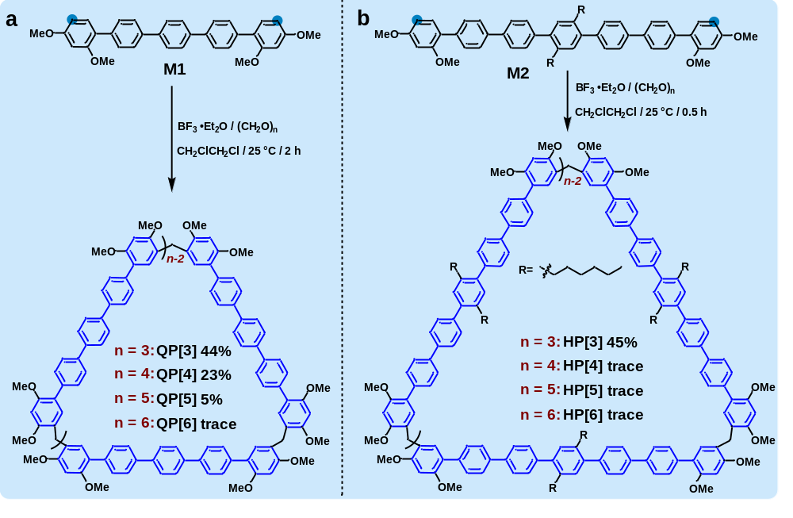
Scheme S1. Synthetic routes of QP[3-6] and HP[3-6].

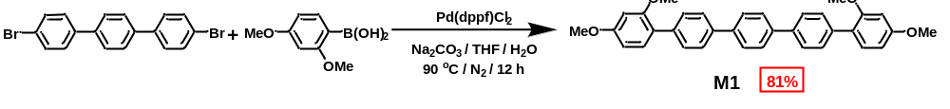
Scheme S2. Synthesis of monomer M1.
4, 4''-dibromo-p-terphenyl (6.2 g, 16 mmol) and 2, 4-dimethoxyphenylboronic acid (6.4 g, 35 mmol) were dissolved in 250 mL tetrahydrofuran and 50 mL water (5:1). After addition of Pd(dppf)Cl₂ (1.2 g, 1.7 mmol) and Na₂CO₃ (6.3 g, 62 mmol), the mixture was stirred at 90 ℃ for 12 hours under nitrogen atmosphere. After quenching the reaction, the mixture was cooled to the room temperature, extracted with dichloromethane and washed with brine. Then the organic layer was dried with anhydrous Na₂SO₄, the solvent was removed under vacuum and the residue was purified by column chromatography (silica gel, eluent: pure CH₂Cl₂) to afford M1 as white solid (6.5 g, 81%).
m. p. 240 - 242 ºC. ¹H NMR (400 MHz, CDCl₃) δ 7.72 (s, 4H), 7.68 (d, J = 8.3 Hz, 4H), 7.61 (d, J = 8.3 Hz, 4H), 7.31 (d, J = 8.9 Hz, 2H), 6.61 - 6.59 (m, 4H), 3.87 (s, 6H), 3.84 (s, 6H). ¹³C NMR (101 MHz, CDCl₃) δ 160.61, 157.77, 140.01, 139.01, 137.63, 131.37, 130.00, 127.54, 126.79, 123.37, 104.98, 99.30, 55.78, 55.62. HRMS (ESI, m/z): calcd. for [M+H]⁺, 503.2217; found, 503.2217.
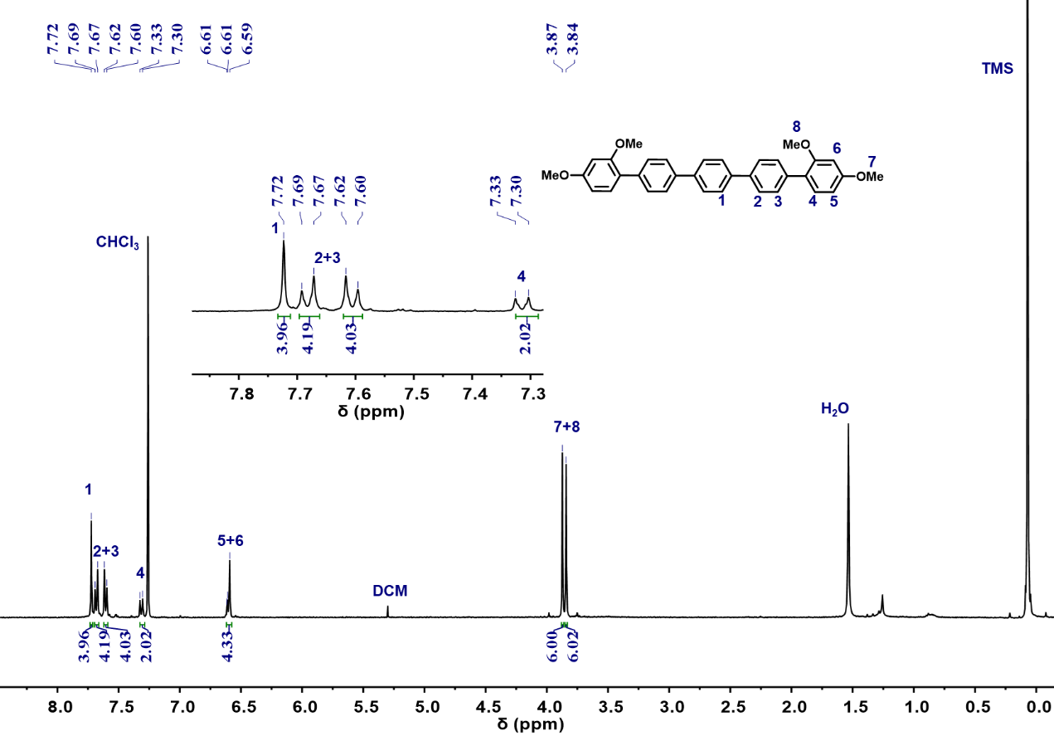
Figure S3. ¹H NMR spectrum (400 MHz, CDCl₃, 298K) of monomer M1.

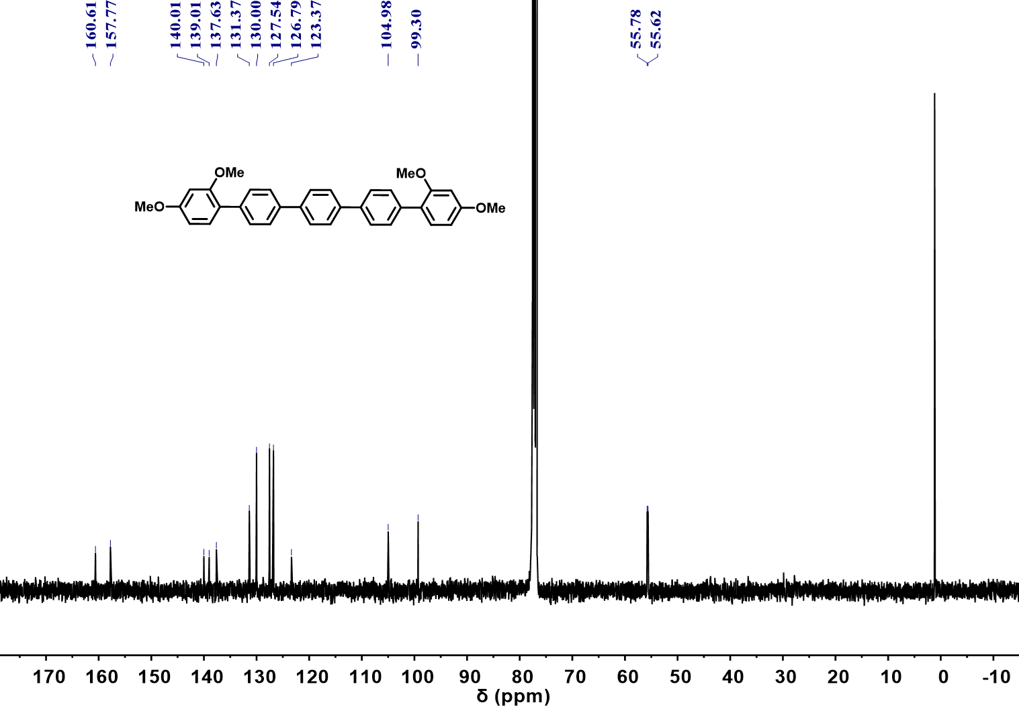
Figure S4. ¹³C NMR spectrum (101 MHz, CDCl₃, 298K) of monomer M1.
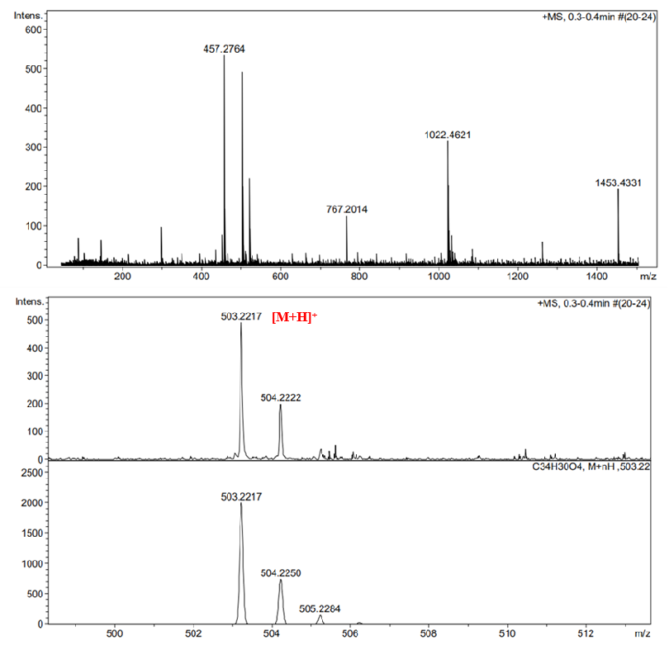
Figure S5. HRMS of monomer M1.

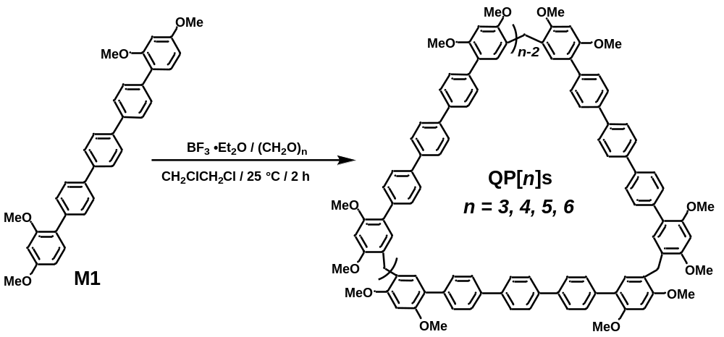
Scheme S3. Synthesis of QP[n]s.
The M1 (0.60 g, 1.2 mmol) were dissolved in 300 mL 1, 2-dichloroethane and then paraformaldehyde (90 mg, 3.0 mmol) was added. Subsequently, BF₃⋅Et₂O (12 μL, 0.092 mmol) was dropped into and the mixture was stirred at room temperature for 2 h. After it was quenched with saturated NaHCO₃ solution, extracted with dichloromethane and water, the organic layer was dried with anhydrous Na₂SO₄. Then the organic solvent was removed under vacuum and the residue was purified by column chromatography (silica gel, eluent: petroleum ether/CH₂Cl₂ 3:1) to afford QP[3] (0.27 g, 44%), QP[4] (0.14 g, 23 %), QP[5] (29 mg, 5%), and trace QP[6] as white powder.
QP[3]: m. p. >320 ºC. ¹H NMR (400 MHz, CDCl₃) δ 7.68 (s, 12H), 7.63 (d, J = 8.4 Hz, 12H), 7.55 (d, J = 8.4 Hz, 12H), 7.02 (s, 6H), 6.59 (s, 6H), 3.96 (s, 6H), 3.90 (s, 18H), 3.85 (s, 18H). ¹³C NMR (101 MHz, CDCl₃) δ 157.98, 155.96, 139.89, 138.77, 137.77, 132.02, 130.00, 127.47, 126.72, 122.16, 121.64, 96.14, 56.09, 56.02, 27.88. HRMS (ESI, m/z): calcd. for [M+Na]⁺, 1566.6358; found, 1566.6354.
QP[4]: m. p. >320 ºC. ¹H NMR (500 MHz, CDCl₃) δ 7.67 (s, 16H), 7.62 (d, J = 8.3 Hz, 16H), 7.54 (d, J = 8.3 Hz, 16H), 6.99 (s, 8H), 6.60 (s, 8H), 3.95 (s, 8H), 3.91 (s, 24H), 3.85 (s, 24H). ¹³C NMR (126 MHz, CDCl₃) δ 158.03, 156.00, 139.87, 138.75, 137.74, 132.00, 129.98, 127.42, 126.67, 122.08, 121.56, 96.18, 56.15, 56.09, 27.95. HRMS (ESI, m/z): calcd. for [M]⁺, C₁₄₀H₁₂₀O₁₆⁺, 2057.8610; found, 2057.8586.
QP[5]: m. p. >320 ºC. ¹H NMR (500 MHz, CDCl₃) δ 7.68 (s, 20H), 7.63 (d, J = 8.1 Hz, 20H), 7.55 (d, J = 8.2 Hz, 20H), 7.11 (s, 10H), 6.58 (s, 10H), 3.94 (s, 10H), 3.91 (s, 30H), 3.84 (s, 30H).¹³C NMR (101 MHz, CDCl₃) δ 157.95, 155.91, 139.89, 138.73, 137.82, 132.30, 129.99, 127.48, 126.71, 122.10, 121.64, 95.92, 56.06, 55.90, 27.36. HRMS (ESI, m/z): calcd. for [M]⁺, C₁₇₅H₁₅₀O₂₀⁺, 2572.0754; found, 2572.0727.
QP[6]: HRMS (ESI, m/z): calcd. for [M]⁺, C₂₁₀H₁₈₀O₂₄⁺, 3087.2932; found, 3087.2921.

Table S1. Screening of reaction conditions for QP[3].
Entry | Catalysts | Percentages of Catalysts (mol%) | Solvents^{[b]} | Temperature (℃) | Reaction time^{[c]} | Yields (%)^{[d]}
1 | BF₃·Et₂O | 8 | DCE | 0 | > 12 h | -^{[e]}
2 | BF₃·Et₂O | 8 | DCE | 25 | 2 h | 44
3 | BF₃·Et₂O | 8 | DCE | 60 | 10 min | 24
4 | BF₃·Et₂O | 200 | DCE | 25 | 28 min | 38
5 | FeCl₃ | 150 ^{[a]} | DCE | 25 | 19 min | 29
6 | FeCl₃ | 8 | DCE | 25 | 20 h | 30
7 | TfOH | 28 ^{[a]} | DCE | 25 | 6 min | 30
8  9 | TfOH  AlCl₃ | 8  250 ^{[a]} | DCE  DCE | 25  25 | 20 h  11min | 19  29
10 | AlCl₃ | 8 | DCE | 25 | > 12 h | 8
11 | BF₃·Et₂O | 8 | DCM | 25 | 21 min | 39
12 | BF₃·Et₂O | 8 | TCE | 25 | >12 h | 19
13 | BF₃·Et₂O | 8 | CHCl₃ | 25 | >12 h | 11
14 | BF₃·Et₂O | 30 | CH₃CN | 25 | > 12 h | -^{[e]}
[a] The ratio of catalyst is optimal for given conditions; [b] DCE: 1,2-dichloroethane; DCM: dichloromethane; TCE: 1,1′,2,2′-tetrachloroethane; [c] The reaction time is optimal for given conditions; [d] Yield of isolated product; [e] Not detected.
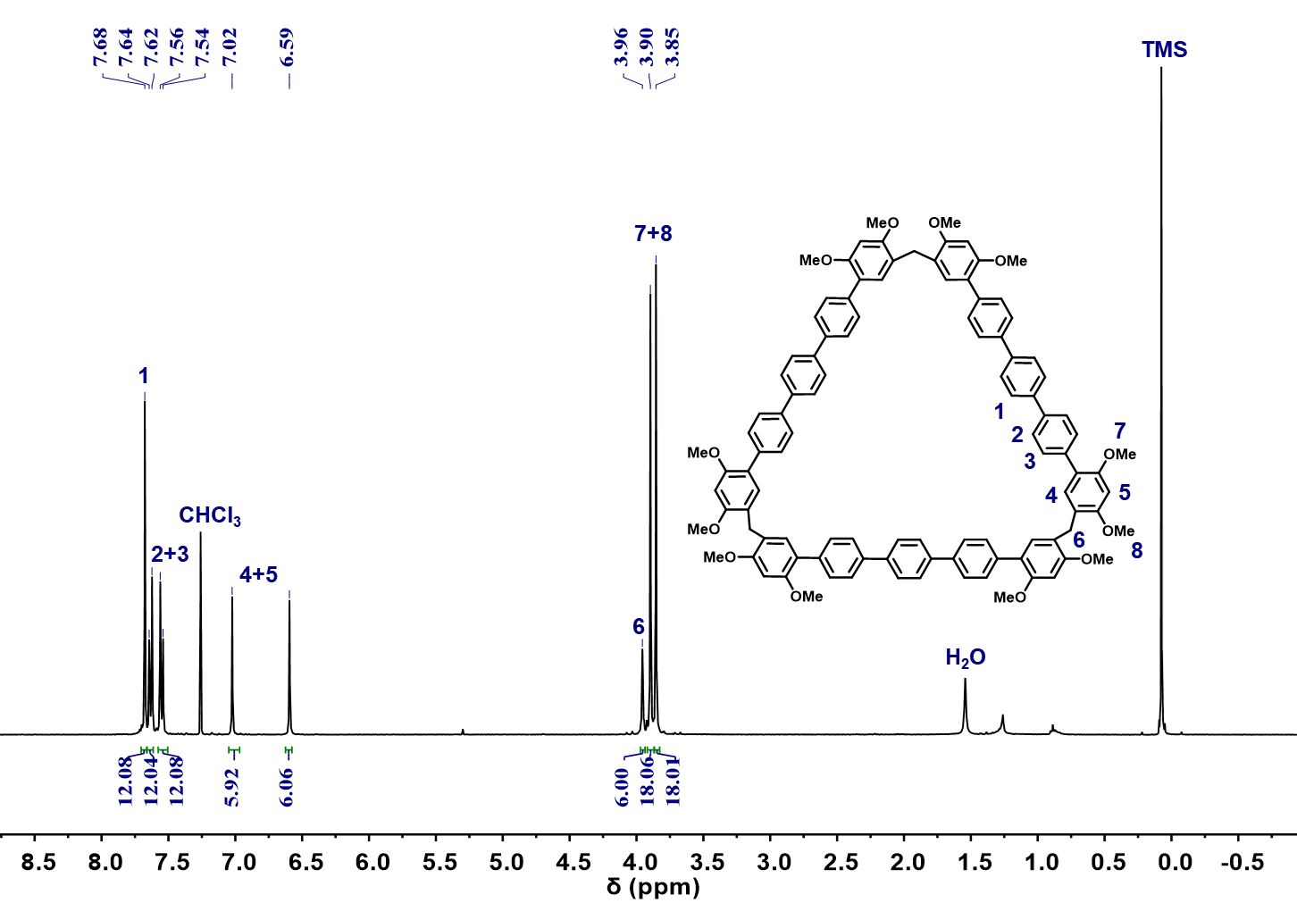
Figure S6. ¹H NMR spectrum (400 MHz, CDCl₃, 298K) of QP[3].

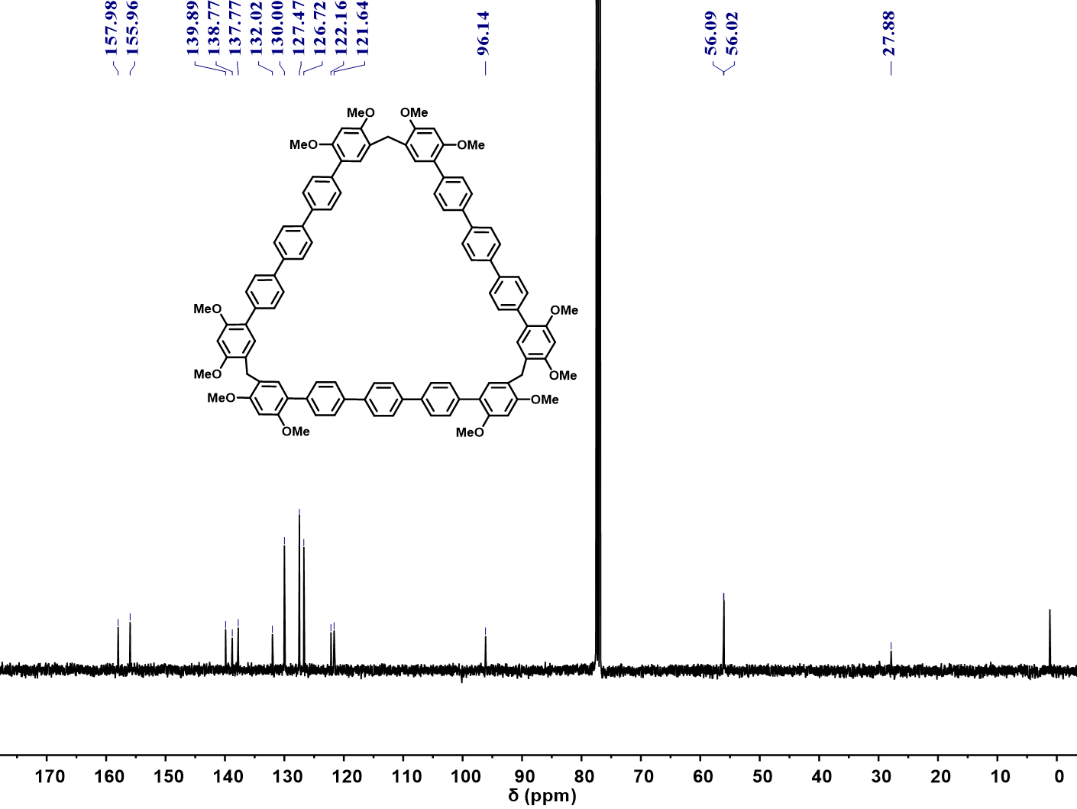
Figure S7. ¹³C NMR spectrum (101 MHz, CDCl₃, 298K) of QP[3].
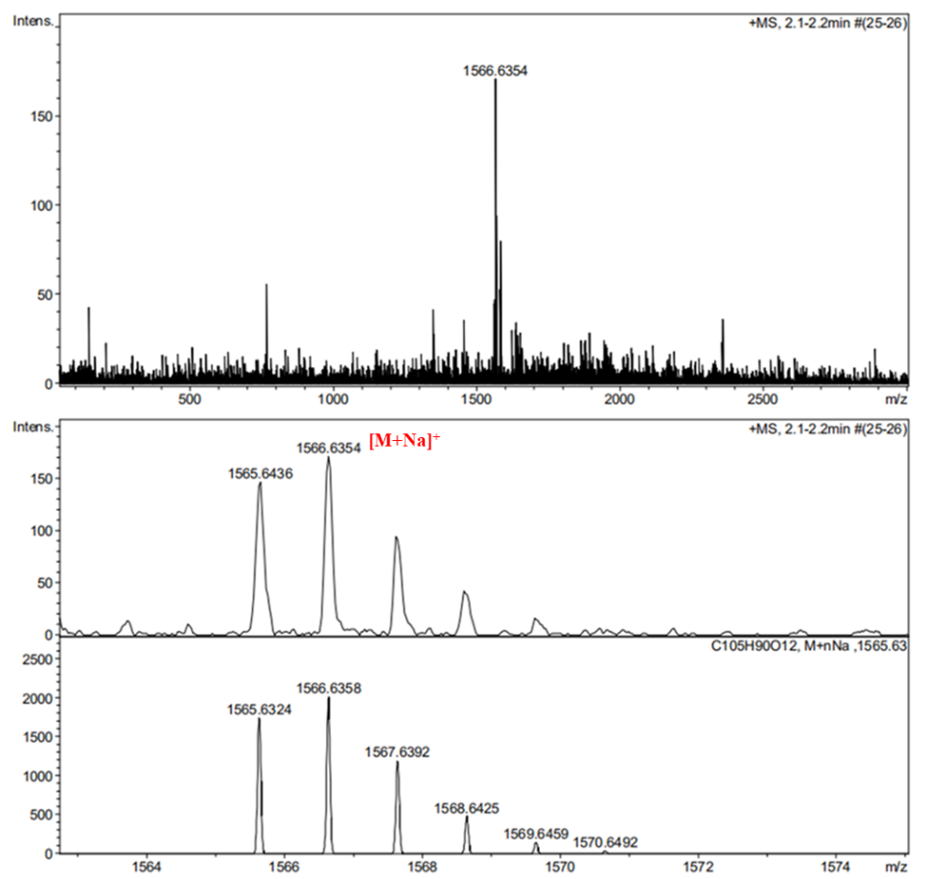
Figure S8. HRMS of QP[3].

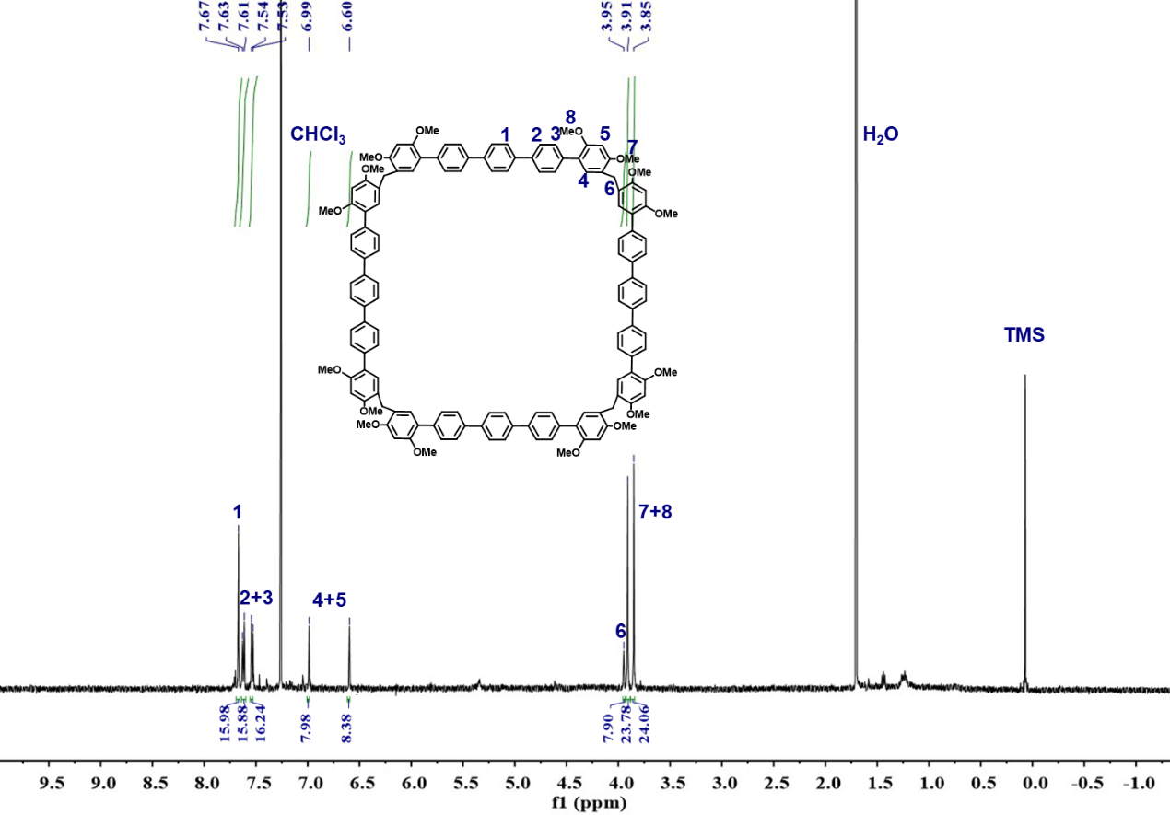
Figure S9. ¹H NMR spectrum (500 MHz, CDCl₃, 298K) of QP[4].

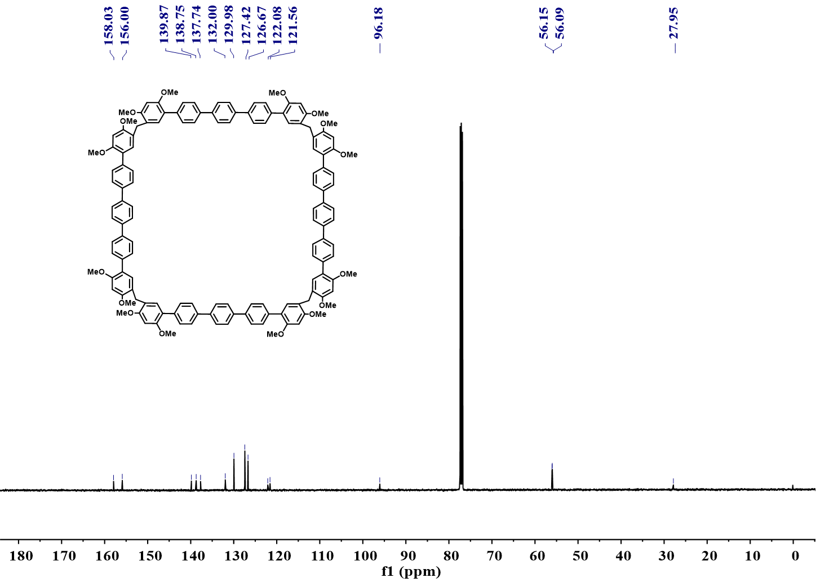
Figure S10. ¹³C NMR spectrum (126 MHz, CDCl₃, 298K) of QP[4].
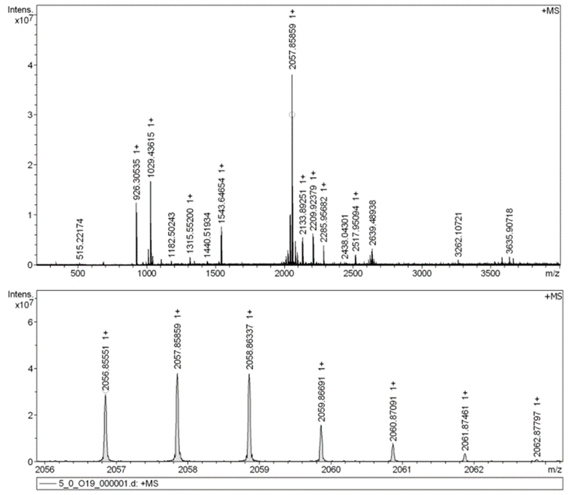
+Na]⁺
Figure S11. HRMS of QP[4].
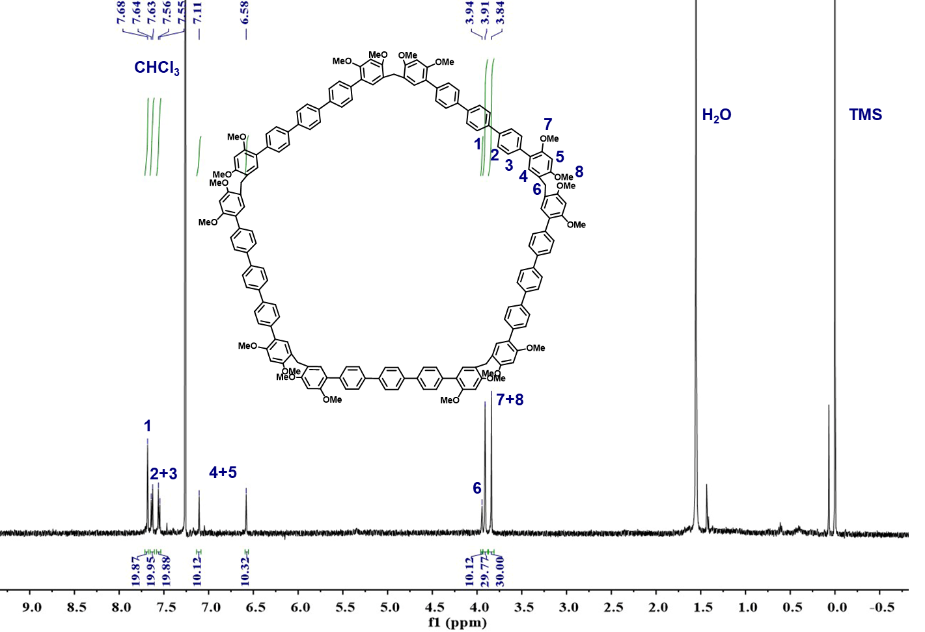
Figure S12. ¹H NMR spectrum (500 MHz, CDCl₃, 298K) of QP[5].

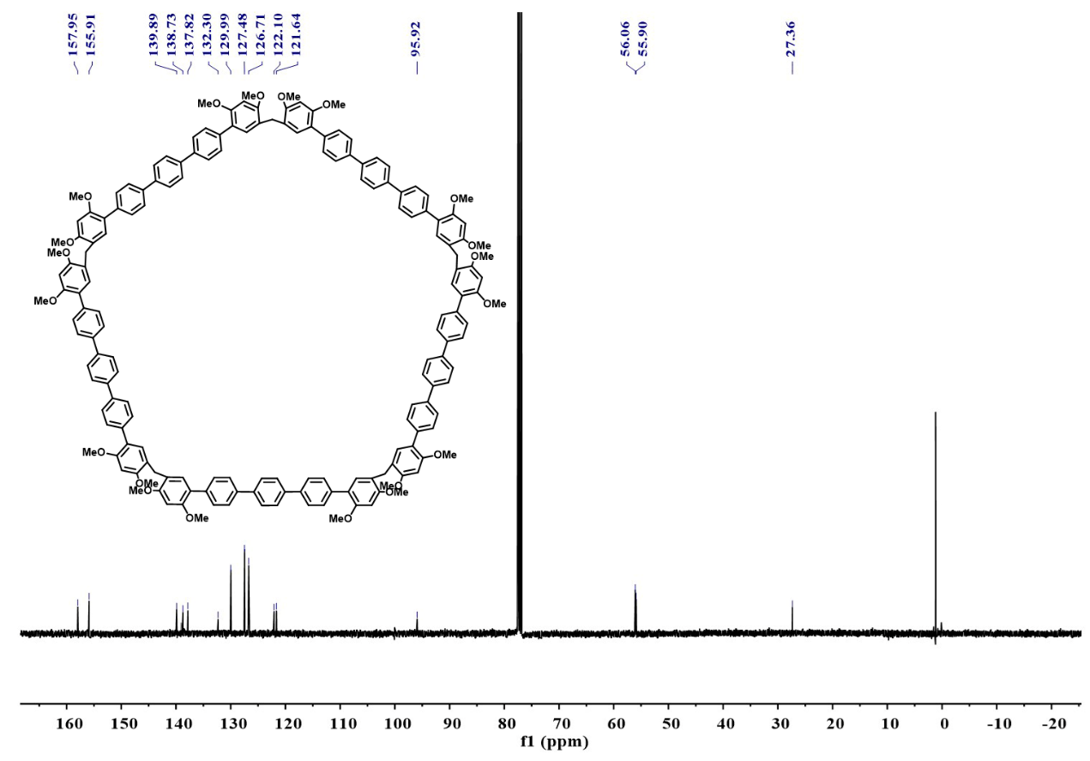
Figure S13. ¹³C NMR spectrum (101 MHz, CDCl₃, 298K) of QP[5].

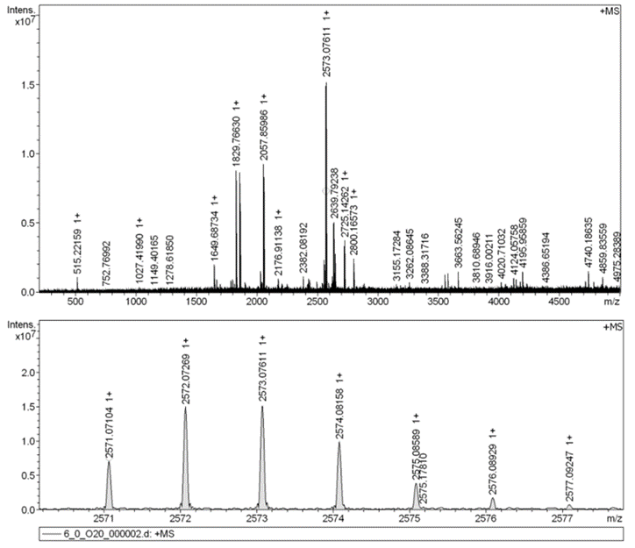
Figure S14. HRMS of QP[5].
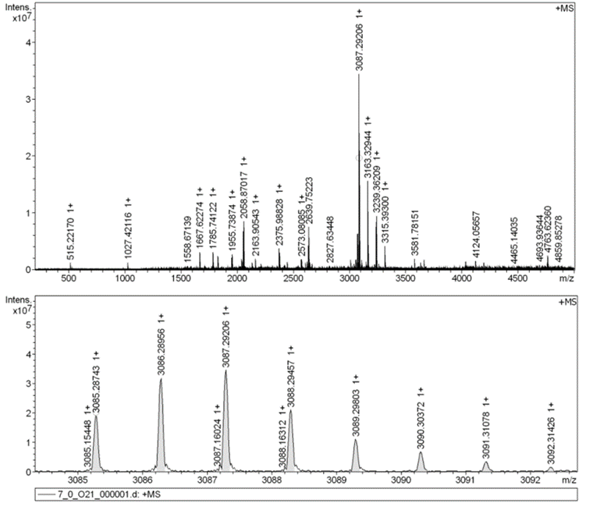
Figure S15. HRMS of QP[6].

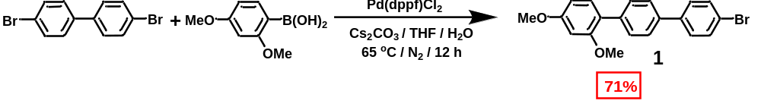
Scheme S4. Synthesis of compound 1.
4, 4'-dibromo-1, 1'-biphenyl (6.2 g, 20 mmol) and 2, 4-dimethoxyphenylboronic acid (1.8 g, 10 mmol) were dissolved in 150 mL tetrahydrofuran and 15 mL water (10:1). After addition of Pd(dppf)Cl₂ (0.73 g, 1.0 mmol) and Cs₂CO₃ (13 g, 40 mmol), the mixture was stirred at 65 ℃ for 12 hours under nitrogen atmosphere. After the mixture was cooled to the room temperature, it was extracted with dichloromethane and washed by brine, the organic layer was dried with anhydrous Na₂SO₄. The organic solvent was removed under vacuum and the residue was purified by column chromatography (silica gel, eluent: petroleum ether/CH₂Cl₂ 30:1 to 10:1) to afford compound 1 (2.6 g, 71%) as a white solid.
¹H NMR (400 MHz, CDCl₃) δ 7.60 - 7.55 (m, 6H), 7.52 - 7.48 (m, 2H), 7.29 (d, J = 8.9 Hz, 1H), 6.61 - 6.58 (m, 2H), 3.87 (s, 3H), 3.83 (s, 3H). ¹³C NMR (101 MHz, CDCl₃) δ 160.6, 157.65, 140.12, 138.13, 137.98, 131.97, 131.30, 130.06, 128.76, 126.66, 123.03, 121.48, 104.87, 99.18, 55.70, 55.57. HRMS (ESI, m/z): calcd. for [M+H]⁺, 369.0490; found, 369.0478.

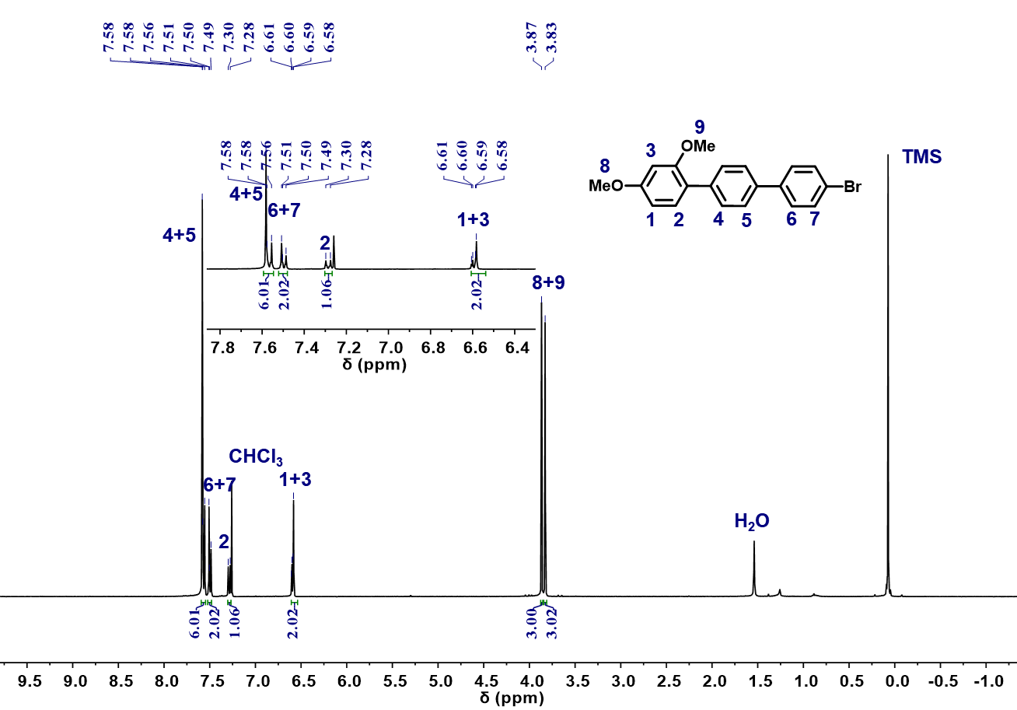
Figure S16. ¹H NMR spectrum (400 MHz, CDCl₃, 298K) of compound 1.
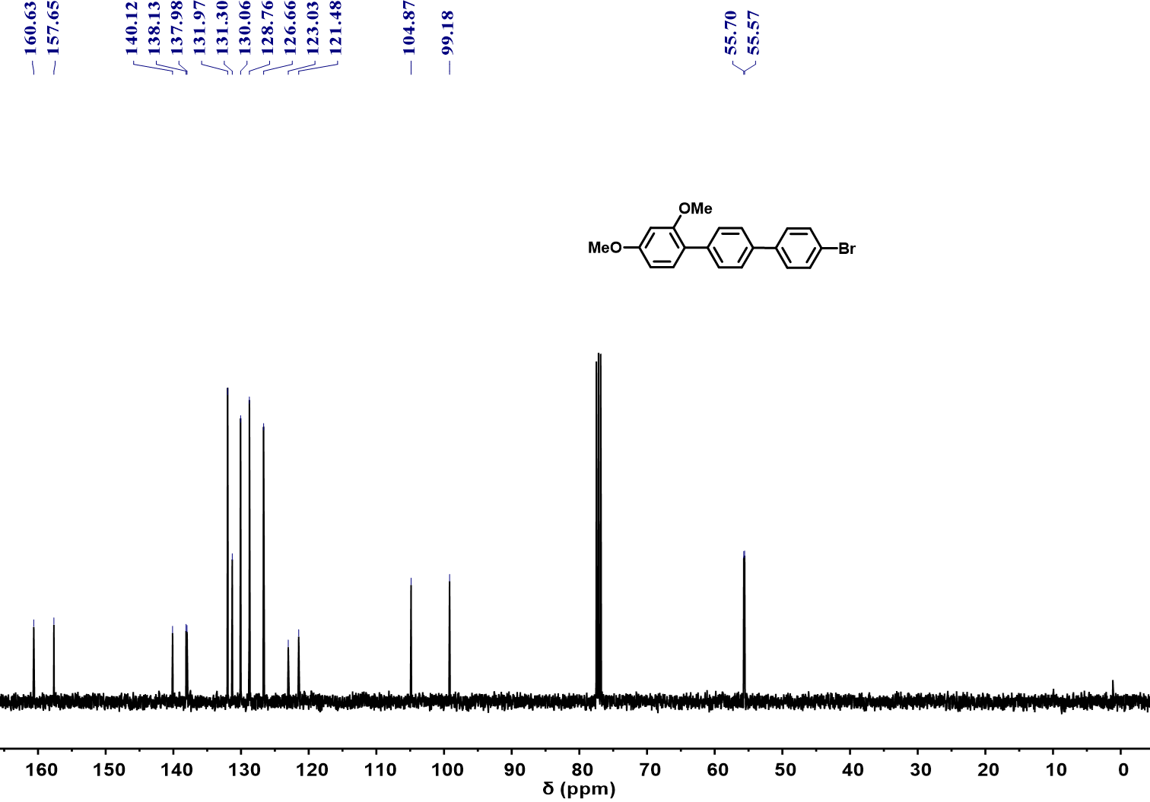
Figure S17. ¹³C NMR spectrum (101 MHz, CDCl₃, 298K) of compound 1.

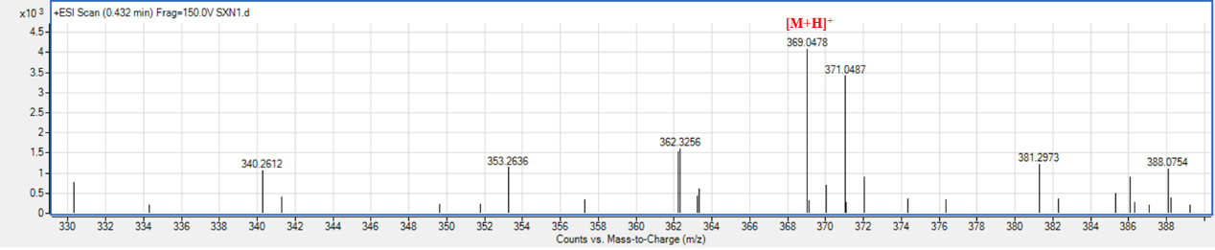
Figure S18. HRMS of compound 1.

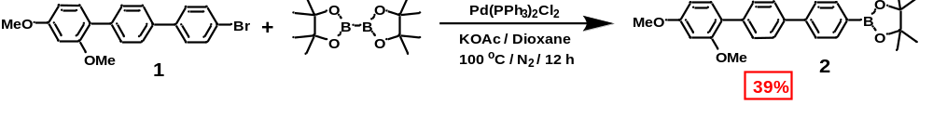
Scheme S5. Synthesis of compound 2.
The compound 1 (1.8 g, 5.0 mmol) and bis(pinacolato)diboron (2.5 g, 10 mmol) were dissolved in 200 mL 1,4-dioxane. After addition of Pd(PPh₃)₂Cl₂ (0.35 g, 0.50 mmol) and KOAc (2.0 g, 20 mmol), the mixture was stirred at 100 ℃ for 12 hours under nitrogen atmosphere. After the mixture was cooled to the room temperature, it was extracted with dichloromethane and washed by brine. Then the organic layer was dried with anhydrous Na₂SO₄, the organic solvent was removed under vacuum and the residue was purified by column chromatography (silica gel, eluent: eluent: petroleum ether/CH₂Cl₂ 3:1 to 1:1) to afford compound 2 (0.81 g, 39%) as a white solid.
¹H NMR (400 MHz, CDCl₃) δ 7.89 (d, J = 8.2 Hz, 2H), 7.65 (d, J = 8.4 Hz, 4H), 7.61 - 7.55 (m, 2H), 7.29 (dd, J = 7.1, 1.7 Hz, 1H), 6.61 - 6.57 (m, 2H), 3.87 (s, 3H), 3.83 (s, 3H), 1.37 (s, 12H). ¹³C NMR (101 MHz, CDCl₃) δ 160.55, 157.66, 143.85, 139.14, 137.87, 135.37, 131.31, 129.94, 126.93, 126.47, 123.18, 104.83, 99.15, 83.91, 55.68, 55.54, 25.01. HRMS (ESI, m/z): calcd. for [M+H]⁺, 417.2237; found, 417.2243.

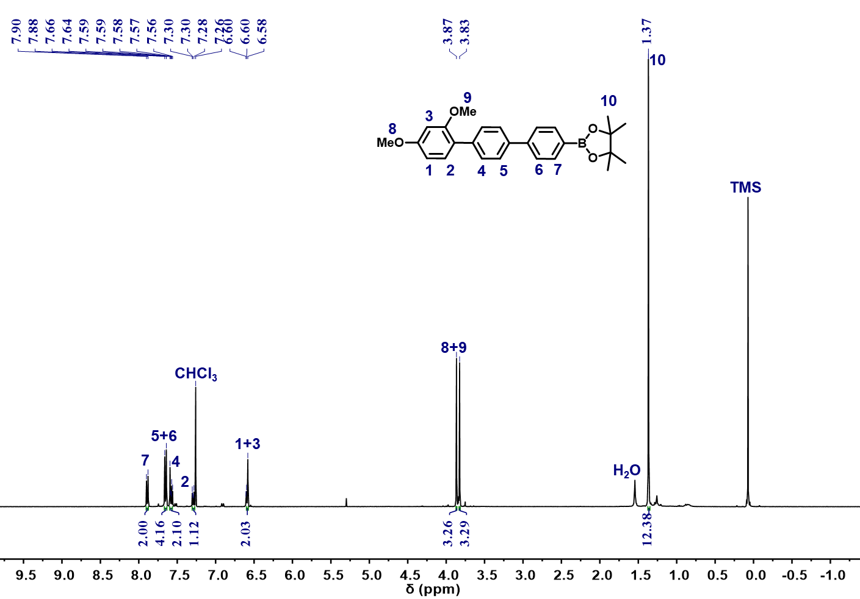
Figure S19. ¹H NMR spectrum (400 MHz, CDCl₃, 298K) of compound 2.
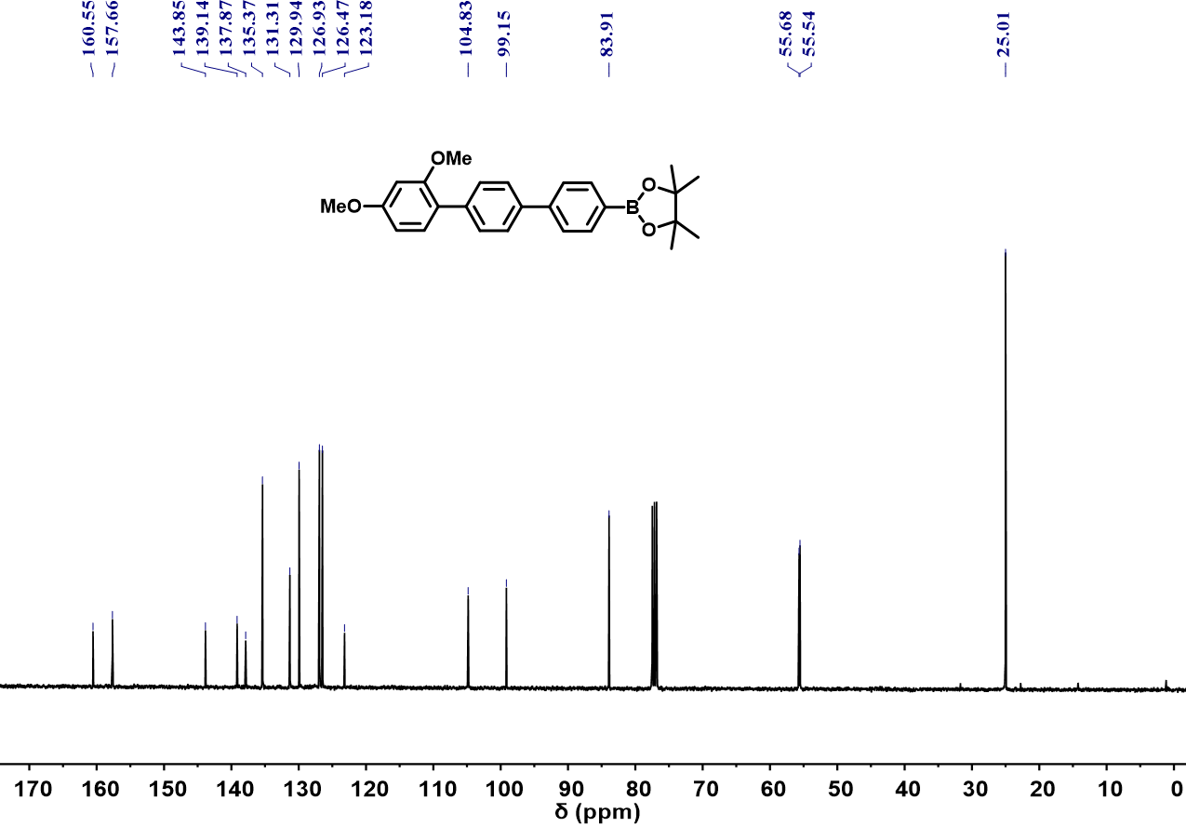
Figure S20. ¹³C NMR spectrum (101 MHz, CDCl₃, 298K) of compound 2.

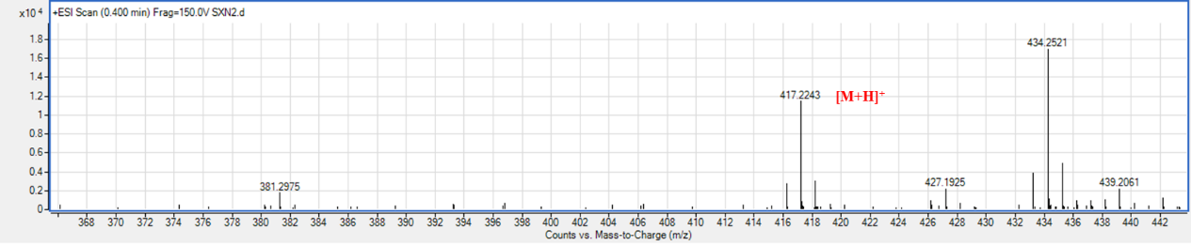
Figure S21. HRMS of compound 2.
[M+Na]⁺

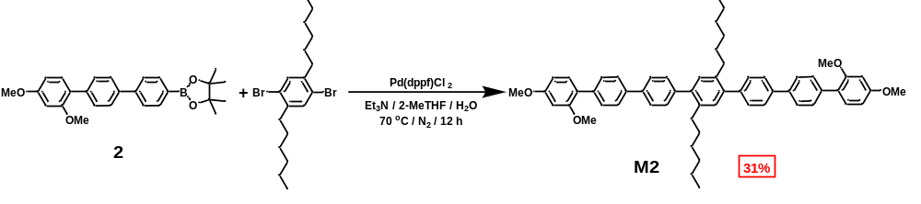
Scheme S6. Synthesis of monomer M2.
The compound 2 (1.3 g, 3.0 mmol) and 1, 4-dibromo-2, 5-dihexylbenzene (0.60 g, 1.5 mmol) were dissolved in 150 mL 2-Methyltetrahydrofuran and 30 mL water (5:1). After addition of Pd(dppf)Cl₂ (54 mg, 0.075 mmol) and 30 mL Et₃N, the mixture was stirred at 70 ℃ for 12 hours under a nitrogen atmosphere. The mixture was cooled to the room temperature, extracted with dichloromethane and washed by brine. Then the organic layer was dried with anhydrous Na₂SO₄, the solvent was removed under vacuum and the residue was purified by column chromatography (silica gel, eluent: petroleum ether/CH₂Cl₂ 3:1) to afford M2 (0.38 g, 31%) as a white solid.
m. p. 190 - 192 ºC. ¹H NMR (400 MHz, CDCl₃) δ 7.71 (d, J = 8.3 Hz, 8H), 7.62 (d, J = 8.3 Hz, 4H), 7.46 (d, J = 8.2 Hz, 4H), 7.33 (d, J = 8.9 Hz, 2H), 7.21 (s, 2H), 6.64 - 6.57 (m, 4H), 3.88 (s, 6H), 3.85 (s, 6H), 2.71 - 2.56 (m, 4H), 1.35 - 1.09 (m, 16H), 0.82 (t, J = 6.9 Hz, 6H). ¹³C NMR (101 MHz, CDCl₃) δ 160.54, 157.70, 140.99, 140.59, 139.50, 139.13, 137.77, 137.52, 131.36, 131.12, 129.97, 129.88, 126.82, 126.78, 123.28, 104.87, 99.21, 55.74, 55.58, 32.85, 31.66, 31.61, 29.38, 22.64, 14.20. HRMS (ESI, m/z): calcd. for [M+H]⁺, 823.4721; found, 823.4708.
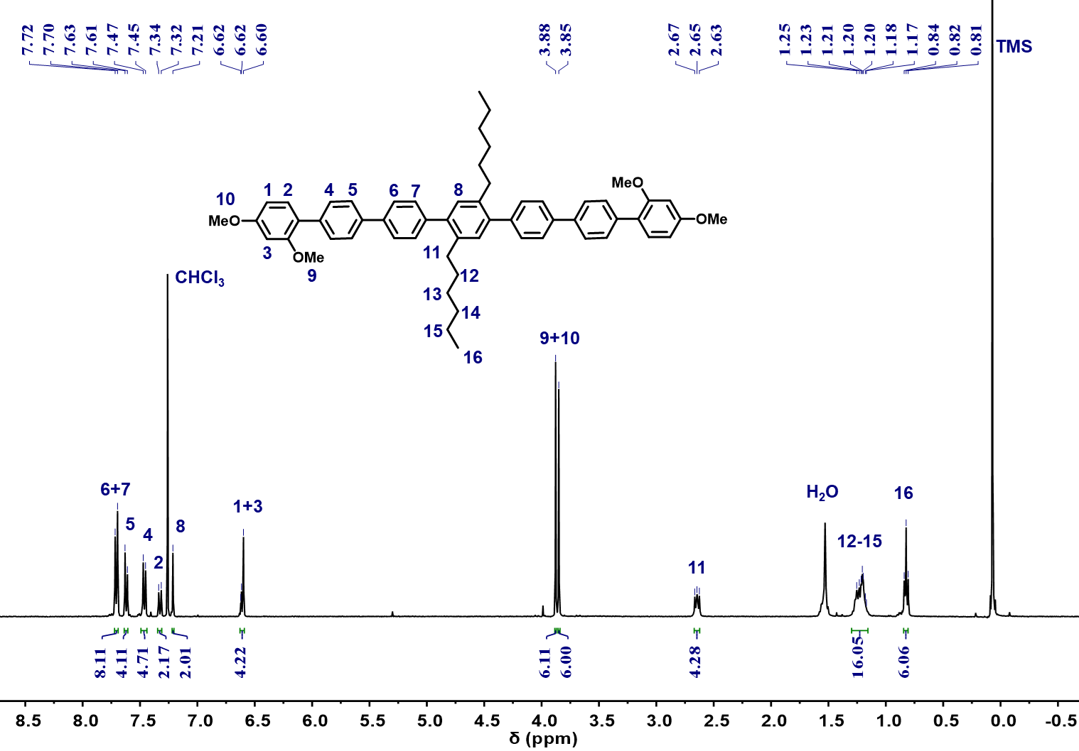
Figure S22. ¹H NMR spectrum (400 MHz, CDCl₃, 298K) of monomer M2.
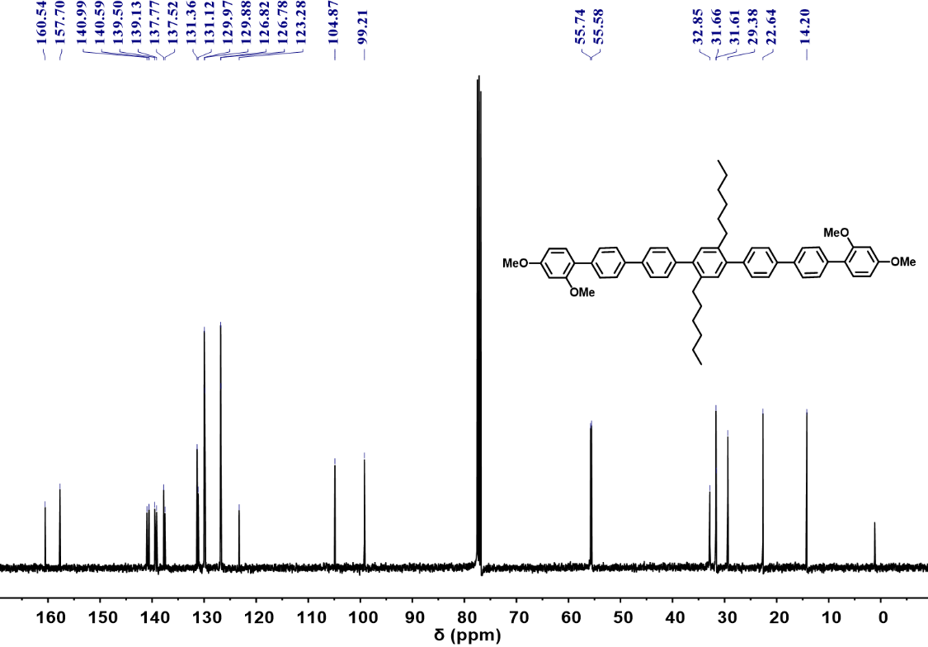
Figure S23. ¹³C NMR spectrum (101 MHz, CDCl₃, 298K) of monomer M2.
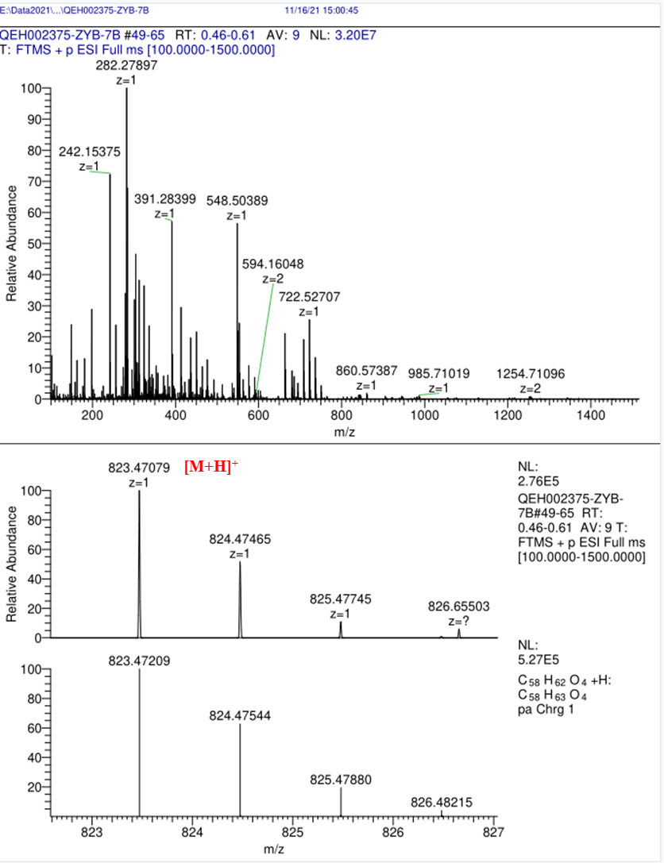
Figure S24. HRMS of monomer M2.
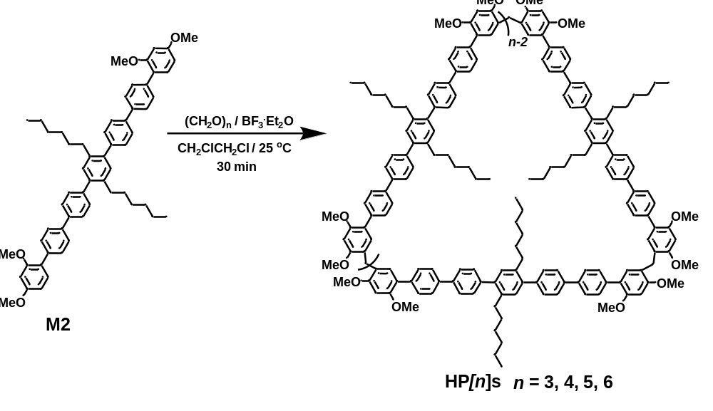
Scheme S7. Synthesis of HP[n]s.
M2 (82 mg, 0.10 mmol) were dissolved in 150 mL 1, 2-dichloroethane and then paraformaldehyde (62 mg, 2.0 mmol) was added. Subsequently, BF₃⋅Et₂O (5.0 μL, 0.040 mmol) was dropped into and the mixture was stirred at room temperature for 30 minutes. After the reaction was monitored by TLC, it was quenched with saturated NaHCO₃ solution, extracted with dichloromethane and water to obtain the organic layer. Then the organic layer was dried with anhydrous Na₂SO₄, the solvent was removed under vacuum and the residue was purified by column chromatography (silica gel, eluent: petroleum ether/CH₂Cl₂ 1:1 to 1:2) to afford HP[3] as a white solid (37 mg, 45%) and trace HP[4-6] which can be detected in HRMS.
HP[3]: m. p. 285 - 287 ºC. ¹H NMR (600 MHz, CDCl₃) δ 7.69 (dd, J = 8.3, 6.4 Hz, 24H), 7.59 (d, J = 8.3 Hz, 12H), 7.45 (d, J = 8.2 Hz, 12H), 7.21 (s, 6H), 7.05 (s, 6H), 6.62 (s, 6H), 3.98 (s, 6H), 3.92 (s, 18H), 3.88 (s, 18H), 2.69 - 2.59 (m, 12H), 1.53 (dd, J = 15.5, 7.9 Hz, 12H), 1.28 - 1.14 (m, 36H), 0.82 (t, J = 7.0 Hz, 18H). ¹³C NMR (101 MHz, CDCl₃) δ 158.35, 155.82, 140.41, 139.34, 138.78, 137.59, 131.86, 130.93, 129.85, 129.67, 126.62, 126.57, 122.01, 121.47, 96.00, 55.95, 55.85, 32.67, 31.48, 29.20, 27.10, 22.46, 13.98. HRMS (ESI, m/z): calcd. for [M+H]⁺, 2505.4051; found, 2505.4098.
HP[4]: HRMS (ESI, m/z): calcd. for [M]⁺, C₂₃₆H₂₄₉O₁₆⁺, 3339.8660; found, 3339.8618. HP[5]: HRMS (ESI, m/z): calcd. for [M]⁺, C₂₉₈H₃₁₁O₂₀⁺, 4175.3341; found, 4175.3221. HP[6]: HRMS (ESI, m/z): calcd. for [M]⁺, C₃₅₄H₃₇₃O₂₄⁺, 5010.8023; found, 5010.8036.
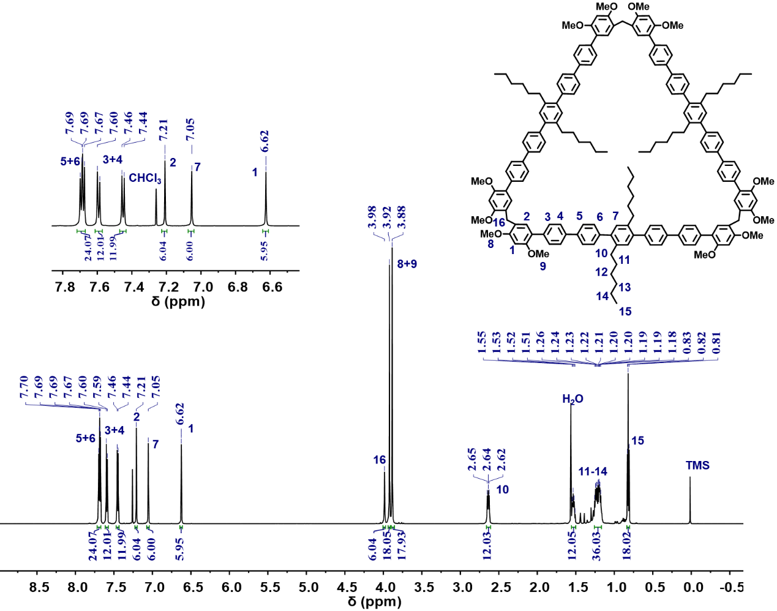
Figure S25. ¹H NMR spectrum (600 MHz, CDCl₃, 298K) of HP[3].

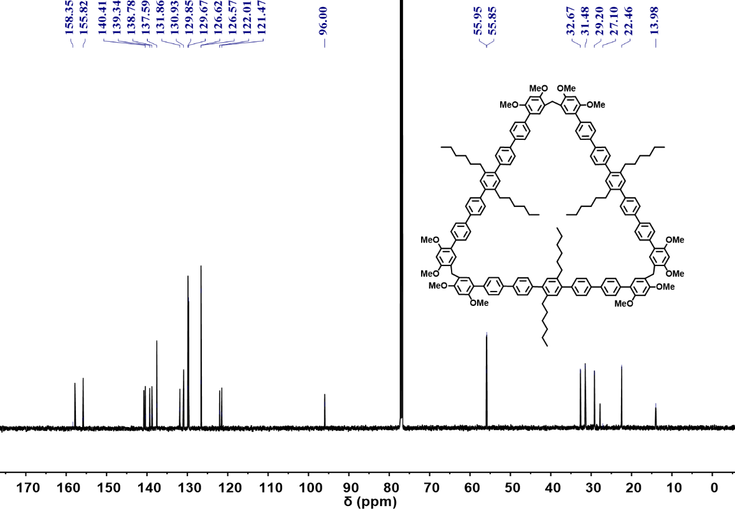
Figure S26. ¹³C NMR spectrum (101 MHz, CDCl₃, 298K) of HP[3].
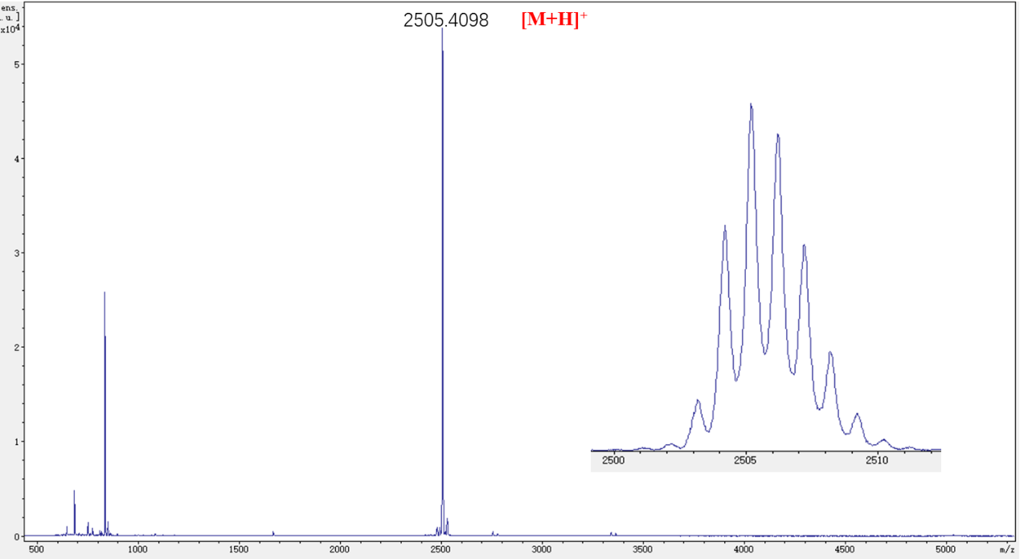
Figure S27. HRMS of HP[3].

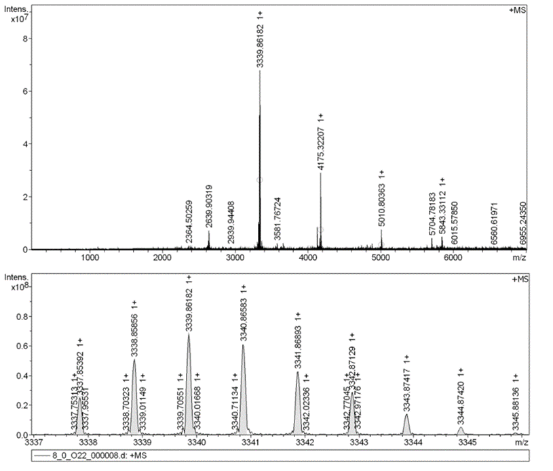
Figure S28. HRMS of HP[4].
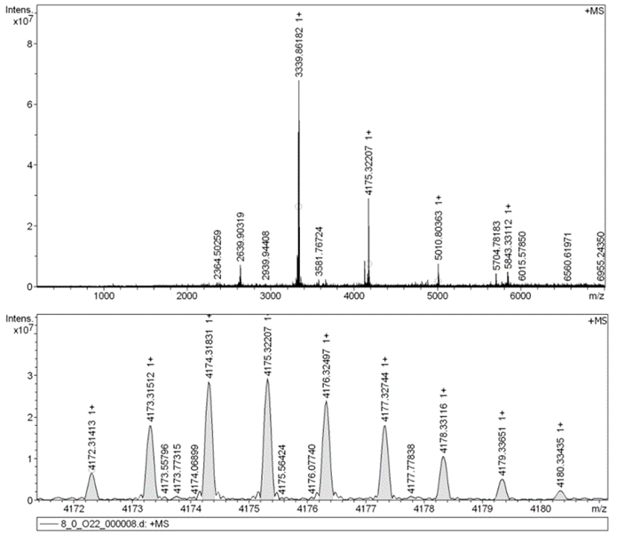
Figure S29. HRMS of HP[5].

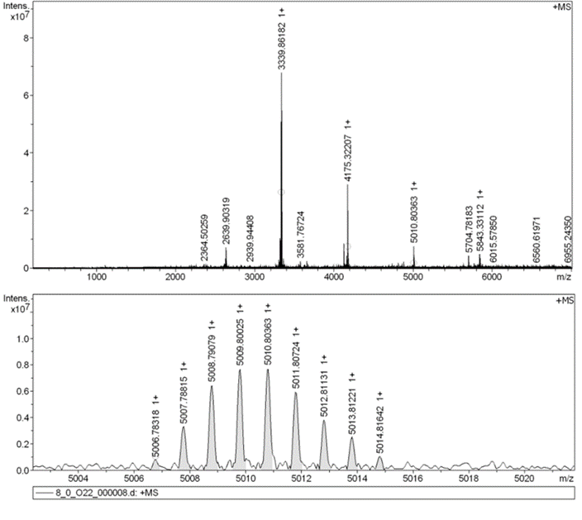
Figure S30. HRMS of HP[6].

Crystal structure of QP[3] (CCDC: 2265471)
Method: 4 mg QP[3] was dissolved in 1 mL 1,4-dioxane and filtered by a 0.22 μm filter to obtain QP[3] solution. Slow vapor diffusion of n-hexane into the QP[3] solution for 2 weeks yielded transparent block crystal of QP[3].

Table S2. Crystal data for QP[3].
Empirical formula | C₂₂₂H₂₀₄O₃₀
Formula weight | 3351.84
Temperature / K | 193.0
Wavelength/ Å | 1.54178
Crystal system | Triclinic
Space group | P-1
a / Å | 17.1761(4)
b / Å | 25.0792(5)
c / Å | 26.4914(5)
α / ° | 103.9350(1)
β / ° | 92.7750(1)
γ / ° | 100.9530(1)
Volume/ Å³ | 10820.7(4)
Z | 2
Density (calculated) | 1.029 g/cm³
Absorption coefficient | 0.540 mm⁻¹
F(000) | 3552.0
Crystal size | 0.15 × 0.12 × 0.1 mm³
2θ range for data collection /° | 3.71 to 149.568
Index ranges | -21 ≤ h ≤ 21, -30 ≤ k ≤ 31, -32 ≤ l ≤ 33
Reflections collected | 118548
Independent reflections | 42346 [R(int) = 0.0753]
Data / restraints / parameters | 42346 / 80 / 2315
Goodness-of-fit on F² | 1.023
Final R indices [I>2sigma(I)] | R₁ = 0.0879, wR₂ = 0.2487
R indices (all data) | R₁ = 0.1213, wR₂ = 0.2836
Largest diff. peak and hole / e.Å⁻³ | 0.80 and -0.56
CCDC number | 2265471

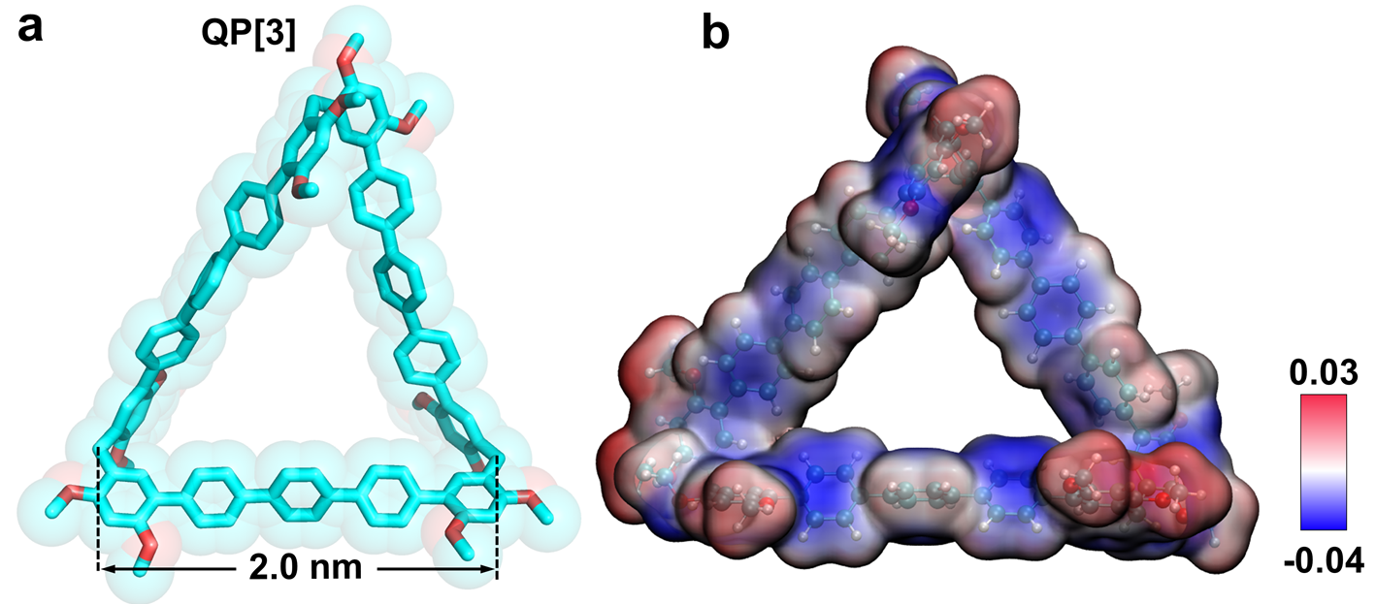
Figure S31. (a) Single-crystal structure and (b) electrostatic potential map of QP[3]. The hydrogen atoms are omitted for the sake of clarity.
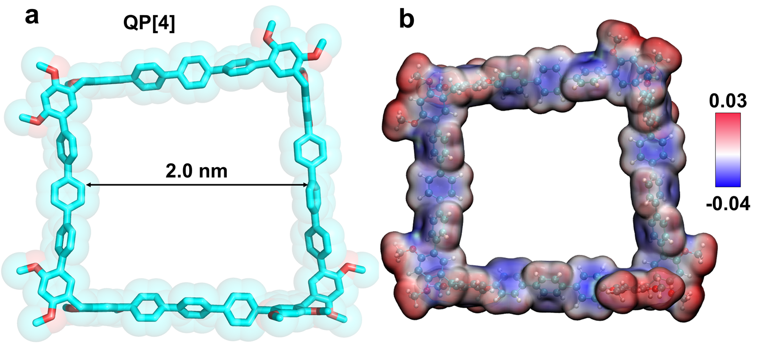
Figure S32. (a) Optimized structures and (b) electrostatic potential maps of QP[4]. The hydrogen atoms are omitted for the sake of clarity.
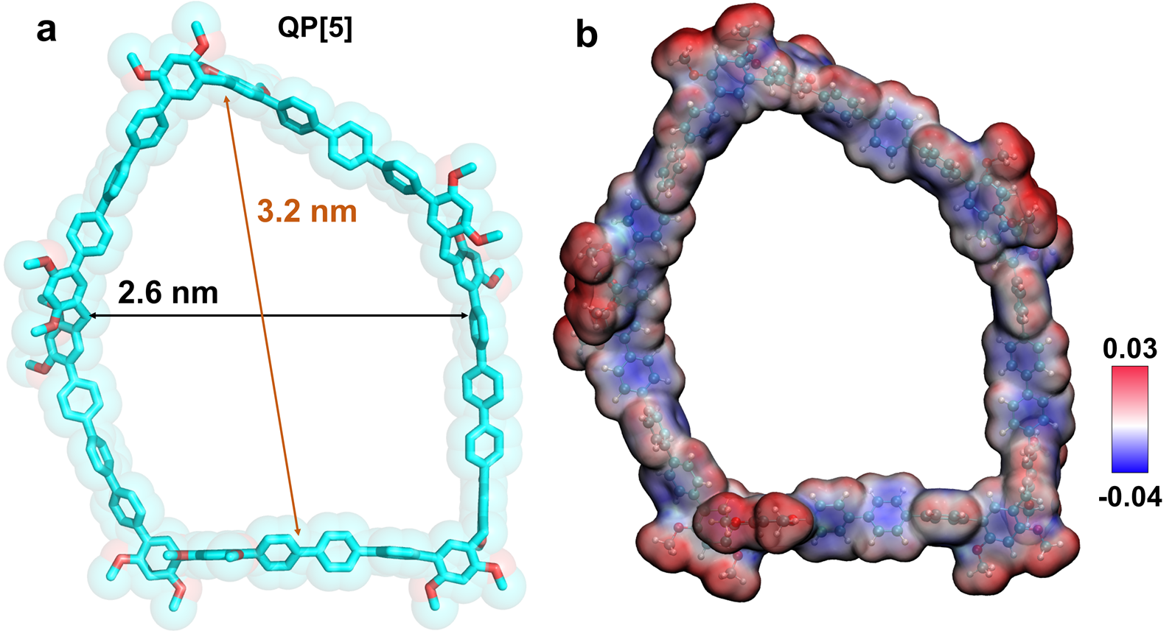
Figure S33. (a) Optimized structure and (b) electrostatic potential map of QP[5]. The hydrogen atoms are omitted for the sake of clarity.
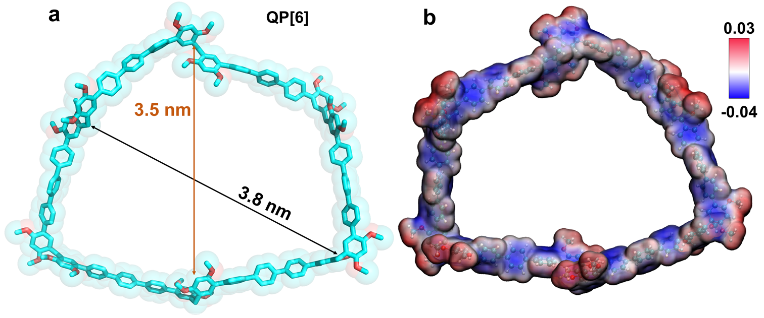
Figure S34. (a) Optimized structure and (b) electrostatic potential map of QP[6]. The hydrogen atoms are omitted for the sake of clarity.
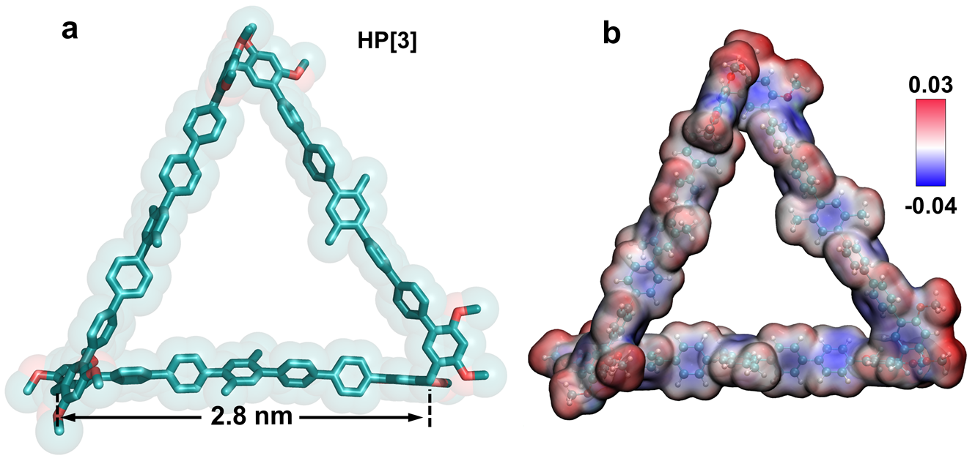
Figure S35. (a) Optimized structure and (b) electrostatic potential map of HP[3]. The hydrogen atoms are omitted for the sake of clarity.
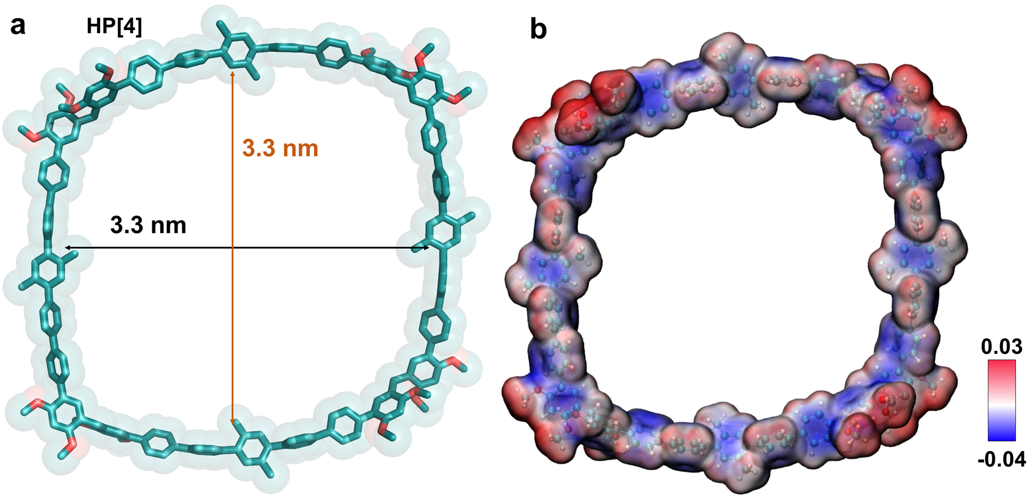
Figure S36. (a) Optimized structure and (b) electrostatic potential map of HP[4]. The hydrogen atoms are omitted for the sake of clarity.
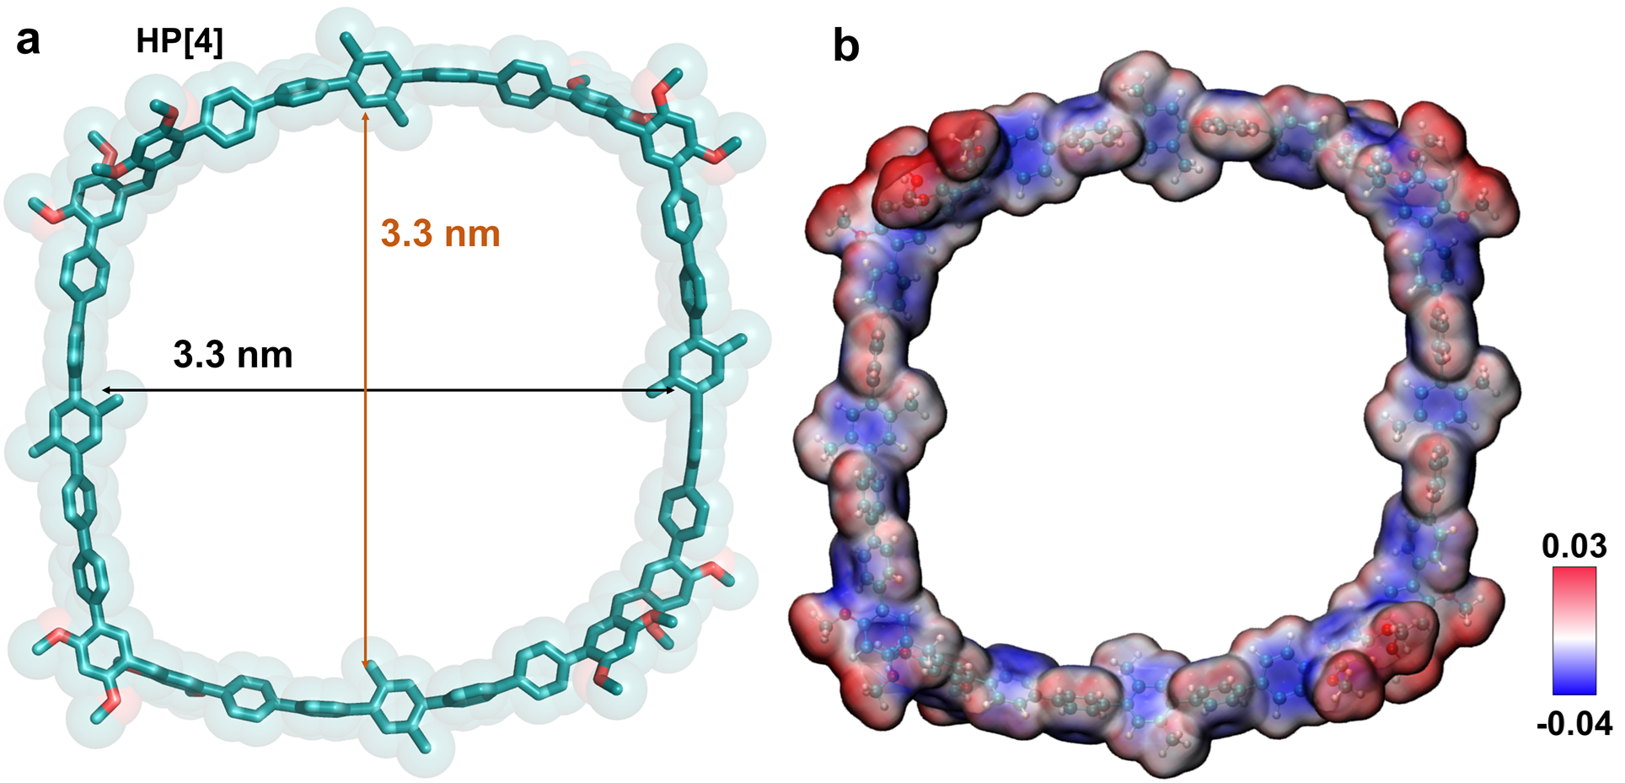
Figure S37. (a) Optimized structure and (b) electrostatic potential map of HP[5]. The hydrogen atoms are omitted for the sake of clarity.

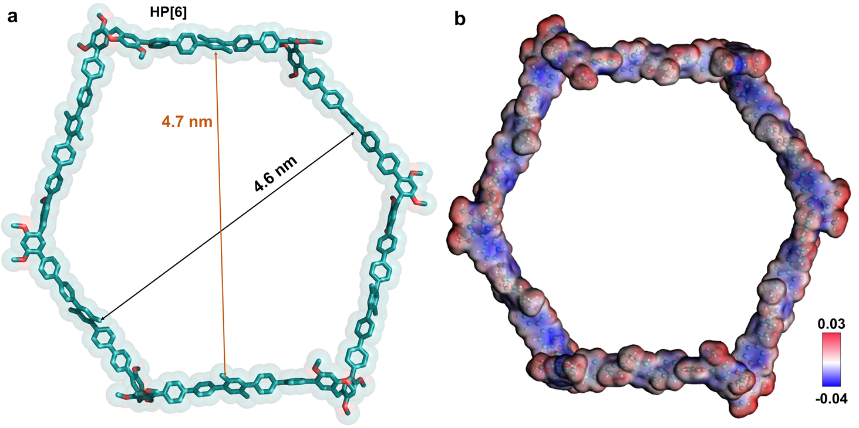
Figure S38. (a) Optimized structure and (b) electrostatic potential map of HP[6]. The hydrogen atoms are omitted for the sake of clarity.

2. Synthetic Protocols of 2,5-QP[3-6], CN-HP[3-5] and CHO-HP[3-4]
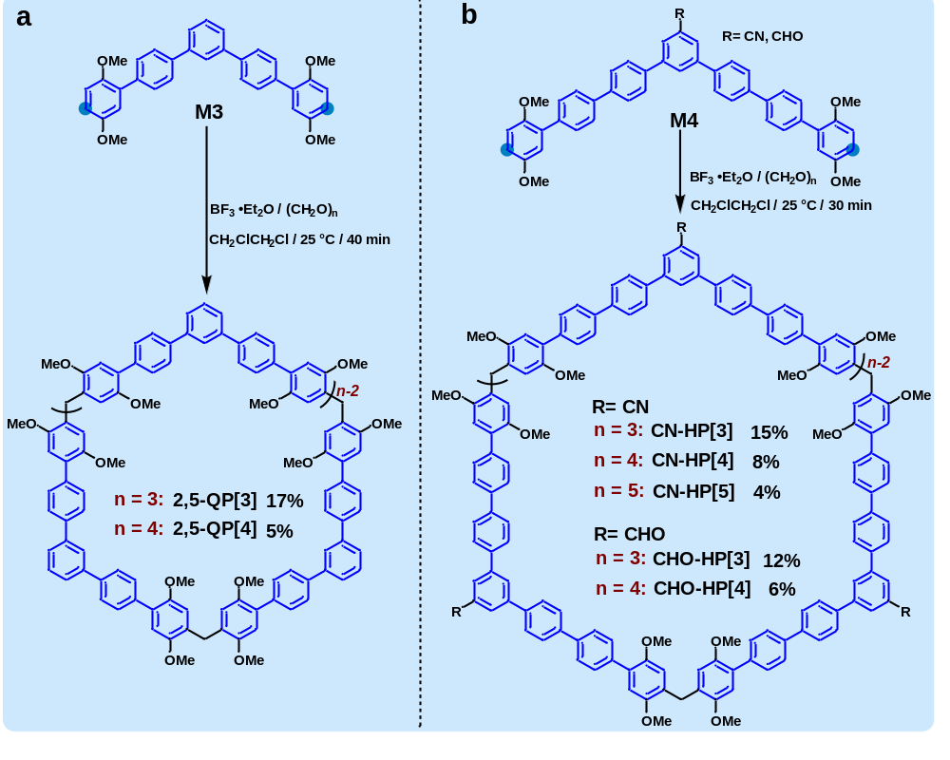
Scheme S8. Synthetic routes of 2,5-QP[3-6], CN-HP[3-5] and CHO-HP[3-4].

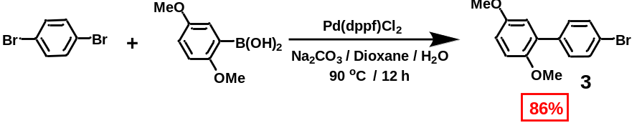
Scheme S9. Synthesis of compound 3.
p-dibromobenzene (14 g, 60 mmol) and 2, 5-dimethoxyphenylboronic acid (5.5 g, 30 mmol) were dissolved in 100 mL 1, 4-dioxane and 20 mL water (5:1). After addition of Pd(dppf)Cl₂ (0.95 g, 1.3 mmol) and Na₂CO₃ (6.2 g, 60 mmol), the mixture was stirred at 90 ℃ for 12 hours. After the mixture was cooled to the room temperature, it was extracted with dichloromethane and washed by brine. Then the organic layer was dried with anhydrous Na₂SO₄, the solvent was removed under vacuum and the residue was purified by column chromatography (silica gel, eluent: petroleum ether/CH₂Cl₂ 10:1) to afford compound 3 (7.5 g, 86%) as a white solid. The ¹H NMR spectrum matched well with the literature.¹⁵
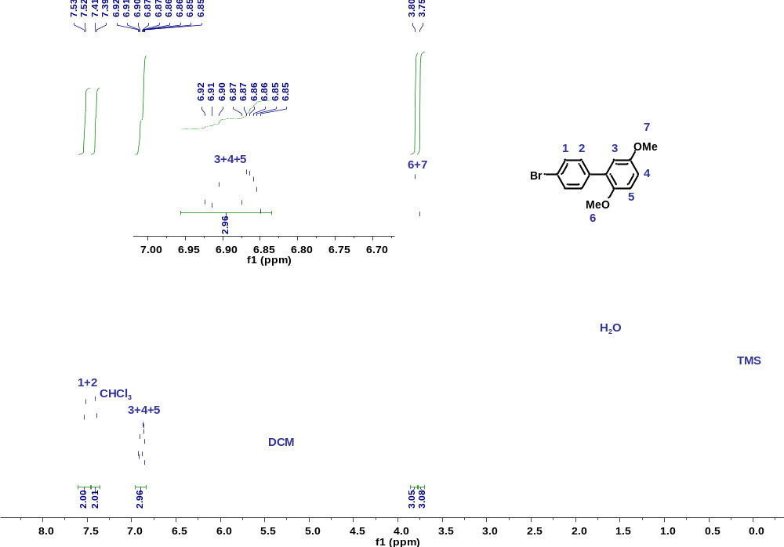
Figure S39. ¹H NMR spectrum (400 MHz, CDCl₃, 298K) of compound 3.

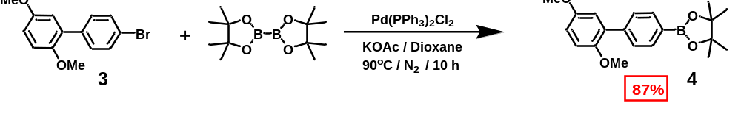
Scheme S10. Synthesis of compound 4.
Compound 3 (1.1 g, 3.7 mmol) and bis(pinacolato)diboron (1.5 g, 6.0 mmol) were dissolved in 100 mL dioxane. After addition of Pd(PPh₃)₂Cl₂ (0.13 g, 0.19 mmol) and KOAc (1.1 g, 11 mmol), the mixture was stirred at 100 ℃ for 10 hours under nitrogen atmosphere. After the mixture was cooled to the room temperature, it was extracted with dichloromethane and washed by brine. Then the organic layer was dried with anhydrous Na₂SO₄, the solvent was removed under vacuum and the residue was purified by column chromatography (silica gel, eluent: eluent: petroleum ether/CH₂Cl₂ 8:1 to 1:1) to afford compound 4 (1.1 g, 87%) as white solid. ¹H NMR (500 MHz, CDCl₃) δ 7.89 (d, J = 8.2 Hz, 2H), 7.57 (d, J = 8.2 Hz, 2H), 6.96–6.92 (m, 2H), 6.88 (dd, J = 8.8, 3.1 Hz, 1H), 3.83 (s, 3H), 3.76 (s, 3H), 1.38 (s, 12H). ¹³C NMR (101 MHz, CDCl₃) δ 153.89, 150.95, 141.44, 134.57, 131.75, 128.90, 116.77, 113.43, 112.97, 83.82, 83.58, 56.48, 55.87, 25.13, 24.97. HRMS (ESI; m/z): calcd. for [M+H]⁺, C₂₀H₂₆BO₄⁺, 341.1919; found, 341.1922.

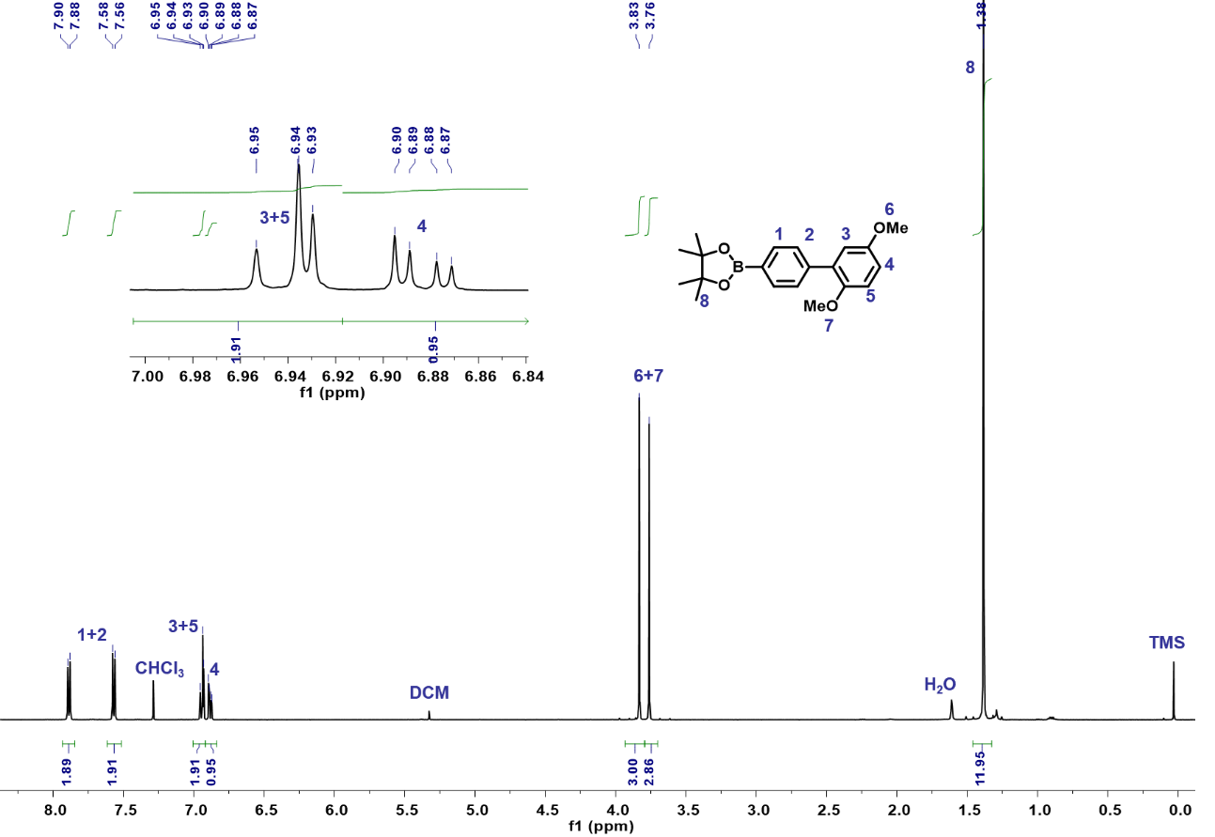
Figure S40. ¹H NMR spectrum (500 MHz, CDCl₃, 298K) of compound 4.
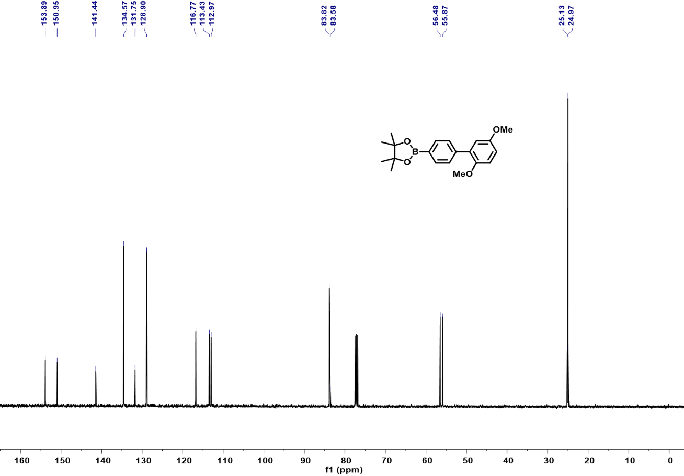
Figure S41. ¹³C NMR spectrum (101 MHz, CDCl₃, 298K) of compound 4.

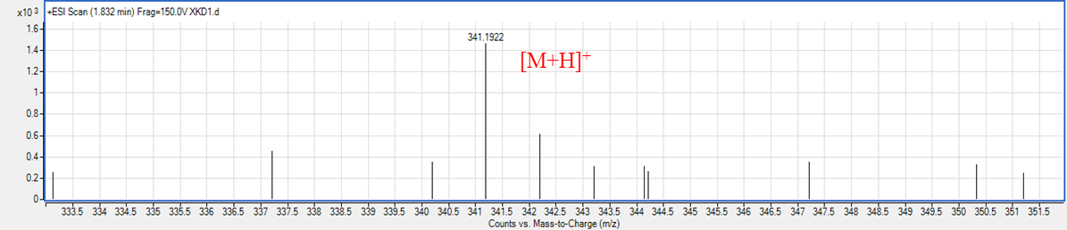
Figure S42. HRMS of compound 4.
[M+Na]⁺

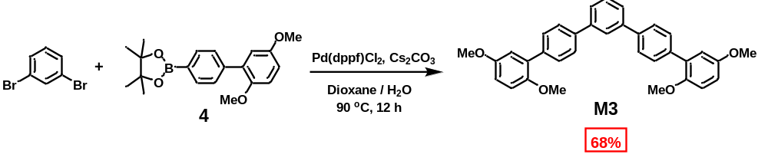
Scheme S11. Synthesis of monomer M3.
The m-dibromobenzene (0.17 g, 0.72 mmol) and compound 4 (0.61 g, 1.80 mmol) were dissolved in 30 mL 1, 4-dioxane and 6 mL water (5:1). After addition of Pd(dppf)Cl₂ (0.11 g, 0.15 mmol) and Cs₂CO₃ (0.95 g, 3.0 mmol), the mixture was stirred at 90 ℃ for 12 hours. Then the mixture was cooled to the room temperature, it was extracted with dichloromethane and washed by brine. Then the organic layer was dried with anhydrous Na₂SO₄, the solvent was removed under vacuum and the residue was purified by column chromatography (silica gel, eluent: petroleum ether/CH₂Cl₂ 2:1) to afford monomer M3 (0.25 g, 68%) as white solid.
¹H NMR (500 MHz, CDCl₃) δ 7.90 (t, J = 1.7 Hz, 1H), 7.74 - 7.68 (m, 4H), 7.68 - 7.60 (m, 6H), 7.57 - 7.50 (m, 1H), 6.98 (d, J = 3.1 Hz, 2H), 6.95 (d, J = 8.9 Hz, 2H), 6.88 (dd, J = 8.9, 3.1 Hz, 2H), 3.83 (s, 6H), 3.80 (s, 6H). ¹³C NMR (101 MHz, CDCl₃) δ 153.95, 150.99, 141.62, 139.98, 137.67, 131.29, 130.01, 129.32, 127.01, 126.16, 116.78, 113.34, 112.81, 56.44, 55.91. HRMS (ESI; m/z): [M+Na]⁺ calcd. for C₃₄H₃₀O₄Na⁺, 525.2036; found, 525.2039.
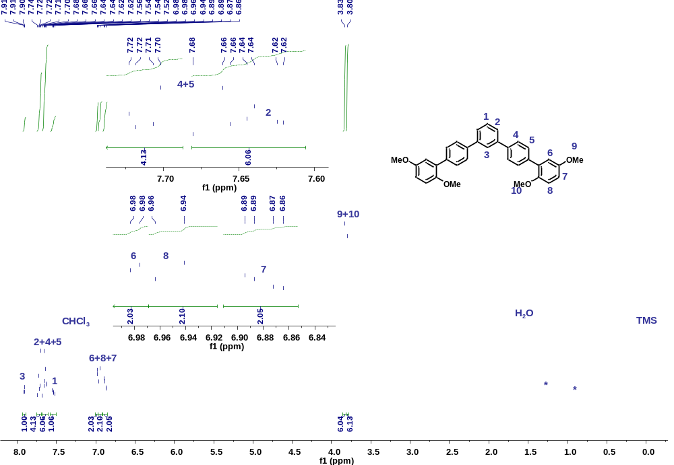
Figure S43. ¹H NMR spectrum (400 MHz, CDCl₃, 298K) of monomer M3.
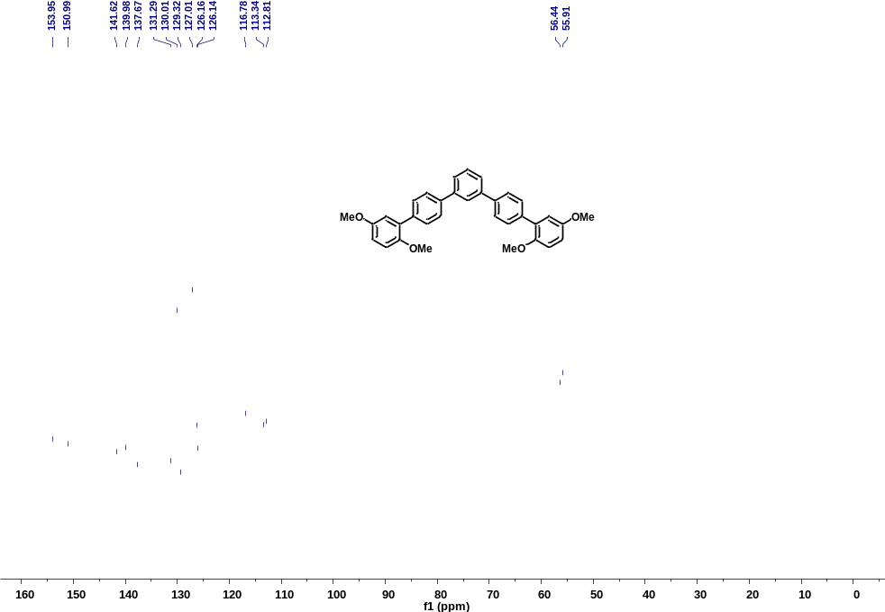
Figure S44. ¹³C NMR spectrum (101 MHz, CDCl₃, 298K) of monomer M3.
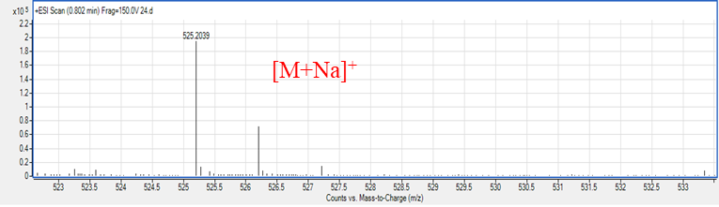
Figure S45. HRMS of monomer M3.
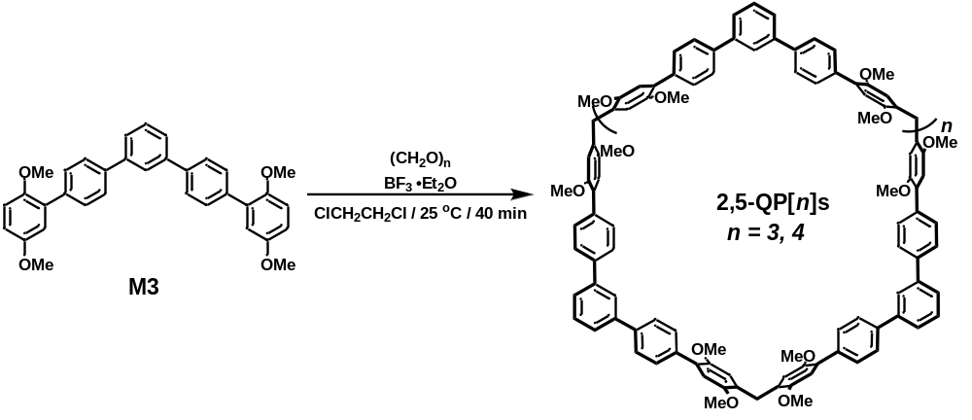
Scheme S12. Synthesis of 2,5-QP[n]s.
M3 (0.25 g, 0.50 mmol) was dissolved in 150 mL 1, 2-dichloroethane and then paraformaldehyde (46 mg, 1.5 mmol) was added. Subsequently, BF₃⋅Et₂O (0.41 mL, 3.0 mmol) was dropped into and the mixture was stirred at room temperature for 40 minutes. Then it was quenched with saturated NaHCO₃ solution, extracted with dichloromethane and water to obtain the organic layer. The organic layer was dried with anhydrous Na₂SO₄, the solvent was removed under vacuum and the residue was purified by column chromatography (silica gel, eluent: petroleum ether/CH₂Cl₂ 1:5) to afford 2,5-QP[3] (43 mg, 17%) and 2,5-QP[4] (17 mg, 5%) as white powder.
2,5-QP[3]: m.p. 228 - 230 ºC. ¹H NMR (400 MHz, CDCl₃) δ 7.89 (dt, J = 4.0, 1.9 Hz, 3H), 7.74-7.68 (m, 12H), 7.67-7.57 (m, 18H), 7.53 (dd, J = 8.4, 6.8 Hz, 3H), 6.95 (s, 6H), 6.89 (s, 6H), 4.06 (s, 6H), 3.89 (s, 18H), 3.73 (s, 18H). ¹³C NMR (101 MHz, Chloroform-d) δ 151.93, 150.57, 141.67, 139.76, 137.97, 130.03, 129.44, 128.68, 127.03, 126.32, 126.00, 115.05, 113.52, 56.60, 56.34, 30.22. HRMS (MALDI; m/z): calcd. for [M]⁺, C₁₀₅H₉₀O₁₂⁺,1543.6466; found 1543.6480.
2,5-QP[4]: m.p. >320 ºC. ¹H NMR (400 MHz, CDCl₃) δ 7.89 (s, 4H), 7.76-7.59 (m, 40H), 7.58-7.47 (m, 4H), 6.96 (s, 8H), 6.90 (s, 8H), 4.07 (s, 8H), 3.90 (s, 24H), 3.74 (s, 24H). ¹³C NMR (101 MHz, CDCl₃) δ 151.90, 150.51, 141.66, 139.81, 137.87, 129.96, 129.26, 128.51, 127.05, 126.23, 126.11, 114.88, 113.46, 56.52, 56.28, 31.69. HRMS (MALDI; m/z): calcd. For [M+Na]⁺, C₁₄₀H₁₂₀O₁₆⁺, 2057.8610; found 2057.8616.
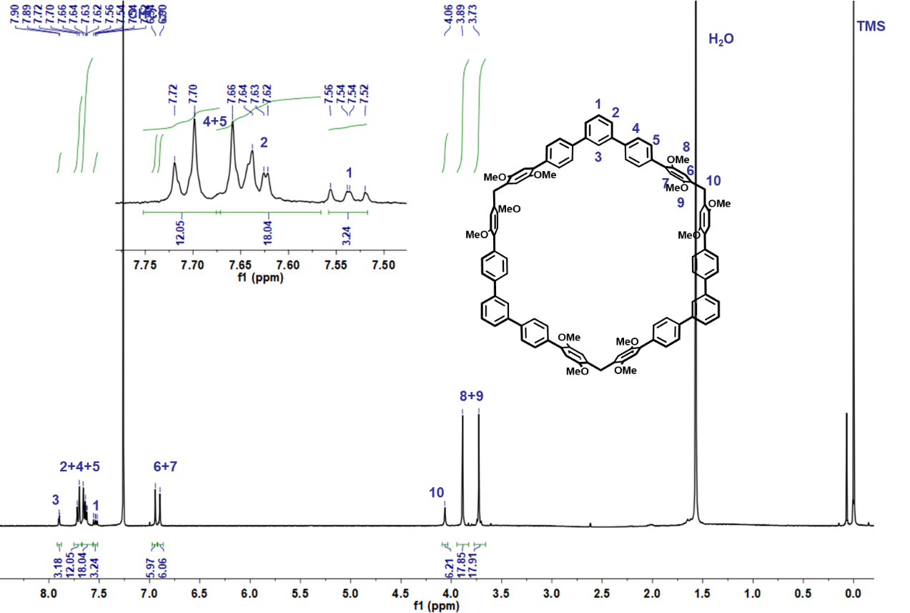
Figure S46. ¹H NMR spectrum (400 MHz, CDCl₃, 298K) of 2,5-QP[3].
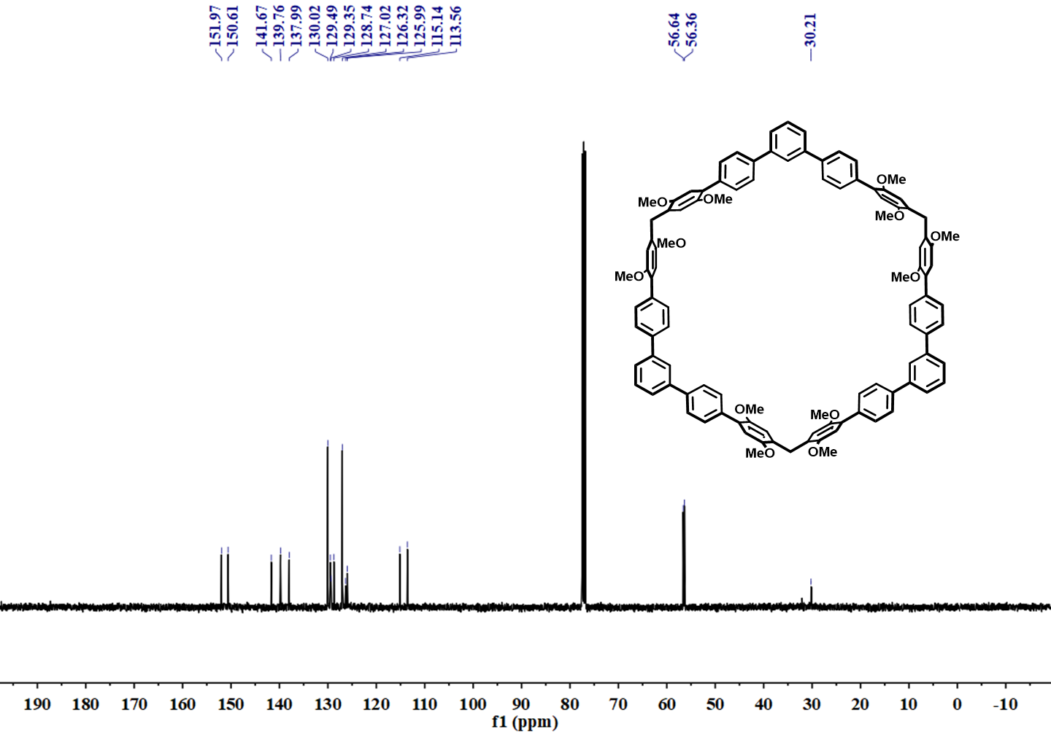
Figure S47. ¹³C NMR spectrum (101 MHz, CDCl₃, 298K) of 2,5-QP[3].
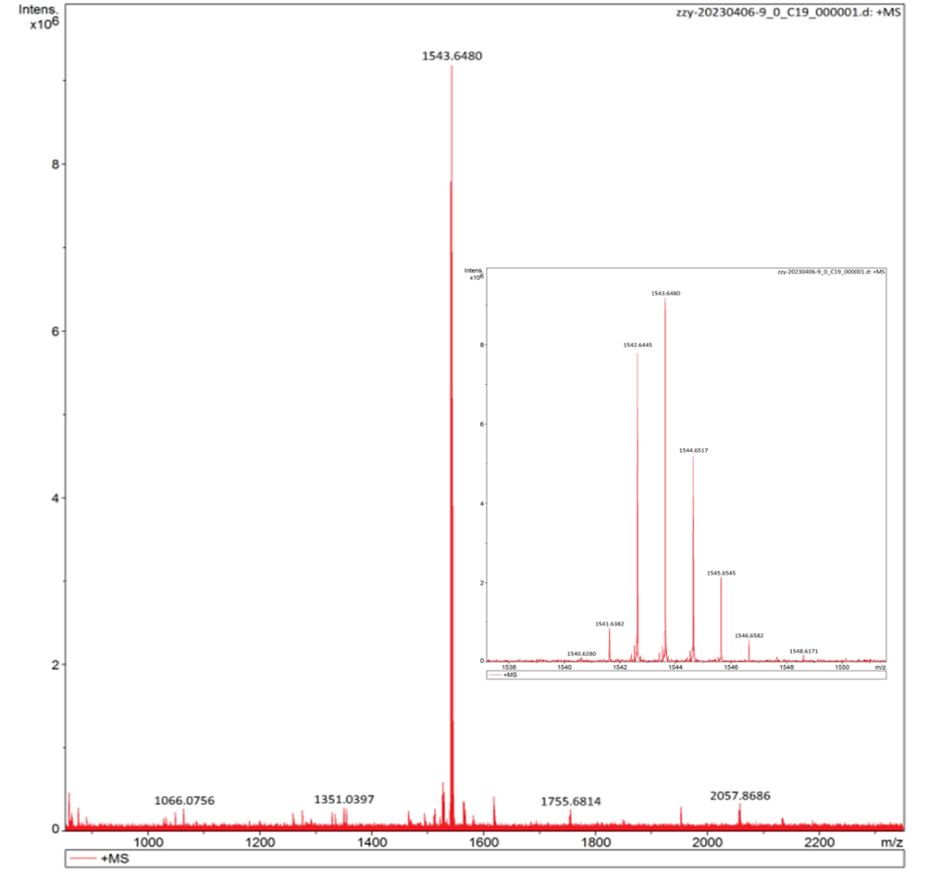
Figure S48. HRMS of 2,5-QP[3].
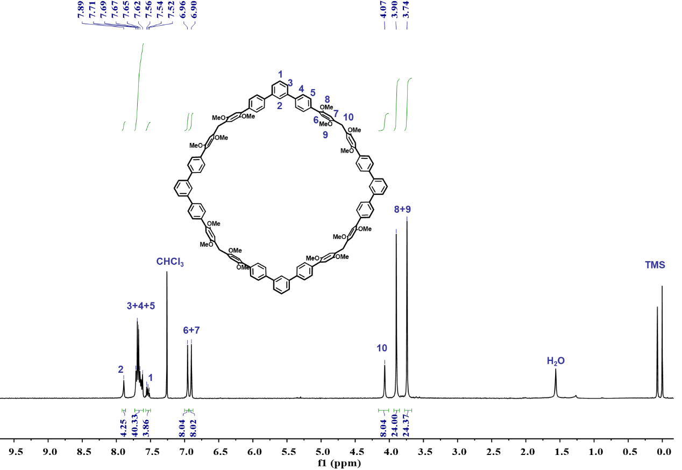
Figure S49. ¹H NMR spectrum (400 MHz, CDCl₃, 298K) of 2,5-QP[4].

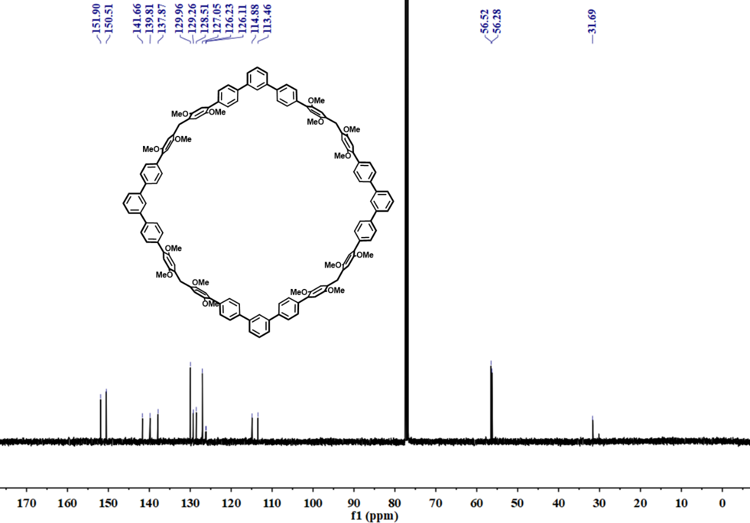
Figure S50. ¹³C NMR spectrum (101 MHz, CDCl₃, 298K) of 2,5-QP[4].
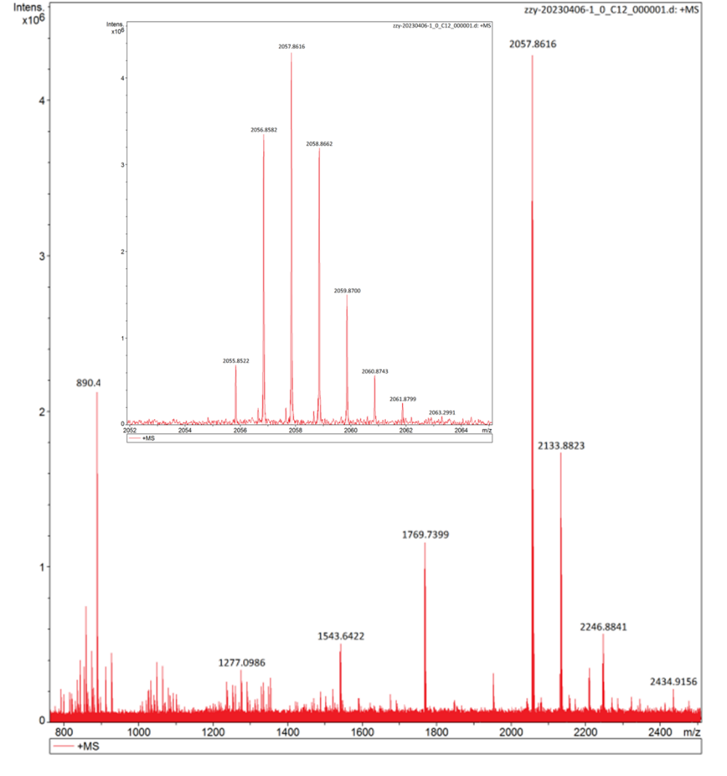
Figure S51. HRMS of 2,5-QP[4].

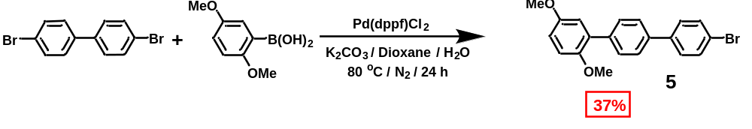
Scheme S13. Synthesis of compound 5.
4, 4'-dibromo-1, 1'-biphenyl (17 g, 55 mmol) and 2, 5-dimethoxyphenylboronic acid (2.0 g, 55 mmol) were dissolved in 80 mL 1, 4-dioxane and 16 mL water (5:1). After addition of Pd(dppf)Cl₂ (2.0 g, 2.7 mmol) and K₂CO₃ (23 g, 0.16 mol), the mixture was stirred at 80 ℃ for 12 hours under nitrogen atmosphere. After the reaction, the mixture was cooled to the room temperature, extracted with dichloromethane and washed by brine. Then the organic layer was dried with anhydrous Na₂SO₄, the solvent was removed under vacuum and the residue was purified by column chromatography (silica gel, eluent: petroleum ether/CH₂Cl₂ 1:1) to afford compound 5 (7.5 g, 37%) as a white solid. The ¹H NMR spectrum matched well with the literature.¹⁵ ¹H NMR (400 MHz, CDCl₃) δ 7.62 (d, J = 9.1 Hz, 4H), 7.57 (d, J = 8.5 Hz, 2H), 7.50 (d, J = 7.7 Hz, 2H), 6.96 - 6.92 (m, 2H), 6.88 (d, J = 9.0 Hz, 1H), 3.82 (s, 3H), 3.79 (s, 3H).
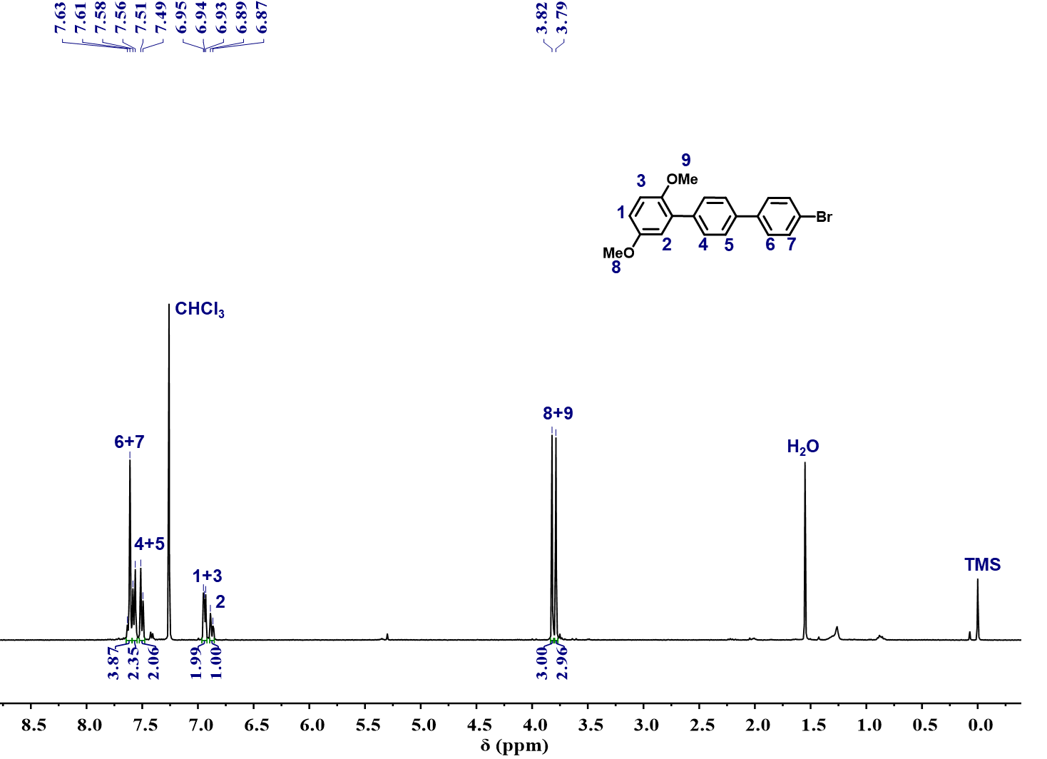
Figure S52. ¹H NMR spectrum (400 MHz, CDCl₃, 298K) of compound 5.

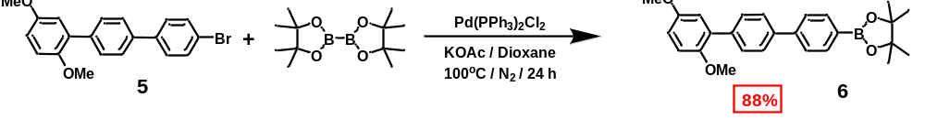
Scheme S14. Synthesis of compound 6.
The compound 5 (3.0 g, 8.0 mmol) and bis(pinacolato)diboron (3.0 g, 12 mmol) were dissolved in 80 mL 1,4-dioxane. After addition of Pd(PPh₃)₂Cl₂ (0.29 g, 0.28 mmol) and KOAc (2.2 g, 22 mmol), the mixture was stirred at 100 ℃ for 24 hours under nitrogen atmosphere. After the reaction, the mixture was cooled and extracted with dichloromethane and water to obtain the organic layer. Then the organic layer was dried with anhydrous Na₂SO₄, the organic solvent was removed under vacuum and the residue was purified by column chromatography (silica gel, eluent: eluent: petroleum ether/CH₂Cl₂ 3:1) to afford compound 6 (2.9 g, 88%) as a white solid. ¹H NMR (400 MHz, CDCl₃) δ 7.90 (d, J = 7.9 Hz, 2H), 7.66 (dt, J = 16.2, 7.2 Hz, 6H), 6.95 (t, J = 6.3 Hz, 2H), 6.87 (dd, J = 8.9, 3.0 Hz, 1H), 3.82 (s, 3H), 3.79 (s, 3H), 1.37 (s, 12H).¹³C NMR (101 MHz, CDCl₃) δ 153.90, 150.95, 143.71, 139.77, 137.83, 135.38, 131.25, 129.99, 126.99, 126.52, 116.74, 113.33, 112.75, 83.93, 56.43, 55.92, 25.02. HRMS (ESI, m/z): calcd. for [M+H]⁺, 417.2232; found, 417.2243.

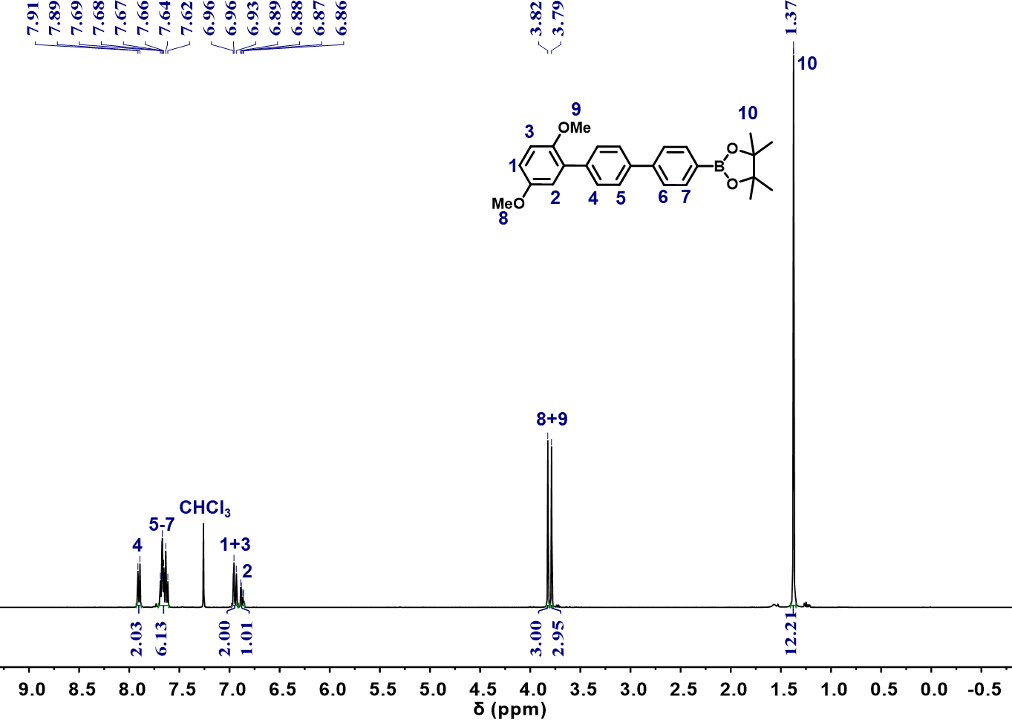
Figure S53. ¹H NMR spectrum (400 MHz, CDCl₃, 298K) of compound 6.
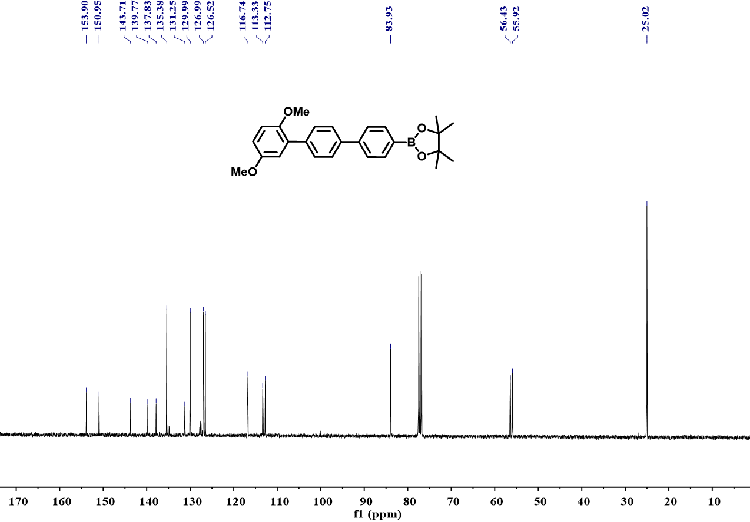
Figure S54. ¹³C NMR spectrum (101 MHz, CDCl₃, 298K) of compound 6.

Figure S55. HRMS of compound 6.
[M+Na]⁺

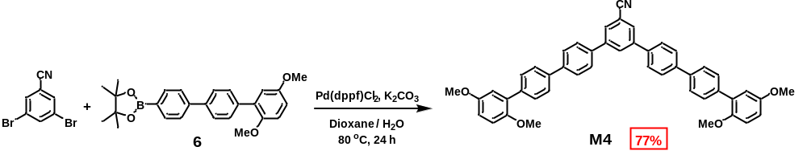
Scheme S15. Synthesis of monomer M4.

The 3, 5-dibromobenzonitrile (1.0 g, 3.8 mmol) and compound 6 (4.0 g, 9.5 mmol) were dissolved in 50 mL 1, 4-dioxane and 10 mL water (5:1). After addition of Pd(dppf)Cl₂ (0.14 g, 0.20 mmol) and K₂CO₃ (1.6 g, 11 mmol), the mixture was stirred at 80 ℃ for 24 hours. After the mixture was cooled to the room temperature, it was extracted with dichloromethane and washed by brine. Then the organic layer was dried with anhydrous Na₂SO₄, the solvent was removed under vacuum and the residue was purified by column chromatography (silica gel, eluent: petroleum ether/CH₂Cl₂ 2:3) to afford monomer M4 (2.0 g, 77%) as white solid.
m. p. 118 - 120 ºC, ¹H NMR (400 MHz, CDCl₃) δ 8.12 (t, J = 1.5 Hz, 1H), 7.91 (d, J = 1.6 Hz, 2H), 7.81 - 7.65 (m, 16H), 7.00 - 6.93 (m, 4H), 6.89 (dd, J = 8.9, 3.0 Hz, 2H), 3.84 (s, 6H), 3.81 (s, 6H).¹³C NMR (101 MHz, CDCl₃) δ 153.97, 151.00, 142.78, 141.33, 139.02 (s), 137.95, 137.10, 131.17, 130.16, 129.33, 127.96, 127.73, 126.90, 116.82, 113.73, 113.43, 112.79, 56.48, 55.99. HRMS (ESI, m/z): calcd. For [M+H]⁺, C₄₇H₃₈NO₄⁺: 680.2795; found, 680.2801.

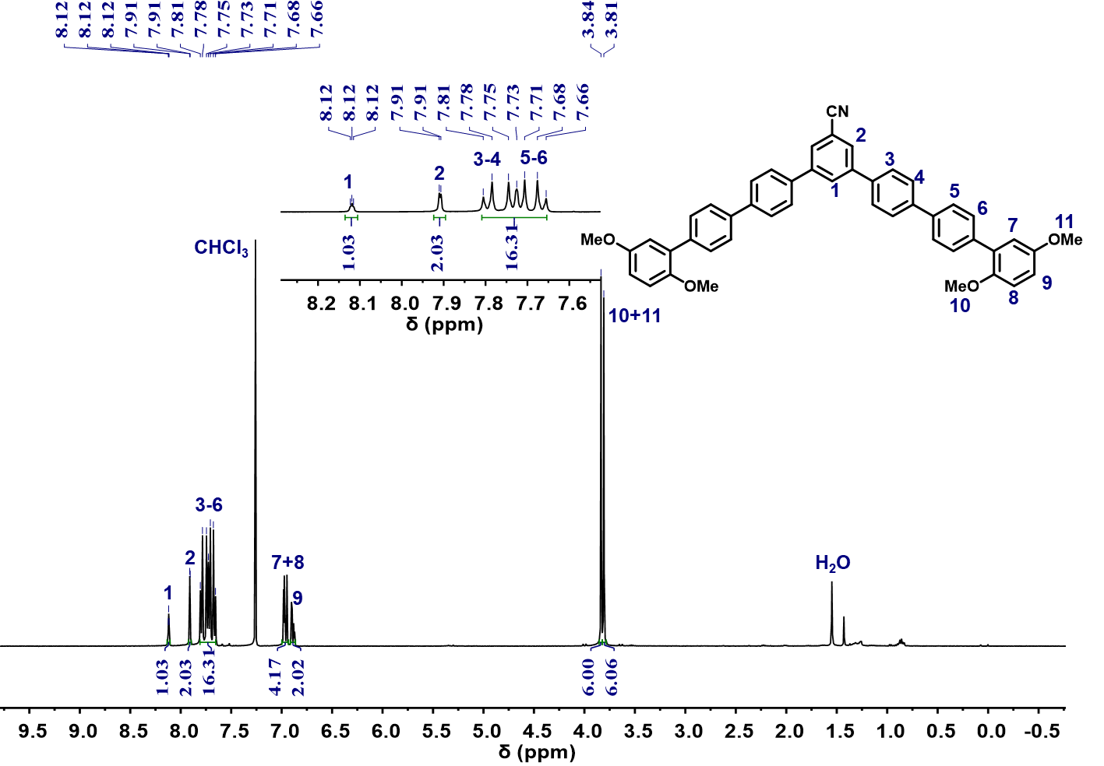
Figure S56. ¹H NMR spectrum (400 MHz, CDCl₃, 298K) of monomer M4.
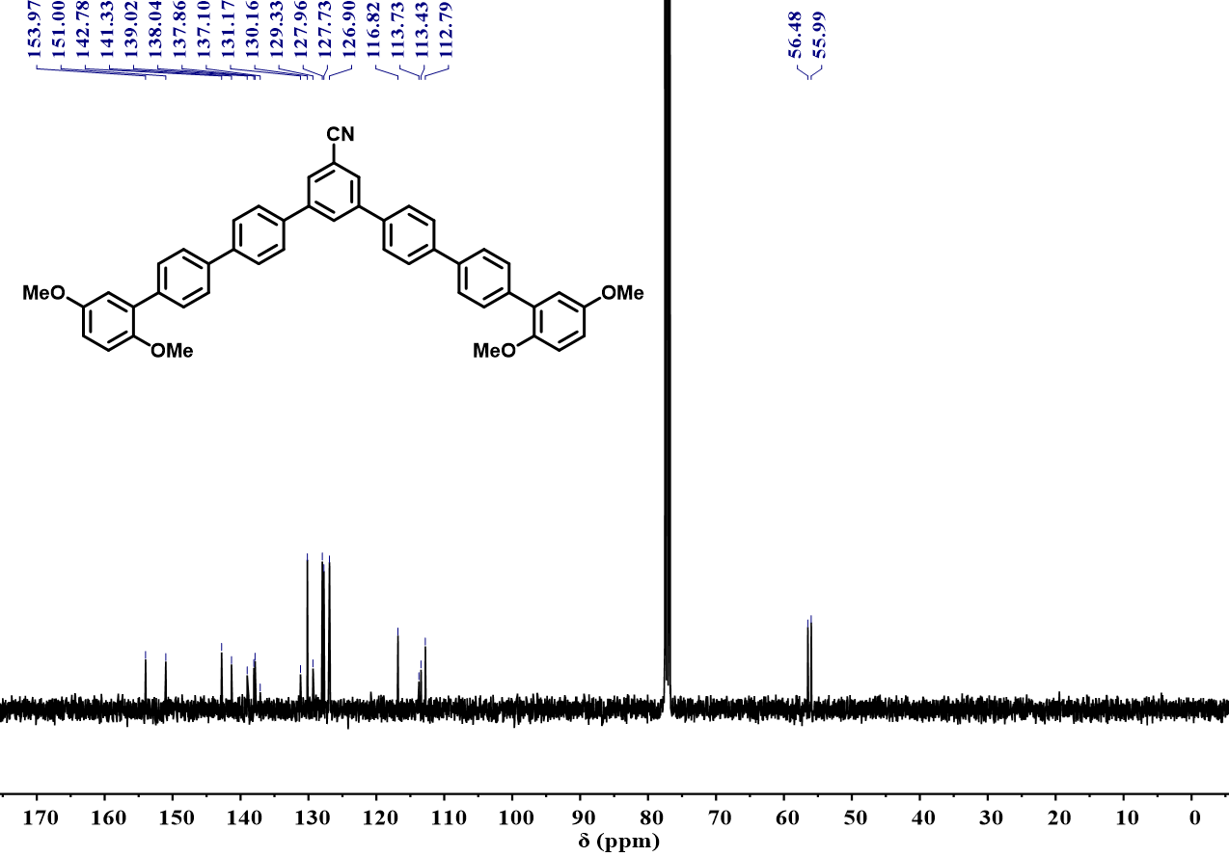
Figure S57. ¹³C NMR spectrum (101 MHz, CDCl₃, 298K) of monomer M4.

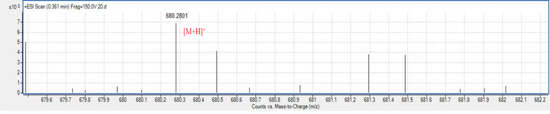
Figure S58. HRMS of monomer M4.
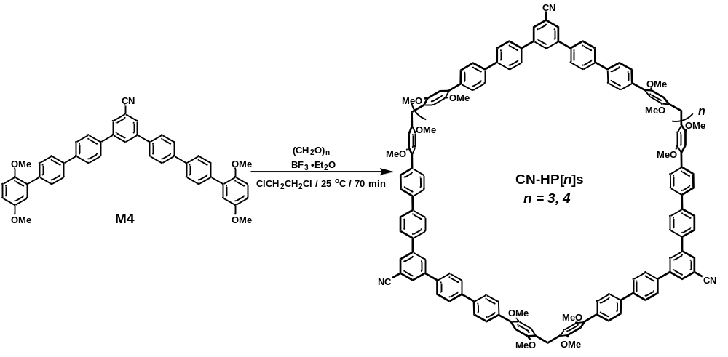
Scheme S16. Synthesis of CN-HP[n]s.
M4 (0.20 g, 0.30 mmol) was dissolved in 100 mL 1, 2-dichloroethane and then paraformaldehyde (22 mg, 0.73 mmol) was added. Subsequently, BF₃⋅Et₂O (0.20 mL, 1.6 mmol) was dropped into and the mixture was stirred at room temperature for 70 minutes. It was quenched with saturated NaHCO₃ solution, extracted with dichloromethane and water to obtain the organic layer. Then the organic layer was dried with anhydrous Na₂SO₄, the solvent was removed under vacuum and the residue was purified by column chromatography (silica gel, eluent: CH₂Cl₂) to afford CN-HP[3] (31 mg, 15%) and CN-HP[4] (17 mg, 8%) as white powder.
CN-HP[3]: m. p, >320 ºC. ¹H NMR (400MHz, CDCl₃) δ 8.12 (d, J = 1.6 Hz, 3H), 7.91 (d, J = 1.7 Hz, 6H), 7.80 - 7.67 (m, 48H), 6.96 (s, 6H), 6.93 (s, 6H) 4.08 (s, 6H), 3.91 (s, 18H), 3.75 (s, 18H). ¹³C NMR (101 MHz, CDCl₃) δ 152.06, 150.69, 142.81, 141.42, 138.83, 138.37, 137.85, 130.42, 130.15, 129.72, 129.64, 129.20, 128.63, 127.95, 127.74, 126.91, 119.00, 115.23, 113.82, 113.64, 113.60, 56.64, 56.41, 30.23. HRMS (MALDI; m/z): calcd. For [M]⁺, C₁₄₄H₁₁₁N₃O₁₂⁺, 2074.8201; found, 2074.8189.
CN-HP[4]: m. p >320 ºC, ,¹H NMR (400 MHz, CDCl₃) δ 8.12 (s, 4H), 7.91 (d, J = 1.5 Hz, 8H), 7.87 - 7.61 (m, 64H), 6.97 (s, 8H), 6.93 (s, 8H), 4.09 (s, 8H), 3.91 (s, 24H), 3.76 (s, 24H). ¹³C NMR (101 MHz, CDCl₃) δ 152.00, 150.62, 142.51, 141.01, 139.00, 138.65, 138.20, 137.79, 130.12, 129.60, 128.61, 127.85, 127.79, 126.91, 115.12, 113.54, 56.61, 56.37, 32.08. HRMS (MALDI; m/z): calcd. for [M]⁺, C₁₉₂H₁₄₈N₄O₁₆⁺, 2767.0957; found, 2767.0928.
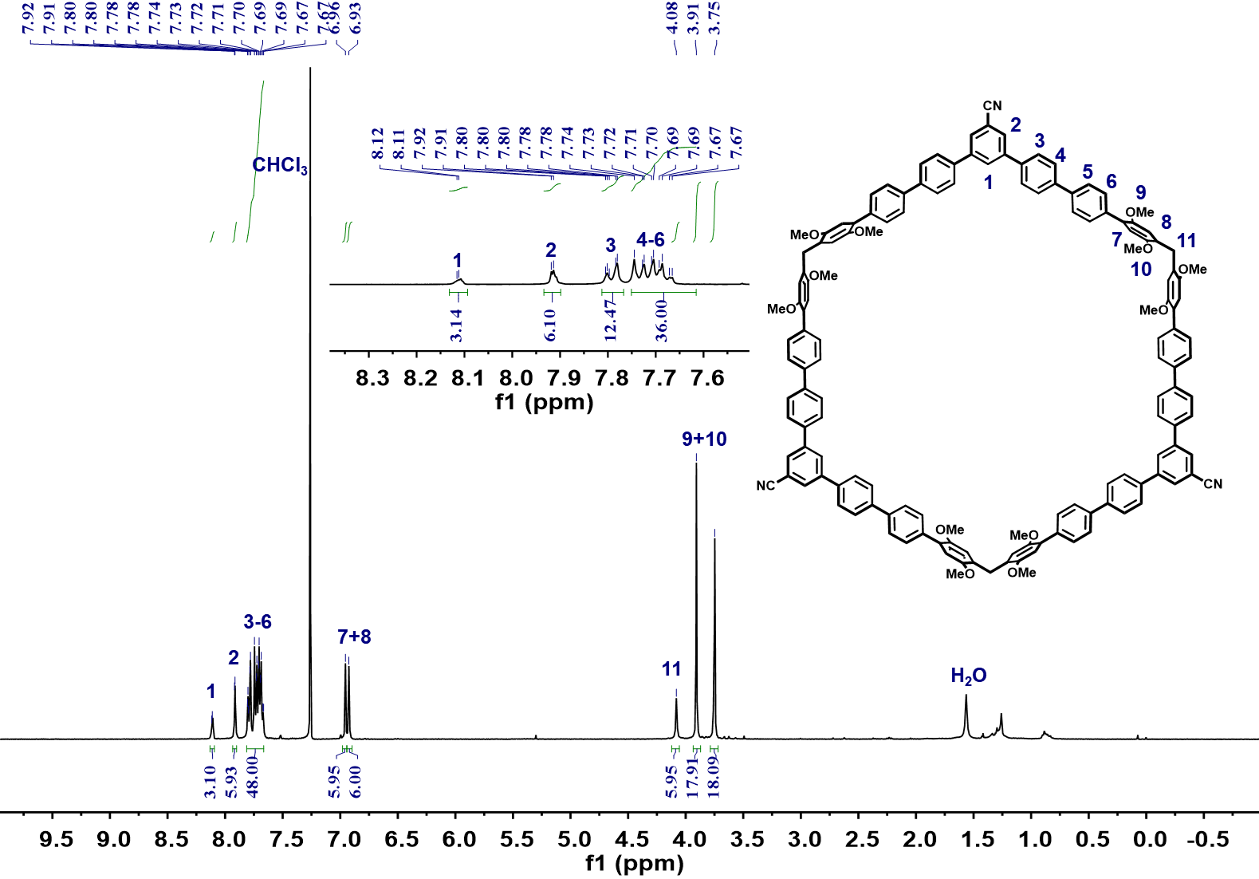
Figure S59. ¹H NMR spectrum (400 MHz, CDCl₃, 298K) of CN-HP[3].

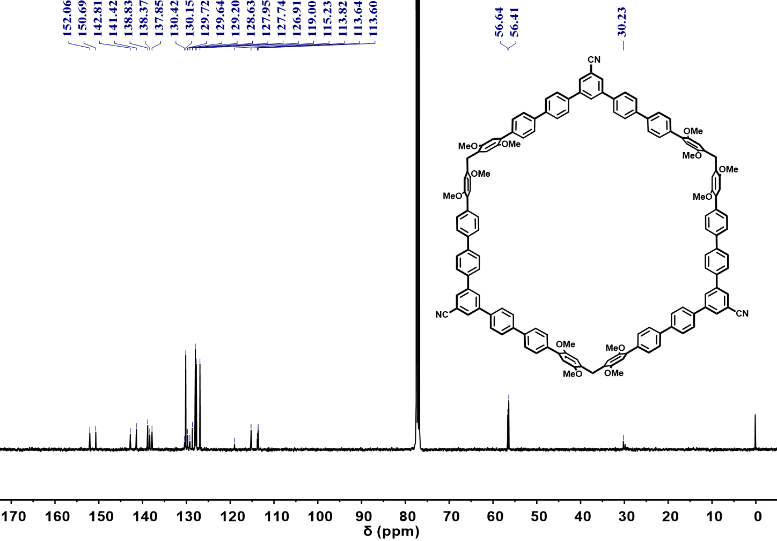
Figure S60. ¹³C NMR spectrum (101 MHz, CDCl₃, 298K) of CN-HP[3].
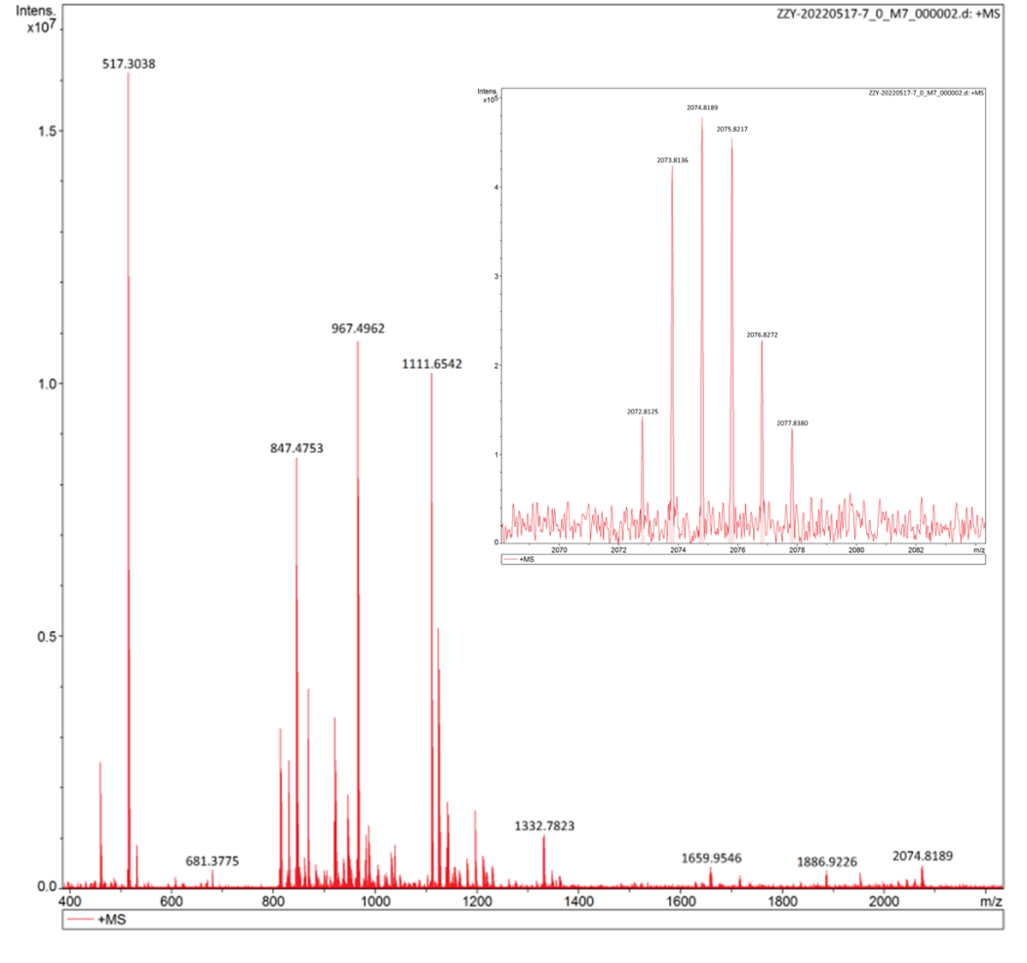
Figure S61. HRMS of CN-HP[3].

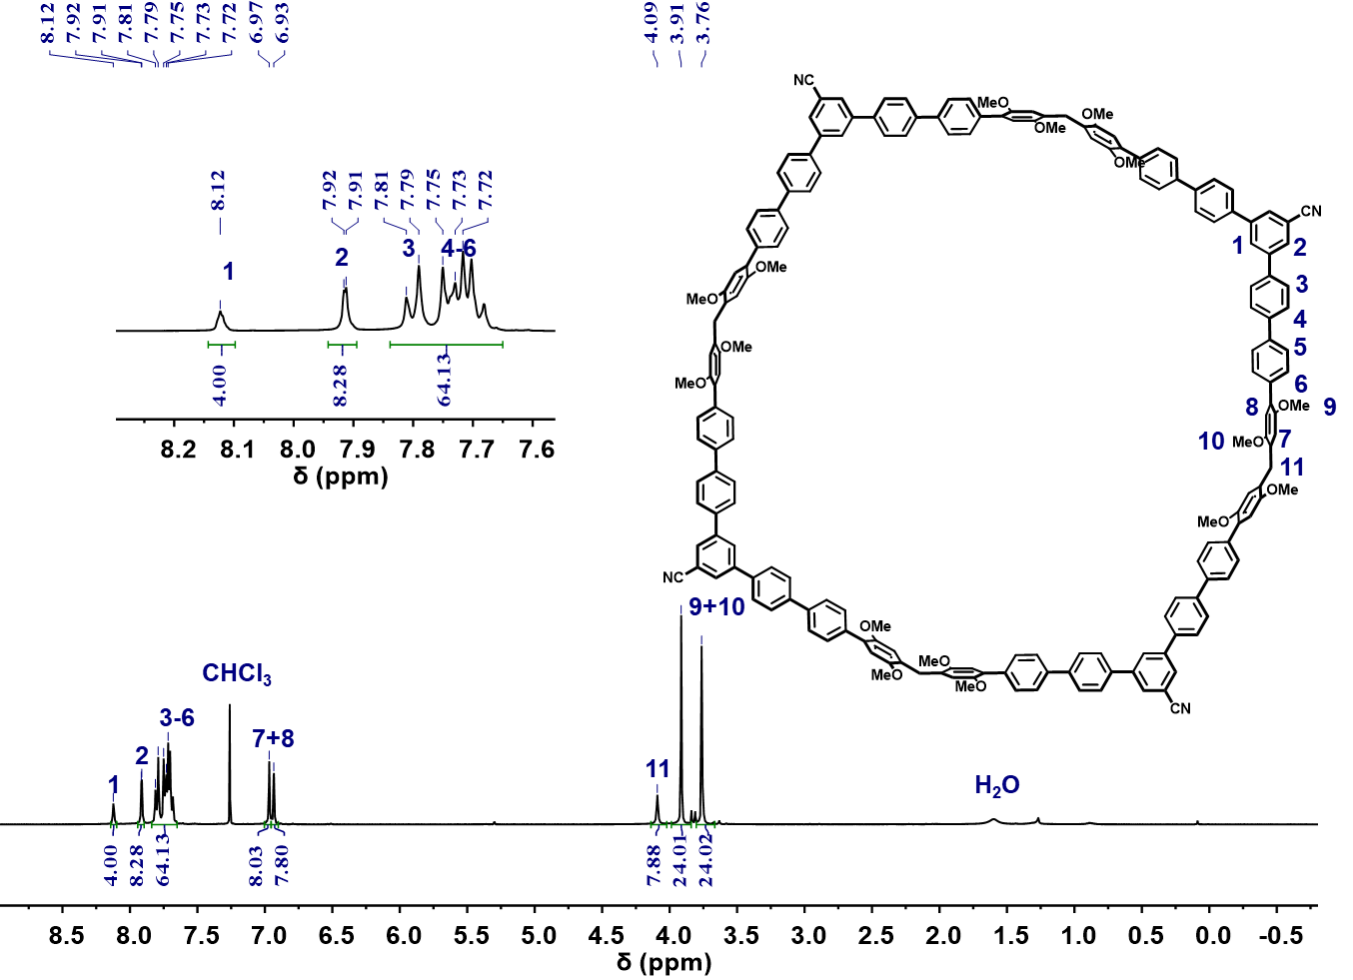
Figure S62. ¹H NMR spectrum (400 MHz, CDCl₃, 298K) of CN-HP[4].
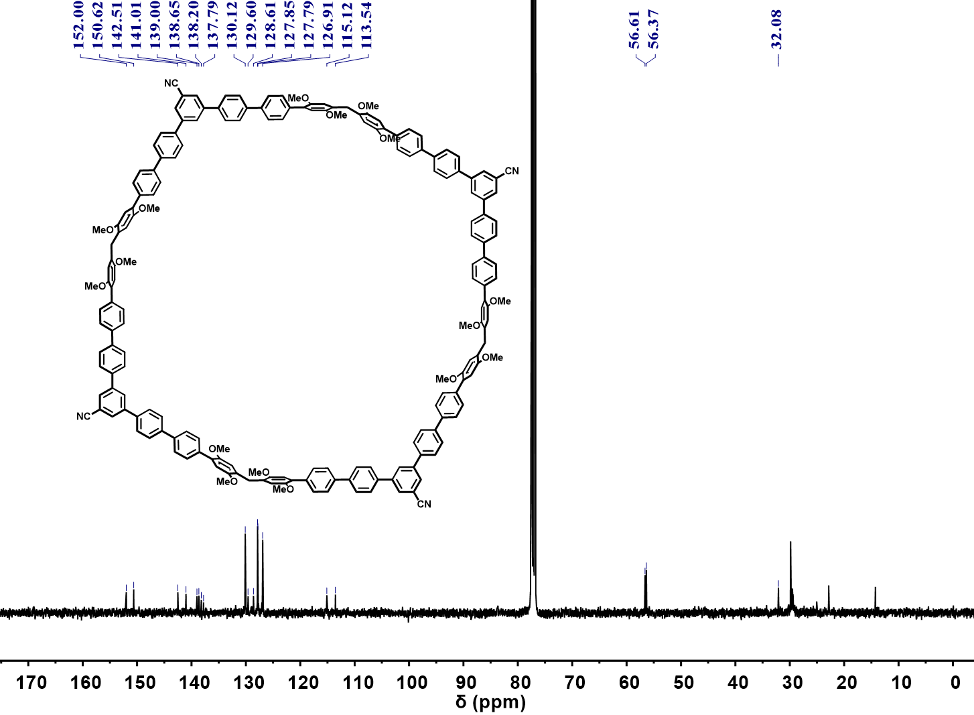
Figure S63. ¹³C NMR spectrum (101 MHz, CDCl₃, 298K) of CN-HP[4].

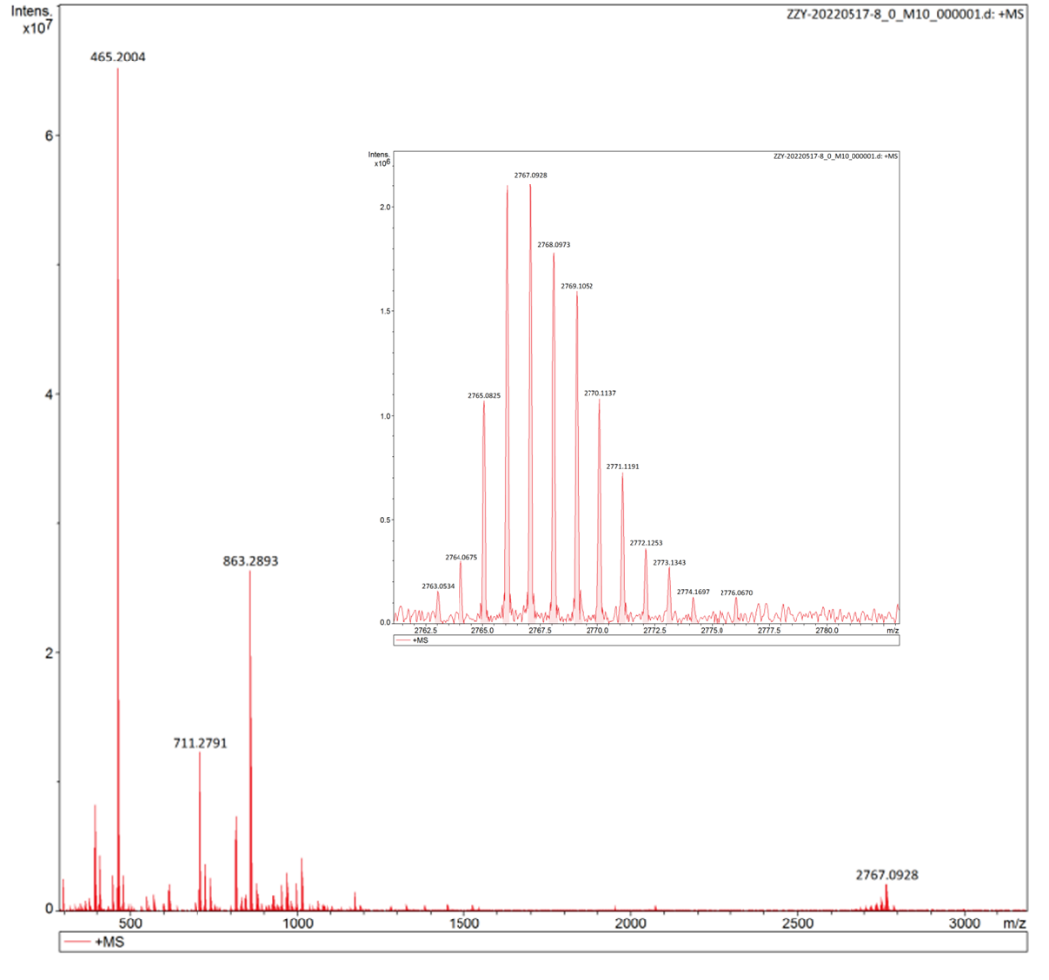
Figure S64. HRMS of CN-HP[4].
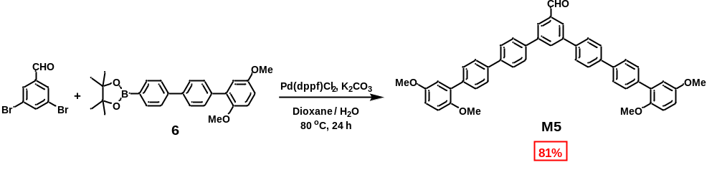
Scheme S17. Synthesis of monomer M5.
The 3,5-dibromobenzaldehyde (1.0 g, 3.9 mmol) and compound 6 (4.0 g, 9.5 mmol) were dissolved in 50 mL 1, 4-dioxane and 10 mL water. After addition of Pd(dppf)Cl₂ (0.14 g, 0.20 mmol) and K₂CO₃ (1.6 g, 11 mmol), the mixture was stirred at 80 ℃ for 24 hours. After the mixture was cooled, it was extracted with dichloromethane and water to obtain the organic layer. Then the organic layer was dried with anhydrous Na₂SO₄, the solvent was removed under vacuum and the residue was purified by column chromatography (silica gel, eluent: petroleum ether/CH₂Cl₂ 1:1) to afford monomer M5 (2.2 g, 81%) as white solid.
m. p. 110 - 112ºC. ¹H NMR (400 MHz, CDCl₃) δ 10.20 (s, 1H), 8.19 (d, J = 1.7 Hz, 1H), 8.16 (d, J = 1.7 Hz, 2H), 7.80 (s, 8H), 7.74 - 7.66 (m, 8H), 6.97 (dd, J = 9.5, 6.0 Hz, 5H), 6.89 (dd, J = 8.9, 3.0 Hz, 2H), 3.84 (s, 7H), 3.81 (s, 6H). ¹³C NMR (101 MHz, CDCl₃) δ 192.43, 153.97, 151.01, 142.51, 140.94, 139.20, 138.67, 137.91, 137.73, 131.62, 131.23, 130.13, 127.86, 127.79, 127.20, 126.89, 116.82, 113.41, 112.80, 56.49, 55.98. HRMS (ESI, m/z): calcd. for [M+H]⁺, C₄₇H₃₉O₅⁺, 683.2792; found, 683.2796.

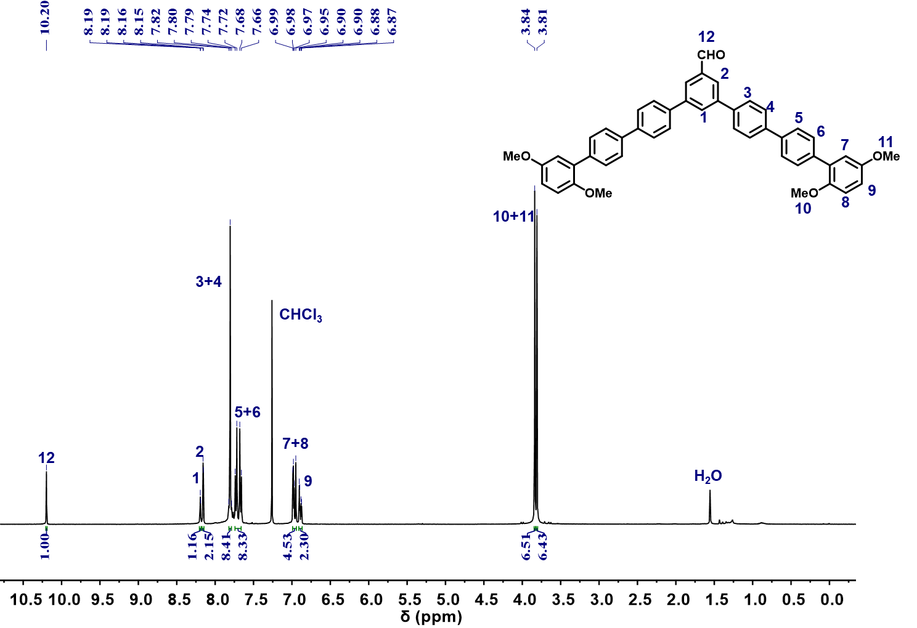
Figure S65. ¹H NMR spectrum (400 MHz, CDCl₃, 298K) of monomer M5.

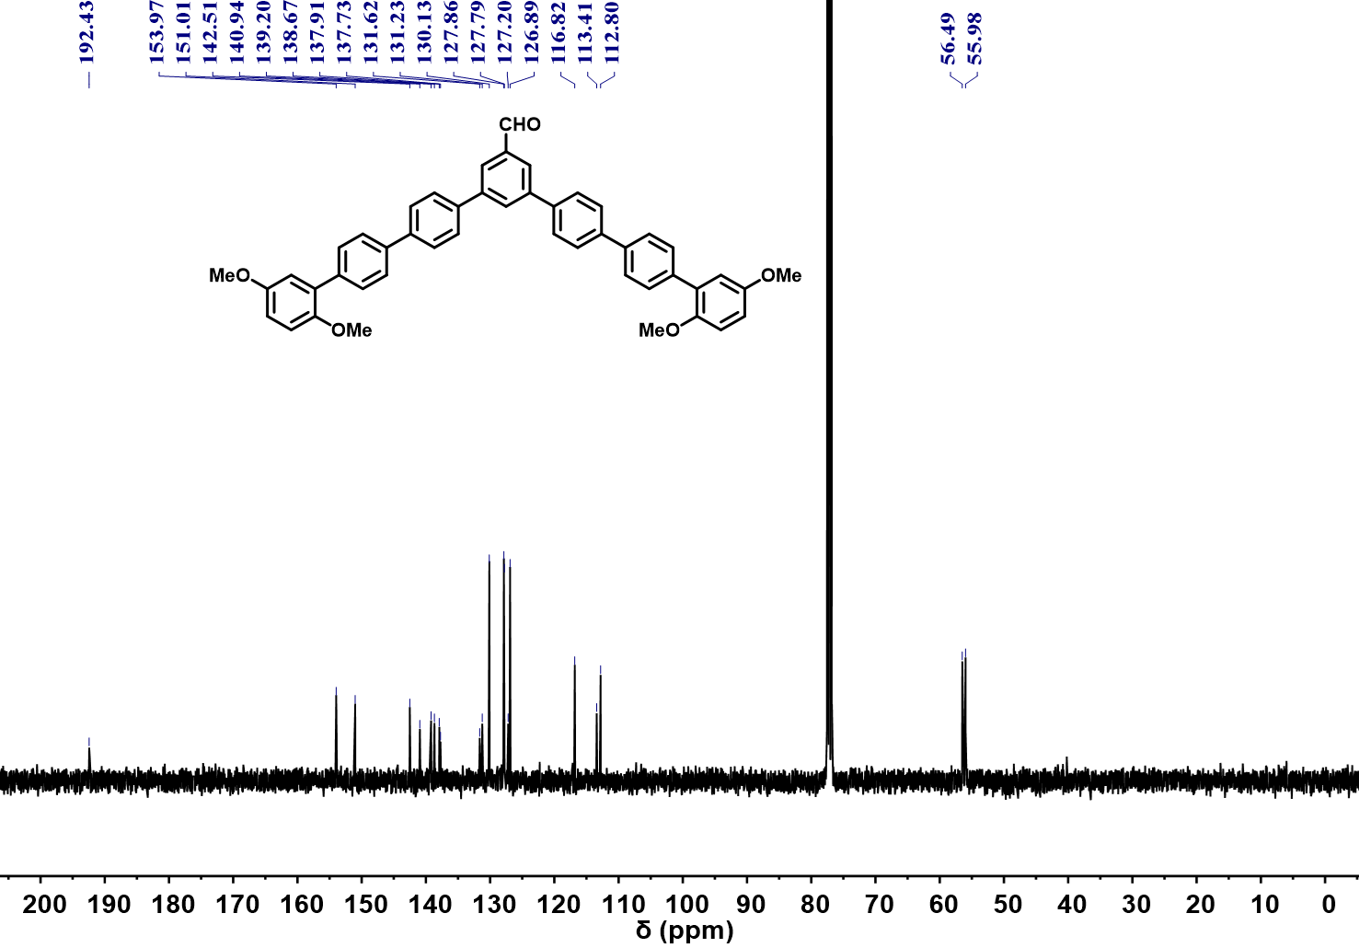
Figure S66. ¹³C NMR spectrum (101 MHz, CDCl₃, 298K) of monomer M5.

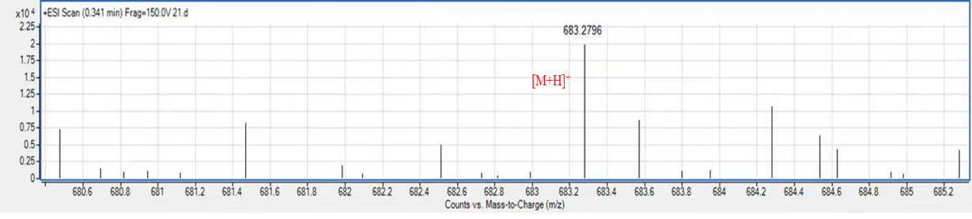
Figure S67. HRMS of monomer M5.

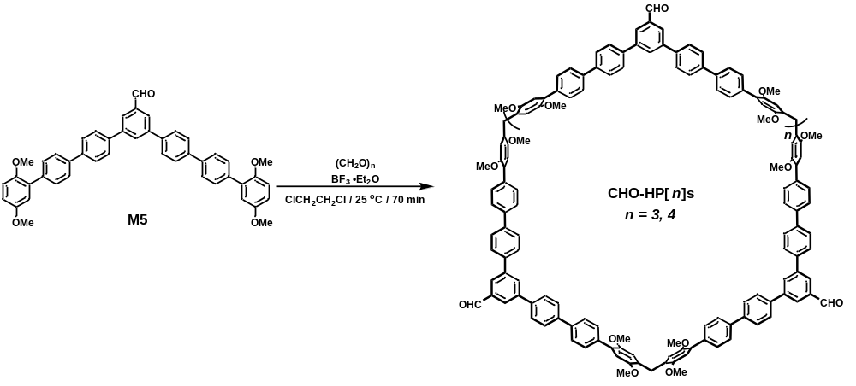
Scheme S18. Synthesis of CHO-HP[3,4]s.
M5 (0.20 g, 0.30 mmol) was dissolved in 100 mL 1, 2-dichloroethane and then paraformaldehyde (22 mg, 0.73 mmol) was added. Subsequently, BF₃⋅Et₂O (0.20 mL, 1.6 mmol) was dropped into and the mixture was stirred at room temperature for 70 minutes. After quenching with saturated NaHCO₃ solution, the solution was extracted with dichloromethane and water to obtain the organic layer. Then the organic layer was dried with anhydrous Na₂SO₄, the solvent was removed under vacuum and the residue was purified by column chromatography (silica gel, eluent: CH₂Cl₂) to afford CHO-HP[3] (25 mg, 12%) and CHO-HP[4] (12 mg, 6%) as white powder.
CHO-HP[3]: m. p >320 ºC. ¹H NMR (400 MHz, CDCl₃) δ 10.20 (s, 3H), 8.17 (d, J = 6.9 Hz, 9H), 7.80 (s, 24H), 7.72 (d, J = 8.4 Hz, 12H), 7.67 (d, J = 8.2 Hz, 12H), 6.96 (s, 6H), 6.92 (s, 6H), 4.08 (s, 6H), 3.91 (s, 18H), 3.75 (s, 18H).¹³C NMR (101 MHz, CDCl₃) δ 192.42, 152.00, 150.62, 142.51, 141.01, 139.00, 138.65, 138.20, 137.79, 130.12, 129.60, 128.61, 127.85, 127.79, 126.91, 115.12, 113.54, 56.61, 56.37, 32.08. HRMS (MALDI, m/z): calcd. for [M]⁺, C₁₄₄H₁₁₄O₁₅⁺, 2083.8191; found, 2083.8186.
CHO-HP[4]: m. p. >320 ºC.¹H NMR (400 MHz, CDCl₃) δ 10.20 (s, 4H), 8.19 (s, 4H), 8.16 (d, J = 1.4 Hz, 8H), 7.80 (s, 32H), 7.73 (d, J = 8.4 Hz, 16H), 7.68 (d, J = 8.3 Hz, 16H), 6.96 (s, 8H), 6.92 (s, 8H), 4.08 (s, 8H), 3.91 (s, 24H), 3.76 (s, 24H). ¹³C NMR (101 MHz, CDCl₃) δ 192.36, 152.09, 150.71, 142.56, 141.03, 139.01, 138.69, 138.26, 137.81, 131.64, 130.12, 129.59, 128.67, 127.85, 127.80, 127.17, 126.91, 115.20, 113.65, 56.67, 56.41, 30.24. HRMS (MALDI, m/z): calcd. for [M]⁺, C₁₉₂H₁₅₂O₂₀⁺, 2779.0944; found, 2779.0923.

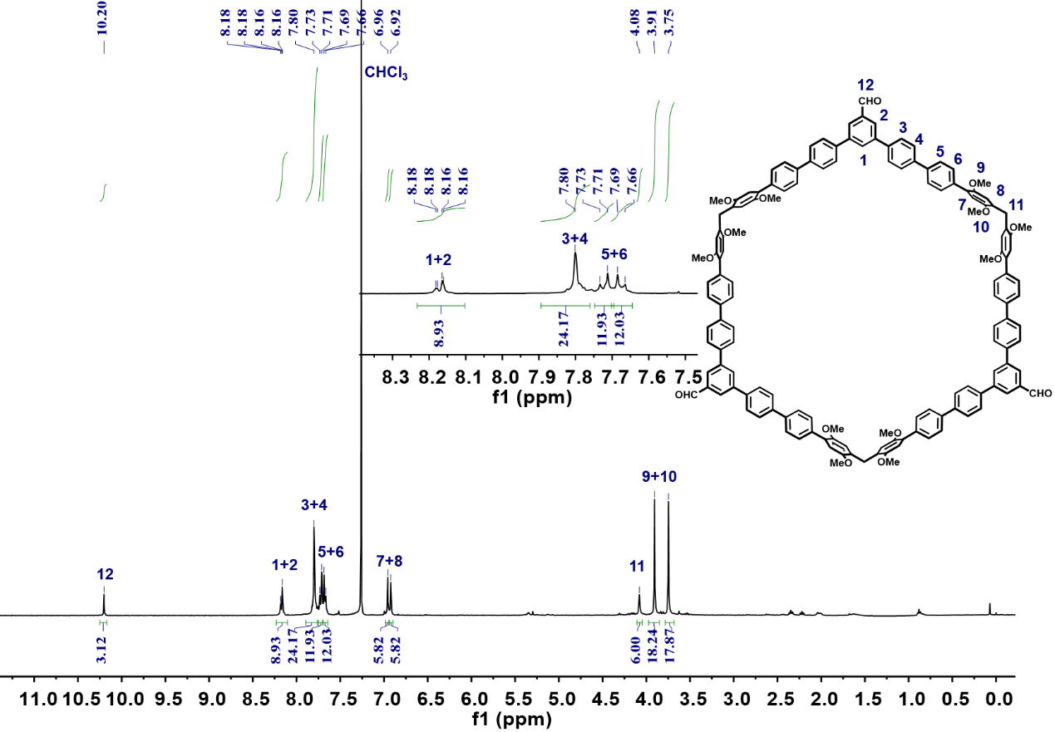
Figure S68. ¹H NMR spectrum (400 MHz, CDCl₃, 298K) of 2,5-CHO-HP[3].

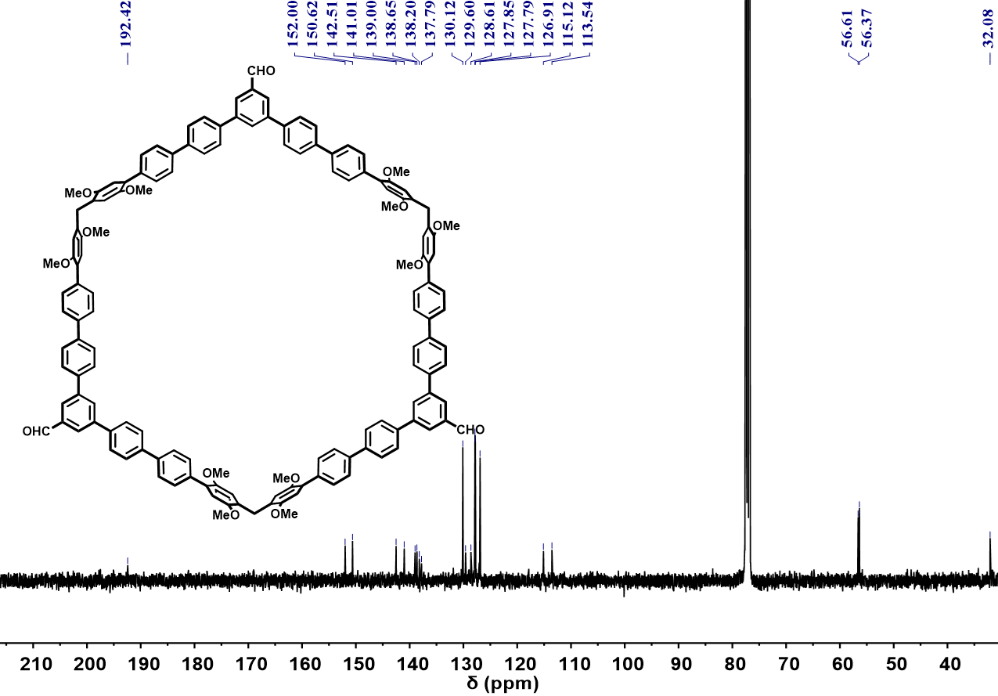
Figure S69. ¹³C NMR spectrum (101 MHz, CDCl₃, 298K) of CHO-HP[3].
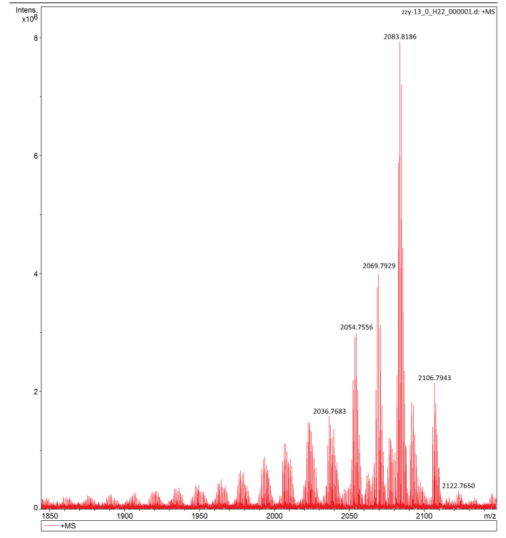
Figure S70. HRMS of CHO-HP[3].
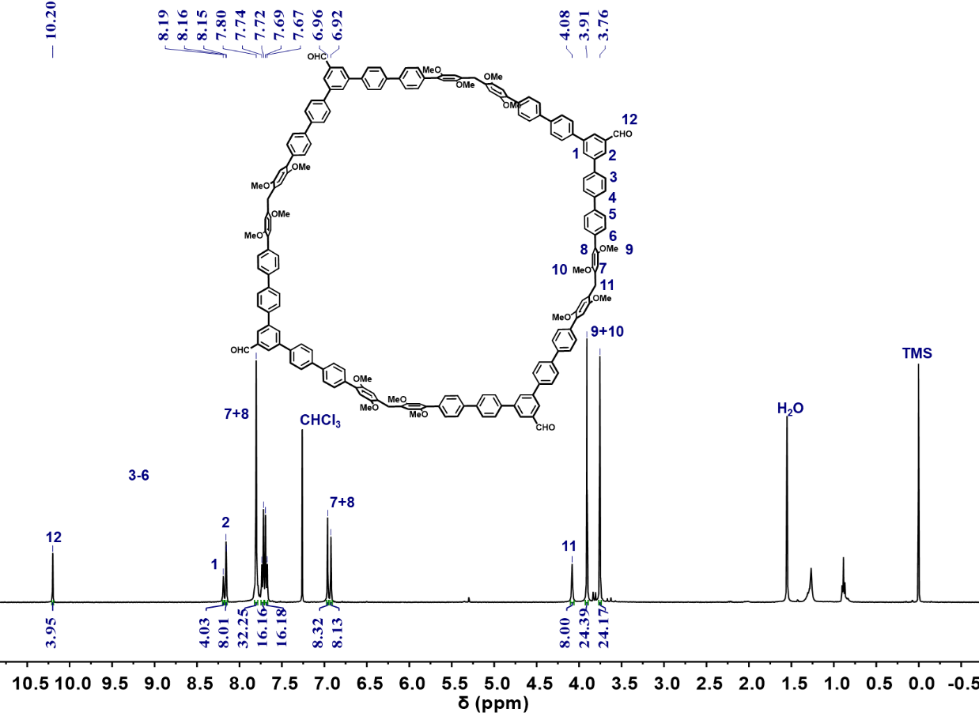
Figure S71. ¹H NMR spectrum (400 MHz, CDCl₃, 298K) of CHO-HP[4].

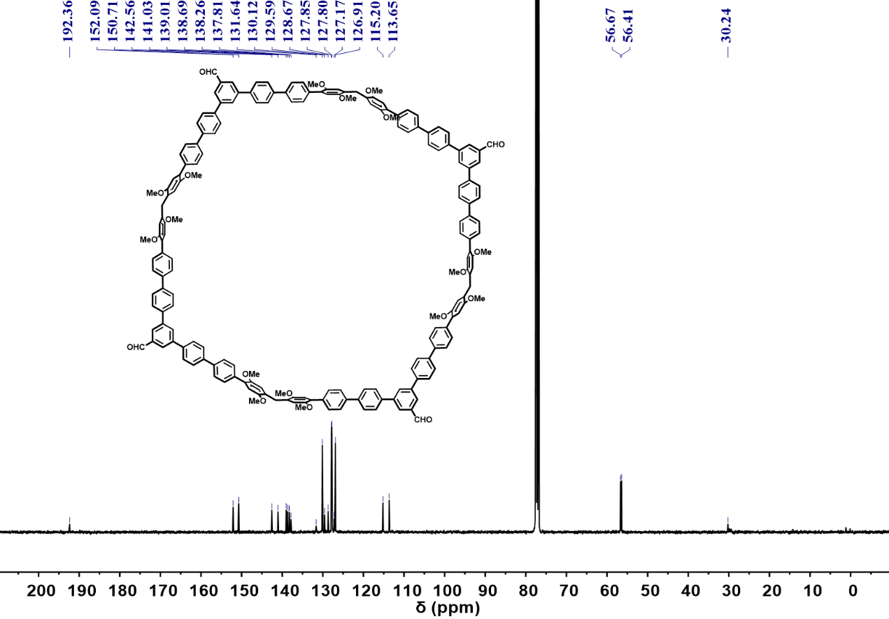
Figure S72. ¹³C NMR spectrum (101 MHz, CDCl₃, 298K) of CHO-HP[4].
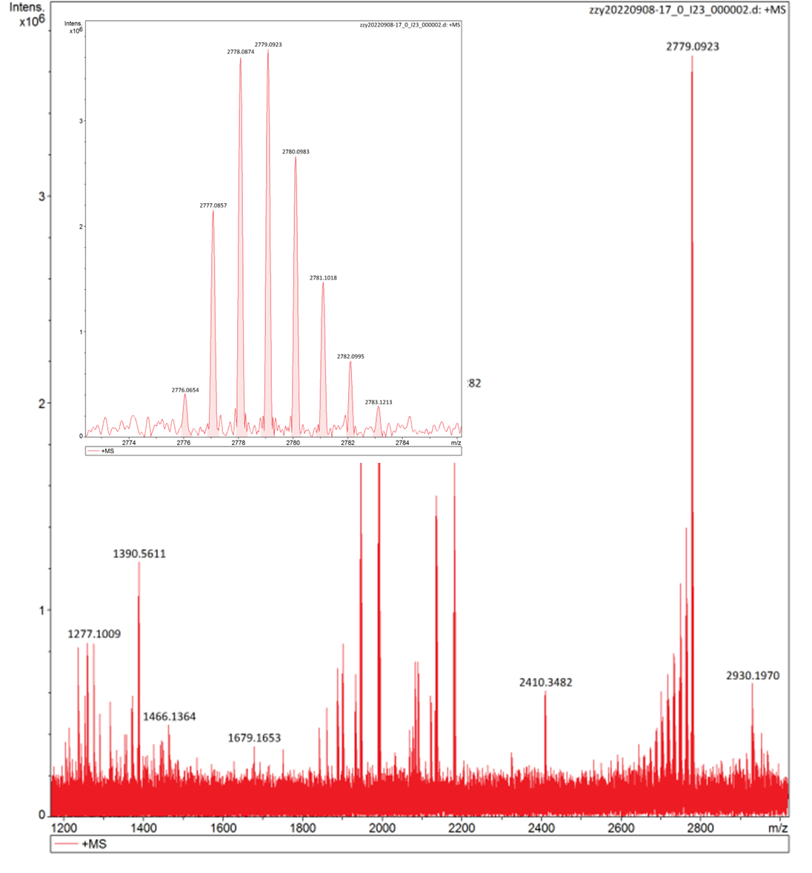
Figure S73. HRMS of CHO-HP[4].

Crystal structure of 2,5-QP[3] (CCDC: 2249910)

Method: 5 mg 2,5-QP[3] was dissolved in 12 mL toluene and filtered by a 0.22 μm filter to obtain 2,5-QP[3] solution. After slow evaporation of solvent for 7 days in cryogenic incubator (8 ºC), crystal of 2,5-QP[3] was obtained as colorless needle.

Table S3. Crystal data for 2,5-QP[3].
Empirical formula | C₁₀₅H₉₀O₁₂
Formula weight | 1543.76
Temperature | 170 K
Wavelength | 1.54178 Å
Crystal system | monoclinic
Space group | C2/c
Unit cell dimensions | a = 24.7796(8) Å α = 90°
 | b = 39.9097(13) Å β = 97.459°(2)
 | c = 14.1323(4) Å γ =90°(2)
Volume | 13857.8(7) Å³
Z | 4
Density (calculated) | 0.740 g/cm³
Absorption coefficient | 0.379 mm⁻¹
F(000) | 3264.0
Crystal size | 0.09 × 0.05 × 0.04 mm³
2θ range for data collection | 4.428 to 127.666°.
Index ranges | -28 ≤ h ≤ 28, -43 ≤ k ≤ 44, -16 ≤ l ≤ 16
Reflections collected | 37687
Independent reflections | 11278 [R_{int}= 0.0535,R_{sigma} = 0.0394]
Refinement method | Least Squares minimisation
Absorpt correction type | multi-scan
Data / restraints / parameters | 11278 / 12 / 721
Goodness-of-fit on F² | 1.060
Final R indices [I>2sigma(I)] | R₁ = 0.0620, wR₂ = 0.1912
R indices (all data) | R₁ = 0.0795, wR₂ = 0.2076
Largest diff. peak and hole | 0.21 and -0.17 e.Å⁻³
CCDC number | 2249910

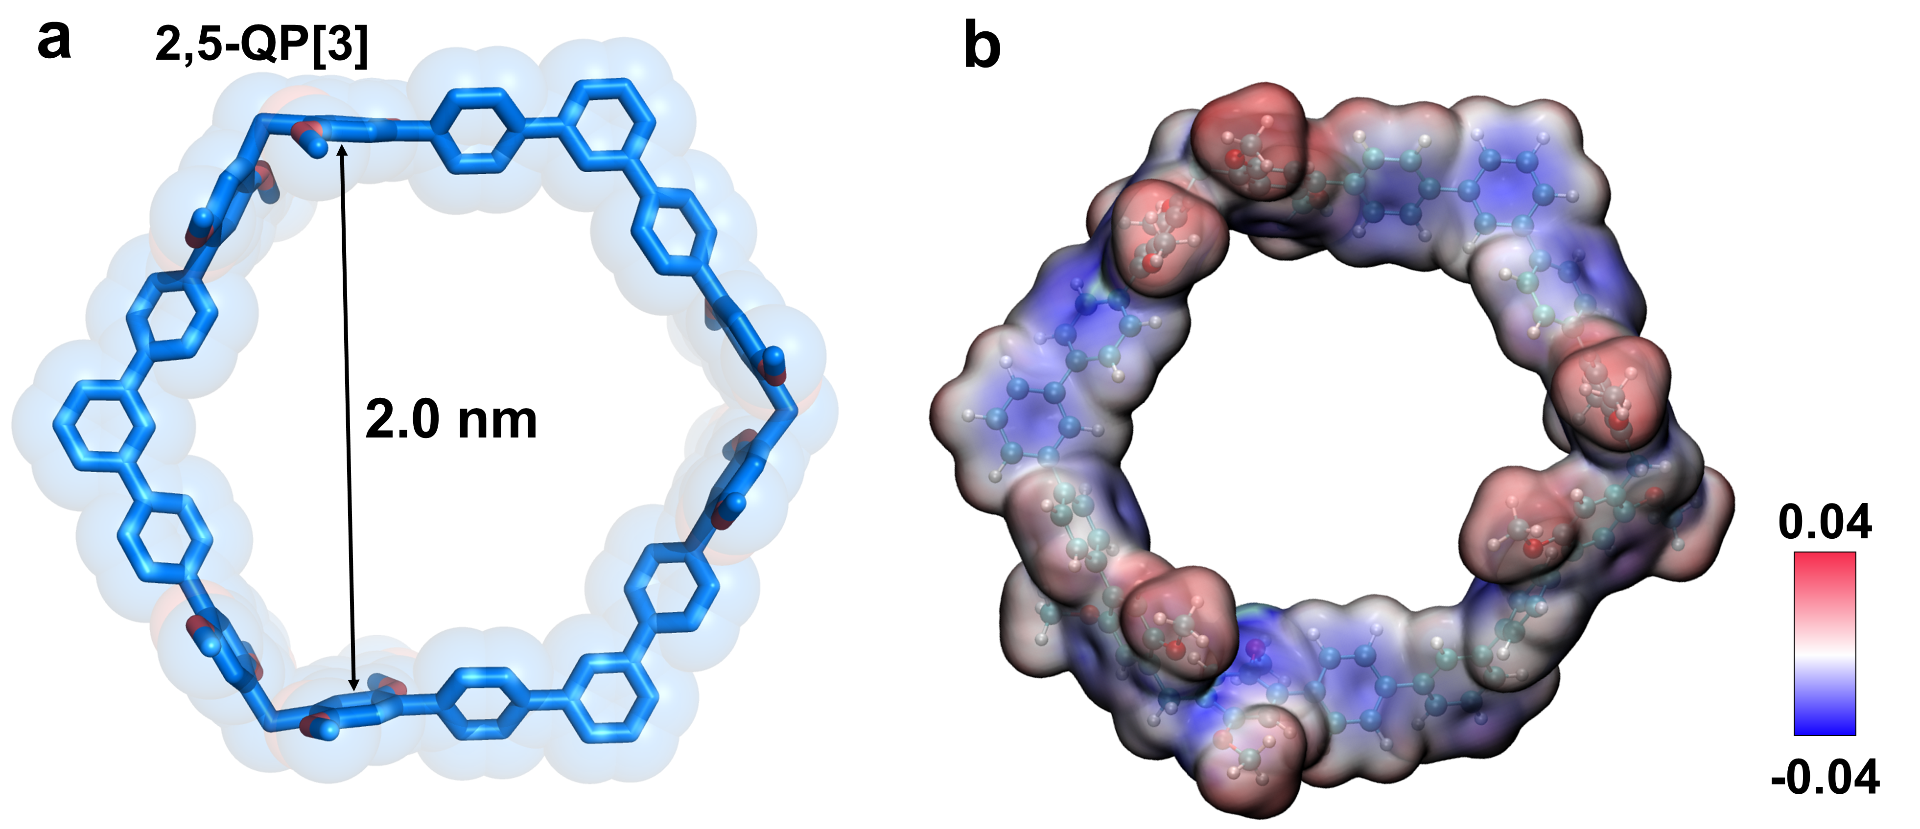
Figure S74. (a) Single-crystal structure and (b) electrostatic potential map of 2,5-QP[3]. The hydrogen atoms are omitted for the sake of clarity.
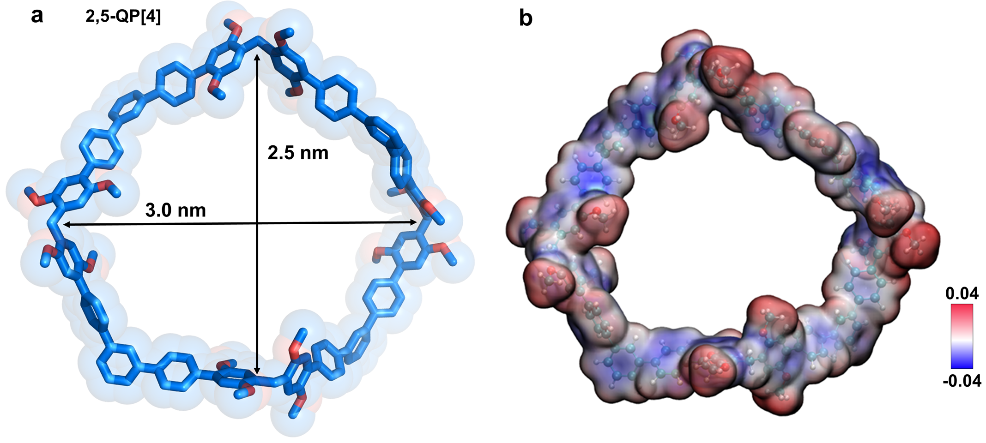
Figure S75. (a) Optimized structure and (b) electrostatic potential map of 2,5-QP[4]. The hydrogen atoms are omitted for the sake of clarity.
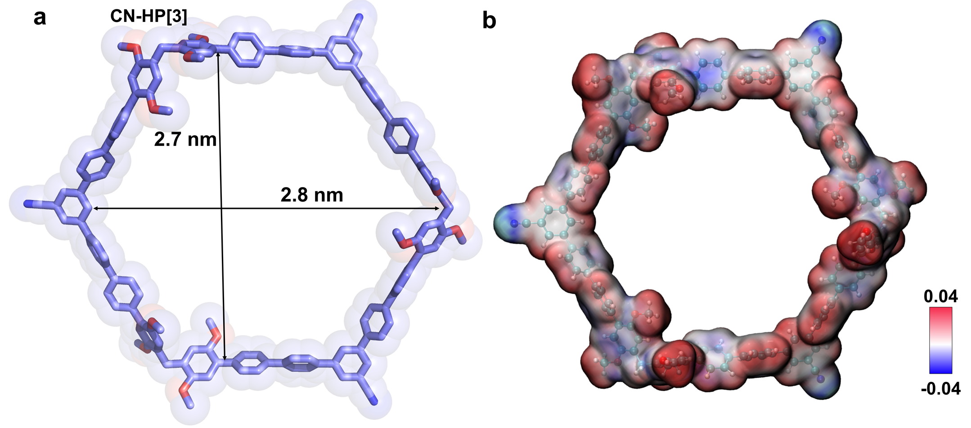
Figure S76. (a) Optimized structure and (b) electrostatic potential map of CN-HP[3]. The hydrogen atoms are omitted for the sake of clarity.
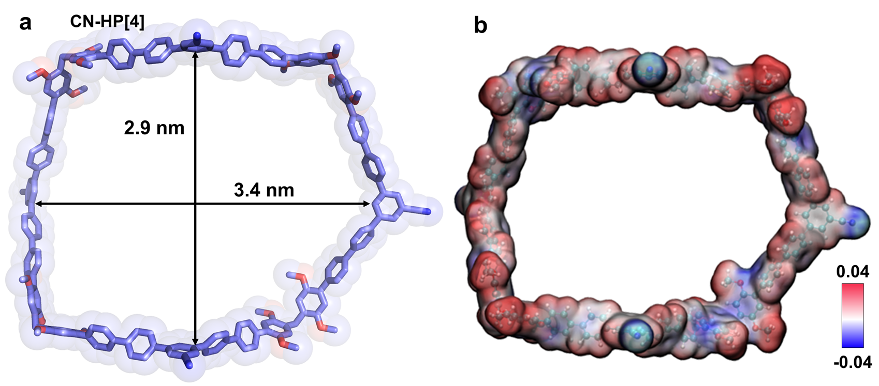
Figure S77. (a) Optimized structure and (b) electrostatic potential map of CN-HP[4]. The hydrogen atoms are omitted for the sake of clarity.
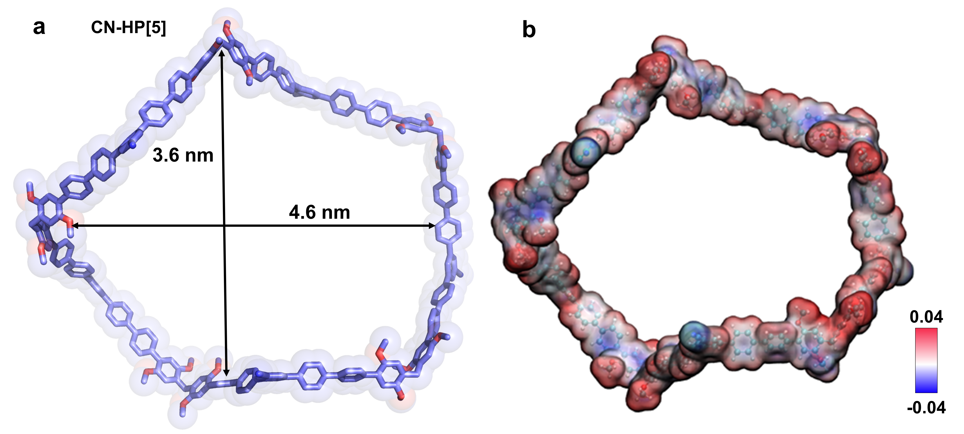
Figure S78. (a) Optimized structure and (b) electrostatic potential map of CN-HP[5]. The hydrogen atoms are omitted for the sake of clarity.

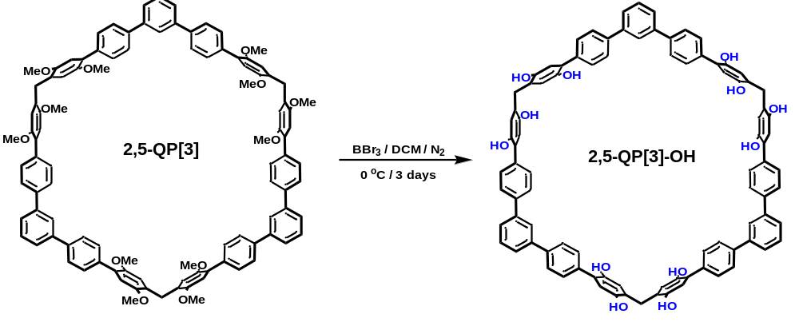
Scheme S19. Synthesis of 2,5-QP[3]-OH.
To the solution of 2,5-HP[3] (0.15 g, 0.10 mmol) in DCM (50 mL) was gradually added BBr₃ (0.36 mL, 4.8 mmol) and stirred at 0 ºC for 3 days under nitrogen atmosphere. After pouring the reaction solution into iced water, a precipitate appeared. The precipitate was filtered and dried, the product 2,5-QP[3]-OH was obtained as pale pink powder (0.13 g, 97%). m.p. >320 ºC. ¹H NMR (400 MHz, DMSO-d₆) δ 8.82 (s, 2H), 8.75 (s, 2H), 7.93 (s, 4H), 7.76 (d, J = 8.4 Hz, 3H), 7.67 (d, J = 7.7 Hz, 12H), 7.59 (d, J = 8.5 Hz, 15H), 7.54 (m, 3H), 6.77 (s, 6H), 6.58 (s, 6H), 3.71 (s, 6H). ¹³C NMR (101 MHz, Methanol-d₄) δ 149.16, 148.36, 142.88, 140.41, 139.52, 130.79, 130.38, 129.17, 127.84, 127.60, 126.64, 126.55, 119.15, 117.70, 30.89. HRMS (MALDI-TOF; m/z): [M+Na]⁺ calcd. for C₉₃H₆₆O₁₂Na⁺, 1397.4446; found, 1397.4469.

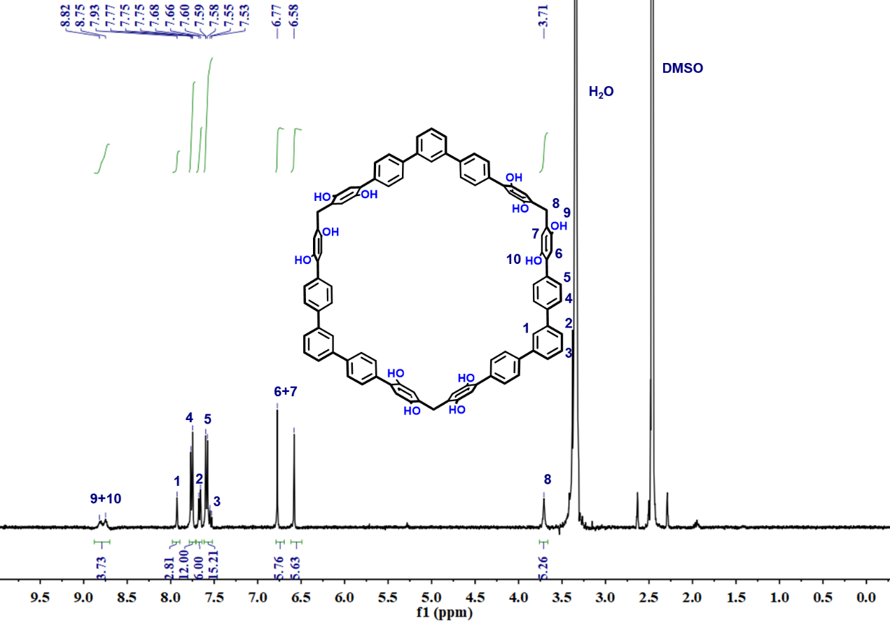
Figure S79. ¹H NMR spectrum (400 MHz, DMSO-d₆, 298K) of 2,5-QP[3]-OH.

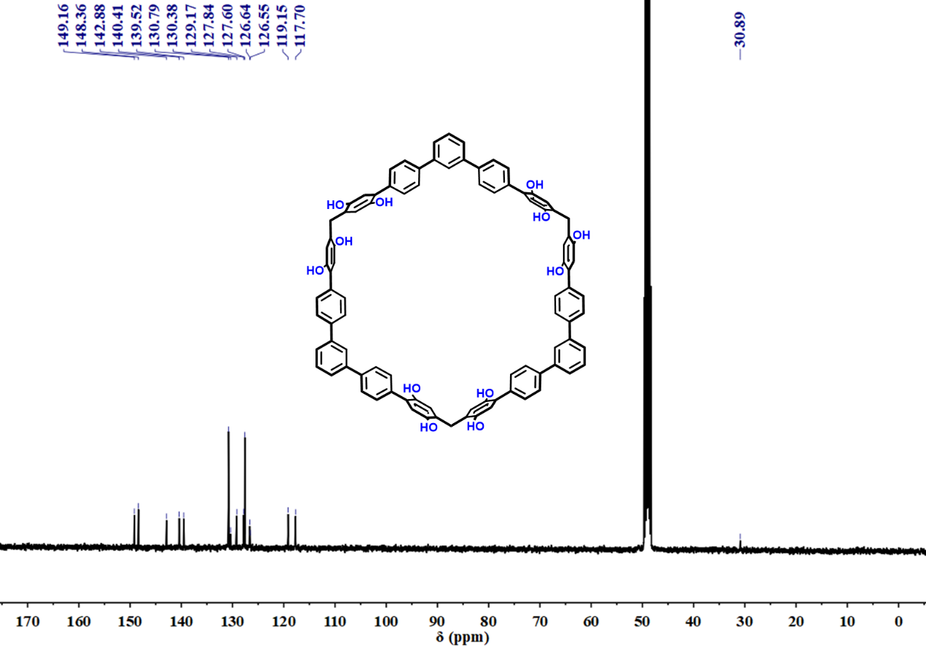
Figure S80. ¹³C NMR spectrum (101 MHz, Methanol-d₄, 298K) of 2,5-QP[3]-OH.

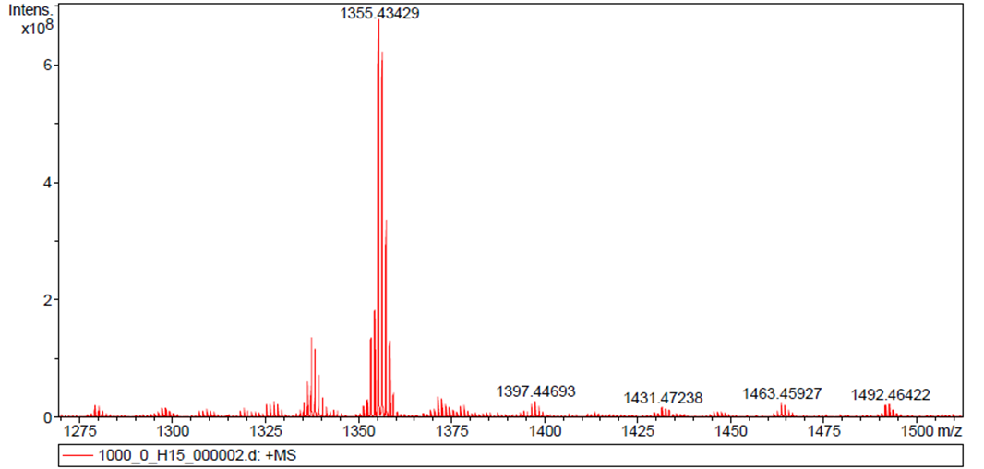
Figure S81. HRMS of 2,5-QP[3]-OH.

Section IV. Assembly and Photophysical properties of Giant Macrocycles
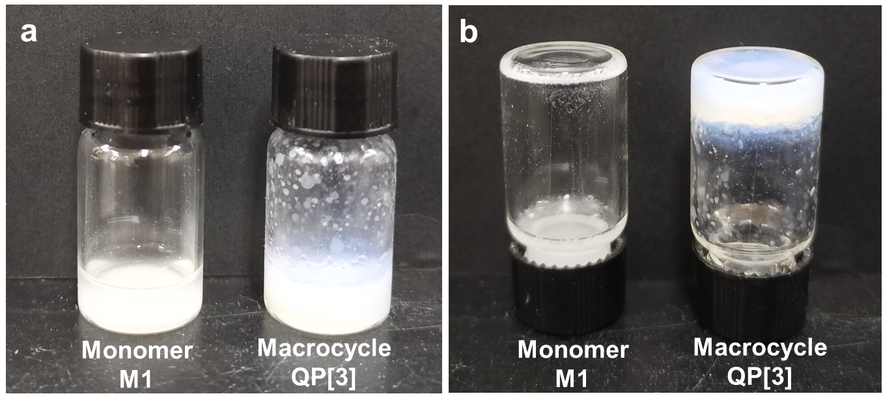
Figure S82. Organogel of monomer M1 and macrocycle QP[3] in (a) upright and (b) inverted bottle.
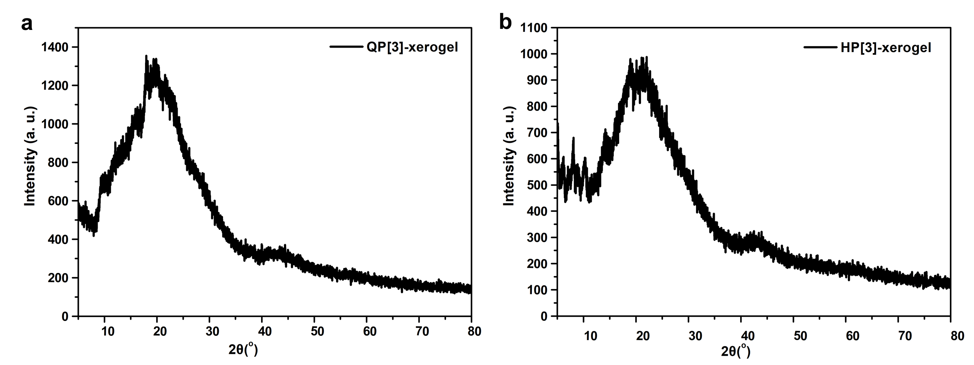
Figure S83. XRD patterns of (a) QP[3] xerogel and (b) HP[3] xerogel.
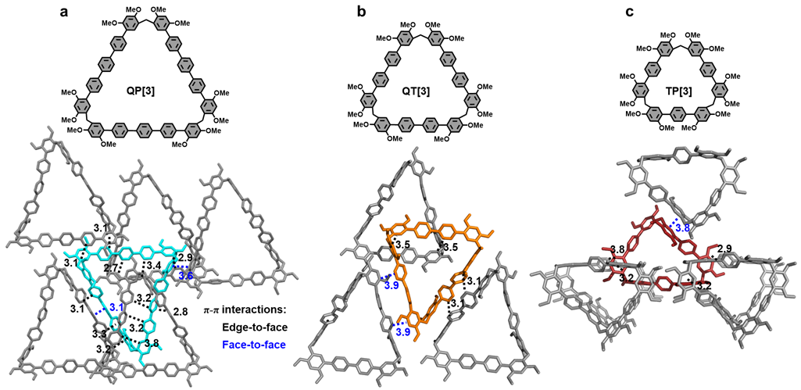
Figure S84. Chemical structures and single-crystal structures of (a) QP[3], (b) QT[3], and (c) TP[3]. The hydrogen atoms are omitted for the sake of clarity.
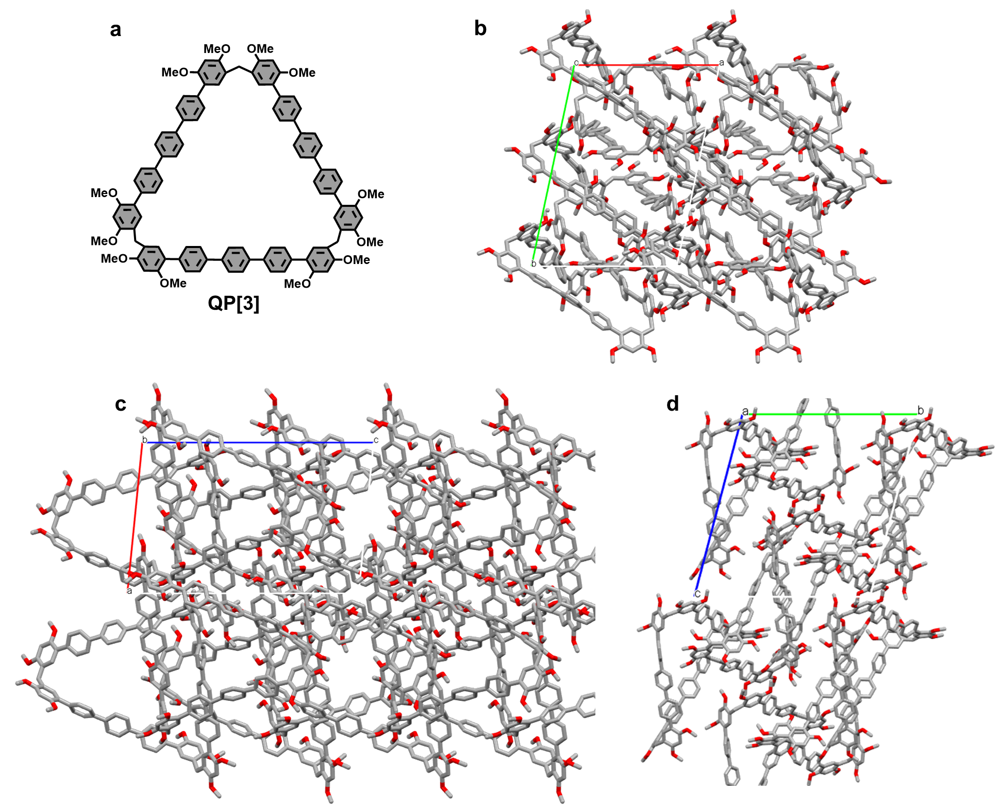
Figure S85. (a) Chemical structure and (b-d) single-crystal structures of QP[3] in (b) c-axis, (c) b-axis and (d) a-axis. The hydrogen atoms are omitted for the sake of clarity.
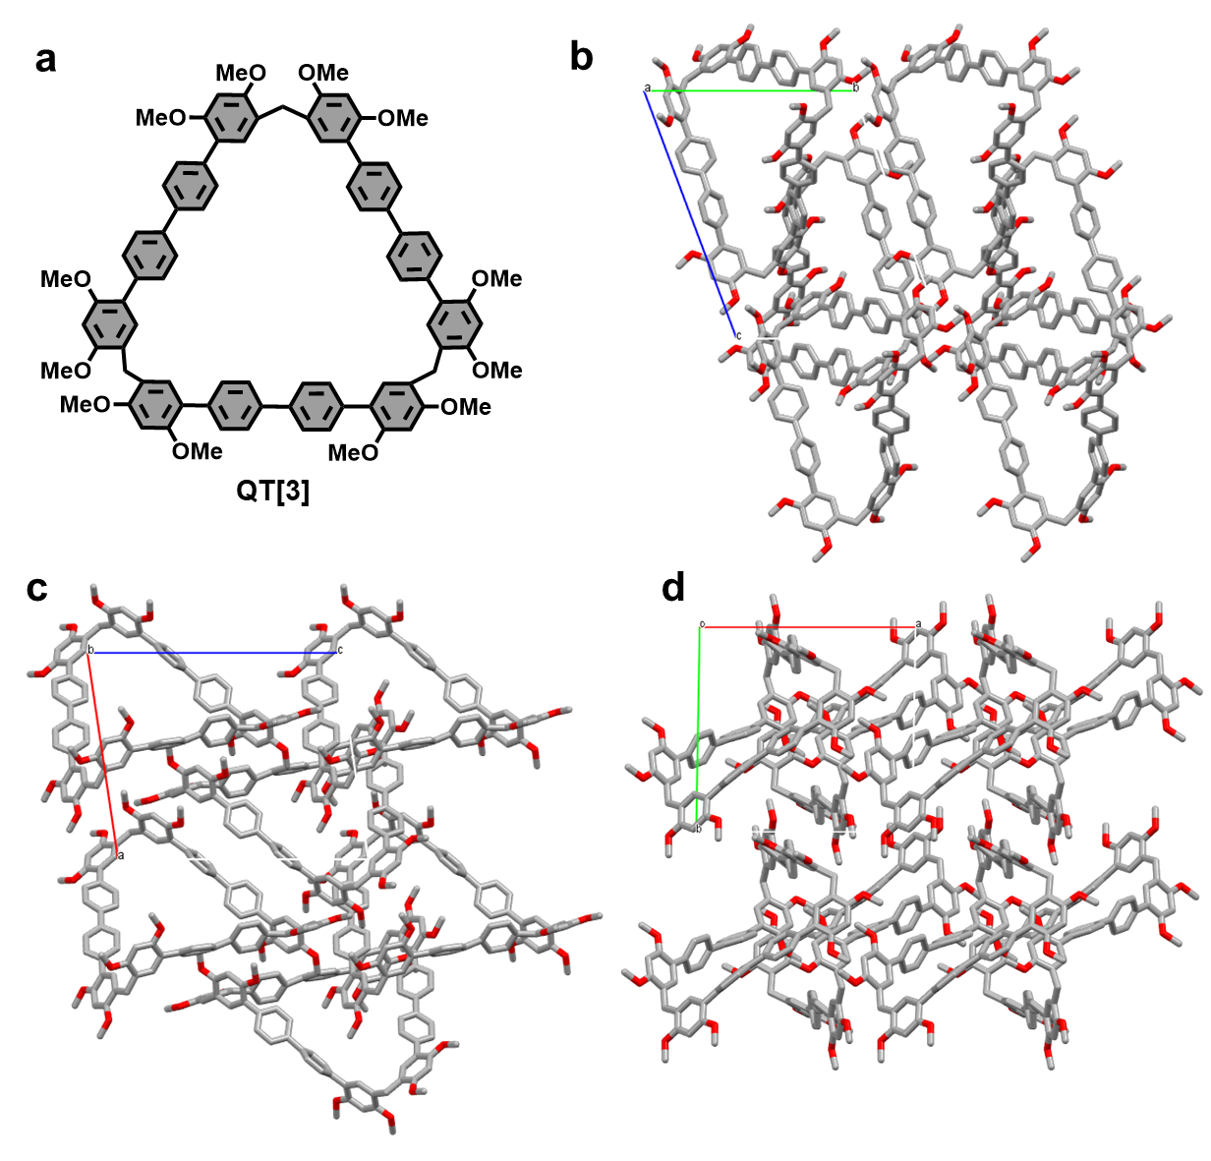
Figure S86. (a) Chemical structure and (b-d) single-crystal structures of QT[3] in (b) a-axis, (c) b-axis and (d) c-axis. The hydrogen atoms are omitted for the sake of clarity. This crystal was reported in our previous work.¹
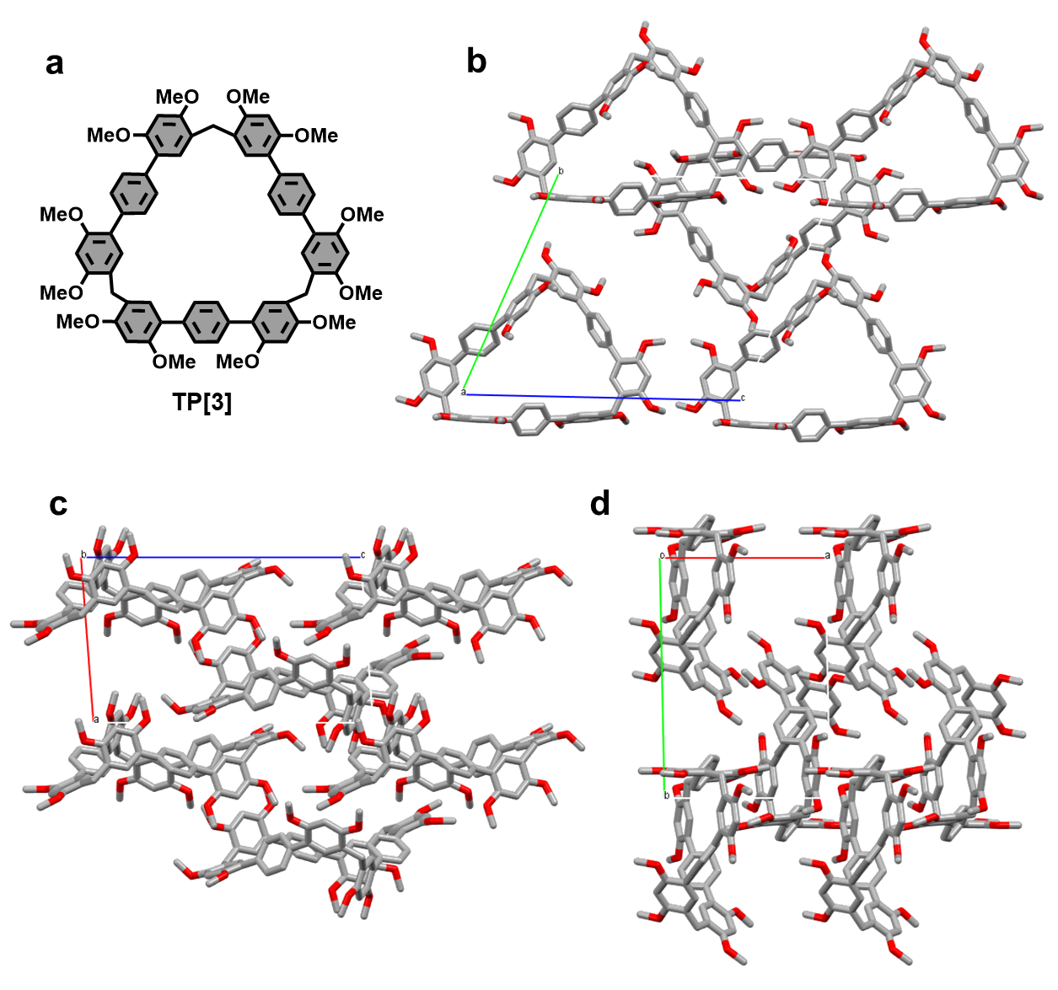
Figure S87. (a) Chemical structure and (b-d) single-crystal structures of TP[3] in (b) a-axis, (c) b-axis and (d) c-axis. The hydrogen atoms are omitted for the sake of clarity.
Crystal structure of TP[3] (CCDC: 2266019)
Method: 4 mg TP[3] was dissolved in 1 mL 1,2- dichloroethane and filtered by a 0.22 μm filter to obtain TP[3] solution. Slow vapor diffusion of n-hexane into the TP[3] solution for 2 weeks yielded transparent block crystal of TP[3].

Table S4. Crystal data for TP[3].
Empirical formula | C_{36.5}H₃₇Cl₁₂O₆
Formula weight | 642.56
Temperature / K | 203(2)
Wavelength/ Å | 0.71073
Crystal system | Triclinic
Space group | P-1
a / Å | 11.4902(14)
b / Å | 18.050(2)
c / Å | 21.034(3)
α / ° | 67.173(2)
β / ° | 84.847(2)
γ / ° | 86.973(2)
Volume/ Å³ | 4003.7(9)
Z | 4
Density (calculated) | 1.066 g/cm³
Absorption coefficient | 0.199 mm⁻¹
F(000) | 1352
Crystal size | 0.36 × 0.13 × 0.05 mm³
2θ range for data collection /° | 1.053 to 26.999
Index ranges | -13 ≤ h ≤ 14, -23 ≤ k ≤ 23, -17 ≤ l ≤ 26
Reflections collected | 25551
Independent reflections | 17165 [R(int) = 0.0396]
Data / restraints / parameters | 17165 / 1 / 814
Goodness-of-fit on F² | 1.026
Final R indices [I>2sigma(I)] | R₁ = 0.0889, wR₂ = 0.2444
R indices (all data) | R₁ = 0.1698, wR₂ = 0.3407
Largest diff. peak and hole / e.Å⁻³ | 0.54 and -0.552
CCDC number | 2266019

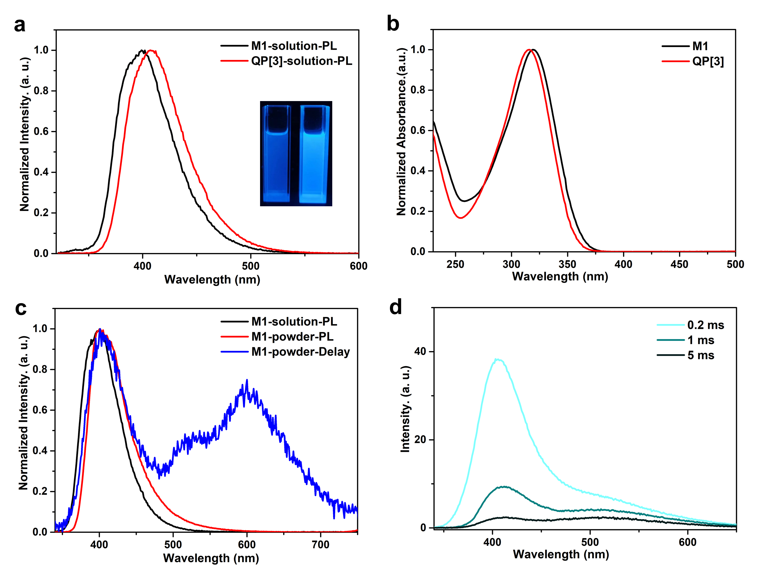
Figure S88. (a) Photoluminescence spectra of M1 and QP[3] in DCM solution (1×10⁻⁶ mol/L). (b) UV-Vis spectra of M1 and QP[3] in DCM solution (1×10⁻⁵ mol/L). (c) Photoluminescence spectra of M1 in DCM solution (black) and powder (red) and delay-time photoluminescence spectra (cyan) of M1 in powder (excitation wavelength: 330 nm, delay time: 5 ms). (d) Delay-time photoluminescence spectra of QP[3] in xerogel.

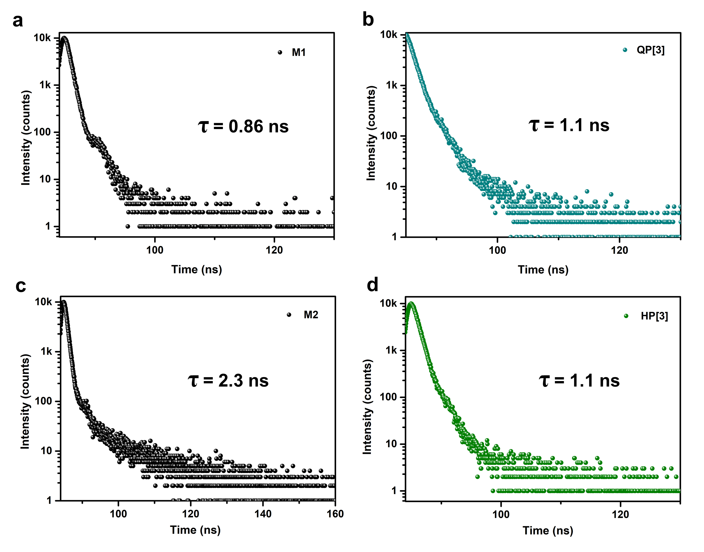
Figure S89. Time-resolved PL decay of (a) M1 in powder @400 nm, (b) QP[3] in xerogel @414 nm, (c) M2 in powder @402 nm, and (d) HP[3] in xerogel @388 nm.
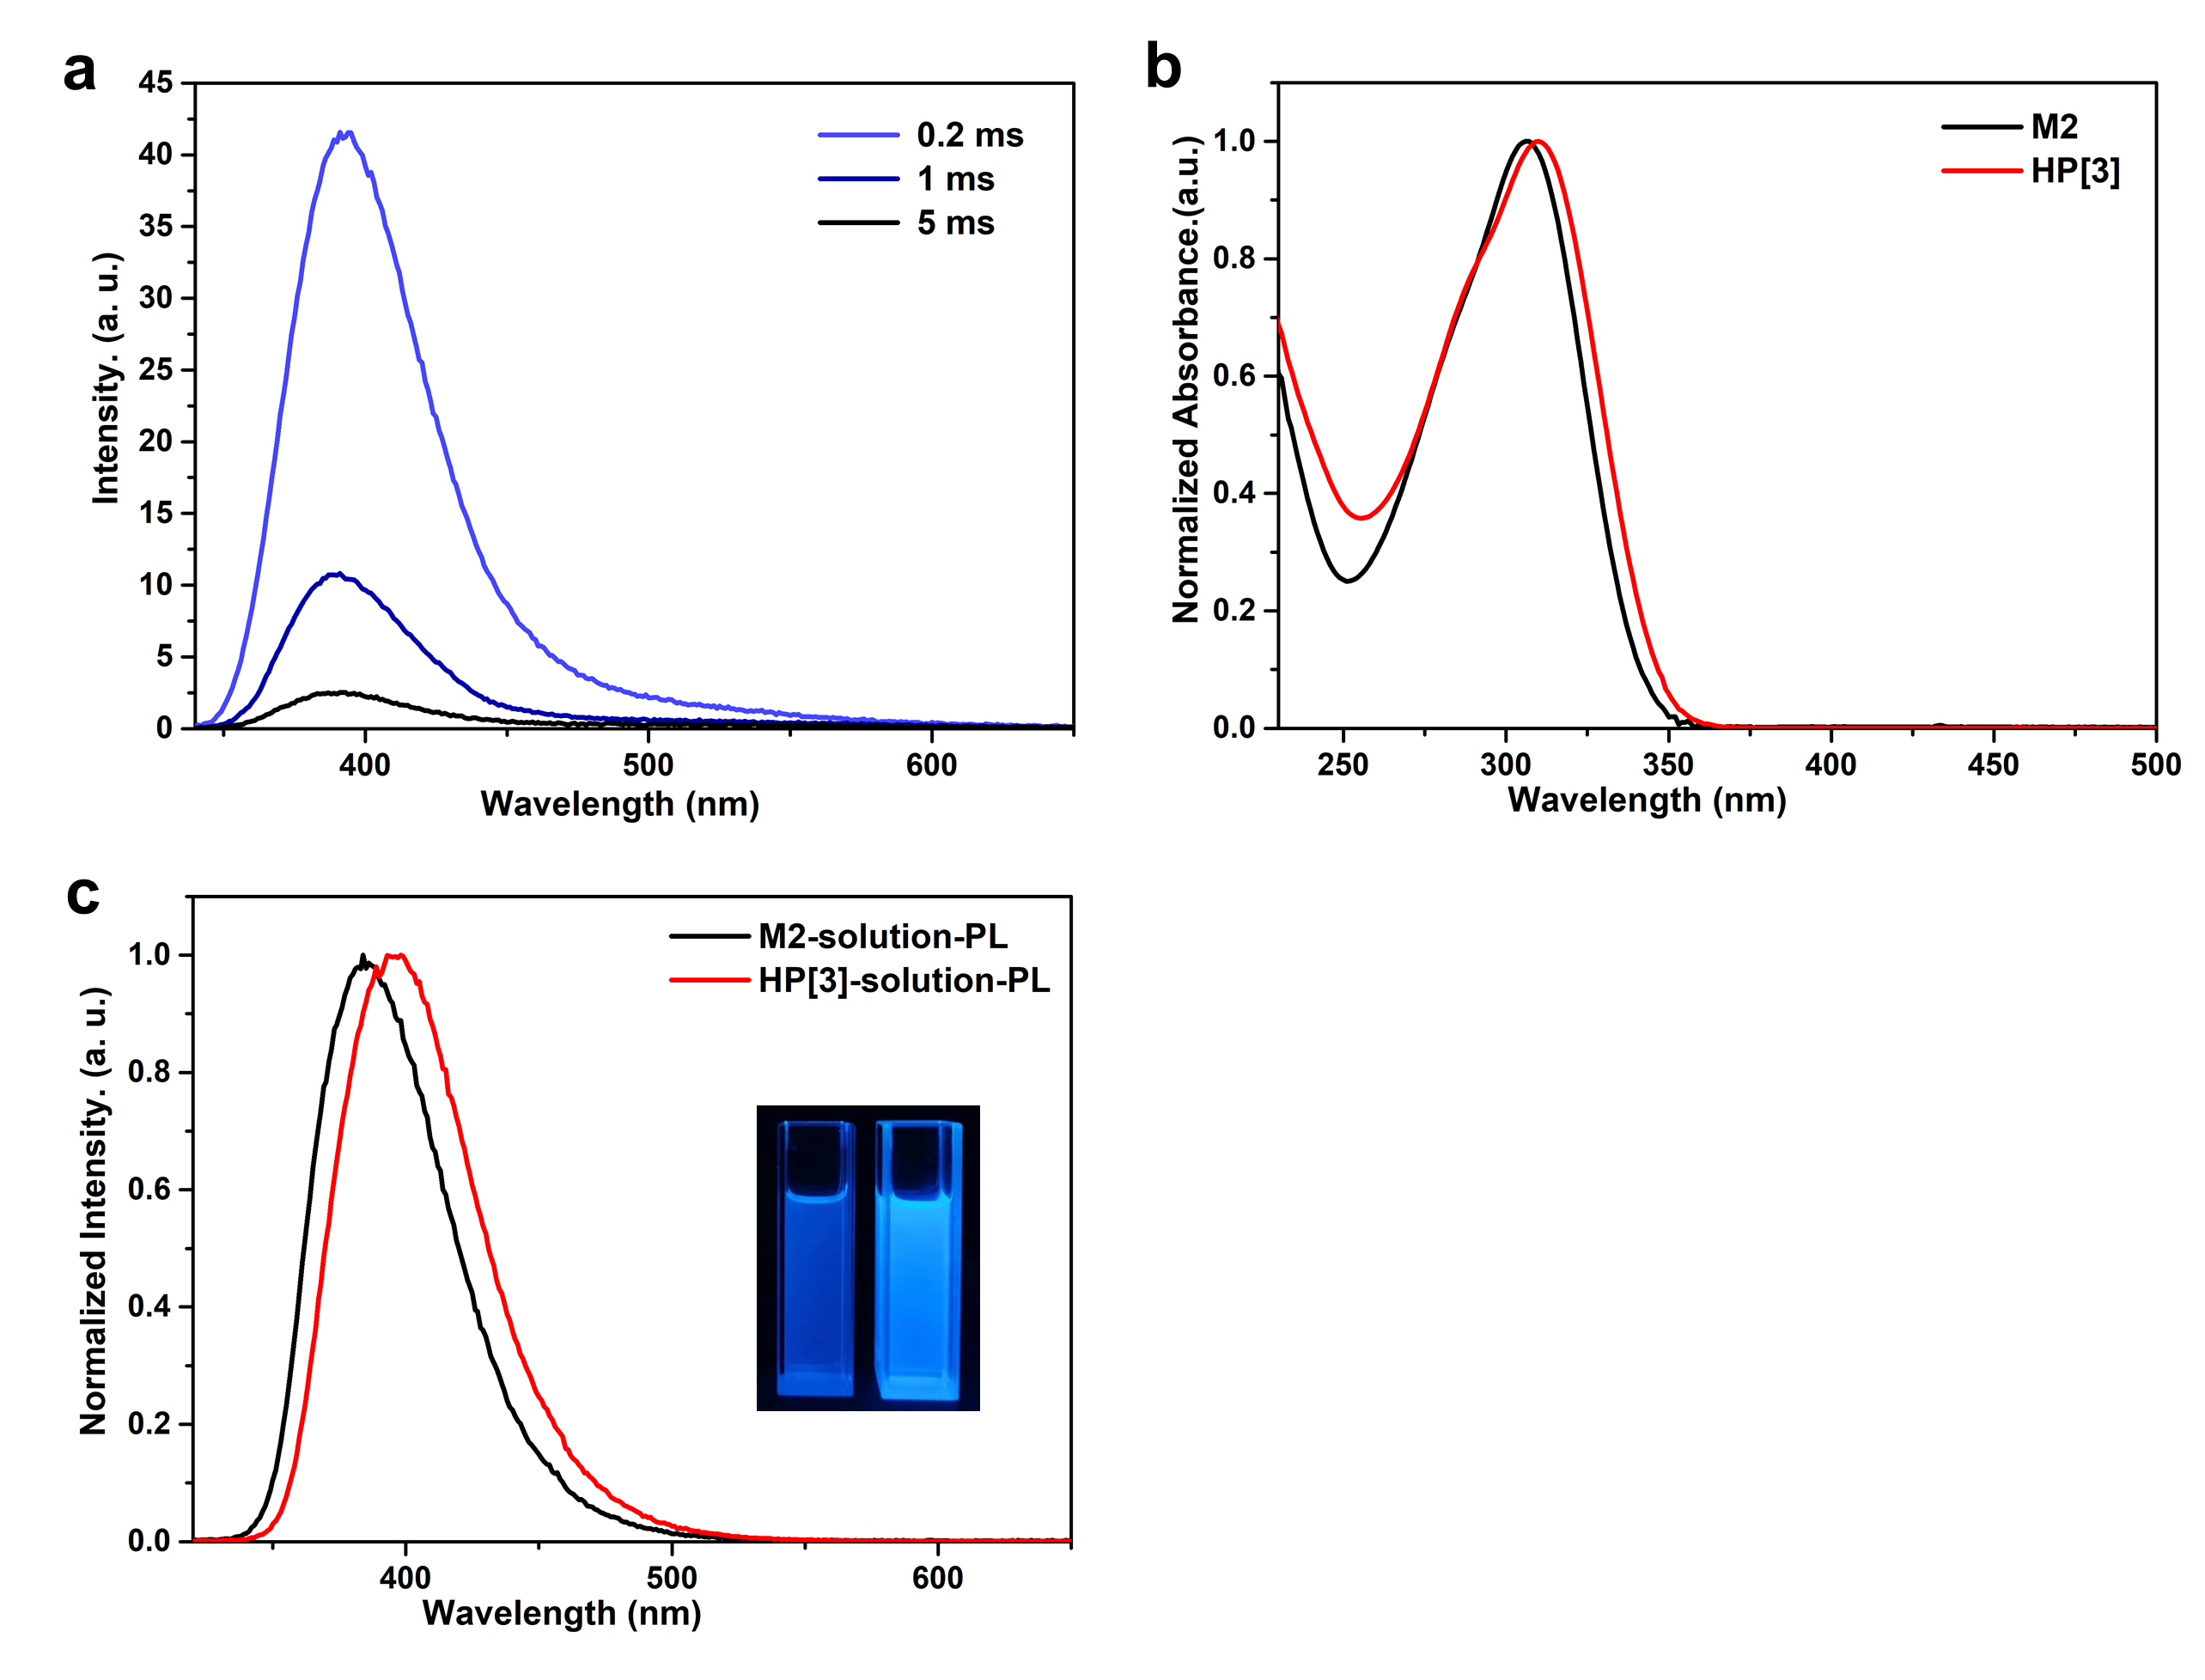
Figure S90. (a) Delay-time photoluminescence spectra of HP[3] xerogel. (b) UV-Vis spectra of M2 and HP[3] in DCM solution (1×10⁻⁵ mol/L). (c) Photoluminescence spectra of M2 and HP[3] in DCM solution (1×10⁻⁶ mol/L).
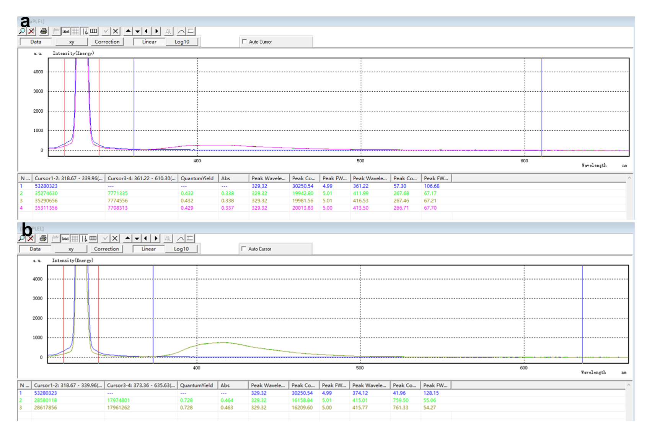
Figure S91. Phosphorescence quantum efficiency of (a) M1 in powder and (b) QP[3] in xerogel.
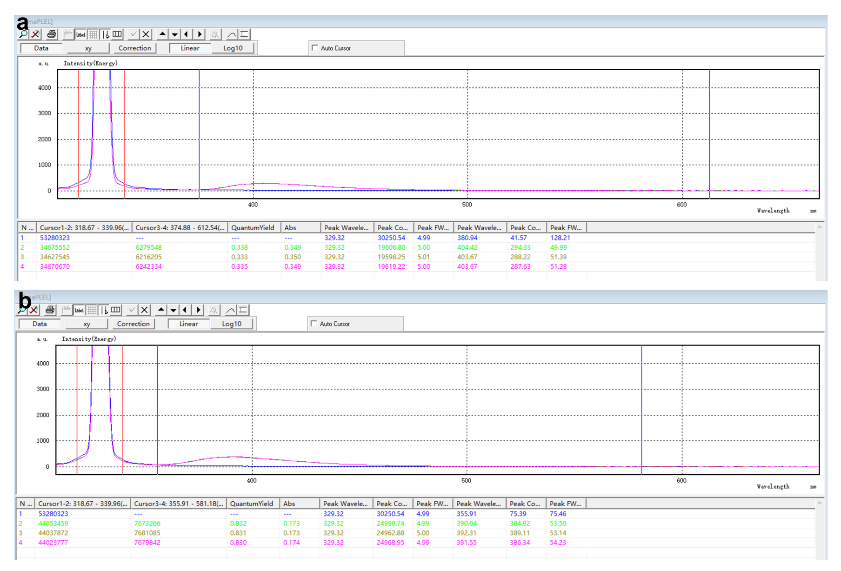
Figure S92. Phosphorescence quantum efficiency of (a) M2 in powder and (b) HP[3] in xerogel.

Table S5. Photophysical data of M1, QP[3], M2, HP[3].
Entry | Name | λ_{F} (nm) | λ_{P} (nm) | τ_{F} (ns) | τ_{P} (ms) | Φ_{F} (%) | $k_{r}^{F}$(s⁻¹)ª | $k_{nr}^{F}$(s⁻¹)^{b}
1 | M1 | 400 | 578 | 0.86 | 0.39 | 43.1 | 5.0 × 10⁸ | 6.6 × 10⁸
2 | QP[3] | 414 | 508 | 1.1 | 0.35 | 72.8 | 6.7 × 10⁸ | 2.5 × 10⁸
3 | M2 | 402 | 577 | 2.3 | 0.37 | 33.5 | 1.5 × 10⁸ | 2.9 × 10⁸
4 | HP[3] | 388 | 534 | 1.1 | 0.37 | 83.1 | 7.6 × 10⁸ | 1.5 × 10⁸
a: The radiative decay rate constant of fluorescence $k_{r}^{F}$= Φ_{F}/τ_{F}. b: The singlet state nonradiative decay rate constant of fluorescence $k_{nr}^{F}$= (1- Φ_{F})/τ_{F}.

Section V. References
1. Xu, K. et al. A Modular Synthetic Strategy for Functional Macrocycles. Angew. Chem. Int. Ed. 59, 7214-7218 (2020).
2. Sheldrick, G. SHELXT - Integrated space-group and crystal-structure determination. Acta Crystallogr. A. 71, 3-8 (2015).
3. Sheldrick, G. Crystal structure refinement with SHELXL. Acta Crystallogr. C. 71, 3-8 (2015).
4. Dolomanov, O. V., Bourhis, L. J., Gildea, R. J., Howard, J. A. K. & Puschmann, H. OLEX2: a complete structure solution, refinement and analysis program. J. Appl. Crystallogr. 42, 339-341 (2009).
5. Stewart, J. J. P. MOPAC2016, Stewart Computational Chemistry, Colorado Springs, CO, USA, 2016, HTTP://OpenMOPAC.net
6. Stewart, J. J. P. Optimization of parameters for semiempirical methods VI: more modifications to the NDDO approximations and re-optimization of parameters. J. Mol. Model. 19, 1-32 (2013).
7. Jacob, J. et al. Strain-Induced “Band Flips” in Cyclodecaamylose and Higher Homologues. Angew. Chem. Int. Ed. 37, 605-609 (1998).
8. Xing, T., Prior, T. J. & Redshaw, C. Lead calix[n]arenes (n = 4, 6, 8): structures and ring opening homo-/co-polymerization capability for cyclic esters. Dalton Trans. 50, 15140-15152 (2021).
9. Kieliszek, A. & Malinska, M. Conformations of p-tert-Butylcalix[8]arene in Solvated Crystal Structures. Cryst. Growth Des. 21, 6862-6871 (2021).
10. Perrin, M. et al. Crystal Structures of Two Calix[10]arenes Complexed with Neutral Molecules. J. Incl. Phenom. Macrocycl. Chem. 39, 273-276 (2001).
11. Dumazet, I., Regnouf-de-Vains, J.-B. & Lamartine, R. Synthesis and Characterization of P-tert-Butyl-calix[9, 10, 11 and 12]arenes. Synth. Commun. 27, 2547-2555 (1997).
12. Li, Q. et al. Twisted Cucurbit[n]urils. Org. Lett. 18, 4020-4023 (2016).
13. Cheng, X.-J. et al. Twisted Cucurbit[14]uril. Angew. Chem. Int. Ed. 52, 7252-7255 (2013).
14. Hu, X.-B. et al. Pillar[n]arenes (n = 8–10) with two cavities: synthesis, structures and complexing properties. Chem. Commun. 48, 10999-11001 (2012).
15. Hyslop, A. G. & Therien, M. J. Synthesis of porphyrin-spacer-quinone compounds via metal-mediated cross-coupling: new systems for probing the relative magnitudes of axial and equatorial electronic coupling at the porphyrin macrocycle in thermal and photoactivated electron transfer reactions. Inorg. Chim. Acta 275-276, 427-434 (1998).

