Supplementary for
Oxymatrine Modulation of TLR3 Signaling Pathway: A Dual-Action Mechanism against H9N2 Avian Influenza Virus and Immune Regulation
Yan Zhiª, Zhenyi Liuª, Guoyu Shenª, Xiangdong Wang^{b}, Ying Liu^{c}, Tao Zhangª and Ge Hu^{a,*}
ª. College of Animal Science and Technology, Beijing University of Agriculture, Beijing, China
^{b}. Department of Otolaryngology Head and Neck Surgery, Beijing TongRen Hospital, Capital Medical University, the Key Laboratory of Otolaryngology-Head and Neck Surgery (Ministry of Education of China), Beijing Key Laboratory of Nasal Diseases, Beijing Institute of Otolaryngology, Beijing, China
^{c}. Institute of Animal Husbandry and Veterinary Medicine, Beijing Municipal Academy of Agriculture and Forestry Science, Beijing, China.
*. Correspondence author. Tel : +86 13693501841
Email address : bnhuge@126.com (Ge Hu)
This file includes:
Supplementary Tables 1 to 3
Supplementary Figs. 4 to 8

Content list
Supplementary Tables
Supplementary Table 1 ------------------------------------------------------------------------ 1
Supplementary Table 2 ------------------------------------------------------------------------ 2
Supplementary Table 3 ------------------------------------------------------------------------ 3

Supplementary Figures
Supplementary Fig. 1 -------------------------------------------------------------------------- 4
Supplementary Fig. 2 -------------------------------------------------------------------------- 5
Supplementary Fig. 3 -------------------------------------------------------------------------- 6
Supplementary Fig. 4 -------------------------------------------------------------------------- 7
Supplementary Fig. 5 -------------------------------------------------------------------------- 8

Supplementary Table 1 siRNA sequences
Group | Target Sequence | siRNA Sequence
TLR3 RNAi | si-TLR3-1-ss | GGUGAGCAGUUCGAAUACATT
 | si-TLR3-1-as | UGUAUUCGAACUGCUCACCTT
 | si-TLR3-2-ss | GUUCAAGAACUUAUUCGAATT
 | si-TLR3-2-as | UUCGAAUAAGUUCUUGAACTT
 | si-TLR3-3-ss | CAUGGACGAUAAUACUAUATT
 | si-TLR3-3-as | UAUAGUAUUAUCGUCCAUGTT
Negative Control | TLR3-negative | siRNA Negative Control
Note：The aforementioned siRNA sequences, along with the negative control sequence, were subjected to NCBI's BLAST search and showed specificity only to the rat genome, exclusively aligning with the TLR3 sequence, ensuring no off-target effects on other genes.

Supplementary Table 2 Quantitative Real-time PCR Primer sequences

Genes | Primer Direction | Sequences (5’→3’)
PKR | Forward primer | CCGGATCCAGAAAGTCGGTC
 | Reverse primer | TTCGCCTCCTGCTTTGATCT
Mx1 | Forward primer | CGGAGGATTGGTAAGCCCTCT
 | Reverse primer | TATCCACAGACTCCATTGCCTG
TLR3 | Forward primer | GGTCAGTTTATGAATTCCAGGAGG
 | Reverse primer | GGGCAGTTTTACTTCCCCGA
NF-κB | Forward primer | ATACCACTGTCAACAGATGGCCC
 | Reverse primer | TTCCATTTGTGACCAACTGAACG
IRF-3 | Forward primer | GTATGCGCAGGCTGGATCA
 | Reverse primer | CAGGTTGACAGGTCTGGCTT
β-actin | Forward primer | CCCGCGAGTACAACCTTCTT
 | Reverse primer | CCATACCCACCATCACACCC
NAPDH | Forward primer | CCCCCATGTTTGTGATGGGT
 | Reverse primer | GCACGATGCATTGCTGACAA

Supplementary Table 3 Effects of different low concentrations of OMT on the survival rate of PMVECs
OMT  Concentration  (μg/ml)  Survival  Rate (%)  Time (h) | 0 | 2.5 | 5 | 7.5 | 10 | 12.5 | 15
12 | 100.00 | 100.76 | 97.36 | 96.94 | 94.92 | 100.11 | 100.74
24 | 100.00 | 99.52 | 97.92 | 96.15 | 94.76 | 94.29 | 98.55
36 | 100.00 | 100.07 | 98.88 | 103.82 | 95.78 | 92.53 | 88.35
48 | 100.00 | 99.29 | 100.50 | 97.85 | 94.77 | 91.27 | 87.93

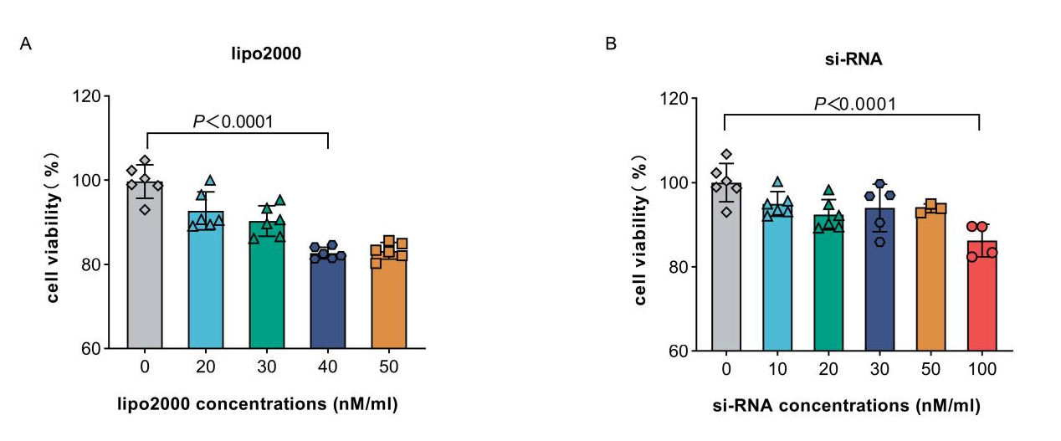
Supplementary Fig. 1 Safe concentration of siRNA and transfection reagent.
(A) Determination of the safe concentration for transfection reagent.
(B) Selection of the optimal concentration for siRNA.
Experiments were performed as three biologically independent experiments, and the mean ± S.D. (n = 6) is shown. P values were determined by non-parametric one-way ANOVA.

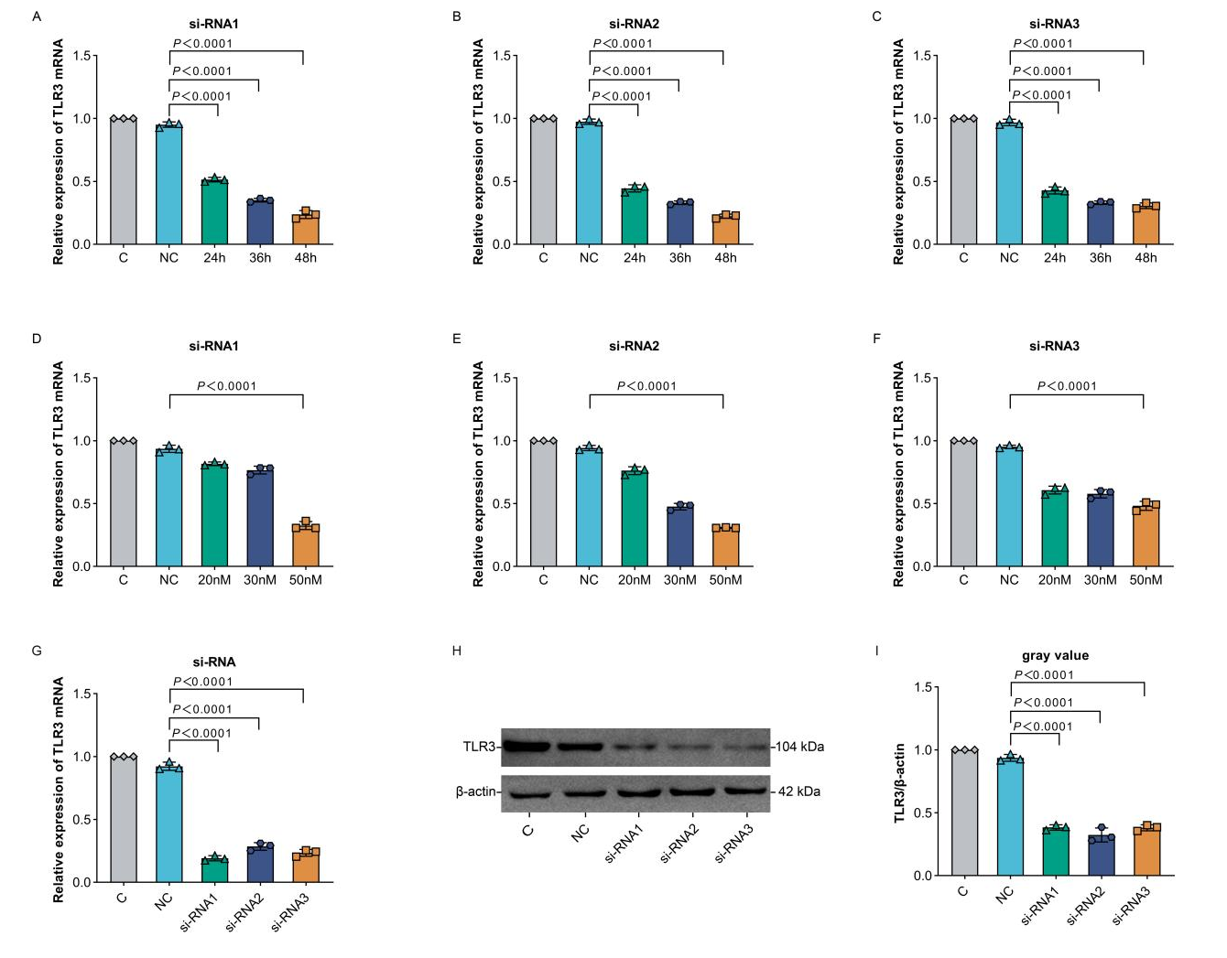
Supplementary Fig. 2 Evaluation of siRNA's temporal, concentration, and sequence efficacy.
(A-C) Effects of different siRNAs on the relative expression of TLR3 mRNA under different action time.
(D-F) Effect of different siRNAs on the relative expression of TLR3 mRNA.
(G-I) Effect of different siRNAs on the relative expression of TLR3 protein.
Experiments were performed as three biologically independent experiments, and the mean ± S.D. (n = 3) is shown. P values were determined by non-parametric one-way ANOVA.

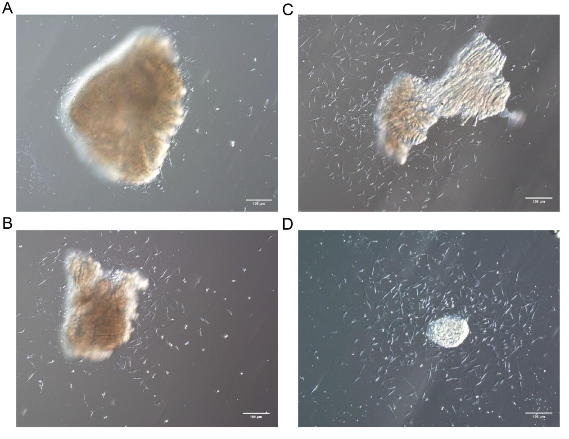
Supplementary Fig. 3 Monitoring of morphological changes and migration in primary isolated PMVECs over time

(A) Migration initiation from the tissue block periphery observed at around 6 hours post-culture initiation.
(B-D) Escalation of migration from the tissue block periphery over time, captured under phase-contrast microscopy at various time points. Scale bar = 100 μm

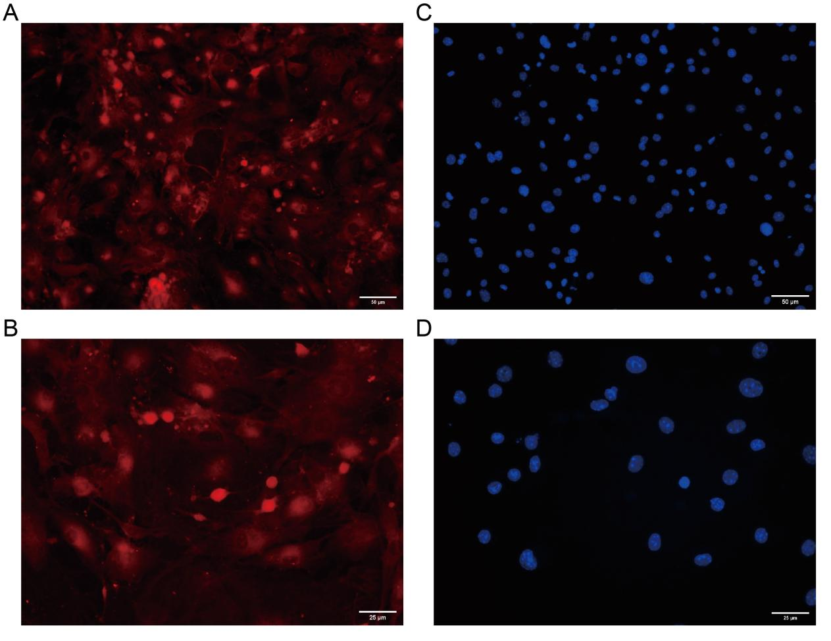
Supplementary Fig. 4 CD31 Expression in PMVECs Identified through Immunofluorescence Staining
(A-B) Immunofluorescence identification of CD31 antigen in PMVECs. Images at 200x (A) and 400x (B) magnification depict CD31 expression with red staining.Scale bar =50 μm and 25 μm.
(C-D) Immunofluorescence identification of CD31 antigen in PMVECs. Images at 200x (C) and 400x (D) magnification show nuclei with blue staining by DAPI. Scale bar =50 μm and 25 μm.
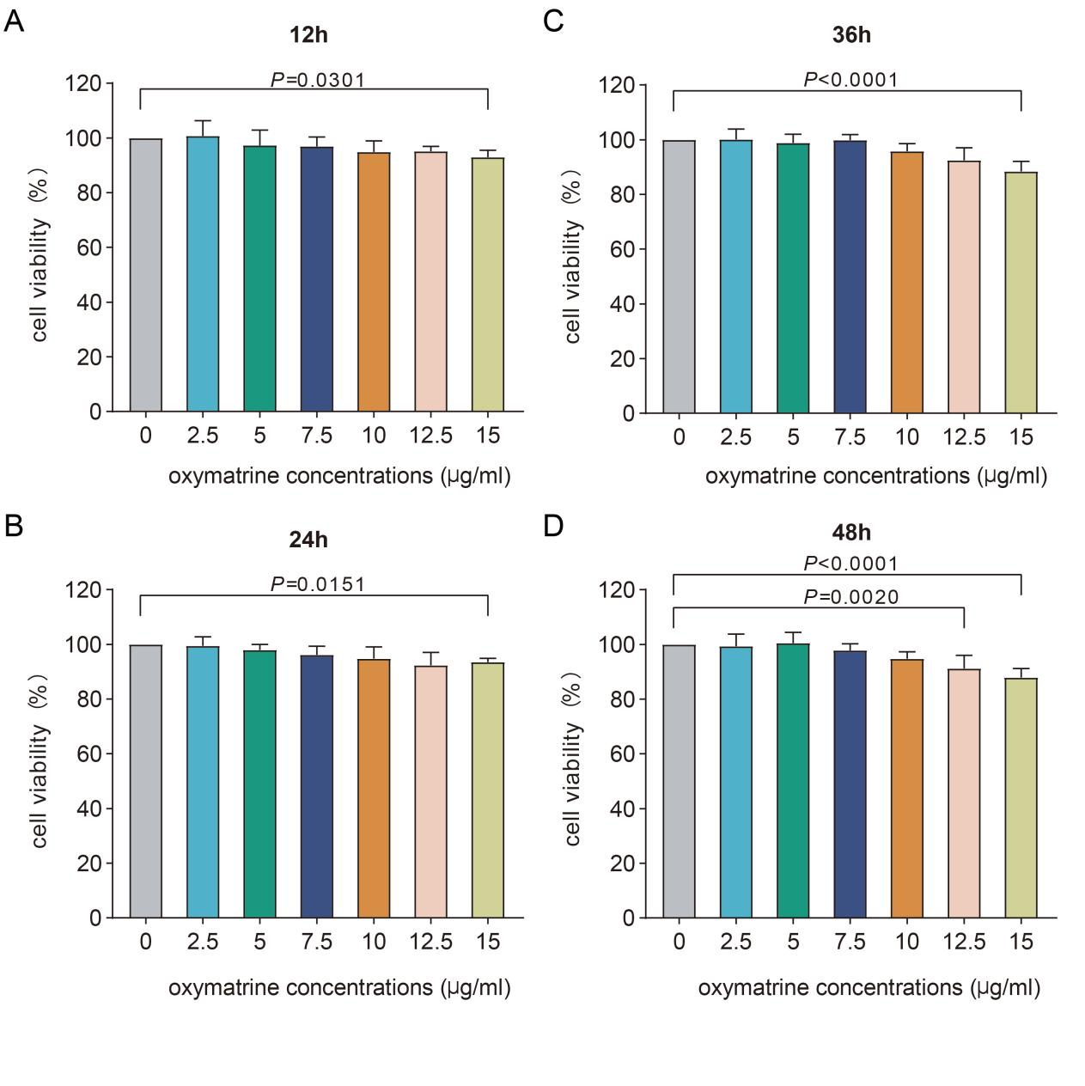
Supplementary Fig. 5 Cell Viability in PMVECs Following Exposure to a Narrow Concentration Range of OMT Over Various Time Intervals.
(A-D) This bar graph illustrates the impact of varying concentrations of Oxymatrine (OMT) on the viability of Pulmonary Microvascular Endothelial Cells (PMVECs) across four distinct time intervals: 12h (A), 24h (B), 36h (C), and 48h (D). The cell viability post-OMT exposure was quantitatively evaluated using the CCK-8 assay.
Experiments were performed in triplicate, and the mean ± S.D. (n = 3) is shown. P values were determined by non-parametric one-way ANOVA.

