Supporting information
Title
Distilling Nanoscale Heterogeneity of Amorphous Silicon using Tip-enhanced Raman Spectroscopy (TERS) via Multiresolution Manifold Learning
Guang Yang¹*, Xin Li¹*, Yongqiang Cheng¹, Mingchao Wang², Dong Ma¹, Alexei P. Sokolov ^{1,3}, Sergei V. Kalinin¹ , Gabriel Veith¹ and Jagjit Nanda¹*

1 Oak Ridge National Laboratory, Oak Ridge, TN 37831 USA
2 Department of Materials Science and Engineering, Monash University, Clayton, VIC 3800, Australia.
3 Department of Applied Physics and Materials, Tulane University, LA USA
4 Department of Chemistry, University of Tennessee, Knoxville, TN 37996 USA
*Corresponding author emails:
yangg@ornl.gov; lix3@ornl.gov; nandaj@ornl.gov

This manuscript has been authored by UT-Battelle, LLC under Contract No. DE-AC05-00OR22725 with the U.S. Department of Energy. The United States Government retains and the publisher, by accepting the article for publication, acknowledges that the United States Government retains a non-exclusive, paid-up, irrevocable, world-wide license to publish or reproduce the published form of this manuscript, or allow others to do so, for United States Government purposes. The Department of Energy will provide public access to these results of federally sponsored research in accordance with the DOE Public Access Plan (http://energy.gov/downloads/doe-public-access-plan).

Finite difference time domain (FDTD) simulation Figure S1. (a) Scheme of the FDTD model setup. (b) Simulated enhancement factor (EF) distribution around the tip apex. The line plot below presents the EF distribution in log scale along x-axis, with the origin at the Si surface. The dash line marks the surface of Si sample.
Three-dimensional (3D) finite difference time domain (FDTD) simulation (Lumerical Solutions, Inc.) was used to better study the penetration depth of the locally enhanced EM field on the Si surface. Briefly, a silver tip of a 42 nm diameter at the apex was set 2 nm from Si surface. The tip axis had an angle of 10° with the vector of the sample plane. A plane wave of electric field, E, polarized along the blue double-arrow in Figure S1 propagates along the vector. The laser propagation direction is in 55º with the perpendicular direction of the Si substrate. The wavelength of the plane wave was set at 532 nm. The spatial mesh size was set at 0.1 nm. The perfectly matched layer (PML) boundary condition (BC) was used for all edges of the simulation box (resort to the supporting information of the reference ¹ for mathematical details).

Combined TERS mapping of various TERS modes of a-Si
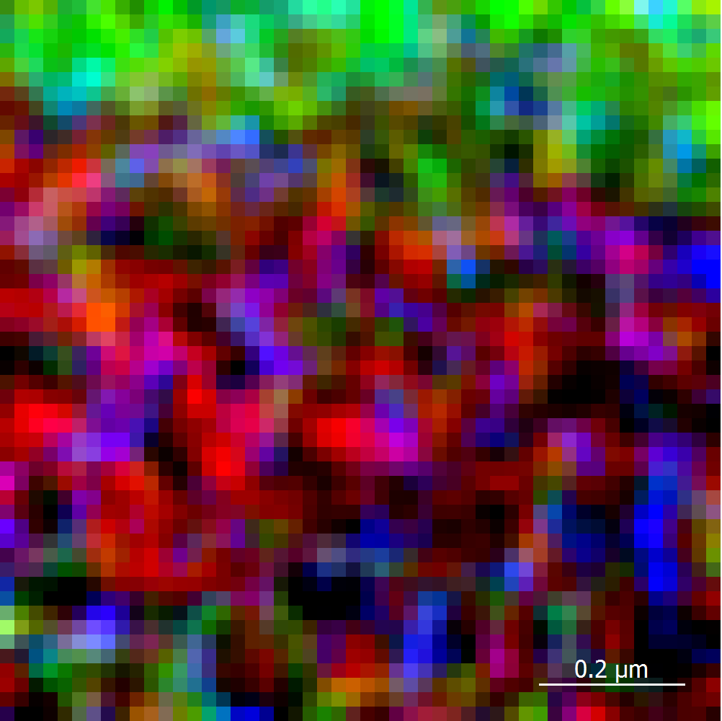
Figure S2. The composite TERS mapping combined ones shown in Figure 2(b-d).

Raman spectral comparison among different samples and values with respect to laser power
Figure S3. (a) Comparison between the normalized TERS spectra collected from the a-Si sample surface, and from the tip when it is far from (2 mm) the a-Si surface. The a-Si TERS spectrum was an average one over 2500 TERS spectra. The tip TERS spectra were averaged over 10 pixels from the TERS mapping of the tip shown in the inset. (b) Comparison among different micro-Raman spectra obtained using different values of laser power and collection time. The average TERS spectrum from the a-Si was used as a reference.
The TERS spectra collected from the a-Si surface composed vibrational contributions from both of the amorphous silicon (a-Si) and crystal silicon (c-Si). The most distinguished band for the c-Si locates at 520 cm⁻¹, representing the first order TO mode. Its counterpart of a-Si locates at 473 cm⁻¹. A close inspection on the a-Si sample using a higher laser power at > 100 µW indicates the a-Si sample used in this study is in completely amorphous phase as no c-Si TO mode presents (Figure S3). It worth emphasizing again that using the same experimental condition for TERS (i.e. laser power of 25 µW and collection time of 1s), the spectrum collected from a-Si with micro-Raman is almost featureless as shown in Figure S3(b). Further increase in the laser power and collection time leads to meaningful Raman spectrum of a-Si. With 100 µW laser power and 1 min collection time, no Si-H stretching mode at 2109 cm⁻¹ was observed. The Si-H bending mode as reflected by the INS spectrum in Figure 6 may also show in the Raman or TERS spectrum at 629 cm⁻¹. But it possibly overlaps with the second order LA mode. The average TERS spectrum over 2500 spectra collected from the scanning area of a-Si does not reflect the Si-H stretching mode at 2109 cm⁻¹. This may be due to the fact that the total abundance of the Si-H group on a-Si surface is not high enough, and the Raman cross section of the Si-H stretching mode is low in comparison with other vibrational modes. Further increase the laser power to 300 µW with 1 min collection time, the Si-H stretching mode at 2109 cm⁻¹ shows up. The exploration of the Si-H mode on a-Si surface using TERS necessitates an increased laser power and collection time with respect to the current conditions in the TERS setup.

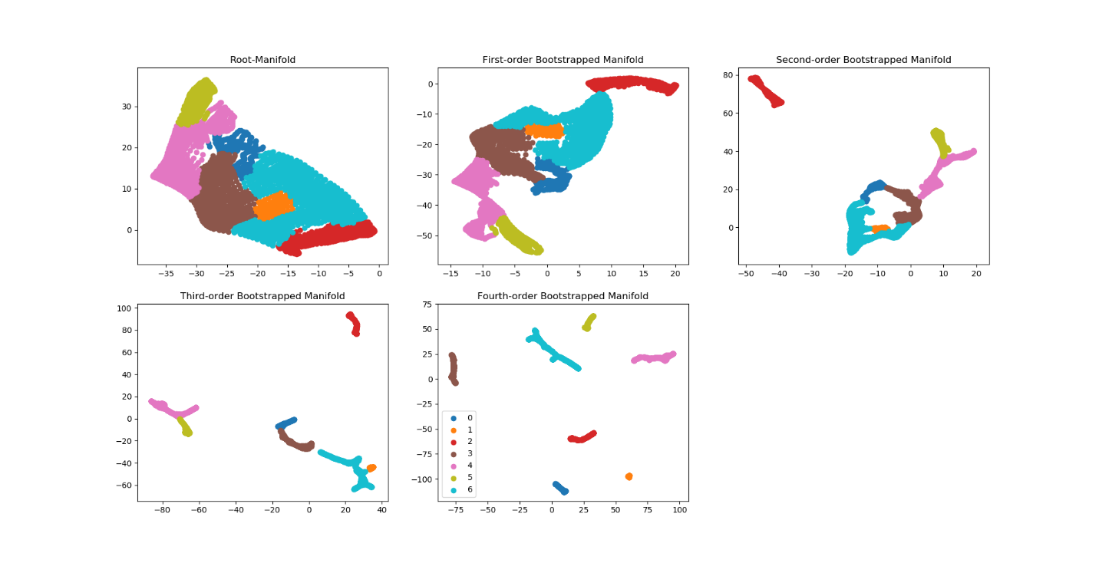
Figure S4. Manifold layouts overlaid with same set of cluster labels in Figure 4(a), (a) root manifold and (b,c,d,e) 1st, 2nd, 3rd and 4th-order manifold layouts during iterations of graph-bootstrapping procedure.
Possible reaction paths of the water with the a-Si
It has been reported previously that silicon nanometer objectives reacted with the oxidation agent, water to generate hydrogen following the reaction path ^{2, 3}
Thus, it is reasonable that the surface unsaturated Si bonds for as sputtered a-Si are capable of splitting water. We herein propose intermittent reaction between water and a-Si as
This reaction path explains the vibrational modes based on Si-OH and Si-H moieties observed in INS spectrum in Figure 6. The existence of the Si-OH from water reaction with a-Si agrees with what was reported by Liao, et al. ⁴ It should be noted that we cannot rule out the existence of the Si-O-Si in the current sample. Therefore, the surface chemistry of the a-Si may include Si-O-Si, Si-OH, Si-H and unreacted Si-Si groups.

Surface free energy evaluation for a-Si thin film sample
As noted by Saito et al. in an early study, the surface free energy difference between the a-Si and c-Si mainly stems from the bond angle distortions. ⁵ The strain energy per mole of the a-Si can be related to the bond angle distortions by
,
where k_{θ} is the force constant for the Si-Si bond bending; r is the estimated Si-Si distance (~2.35 A); the number of bond pairs per each Si atom is 6 and the summation is over all Si embedded in the random a-Si network, NA is the Avogadro's constant. The factor of 0.0003046 is used to convert the energy unit to ‘Joule’. k_{θ} is related to the Keating potential force constant, β using k_{θ} = 2/3β. The value of β can be estimated over a range of 6.7-9.7 N/m, ^{5, 6, 7, 8} leading to k_{θ} over a range of 4.5-6.5 N/m. Taking the minimum value of k_{θ} here, the estimated surface free energy is calculated to be 23 KJ/mole, nearly twice of which corresponding to the minimum distortion angel (6.6º) at 12 KJ/mole. This indicates that the surface amorphous Si on the thin film surface used is highly disordered and far from the equilibrium structure in the current study
The stability ratio calculation for SiO_{z} based on effective media theory
For the case of the SiO_{z} (0 < z < 2) as the next-nearest neighbors, a geometric average SRX is given by ^{9, 10}
For z= 2, the SRX electronegativity, X_{SiOz} can be calculated as 4.14.

Supporting Information Reference
1. Yang G, Hallinan DT. Gold Nanoparticle Monolayers from Sequential Interfacial Ligand Exchange and Migration in a Three-Phase System. Scientific reports 6, 35339 (2016).

2. Erogbogbo F, et al. On-demand hydrogen generation using nanosilicon: splitting water without light, heat, or electricity. Nano letters 13, 451-456 (2013).

3. Goller B, Kovalev D, Sreseli O. Nanosilicon in water as a source of hydrogen: size and pH matter. Nanotechnology 22, 305402 (2011).

4. Liao WS, Lee SC. Water‐induced room‐temperature oxidation of Si–H and–Si–Si–bonds in silicon oxide. Journal of applied physics 80, 1171-1176 (1996).

5. Saito T, Karasawa T, Ohdomari I. Distortion energy distributions in the random network model of amorphous silicon. Journal of Non-Crystalline Solids 50, 271-276 (1982).

6. Alben R, Smith Jr J, Brodsky M, Weaire D. Theory of infrared and Raman spectra of amorphous Si and Ge. Physical Review Letters 30, 1141 (1973).

7. Alben R, Weaire D, Smith Jr J, Brodsky M. Vibrational properties of amorphous Si and Ge. Physical Review B 11, 2271 (1975).

8. Biswas R, Bouchard A, Kamitakahara W, Grest G, Soukoulis C. Vibrational localization in amorphous silicon. Physical review letters 60, 2280 (1988).

9. Carver JC, Gray RC, Hercules DM. Remote inductive effects evaluated by x-ray photoelectron spectroscopy (ESCA). Journal of the American Chemical Society 96, 6851-6856 (1974).

10. Tsu D, Lucovsky G, Davidson B. Effects of the nearest neighbors and the alloy matrix on SiH stretching vibrations in the amorphous SiO r: H (0< r< 2) alloy system. Physical Review B 40, 1795 (1989).

