Supplementary Data

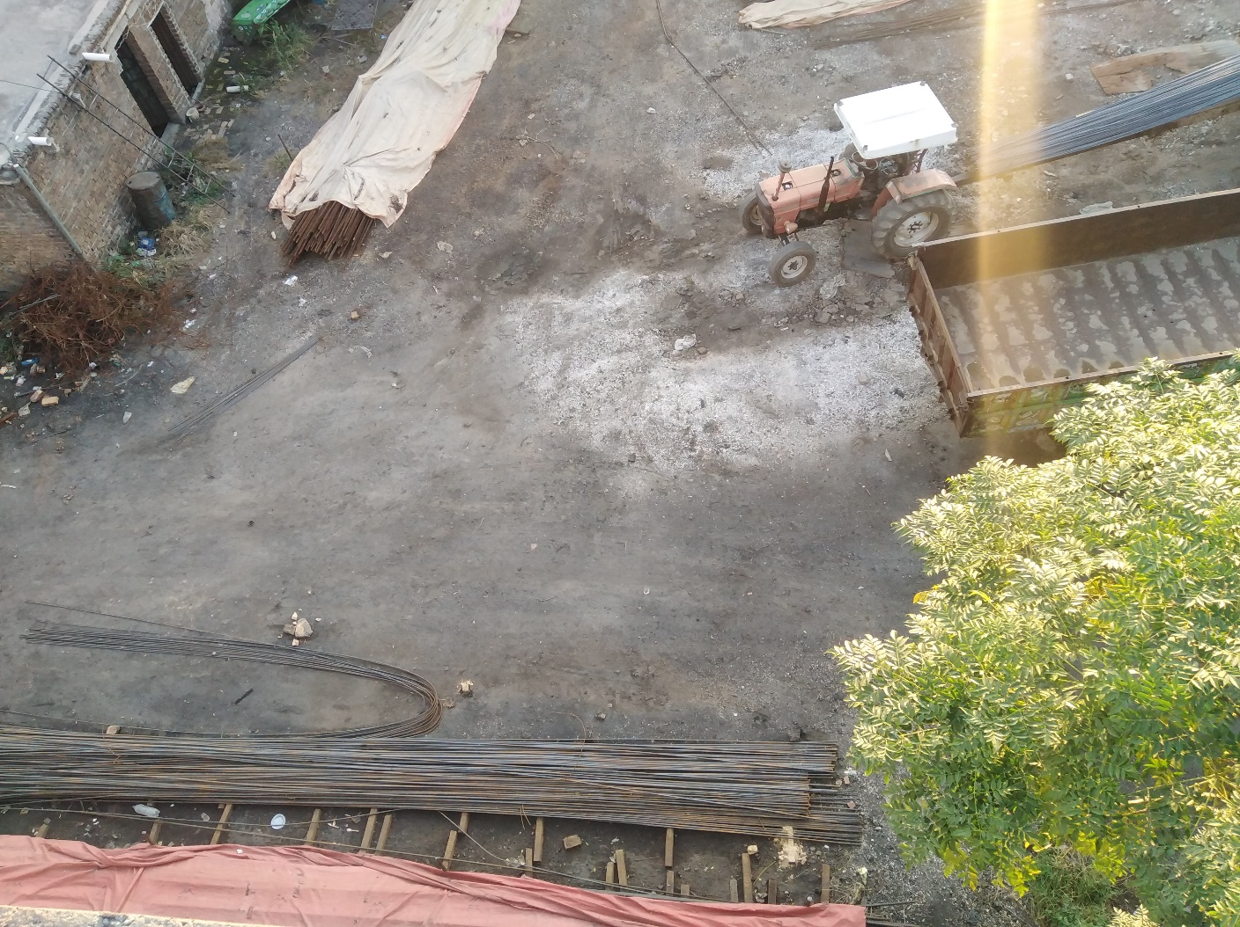
Fig S 1 The Site with the extreme pollution I9-2(c).
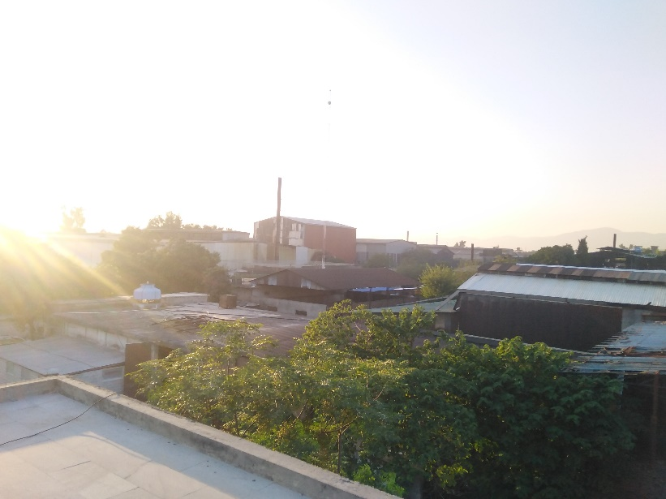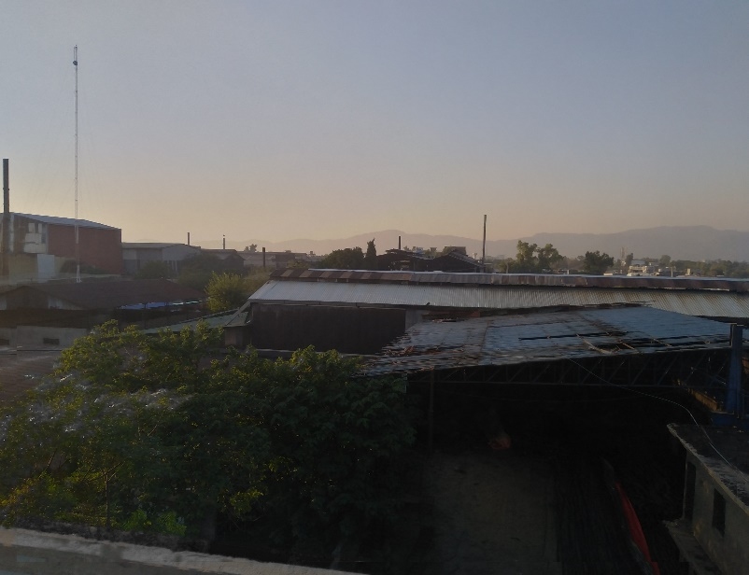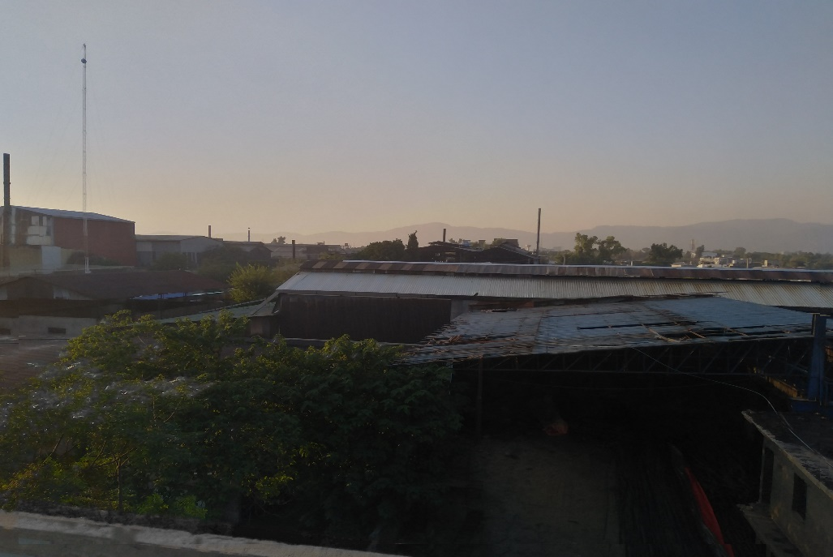
Fig S 2 Steel re-rolling mills in sector I-9.
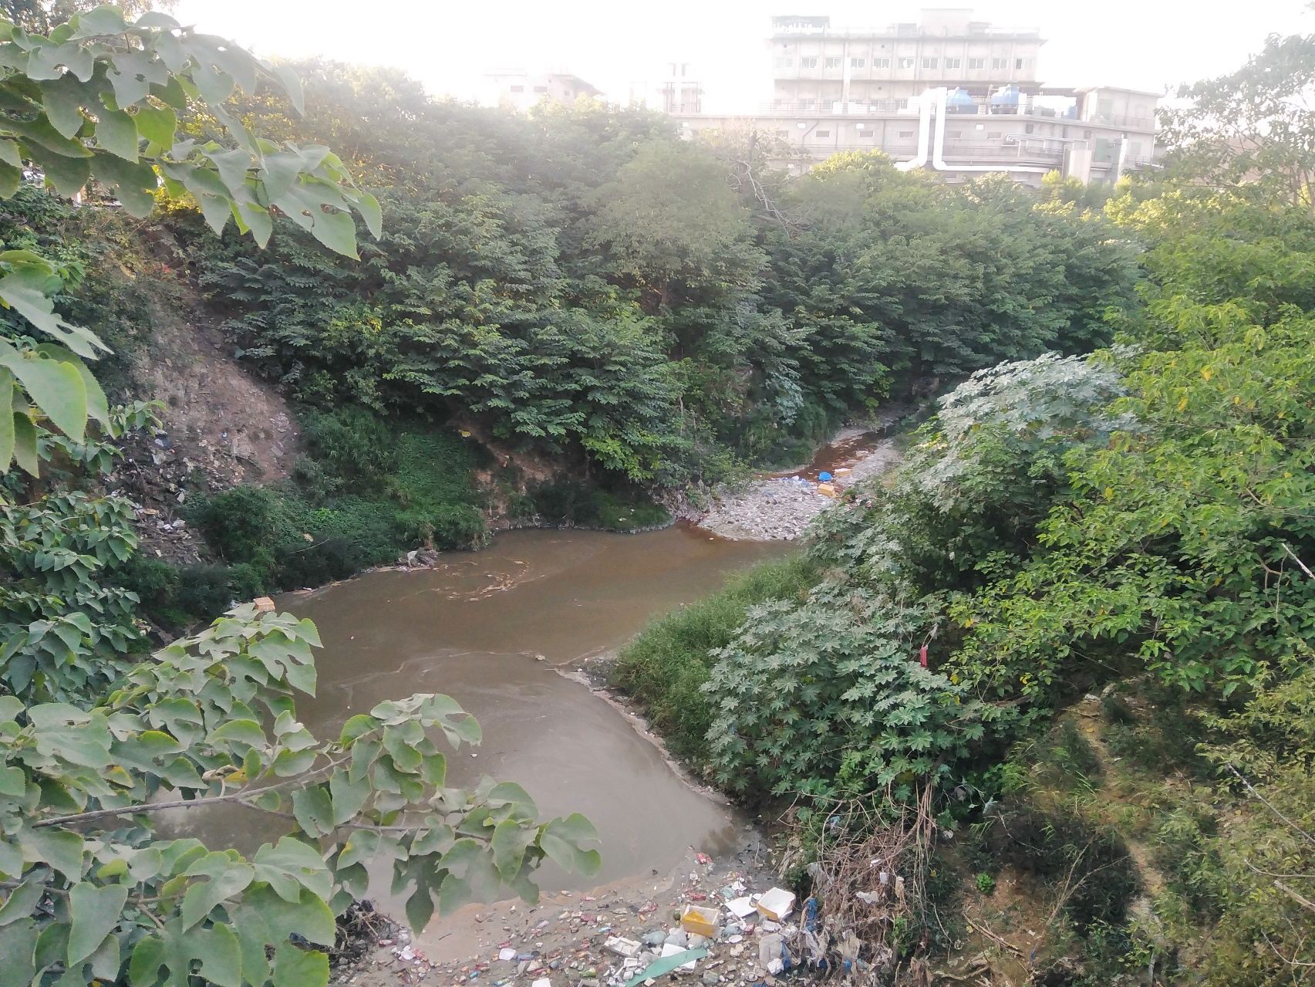
Fig S 3 Marble processing plant waste dumped into the stream sector I-9.
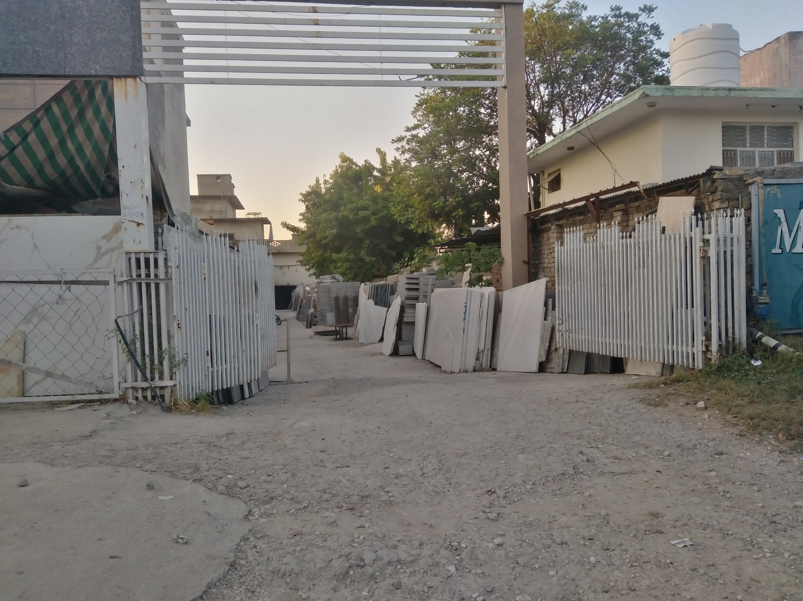
Fig S 4 Marble processing plant sector I-9.
Table S1 Experimental conditions of ICP-OES
Parameter | Value
RF Power | 1150 W
Pump Rate | 50 rpm
Auxiliary Gas Flow | 0.5 L/min
Nebulizer Gas Flow | 0.5 L/min
Coolant Gas Flow | 12 L/min
Purge Gas Flow | Normal
Viewing Plasma Height | 14mm

Table S2 Enrichment categories based on EF values.
Sr. No | EF Value | Enrichment Category
1 | EF < 2 | Minimum Enrichment
2 | EF = 2-5 | Moderate Enrichment
3 | EF = 5-20 | Significant Enrichment
4 | EF = 20-40 | Very High Enrichment
5 | EF > 40 | Extremely High Enrichment

Table S3 Contamination classification based on I_{geo} values.
Sr. No | I_{geo} Level | Contamination Class
1 | I_{geo} ≤ 0 | Not polluted
2 | 0 < I_{geo} < 1 | Not polluted - moderately polluted
3 | 1 < I_{geo} < 2 | Moderately polluted
4 | 2 < I_{geo} < 3 | Moderate - strong pollution
5 | 3 < I_{geo} < 4 | Strong Pollution
6 | 4 < I_{geo} < 5 | Strong - very strong pollution
7 | I_{geo} > 5 | Very strong pollution level
Table S4 Pollution level based on PI and IPI values
Sr. No | PI value | IPI value | Pollution Level
1 | PI ≤ 1 | IPI ≤ 1 | Low
2 | 1 < PI ≤ 3 | 1 < IPI ≤ 2 | Moderate
3 | PI > 3 | IPI > 2 | High

Table S5 Toxic response factor of Metals.
Elements | Toxic Response Factor
Zn | 1
Pb | 5
Ba | 2
Cu | 5
Co | 5
Ni | 5
Cr | 2
Mn | 1
As | 10
Table S6 Risk classification based on ERF values.

Sr. No | ERF value | Risk classification
1 | ERF < 40 | Low
2 | 40 < ERF < 80 | Moderate
3 | 80 < ERF > 160 | Considerable
4 | 160 < ERF > 320 | High
5 | ERF > 320 | Very High

Table S7 ADD parameters values.
Parameters | Adult | Child | Parameters | Adult | Child
R_{ING} (mg/day) | 100 | 200 | EF (days/year) | 180 | 180
R_{INH} (mg/cm²) | 20 | 20 | SA (cm²) | 2145 | 1150
ED (Years) | 24 | 6 | W (kg) | 70 | 15
PEF (m3/kg) | 1.3$×$10⁹ | 1.3$×$10⁹ | AT (days) | 8760 | 2190
ABF (As) | 0.03 | 0.03 | ABF (OM) | 0.001 | 0.001

Table S8 RFD and CSF values for the three exposure pathways.
Metals | RFD ING | RFD INH | RFD DER | CSF ING | CSF INH | CSF DER
Cu | 4.00$×$10⁻² | 4.02$×$10⁻² | 1.20$×$10⁻² | - | - | -
Pb | 3.50$×$10⁻³ | 3.25$×$10⁻³ | 5.25$×$10⁻⁴ | 0.0085 | - | 0.042
As | 3.00$×$10⁻⁴ | 3.00$×$10⁻⁴ | 1.23$×$10⁻⁴ | 1.5 | 1.5 | 1.5
Ni | 2.00$×$10⁻² | 2.06$×$10⁻² | 5.40$×$10⁻⁴ | - | 8.4 | -
Cr | 3.00$×$10⁻³ | 2.86$×$10⁻⁵ | 6.00$×$10⁻⁵ | 0.5 | - | 41
Mn | 1.40$×$10⁻¹ | 1.40$×$10⁻¹ | 1.80$×$10⁻³ | - | - | -
Ba | 7.00$×$10⁻² | 1.43$×$10⁻⁴ | 4.90$×$10⁻³ | - | - | -
Zn | 3.00$×$10⁻¹ | 3.00$×$10⁻¹ | 6.00$×$10⁻² | - | - | -
Li | - | - | - | - | - | -
Co | 3.00$×$10⁻⁴ | 5.71$×$10⁻⁶ | 1.60$×$10⁻² | - | 9.8 | -

Table S9: Water quality indices with permissible limits used in the study
S. No | Water quality assessment parameters | Values |  |  |  |  | References
1 | Sodium adsorption ratio (SAR) meq/L | < 10 | 10--18 | 18-26 | > 26 | - | (Alfaifi et al., 2021)
1 | Category | Excellent | Good | Doubtful | Unsuitable | -
2 | Salinity hazard (EC) µs/cm | < 250 | 250-750 | 750-2000 | 2000-3000 | > 3000 | (Raghunath, 1987)
2 | Category | Excellent | Good | Permissible | Doubtful | Unsuitable
3 | Sodium percentage (Na%) meq/L | < 20 | 20-40 | 40-60 | 40-80 | > 80 | (Xiao et al., 2019)
3 | Category | Excellent | Good | Permissible | Doubtful | Unsuitable
4 | Magnesium adsorption (MAR) meq/L | < 50 | > 50 | - | - | - | (Jehan et al., 2020)
4 | Category | Suitable | Unsuitable | - | - | -
5 | Kelly ratio (KR) meq/L | < 1 | > 1 | - | - | - | (Kelley, 1963)
5 | Category | Fit | Unfit | - | - | -

Table S10 Pearson’s correlation matrix for elemental data of soil.
 | Al | As | Ba | Ca | Cd | Co | Cr | Cu | Fe | K | Li | Mg | Mn | Mo | Na | Ni | P | Pb | S | Sb | Sn | Sr | Ti | V | Zn | Zr
Al | 1.00
As | -0.79 | 1.00
Ba | 0.83 | -0.72 | 1.00
Ca | 0.32 | -0.65 | 0.14 | 1.00
Cd | 0.39 | -0.42 | 0.38 | 0.26 | 1.00
Co | -0.72 | 0.96 | -0.69 | -0.59 | -0.26 | 1.00
Cr | -0.79 | 0.94 | -0.74 | -0.54 | -0.26 | 0.99 | 1.00
Cu | -0.82 | 0.98 | -0.76 | -0.57 | -0.37 | 0.98 | 0.99 | 1.00
Fe | -0.71 | 0.88 | -0.70 | -0.48 | -0.16 | 0.96 | 0.98 | 0.94 | 1.00
K | 0.96 | -0.79 | 0.82 | 0.28 | 0.43 | -0.76 | -0.83 | -0.85 | -0.77 | 1.00
Li | 0.32 | 0.18 | 0.10 | -0.23 | 0.37 | 0.24 | 0.11 | 0.09 | 0.14 | 0.38 | 1.00
Mg | 0.87 | -0.84 | 0.66 | 0.69 | 0.42 | -0.76 | -0.80 | -0.84 | -0.74 | 0.83 | 0.23 | 1.00
Mn | -0.65 | 0.87 | -0.65 | -0.47 | -0.13 | 0.96 | 0.97 | 0.93 | 0.98 | -0.74 | 0.18 | -0.69
Mo | -0.82 | 0.99 | -0.76 | -0.58 | -0.39 | 0.98 | 0.98 | 1.00 | 0.93 | -0.85 | 0.10 | -0.84 | 1.00
Na | 0.85 | -0.75 | 0.83 | 0.39 | 0.21 | -0.68 | -0.70 | -0.73 | -0.63 | 0.73 | -0.08 | 0.74 | -0.74 | 1.00
Ni | -0.80 | 0.98 | -0.75 | -0.58 | -0.34 | 0.99 | 0.99 | 1.00 | 0.95 | -0.83 | 0.14 | -0.82 | 1.00 | -0.74 | 1.00
P | -0.16 | -0.26 | 0.20 | 0.22 | 0.34 | -0.29 | -0.25 | -0.25 | -0.30 | -0.05 | -0.27 | 0.09 | -0.25 | -0.15 | -0.25 | 1.00
Pb | -0.83 | 0.99 | -0.76 | -0.58 | -0.43 | 0.96 | 0.96 | 0.99 | 0.89 | -0.86 | 0.08 | -0.84 | 1.00 | -0.75 | 0.99 | -0.21 | 1.00
S | -0.89 | 0.95 | -0.74 | -0.55 | -0.31 | 0.92 | 0.93 | 0.96 | 0.86 | -0.89 | 0.03 | -0.85 | 0.96 | -0.82 | 0.95 | 0.02 | 0.97 | 1.00
Sb | -0.82 | 0.99 | -0.75 | -0.60 | -0.39 | 0.98 | 0.97 | 1.00 | 0.92 | -0.84 | 0.11 | -0.84 | 1.00 | -0.74 | 0.99 | -0.24 | 1.00 | 0.96 | 1.00
Sn | -0.83 | 0.99 | -0.76 | -0.58 | -0.40 | 0.98 | 0.98 | 1.00 | 0.92 | -0.85 | 0.09 | -0.84 | 1.00 | -0.74 | 1.00 | -0.24 | 1.00 | 0.96 | 1.00 | 1.00
Sr | 0.16 | -0.36 | -0.01 | 0.83 | 0.06 | -0.34 | -0.30 | -0.30 | -0.30 | 0.04 | -0.23 | 0.46 | -0.31 | 0.33 | -0.33 | 0.07 | -0.28 | -0.27 | -0.30 | -0.30 | 1.00
Ti | 0.97 | -0.72 | 0.83 | 0.18 | 0.37 | -0.66 | -0.73 | -0.76 | -0.65 | 0.93 | 0.32 | 0.74 | -0.77 | 0.82 | -0.75 | -0.24 | -0.78 | -0.85 | -0.76 | -0.77 | 0.03 | 1.00
V | -0.56 | 0.92 | -0.59 | -0.55 | -0.33 | 0.93 | 0.88 | 0.90 | 0.82 | -0.63 | 0.37 | -0.60 | 0.91 | -0.55 | 0.91 | -0.34 | 0.91 | 0.85 | 0.92 | 0.91 | -0.20 | -0.55 | 1.00
Zn | -0.85 | 0.96 | -0.74 | -0.53 | -0.29 | 0.97 | 0.99 | 0.99 | 0.94 | -0.87 | 0.05 | -0.83 | 0.98 | -0.74 | 0.99 | -0.13 | 0.98 | 0.98 | 0.98 | 0.98 | -0.27 | -0.80 | 0.88 | 1.00
Zr | 0.70 | -0.67 | 0.77 | 0.13 | 0.50 | -0.63 | -0.66 | -0.69 | -0.61 | 0.71 | 0.20 | 0.54 | -0.55 | -0.70 | 0.53 | -0.69 | 0.20 | -0.70 | -0.64 | -0.70 | -0.70 | 0.00 | 0.78 | -0.60 | -0.69 | 1.00

Al, Ba, K, Mg, Na, Ti, Zr
As, Co, Cr, Cu, Fe, Mn, Mo, Ni, Pb, S, Sb, Sn, V, Zn
Ba, K, Mg, Na, Ti, Zr and
Ca, Mg, Sr

Table S11 Elemental concentration in mg/kg of soil samples collected from Industrial area of Islamabad with RSD ≤ 2% on dry weight basis.
Elements | I9-1 | I9-2(a) | I9-2(b) | I9-2(c) | I9-3 | I9-4 | I8-1 | I8-2 | I8-3 | I10-1 | I10-2 | I10-3
Al | 55050 | 49290 | 61970 | 19600 | 51660 | 41580 | 54990 | 56120 | 53110 | 61510 | 69220 | 62700
As | 5.17 | 3.13 | 3.89 | 73.91 | - | - | - | 2.29 | 2.63 | 5.36 | 2.76 | 7.5
Ba | 192 | 177 | 227 | 106 | 205 | 229 | 194 | 187 | 191 | 222 | 256 | 261.0
Ca | 64260 | 61825 | 52753 | 14014 | 81725 | 52785 | 63591 | 60242 | 37851 | 62914 | 41413 | 21078.0
Cd | 0.59 | 0.55 | 0.9 | - | - | 0.62 | 0.43 | 0.62 | - | 0.45 | 0.29 | 0.5
Co | 9.81 | 11.7 | 14.02 | 28.83 | 8.27 | 8.71 | 8.77 | 9.62 | 8.27 | 10.35 | 10.84 | 9.5
Cr | 69.3 | 142 | 165 | 446 | 66.6 | 74.7 | 63 | 65.44 | 55.88 | 63.47 | 72.11 | 54.1
Cu | 46.83 | 215 | 260 | 1720 | 68 | 50 | 27.7 | 27.61 | 21.34 | 32.13 | 25.98 | 24.2
Fe | 32300 | 68820 | 75034 | 139258 | 31912 | 31267 | 29579 | 31446 | 27517 | 33516 | 35029 | 28512.0
K | 29480 | 24348 | 26781 | 7311 | 22301 | 21161 | 24098 | 28123 | 25541 | 29971 | 32291 | 32395.0
Li | 22.22 | 18.15 | 21.29 | 20.5 | 15.17 | 15.8 | 16.82 | 22.72 | 16.83 | 22.99 | 22.11 | 20.8
Mg | 11410 | 9483 | 10987 | 3197 | 10696 | 9005 | 10708 | 10886 | 9020 | 12885 | 12476 | 8596.0
Mn | 634 | 896 | 1337 | 2018 | 651 | 547 | 601 | 596 | 541 | 656 | 645 | 567.0
Mo | 1.13 | 5.61 | 5.76 | 53 | 1.35 | 0.83 | 0.57 | 0.73 | 0.56 | 0.67 | 1.13 | 0.4
Na | 8770 | 8427 | 12225 | 2742 | 12133 | 8085 | 11274 | 7025 | 9120 | 10178 | 12578 | 11585.0
Ni | 27.4 | 47.6 | 47.8 | 207.5 | 20.2 | 23.7 | 20.64 | 25.46 | 19.48 | 26.26 | 27.06 | 22.4
P | 1160 | 610 | 561 | 415 | 653 | 3255 | 839 | 1245 | 575 | 854 | 826 | 401.0
Pb | 35.81 | 45.96 | 75.33 | 1090.83 | 52 | 44 | 39.22 | 23.48 | 23.99 | 29.58 | 21.23 | 17.4
S | 254 | 178 | 361 | 2674 | 152 | 758 | 153 | 327 | 138 | 149 | 35.73 | 57.1
Sb | 5.48 | 5.86 | 7.76 | 40.12 | 4.34 | 4.46 | 4.33 | 3.81 | 3.99 | 3.9 | 4.47 | 4.5
Sn | 3.26 | 14.3 | 16.9 | 173.09 | 5.0 | 3.29 | 2.23 | 1.1 | 1.29 | 1.79 | 1.84 | 1.6
Sr | 335 | 212 | 316 | 201 | 435 | 253 | 348 | 308 | 222 | 282 | 225 | 168.0
Ti | 27705 | 2692 | 3407 | 1345 | 2747 | 2244 | 2752 | 2999 | 2986 | 3163 | 3441 | 3624.0
V | 87 | 69.4 | 94.6 | 159 | 77.9 | 67.22 | 85.08 | 84.82 | 72.19 | 87.24 | 99.75 | 78.5
Zn | 284 | 406 | 540 | 2143 | 229 | 431 | 160 | 146 | 103 | 135 | 174 | 91.0
Zr | 64.64 | 68.8 | 101 | 37 | 76.8 | 91.14 | 66.72 | 106 | 84 | 89.81 | 84.11 | 105.0
- Below detection limit

Table S12 Water quality parameters for irrigation.
Sites | SAR (meq/L) | Remarks | NA (%)(meq/L) | Remarks | MAR (meq/L) | Remarks | KR (meq/L) | Remarks | Salinity(µs/cm) | Remarks
IS-1 | 0.94 | E | 20.85 | G | 12.86 | S | 0.27 | E | 179 | E
IS-2 | 1.07 | E | 21.91 | G | 19.29 | S | 0.23 | E | 216 | E
IS-3 | 1.44 | E | 24.00 | G | 19.49 | S | 0.26 | E | 319 | G
IS-4 | 2.39 | E | 50.27 | P | 40.00 | F | 0.64 | F | 206 | E
IS-5 | 1.43 | E | 23.21 | G | 17.99 | S | 0.25 | E | 225 | E
IS-6 | 1.84 | E | 27.22 | G | 19.66 | S | 0.31 | E | 239 | E
IS-7 | 1.38 | E | 24.04 | G | 20.18 | S | 0.26 | E | 352 | G
IS-8 | 1.41 | E | 24.07 | G | 19.44 | S | 0.26 | E | 361 | G
IS-9 | 2.14 | E | 30.89 | G | 16.92 | S | 0.44 | E | 379 | G
IS-10 | 1.84 | E | 27.25 | G | 16.60 | S | 0.39 | E | 382 | G
IS-11 | 1.38 | E | 23.85 | G | 19.96 | S | 0.25 | E | 450 | G
IS-12 | 1.14 | E | 20.41 | G | 18.01 | S | 0.21 | E | 430 | G
IS-13 | 1.16 | E | 20.05 | G | 17.03 | S | 0.21 | E | 419 | G
IS-14 | 1.43 | E | 27.35 | G | 16.02 | S | 0.36 | E | 377 | G
IS-15 | 1.94 | E | 28.24 | G | 16.82 | S | 0.41 | E | 380 | G
Min | 0.94 | E | 20.05 | G | 12.86 | S | 0.21 | E | 216 | E
Max | 2.39 | E | 50.27 | P | 40 | F | 0.64 | F | 450 | G
Mean | 1.53 | E | 26.24 | G | 19.35 | S | 0.32 | E | 327 | G
*E = Excellent; G = Good; P = Permissible; F = Fair; S = Suitable

References
Alfaifi, H., El-Sorogy, A. S., Qaysi, S., Kahal, A., Almadani, S., Alshehri, F., & Zaidi, F. K. (2021). Evaluation of heavy metal contamination and groundwater quality along the Red Sea coast, southern Saudi Arabia. Marine Pollution Bulletin, 163, 111975.
Jehan, S., Ullah, I., Khan, S., Muhammad, S., Khattak, S. A., & Khan, T. (2020). Evaluation of the Swat River, Northern Pakistan, water quality using multivariate statistical techniques and water quality index (WQI) model. Environmental Science and Pollution Research, 27(31), 38545–38558. https://doi.org/10.1007/s11356-020-09688-y
Kelley, W. P. (1963). Use of saline irrigation water. Soil Science, 95(6), 385–391.
Raghunath, H. M. (1987). Geochemical survey and water quality. Groundwater Wiley Eastern Limited, New Delhi, 343–347.
Xiao, J., Wang, L., Deng, L., & Jin, Z. (2019). Characteristics, sources, water quality and health risk assessment of trace elements in river water and well water in the Chinese Loess Plateau. Science of the Total Environment, 650(October), 2004–2012. https://doi.org/10.1016/j.scitotenv.2018.09.322

