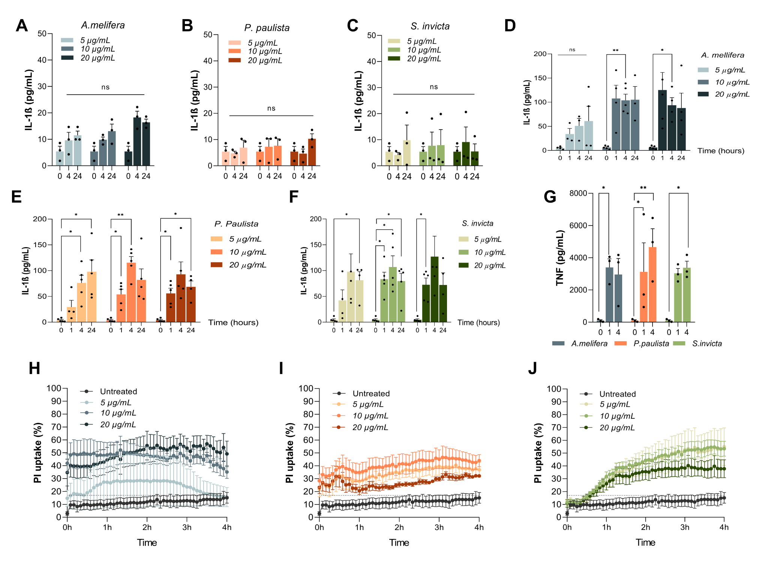
Supplementary File 2. Standardization of time of stimuli and concentration of Hymenoptera venoms.
8x10⁴ MDM from healthy donors were stimulated for 4 or 24 hours with 5, 10 or 20 µg/mL of extracts from Apis mellifera venom (n = 6)(A); Polybia paulista (n = 5)(B), and Solenopsis invicta (n = 6)(C), without priming of the cells and the IL-1ß was measured by ELISA and is reported. 8x10⁴ MDM were stimulated for 1, 4, or 24 hours with 5, 10 or 20 µg/mL of extracts from Apis mellifera venom (n = 6)(D); Polybia paulista (n = 5)(E), and Solenopsis invicta (n = 6)(F), with a priming step of 1 µg/mL of LPS for 3 hours prior to the stimulation with the venoms and the IL-1ß was measured by ELISA and is reported. The concentrations of TNF-α in cell culture supernatant were dosed through ELISA in the MDM stimulated with 10 µg/mL of each venom for 1 and 4 hours and is reported in G. About 2,5x10⁴ MDM were stimulated with 5, 10, or 20 µg/mL of extract of bee venom (n = 4)(H), wasp (n = 4)(I), or ant (n = 4)(J) for 4 hours. 2.5 µg/mL of PI per well was added before the beginning of the real-time fluorometer readings and the kinetics of incorporation is reported.
The Two-way ANOVA test, followed by multiple comparisons post-test, was applied to compare the production of cytokines in the three experimental conditions. Differences were considered statistically significant when p < 0.05. ns= non significant; * = p < 0.05; ** = p < 0.01.

