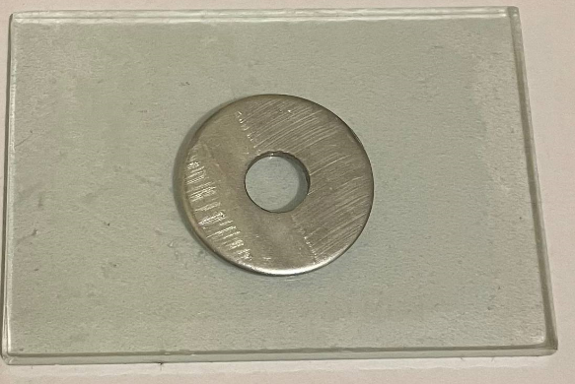
Figure a. Metal mold samples

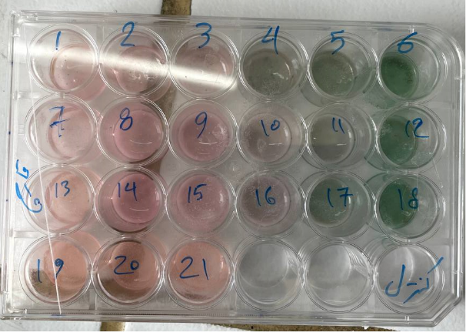
Figure b. Micro-plate containing tissue conditioner samples

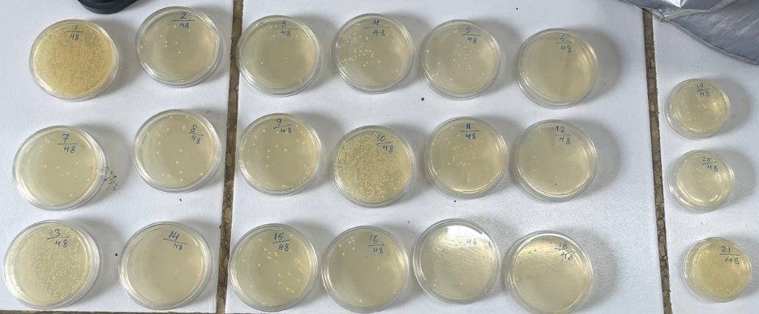
Figure c. Cultivated plates

Table 1. Intergroup comparisons of bacterial growth in different concentrations of copper oxide nanoparticle following 24 hours.
CuO nanoparticle concentration | Bacterial Growth in 24 hours (CFU/mL) ª
CuO nanoparticle concentration | Enterococcus faecalis | Pseudomonas aeruginosa
0% | 1.5×10⁸ ± 0 | 1.5×10⁸ ± 0
0.625% | 1.0×10⁸ ± 7.7×10⁷ | 5.0×10⁷ ± 7.7×10⁷
1.25% | 1.5×10⁴ ± 1.6×10⁴ | 3.6×10⁴ ± 3.4×10⁴
2.5% | 3.4×10³ ± 6.7×10³ | 7.5×10³ ± 9.4×10³
5% | 3.6×10³ ± 8.5×10³ | 2.1×10³ ± 1.5×10³
10% | 1.3×10² ± 2.2×10² | 2.7×10² ± 2.9×10²
20% | 0 | 0
P-value ^{b} | <0.001* | <0.001*
ª Presented as mean±SD. ^{b} Calculated using the one-way ANOVA. * Significant difference (P<0.05).

Table 2. Intergroup and intragroup comparisons of C. albicans growth in different concentrations of copper oxide nanoparticle following 24 and 48 hours.
CuO nanoparticle concentration | Candida albicans Growth (CFU/mL) ª |  | Intragroup comparison
CuO nanoparticle concentration | 24-hour growth | 48-hour growth | Mean difference | P-value ^{c}
0% | 1.0×10⁵ ± 0 | 1.6×10³ ± 1.6×10² | 9.8×10⁴ | 0.002*
0.625% | 1.0×10⁵ ± 0 | 1.3×10³ ± 5.1×10² | 9.9×10⁴ | 0.002*
1.25% | 1.0×10⁵ ± 0 | 6.6×10² ± 6.2×10² | 9.9×10⁴ | 0.002*
2.5% | 1.0×10⁵ ± 0 | 7.8×10² ± 4.2×10² | 9.9×10⁴ | 0.002*
5% | 1.0×10⁵ ± 0 | 7.6×10² ± 4.0×10² | 9.9×10⁴ | 0.002*
10% | 1.0×10⁵ ± 0 | 5.8×10² ± 3.1×10² | 9.9×10⁴ | 0.002*
20% | 1.0×10⁵ ± 0 | 3.0×10² ± 1.6×10² | 9.9×10⁴ | 0.002*
Intergroup comparison | 1 | <0.001*
P-value ^{b}
ª Presented as mean±SD. ^{b} Calculated using the one-way ANOVA. ^{c} Calculated using the Mann-Whitney test. * Significant difference (P<0.05).

Table 3. Pairwise intergroup comparison of microbial growth following 24 or 48 hours.
CuO nanoparticle concentration |  | Microbial Growth (CFU/mL)
 |  | Enterococcus faecalis (24 h) |  | Pseudomonas aeruginosa (24 h) |  | Candida albicans (48 h)
 |  | Mean difference | P-value ª | Mean difference | P-value ª | Mean difference | P-value ª
0% | 0.625% | 4.9×10⁷ | 0.074 | 9.9×10⁷ | <0.001* | 2.3×10² | 0.953
0% | 1.25% | 1.4×10⁸ | <0.001* | 1.4×10⁸ | <0.001* | 8.9×10² | 0.008
0% | 2.5% | 1.4×10⁸ | <0.001* | 1.4×10⁸ | <0.001* | 7.7×10² | 0.033
0% | 5% | 1.4×10⁸ | <0.001* | 1.4×10⁸ | <0.001* | 7.9×10² | 0.025
0% | 10% | 1.4×10⁸ | <0.001* | 1.4×10⁸ | <0.001* | 9.7×10² | 0.003
0% | 20% | 1.5×10⁸ | <0.001* | 1.5×10⁸ | <0.001* | 1.2×10³ | <0.001*
0.625% | 1.25% | 9.9×10⁷ | <0.001* | 5.0×10⁷ | 0.072 | 6.6×10² | 0.092
0.625% | 2.5% | 1.0×10⁸ | <0.001* | 5.0×10⁷ | 0.071 | 5.4×10² | 0.267
0.625% | 5% | 1.0×10⁸ | <0.001* | 5.0×10⁷ | 0.071 | 5.6×10² | 0.221
0.625% | 10% | 1.0×10⁸ | <0.001* | 5.0×10⁷ | 0.071 | 7.4×10² | 0.042
0.625% | 20% | 1.0×10⁸ | <0.001* | 5.0×10⁷ | 0.071 | 1.0×10³ | 0.002*
1.25% | 2.5% | 1.1×10⁴ | 0.999 | 2.8×10⁴ | 0.999 | 1.3×10² | 0.998
1.25% | 5% | 1.1×10⁴ | 0.999 | 3.3×10⁴ | 0.999 | 1×10² | 0.999
1.25% | 10% | 1.5×10⁴ | 0.999 | 3.5×10⁴ | 0.999 | 8.0×10¹ | 0.999
1.25% | 20% | 1.5×10⁴ | 0.999 | 3.6×10⁴ | 0.999 | 3.5×10² | 0.730
2.5% | 5% | 1.2×10² | 0.999 | 5.4×10³ | 0.999 | 2.5×10¹ | 0.999
2.5% | 10% | 3.3×10³ | 0.999 | 7.2×10³ | 0.999 | 2.1×10² | 0.972
2.5% | 20% | 3.4×10³ | 0.999 | 7.5×10³ | 0.999 | 4.8×10² | 0.393
5% | 10% | 3.4×10³ | 0.999 | 1.8×10³ | 0.999 | 1.8×10² | 0.985
5% | 20% | 3.6×10³ | 0.999 | 2.1×10³ | 0.999 | 4.6×10² | 0.456
10% | 20% | 1.3×10² | 0.999 | 2.6×10² | 0.999 | 2.7×10² | 0.898
ª Calculated using the Tukey's post hoc test with Bonferroni's adjustment. * Significant difference (P<0.002).

