Supplementary information

- Methods
Materials
LC reactive mesogens RM257 and RM82 were purchase from Shijiazhuang Sdyano Fine Chemical, Co., Ltd. 2,2-(Ethylenedioxy)diethanethiol (EDDET), 1,4-butanediol bis(thioglycolate) (GDMP), 1,6-Hexanedithiol (HDT), pentaerythritol tetrakis(3-mercaptopropionate) (PETMP), 1,3,5-Triallyl-1,3,5-triazine-2,4,6(1H,3H,5H)-trione (TATATO), I-369, butylated hydroxytoluene (BHT), and tetraethyl orthosilicate (TEOS), Ammonia solution (30%), Poly(vinylidene fluoride-co-trifluoroethylene) (PVDF-TrFE) (Solvene 250/P400) were purchased from Sigma. Triethylamine (TEA) was used as supplied by EMD. Sylgard 184 PDMS kits were purchased from Ellsworth. Silicone glue (Henkel 908570) was purchased from Amazon.

Materials fabrication
Candle soot (CS) was deposited on an aluminum foil above the candle flame, taken into hexane, sonicated till good dispersion, and dried after solvent evaporation. PDMS was made by mixing 5:1 polymeric base and curing agent, spin-coated on clean glass slides with different rotating speeds for 2 mins and cured on a 110℃ hot plate for 2 h. Rotating speeds of 180 rpm, 240 rpm, 360 rpm, and 720 rpm resulted in PDMS thickness of 252, 134, 75, and 50 μm. For 320, 460, and 610 μm PDMS, we cured precursor solution between two glass slides with predefined spacers.

DIW-TE LCEs
LCE was fabricated by a thiol-ene click reaction¹ with modified chemistry. The functionality of acrylate mesogen, thiol spacer, and vinyl crosslinker are 2, 2, and 3. Molar ratio used was 0.8 acrylate: 1 thiol: 0.133 vinyl. The molar ratio of acrylate mesogens was 0.75 RM82: 0.25 RM257. For thiol spacers, we kept the total molar amount to the same and varied the molar ratio of HDT/(HDT+EDDET) from 0%, 50%, 75%, and 100%. 0.5wt% CS was added as a photothermal absorber and dispersed by a probe sonicator (Qsonica Sonicator Q500, 25% amplitude, 1s on, 1s off pulse for 2 min). Taken 75% HDT recipe as an example, 96.7 mg EDDET, 239 mg HDT, 70.4 mg TATAOTO, 24.0 mg BHT, 250 mg RM257, 857 mg RM82, 8 mg CS, and 25 μl TEA were added, sequentially. After mixing the precursors, oligomerization of ink was completed for 3 h at 65 ℃. Oligomerized ink was extruded by a DIW printer (Cellink, BIO-X) on a non-treated PDMS surface with 30 mm/s and 170kPa pneumatic pressure. The as-printed samples were post-crosslinked under UV light (134 mW/cm², 365-400 nm) for 5min on two sides.

MeS-TE LCEs
We used mechanical stretching to increase mesogen alignment and adopted the thiol-ene click reaction to formulate a UV crosslinking reaction at the second step. The molar ratio of mesogens, thiol spacers, PETMP thermal-induced crosslinker, and TATATO photo-induced crosslinker were 1:1:0.125:0.167. The TATATO concentration was the same as that of DIW-TE LCE. Mesogens were chosen as a mixture of RM82 and RM257, where the RM82 molar ratio was 100%, 75%, 60%, 40%, and 25%. GDMP or HDT were chosen as spacers due to higher modulus compared to EDDET.² PETMP was added as a thermally-induced thiol-acrylate crosslinker to form a free-standing film after first-stage thermal oligomerization. The first-stage thermal oligomerization was completed after 4h at 65℃. Then, the partially polymerized films were stretched to monodomain and irradiated under UV light to trigger thiol-ene crosslinking for 30min along two sides.

MeS-TA LCEs
We used the Yakacki³ method to synthesize MeS-TA LCE. The molar ratio of mesogen (also serves as acrylate crosslinker), spacer, and crosslinker were 1.025:0.867:0.067. The first stage of thermal oligomerization was completed under room temperature overnight, and all thiol spacers and crosslinkers completed the reaction. Then the samples were taken from the mold and kept in a 65 ℃ oven overnight to remove the toluene solvent. Finally, the sample was cut to a desired shape, uniaxially stretched to a monodomain state, and irradiated under UV light to complete the diacrylate crosslinking for 2h in total.

FLaPTOR fabrication
A thin-layer silica coating was grown on LCE to ensure good adhesion between LCE and PDMS. The silica layer was coated by a room-temperature chemical vapor deposition method using TEOS and ammonia solution after oxygen plasma of LCE for 3 min.⁴ 10wt% silicone glue was dissolved in hexane to form a dilute solution. For fabrication of the trilayer, PDMS film was sandwiched by two silica-coated LCEs with silicone glue in between. The crosslinking of the silicone glue was carried out at room temperature for 3 days with moisture.

Proprioceptive oscillator
PDMS was firstly masked with transparent tape and laser cut into a designed pattern. The enclosure area was peeled and exposed for gold sputtering for 120 s. PDMS was carefully peeled with a razor and sandwiched by two LCE (DIW-TE formulation) films with silicone glue/hexane solution. Resistance was measured by connecting the gold electrode to an electrochemical workstation (CHI 660E) and using a current-time mode with constant applied voltage (0.01 V). Frequency was extracted by the peak of time-dependent Fourier transform analysis according to resistance change and tip displacement data separately.
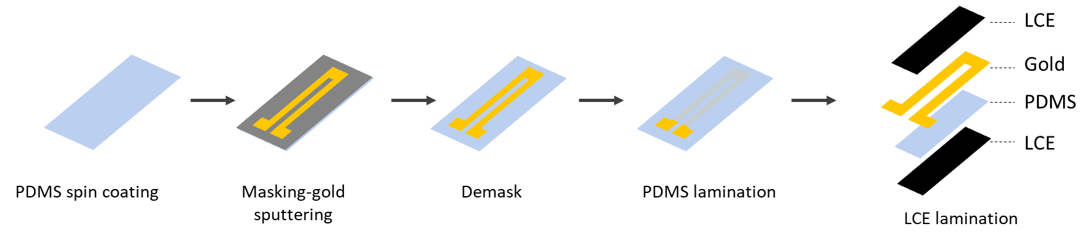
Figure S1. Fabrication process flow of a proprioceptive oscillator.

Piezoelectric/pyroelectric nanogenerator
To build a piezoelectric/pyroelectric nanogenerator, we used the commercially available PVDF-TrFE as an active layer and two gold layers were coated on two sides of PVDF-TrFE for electrodes. The sandwiched structure formed a capacitive configuration. To integrate the nanogenerator component within the trilayer, we fabricated the device as follows:
1) PDMS bottom layer: PDMS was spin-coated on a glass slide with 240 rpm and 2 min and cured on a 120 ℃ hot plate for 2 h.
2) Gold electrode sputtering: A transparent tape was attached to the PDMS surface, and laser cut into a designed pattern. The enclosure area was peeled and exposed for gold sputtering for 240 s.
3) Coating of PVDF-TrFE: The transparent tape was fully peeled, and 10% PVDF-TrFE/DMF solution was dropped on the surface, followed by 750 rpm spin coating in 1min. The PVDF-TrFE film was annealed on a 120 ℃ hot plate for 2 h.
4) Gold electrode sputtering: Then another mask was applied on the surface for gold sputtering for 240s.
5) PDMS top layer: A top PDMS layer was coated by blade casting to seal the nanogenerator. PDMS was cured on a 120 ℃ hot plate for 2 h.
6) Activate the PDMS surface: The multilayer structure was carefully peeled from the glass slide. Then the multilayer was activated by plasma cleaning and coated with silica by room-temperature chemical vapor deposition.
7) Lamination of LCES: The multilayer was sandwiched by two silica-coated LCEs with silicone glue in between. Gluing process cost 3 days.
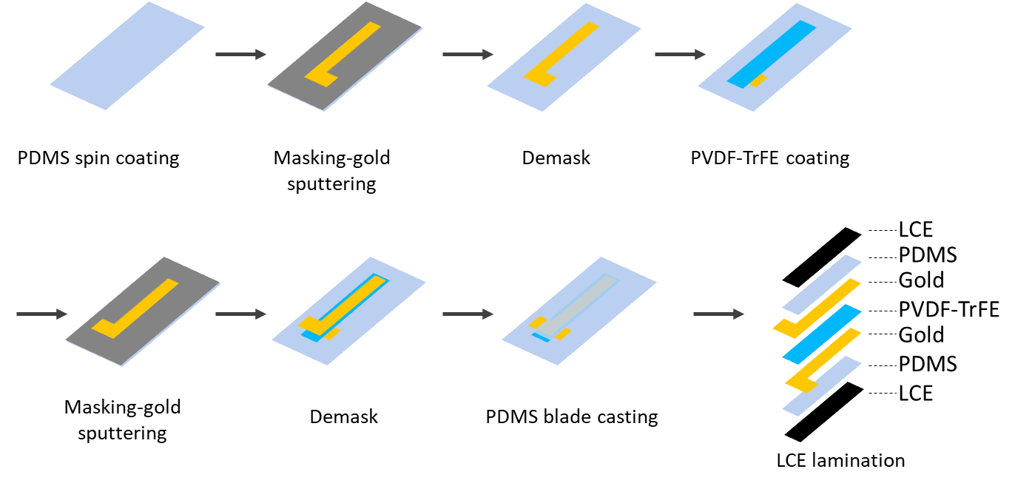
Figure S2. Fabrication process flow of an oscillator integrated with nanogenerator.

FLaPTOR-wing structure
The passive wing was made of Polyethylene terephthalate (PET) with a thickness of 10 μm and the wing shape was fabricated by a laser cutter (PROVerXL 4030). Two PDMS strips were fabricated by blade casting to produce a thickness of 140 μm. LCE formulation was MeS-TA with RM257-HDT. LCEs and PET film were cleaned using ethanol, activated by oxygen plasma for 3 min, and coated with silica by room-temperature chemical vapor deposition overnight. PDMS was cleaned using ethanol, activated by oxygen plasma for 3 min, and coated with silica for 1.5 h. The multilayer wing was laminated by LCE, PDMS, PET, PDMS, and LCE, sequentially. The interface between each layer was glued with silicone glue to enhance the adhesion.
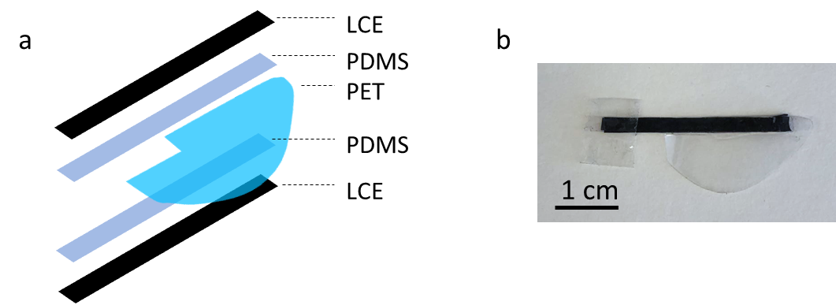
Figure S3. (a) Schematic and (b) photograph of a FLaPTOR-wing structure

- Characterizations
Thermomechanical characterizations of LCE
Before testing, LCEs were annealed at 180 ℃ for 5 min and cooled at room temperature for 5 min to remove thermal history. Storage modulus, loss tangent, and actuation strain were measured by a dynamic mechanical analyzer (DMA850, TA instrument) with 25 kPa preload, 1Hz oscillation frequency, 20 μm amplitude, 25-210 ℃ temperature range, and 5 ℃/min heating rate. Actuation strain was calculated by ε= (L-L₀)/L₀, L and L₀ are the instant length and original length. Actuation stress was measured by an isostrain mode, with a 25-140℃ temperature range, and a 5℃/min heating rate. Work capacity was measured by an isostress mode, with P₀=500 kPa constant load, 25-210 ℃ temperature range, and 5 ℃/min heating rate. Lengths at 30 ℃ and 210 ℃ were denoted as L₁ and L₂. We assume the material is incompressible and the volume keeps unchanged during actuation. Work capacity was estimated as follows:⁵
$$Work capacity=σε=\frac{P_{0}\left(L_{1}-L_{2}\right)}{L_{1}}$$

Oscillation characterizations
Trilayers were horizontally mounted on a stage by a tape with light illuminated also from a horizontal direction. The light spot was a rectangular shape with dimensions of 3.5x4.5 mm and the light exposure area fully covered the cross-sectional area of the trilayer. A linear translational stage was fixed on the laser to precisely control the height of the light to the trilayer. A power threshold was needed to trigger out-of-equilibrium oscillation of the trilayer. In addition, since the light beam was originally parallel to the LCE surface, the trilayer was manually bent back and forth so that the two LCE surfaces could be exposed and heated to help initiate the oscillation. Then the trilayer could autonomously reach a steady oscillatory state. The oscillation behavior was recorded by a camera with 60fps. The tip angle of the trilayer was measured by a software Tracker. Frequency, amplitude, and power density were calculated based on the time-dependent angle change.

- Calculation of oscillation performance: kinetic energy, energy density, output power, power density
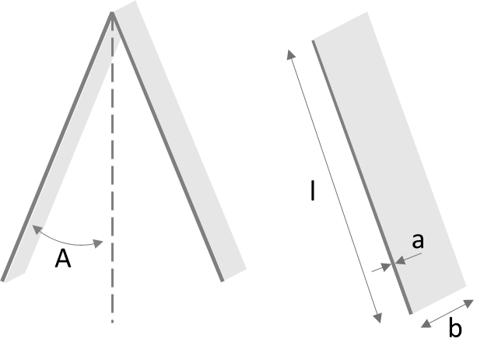
Figure S4. Schematic diagram of a cantilever shape oscillator

Considering a cantilever film with density , length l, width b, and thickness a. The rotational inertia is
$$J=\int_{0}^{l}{ρabx^{2}dx=\frac{1}{3}ρabl^{3}}$$
The kinetic energy at time t is
$$E_{k}\left(t\right)=\frac{1}{2}J\dot{θ}{(t)}^{2}$$
Assuming that the cantilever is oscillating harmonically, i.e., 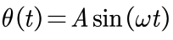, with A and as the oscillation amplitude and angular frequency, then
$$\dot{θ}\left(t\right)=\frac{dθ}{dt}=Aωcos⁡(ωt)$$
and $$E_{k}\left(t\right)=\frac{1}{2}J\dot{θ}{(t)}^{2}=\frac{1}{6}ρabl^{3}A^{2}ω^{2}\cos^{2}(ωt)$$
The averaged kinetic energy over one period is
$$\overline{E_{k}}=\frac{1}{T}\int_{0}^{T}{E_{k}\left(t\right)dt=}\frac{1}{T}\int_{0}^{T}{\frac{1}{6}ρabl^{3}A^{2}ω^{2}\cos^{2}(ωt)dt=\frac{1}{12}ρabl^{3}A^{2}ω^{2}}$$
We define the energy density of an oscillating cantilever as the average kinetic energy per volume
$$U=\frac{\overline{E_{k}}}{abl}=\frac{\frac{1}{12}ρabl^{3}A^{2}ω^{2}}{abl}=\frac{1}{12}{ρl}^{2}A^{2}ω^{2}$$
The instant output power and average (RMS) output power is
$$P\left(t\right)= \frac{∂E_{k}\left(t\right)}{∂t}=\frac{1}{6}ρabl^{3}A^{2}ω^{3}sin(2ωt)$$
$$P_{RMS}=\frac{1}{6\sqrt{2}}ρabl^{3}A^{2}ω^{3}=\frac{\sqrt{2}}{12}ρabl^{3}A^{2}ω^{2}\left(2πf\right)=8.89\overline{E_{k}}f$$
Power density as the average output power per mass
$$P_{m}=\frac{\frac{\sqrt{2}}{12}ρabl^{3}A^{2}ω^{2}\left(2πf\right)}{ρabl}=\frac{\sqrt{2}}{12}l^{2}A^{2}ω^{2}\left(2πf\right)=8.89Uf/ρ$$

The angular frequency of the first bending mode of a cantilever beam⁶⁷
$$ω=\frac{1.01a}{l^{2}}\sqrt{\frac{E}{ρ}}$$
Power scales with $P_{m}\sim {abl}^{3}A^{2}ω^{3}\sim \frac{a^{4}b}{l^{3}}{(\frac{E}{ρ})}^{3/2}A^{2}$
Power density scales with $P_{m}\sim l^{2}A^{2}ω^{3}\sim \frac{a^{3}}{l^{4}}{(\frac{E}{ρ})}^{3/2}A^{2}$
From the estimation, given the material and the same angular amplitude, scaling down by reducing length can increase power density drastically. However, in reality, the oscillation is more difficult to trigger with lower length and it needs higher energy input to achieve comparable amplitude. From the experimental results, an appropriate length to trigger the LCE oscillation is 2-2.5cm.

- Light-thermal-mechanical coupling simulations
4.1 Oscillation
While we have proposed that the enhanced energy output of the trilayer structure can be attributed to the geometric and mechanical constraints offered by the PDMS passive layer, which restricts LCE shortening but provides sufficient thermal actuation strain, a theoretical model is indispensable to validate this enhancement mechanism. In this pursuit, we employed COMSOL Multiphysics to simulate the light-thermal-mechanical coupling process of the LCE/PDMS/LCE trilayer and the LCE monolayer system, modeling them as cantilever beams. The temperature-dependent material properties, including Young’s modulus E(T) and the coefficient of thermal contraction α(T) were derived from DMA measurements for LCE and PDMS. The strong interfacial bonding, facilitated by surface treatments and adhesive design at the LCE/PDMS interface, ensures that the interfacial stress and strain can be withstood by the trilayer structure within our target temperature range. Therefore, we assumed perfect bonding between LCE and PDMS in numerical simulations. These simulations were conducted under the plane-strain condition, given that the nematic-isotropic primarily induces longitudinal (x) shrinkage and transverse (z) oscillation, allowing us to neglect strain in the out-of-plane direction (y). To simulate this intricate light-thermal-mechanical coupling, we employed the Heat Transfer (hs), Solid Mechanics (solid), and Thermal Expansion (te) interfaces in COMSOL.
It is necessary to interpret the coupling process in a way of dynamics. First, the coupling between the incident light and thermal energy input is achieved through the structural oscillation angle θ. Imagine that if a horizontal beam is illuminated by horizontal light, the heat input to the structure is zero ideally. Conversely, when a vertical beam is illuminated by horizontal light, the effective heat input is maximized. The degree of coupling between light and heat is quantified by the oscillation angle θ of the cantilever beam. The illuminated area also moves during the oscillation. Assuming that only the light component normal to the beam structure can be absorbed by the CS-doped LCE, the effective heat input q_{in} to this structure will be
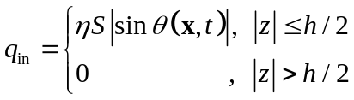
where S represents the power of incident light in the horizontal direction, the oscillation angle θ(x,t) is a function of position x on the beam and time t, h denotes the height of the incident laser spot, and η is the photothermal efficiency, which can be determined based on experimental results or the analytical model detailed in our previous paper⁸. As the oscillation is stabilized with consistent amplitude and frequency output, the temperature within the structure eventually stabilizes, as opposed to increasing infinitely. Thus, the heat dissipation from the structure to the surroundings also need to be considered by using Newton’s low of cooling q_{diss}=k[T(x,t)-T_{ref}], where proportionality constant k was determined through experiments and preliminary simulations, and T_{ref} represents the temperature of the surroundings (T_{ref}=293.15K)
Following the conversion of incident light into heat input, the heat will transfer along both x- and z- direction, governed by a heat transfer equation.
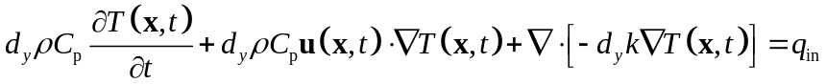
d_{z} is the structural dimension along the out-of-plane direction (width of the samples), ρ is the material density, C_{p} is the heat capacity, u(x,t) is the velocity field during oscillation, and k is the thermal conductivity. Subsequently, the temperature increase within the active material produces a thermal strain ε_{th}(x,t)=-α(T)ΔT(x,t) along the longitudinal direction. The coefficient of thermal contraction along the x direction, α(T), connects thermal quantities to mechanical deformation, which is modeled in the Thermal Expansion (te) interface of COMSOL. Except for the actuation thermal strain ε_{th}(x,t), the elastic contribution due to interaction between active and passive layers should also be considered. The finite deformation theory was utilized to describe the self-excited oscillation characterized by substantial deformations (max. θ>80º, Figure 2f). A total deformation gradient F=F_{el}F_{inel}=∂x/∂X governing the deformation behaviors of the structures was introduced. Here, F_{el} and F_{inel} refer to the elastic and inelastic (thermal) deformation gradients, respectively. The deformation process was simulated using the Solid Mechanics module in COMSOL.
The geometric and material parameters used for the simulations are as follows: beam length L=2.5cm, thickness H=640 µm k=0.6 W/(mK), C_{p}=1300 J/(kgK), ρ=1100kg/m³, and the values of E(T) and α(T) for LCE and PDMS were derived from the DMA measurements. To capture the oscillation and heat transfer in simulations, it is essential to choose a time step smaller than one-quarter of the oscillation period. In our case, 0.01 s was selected as the simulation time step since the highest observed oscillation frequency in the experiments is less than 20 Hz. Additionally, the maximum mesh size in simulations should be much smaller than the thickness of the structures. Calculation convergence has been checked by reducing the mesh size by half to determine if the simulated results remained consistent.

  - Relationship between bending angle and temperature
In Section 4.1, the oscillation characteristics and negative feedback of LMO and FLaPTOR were verified using light-thermal-mechanical coupling simulations. In this section, the negative feedback loop between deformation and incident light was to verify the relationship between bending angle and temperature obtained from the experimental results in Figure 2d. The same COMSOL Multiphysics interfaces as in Section 4.1 were applied. LCE and LCE/PDMS/LCE films with the same dimensions were placed on a horizontal test platform. The left half of their bottom surfaces were fixed (no displacement). A vertically downward incident light with a spot area of 2mm×2mm illuminated the middle of their top surfaces. In order to exclude the negative feedback loop between the deformation and incident light, the light intensity was controlled to be small to avoid overbending of the films. In other words, the light-induced bending angle should be less than 90 degrees so that the films do not block the incident light and the top surfaces are always illuminated.

As shown in Figure 2d, the bending angle of LMO first increased from 20 to 150 degrees Celsius and then gradually decreased. Interestingly, the highest bending angle occurred at 150 degC, where the LCE material also has the lowest storage modulus and the highest coefficient of thermal contraction α(T), according to DMA characterization in Figure 2a. Thereafter, the stiffness increased and α(T) decreased, which means that the structure is more difficult to bend; therefore, in the high-temperature range, the bending angle of LMO naturally decreased. Since the maximum bending angle was kept below 90 degrees and the bottom surface was never illuminated, this non-monotonic trend of bending angle versus temperature was independent of the negative feedback loop between the deformation and the incidental angle. In contrast, the bending angle of FLaPTOR increased monotonically and relatively linearly with temperature in the range from 20 to 240 degC. This is due to the fact the introduction of PDMS substantially increased the stiffness and provided elastic stresses to resist the thermal contraction of LCE according to the DMA characterization in Figure 2a, which suggests that it is difficult to bend the structure to ultra-high angles (more than 80 deg) in the temperature range of interest, but the linear responsiveness of the PDMS tends to maintain a monotonic bending of the composite with temperature.

Table S1. Comparisons of flapping-wing actuators.
 | Insects | Conventional flapping-wing actuators | FLaPTOR
Actuation configuration | Asynchronous contraction of antagonistic muscles | Varying | Asynchronous contraction of antagonistic muscles
Frequency | Resonant frequency | Varying | Resonant frequency
Transduction | Muscle to wing | Transmission unit (friction, viscous) | Muscle to wing
Oscillation mechanism | Self-oscillation | Time-varying voltage using a signal generator, control unit | Self-oscillation
Energy supply | Onboard chemical energy | Offboard, tethered | Untethered light

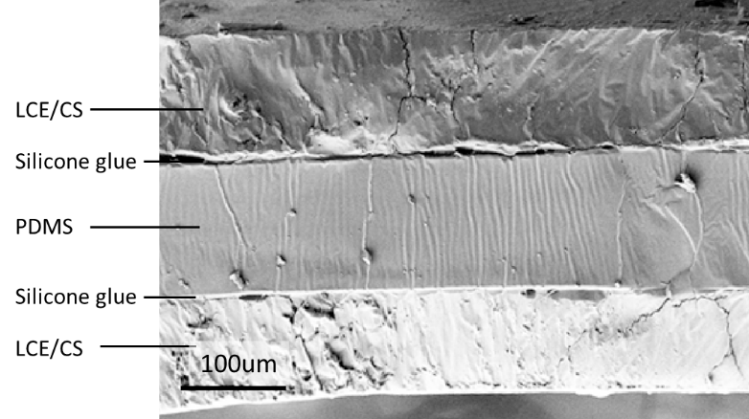
Figure S5. Cross-sectional SEM of FLAPTOR based on DIW-TE recipe.
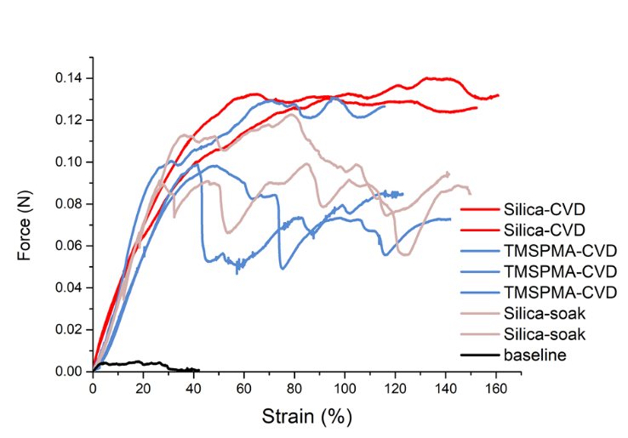
Figure S6. Bonding analysis of PDMS and LCE by different surface treatments. LCE surface was treated with oxygen plasma for 3min and then i) coated with silica by CVD overnight, ii) coated with TMSPMA by CVD, iii) coated with silica by solution soaking, and iv) kept as control. The silica CVD method demonstrated the highest and most stable bonding over other methods.

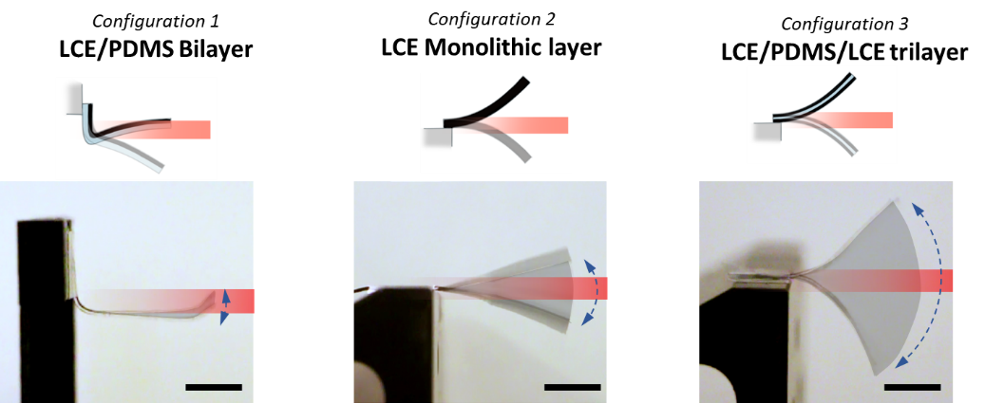

Figure S7. Schematic diagrams and superimposed pictures of LCE oscillators based on different configurations: 1) LCE/PDMS bilayer oscillator (LPBO), 2) LCE monolithic layer oscillator (LMO), 3) LCE/PDMS/LCE trilayer oscillator (FLaPTOR).
Table S2. Comparisons of the three configurations regarding oscillation mechanism, energy injection, and oscillation performance. The total thickness of all configurations was around 600μm and the length was 2.5cm.

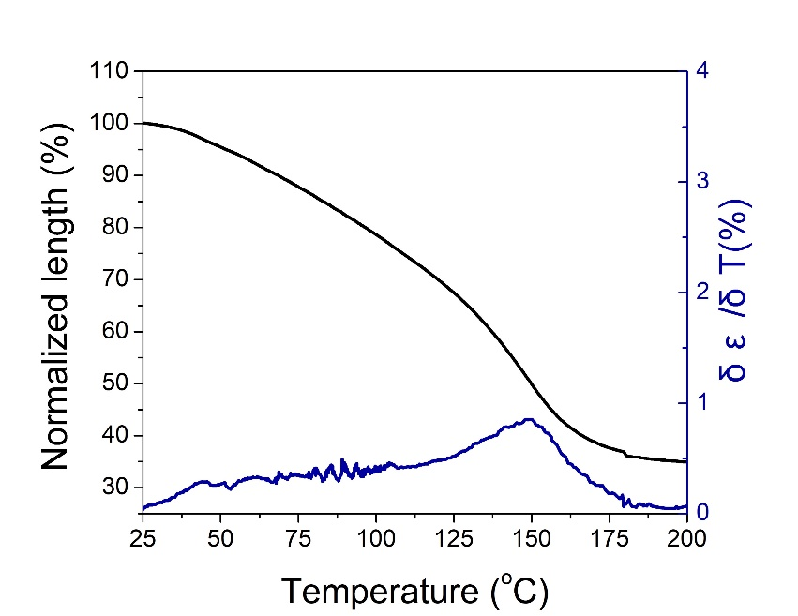
Figure S8. Normalized length and temperature-strain gradient over temperature. The contraction was almost completed after 150℃ and strain rate δε/δT reached a peak also at 150℃, which can explain the peak thermomechanical angular bending at 150℃ of monolithic LCE.

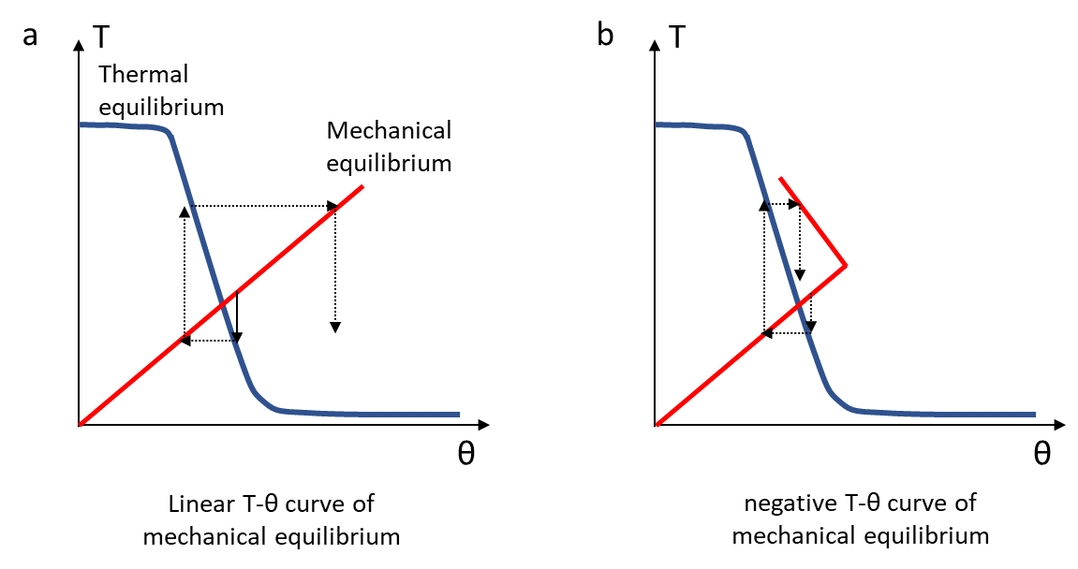
Figure S9. Schematic drawings showing the photo-thermo-mechanical feedback loop. The oscillation is produced by the coupling of thermal equilibrium and mechanical equilibrium. The schematic diagram only illustrates mono-directional deformation for simplification. Thermal equilibrium describes how self-shadowing affects temperature when film and light have an angle θ. A higher angle will lead to less light projected on the film and lower temperature elevation. Mechanical equilibrium describes how temperature affects thermomechanical angular bending. The higher temperature usually induces a larger bending angle. To trigger the oscillation, the derivative of mechanical equilibrium shall be smaller than thermal equilibrium, as shown in (a). If mechanical equilibrium performs a negative slope as shown in (b), the T-θ curve will quickly converge to the tracking state.

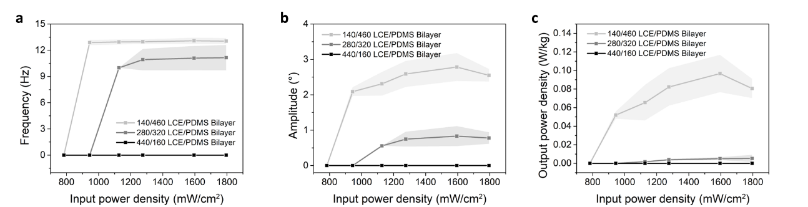
Figure S10. Oscillation performance of LPBOs. Thickness in total was 600μm and LCE thickness was 140, 280, and 440μm, respectively. a) Frequency, b) Amplitude, and c) output power density of three configurations of LPBOs at different input light intensities showed that LPBPO with 140/460 configurations could produce the best performance. The highest power density was ~0.1W/kg.

Table S3. Property-performance relationship of LCE. We have examined LCE thermomechanical properties, including storage modulus (E’) at room temperature, actuation strain at 200℃, actuation stress at 140℃, work capacity at 500kPa load, and light-driven oscillation power density. The length of the oscillator was 2cm for DIW recipe and 2.5cm for MeS-TE and MeS-TA recipes. Configuration was 110/134/110 for DIW and 140/310/140 for MeS-TE and MeS-TA recipes. The highest oscillation power density was selected for each recipe under light intensity from 0 to 6500mW/cm². Parameter change for each recipe was shown in grey colors. R82=RM82, R257=RM257, E=EDDET, H=HDT, G=GDMP, P=PETMP, T=TATATTO.

# | Method | Mesogens | 1st step Poly. | 2nd step Poly. | E’  (MPa) | Act. strain |  | Act. stress (MPa) | Work capacity  (kJ/m³) | Osc. Power density  (W/kg)
101 | DIW-TE | 0.75 R82  0.25 R257 | 1.25 E | 0.17 T | 1.6 | 25% |  | - | - | -
102 | DIW-TE | 0.75 R82  0.25 R257 | 0.63 H  0.63 E | 0.17 T | 3.4 | 34% |  | - | - | -
103 | DIW-TE | 0.75 R82  0.25 R257 | 0.94 H  0.31 E | 0.17 T | 4.4 | 35% |  | 0.56 | 216 | 4.5
104 | DIW-TE | 0.75 R82  0.25 R257 | 1.25 H | 0.17 T | 5.0 | 35% |  | - | - | -
201 | MeS-TE | 0.25 R82  0.75 R257 | 1 G  0.125 P | 0.17 T | 2.8 | 14% |  | - | - | -
202 | MeS-TE | 0.4 R82  0.6 R257 | 1 G  0.125 P | 0.17 T | 3.7 | 24% |  | - | - | -
203 | MeS-TE | 0.6 R82  0.4 R257 | 1 G  0.125 P | 0.17 T | 6.3 | 31% |  | - | - | -
204 | MeS-TE | 0.75 R82  0.25 R257 | 1 G  0.125 P | 0.17 T | 8.5 | 33% |  | - | - | -
205 | MeS-TE | 1 R82 | 1 G  0.125 P | 0.17 T | 13.5 | 47% |  | 0.90 | 195 | 12
206 | MeS-TE | 1 R82 | 1 H  0.125 P | 0.17 T | 15.5 | 49% |  | 1.05 | 245 | 10.5
301 | MeS-TA | 1 R257 | 0.867 H  0.067 P | 0.025 R257 | 21.5 | 64% |  | 1.19 | 311 | 20.7
302 | MeS-TA | 1 R257 | 0.867 E  0.067 P | 0.025 R257 | 6.4 | 51% |  | 1.07 | 267 | 6.1
303 | MeS-TA | 1 R257 | 0.867 G  0.067 P | 0.025 R257 |  |  | Fast gelation, irreversible deformation
304 | MeS-TA | 1 R82 | 0.867 H  0.067 P | 0.025 R82 | 19.6 | 50% |  | 0.86 | 200 | 11.8
305 | MeS-TA | 1 R82 | 0.867 E  0.067 P | 0.025 R82 | 13.2 | 48% |  | 0.89 | 214 | 12.2
306 | MeS-TA | 1 R82 | 0.867 G  0.067 P | 0.025 R82 |  |  | Fast gelation, irreversible deformation
Specifically, for DIW method, 104 had higher modulus and actuation strain, but it was unsuccessful to fabricate thin film due to the overly low viscosity of oligomerized ink. For MeS-TE method, among #201-205 with the same spacer and different mesogen mixtures, #201 with 100%RM82 had the highest modulus and actuation strain. Therefore, we used #201 to test trilayer oscillation performance. Note that #206 with HDT spacer had slightly better thermomechanical performance compared to #201, but the tested power density of trilayer oscillation was lower.
DIW is direct ink writing to align LCE ink. MeS is mechanical stretching to align LCE oligomer and the oligomerized LCE after the first step polymerization is a freestanding film instead of viscous ink.
TE indicates the photocrosslinking step based on thiol-ene chemistry. TA indicates thiol-acrylate reaction to trigger the first step polymerization and acrylate polymerization to permanently fix the network at the second step.

Methodology I. DIW-TE (Direct ink writing +thiol-ene chemistry):
Main-chain LCE systems were selected to provide stronger chain anisotropy, which results in enhanced actuation function, such as actuation strain and stress. We started from DIW method with thiol-ene chemistry due to its low T_{NI}.^{1,9} First, mesogens and difunctional thiol spacers undergo thiol-acrylate Michael addition and form viscous liquid as ink, and the ink can be used for extrusion-based printing. Mesogens are oriented along the printing direction. The subsequent photoreaction will polymerize the excess thiol group and vinyl group of TATATO, which is a tri-functional vinyl crosslinker. However, reported LCE had relatively low modulus (~1MPa), unfavorable for the design of a high-frequency oscillator. We observed that increasing HDT/EDDET ratio and keeping the total thiol group amount can simultaneously increase modulus and strain (#101-104). This is because HDT can facilitate the segregation of rigid mesogen and spacers, resulting in enhanced mechanical properties.¹⁰ Using LPBO configuration (50μm PDMS and 100μm LCE), we demonstrated that increasing HDT content would generally improve oscillation performance. However, the total replacement of EDDET with HDT caused the viscosity to be very low, making trouble to control the printing thickness of LCE. The LPBO performance was also decayed. Therefore, we selected 75%HDT/25%EDDET recipe and made first generation of FLaPTOR. Geometrical optimization for the thickness of PDMS and LCE resulted in oscillation performance of light intensity =1000-3500mW/cm², frequency =6-8Hz, and maximum oscillation power density =4.5W/kg.

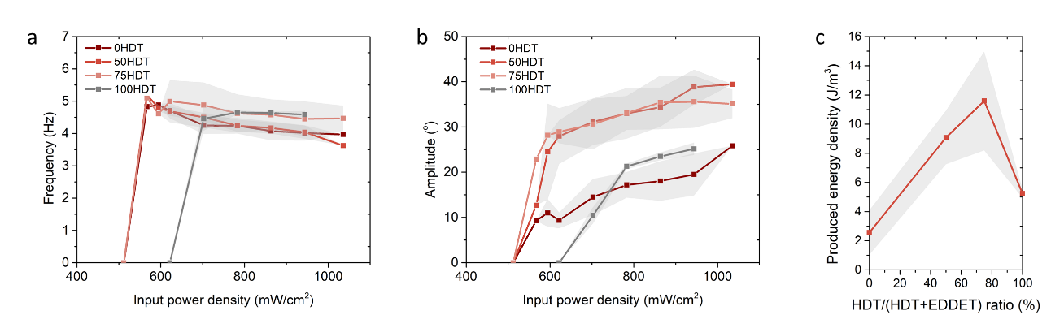
Figure S11. LPBO performance using DIW-TE synthesis route.

Methodology II. MeS-TE (Mechanical stretch +thiol-ene chemistry):
To ensure good alignment of mesogens, precise control thickness down to micrometer level, and a broader selection of chemicals, we then implemented a two-stage mechanical stretching methodology. The fabrication route is that at 1st step, mesogens and thiol spacers that contain di-functionality tetra-functionality undergo thiol-acrylate Michael addition and form a freestanding film. Such oligomerization can form a polydomain loosely crosslinked network. Then, we uniaxially stretch the film to align mesogens, followed by UV to polymerize excess thiol group and tri-functional vinyl crosslinker. The oriented network can be permanently fixed. Tetra-functional PETMP is added to allow freestanding sample gelation after 1st step of oligomerization. TATATO was used as a vinyl crosslinker to trigger 2nd step of thiol-ene photo-crosslinking. GDMP was used as a thiol spacer because of the sharp actuation transition and good mechanical properties.
We changed RM82/RM257 ratio from 25%RM82 to 100% RM82 (#201-206), and we found that a higher RM82 ratio led to higher modulus and strain. This is presumably because the incorporation of more RM257 with a longer molecular chain shifts the temperature-strain curve to lower temperature, and the contraction from room temperature to high temperature is reduced.¹ Therefore, RM82 was used for this development. We further fixed RM82 and changed spacers to HDT. We examined the FLaPTOR performance of both two spacer species. Although HDT spacer exhibited slightly higher thermomechanical properties, including modulus, strain, stress, and work capacity, FLaPTOR based on the same configuration (110/320/110) is close to GDMP-based FLaPTOR. GDMP-based FLaPTOR leads to frequency=10Hz, Amplitude=45°, and power density=12W/kg.

Methodology III. MeS-TA (Mechanical stretch +thiol-acrylate and acrylate polymerization):
Furthermore, we used the two-stage thiol-acrylate Michael addition photopolymerization (TAMAP) method to fabricate LCE. This method obtains broad tailorability and programmability to synthesize well-defined LCE properties.¹¹ Typically, the 1st step of oligomerization is similar to MeS-TE. 2nd step of crosslinking is done by radial polymerization of excess acrylate group rather than thiol-ene chemistry. 2.5% excess acrylate is used to trigger photopolymerization because LCE with lower crosslinker content can generate higher actuation strain and higher energy density.³ We varied species of monomers, spacers, and crosslinkers: RM82 or RM257 was selected as monomers; HDT, GDMP, or EDDET were selected as di-functional flexible spacers; PETMP as four functional group thiol crosslinker; 6 formulations were fabricated by changing spacers and mesogens.
We found that RM257-GDMP (#303) and RM82-GDMP (#306) systems performed overly fast gelation once a mixture of precursor solutions. Although the liquid-like portion of the precursor could be cast as films and form LCE, the prepared LCE was polydomain and deformation was irreversible. It is presumably because the solution could not be fully mixed and stoichiometry within the network was disrupted. Therefore, these two formulations were deprioritized for further development.
Regarding RM257-HDT (#301), RM257-EDDET (#302), RM82-HDT (#304), and RM82-EDDET (#305), RM257-based LCE exhibited modulus, strain, stress, and work capacity. These are presumably because the RM82-based LCE could only be self-relaxed to ~80% of its original length after the first cycle relaxation, and the orientation could not be fully recovered. The disability to be fully recovered may attribute to the high molecular chain length of RM82 compared to that of RM257. This phenomenon is more obvious in a loosely-crosslinked network, which is 2.5% in the current development. For the spacer effect, HDT-based LCE performed higher modulus and strain, which can be explained by the formation of phase segregation. However, the actuation stress and work capacity showed an inconsistent trend between the four formulations. The actuation stress and work capacity scale with the modulus at high temperature and actuation strain. Since modulus is a function of temperature, the performance of actuation stress and work capacity may vary with specific material. Among them, RM257-HDT-based LCE exhibited the best thermomechanical properties in all characterizations: modulus=22 MPa, actuation strain=66%, actuation stress=1.2 MPa, work capacity=311kJ/m³. The performance is highly reproducible over different batches. After assembling into FLaPTOR with PDMS thickness of 310 μm and the total thickness of 600 μm, RM257-HDT-based FLaPTOR demonstrated significantly higher performance: frequency>12 Hz, amplitude>40°, and maximum output power density=20.7 W/kg. Therefore, we finally selected RM257-HDT LCE (#301) for further development.

Table S4. Comparisons of thermomechanical actuation performance of LCEs
# | Method | E’  (MPa) | Act. strain | Act. stress (MPa) | Work capacity  (kJ/m³)
¹¹ | RM257-EDDET-PETMP | 10 | 26% | - | -
¹⁰ | RM257-HDT-PETMP | 4-5 | 78% |  | 200 at 50kPa
¹² | RM257/82-EDDET-TATATO | 1 | 40% | - | 60 at 40g
₅ | RM257-HDT fiber | ~0.3 | 50% | 0.3 | 20
 | RM257-EDDET |  | 45% | 0.2 | 20 at 100kPa
¹³ | RM257-EDDET-MBTA-PETMP | 2.5 | 50% | - | -
¹⁴ | RM257-PETMP  UPyMA-EDDET | ~1 | 50% |  | 121.2 at 40g
¹⁵ | RM82-EDDET-TATATO | 3 | 38% | - | -
¹⁶ | RM82- 1,5-diaminopen-tane | 10.6 | 38%
¹⁷ | RM82-PDT-AuNR | 20 | 25% | - | -
¹⁸ | BHHBP-6HCA |  | 34%
¹⁹ | PMMS-LCE | 13 | 25% | 0.06 | 20 at 79kPa
²⁰ | Y1709-YHD796C | 178 | 50%
Our work | RM257-HDT-PETMP | 21.5 | 64% | 1.2 | 311 at 500kPa

Table S5. Comparisons of the performance of light-driven self-oscillators. Pol.=light polarization; P_{in}=light intensity; Thick.=thickness; Freq.=frequency; Ampl.=amplitude; KE=normalized kinetic energy, assuming the width is 0.2 cm; PD=power density. Overall, FLaPTOR exhibited high thickness, high length, high kinetic energy, and high power. Note that the power densities of some LCNs oscillators were higher than our power densities, mainly because the power density scales with 1/L⁴ as described in section 3 of supplementary information. For instance, for the azo-LCN1 oscillator with a power density of 3232 W/kg, the length was 0.15 cm, one orders of magnitude lower than our works. Taking the frequency scaling with 1/L², the oscillation frequency using their formulation at L=2.5 cm would be 1Hz, much lower than 13 Hz in our work at L=2.5 cm. Therefore, our FLaPTOR design still exhibits unprecedented performance in comparable dimensions.

Year | Method | Pol. | P_{in}  (mW/cm²) | Thick.  (μm) | Length  (cm) | Freq.  (Hz) | Ampl.  (°) | KE  (nJ) | Power  (μW) | PD  (W/kg)
2010⁶ | azo-LCN 1 | Y | 2000 | 50 | 0.15 | 271 | 90 | 221 | 0.533 | 3232
2008²¹ | azo-LCN 2 | Y | 800 | 50 | 0.5 | 30 | 85 | 89.6 | 0.024 | 43
2011²² | azo-LCN 3 | Y | 1500 | 20 | 0.5 | 45 | 47 | 24.7 | 9.86E-3 | 45
2017⁷ | dye-LCN | N | 525 | 20 | 1.7 | 6 | 20 | 3.12 | 1.66E-4 | 0.22
2020²³ | LCE/Dichronic dye | Y |  | 45 | 0.8 | 16.7 | 30 | 12.8 | 1.89E-3 | 2.39
2019²⁴ | azo-LCN 4 | N | 4735 | 50 | 0.55 | 80 | 20 | 47.0 | 3.34E-2 | 55.2
2020²⁵ | PDA-LCN | N | 2500 | 20 | 1.8 | 9 | 11 | 2.30 | 1.84E-4 | 0.23
2017²⁶ | Hydrazone-LCN | N | 500 | 20 | 1.2 | 12.5 | 15 | 2.68 | 2.98E-4 | 0.564
2017²⁷ | Photostablizer-LCN | N | 530 | 20 | 1.5 | 5 | 22.5 | 1.88 | 8.37E-5 | 0.127
2018²⁸ | PC/GO-LCN | N |  | 40 | 2 | 2 | 45 | 5.71 | 1.02E-4 | 0.058
2021²⁹ | Tinuvin-LCN | N | 500 | 20 | 1.5 | 8.5 | 10 | 1.08 | 8.12E-5 | 0.123
2020³⁰ | Sn/FEP | N | 100 | 10 | 2.5 | 2.8 | 90 | 21.9 | 5.45E-4 | 0.99
Our work | FLaPTOR (DIW-TE) | N | 2912 | 400 | 2 | 6.9 | 52 | 1000 | 0.062 | 3.5
Our work | FLaPTOR (MeS-TE) | N | 6400 | 550 | 2.5 | 9.5 | 45 | 3498 | 0.294 | 10
Our work | FLaPTOR (MeS-TA) | N | 6400 | 610 | 2.5 | 13.1 | 40.6 | 5944 | 0.692 | 20.6

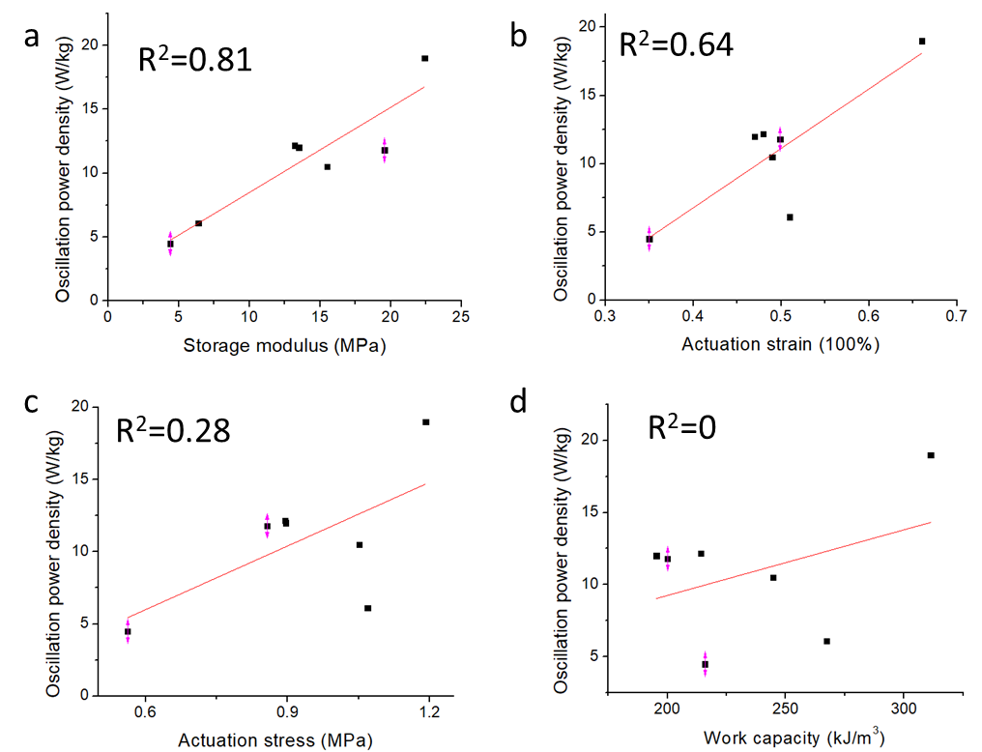
Figure S12. Correlation of power density and thermomechanical properties.

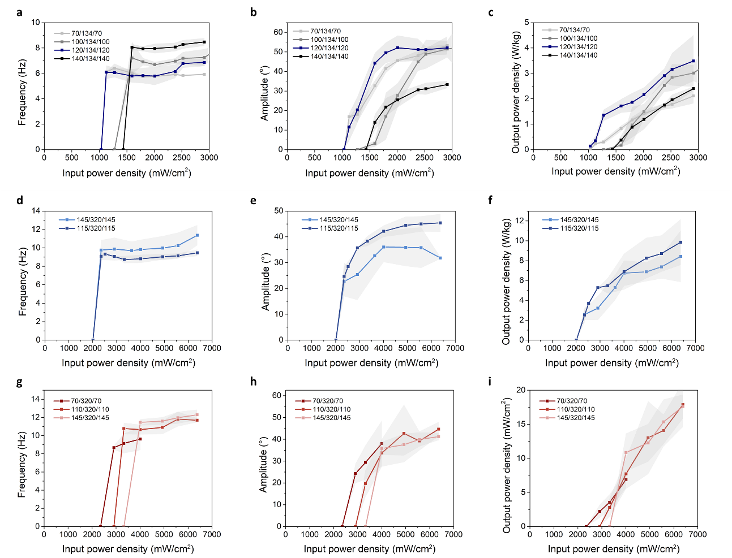
Figure S13. LCE thickness study of trilayer oscillation. (a-c), (d-f), and (g-i) were characterized using DIW-TE, MeS-TE, and MeS-TA recipes. Trilayers with DIW-TE had a length of 2cm and trilayers with MeS-TE and MeS-TA had a length of 2.5 cm, because DIW-TE trilayers were mechanically softer and tended to curved down at a higher length. For MeS-TE and MeS-TA based trilayers, input power density higher than 6500 mW/cm² had risks of LCE fracture, indicating the upper limit of the operation condition.
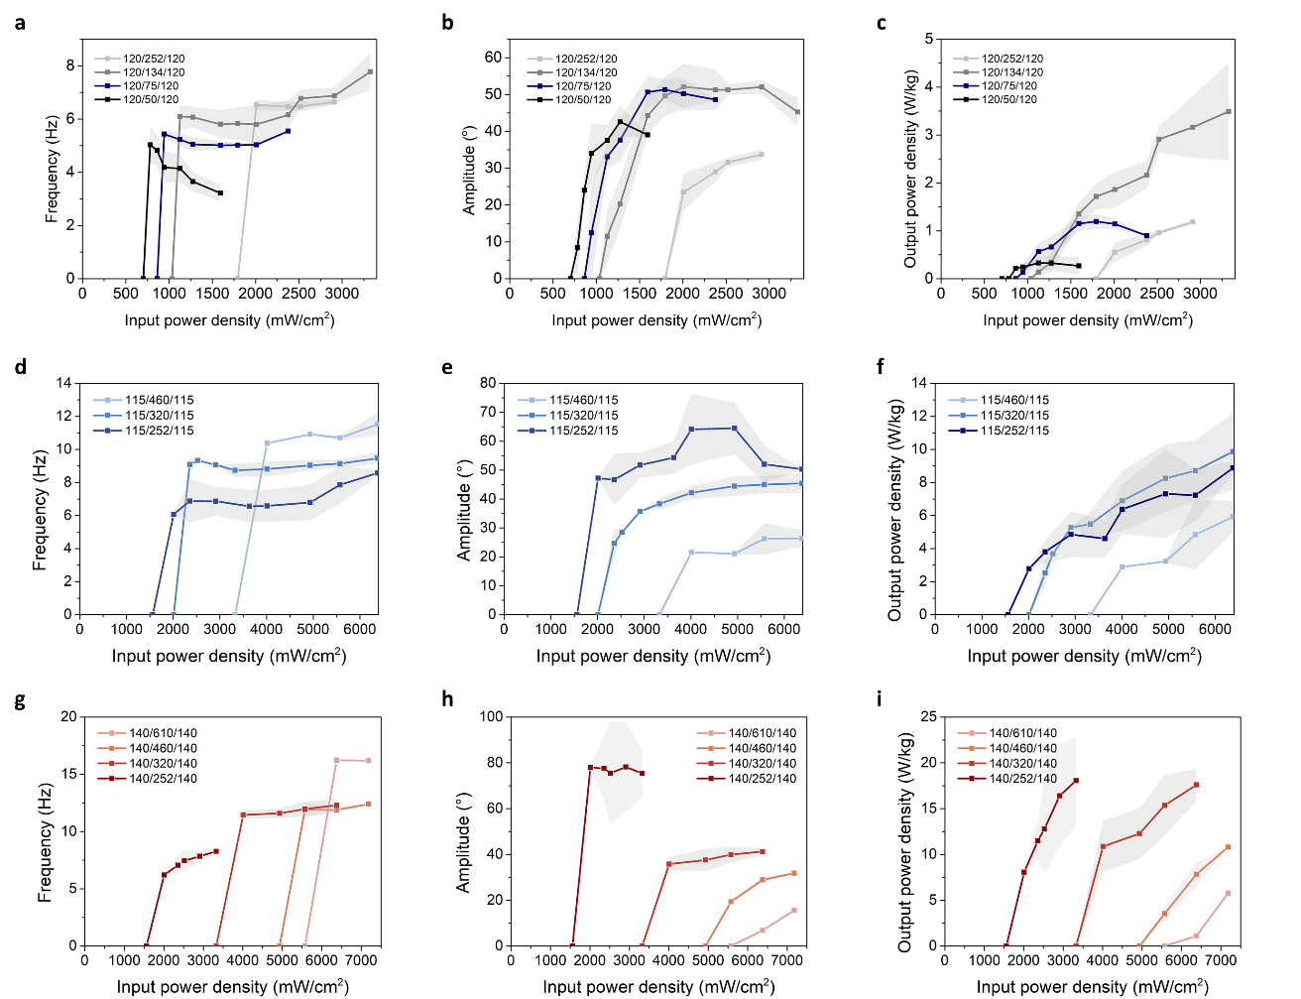
Figure S14. PDMS thickness study of trilayer oscillation. (a-c), (d-f), and (g-i) were characterized by DIW-TE, MeS-TE, and MeS-TA recipe. Trilayers with DIW-TE had a length of 2cm and trilayers with MeS-TE and MeS-TA had a length of 2.5 cm. Note that 140/252/140 with MeS-TA method had a similar maximum output power density as 140/320/140 with MeS-TA method. However, 140/252/140 suffered from relatively lower frequency and unstable oscillating performance, which may be due to the film twisting issue at the illumination site. Therefore, we rationally chose the configuration of 140/320/140-2.5 cm for further development.

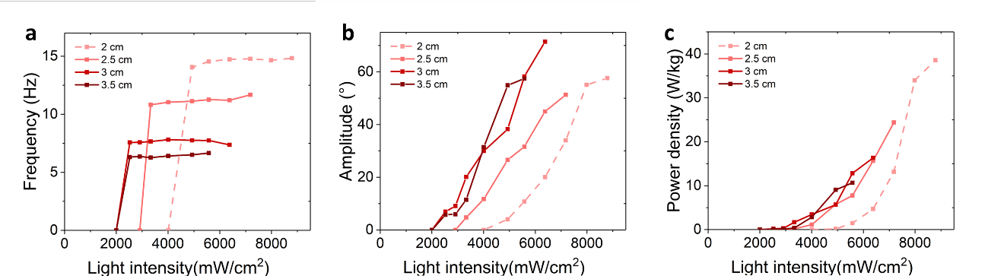
Figure S15. Overall length study of trilayer oscillation. (a) frequency, (b) amplitude, and (c) output power density of trilayer under different input light intensities. LCE was made by MeS-TA method. When the length was 2cm, there was high risk of LCE fracture.

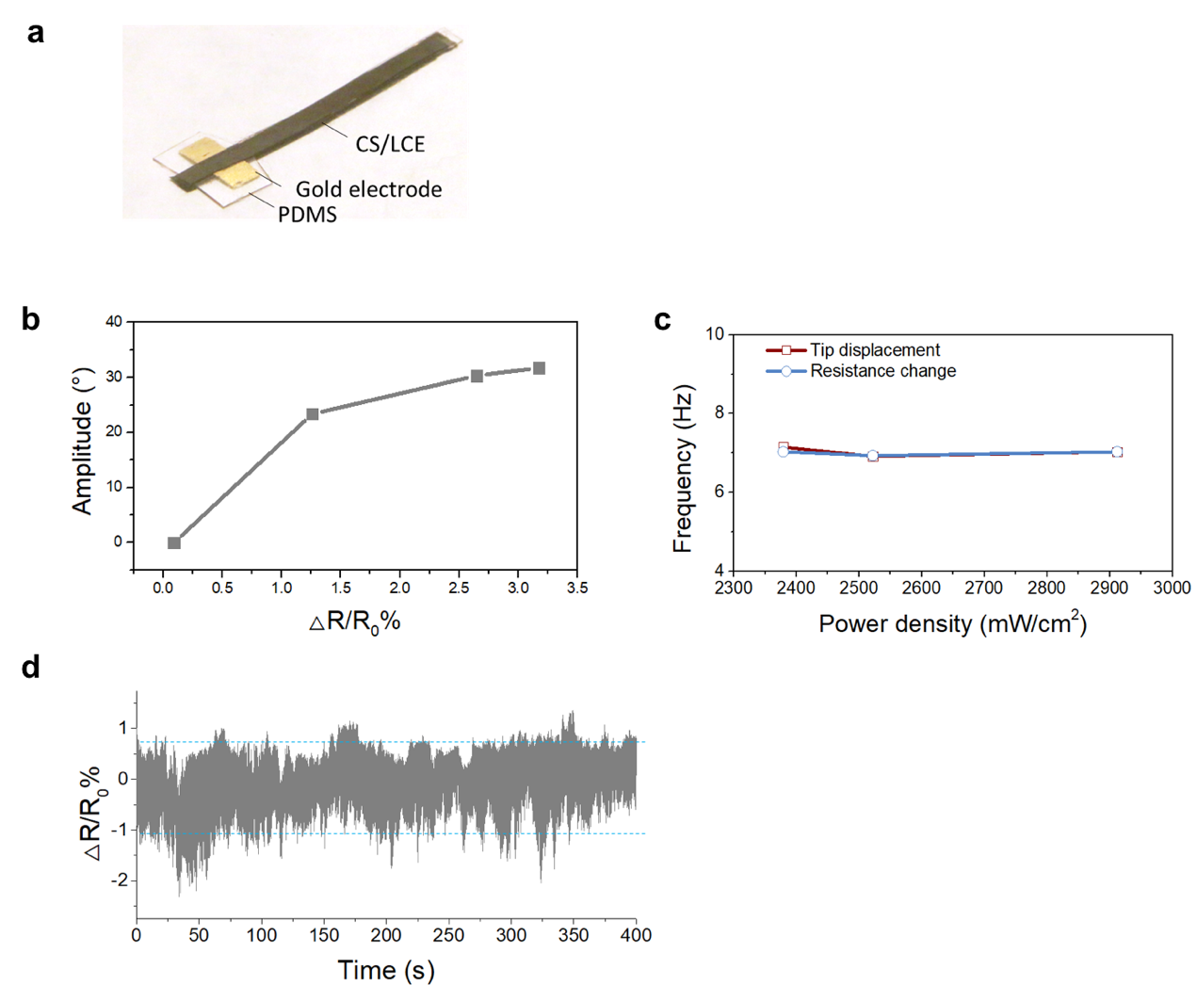
Figure S16. Proprioceptive oscillation characterizations. a) A photo of the FLaPTOR integrated with gold electrodes as a sensing unit, b) Resistance changes related to oscillation amplitude. Interestingly, we found that the resistance change showed a nonlinear correlation to bending amplitude, which could be explained by more insulating island formation, c) Frequency of tip displacement extracted from mechanical oscillation and resistance change extracted from an electrical signal using time-dependent Fourier transform analysis. The two data demonstrated the consistency of frequency over different light power densities, suggesting that the sensing property can well reflect the deformation of the oscillator. d) Cyclic stability of the self-sensing oscillation performance.

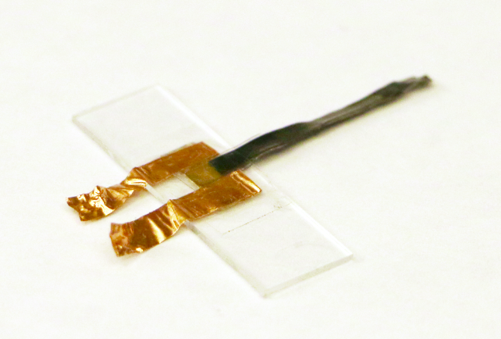
Figure S17. A photo of piezoelectric/pyroelectric nanogenerator

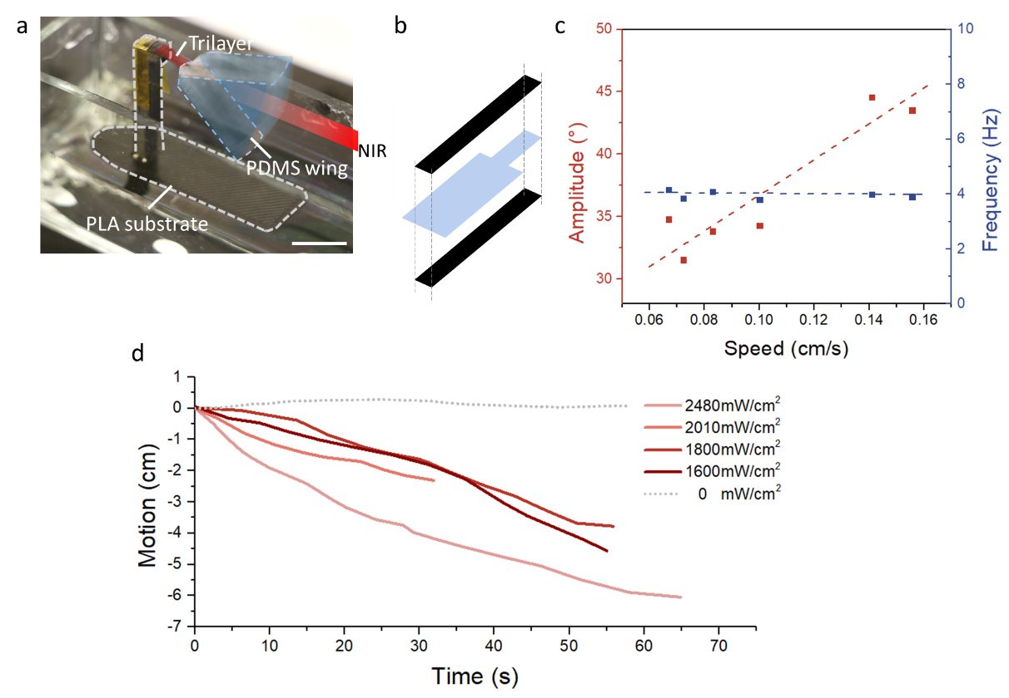
Figure S18. Light-driven Sailboat demonstration. a) a photograph of the assembled sailboat with a FLaPTOR-based wing, b) Schematic representation of the FLaPTOR-based wing, c) Frequency and amplitude

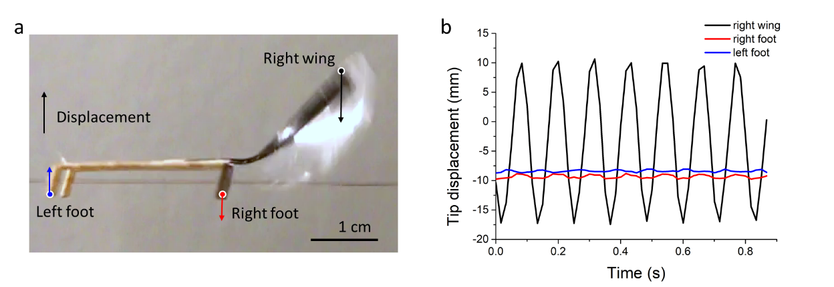
Figure S19. Directional walking mechanism. The right foot and the right wing moved in the same directions; The left foot and the right foot moved in opposite directions. These could be attributed to the reciprocal rotation motion of the walker with respect to the center of the mass of the system. Since the two feet of the walker always move in opposite directions to produce the reciprocal motion, and the feet have a tilted angle relative to the rail to the friction bias, the motion can be transferred to a directional motion along the rail.

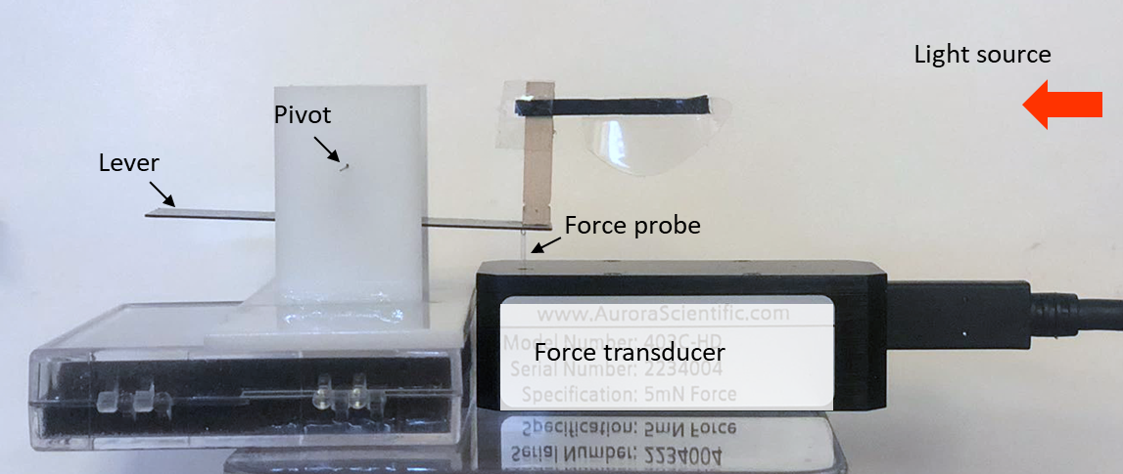
Figure S20. Experimental setup to measure the instantaneous lift force of an oscillating wing. The force is measured by a micro force probe (403C HD from AURORA scientific) along with a balance lever. The voltage is measured by an oscilloscope.

Movies
Movie 1: Structural configuration of oscillators: FLaPTOR, LMO, and LPBO.
All LCEs in the oscillators were fabricated by MeS-TA RM257-HDT method. The structural configurations and light intensities of oscillators were described as follows: FLaPTOR comprised of LCE 140 μm, PDMS 320 μm, LCE 140 μm, and had a length of 2.5 cm. Light intensity was 6400 mW/cm²; LMO was 600 μm in thickness and 2.5cm in length, where the length was measured during oscillation. Light intensity was 6400 mW/cm²; LPBO comprised of LCE with 140 μm in thickness, PDMS with 460 μm in thickness, and 2.5 cm in length. Light intensity was 1560 mW/cm².

Movie 2: Initialization of oscillations: FLaPTOR and LMO.
All LCEs in the oscillators were fabricated by MeS-TA RM257-HDT method. FLaPTOR comprised of LCE 140 μm, PDMS 320 μm, LCE 140 μm, and had a length of 2.5cm; LMO was 600 μm in thickness. The lengths were 2.5 cm, 3 cm, and 5 cm when the light was switched off. The length was shortened after the initialization of the oscillation. Light intensity was 5580 mW/cm². To initialize the oscillation at the beginning, we manually bend the oscillators to allow heat accumulation on the actuator roots until they could autonomously oscillate.

Movie 3: Molecularly engineering of LCE for FLaPTOR
Three methodologies of LCEs were demonstrated in the study: DIW-TE method with a configuration of 120/134/120-2 cm and light intensity was 2900 mW/cm²; MeS-TE method with a configuration of 115/320/115-2.5 cm and light intensity was 6400 mW/cm²; MeS-TA method with a configuration of 145/320/145-2.5 cm and light intensity was 6400 mW/cm². Movies were slowed down to 0.5x speed to distinguish the oscillatory behaviors of different FLaPTORs.

Movie 4: Wide-spectrum operation of FLaPTOR
LCEs in the oscillators were fabricated by DIW-TE method. FLaPTOR comprised of LCE 120 μm, PDMS 134 μm, LCE 120 μm and had a length of 2 cm. Five different light sources were used to demonstrate the wide-spectrum operation of oscillation: 1) blue light with 470 nm and 3000 mW/cm²; 2) green light with 532 nm and 200 mW; 3) red light with 635 nm and 100 mW; 4) NIR light with 808 nm and 2900 mW/cm²; simulated solar light with 2400 mW/cm².

Movie 5: Proprioceptive actuation and energy harvesting
The LCEs in the proprioceptive actuator was made by DIW-TE method. Configuration was 120/134/120-2cm with gold layer sputtered on the PDMS surface. Light intensity was 2380 mW/cm². Electrodes were attached on the two ends of gold layer and connected to an electrochemical workstation CHI660. Current and resistance were measured at a constant voltage applied on the electrode.
The energy harvesting was mad by laminating gold, PVDF-TrFE, and gold layers within the PDMS layer. LCEs were made by MeS-TA method. Configuration was 145/280/145-2.5 cm. Light intensity was 4000 mW/cm². Electrodes were attached on the two gold layers and connected to an electrochemical workstation CHI660. Voltage was measured using an open circuit mode.

Movie 6: Sailboat Locomotion by FLaPTOR
The middle PDMS of FLaPTOR was expanded as a large-area propeller, and the oscillator was assembled on a 3D-printed boat. Under the illumination of NIR light parallel to the water surface, the oscillator propels air, moving the sailboat away from the light.

Movie 7: Rail-Assisted Walker Powered by FLaPTOR
A plastic wing was assembled on FLaPTOR, and the oscillator was attached to a wood-made walker. The walker was mounted on two copper wires serving as a rail. Under the illumination of NIR light parallel to the copper wire rail, the oscillator propels air, moving the walker towards or away from the light.

Movie 8: Flapping Wing Motion Generated by FLaPTOR
The FLaPTOR-wing system was validated in constrained and partially unconstrained scenarios.

References
1. Mohand O. Saed, Cedric P. Ambulo, Hyun Kim, Rohit De, Vyom Raval, Kyle Searles, Danyal A. Siddiqui, John Michael O. Cue, Mihaela C. Stefan, M. Ravi Shankar, and T. H. W. Molecularly-Engineered, 4D-Printed Liquid Crystal elastomer actuators. 1806412 (2019).
2. McCracken, J. M., Donovan, B. R., Lynch, K. M. & White, T. J. Molecular Engineering of Mesogenic Constituents Within Liquid Crystalline Elastomers to Sharpen Thermotropic Actuation. Adv. Funct. Mater. 31, (2021).
3. Saed, M. O. et al. Thiol-acrylate main-chain liquid-crystalline elastomers with tunable thermomechanical properties and actuation strain. J. Polym. Sci. Part B Polym. Phys. 55, 157–168 (2017).
4. Deng, X., Mammen, L., Butt, H. J. & Vollmer, D. Candle soot as a template for a transparent robust superamphiphobic coating. Science (80-. ). 335, 67–70 (2012).
5. He, Q. et al. Electrospun liquid crystal elastomer microfiber actuator. Sci. Robot. 6, (2021).
6. Serak, S. et al. Liquid crystalline polymer cantilever oscillators fueled by light. Soft Matter 6, 779–783 (2010).
7. Gelebart, A. H., Vantomme, G., Meijer, E. W. & Broer, D. J. Mastering the Photothermal Effect in Liquid Crystal Networks: A General Approach for Self-Sustained Mechanical Oscillators. Adv. Mater. 29, (2017).
8. Shi, P., Zhao, Y., Liu, Z. & He, X. Liquid crystal elastomer composite-based photo-oscillator for microrobots. J. Compos. Mater. 57, 633–643 (2023).
9. Kotikian, A. et al. Untethered soft robotic matter with passive control of shape morphing and propulsion. Sci. Robot. 4, 1–11 (2019).
10. Saed, M. O. et al. High strain actuation liquid crystal elastomers via modulation of mesophase structure. Soft Matter 13, 7537–7547 (2017).
11. Yakacki, C. M. et al. Tailorable and programmable liquid-crystalline elastomers using a two-stage thiol-acrylate reaction. RSC Adv. 5, 18997–19001 (2015).
12. Li, S. et al. Digital light processing of liquid crystal elastomers for self-sensing artificial muscles. Sci. Adv. 7, (2021).
13. Qian, X. et al. Untethered Recyclable Tubular Actuators with Versatile Locomotion for Soft Continuum Robots. Adv. Mater. 30, (2018).
14. Li, M. et al. High-Strength, Large-Deformation, Dual Cross-Linking Network Liquid Crystal Elastomers Based on Quadruple Hydrogen Bonds. Langmuir 38, 1560–1566 (2022).
15. Gao, J., Clement, A., Tabrizi, M. & Shankar, M. R. Molecularly Directed, Geometrically Latched, Impulsive Actuation Powers Sub-Gram Scale Motility. Adv. Mater. Technol. 7, 1–8 (2022).
16. Zou, W., Lin, X. & Terentjev, E. M. Amine-Acrylate Liquid Single Crystal Elastomers Reinforced by Hydrogen Bonding. Adv. Mater. 33, (2021).
17. Wang, Y. et al. Repeatable and Reprogrammable Shape Morphing from Photoresponsive Gold Nanorod/Liquid Crystal Elastomers. Adv. Mater. 32, 1–8 (2020).
18. Yang, R. & Zhao, Y. Non-Uniform Optical Inscription of Actuation Domains in a Liquid Crystal Polymer of Uniaxial Orientation: An Approach to Complex and Programmable Shape Changes. Angew. Chemie 129, 14390–14394 (2017).
19. Wang, L. et al. A room-temperature two-stage thiol-ene photoaddition approach towards monodomain liquid crystalline elastomers. Polym. Chem. 8, 1364–1370 (2017).
20. Liu, L., Liu, M. H., Deng, L. L., Lin, B. P. & Yang, H. Near-Infrared Chromophore Functionalized Soft Actuator with Ultrafast Photoresponsive Speed and Superior Mechanical Property. J. Am. Chem. Soc. 139, 11333–11336 (2017).
21. White, T. J. et al. A high frequency photodriven polymer oscillator. Soft Matter 4, 1796 (2008).
22. Lee, K. M. et al. Photodriven, flexural-torsional oscillation of glassy azobenzene liquid crystal polymer networks. Adv. Funct. Mater. 21, 2913–2918 (2011).
23. Li, Y., Liu, Y. & Luo, D. Polarization Dependent Light-Driven Liquid Crystal Elastomer Actuators Based on Photothermal Effect. Adv. Opt. Mater. 9, 1–9 (2021).
24. Zeng, H. et al. Light-fuelled freestyle self-oscillators. Nat. Commun. 1–9 doi:10.1038/s41467-019-13077-6.
25. Lan, R. et al. Near-Infrared Photodriven Self-Sustained Oscillation of Liquid-Crystalline Network Film with Predesignated Polydopamine Coating. Adv. Mater. 32, 1–8 (2020).
26. Vantomme, G., Gelebart, A. H., Broer, D. J. & Meijer, E. W. A four-blade light-driven plastic mill based on hydrazone liquid-crystal networks. Tetrahedron 73, 4963–4967 (2017).
27. Vantomme, G., Gelebart, A. H., Broer, D. J. & Meijer, E. W. Self-sustained actuation from heat dissipation in liquid crystal polymer networks. J. Polym. Sci. Part A Polym. Chem. 56, 1331–1336 (2018).
28. Wei, W., Zhang, Z., Wei, J., Li, X. & Guo, J. Phototriggered Selective Actuation and Self-Oscillating in Dual-Phase Liquid Crystal Photonic Actuators. Adv. Opt. Mater. 6, 1800131 (2018).
29. Vantomme, G. et al. Coupled liquid crystalline oscillators in Huygens’ synchrony. Nat. Mater. (2021) doi:10.1038/s41563-021-00931-6.
30. Dong, X. et al. Sunlight-Driven Continuous Flapping-Wing Motion. ACS Appl. Mater. Interfaces 12, 6460–6470 (2020).

