CpG methylation changes associated with hyperglycemia in type 1 diabetes occur at angiogenic glomerular and retinal gene loci.

Xiaojian Shao^{1,2}, Sophie Le Fur³, Warren Cheung⁴, Marie-Pierre Belot³, Kevin Perge⁵, Natacha Bouhours-Nouet⁶, Candace Bensignor⁷, Lucie Levaillant⁶, Bing Ge⁸, Tony Kwan⁸, Mark Lathrop⁸, Tomi Pastinen⁴, Pierre Bougnères³

Affiliations
1 Digital Technologies Research Center, National Research Council Canada, Ottawa, ON, Canada, K1A 0R6
2 Department of Biochemistry, Microbiology and Immunology, University of Ottawa, Ottawa, ON, Canada, K1H 8M5
3 Groupe d’Études Diabète-Obésité-Croissance, Hôpital Bicêtre, 94276 Le Kremlin-Bicêtre,
4 Genomic Medicine Center, Children’s Mercy - Kansas City and Children’s Mercy Research Institute, Kansas City, MO 64108
5 Endocrinologie Pédiatrique, Hôpital Mère Enfant, Lyon, 69677 Bron
6 Pediatric endocrinology and Diabetology, University Hospital, Angers, , 49100 Angers, France
7 CHU Dijon Bourgogne, Hôpital d’enfants, 21000 Dijon
8 Department of Human Genetics, McGill University and McGill Genome Center, Montreal, QC, Canada H3A 0G1

Corresponding authors
Xiaojian Shao Xiaojian.Shao@nrc-cnrc.gc.ca
Pierre Bougnères pierre@bougneres.fr

Classification: Biological Sciences - Medical Sciences

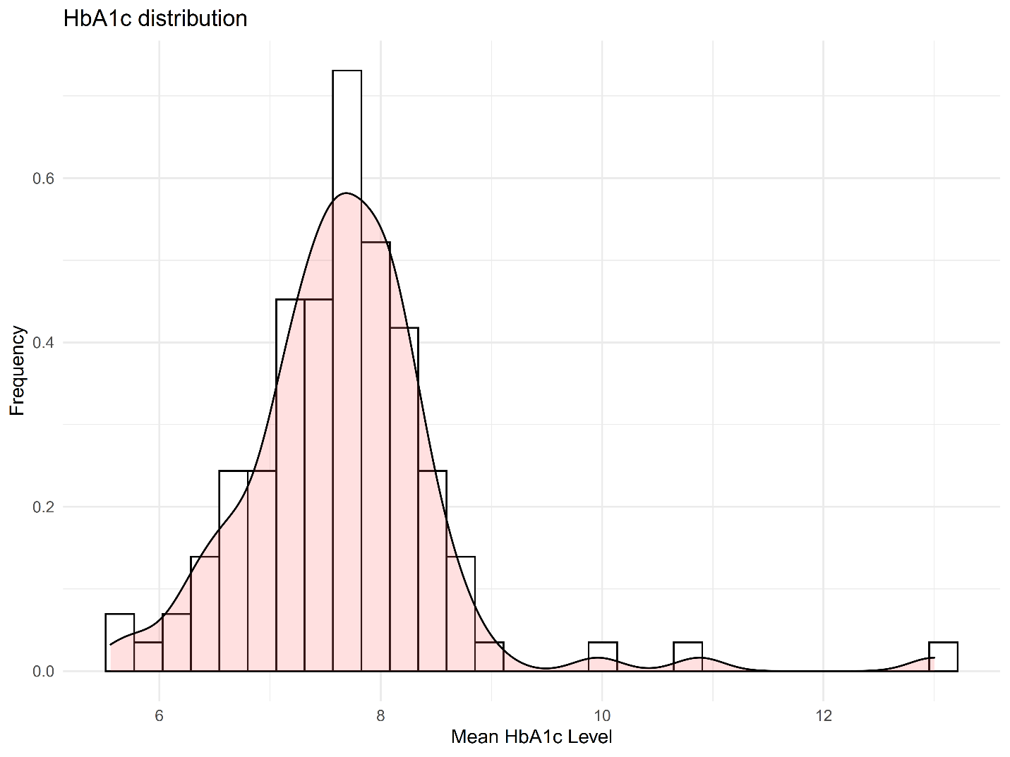
Figure S1. Distribution of average HbA1c level in this study.

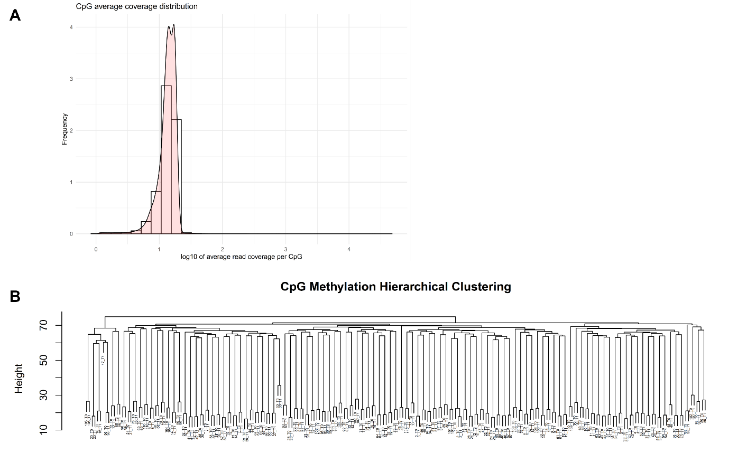
Figure S2. Sequencing Statistics and Quality Control. (A). Distribution of mean read coverage of samples. (B). Hierarchical clustering based on top 1% variable CpGs in chr1.

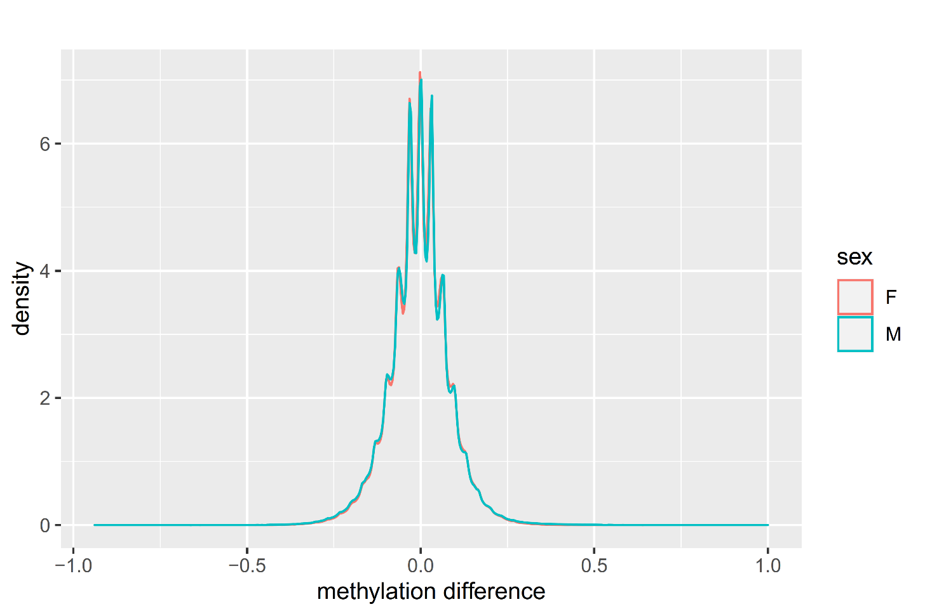
Figure S3. Distribution of the DNA methylation changes between two time points for both male and female.

