Figure S1

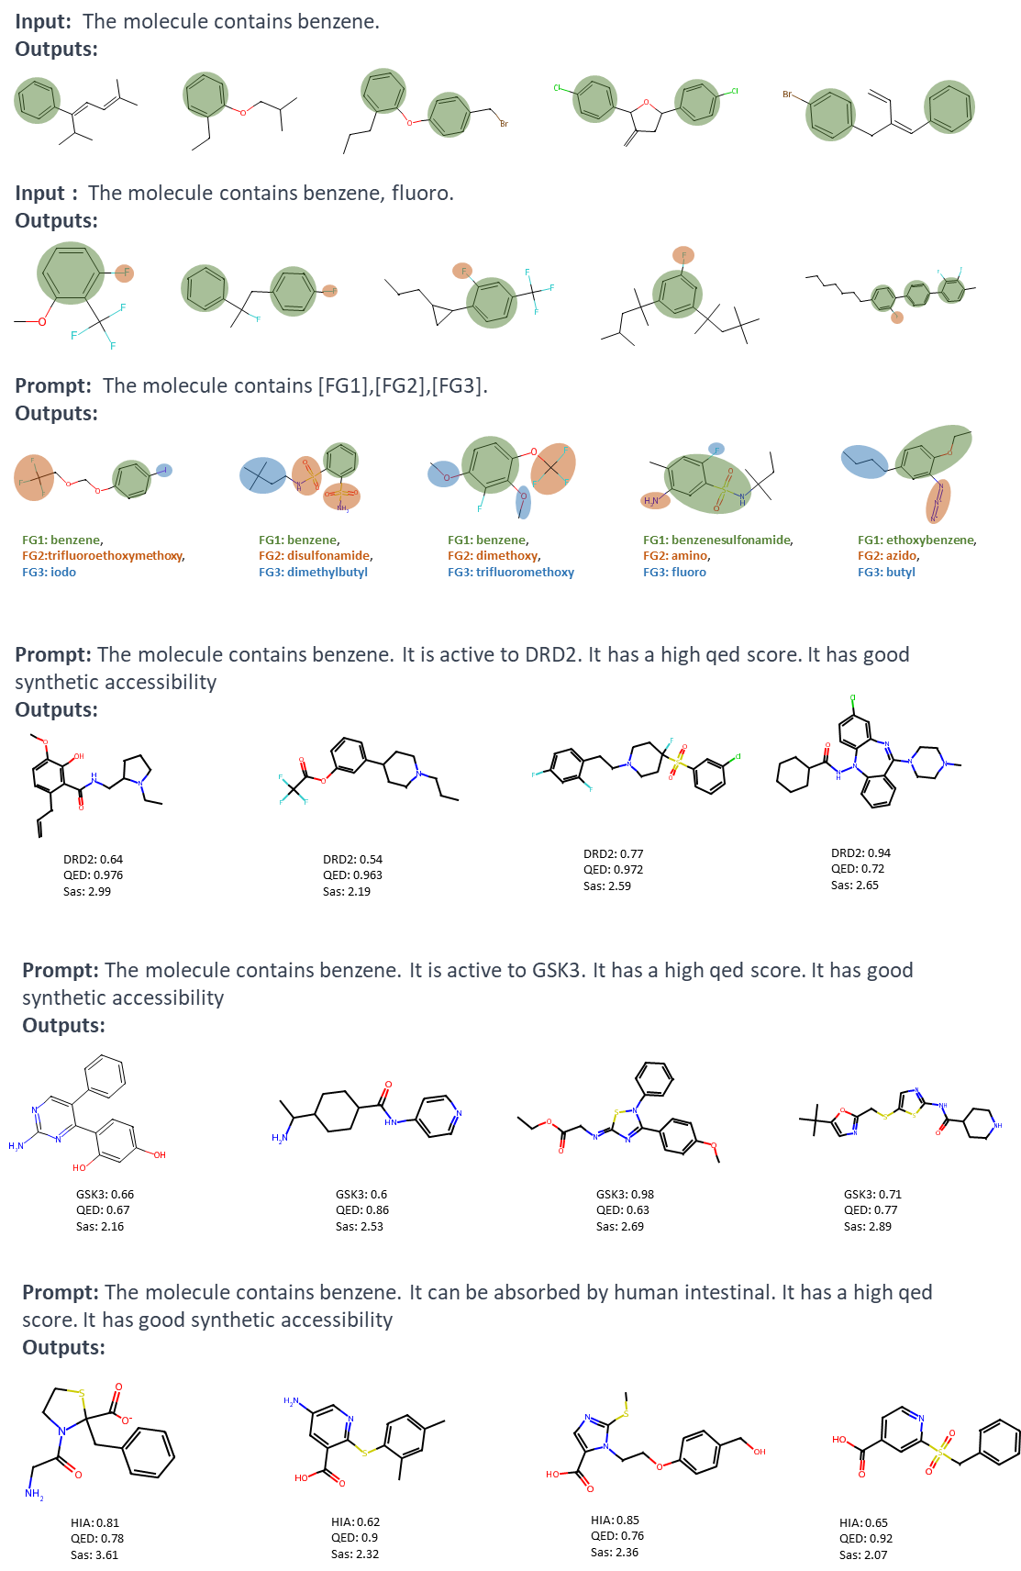

Figure S1 Molecules generated by STMMG with different prompt
Figure S2
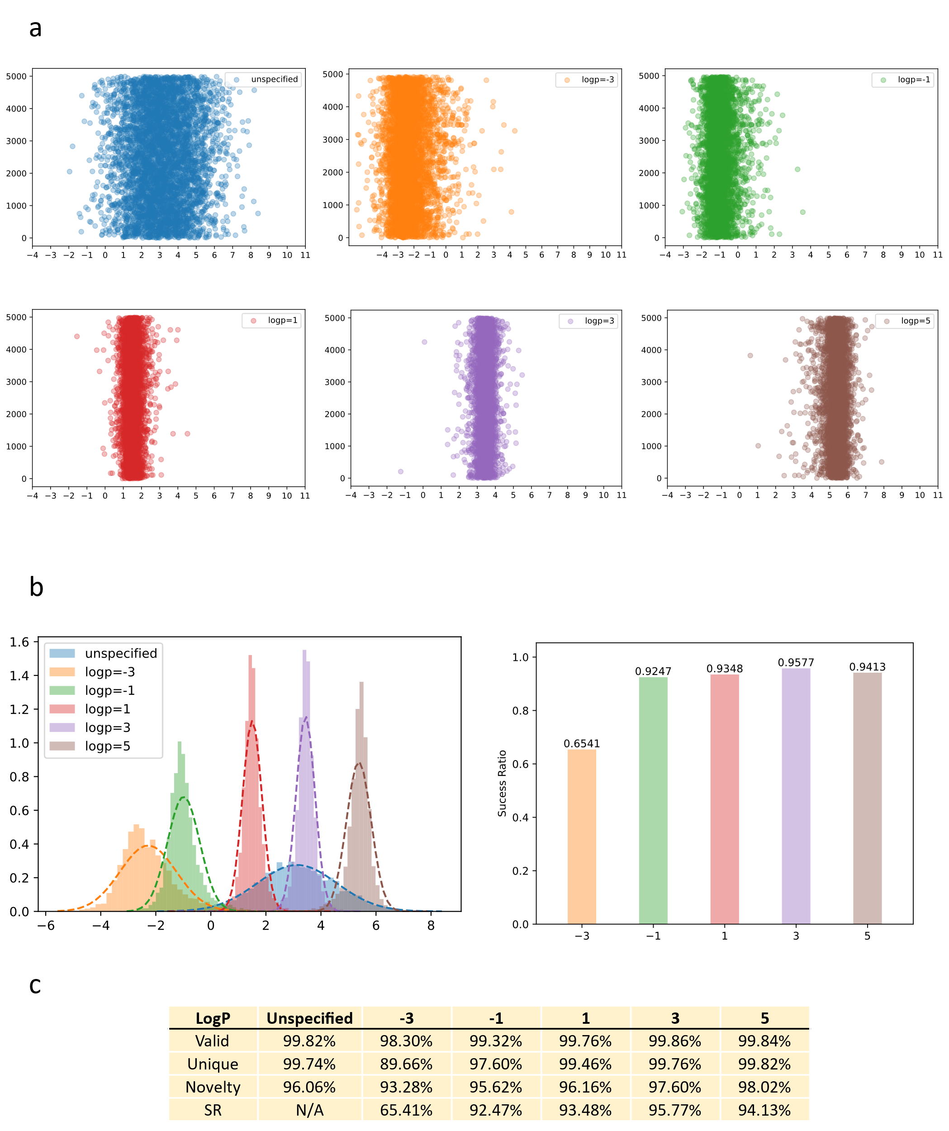

Figure S2 Experimental results when specifying LogP. (a) Scatter plot of LogP of molecules generated with specified values. It can be observed that the LogPs of most generated molecules are concentrated around the specified value. (b) Distribution of LogP (left) and success rate (right) of molecules generated with different specified values. We consider a generated molecule to be successful if its LogP differs from the specified value by no more than 1. (c) Detailed experimental data when specifying different LogPs.

Figure S3
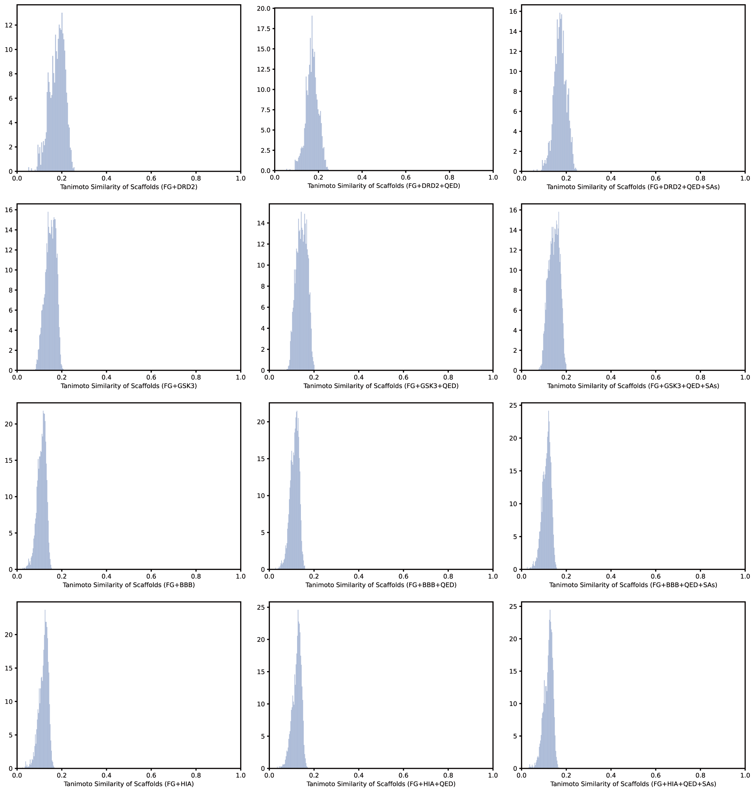
Figure S3 Tanimoto similarity of scaffolds for generated molecules.

