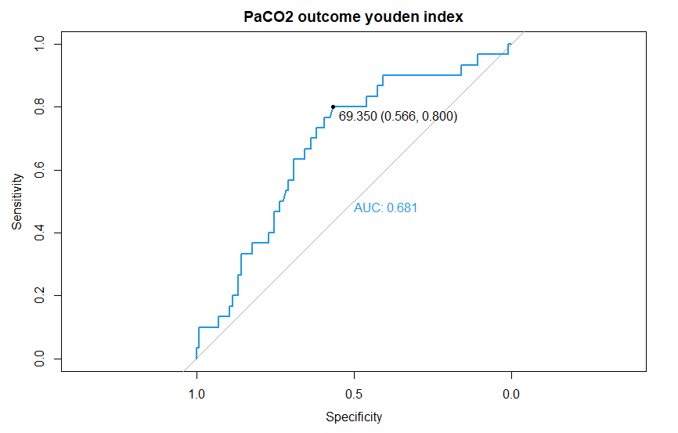
PaCO₂ (mmHg) | sensitivity | specificity | Youden index
69.35 | 0.566 | 0.800 | 1.366
67.30 | 0.593 | 0.767 | 1.360
69.70 | 0.558 | 0.800 | 1.358
63.20 | 0.619 | 0.733 | 1.353
68.10 | 0.584 | 0.767 | 1.351
70.10 | 0.549 | 0.800 | 1.349
63.75 | 0.611 | 0.733 | 1.344
68.95 | 0.575 | 0.767 | 1.342
70.50 | 0.540 | 0.800 | 1.340
62.75 | 0.637 | 0.700 | 1.337
64.90 | 0.602 | 0.733 | 1.335

Supplementary table 1. ROC curve and Youden index of PaCO₂ and neurological outcome.

ECPR selection criteria of
- CRITICAL study¹: initial shockable rhythm + collapse-hospital time<45min + age <75yr
- Lunz²: age≤65 years + witnessed cardiac arrest with bystander CPR + arrest-ECMO time <60min
CRITICAL study | 100 patients meeting all criteria。 19 patients with FO (19%).  48 patients meeting all criteria + PaCO₂ < 70mmHg。 16 patients with FO (33%).
CRITICAL study | 3 patients with FO were excluded.  FO percentage increased from 19% to 33%.
LUNZ | 37 patients meeting all criteria。 11 patients with FO (29%).  23 patients meeting all criteria + PaCO₂ < 70mmHg。 8 patients with FO (34%).
LUNZ | 3 patients with FO were excluded.  FO percentage increased from 29% to 34%.

Supplementary table 2. Analysis of the study population with pre-specified ECPR criteria and PaCO₂ 70 mmHg.
1. Okada Y, Irisawa T, Yamada T, et al. Clinical outcomes among out-of-hospital cardiac arrest patients treated by extracorporeal cardiopulmonary resuscitation: The CRITICAL study in Osaka. Resuscitation 2022;178:116-23.
2. Lunz D, Calabrò L, Belliato M, et al. Extracorporeal membrane oxygenation for refractory cardiac arrest: a retrospective multicenter study. Intensive care medicine 2020;46:973-82.

