Supporting Information

Realization of strong microwave absorption characteristics of Gd₅Si₂Ge₂ nanoparticles with materials data-driven discovery

Pritom J. Bora^{1*}, Bibhusita Mahanta¹, Shalabh Gupta², Praveen C. Ramamurthy^{1*} and Ravi L. Hadimani^{3, 4*}

¹ Department of Materials Engineering, Indian Institute of Science, Bangalore-560012, India.
²Division of Materials Science and Engineering, Ames Laboratory, US Department of Energy, Ames, IA 50011, USA
²Department of Mechanical and Nuclear Engineering, Virginia Commonwealth University, Richmond, VA 23059, U S A
⁴Martino’s Center for Biomedical Imaging, Department of Psychiatry, Harvard Medical School, Harvard University, Boston, MA 021129, USA

*Corresponding author e-mail:
E-mail: jyotipritom09@gmail.com, onegroupb203@gmail.com , rhadimani@vcu.edu

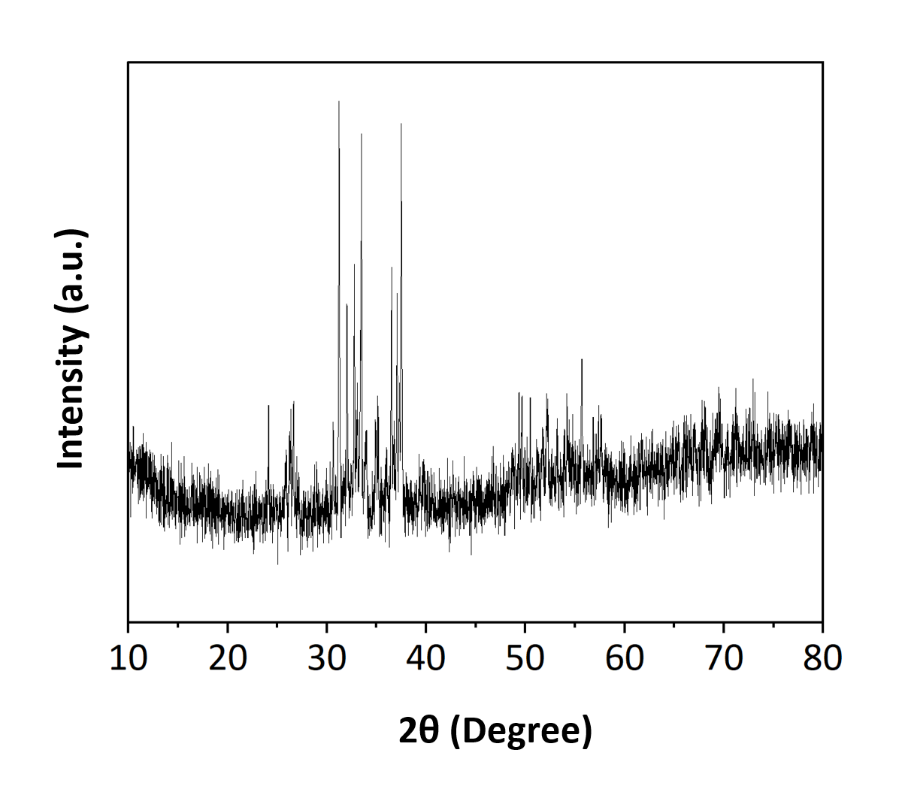

Fig.S1. Recorded XRD diffractogram of the Gd₅Si₂Ge₂ nanoparticles.

