Supplementary Figures
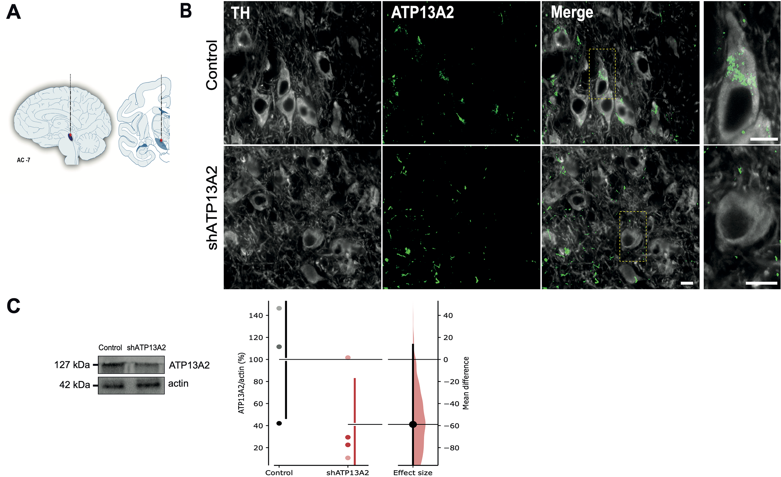

Supp. Figure 1. Intranigral injection of a shATP13A2 lentiviral vector decreases ATP13A2 expression levels. (A) Schematic diagram indicating the site of nigral stereotactic LB inoculations in monkeys. (B) Representative confocal micrographs of double immunostaining for dopaminergic marker tyrosine hydroxylase (TH) and the ATP13A2 protein in the substantia nigra of control and shATP13A2-injected monkey five months post-administration. Scale bar = 10 μm. (C) Immunoblot representative image and analysis of ATP13A2 protein levels in the substantia nigra of control and shATP13A2-injected monkeys (p=0.07825, t=1.666). Each dot represents one hemisphere of the control (black) and shATP13A2-injected NHPs (red). Bootstrapped mean difference with 95% CI (error bar) is shown on the right side of each graph. Comparisons were made using an unpaired Student's t-test.

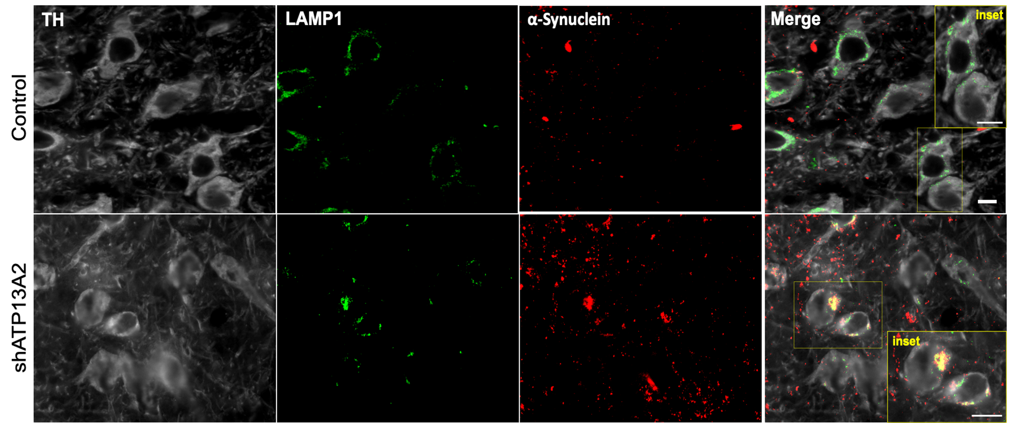

Supp. Figure 2. Intranigral injection of a shATP13A2 lentiviral vector changes the a- syn staining distribution pattern. Representative confocal micrographs of triple immunostaining for dopaminergic marker tyrosine hydroxylase (TH), lysosomal-related marker (LAMP1) and α-synuclein (syn211 antibody) in the substantia nigra of shATP13A2-injected monkey mice five months after injection. Scale bar = 10 μm.

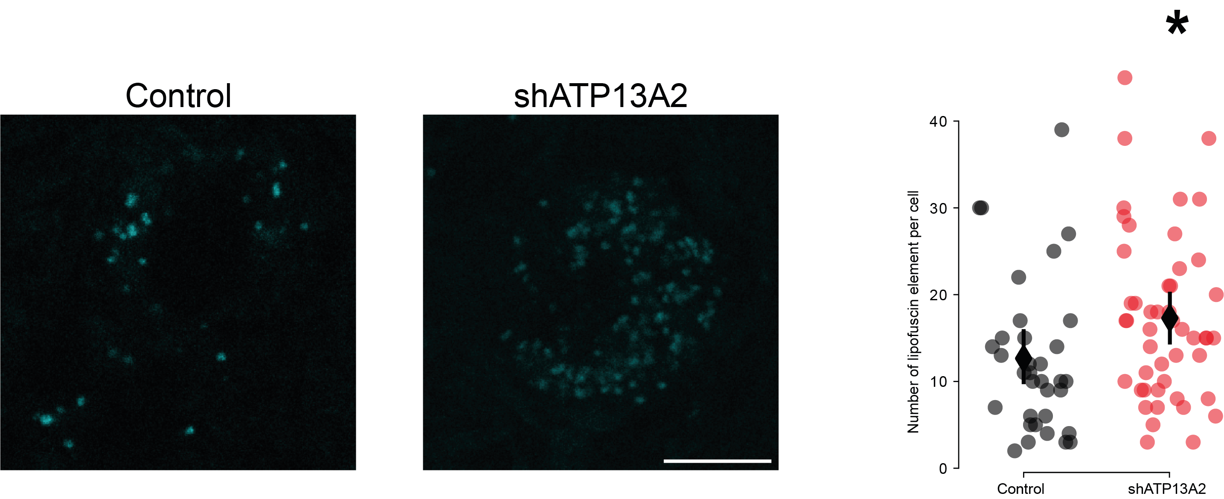
Supp. Figure 3. Accumulation of lipofuscin in the substantia nigra in shATP13A2 monkeys. Representative images (left) and quantification (right) of lipofuscin element per cell in the substantia nigra in the substantia nigra of the shATP13A2-injected monkey five months post-injection (n = 34-48 cells) (p=0.01455, t=2.222). Scale bar: 10 μm. Comparisons were made using an unpaired Student's t-test. *p-value<0.05 compared to control animals.

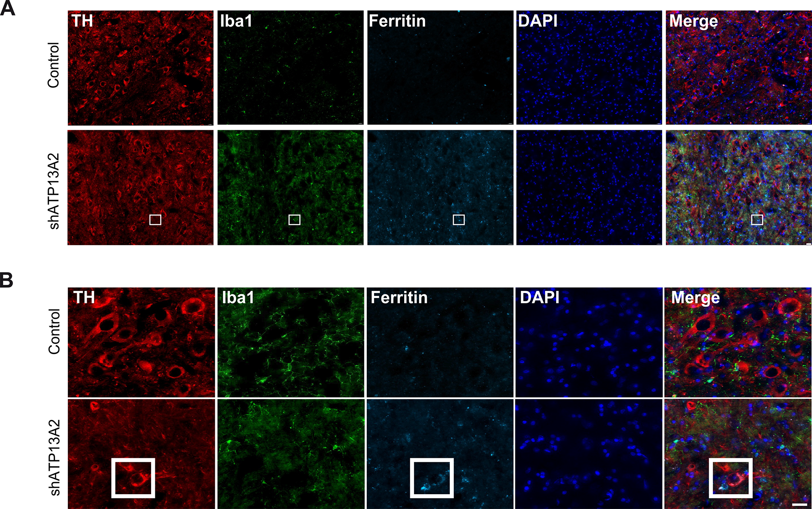

Supp. Figure 4. Increased ferritin levels in microglia in shATP13A2 monkeys. (A-B) Representative confocal micrographs of triple immunostaining for dopaminergic marker tyrosine hydroxylase (TH), microglial marker (Iba1), and ferritin in the substantia nigra of shATP13A2-injected monkey five months post-injection at different magnification (low, A; high, B). Scale bar = 10 μm.

