Supplemental digital content to

NephroPOC – Proenkephalin A 119-159 predicts acute kidney injury and 28-day mortality in patients with suspected organ dysfunction in the emergency department (ED): secondary analysis from the prospective observational LifePOC study.
Caroline Neumann¹, Fabia D. Lobo de Sá², Oliver Hartmann², Thomas Lehmann³, Michael Kiehntopf⁴, Michael Joannidis⁵, Myrto Bolanaki⁶, Anna Slagman⁶, Martin Möckel⁶, Michael Bauer¹ and Johannes Winning¹

¹Department of Anaesthesiology and Intensive Care Medicine, University Hospital Jena, Am Klinikum 1, 07747 Jena, Germany
²SphingoTec GmbH, Neuendorfstraße 15 A, 16761 Hennigsdorf, Germany
³Center for Clinical Studies, University Hospital Jena, Am Klinikum 1, 07747 Jena, Germany
⁴Institute of Clinical Chemistry and Laboratory Diagnostics and Integrated Biobank Jena (IBBJ), University Hospital Jena, Am Klinikum 1, 07747 Jena, Germany
⁵Division of Intensive Care and Emergency Medicine, Department of Internal Medicine, Medical University Innsbruck, Anichstrasse 35, 6020 Innsbruck, Austria
⁶Department of Emergency and Acute Medicine, Campus Virchow and Mitte, Charité-Universitätsmedizin Berlin, Augustenburger Platz 1, 13353 Berlin, Germany

Table S1: estimated GFR calculated from the biomarker values of patients at admission with and without AKI within 48 hours (n=453)
Patient characteristics | Total  (n=453, 100%) | Patients with AKI  (n= 88,19.4%) | Patients without AKI  (n=365, 80.6%) | p-value
eGFR CKD-EPI | 52.4 [30.8-83.1] | 41.6 [24.6-61.9] | 56.8 [32.2-86.0] | 0.0006
eGFR PENK-Crea | 57.5 [32.3-83.5] | 43.4 [21.0-61.6] | 63.9 [36.5-89.4] | <0.0001

Table S2: Prediction of AKI within 24, 48, and 72 h using admission biomarkers and eGFR
Model | n | Events | Model Chi2 | p-value | C index [95% CI]
24 h
penKid | 767 | 56 | 47.24 | <0.00001 | 0.746 [0.679-0.813]
sCr | 767 | 56 | 26.16 | <0.00001 | 0.724 [0.659-0.789]
eGFRPENK-Crea | 767 | 56 | 38.17 | <0.00001 | 0.738 [0.671-0.804]
eGFRCKD-EPI | 767 | 56 | 29.29 | <0.00001 | 0.709 [0.642-0.777]
48h
penKid | 453 | 88 | 28.82 | <0.00001 | 0.678 [0.618-0.737]
sCr | 453 | 88 | 7.08 | 0.0078 | 0.610 [0.547-0.674]
eGFRPENK-Crea | 453 | 88 | 22.06 | <0.00001 | 0.656 [0.596-0.717]
eGFRCKD-EPI | 453 | 88 | 12.9 | 0.00033 | 0.619 [0.556-0.681]
72 h
penKid | 337 | 108 | 17.89 | 0.00002 | 0.642 [0.581-0.703]
sCr | 337 | 108 | 0.37 | 0.5438 | 0.537 [0.472-0.603]
eGFRPENK-Crea | 337 | 108 | 10.47 | 0.00121 | 0.605 [0.542-0.668]
eGFRCKD-EPI | 337 | 108 | 3.64 | 0.05629 | 0.559 [0.495-0.623]

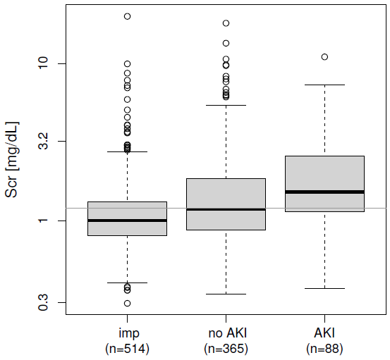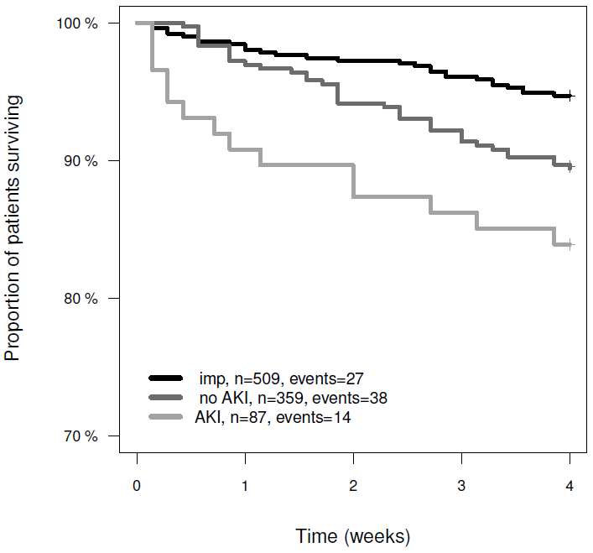
Figure S1 a and b: Rational for sensitivity analysis according to the primary endpoint AKI within 48h: Admission Scr (left) and 28-day survival rates (right) for patients reaching the AKI endpoint within 48h (AKI), patients not reaching AKI within 48h (no AKI) and patients with imputed endpoint (imp). Patients with baseline Scr, at least one Scr measurement during the 72 h follow up, but otherwise incomplete Scr data (group no-AKI-prob) had lower Scr baseline values and a lower 28-day mortality rate.

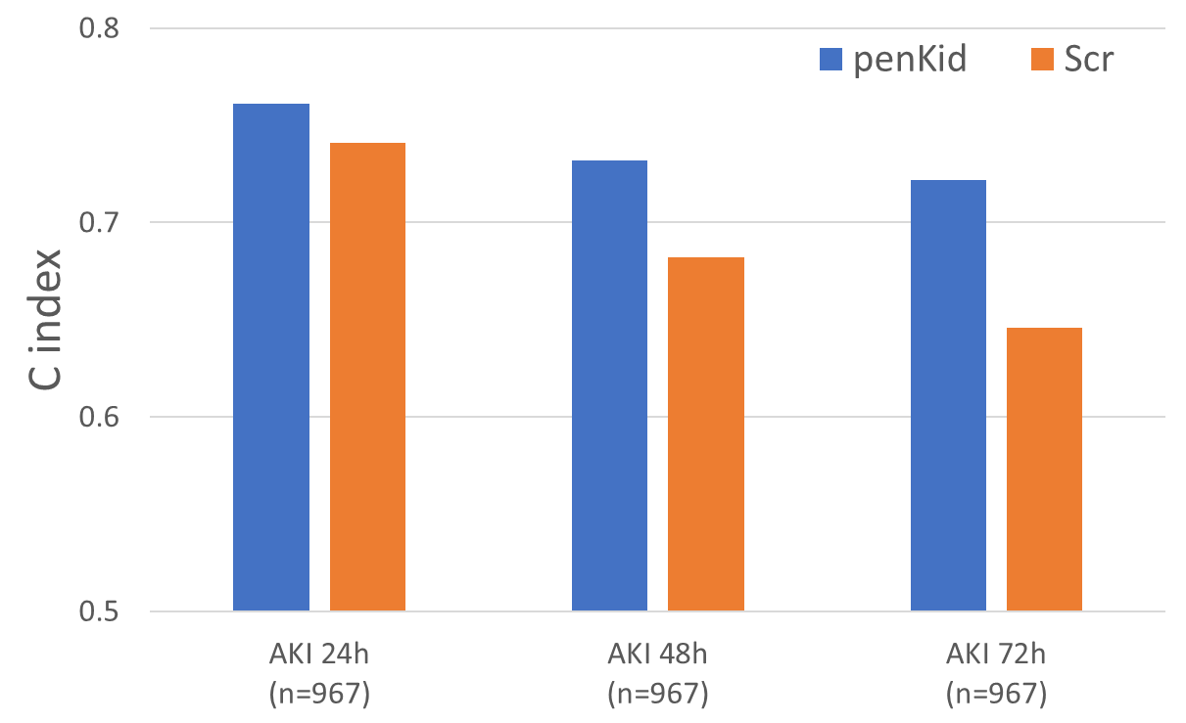
Figure S2: Sensitivity analysis - Prediction of AKI within 24, 48, and 72 h using admission biomarkers penKid and Scr. C index: concordance index (area under the curve (AUC)); penKid: Proenkephalin A 119-159; Scr: serum creatinine; AKI: acute kidney injury

Table S3: Sensitivity analysis - Prediction of AKI within 24, 48, and 72 h using admission biomarkers penKid and Scr.
Model | n | Events | Model Chi2 | p-value | C index [95% CI]
AKI 24 h (all patients with at least 1 follow up Scr value)
penKid | 967 | 60 | 59.0 | <0.00001 | 0.761 [0.698-0.824]
Scr | 967 | 60 | 31.3 | <0.00001 | 0.741 [0.680-0.801]
AKI 48 h (all patients with at least 1 follow up Scr value)
penKid | 967 | 90 | 58.7 | <0.00001 | 0.732 [0.680-0.784]
Scr | 967 | 90 | 26.7 | <0.00001 | 0.682 [0.624-0.741]
AKI 72 h (all patients with at least 1 follow up Scr value)
penKid | 967 | 108 | 58.8 | <0.00001 | 0.722 [0.674-0.771]
Scr | 967 | 108 | 19.8 | 0.00001 | 0.646 [0.590-0.703]

Table S4: Prediction of AKI within 48h using admission biomarkers and GFR estimates: Net reclassification improvement based on GFR categories.
Patients without AKI within 48 h |  |  |  |  |  | Patients with AKI within 48 h
 |  | PENK-Crea |  |  |  |  |  | PENK-Crea
 |  | (0,30] | (30,60] | (60,90] | (90,140] |  |  | (0,30] | (30,60] | (60,90] | (90,140]
CKD-EPI | (0,30] | 65 | 15 | 0 | 0 | CKD-EPI | (0,30] | 25 | 1 | 0 | 0
CKD-EPI | (30,60] | 7 | 74 | 30 | 3 | CKD-EPI | (30,60] | 5 | 29 | 4 | 0
CKD-EPI | (60,90] | 0 | 9 | 62 | 25 | CKD-EPI | (60,90] | 0 | 4 | 9 | 1
CKD-EPI | (90,140] | 0 | 1 | 12 | 62 | CKD-EPI | (90,140] | 0 | 0 | 5 | 5
 | Patients with lower GFR in PENK-Crea: n=29 |  |  |  |  |  | Patients with lower GFR in PENK-Crea: n=14
 | Patients with higher GFR in PENK-Crea: n=73 |  |  |  |  |  | Patients with higher GFR in PENK-Crea: n=6
 | Nett gain: n=44 |  |  |  |  |  | Nett gain: n=8
 | rel. Gain: 12.1% |  |  |  |  |  | rel. Gain: 9.1%

