Supplementary Information:
Controlling edwardsiellosis caused by Edwardsiella piscicida and mitigating drug-resistant gene dissemination: Bacteriophage EPP-1, a promising antibiotic alternative

Ganghua Han ª, Ting Huang ª, Xinchun Liu ª, Ruyin Liu ^{a, b, *}

ª College of Resources and Environment, University of Chinese Academy of Sciences, Beijing, China.
^{b} Yanshan Earth Critical Zone National Research Station, University of Chinese Academy of Sciences, Beijing, China.

* Corresponding author: Ruyin Liu
Address: College of Resources and Environment, University of Chinese Academy of Sciences, No.19(A) Yuquan Road, Shijingshan District, Beijing, P.R. China 100049.
Phone: 86-010-69672961
Email: Lry1981@ucas.ac.cn

Supplementary Methods

Phage isolation and purification
Edwardsiella phage was isolated using the methods reported by Thung (Thung et al., 2017) with partial modification. Briefly, the collected environmental water samples were centrifuged at 6000 × g for 10 min to remove debris and coarse particles, the resulting supernatant was then passed through a 0.22 μm pore size filter and subsequently used for phage isolation. The host bacteria E. piscicida MCCC 1K00246 in the early exponential phase was incubated overnight with the filtrate and TSB medium at 30℃ and 120 rpm to enrich phages, the mixture was centrifuged and filtered, and then visualize phages by the double layer agar plate method (DLA). The individual plaque was puncture picked up and resuspended in SM buffer, purified 3 to 5 times, and proliferated to 10⁹ PFU/mL for further analysis.

Transmission electron microscopy
Phage structure and morphology were observed using transmission electron microscopy. Briefly, 3 μL of purified phage particle suspension with titer over 10⁹ PFU/mL was gently placed on carbon-coated 300 mesh copper grids. The grid was then negative stained with 2% (wt/vol) uranyl acetate and air-dried. Phage structure and morphology were visualized with a Transmission electron microscope (JEM-1400, Japan) at an operating voltage of 100 kV. Phage particle dimensions were measured using the ImageJ software (Schneider et al., 2012).

Host range test
The host range of phage isolated in this study was determined using 12 other strains of Edwardsiella purchased from MCCC by spot assay. Three μL of purified phage suspension (> 10⁹ PFU/mL) was spotted over a lawn of bacteria, incubated overnight at 30℃ without shaking, and then observed for plaque formation.

Temperature and pH tolerance assay
For thermal tolerance assay, equivalent volumes of phage suspension were kept at -80℃, -20℃, 4℃, 25℃, 37℃, 50℃, 65℃, and 80℃ in the refrigerator or water bath for 60 min, respectively, and then the titers were determined by DLA method. Similarly, for pH tolerance assay, 100 μL of phage suspension was added to 900 μL of TSB medium with pH of 1, 3, 5, 7.3, 9, 11 and 13, respectively, and rested for 60 min at 30℃, and then the titer was determined by DLA method. Each experiment was conducted in triplicate.

Antibacterial effect in vitro
The phage storage solution was diluted and mixed with logarithmic growth-phase host E. piscicida MCCC 1K00246 and TSB medium at a ratio of 1:1:98 to make their MOI to 100, 10, 1, 0.1, 0.01, and 0, respectively, and incubated at 30℃, 120rpm, and the OD₆₀₀ values were measured every hour with a microplate reader (SynergyTM H1, BioTek Inc., Winooski, VT, USA). MOI of 0 without phages as control and 6 replicates per MOI.

Phage DNA extraction
Phage nucleic acid extraction was performed as described previously by Kim et al. (Kim et al., 2019). Briefly, 500 μL of the phage particle suspension was treated with DNase Ⅰ and RNase A (Solarbio, Beijing, China) and incubated at 37℃ for 60 min to degrade the DNA and RNA from E. piscicida MCCC 1K00246. Ethylenediaminetetraacetic acid (EDTA, Solarbio, Beijing, China) was then added to inactivate the DNase Ⅰ for prevention of the subsequent degradation of phage DNA. Later, proteinase K and 10% SDS solution (Solarbio, Beijing, China) were added, 37℃ water bath for 30 min followed by 56℃ water baths for 60 min, and then a rapid ice bath. DNA purification was performed according to the traditional phenol-chloroform extraction method (Chong, 2001).

Bioinformatic analysis
The coding DNA sequences (CDSs) of the phage were predicted and annotated using PHASTER (Arndt et al., 2016) and the genome profiles of the phage were mapped by CGview Server (Grant and Stothard, 2008). The presence of antibiotic resistance genes and virulence factors were screened using the Comprehensive Antibiotic Resistance Database (CARD) (Alcock et al., 2020) and Virulence Factors Database (VFDB) (Liu et al., 2019), respectively. The phylogenetic tree based on terminase large (TerL) subunit of phage was constructed using the neighbour-joining method in MEGA X with 1000 bootstrap replications (Kumar et al., 2018). To avoid bias from single gene, whole genome-wide average nucleotide identity (ANI) values were also calculated through the online platform JspeciesWS (http://jspecies.ribohost.com/jspeciesws/) and visualized on GraphPad Prism 9.

Determination of pathogenic infection dose and phage therapeutic dose
To assess the pathogenicity of E. piscicida MCCC 1K00246 and the efficacy of phage EPP-1, it is warranted to determine the pathogen infection dose and the phage therapeutic dose. Four groups of different infectious doses were set up with 10 zebrafish per tank and zebrafish in each tank were injected intraperitoneally with 2 μL of different CFU of bacterial solution (dilution with sterile PBS buffer) making the injection dose of each group to 0, 10⁴, 10⁵, and 10⁶ CFU/fish, respectively. In which, the 0 CFU/fish group was injected with 2 μL sterile PBS buffer and served as the control group. The mortality rate was recorded daily for 15 consecutive days. To highlight the efficacy of phage therapy, a dose with mortality of no less than 50% was selected for subsequent experiments.
Therapeutic phages were injected intraperitoneally simultaneously with a dose of bacterial infection identified, making their MOI to 0, 0.1, 1, 5, and 10, respectively. High titer phage lysate was diluted with SM buffer. In which, the MOI=0 group was injected with 1 μL sterile PBS buffer and 1 μL sterile SM buffer. The mortality rate was recorded daily for 10 consecutive days and the MOI with optimal therapeutic effect was selected for the further trials. The breeding conditions are standard aquaculture system, as shown in the text.

Quantitative PCR
The gyrB and floR genes were quantified in water and stool samples in triplicate against a 10-fold serial dilution standard curve and a DNA-free negative control. Results of the assays were analyzed based on the standard curve of each gene. Briefly, amplification of gyrB gene was performed in a 20 μL reaction volume containing 10 μL of 2 × SYBR® Premix TaqTM (TaKaRa, Japan), 0.5 μL of each primer (10 μmol/L), 1 μL of template DNA, 0.4 μL of bovine serum albumin (5 mg/mL, Solarbio, Beijing, China), and 7.6 μL of ddH₂O using an ABI QuantStudio™ 1 real-time PCR instrument (Applied Biosystems, Grand Island, NY, USA). The thermal cycle consists of 30 s initial denaturation at 95℃, followed by 40 cycles of the following: 10 s at 95℃, 20 s at 63℃, and 20 s at 72℃, with reading plate after each cycle. The setting of the amplification melting curve to verify the absence of non-specific amplicons are as follows: 15 s at 95℃, 15 s at 60℃, and 15 s at 95℃. For the amplification of floR gene, a 20 μL reaction system containing 10 μL of 2 × SYBR® Premix TaqTM (TaKaRa, Japan), 0.2 μL of each primer (10 μmol/L), 1 μL of template DNA, 0.4 μL of bovine serum albumin (5 mg/mL, Solarbio, Beijing, China), and add ddH₂O to the required volume. The thermal cycle for this amplification consists of 10 min initial denaturation at 95℃, followed by 40 cycles of denaturation at 95℃ for 15 s, annealing at 56℃ for 15 s, and extension at 72℃ for 1 min, and the melting curve was performed under default settings.

PCR for 16S rRNA gene
The amplification of V3–V4 hypervariable regions of bacteria was performed in a 20 μL reaction volume containing 4 μL of 5 × FastPfu Buffer, 2 μL of 2.5 mM dNTPs, 0.8 μL of each primer (5 μM), 0.4 μL of FastPfu Polymerase, 0.2 μL of BSA, 10 ng of template DNA, and add ddH₂O to 20 μL using an ABI GeneAmp® 9700 instrument (Applied Biosystems, Grand Island, NY, USA). The thermal cycle consists of 95℃ for 3 min, followed by 29 cycles at 95℃ for 30 s, 53℃ for 30 s, and 72℃ for 45 s and extension at 72℃ for 10 min. The PCR products were identified by 2% agarose gel electrophoresis and further perform amplicon sequencing.

Supplementary Tables
Table S1. Bacterial strains and host range of EPP-1
Bacterial species | Strain ID | Lysis effect
Edwardsiella anguillarum | DSMZ 27202 | -
Edwardsiella hoshinae | ATCC 33379 | -
Edwardsiella ictaluri | ATCC 33202 | -
Edwardsiella ictaluri | MCCC 1K00244 | -
Edwardsiella piscicida | MCCC 1K00245 | -
Edwardsiella piscicida | MCCC 1K00246 | host
Edwardsiella piscicida | MCCC 1K03230 | +
Edwardsiella tarda | ATCC 15947 | -
Edwardsiella tarda | MCCC 1K00241 | +
Edwardsiella tarda | MCCC 1K00243 | -
Edwardsiella sp. | MCCC 1K00239 | +
Edwardsiella sp. | MCCC 1K00240 | +
Edwardsiella sp. | MCCC 1K00242 | +
All bacterial strains used in study were obtained from the MCCC. (-): no plaque; (+) clear plaque.

Table S2. Water quality and measurement methods of feeding water
Parameters | Methods* | Water quality
Temperature (℃) | HACH multiparameter | 23.45±0.55
pH | HACH multiparameter | 8.31±0.05
ORP (mV) | HACH multiparameter | -89.11±3.58
Hardness (mg CaCO₃/L) | Colorimetric with test strips | 250–375
DO (mg/L) | HACH multiparameter | 8.42±0.16
TDS (μS/cm) | TDS meter | 593.25±30.34
NH₄⁺-N (mg/L) | HACH Lange cuvette kit | 0.01±0.02
*HACH multiparameter: HACH DR1900, USA; Colorimetric with test strips: Total Hardness Test, Millipore, Bedford, MA, USA; TDS meter; Sartorius, Germany

Table S3. Primers and corresponding profiles for PCR or qPCR
Gene | Primer | Sequence (5’–3’) | Product size
16S V3–V4 | 338F | ACTCCTACGGGAGGCAGCAG | 468bp
16S V3–V4 | 806R | GGACTACHVGGGTWTCTAAT | 468bp
gyrB | F | TGGCGACACCGAGCAGA | 207bp
gyrB | R | ACAAACGCCTTAATCCCACC | 207bp
floR | F | CGGTCGGTATTGTCTTCACG | 171bp
floR | R | TCACGGGCCACGCTGTAT | 171bp

Supplementary Figures
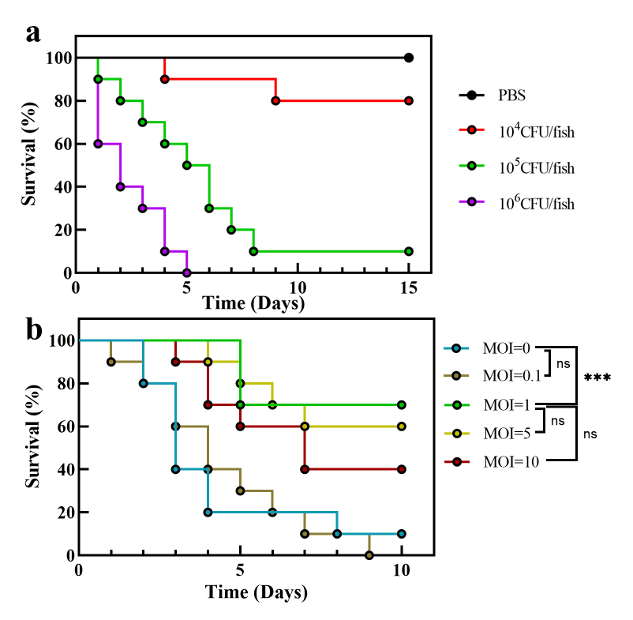
Fig. S1. (a) Survival curves of zebrafish under different infection doses within 15 days (n=10). (b) Survival curves of zebrafish under different MOIs at the infection dose of 10⁵ CFU/fish within 10 days (n=10, *P<0.05, **P<0.01, ***P<0.001, ****P<0.0001, Mantel-Cox test). The mortality of zebrafish at the infection dose of 10⁵ CFU/fish was 90% within 15 days, which is an ideal dose for follow-up studies compared to the infected dose of 10⁴ or 10⁶ CFU/fish that result in either excessively low or high mortalities, and selected for further studies. The phage treatment dose of MOI=1 was the most effective of the four doses selected, and therefore, it was chosen for efficacy comparison with florfenicol.

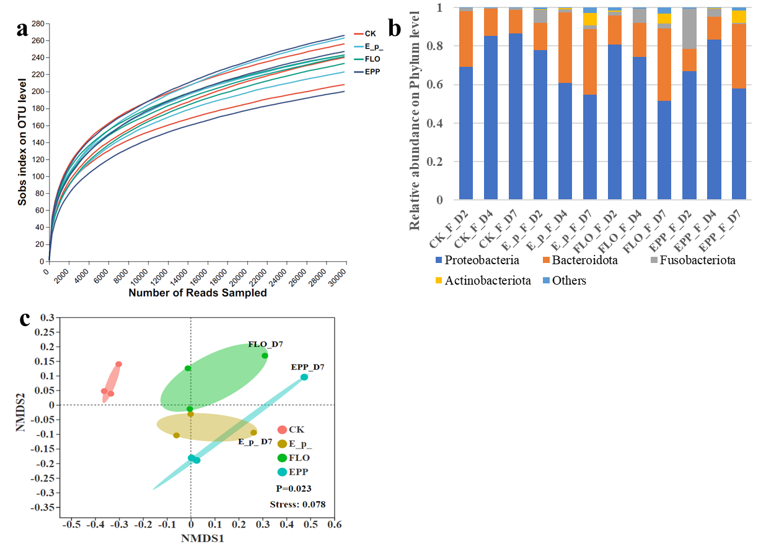
Fig. S2. (a) The tending saturation rarefaction curves for each sample indicating their sufficient sequencing data for further analysis. (b) Relative abundance of bacterial composition of each sample on Phylum level. Only 4 major Phylum are listed in the figure, and the rest are merged into others. (c) NMDS analysis of the bacterial community of the PBS + SM, E. p. + SM, E. p. + FLO, and E. p. +EPP groups on OTU level based on Bray-Curtis distance. The ANOSIM test was used for statistical test. The CK, E_p_, FLO, and EPP in the legend refer to the PBS + SM, E. p. + SM, E. p. + FLO, and E. p. +EPP groups, respectively.

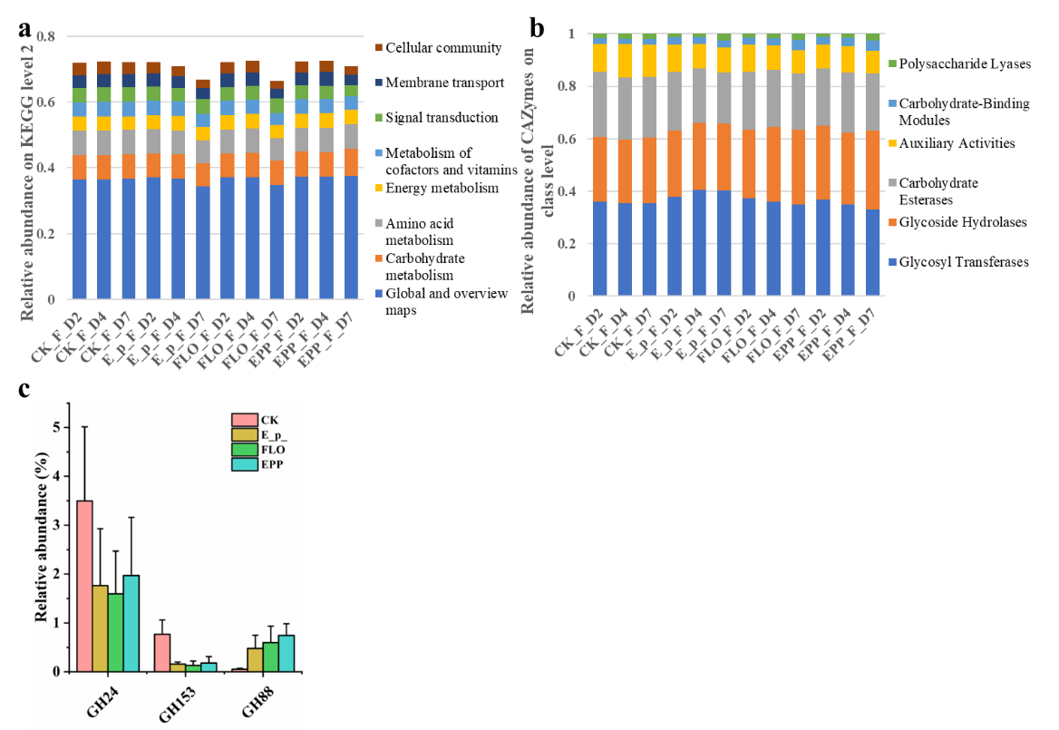
Fig. S3. (a) Relative abundance of gut microbial function of each sample on KEGG level 2. Only 8 major functions are listed in the figure. (b) Relative abundance of top 6 carbohydrate active enzymes of each sample on class level. (c) Relative abundance of lysozyme GH24 and hydrolase GH153, and hydrolase GH88 in four different treatment groups.

Fig. S4. Relative abundance of different types of ARGs detected in each sample. The types with relative abundance lower than 5% are merged into others, but the ARGs of the Phenicol class are shown in the figure.

Reference:
Alcock, B.P., Raphenya, A.R., Lau, T.T.Y., Tsang, K.K., Bouchard, M., Edalatmand, A., Huynh, W., Nguyen, A.L.V., Cheng, A.A., Liu, S.H., Min, S.Y., Miroshnichenko, A., Tran, H.K., Werfalli, R.E., Nasir, J.A., Oloni, M., Speicher, D.J., Florescu, A., Singh, B., Faltyn, M., Hernandez-Koutoucheva, A., Sharma, A.N., Bordeleau, E., Pawlowski, A.C., Zubyk, H.L., Dooley, D., Griffiths, E., Maguire, F., Winsor, G.L., Beiko, R.G., Brinkman, F.S.L., Hsiao, W.W.L., Domselaar, G.V., McArthur, A.G., 2020. CARD 2020: Antibiotic resistome surveillance with the comprehensive antibiotic resistance database. Nucleic Acids Res. 48 (D1), D517-D525.
Arndt, D., Grant, J.R., Marcu, A., Sajed, T., Pon, A., Liang, Y.J., Wishart, D.S., 2016. PHASTER: A better, faster version of the PHAST phage search tool. Nucleic Acids Res. 44 (W1), W16-W21.
Chong, L., 2001. Molecular cloning - A laboratory manual, 3rd edition. Science. 292 (5516), 446-446.
Grant, J.R., Stothard, P., 2008. The CGView Server: A comparative genomics tool for circular genomes. Nucleic Acids Res. 36, W181-W184.
Kim, S.G., Jun, J.W., Giri, S.S., Yun, S., Kim, H.J., Kim, S.W., Kang, J.W., Han, S.J., Jeong, D., Park, S.C., 2019. Isolation and characterisation of pVa-21, a giant bacteriophage with anti-biofilm potential against Vibrio alginolyticus. Sci. Rep. 9, 6284.
Kumar, S., Stecher, G., Li, M., Knyaz, C., Tamura, K., 2018. MEGA X: Molecular evolutionary genetics analysis across computing platforms. Mol. Biol. Evol. 35 (6), 1547-1549.
Liu, B., Zheng, D.D., Jin, Q., Chen, L.H., Yang, J., 2019. VFDB 2019: A comparative pathogenomic platform with an interactive web interface. Nucleic Acids Res. 47 (D1), D687-D692.
Schneider, C.A., Rasband, W.S., Eliceiri, K.W., 2012. NIH Image to ImageJ: 25 years of image analysis. Nat. Methods. 9 (7), 671-675.
Thung, T.Y., Norshafawatie, B., Premarathne, J., Chang, W.S., Loo, Y.Y., Kuan, C.H., New, C.Y., Ubong, A., Ramzi, O.S.B., Mahyudin, N.A., Dayang, F.B., Jasimah, W., Son, R., 2017. Isolation of food-borne pathogen bacteriophages from retail food and environmental sewage. Int. Food Res. J. 24 (1), 450-454.

