Supplementary Materials
Sup Table 1: Details of remote sensing data used in this study.
SL. No. | Satellite Sensors | Year | Path/  Row | Resolution (m) | Date of image collection | Image Type
1 | Landsat 5 TM | 2000 | 139/41 | 30 | 26 December 2000 | Level-1 GeoTIFF
2 | Landsat 5 TM | 2000 | 138/42 | 30 | 26 January 2000 | Level-1 GeoTIFF
3 | Landsat 5 TM | 2010 | 139/41 | 30 | 30 December 2010 | Level-1 GeoTIFF
4 | Landsat 5 TM | 2010 | 138/42 | 30 | 23 December 2010 | Level-1 GeoTIFF
5 | Landsat 8 OLI | 2020 | 139/41 | 30 | 09 December 2020 | Level-1 GeoTIFF
6 | Landsat 8 OLI | 2020 | 138/42 | 30 | 02 December 2020 | Level-1 GeoTIFF

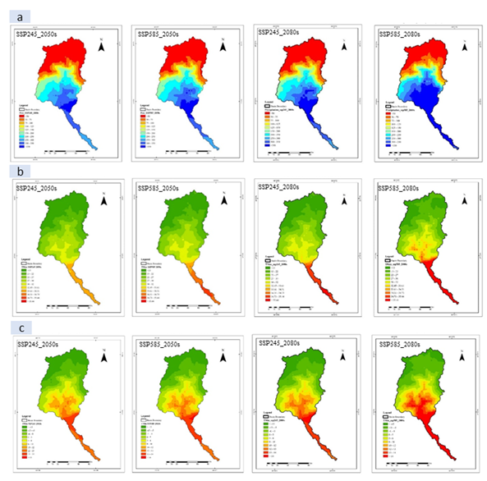
Supp. Figure 1: (a) Map of future Precipitation over Teesta basin SSP245 scenario the near future, SSP585 scenario near future, SSP245 scenario far future and SSP585 scenario far future; (b) Map of future Maximum over Teesta basin SSP245 scenario near future, SSP585 scenario near future, SSP245 scenario far future and SSP585 scenario far future; (c) Map of future minimum temperature over Teesta basin SSP245 scenario near future, SSP585 scenario near future, SSP245 scenario far future and SSP585 scenario far future

Sup Table 2: Percentage Changes of monthly discharge from the base period (2020s) to the near future and far future.
Month | 2050 |  | far future
Month | SSP245 | SSP585 | SSP 245 | SSP585
January | -57.31% (-90% --11%) | -54.51% (-86% -18%) | -46.86% (-88% -49%) | -41.53% (-88 % -53%)
February | -40.24% (-86% -81%) | -55.27% (-91% -37%) | -38.67% (-90% -67%) | -41.08% (-90% -72%)
March | 1.42% (-83% -133%) | -8.57% (-88% -127%) | -17.78% (-92% -138%) | -2.77% (-89% -180%)
April | 29.49% (-69% -238%) | 14.62% (-74% -188%) | 42.73% (-73% -266%) | 47.56% (-80% -253%)
May | 54.81% (-51% -212%) | 75.89% (-59% -283%) | 54.83% (-40% -197%) | 96.49% (-26% -271%)
June | 78.59% (-50% -252%) | 93.71% (-49% -282%) | 82.71% (-52% -308%) | 97.78% (-47% -316%)
July | 38.85% (-26% -155%) | 47.61% (-29% -218%) | 34.05% (-41% -177%) | 55.65% (-22% -222%)
August | -8.05% (-38% -22%) | 2.37% (-37% -49%) | -2.81% (-35% -32%) | 11.95% (-26% -65%)
September | -4.85% (-43% -52%) | 8.91% (-28% -56%) | 3.08% (-39% -58%) | 14.73% (-27% -65%)
October | -1.34% (-41% -90%) | 21.56% (-23% -78%) | 13.02% (-40% -70%) | 38.97% (-27% -111%)
November | -16.35% (-59% -48 %) | -10.77% (-53% -52%) | -10.81% (-51% -49%) | 6.46% (-56% -90%)
December | -41.04% (-75% -4%) | -39.79% (-74% -28%) | -37.28% (-74% -38%) | -34.31% (-79% -18%)

Sup Table 3: LULC changes impact on discharge at Dalia Point in the near future and far future.
Month | near future |  | far future
Month | SSP245 | SSP585 | SSP245 | SSP585
January | 0.31% (-0.96% -2%) | 0.9% (-1% -7%) | -7.4% (-19% -5%) | -16.7% (-66% -56%)
February | 1.19% (-0.58% -4.16%) | 1.4% (0.3% -3%) | -5.4% (-12% -1%) | -3.9% (-60% -87%)
March | 3.67% (0.56% -6.73%) | 4.3% (2% -6%) | -4% (-7% -1%) | 7.3% (-42% -92%)
April | 3.71% (2.72% -8.38%) | 5.14% (1% -7%) | -1.34% (-4% -2%) | 23.7% (-40% -117%)
May | 3.72% (-1.8% -9%) | 4.3% (-0.1% -7%) | 2.4% (-1% -8%) | 42.1% (-24% -138%)
June | 4.2% (-3.4% -7.3%) | 6.8% (-3% -10%) | 11.9% (4% -18%) | 55.6% (-28% -163%)
July | 6 % (-8% -5.9%) | 7.1% (-7% -10%) | 13.4% (5% -18%) | 51.2% (-16% -145%)
August | 2.8% (-9.8% -4.2%) | 4.3% (-13.4% -11.2%) | 15.4% (-0.5% -25%) | 59.6% (-33% -156%)
September | 2.8% (-10.9% -2.8%) | 2.4% (-10% -10.2%) | 12.4% (-7% -32%) | 41.7% (-41% -140%)
October | 0.8% (-6.5% -4.4%) | -0.4% (-6.8% -6.3%) | 1.4% (-17% -32%) | 10% (-68% -137%)
November | -0.99% (-3.5% -6.1%) | -0.27% (-2.8% -8.2%) | -2.4% (-18% -23%) | -7% (-76% -62%)
December | -0.59% (-3.5% -3.5%) | 0.27% (-2.4% -5.75%) | -7.6% (-19% -6%) | -20% (-66% -44%)

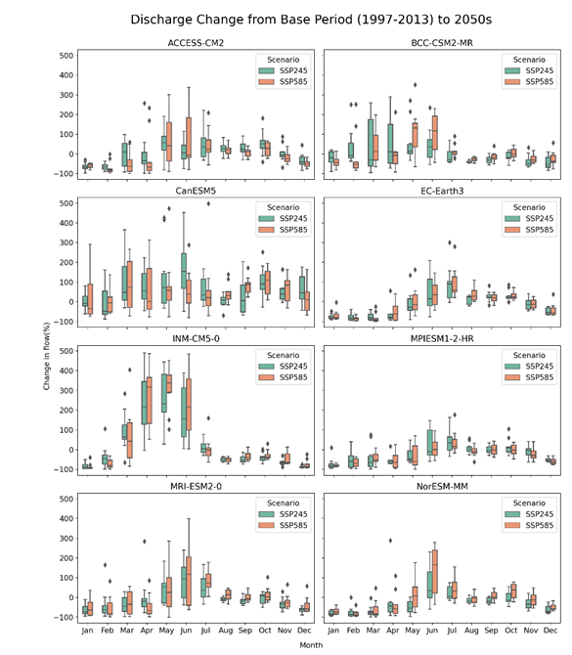
Supp. Figure 2. Predicted change in the future mean monthly discharge of Teesta River at Dalia station under SSP245 and SSP585 of 8 Models of 2050.

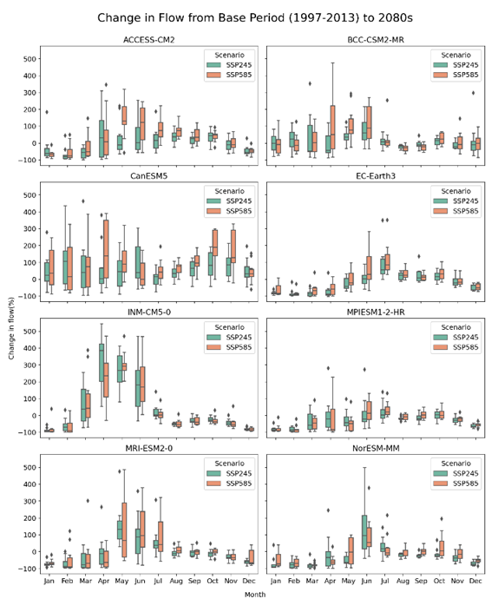
Supp. Figure 3. Predicted change in the future mean monthly discharge of Teesta River at Dalia station under the SSP245 and SSP585 scenarios of eight GCM models for the far future.
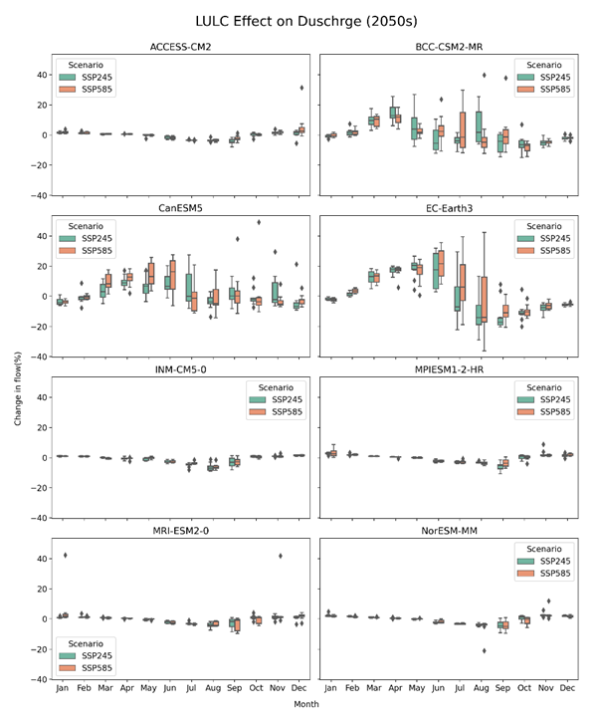
Supp. Figure 4. Predicted change in the future mean monthly discharge of Teesta River at Dalia station due to LULC change under SSP245 and SSP585 of 8 Models of 2050.
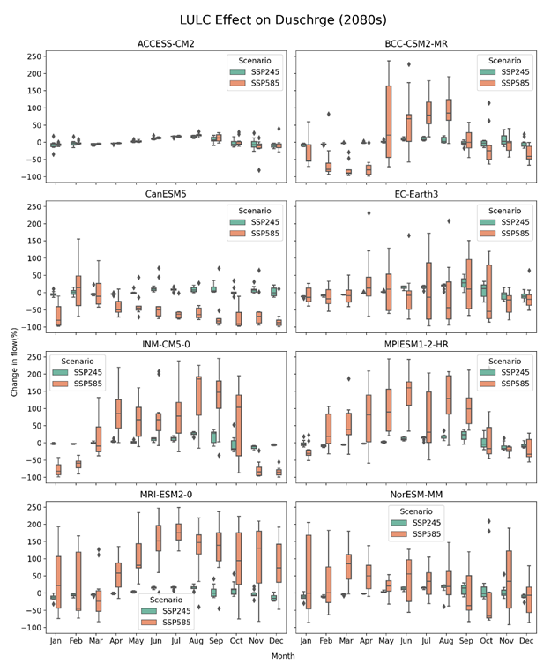
Supp. Figure 5. Predicted change in the future mean monthly discharge of Teesta River at Dalia station due to LULC change under SSP245 and SSP585 scenarios using eight models for the year 2080.

