Title: Basolateral amygdala Rims1 mediates adolescent social isolation-induced schizophrenia-like behaviors in mice
Lian-Hong Lin^{1,2,3}, Wei-Min Li^{1,2,3}, Qian-Yun Wu^{1,2,3}, Shuang-Yan Li^{1,2}, Xu-Xuan Ma^{1,2}, Yuan Xu^{1,2}, Si-Fu Deng^{1,2}, Bin Zhang^{1,2}*, Ji-Hong Liu ^{1,2}*

¹ Department of Psychiatry, Sleep Medicine Center, Nanfang Hospital, Southern Medical University, Guangzhou, 510515, China
² Key Laboratory of Mental Health of the Ministry of Education, Southern Medical University, Guangzhou, 510515, China
³ These authors contributed equally to this work.

*Corresponding author. Department of Psychiatry, Sleep Medicine Center, Nanfang Hospital, Southern Medical University, No.1838, North Guangzhou Avenue, Baiyun District, Guangzhou, China. Tel.: +86 20 61648215.
E-mail address: B. Zh. (zhang73bin@hotmail.com) or J.-H. L. (weiliu1029@smu.edu.com).

Supplementary Table S1 Descriptions of the studies and datasets used for MR analysis. （This supplementary table is included in another Excel file）

Supplementary Table S2 qPCR primer
Table S2. qPCR primer
Gene | Former primer | Reverse primer
Rims1 | CCC CCT ATG CAA GAA CTG CC | CGC CAT GTC CCT GAC AAC A
Rims2 | ACA AAG CAC AAC CGA CAC AGT | GCT GCG ATT CCT CTC CCA T
Rims3 | GGA ATG TAG TAA GGA GTT CCA GC | GTC AAG CCG ACG ATA GCC AC
Rims4 | CTA CTT CCC GTG CAT GAA CTC | CCT CCA TAG TTA AGG TTG CCC T
18sRNA | AGT TCC AGC ACA TTT TGC GAG | TCA TCC TCC GTG AGT TCT CCA

Supplementary Table S3 Main results, heterogeneity and pleiotropy test of the Mendelian randomization analysis (This supplementary table is included in another Excel file).

Supplementary Table S4 Main results of Brain Rims1 expression on SCZ risk by Mendelian randomization analysis (This supplementary table is included in another Excel file).

Supplementary Table S5 Main results of Brain Rims1 expression on SCZ risk by SMR (This supplementary table is included in another Excel file).

Supplementary Table S6 Characteristics of selected SNPs for different trati pair (This supplementary table is included in another Excel file).

Supplementary Table S7 Characteristics of selected SNPs in Brain Rims1 expression on SCZ risk (This supplementary table is included in another Excel file).

Supplementary Figure S1-S21 Scatter plot for the causal association by MR(These supplementary figures are included in another Excel file).

Supplementary Figure S22-S26 Supplementary results of behavioral test and biochemical test in mice.

Supplementary Figure S27 Full-length pictures of blots presented in the figures.

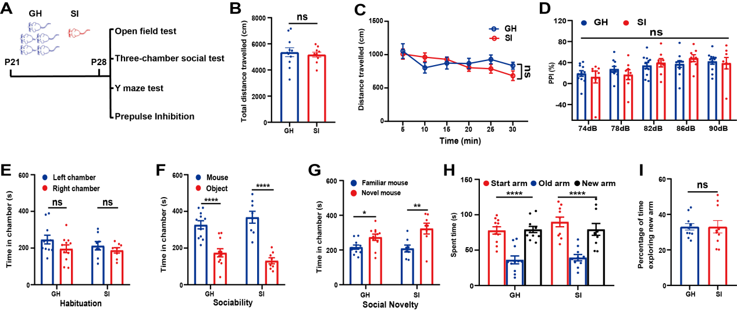
Sup.Fig.S22 1-week social isolation from P21 did not induce schizophrenia-like behaviors. (A) Schematic representation of the experiment. (B) Total travel distance was similar in SI mice compared with GH mice in the open field test. (n = 11 mice for GH group, n = 10 mice for SI group; t=0.4543, two-tailed Student’s t-test, t₍₁₉₎ = 0.4543, P = 0.6548). (C) Travel distance during 30 min was similar in SI mice compared with GH mice in the open field test (n = 11 mice for GH group, n = 10 mice for SI group; two-way ANOVA; F_{(1, 114)} = 0.2064, P = 0.6548). (D) Similar PPI performance between two groups mice in the prepulse inhibition test (n = 11 mice for GH group, n = 8 mice for SI group; F_{(1, 85)} = 0.01156, P=0.9157). (E-G) Similar social performance between two groups mice in the three-chamber social test (n = 11 mice for GH group, n = 8 mice for SI group; two-tailed Student’s t-test; for E: GH group, t₍₂₀₎ = 1.575,P = 0.1309; SI group, t₍₁₄₎ = 0.9227, P = 0.3718,; for F: GH group, t₍₂₀₎ = 4.862, P <0.0001; SI group, t₍₁₄₎ = 6.523, P <0.0001; for G: t₍₂₀₎ = 2.597, P = 0.0172; SI group, t₍₁₄₎ = 3.113, P = 0.0076). (H-I) Similar spatial recognition memory between two groups mice in the Y maze test (n = 11 mice for GH group, n = 10 mice for SI group; for H: one-way ANOVA, GH group, F_{(2, 30)} = 23.43, P < 0.0001; SI group: F_{(2, 27)} = 15.54, P < 0.0001; for I: two-tailed Student’s t-test, t₍₁₉₎ = 0.009525, P = 0.9925). GH: group-housed, SI: socially isolated. Data show mean ± SEM. *P < 0.05, **P < 0.01, ***P < 0.001,****P < 0.0001, ns. no significant difference.

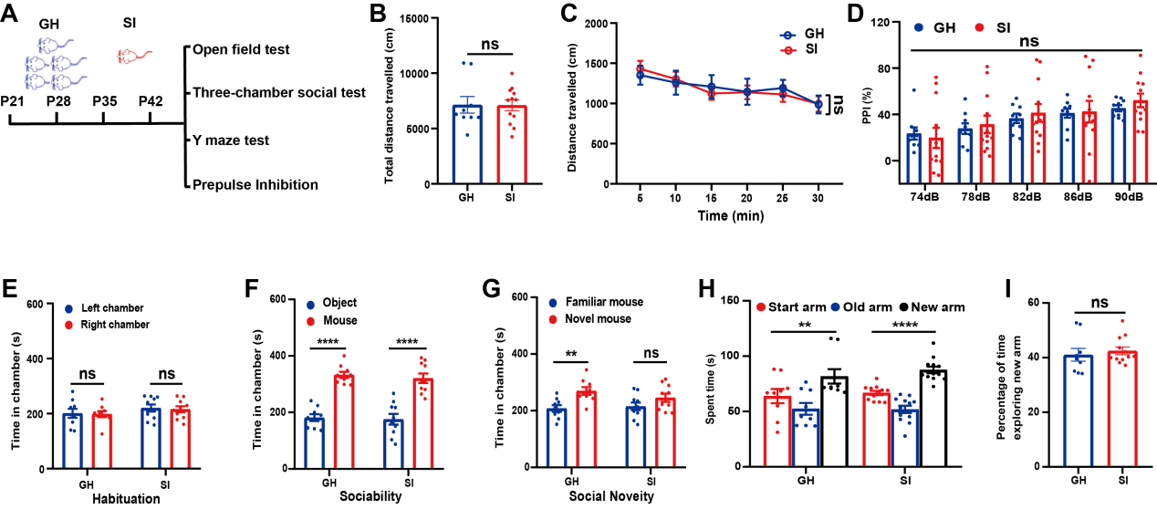
Sup.Fig.S23 3-week social isolation from P21 did not induce schizophrenia-like behaviors. (A) Schematic representation of the experiment. (B) Total travel distance was similar in SI mice compared with GH mice in the open field test (n = 9 mice for GH group, n = 12 mice for SI group; two-tailed Student’s t-test, t₍₁₉₎ = 0.05005, P = 0.9606). (C) Travel distance during 30 min was similar in SI mice compared with GH mice in the open field test (n = 9 mice for GH group, n = 12 mice for SI group; two-way ANOVA, F_{(1, 114)} = 0.002505, P = 0.9606). (D) Similar PPI performance between two groups mice in the prepulse inhibition test (n = 9 mice for GH group, n = 12 mice for SI group; two-way ANOVA, F_{(1, 95)} = 0.07722, P = 0.7841). (E-G) Impaired social novelty in three-week socially isolated mice in the three-chamber test(n = 9 mice for GH group, n = 10 mice for SI group; two-tailed Student’s t-test; for E: GH group, t₍₁₆₎ = 0.1521, P = 0.8810; SI group, t₍₁₈₎ = 0.2569, P = 0.8002; for F: GH group, t₍₁₆₎ = 9.119, P <0.000; SI group, t₍₁₈₎ = 5.743, P <0.0001; for G: t₍₁₆₎ = 3.466, P = 0.0032; SI group, t₍₁₈₎ = 1.561, P = 0.1359). (H-I) Similar spatial recognition memory between two groups mice in the Y maze test (n = 9 mice for GH group, n = 12 mice for SI group; for H: one-way ANOVA, GH group, F_{(2, 24)} = 5.872, P = 0.0084; SI group: F_{(2, 33)} = 40.19, P <0.0001; for I: two-tailed Student’s t-test, t₍₁₉₎ = 0.5629, P = 0.5801). GH: group-housed, SI: socially isolated. Data show mean ± SEM. *P < 0.05, **P < 0.01, ***P < 0.001,****P < 0.0001, ns. no significant difference.

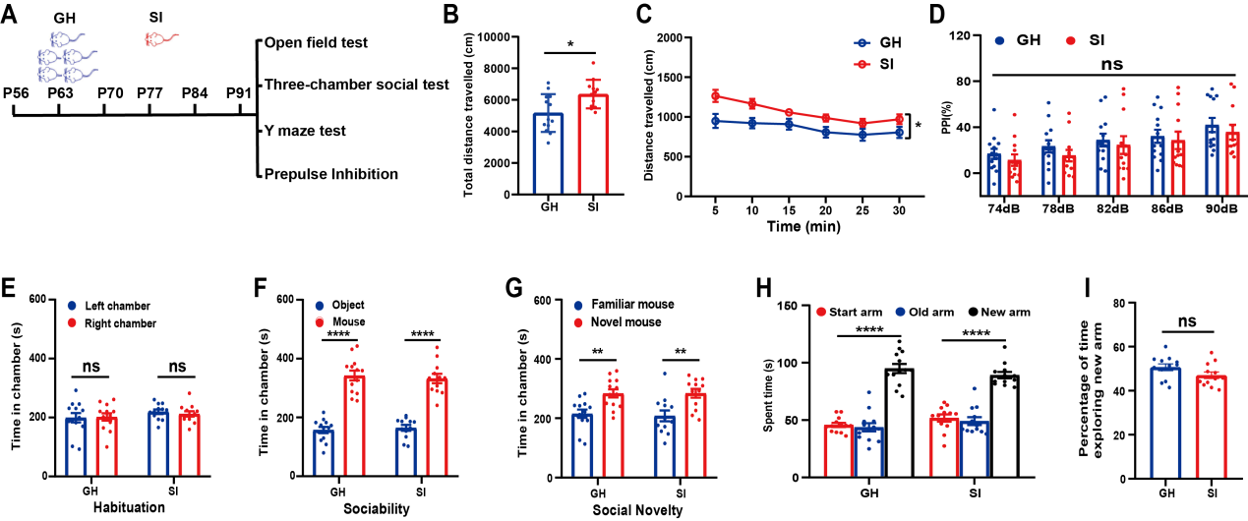
Sup.Fig.S24 Adult mice underwent 5-week social isolation did not display schizophrenia-like behaviors. (A) Schematic representation of the experiment. (B) Total travel distance was increased in SI mice compared with GH mice in the open field test (two-tailed Student’s t-test, t₍₂₃₎ = 2.805, P = 0.0101). (C) Travel distance during 30 min was increased in SI mice compared with GH mice in the open field test (two-way ANOVA, F_{(1, 138)} = 7.867, P = 0.0101). (D) Similar PPI performance between two groups mice in the prepulse inhibition test (two-way ANOVA, F_{(1, 115)} = 0.5038, P = 0.4850). (E-G) Similar social performance between two groups mice in the three-chamber social test (two-tailed Student’s t-test; for E: GH group, t₍₂₄₎ = 0.1205, P = 0.9051; SI group, t₍₂₂₎ = 0.6087,P = 0.5490; for F: GH group, t₍₂₄₎ = 9.357, P <0.0001; SI group, t₍₂₂₎ = 8.960, P <0.0001; for G: GH group, t₍₂₄₎ = 3.487, P = 0.0019; SI group, t₍₂₂₎ = 3.224, P = 0.0039). (H-I) Similar spatial recognition memory between two groups mice in the Y maze test (for H: one-way ANOVA, GH group, F_{(2, 36)} = 77.68, P <0.0001; SI group: F_{(2, 33)} = 49.81, P <0.0001; for I: two-tailed Student’s t-test, t₍₂₃₎ = 1.700, P = 0.1031). n= 13 for GH group,n = 12 for SI group. Data show mean ± SEM. *P < 0.05, **P < 0.01, ***P < 0.001,****P < 0.0001, ns. no significant difference.

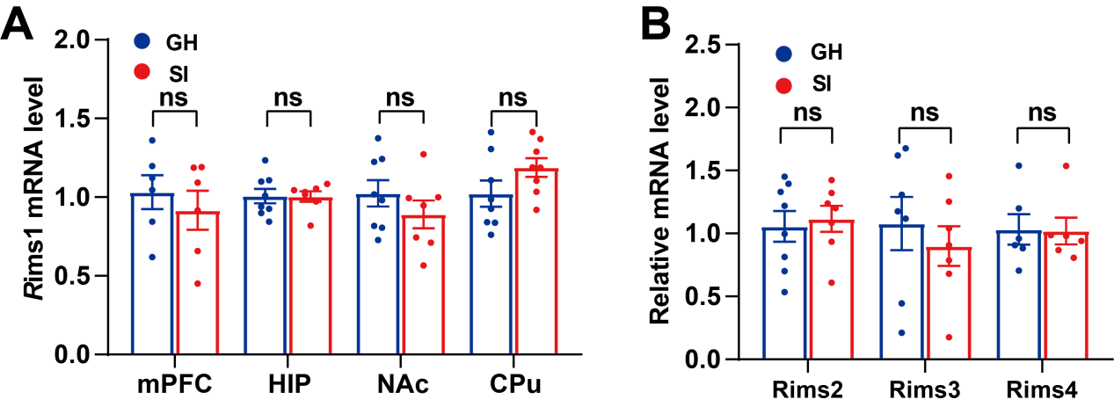
Sup.Fig.S25 5-week social isolation from P21 does not affect the expression of Rims1 in other brain regions or Rims2, Rims 3, Rims 4 in the BLA. (A) 5-week social Isolation from P21 did not change Rims1 mRNA levels in the medial prefrontal cortex (mPFC), hippocampus (HIP), nucleus accumbens (NAc) and caudate putamen (CPu) region(n = 6-8 mice/group; two-tailed Student’s t-test; for mPFC: t₍₁₀₎ = 0.7022, P = 0.4986; for HIP: t₍₁₃₎ = 0.06478, P = 0.9493; for NAc: t₍₁₃₎ = 1.094, P = 0.2940; for CPu: t₍₁₄₎ = 1.629, P = 0.1257). (B) 5-week social Isolation from P21 did not change BLA expression levels of Rims2, Rims3 and Rim4 (n = 6-8 mice/group; two-tailed Student’s t-test; for Rims2: t₍₁₃₎ = 1.076, P = 0.3001; for Rims3: t₍₁₂₎ = 0.5019, P = 0.6236; for Rims4: t₍₁₀₎ =0.07573, P = 0.9411). GH：group-housed, SI: socially isolated. Data show mean ± SEM. *P < 0.05, **P < 0.01, ***P < 0.001,****P < 0.0001, ns. no significant difference.

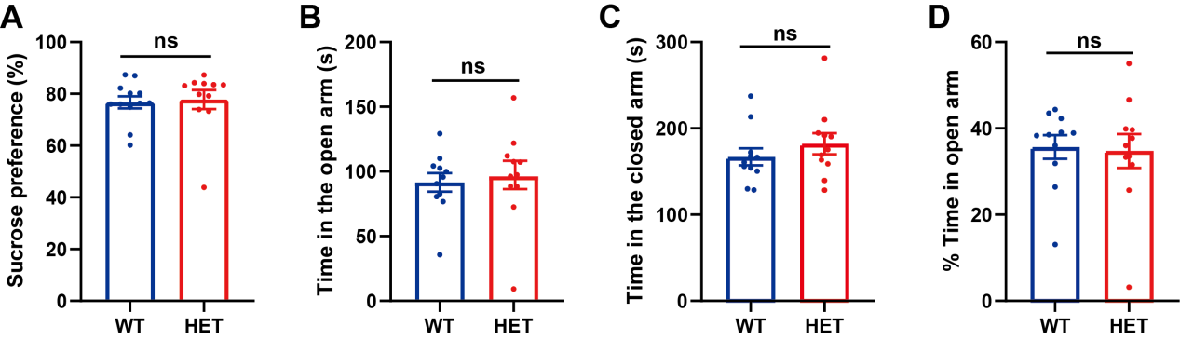
Sup.Fig.S26 Knockdown of Rims1 did not affect depressive-like or anxiety-like behaviors. (A) Sucrose preference (%) in the Sucrose preference test (n = 12 mice for WT group, n = 11 mice for HET group; two-tailed Student’s t-test, t₍₂₁₎ = 0.2498, P = 0.8052). (B) Time spent in the open arms in the elevated plus maze (n = 11 mice/group; two-tailed Student’s t-test, t₍₂₀₎ = 0.3495, P = 0.7304). (C)Time spent in the closed arms in the elevated plus maze (n = 11 mice/group; two-tailed Student’s t-test, t₍₂₀₎ = 0.9612, P = 0.3479). (D) Percentage of time exploring open arms in the elevated plus maze(n = 11 mice/group; two-tailed Student’s t-test, t₍₂₀₎ = 0.1927, P = 0.8491). WT: wild type, HET: heterozygous. Data show mean ± SEM. *P < 0.05, **P < 0.01, ***P < 0.001,****P < 0.0001, ns. no significant difference.

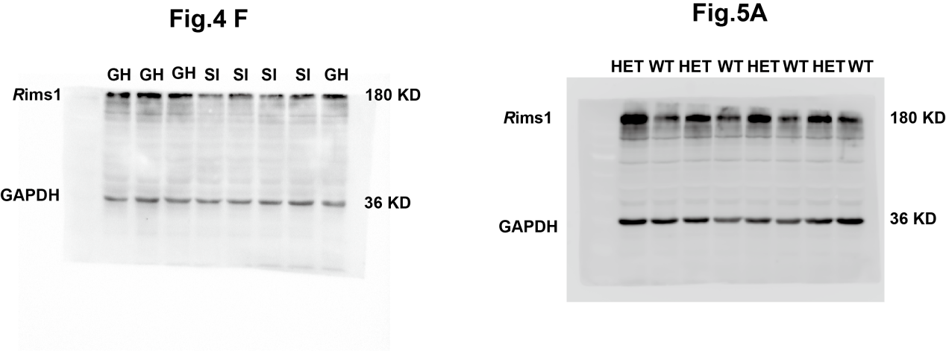
Sup.Fig.S27 Full-length pictures of blots presented in the figures.

