Table 1
AR and VR tools and software used in the STEAM camp
Technology | Description of Digital Tool
Cospaces Edu | Cospaces Edu is an online virtual program that enables kids to design their own virtual content, create animations with code, and explore their digital creations with AR and VR technologies. https://cospaces.io/edu/  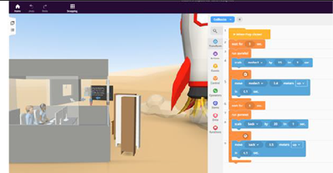
AR Books | AR Books (e.g., iRobot book/iRobot AR app and Jurassic World book/Digital Magic AR app) have links or QR codes that may be scanned by the reader using a handheld device with a camera, connected to a web-based or downloaded app, to act or interact with different images within the book (e.g., creating a 3D image that students can move around a room).  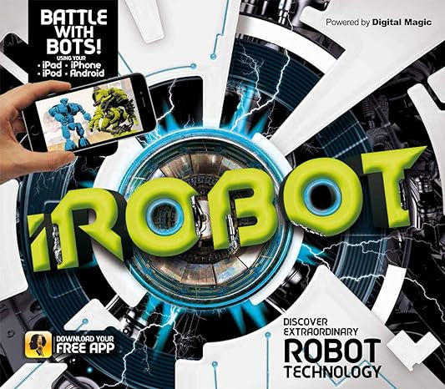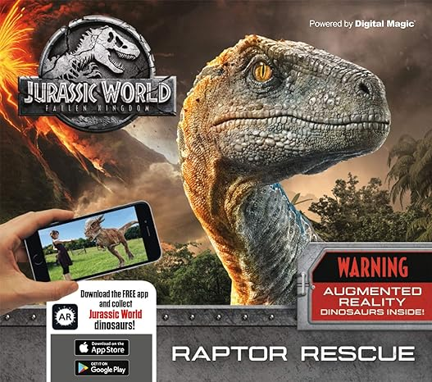
MERGE Cube | MERGE Cube is a physical foam cube that through its outer design, allows various MERGE Cube apps to interact with the cube, projecting realistic graphics and 3D content onto the cube’s surface (i.e., holographic projection). https://mergeedu.com/
VR Goggles | VR Goggles are a connected device accessory worn over one’s head and eyes, where the user is able to view and have an immersive 3D experience in a virtual landscape using virtual technology.  