Supplementary information

Identification and Characterization of Highly Potential Post-Disaster Isolated Areas through Sorting Social Vulnerability

Supplementary Fig. 1
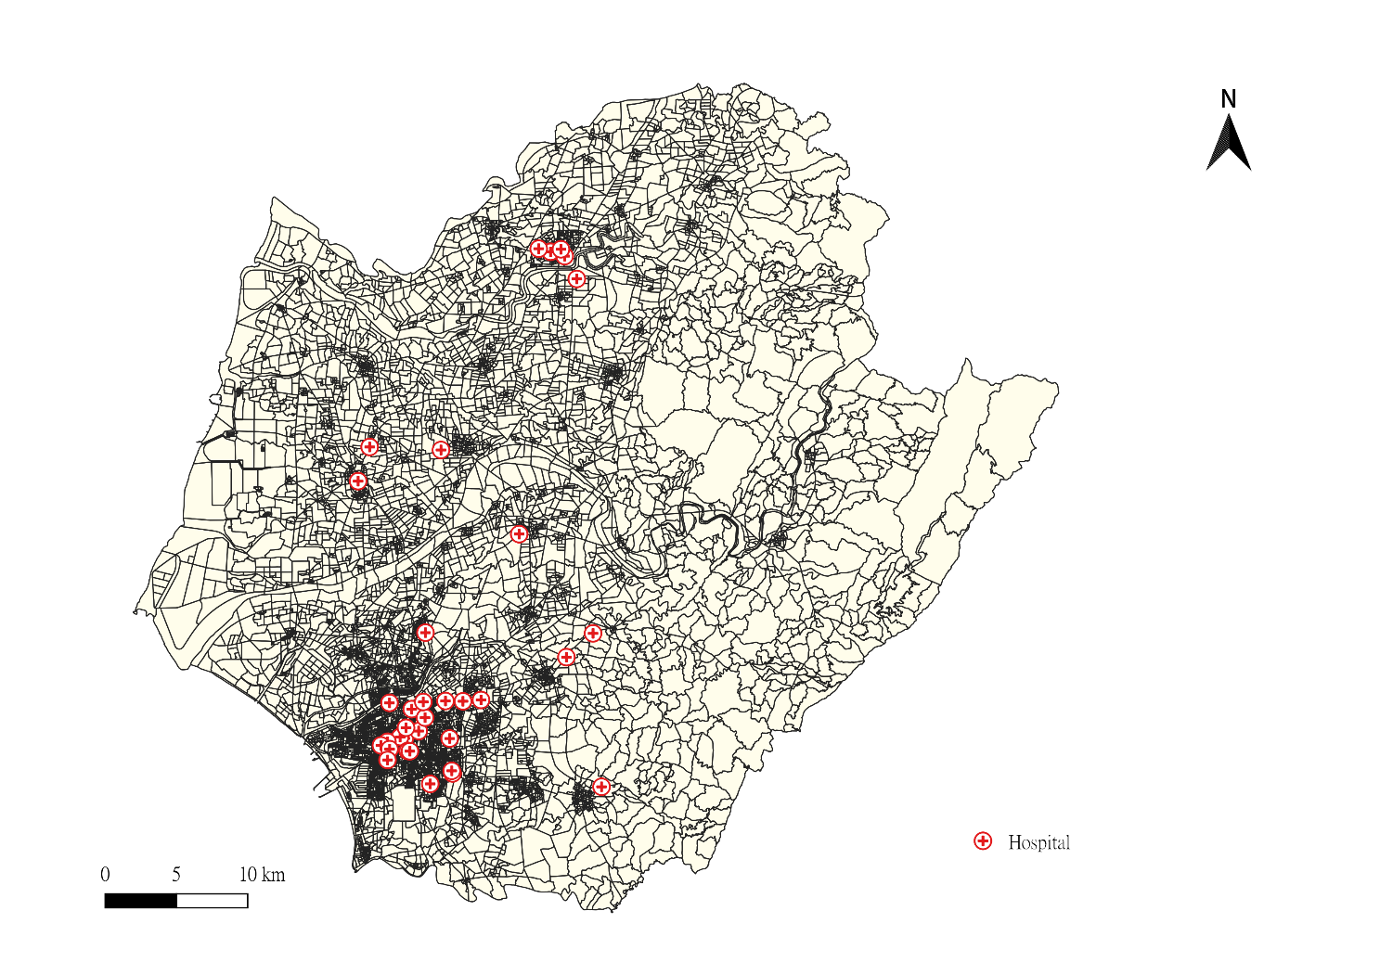
Supplementary Fig. 1 The BSA Map of Tainan City. The icon in the map is hospitals. Each area represents one BSA.

Supplementary Fig. 2
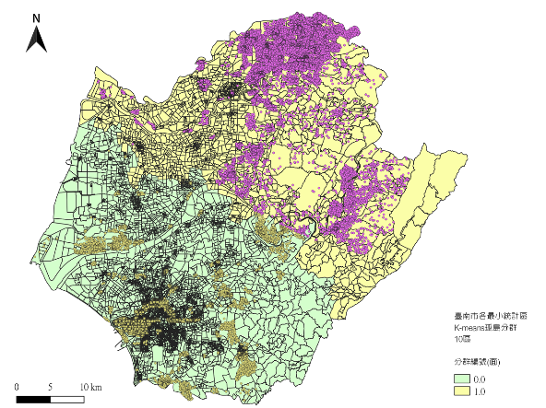 | 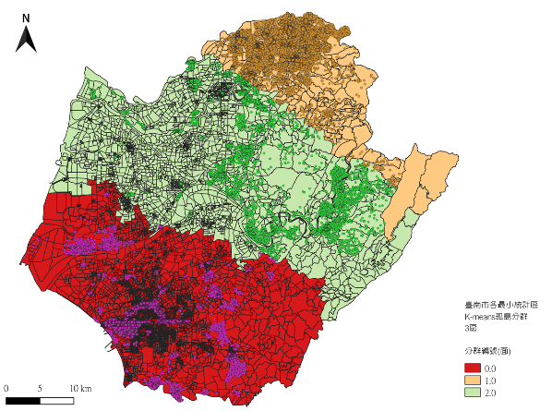
2 Clusters | 3 Clusters
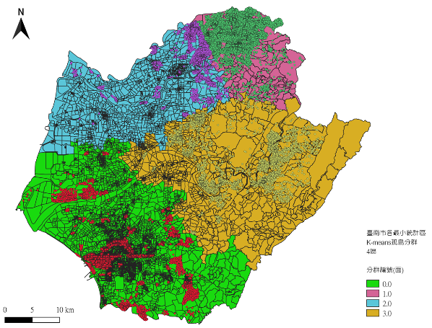 | 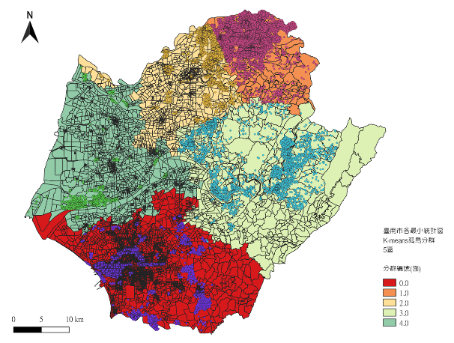
4 Clusters | 5 Clusters
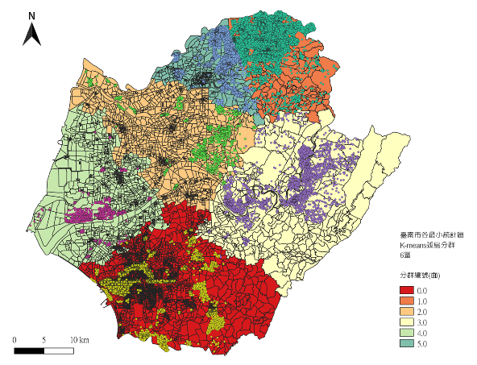 | 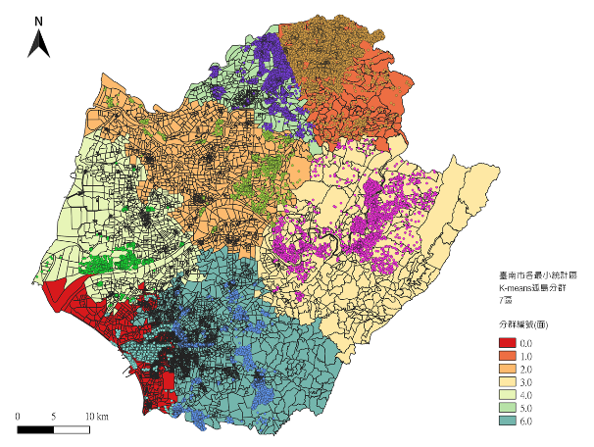
6 Clusters | 7 Clusters
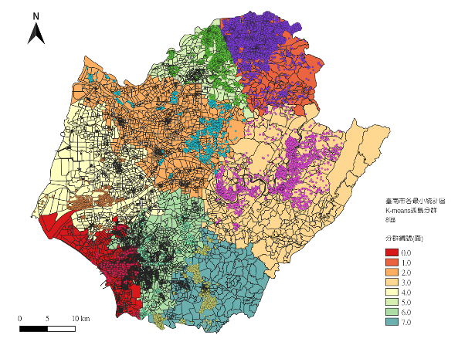 | 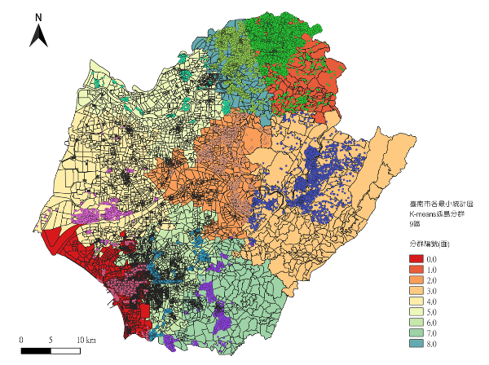
8 Clusters | 9 Clusters
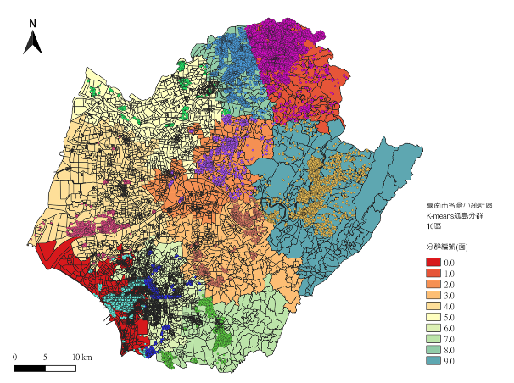 | 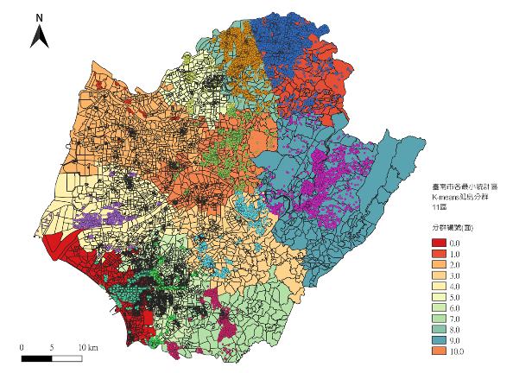
10 Clusters | 11 Clusters
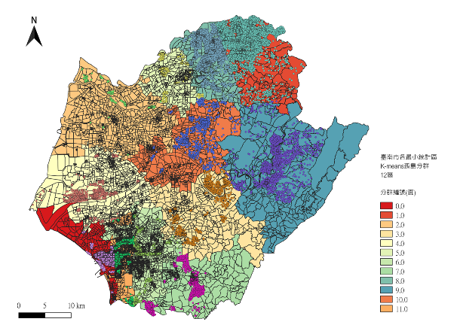 | 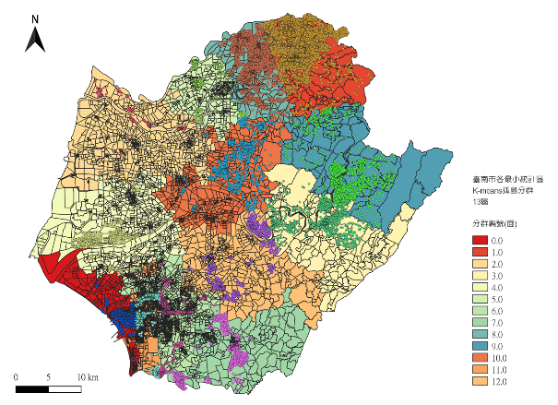
12 Clusters | 13 Clusters
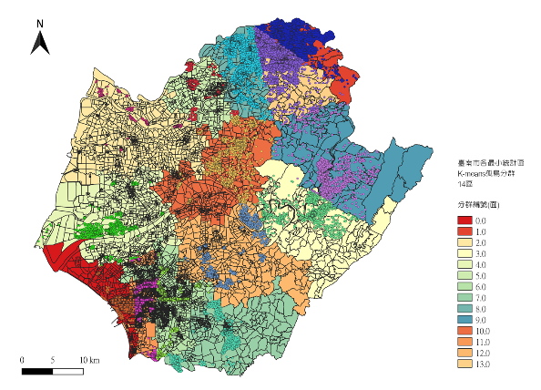 | 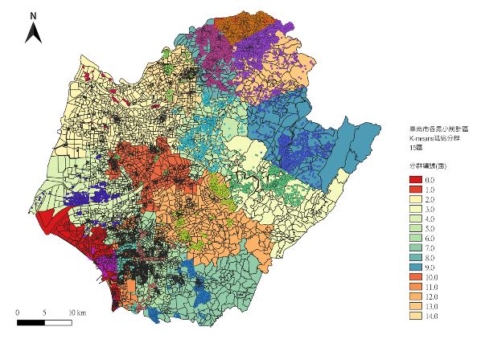
14 Clusters | 15 Clusters
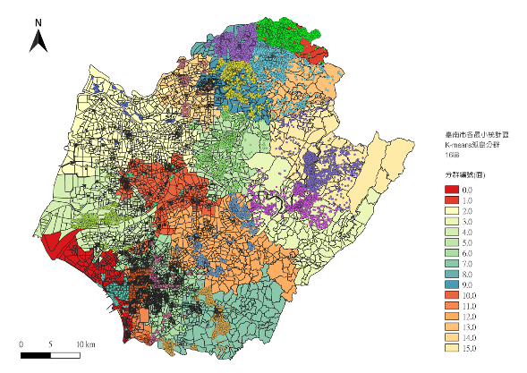 | 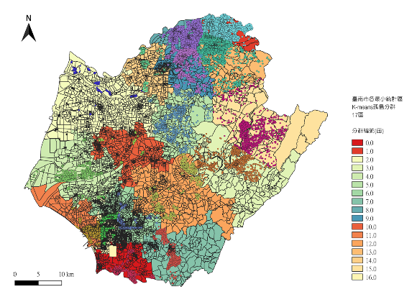
16 Clusters | 17 Clusters
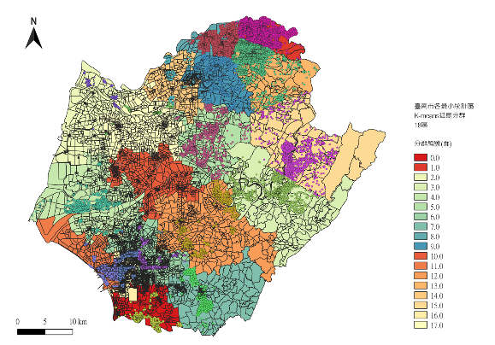 | 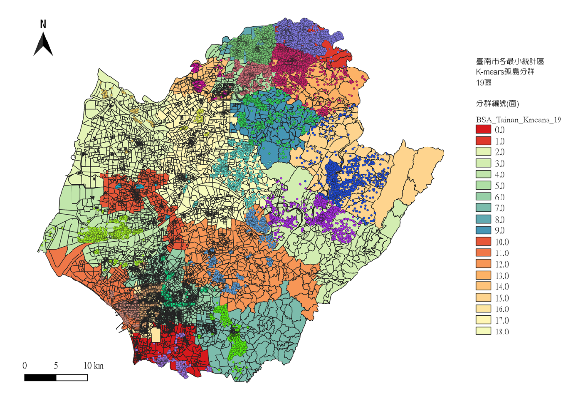
18 Clusters | 19 Clusters
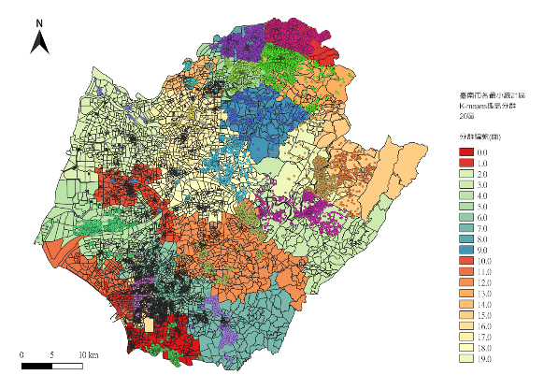
20 Clusters

Supplementary Fig. 2 The clustering result of DBSCAN within different number of clusters. Compared to the Hierarchical Clustering algorithm, the K-means algorithm offers more choices in terms of the number of clusters. Starting from two clusters, the algorithm divides Tainan City into the southern and northern halves, aligning with previous speculations. Furthermore, in the chart with five clusters, we can observe that the cluster corresponds to Tainan City's topography and population concentration areas, making it an appropriate clustering result.

Supplementary Fig. 3
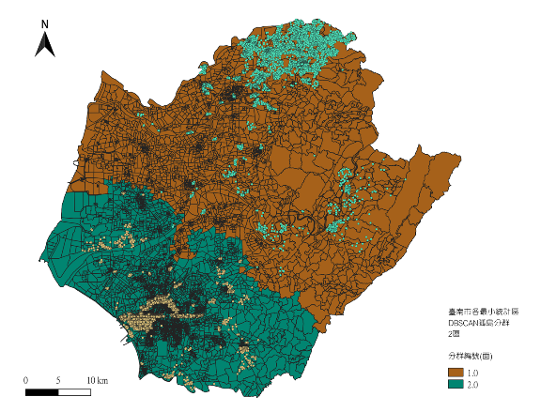 | 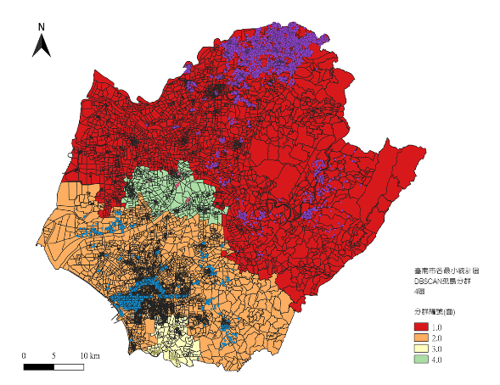
2 Clusters | 4 Clusters
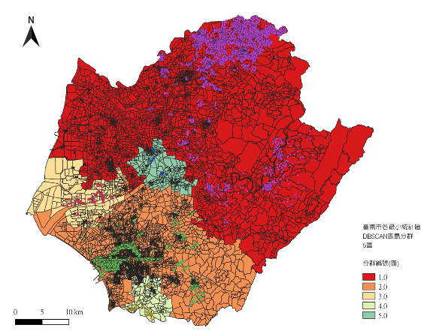 | 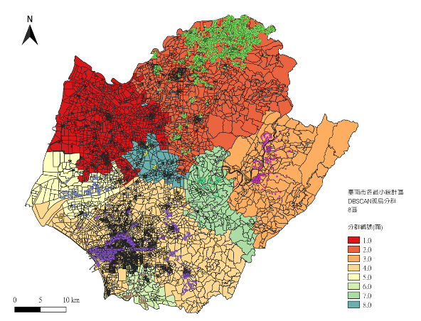
5 Clusters | 8 Clusters
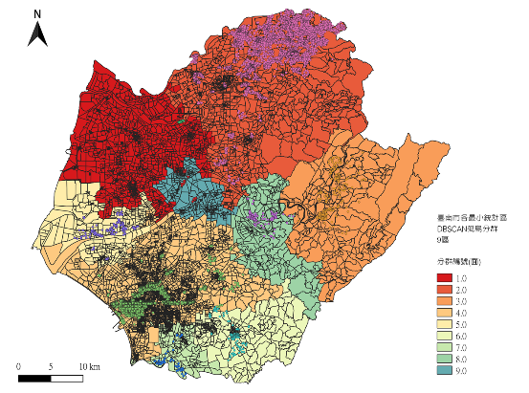 | 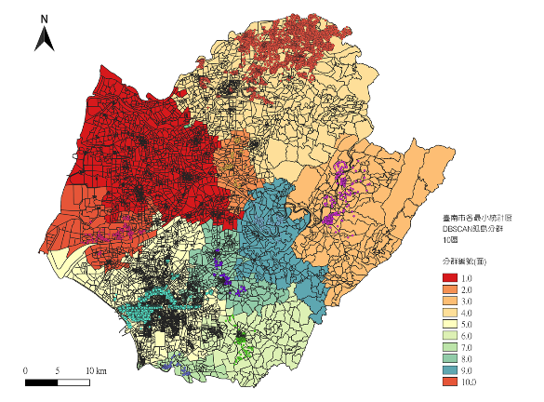
9 Clusters | 10 Clusters
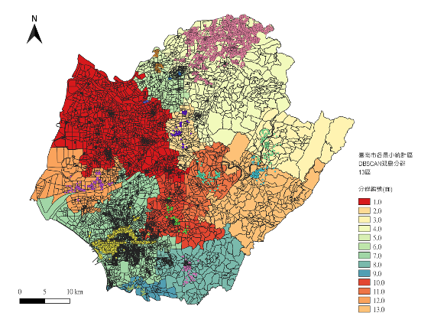 | 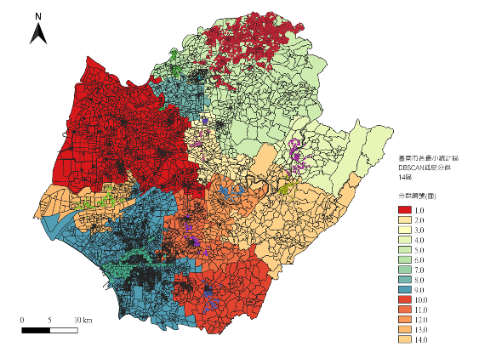
13 Clusters | 14 Clusters
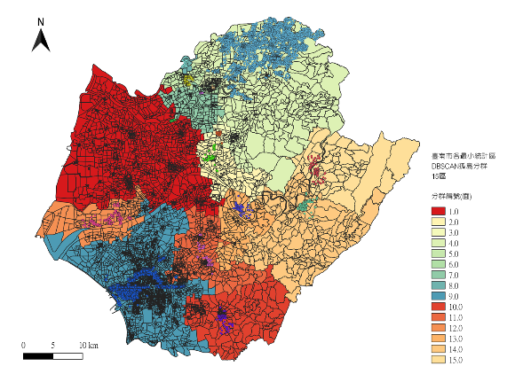 | 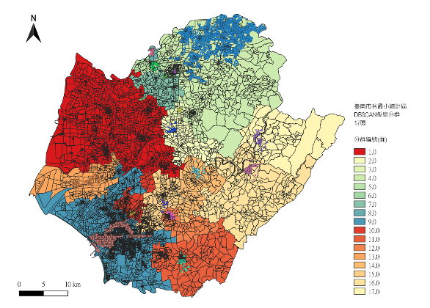
15 Clusters | 17 Clusters
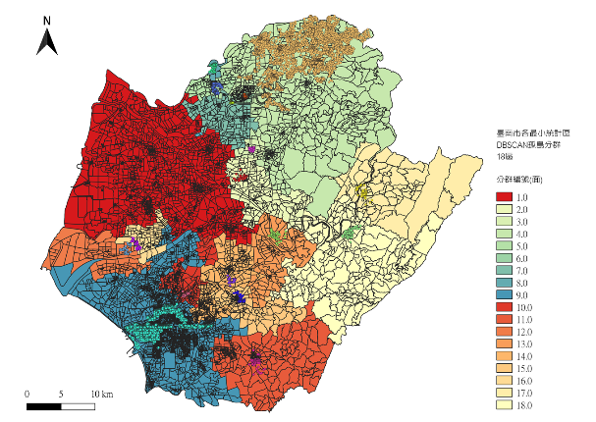 | 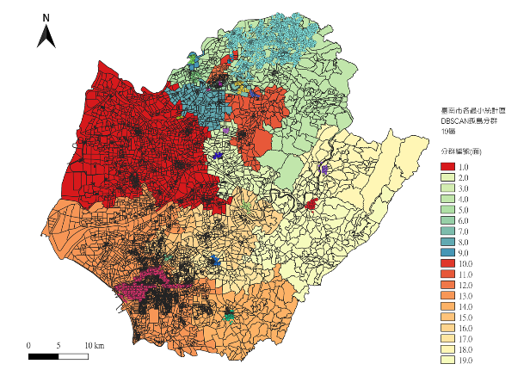
18 Clusters | 19 Clusters
Supplementary Fig. 3 The clustering result of DBSCAN within different number of clusters. DBSCAN clustering provides intensive clustering result and removes noise, which mitigation team can focus on smaller area with higher potential risk.

Supplementary Fig. 4
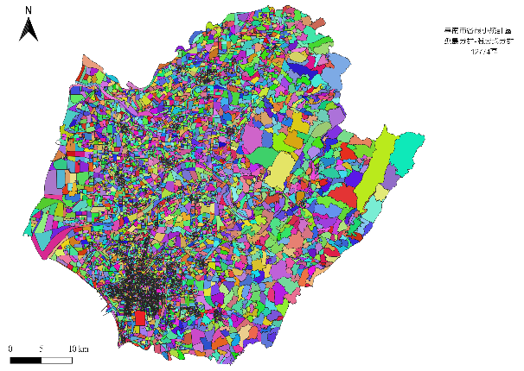 | 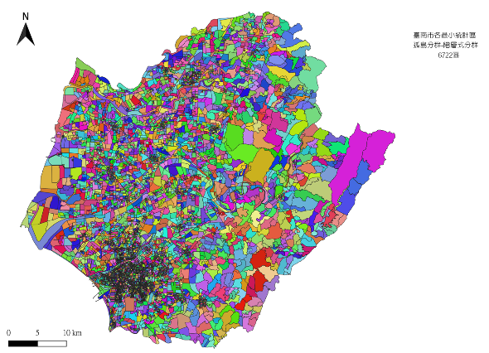
12774 Clusters | 6722 Clusters
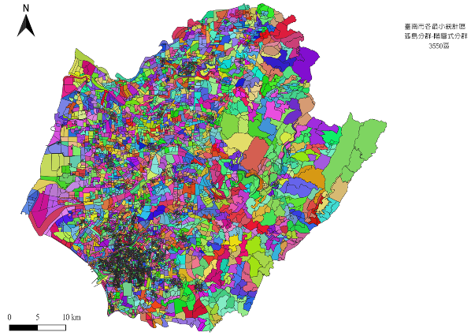 | 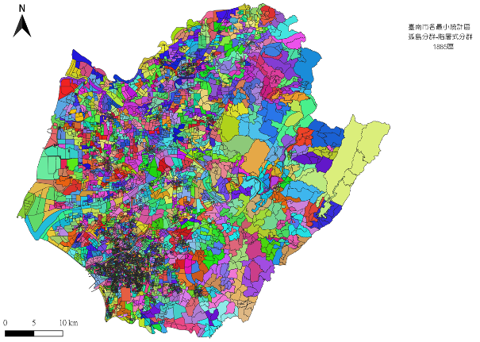
3550 Clusters | 1865 Clusters
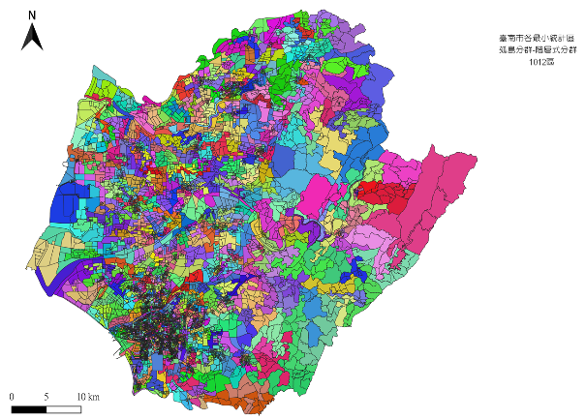 | 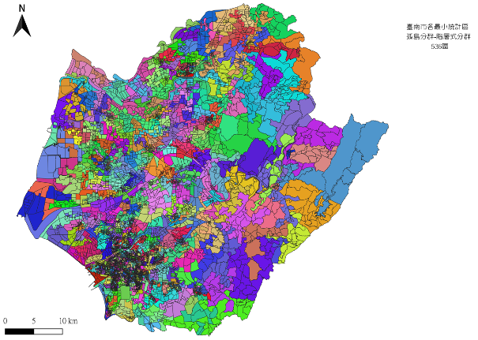
1012 Clusters | 536 Clusters
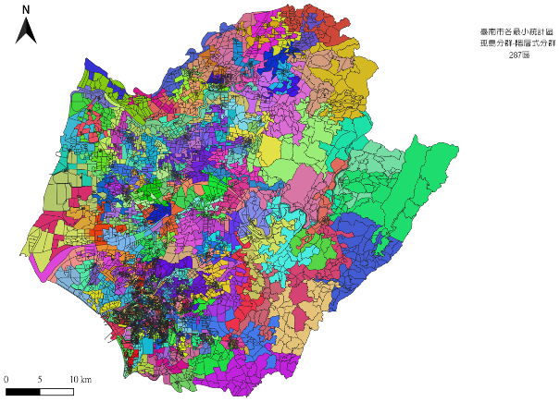 | 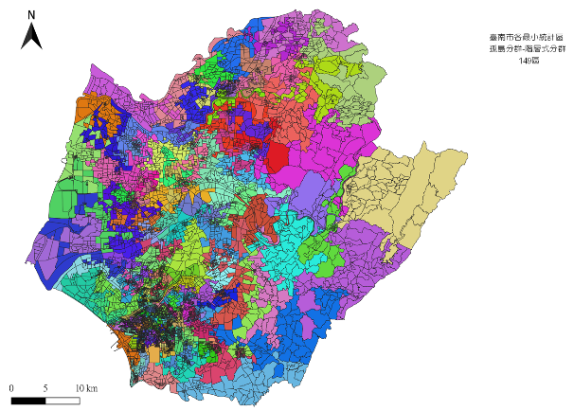
287 Clusters | 149 Clusters
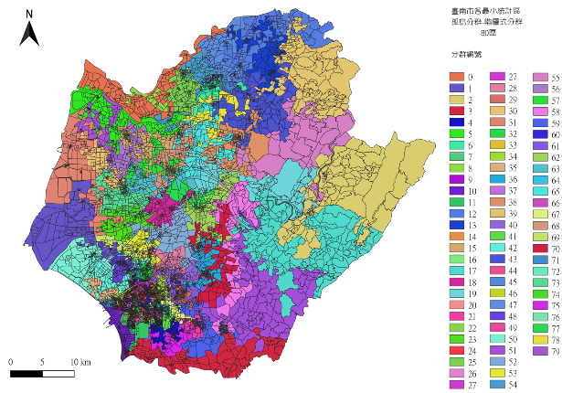 | 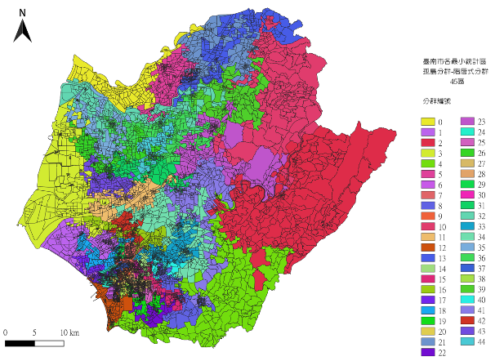
80 Clusters | 45 Clusters
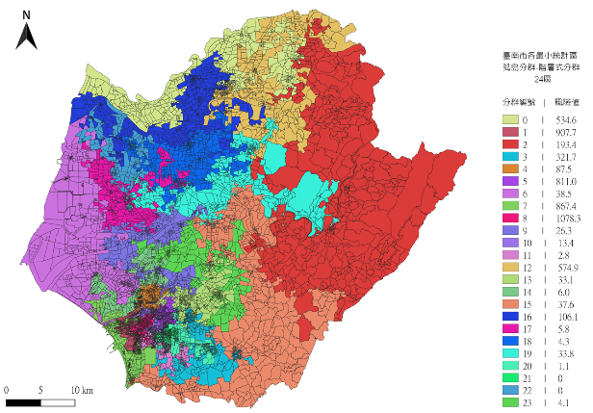 | 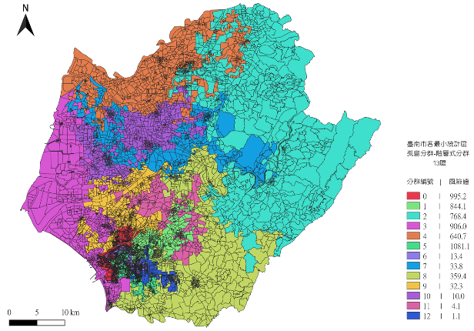
24 Clusters | 13 Clusters
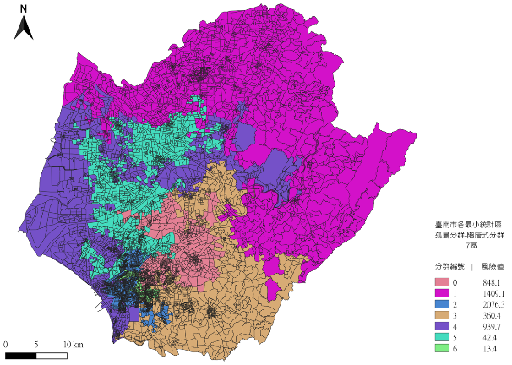 | 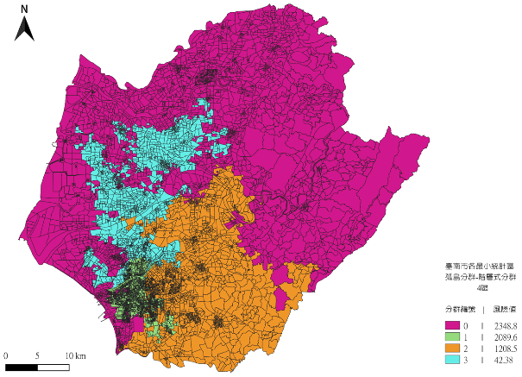
7 Clusters | 4 Clusters
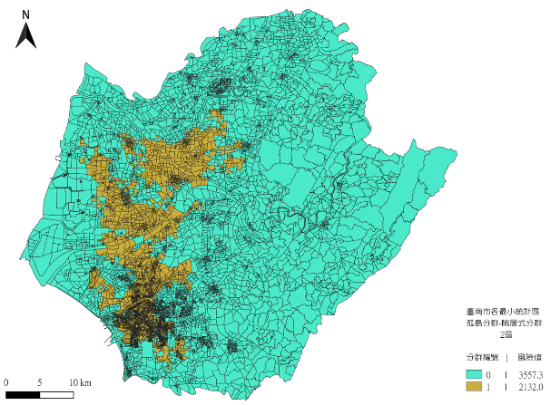 | 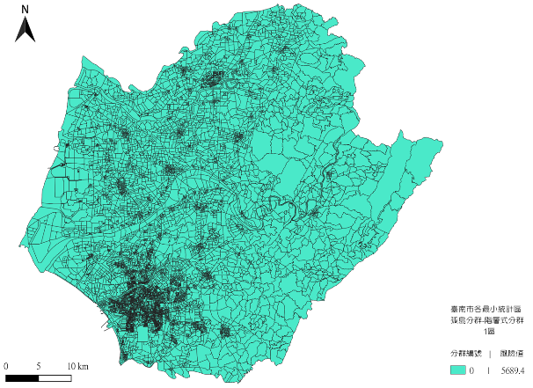
2 Clusters | 1 Cluster

Supplementary Fig. 4 The clustering result of Hierarchical Clustering within different number of clusters. The Hierarchical Clustering algorithm gradually consolidates from an initial 12,774 clusters to 6,722 clusters, then to 3,550 clusters, and finally to a single cluster. By examining the clustering behavior of the Hierarchical Clustering algorithm, we can understand the varying levels of association between different sets of minimal statistical areas.

Supplementary Fig. 5
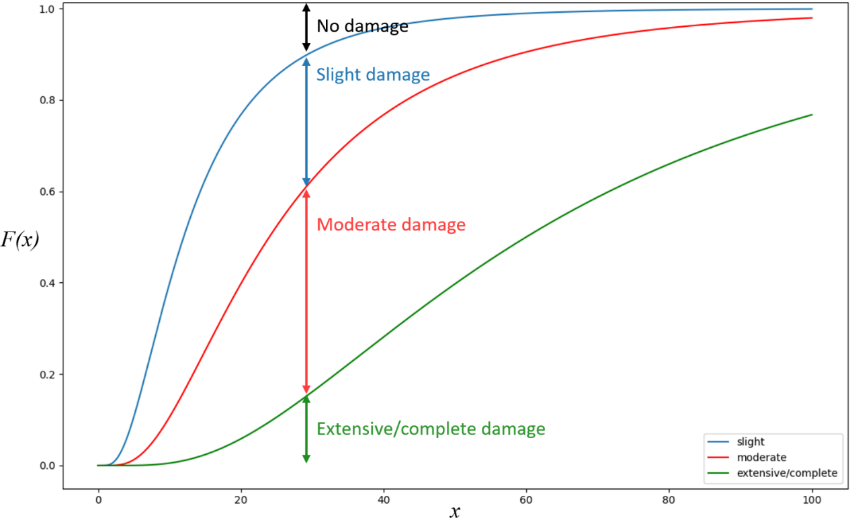
Supplementary Fig. 5 Cumulative distribution function of fragility curves for main roads. The graph presents the cumulative distribution function of fragility curves. $x$ represents the peak ground displacement(inches). $F(x)$presents the probability of each road section falling into different damage states.

