Supporting Information
A Black Phosphorus Nanosheet-based RNA Delivery System for Prostate Cancer Therapy by Increasing the Expression Level of Tumor Suppressor Gene PTEN via CeRNA Mechanism
Shunye Su† #, Leyi Liu† #, Qingfeng Fu†, #, Minghao Ma‡, Na Yang^{ф}, Ting Pan§, Shengyong Geng^{ф}, Xue-Feng Yu^{ф}, Jianqiang Zhu†*
† Department of Urology, Tianjin Institute of Urology, The Second Hospital of Tianjin Medical University, Tianjin 300211, China.
‡ State Key Laboratory of Environmental Chemistry and Ecotoxicology, Research Center for Eco-Environmental Sciences, Chinese Academy of Sciences, Beijing 100085, China.
^{ф}Materials and Interfaces Center, Shenzhen Institutes of Advanced Technology, Chinese Academy of Sciences, Shenzhen 518055, China.
§ Institute of Nanophotonics, College of Physics & Optoelectronic Engineering, Jinan University, Guangzhou 511443, China.
* Corresponding authors: Jianqiang Zhu, Ph.D.
Tel: 86022-88329692; E-mail: zjqwfmu@126.com
SY. S, LY. L and QF. F. are co-first authors

SUPPLEMENTARY FIGURE AND FIGURE LEGEND

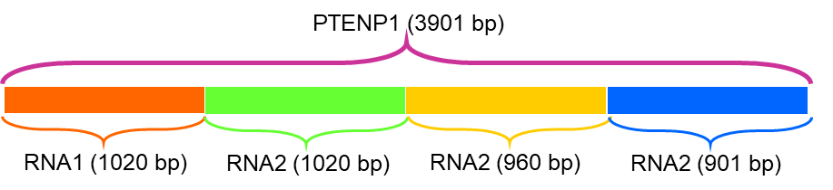
Figure S1. The whole length of PTENP1 (3901 bp) was randomly divided into four segments as templates to synthesize RNA1 (1020 bp), RNA2 (1020 bp), RNA3 (960 bp) and RNA4 (901 bp).

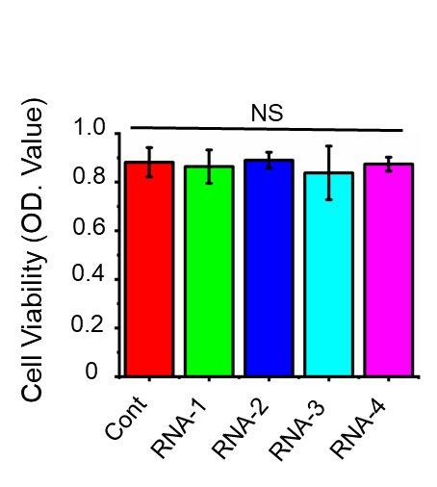
Figure S2. RNAs alone treatment had no effect on the viability of PC3 cells.

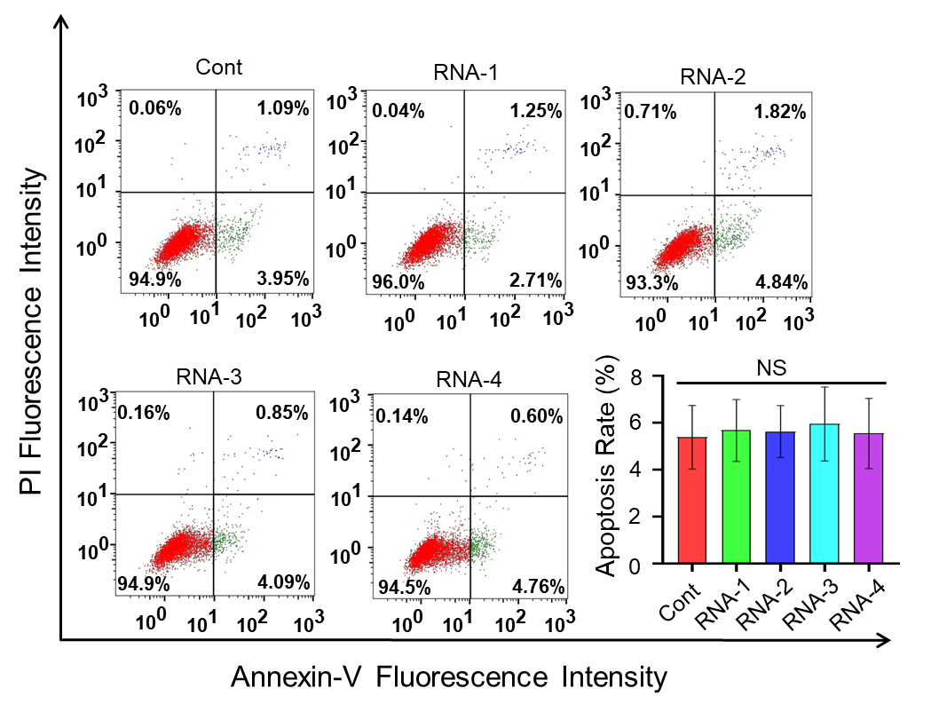
Figure S3. RNAs alone treatment could not promote apoptosis of PC3 cells.

Table S1. The primers for RNAs synthesis
Name | Forward (5’~3’) | Reverse (5’~3’)
RNA1 | AGATGAGAGACAGAGACGGCG | CTGTAATTAGATTTGGCGGTGTCATAATGTCT
RNA2 | AGTTGCGCAATATCCTTTTGAAGAC | CTTTTCAGTTTATTCAAGTTTGTTTTCATGGTGT
RNA3 | GGACCTTTTTTTTTAATGGCAATAGGACA | ATTCACAGCAGGTATATGATTGAAAACTAGT
RNA4 | GCTTCATGTGCTGCCTGCAAG | TCTTTGTGAAGTTATAAACTTTAATTTTATTTGGTAGGTATCT

Table S2. The primers for MicroRNAs RT-qPCR

Name | Forward (5’~3’) | Loop (5’~3’)/ Reverse (5’~3’)
miR-17 | CGGCGGCAAAGTGCTTACAGTGC | GTCGTATCCAGTGCAGGGTCCGAGGTATTCGCACTGGATACGACCTACCT
miR-19a | CGGCGGTGTGCAAATCTATGC | GTCGTATCCAGTGCAGGGTCCGAGGTATTCGCACTGGATACGACTCAGTT
miR-21 | CGGCGGTAGCTTATCAGACTGATG | GTCGTATCCAGTGCAGGGTCCGAGGTATTCGCACTGGATACGACTCAACA
miR-26a | CGGCGGTTCAAGTAATCCAGG | GTCGTATCCAGTGCAGGGTCCGAGGTATTCGCACTGGATACGACAGCCTA
miR-214 | CGGCGGACAGCAGGCACAGACAG | GTCGTATCCAGTGCAGGGTCCGAGGTATTCGCACTGGATACGACACTGCC
miR-216 | AGCGCCTAAATCTCTGCAGGC | GTCGTATCCAGTGCAGGGTCCGAGGTATTCGCACTGGATACGACTCACAT
miR-217 | AGCGAGGCTACTGCATCAGGA | GTCGTATCCAGTGCAGGGTCCGAGGTATTCGCACTGGATACGACTCCAAT
U6 | GCTTCGGCAGCACATATACTAA | CGAATTTGCGTGTCATCCTT

