Supplementary
Table S1 Results of the linear mixed models testing the effects of richness (i.e., lightly, moderately and heavily), microbes (live vs. sterile), competition (alone vs. together), origin (native vs. alien), parasitism (absent vs. parasite) and interactions among them on total biomass (square root transformation value) and plant height (log value). Bold values are significant at p < 0.05.
Fixed factor | Total biomass (natural log transformed) |  |  | Plant height (natural log transformed)
Fixed factor | χ ² | Df | P | χ ² | Df | P
Microbe (M) | 32.362 | 1 | <0.001 | 9.977 | 1 | 0.002
Richness (R) | 10.557 | 2 | 0.005 | 7.724 | 2 | 0.021
Parasitism (P) | 37.057 | 1 | <0.001 | 2.737 | 1 | 0.098
Competition (C) | 69.339 | 1 | <0.001 | 7.595 | 1 | 0.006
Origin (O) | 137.109 | 1 | <0.001 | 63.869 | 1 | <0.001
M × R | 7.142 | 2 | 0.028 | 3.203 | 2 | 0.202
M × P | 0.009 | 1 | 0.923 | 0.348 | 1 | 0.556
R × P | 10.004 | 2 | 0.007 | 14.023 | 2 | 0.001
M × C | 7.920 | 1 | 0.005 | 2.312 | 1 | 0.128
R × C | 2.5 | 2 | 0.287 | 2.469 | 2 | 0.291
P × C | 0.001 | 1 | 0.973 | 0.050 | 1 | 0.823
M × O | 24.112 | 1 | <0.001 | 10.551 | 1 | 0.001
R × O | 20.612 | 2 | <0.001 | 10.079 | 2 | 0.006
P × O | 7.064 | 1 | 0.008 | 1.111 | 1 | 0.292
C × O | 16.637 | 1 | <0.001 | 1.063 | 1 | 0.303
M × R × P | 0.301 | 2 | 0.860 | 0.838 | 2 | 0.658
M × R × C | 4.756 | 2 | 0.093 | 3.368 | 2 | 0.186
M × P × C | 0.004 | 1 | 0.952 | 0.013 | 1 | 0.909
R × P × C | 2.741 | 2 | 0.254 | 0.426 | 2 | 0.808
M × R × O | 1.435 | 2 | 0.488 | 4.722 | 2 | 0.094
M × P × O | 9.033 | 1 | 0.003 | 2.597 | 1 | 0.107
R × P × O | 4.225 | 2 | 0.121 | 2.892 | 2 | 0.235
M × C × O | 0.020 | 1 | 0.887 | 2.097 | 1 | 0.148
R × C × O | 7.747 | 2 | 0.021 | 3.088 | 2 | 0.214
P × C × O | 0.051 | 1 | 0.821 | 0.064 | 1 | 0.800
M × R × P × C | 0.216 | 2 | 0.898 | 0.148 | 2 | 0.921
M × R × P × O | 2.362 | 2 | 0.306 | 1.461 | 2 | 0.481
M × R × C × O | 0.440 | 2 | 0.803 | 0.254 | 2 | 0.881
M × P × C × O | 0.645 | 1 | 0.422 | 0.734 | 1 | 0.392
R × P × C × O | 1.765 | 2 | 0.414 | 0.510 | 2 | 0.775
M × R × P × C × O | 3.237 | 2 | 0.198 | 1.724 | 2 | 0.422
Random factors | Standard deviation
Competition combination |  | 0.047 | 0.397 |  | 0.117 | 0.352

Table S2 Results of the linear mixed model testing the effects of richness (i.e., heavily invaded, moderately invaded, lightly invaded), soil microbes (live vs. sterilized), origin (native vs. alien), parasitism (absent vs. parasite) and interactions among the treatments on the indices of interspecific neighbor effects. Bold values indicate that these effects are significant (p < 0.05).
Fixed factor | χ ² | Df | P
Microorganism (M) | 3.213 | 1 | 0.073
Richness (R) | 0.868 | 2 | 0.648
Parasitism (P) | 1.307 | 1 | 0.253
Plant origin (O) | 4.26 | 1 | 0.039
M × R | 4.788 | 2 | 0.091
M × P | 0.254 | 1 | 0.614
R × P | 1.517 | 2 | 0.468
M × O | 1.68 | 1 | 0.195
R × O | 5.261 | 2 | 0.072
P × O | 0.082 | 1 | 0.774
M × R × P | 0.395 | 2 | 0.821
M × R × O | 0.387 | 2 | 0.824
M × P × O | 0.516 | 1 | 0.473
R × P × O | 0.319 | 2 | 0.852
M × R × P × O | 6.061 | 2 | 0.048
Random effect | Standard deviation
Competition rate |  | <0.001 | 0.687
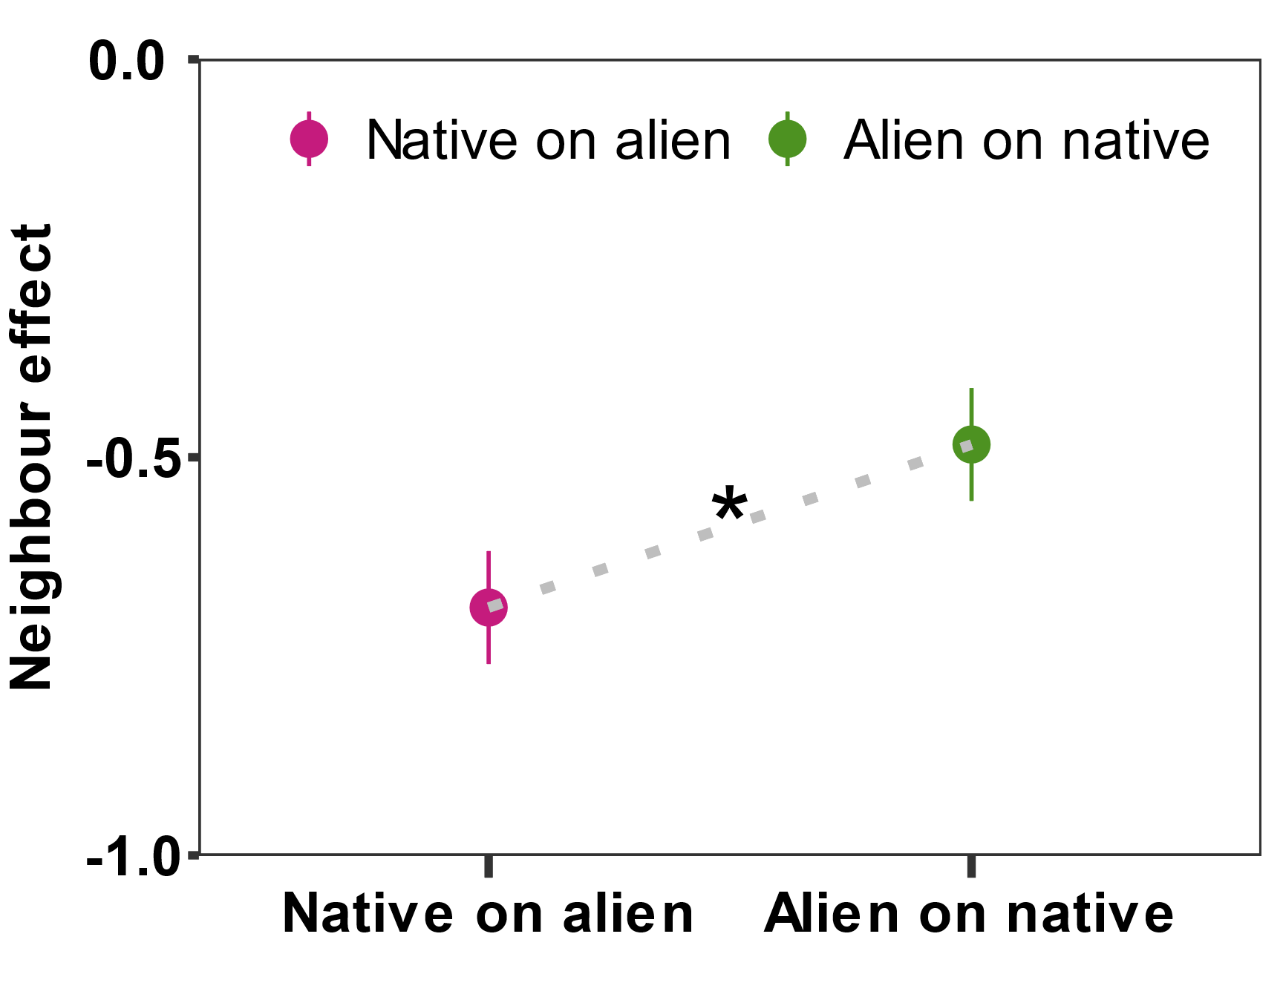
Fig. S1 neighbor effect on alien and native species (*, p < 0.05; **, p < 0.01; ***, p < 0.001).

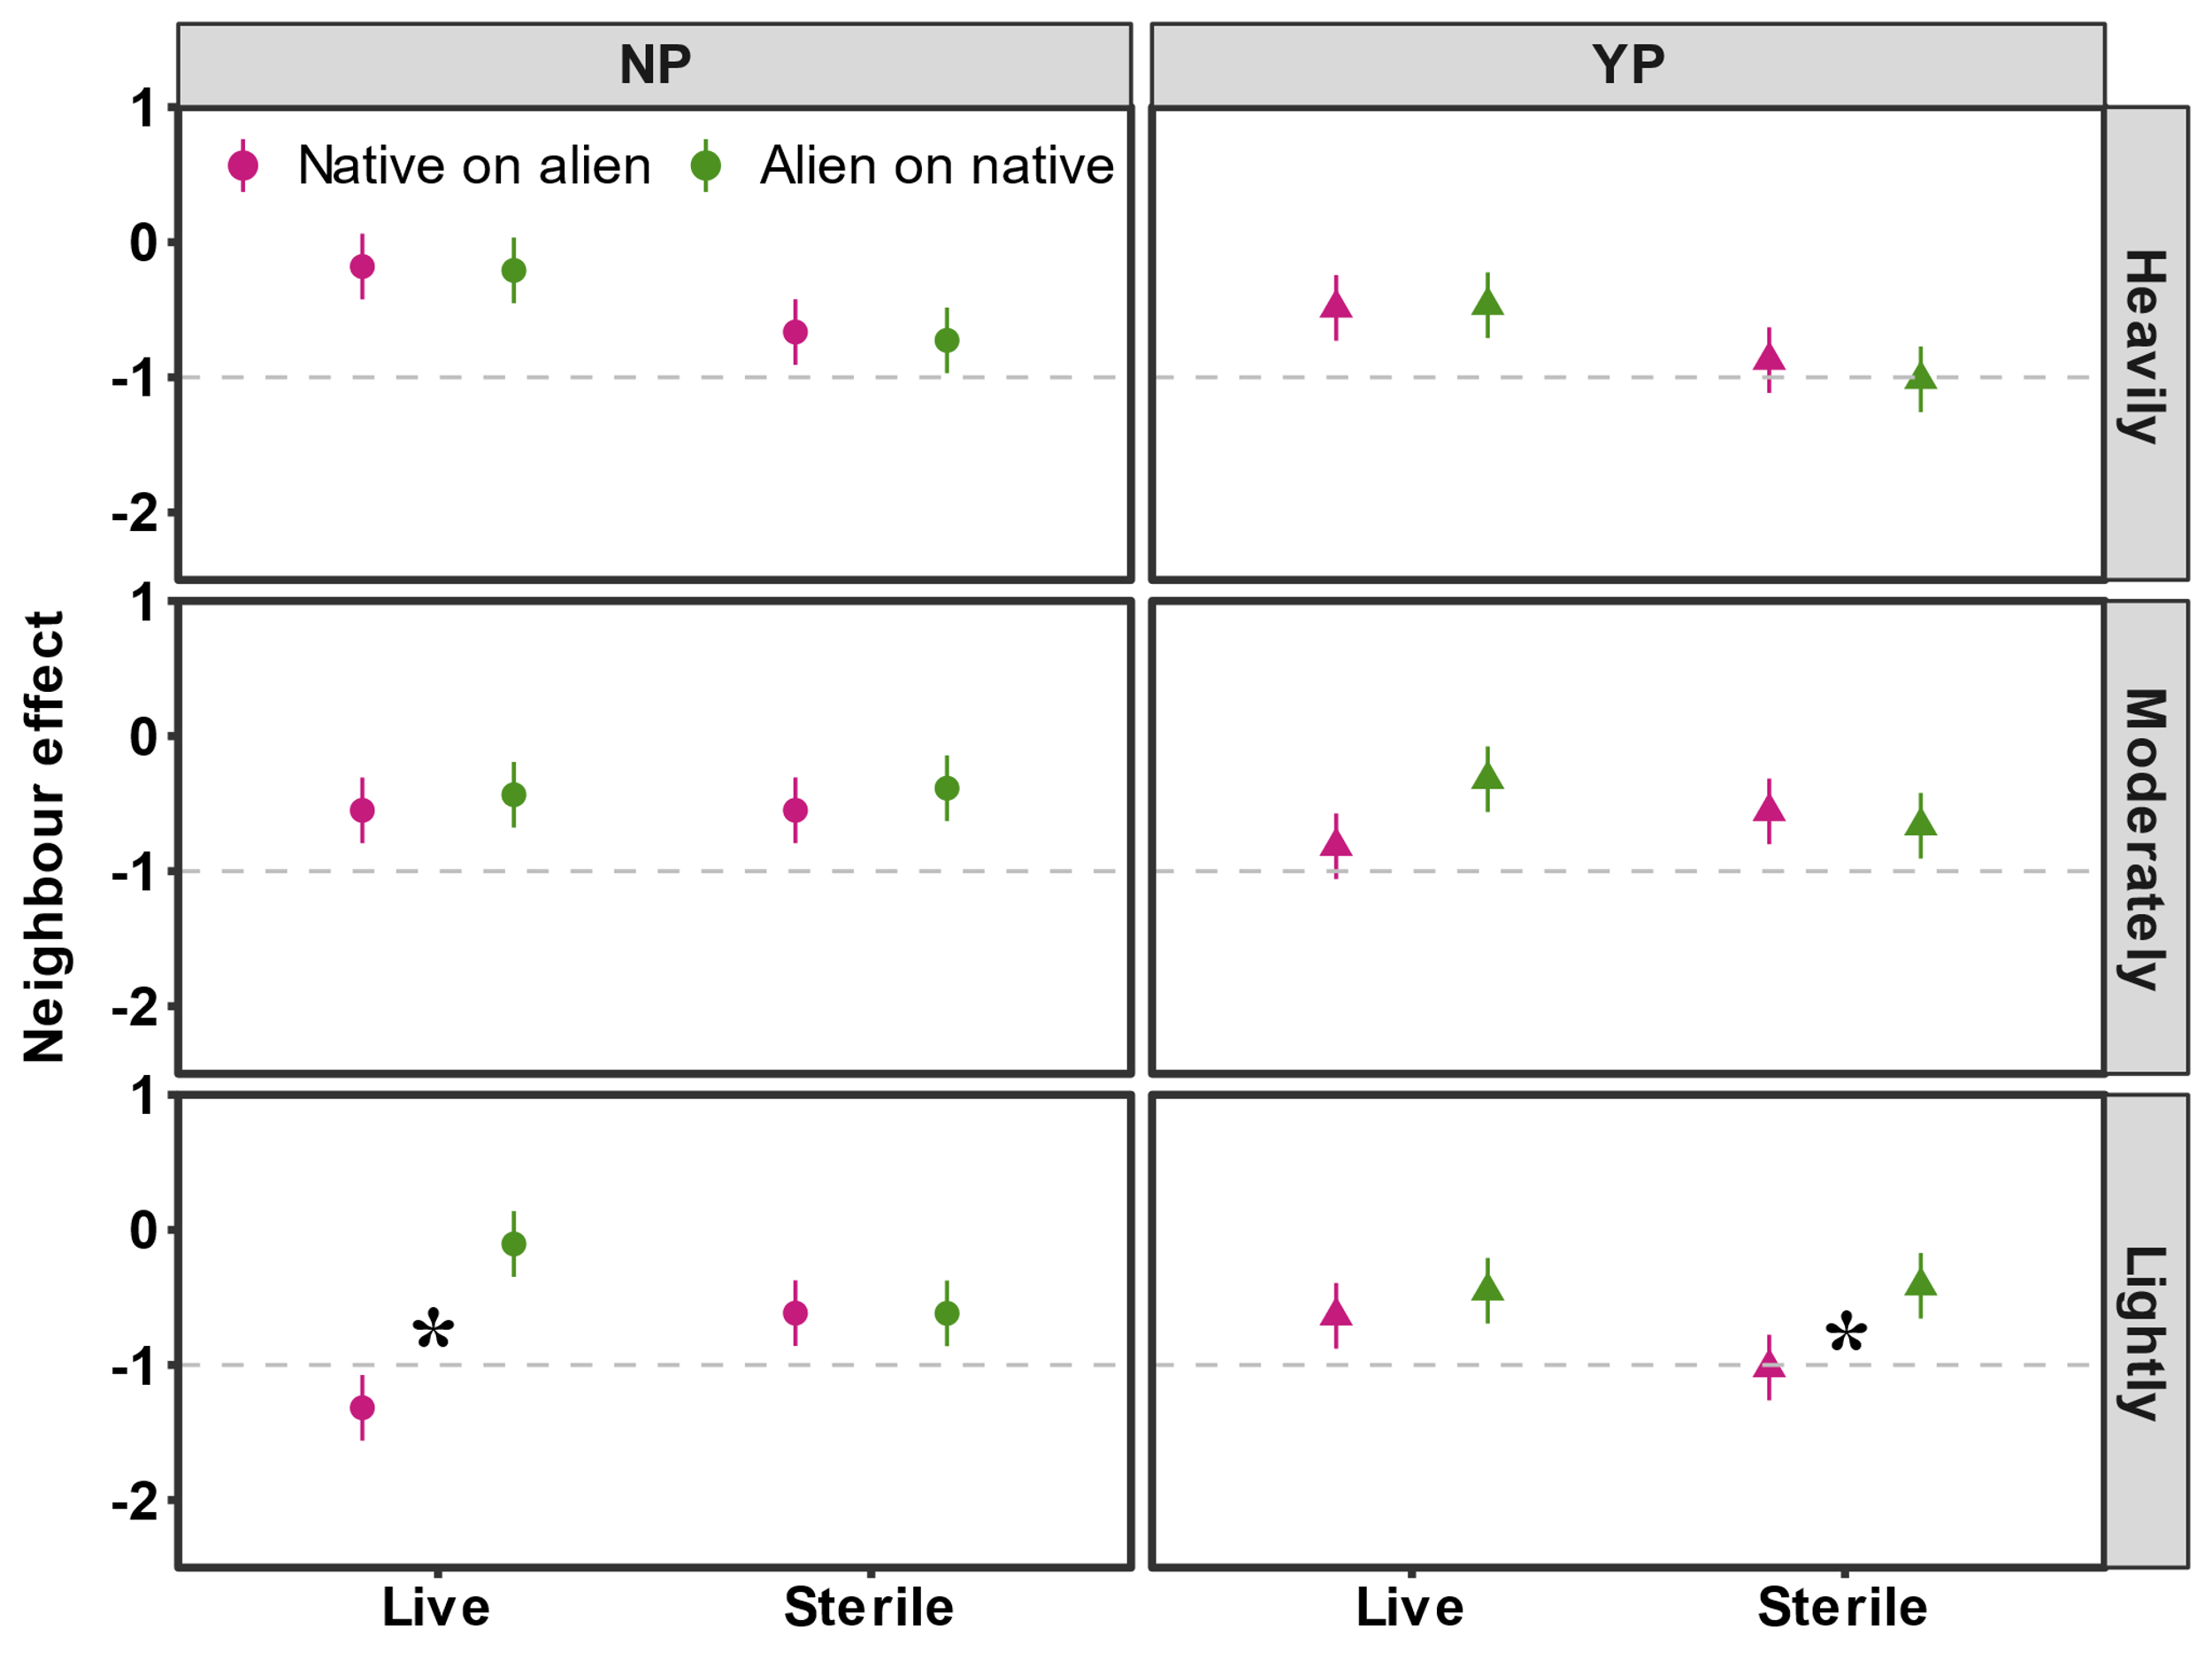Fig. S2 Neighbor effects on alien and native species responses to the various treatment combinations and interactions between parasites, microorganisms and richness (*, p < 0.05; **, p < 0.01; ***, p < 0.001).

