Extended data figures
Extended Table 1 – Key parameters for the waste valorization pathways: summary
 | Sensitive parameter | Unit | Forecasted variation range | Variant | Sensitivity ratios*
 |  |  |  |  | Climate change | Marine eutrophication | Land use | Water use
GB | Protein recovery in green juice | %_{proteins} | 16-69% | GB_AD | 0.3-0.4 | 0.55-0.6 | 0.5-0.6 | 0.3-0.4
 |  |  |  | GB_rough | 0.15-0.25 | 0.2-0.25 | 0.2-0.35 | 0.3-0.35
 |  |  |  | GB_mycofood | 0.1-0.35 | 0.2-0.4 | 0.35-0.55 | 0.15-0.3
GB | Protein recovery in pellet | %_{proteins} | 30-90% | GB_AD | 0.2-0.35 | 0.45-0.5 | 0.4-0.5 | 0.25-0.35
 |  |  |  | GB_rough | 0.15-0.4 | 0.45-0.6 | 0.4-0.55 | 0.3-0.4
 |  |  |  | GB_mycofood | 0.1-0.35 | 0.3-0.45 | 0.3-0.45 | 0.1-0.25
GB | AD methane production | %_{TBMP} | 50-90% | GB_AD | 0.2-0.3 | <0.2 | 0.15-0.3 | <0.2
GB | Soluble carbs recovery in green juice | %_{solubles} | 5-36% | GB_rough | 0.2-0.5 | 0.2-0.3 | 0.25-0.3 | <0.2
GB | Presspulp digestibility | %_{OM} | 60-70% | GB_rough | 0-0.5 | 0.3-0.55 | 0.35-0.6 | <0.2
GB | Pellet digestibility | %_{OM} | 50-85% | GB_rough | 0-0.25 | <0.2 | <0.2 | 0.4-0.5
GB | Multiple other impact-dependent sensitive parameters (especially for GB_mycofood; see SI.4)
BSF | PCR, BSF larvae | %_{proteins} | 25-60% | BSF_feed | 0.5-0.65 | 0.55-0.7 | 0.7 | 0.55-0.65
 |  |  |  | BSF_food | 0.6 | 0.6 | 0.6 | 0.6
BSF | Meat-equivalent substitution rate | %_{weight} | 50-100% | BSF_food | 0.6 | 0.55-0.6 | 0.65 | 0.6
SSF | SSF moisture | %_{ww} | 50-80% | SSF_feed | 0.4-0.6 | <0.2 | 0.5-0.6 | 0.6-0.7
 |  |  |  | SSF_food | 0.25 | <0.2 | 0.25 | <0.2
SSF | SSF digestibility enhancement | %_{OM} | -10-20% or 0-35%** | SSF_feed | 0.4-0.6 | 0.6-0.7 | 0.4-0.5 | 0.6-0.7
SSF | Flour substitution | %_{weight} | 50-100% | SSF_food | 0.65 | 0.7 | 0.65 | 0.7
Myco | Pulp loading | %_{DM} | 5-10% | Myco_feed | 0.1-0.3 | <0.2 | 0.3-0.4 | <0.2
Myco | IL moisture content | %_{ww} | 10-30% | Myco_feed | 0-0.3 | 0.5-0.6 | 0.2-0.25 | <0.2
 |  |  |  | Myco_food | <0.2 | 0.35-0.55 | <0.2 | <0.2
Myco | C₆ sugars yield | %_{cellulose} | 50-96% | Myco_feed | 0.1-0.3 | <0.2 | 0.1-0.4 | 0.3-0.6
 |  |  |  | Myco_food | 0.25-0.35 | 0.1-0.3 | 0.15-0.4 | 0.25-0.4
Myco | C₆ sugars growth | g_{x}.g_{C6}⁻¹ | 0.26-0.36 | Myco_feed | <0.2 | <0.2 | 0.1-0.3 | 0.15-0.45
Myco | Meat-equivalent substitution rate | %_{weight} | 50-100% | Myco_food | 0.5-0.65 | 0.25-0.7 | 0.4-0.65 | 0.5-0.7
Myco | C₅ growth | g_{x}.g_{C5}⁻¹ | 0-0.30 | Myco_food | 0.05-0.45 | <0.2 | 0.05-0.3 | 0.05-0.4
Myco | Multiple other impact-dependent sensitive parameters, see SI.4.
MP | AD methane production | %_{TBMP} | 50-90% | MP_biogas | 0.3-0.5 | 0.35-0.5 | 0.45 | 0.45
 |  |  |  | MP_biometh | 0.3-0.4 | 0.4-0.5 | 0.45 | 0.4
 |  |  |  | MP_shiftb | 0.2-0.4 | 0.35-0.45 | 0.45 | 0.5
MP | MOB yield | g_{x}.g_{CH4}⁻¹ | 0.63-1.11 | MP_biogas | 0.3-0.4 | 0.35-0.45 | 0.45 | 0.45
 |  |  |  | MP_biometh | 0.35-0.45 | 0.4-0.45 | 0.45 | 0.3
 |  |  |  | MP_meths | 0.5 | 0.6 | 0.6 | 0.25
MP | HOB yield | g_{x}.g_{H2}⁻¹ | 2.24-3.4 | MP_shiftb | 0.3-0.4 | 0.3-0.35 | 0.4 | 0.35
 |  |  |  | MP_syngas | 0.2-0.3 | 0.3-0.6 | 0.3-0.5 | 0.1-0.6
 |  |  |  | MP_shifts | 0.4-0.55 | 0.5-0.6 | 0.5-0.6 | 0.2-0.6
MP | HOB H₂ use efficiency | %_{H2} | 80-99% | MP_syngas | <0.2 | 0.15-0.3 | <0.2 | 0-0.3
 |  |  |  | MP_shifts | <0.2 | 0.25-0.3 | 0.2-0.25 | 0.1-0.3
MP | Sensible HT heat reuse | %_{MJ} | 50-80% | MP_syngas | 0.25-0.4 | <0.2 | 0.2-0.3 | <0.2
MP | Gaschar application density | t_{ww}.ha⁻¹ | 1-20 | MP_syngas | 0.3-0.45 | 0.35-0.45 | 0.25-0.35 | 0.55-0.6
MP | Gaschar C losses, 100y | %c | 3-96% | MP_syngas | 0-0.6 | <0.2 | <0.2 | <0.2
MP | Methanation outlet losses | %_{in} | 0-1% | MP_meths | 0.3 | <0.2 | <0.2 | <0.2
AD | AD methane production | %_{TBMP} | 50-90% | AD_grid | 0.1-0.4 | 0-0.3 | 0.6 | 0.2-0.45
 |  |  |  | AD_CHP | <0.2 | 0.1-0.6 | 0.5 | 0.15-0.5
AD | Digestate NH₃ reduction | %_{NH3} | 20-70% | AD_grid | <0.2 | 0.5-0.65 | <0.2 | 0.4-0.7
 |  |  |  | AD_CHP | <0.2 | 0.4-0.7 | <0.2 | 0.1-0.65
AD | AD methane production | %_{TBMP} | 50-90% | AD_CHP | <0.2 | 0.1-0.6 | 0.5 | 0.15-0.5
AD | AD storage emissions reduction potential | %_{CH4&NH3} | 40-80% | AD_CHP | 0.1-0.4 | <0.2 | <0.2 | <0.2
AD | Digestate EF₁ N₂O direct storage | kg_{N2O-N.}kg_{N}⁻¹ | 0.0006-0.01 | AD_CHP | 0.05-0.4 | <0.2 | <0.2 | <0.2
 |  |  |  | AD_grid | 0.05-0.4 | <0.2 | <0.2 | <0.2
AD | Multiple other impact-dependent sensitive parameters, see SI.4.
GA | Methanation outlet losses | %_{in} | 0-1% | GA_grid | 0.5 | <0.2 | <0.2 | <0.2
GA | Methanation electricity GA | kWh.kg_{CH4}⁻¹ | 1-10 | GA_grid | 0.2-0.25 | 0.1-0.2 | 0.45-0.5 | <0.2
GA | Electrolysis O₂ reuse*** | %_{O2} | 10-95% | GA_grid | 0.2-0.25 | 0.1-0.4 | 0.45-0.5 | 0.7-0.75
GA | Gaschar C losses, 100y | %c | 3-96% | GA_CHP | 0-0.7 | <0.2 | <0.2 | <0.2
GA | Gaschar application density | t_{ww}.ha⁻¹ | 1-20 | GA_CHP | 0.4-0.6 | 0.6 | 0.5-0.55 | 0.65
GA | GA stage electricity | kWh.t_{DM}⁻¹ | 100-650 | GA_CHP | <0.2 | <0.2 | 0.15-0.5 | 0-0.5
GA | LT heat reuse | %_{MJ} | 20-65% | GA_CHP | <0.2 | <0.2 | 0.1-0.4 | 0-0.3
GA | Syngas CHP, power efficiency | %_{LHV} | 30-40% | GA_CHP | <0.2 | 0-0.3 | 0.1-0.3 | 0-0.35
Burn | LT heat reuse | %_{MJ} | 20-65% | Dir_CHP | 0.6-0.65 | 0.6 | 0.55-0.6 | 0.4-0.5
Burn | Solid CHP, power efficiency | %_{HHV} | 18-26% | Heat_ind | <0.2 | 0.25 | 0.25 | 0.3-0.35
Burn | Industrial furnace efficiency | %_{HHV} | 70-90% | Heat_ind | 0.7-0.75 | 0.7-0.75 | 0.7-0.75 | 0.6-0.7
Burn | Combustion pelletization (heat) | MJ.kg_{water}⁻¹ | 2.97-3.63 | Heat_ind | 0-0.3 | 0-0.3 | 0-0.3 | 0-0.25
Burn | Domestic furnace efficiency | %_{HHV} | 31-81% | Heat_dom | 0.75 | 0.75 | 0.75 | 0.75
Compost | Impact-dependent sensitive parameters (include emission factors as for decay pathways).

Variants/pathways terminology as detailed in Table 1. *: See supplementary information (SI.3) for definition. Displayed ranges of sensitivity ratios cover their dispersion over the eleven individual case studies. As defined, the sensitivity ratios are a proxy of the contribution to variance (i.e. the higher, the more the parameter contribute to the total dispersion of the impact score for the given pathway and impact category). Values were rounded at the closest 0.05, and were calculated considering the ongoing food and energy systems scenarios. CF, burn, spread and decay pathway variants were not displayed for presenting relatively low LCA scores dispersions due to technological parameters (e.g. CF and burn pathways) or for presenting LCA scores dispersions only due to impact-dependent emission factors (e.g. decay and spreading pathways). **: Two ranges correspond to the increase in digestibility due to SSF if applied to respectively (i) agrifood co-products or (ii) crop residues. ***: This parameter was found as the most sensitive one for the water use impact category for all pathways involving electrolysis (e.g. GA_grid and MP_meths). Acronyms: AD, Anaerobic digestion; CHP, Combined heat & power; DM, Dry matter; EF, Emissions factor; GA, Gasification; HHV, High heating value; HOB, Hydrogen-oxidizing bacteria; HT, High temperature; IL, Ionic liquid; LHV, Low heating value; LT, Low temperature; MOB, Methane-oxidizing bacteria; OM, Organic matter; PCR, Proteins conversion ratio; TBMP, Theoretical biomethane potential; WW, Wet weight.

Extended Figure 1 – Best residual biomass valorization pathways to mitigate marine eutrophication impacts
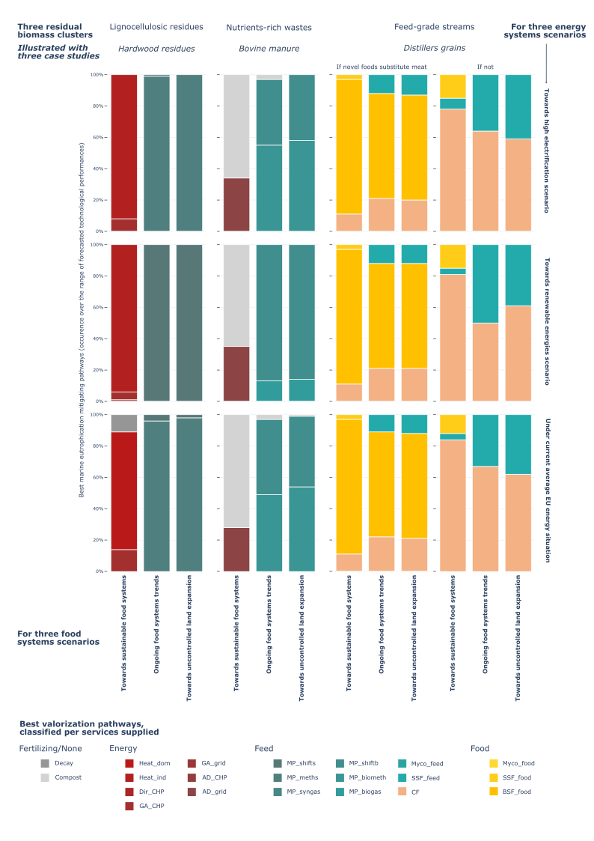
Complements Figure 2: Stacked bars represent the percentage of time when a pathway outperformed all the other options in terms of marine eutrophication mitigation when screening the whole range of forecasted technological improvements (n=8820 samples, see Methods). Simulations were repeated for three contrasted future food systems scenarios (three columns) and for three future energy systems scenarios (three rows; detailed in Table 2). Background data and visualization for the rest of the case studies are both available in the data repository.
Extended Figure 2 – Best residual biomass valorization pathways to mitigate land use impacts
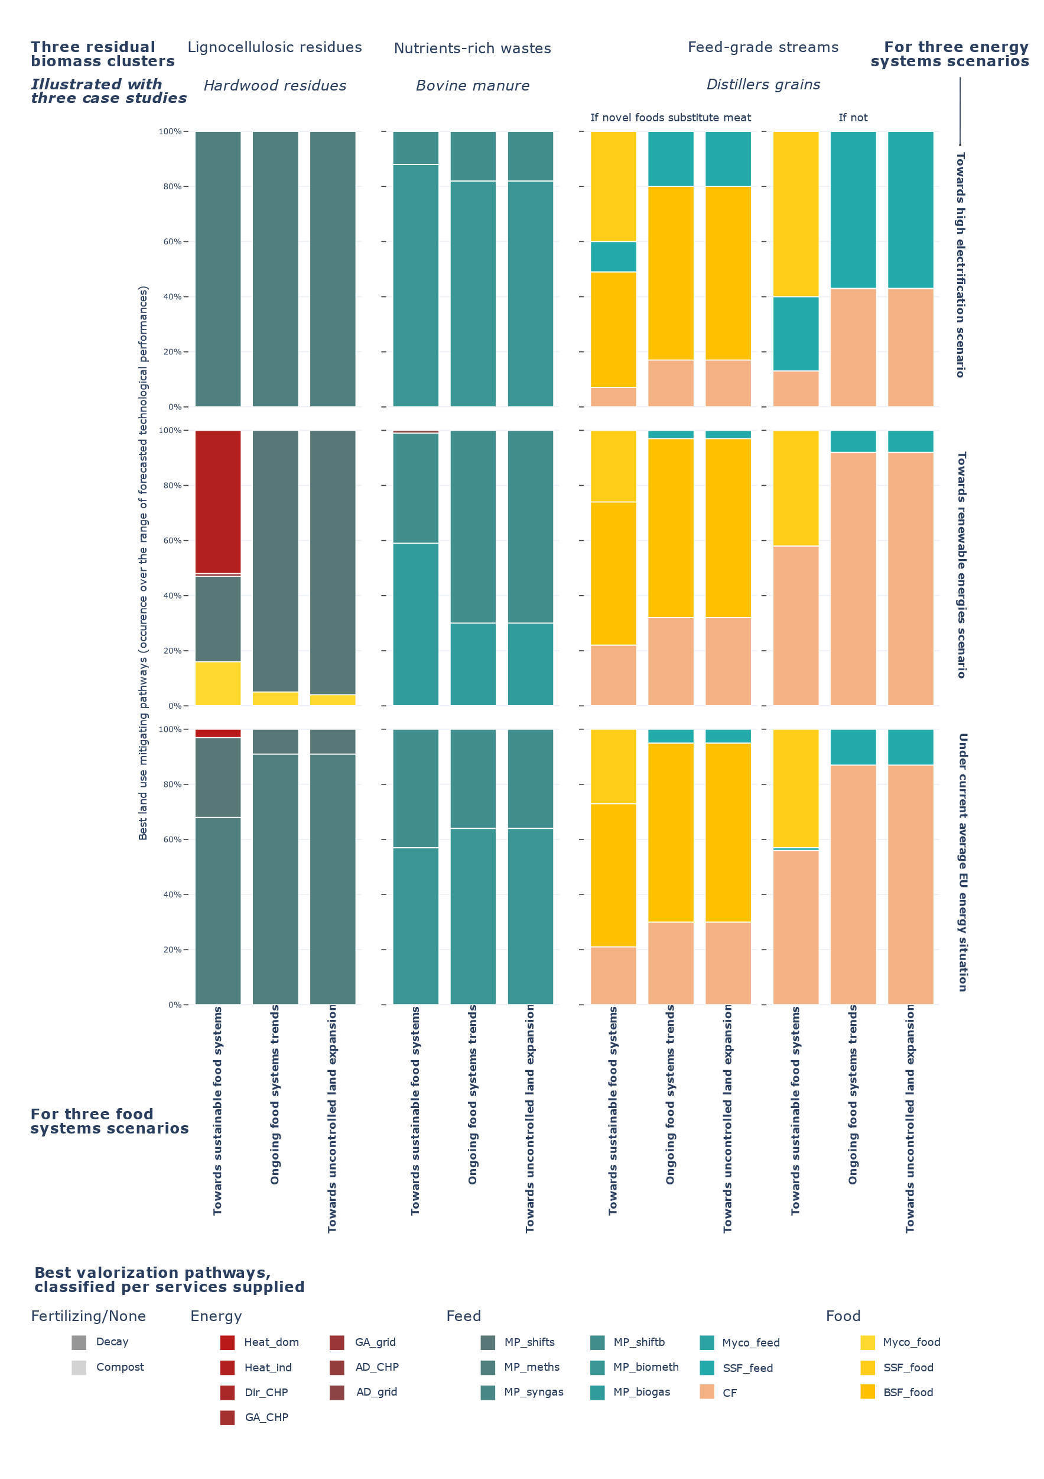
Complements Figure 2: Stacked bars represent the percentage of time when a pathway outperformed all the other options in terms of land use impacts mitigation when screening the whole range of forecasted technological improvements (n=8820 samples, see Methods). Simulations were repeated for three contrasted future food systems scenarios (three columns) and for three future energy systems scenarios (three rows; detailed in Table 2). Background data and visualization for the rest of the case studies are both available in the data repository.
Extended Figure 3 – Best residual biomass valorization pathways to mitigate water use impacts
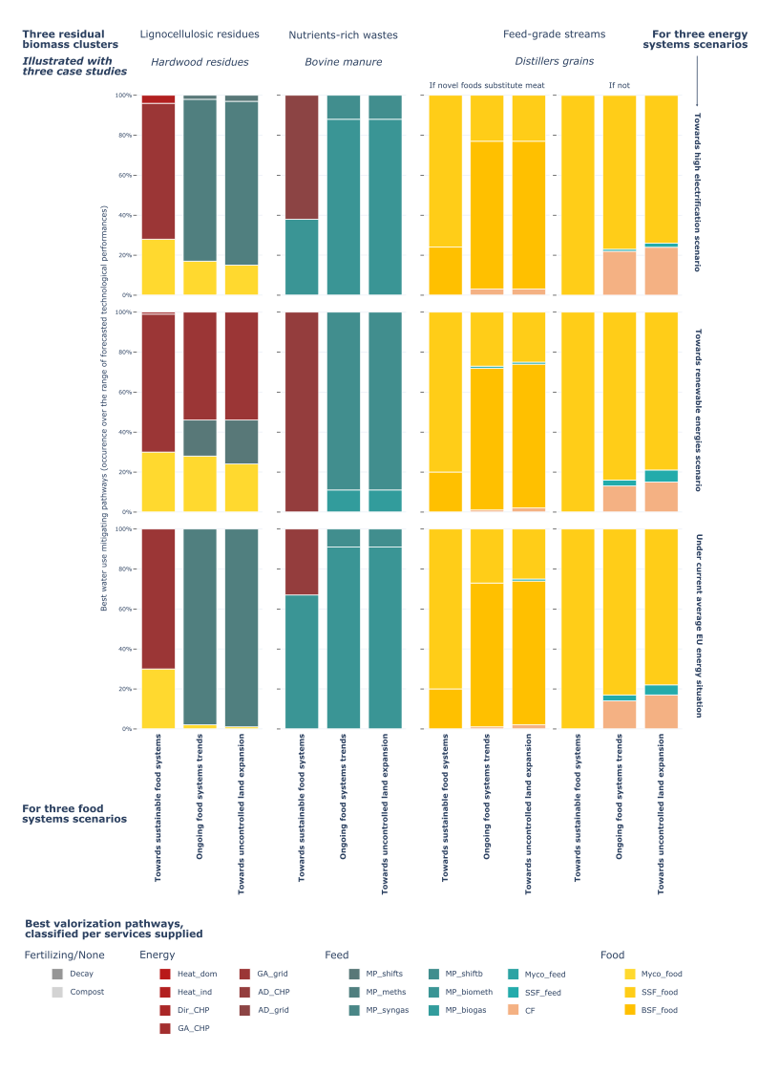
Complements Figure 2: Stacked bars represent the percentage of time when a pathway outperformed all the other options in terms of water use impacts mitigation when screening the whole range of forecasted technological improvements (n=8820 samples, see Methods). Simulations were repeated for three contrasted future food systems scenarios (three columns) and for three future energy systems scenarios (three rows; detailed in Table 2). Background data and visualization for the rest of the case studies are both available in the data repository.
Extended Figure 4 – Forecasted climate change performances of alternative pathways to handle one tonne of distillers grains
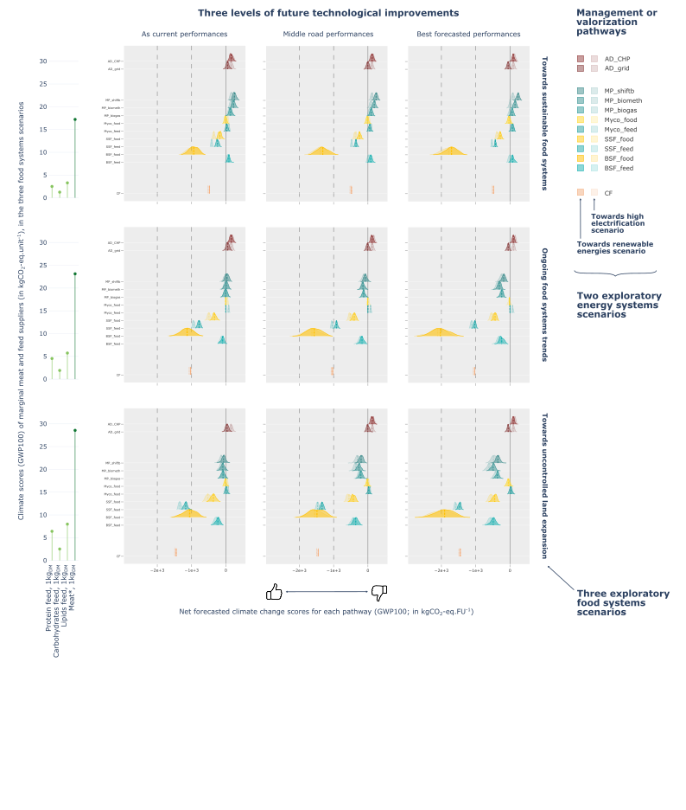
Complements Figure 3: Ridgeline subplots illustrate the dispersion of the climate change scores for each of the twelve waste-to-nutrition and conventional valorization pathways applicable to distillers grains (see Table 1), considering uncertainties on emission factors and future technological performances. The values range of the ten parameters contributing the most to the variance of LCA scores were divided into three equally distributed intervals to perform the simulations (n=150 for each interval; see Methods), corresponding to the three columns. This operation was repeated for the three future food systems scenarios (the three rows) and the two future energy systems scenarios (overlaid within each subplot), all defined in Table 2. Background data and visualization for the rest of the case studies and impact categories are available in the data repository. Net scores were calculated considering 65% moisture content for distillers grains. *: Here, animal-based meat marginal suppliers (corresponds to alternative 1 in Table 2). FU: Functional unit.
Extended Figure 5 – Forecasted climate change performances of alternative pathways to handle one tonne of bovine manure
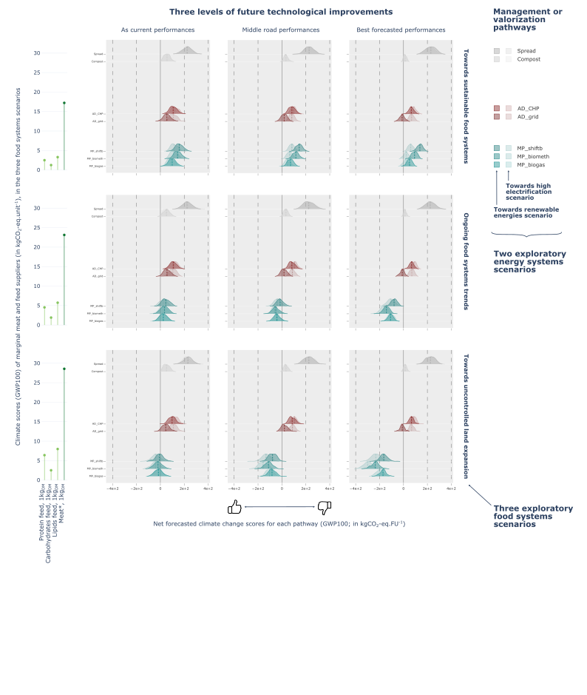
Complements Figure 3: Ridgeline subplots illustrate the dispersion of the climate change scores for each of the seven waste-to-nutrition and conventional valorization pathways applicable to bovine manure (see Table 1), considering uncertainties on emission factors and future technological performances. The values range of the ten parameters contributing the most to the variance of LCA scores were divided into three equally distributed intervals to perform the simulations (n=150 for each interval; see Methods), corresponding to the three columns. This operation was repeated for the three future food systems scenarios (the three rows) and the two future energy systems scenarios (overlaid within each subplot), all defined in Table 2. Background data and visualization for the rest of the case studies and impact categories are available in the data repository. Net scores were calculated considering 72% moisture content for bovine manure. *: Here, animal-based meat marginal suppliers (corresponds to alternative 1 in Table 2). FU: Functional unit.

