Prospective environmental mitigation potential of deploying waste-to-nutrition pathways

Supplementary information document

U. Javourez^{1*}, L. Tiruta-Barna¹, M. Pizzol², L. Hamelin¹
¹TBI, Université de Toulouse, CNRS, INRAE, INSA, Toulouse, France
²Department of Planning, Aalborg University, Rendsburggade 14, 9000 Aalborg, Denmark
*: Corresponding author

Statement
The background data supporting the main findings of this study is available at the following dataverse repository: https://doi.org/10.48531/JBRU.CALMIP/PBS858.
This study grounds on a PhD thesis project entitled: “Transforming residual biomass into food and feed – towards an LCA optimization platform”, available upon requests and in open access after the embargo period.

Abbreviations
AD, Anaerobic digestion; CHP, Combined heat & power; COP, Coefficient of performances; CF, Compound feed (direct feeding); EF, Emission factors; EU, Europe; FCR, Feed conversion ratio; GA, Gasification; GB, Green biorefinery; GHG, Greenhouse gases; GSA, Global sensitivity analysis; HT, High temperature; LCA, Life cycle assessment; LT, Low temperature; LUC, Land use change; LW, Live weight; MP, Microbial proteins; Myco, Mycoproteins; N, Nitrogen; OaT, One-at-the-time; OM, Organic matter; SFU, Scandinavian feed unit

Content
1. Case studies 3
2. Identification of marginal suppliers and scenarios definition 4
3. Global sensitivity analysis design and implementation 18
4. Additional results 28
References 33

Tables
Table SI1 – Selected residual biomass streams: potential and characteristics 3
Table SI2 – LCA scores of marginal power mixes in three future energy scenarios 4
Table SI3 – LCA scores of marginal LT heating mixes in three future energy scenarios 5
Table SI4 – District heating marginal mixes in three future energy scenarios 5
Table SI5 – LCA scores of marginal HT heat mixes in three future energy scenarios 6
Table SI6 – Background activities to model green ammonia production, one kilogram 7
Table SI7 – LCA scores of marginal fertilizer and fertilizing services in three future energy scenarios 7
Table SI8 – Marginal feed suppliers mixes in three future food systems scenarios 9
Table SI9 – Background activities to model the marginal production of concentrated feed services 11
Table SI10 – Background activities to model the marginal production of roughage feed services 12
Table SI11 – LCA scores of marginal feed services in three future food systems scenarios 12
Table SI12 – Marginal animal-based meat suppliers, benchmark and selected mix 15
Table SI13 – Modeling of poultry and swine meat production systems 16
Table SI14 – Background activities used to model marginal meat suppliers 16
Table SI15 – Background activities used to model marginal plant-based meat suppliers 16
Table SI16 – LCA scores of marginal meat-equivalent suppliers in three food systems scenarios 16
Table SI17 – Morris method notations and selected simulation parameters 19
Table SI18 – Sufficient condition finding, illustrated on example I 25
Table SI19 – Sufficient condition finding, illustrated on example II 26

Figures
Figure SI1 – Interpretation of Morris-based indicators 21
Figure SI2 – Sensitivity and uncertainty 22
Figure SI3 – Change in descriptive statistics, cluster analysis, example I.i 24
Figure SI4 – Change in descriptive statistics, cluster analysis, example I.ii 24
Figure SI5 – Change in descriptive statistics, cluster analysis, example II 25
Figure SI6 – Change in descriptive statistics, cluster analysis, example III 26
Figure SI7 – Change in descriptive statistics, cluster analysis, example IV.i 27
Figure SI8 – Change in descriptive statistics, cluster analysis, example IV.ii 27

Case studies
The eleven streams were retained based on selection criteria of Javourez et al., (2024)¹, their characteristics as used in this study are presented in Table SI1.
Table SI1 – Selected residual biomass streams: potential and characteristics
Category | Wood-related |  | Crop residues | Manure & sludge |  | Green residues |  | Agrifood co-product |  |  | Food waste
Case study | Hardwood residues | Sawmill waste | Wheat straw | Bovine manure | Sewage sludge | Manag. grass | Sugar beet tops | PAT | CSG | PS | House-hold
Dry matter | 82% | 84% | 90% | 28% | 7% | 43% | 19% | 94% | 35% | 21% | 31%
Biochemical composition¹ (%_{DM})
Ashes | 2% | 5% | 6% | 19% | 26% | 12% | 18% | 21% | 5% | 3% | 20%
Cellulose | 32% | 44% | 35% | 24% | 0% | 27% | 13% | 0% | 9% | 0% | 5%
Hemicellulose | 22% | 7% | 23% | 18% | 0% | 20% | 14% | 0% | 21% | 8% | 5%
Lignin | 28% | 29% | 13% | 19% | 0% | 9% | 7% | 0% | 4% | 0% | 19%
Proteins | 2% | 0% | 9% | 14% | 38% | 8% | 16% | 66% | 30% | 8% | 14%
Lipids | 0% | 0% | 2% | 6% | 8% | 1% | 2% | 11% | 11% | 0% | 13%
Starch | 0% | 0% | 1% | 0% | 27% | 0% | 14% | 0% | 9% | 75% | 15%
Sugars | 0% | 0% | 1% | 0% | 0% | 13% | 12% | 0% | 2% | 2% | 6%
Others | 14% | 15% | 9% | 0% | 1% | 9% | 4% | 2% | 9% | 4% | 3%
C | 50% | 48% | 48% | 49% | 41% | 51% | 41% | 55% | 50% | 45% | 50%
H | 6% | 6% | 6% | 5% | 6% | 7% | 6% | 7% | 7% | 6% | 7%
N | 0.3% | 0% | 0.6% | 2.7% | 6.3% | 2.0% | 2.3% | 8.5% | 3.8% | 1.1% | 3%
O | 41% | 41% | 39% | 32% | 27% | 26% | 38% | 28% | 34% | 46% | 35%
S | 0.1% | 0% | 0.1% | 0.2% | 0.9% | 0.2% | 0.2% | 0.5% | 0% | 0.1% | 0.9%
P | 0.1% | 0% | 0.1% | 0.6% | 2.6% | 0.3% | 0.2% | 0.3% | 0.8% | 0.2% | 0.4%
K | 0.7% | 0.1% | 1.1% | 3.7% | 0.9% | 0.7% | 4.8% | 0.6% | 1.0% | 1.2% | 1.1%
Rest | 1.8% | 4.9% | 5.1% | 6.8% | 15.3% | 12.8% | 6.7% | 0.1% | 3.4% | 0.3% | 2.6%
Crude fibers | na | na | 42% | 22% | na | 25% | 11% | 0% | 8% | 3% | 17%
Digestibility | na | na | 45% | na | na | 50% | 81% | 89% | 76% | 87% | 84%
TAN | 0.2% | 0% | 0.0% | 1.6% | 0.2% | 0.2% | 0.1% | 0.1% | 0.3% | 0.7% | 0.04%
Potential for France^{1,2}
Mt_{ww}.y⁻¹ | 8.3 | 11.6 | 33.8 | 73.9 | 4.2 | 11.5 | 20.5 | 0.5 | 1.0 | 0.5 | 4.8
Current use³ | Decay | Heat_ind | Plough | Spread | Spread | Decay | Plough | CF | CF | CF | Compost
Rounded values. PAT: Processed animal proteins. CSG: Corn spent grains (referred to as distillers grains in the main manuscript). PS: Potato screenings. Name of pathways as in Table 1 of main manuscript.

Identification of marginal suppliers and scenarios definition
This section details the rationale, sources and assumptions used to model plausible development contexts for residual biomass valorization pathways, formulated as exploratory scenarios. Background data and calculations are available in the data repository. The scenarios were elaborated to capture the main uncertainties regarding the future evolutions of energy, fertilizer, food and feed markets.

Energy markets
Almost all selected pathways supply and consume power and heat. Both markets are further detailed separately. No scenarios on future transportation markets were included in the analysis as none of the selected pathways specifically supplied transportation services, and because transportation was found as neglectable in the LCA contribution analysis (foreground supply chains assumed at France scale). Here, transportation requirements were modeled with a fixed ecoinvent activity proxy, as detailed in a previous study¹. Planning future roadmaps for energy markets is already widely developed at each country scale. Thus, contrasted marginal power and heat production suppliers for France were identified based on a benchmark of authoritative energy systems forecasts for France elaborated in a companion study³.

Electricity markets
The marginal power suppliers mixes (as estimated with the reviewed forecasts³) were found mainly composed by renewable technologies (Table SI2). Yet, RTE’s forecasts⁴ and recent debates in France highlight the uncertain role that nuclear-based technologies will play in future French power supplies. The eventuality that France revamps existing facilities and boosts the development of additional nuclear production capacities was therefore assessed as an alternative scenario “Towards high electrification”. To illustrate the outcomes of the LCA model in a context of unfavorable power mix (in terms of environmental impacts), the average European (EU) situation was taken as an example. The 2030 average EU mix was directly derived from projections by the EUREF2020 scenario⁵. LCI modeling and selected background activities were detailed in a previous study³.
Table SI2 – LCA scores of marginal power mixes in three future energy scenarios
Technology group  (% in mix) | Toward renewable energies | Towards high electrification | Average EU situation, 2030  (Illustrative purposes)
Nuclear | 0.1% | 99.3% | 17.3%
Biomass-waste | 1.4% |  | 5.7%
Hydro | 0.9% |  | 12.1%
Wind, onshore | 42.3% |  | 22.5%
Wind, offshore | 24.2% |  | 6.8%
Solar | 30.5% |  | 11.7%
Geothermal |  |  | 0.2%
Solid fossil fuel |  |  | 9.0%*
Petroleum products |  |  | 0.2%*
Gases | 0.7% | 0.7% | 14.5%
Hydrogen
Others | Reviewed French forecasts³ | Assumed | EUREF2020 scenario⁵
Environmental impacts (EF 3.0), expressed per kWh supplied
Climate change (kgCO₂-eq) | 0.059 | 0.016 | 0.158
Marine eutrophic. (kgN-eq) | 6.8 x 10⁻⁵ | 6.2 x 10⁻⁵ | 9.6 x 10⁻⁵
Land use (points) | 4.8 | 0.1 | 4.5
Water use (m³-eq) | 0.041 | 0.13 | 0.049
Rounded to two digits. *: Modeled as natural gas following ongoing EU policies phasing out solid and liquid fossil fuels.
Nuclear power production performs mostly better than the renewable-based power mix for the selected impact categories, except for water use. For the latter (towards renewable energies scenario), more than half of climate change and eutrophication impacts come from solar-based technologies (albeit only representing 30% of the marginal suppliers mix; Table SI2), and 80% of land use and water use impacts, principally stemming from the photovoltaic plant and equipment fabrication.

Heat markets
The identification of marginal heat suppliers and LCI modeling was already fully detailed in Javourez et al., (2024)³, and summarized in Tables SI3-5. Heating services were separated as low temperature heating (LT; e.g. for domestic and tertiary space heating) and high temperature heating (HT; e.g. industrial heating).
Table SI3 – LCA scores of marginal LT heating mixes in three future energy scenarios
Technology group (% in mix) | Toward renewable energies | Towards high electrification | Average EU situation, 2030*  (Illustrative purposes)
District heating** | 11.8% | 11.8% | 6.3%
Gas grid |  |  | 24.6%
Gas liquefied |  |  | 0.3%***
Heating oil |  |  | 2.3%***
Wood-based heating |  |  | 17.3%
Electricity-based heating | 3.9% | 3.9% | 37.1%
Thermal solar | 4.2% | 4.2% | 0.5%
Heat pump heating | 80.1% | 80.1% | 11.7%
Comment | Considering the corresponding marginal power mix for each scenario as in Table SI2.
Environmental impacts (EF 3.0), expressed per MJ supplied
Climate change (kgCO₂-eq) | 0.014 | 0.010 | 0.046
Marine eutrophic. (kgN-eq) | 1.3 x 10⁻⁵ | 1.2 x 10⁻⁵ | 3.0 x 10⁻⁵
Land use (points) | 0.73 | 0.24 | 1.53
Water use (m³-eq) | 4.1 x 10⁻³ | 13.7 x 10⁻³ | 6.6 x 10⁻³
Rounded to two digits. *: According to ADEME scenarios for France⁶ (no Europe-wise information for future LT heating markets found). **: See Table SI4 for district heating modeling. ***: Modeled as natural gas following ongoing EU policies phasing out solid and liquid fossil fuels.
Table SI4 – District heating marginal mixes in three future energy scenarios
Technology group (% in mix) | Toward renewable energies | Towards high electrification | Average EU situation, 2030*  (Illustrative purposes)
Gas grid |  |  | 42.8%
Heating oil |  |  | 1.1%**
Solid fossil fuel |  |  | 15.6%**
Wood-based heating | 50.6% | 50.6% | 33.5%
Electricity-based heating
Geothermal  (incl. ground heat pumps) | 44.5% | 44.5% | 7.0%
Thermal solar | 4.9% | 4.9%
Comment | Considering the corresponding marginal power mix for each scenario as in Table SI2.
*: According to EUREF2020 scenario⁵. **: modeled as natural gas following ongoing EU policies phasing out solid and liquid fossil fuels.
Under the “towards renewable energies” scenario, on an energy basis, the marginal production of HT heat generates three times as much greenhouse gases (GHG) emissions as both marginal power and LT heat productions. It directly related to the fossil emissions linked to natural gas combustion, and to the land use change required to grow wood. Wood requirements also explain why the mix of HT heat marginal suppliers generate more land use impacts than the ones generated by power (+30%) and LT heat (+240%) suppliers, despite the latter present non-neglectable land use impacts due to the area required to install solar panels. In this scenario, per energy equivalent, LT heat suppliers are slightly less impactful (all impacts) than power suppliers because of the efficiency of heat pump technologies (coefficient of performances; COP; >1). Notably, as estimated here, the marginal HT heat suppliers would provide net water use benefit (negative LCA score in Table SI5). This result stems from complex feedback loops within ecoinvent system models in-between the activities linked to “market for wood chips, RER”. In a nutshell, although wood-based combined heat and power (CHP) systems were removed from the inventory of selected wood-based heat production activities to achieve the best proxy, these were nevertheless found to indirectly influence the LCA scores of these activities due to intricated electricity and heat markets in the consequential ecoinvent system model. In turn, when called in the background inventory, wood-based CHP power substitutes the marginal power mix of Switzerland (as “CH” was selected for lack of French data) which host a high share of hydro power from Alpine regions. Therefore, according to the ecoinvent consequential system model, producing wood-based heat in Switzerland avoids the expansion of hydropower and lead to net water use impacts savings.
Table SI5 – LCA scores of marginal HT heat mixes in three future energy scenarios
Technology group (% in mix) | Toward renewable energies | Towards high electrification | Average EU situation, 2030*  (Illustrative purposes)
Gas grid | 50% |  | 100%
Wood-based heating | 50%
Power-to-heat** |  | 50%
Solar-to-heat** |  | 50%
Comment | Considering the corresponding marginal power mix for each scenario as in Table SI2.
Environmental impacts (EF 3.0), expressed per MJ supplied
Climate change (kgCO₂-eq) | 0.046 | 0.011 | 0.076
Marine eutrophic. (kgN-eq) | 3.9 x 10⁻⁵ | 3.4 x 10⁻⁵ | 1.6 x 10⁻⁵
Land use (points) | 1.75 | 1.16 | 0.04
Water use (m³-eq) | -2.8 x 10⁻³ | 28.7 x 10⁻³ | 0.7 x 10⁻³
*: Assumed for illustrative purposes. **: Described in Javourez et al., (2024)³. Emerging electrified thermal processes for industrial applications include resistors, conduction, induction, mechanical vapor compression, electric boilers, electric arc furnaces, etc., as well as solar-based technologies such as concentrated solar power⁷.
The “high electrification” energy scenario displays comparable marginal HT heat and power production impacts on an energy basis, as both are only based on power-to-heat and solar-to-heat technologies. Moreover, the impacts related to the marginal production of LT heat are following the ones of marginal power production for climate change, but differ for water and land use (due to the contrasted LCA scores between solar panels and nuclear for these two impact categories). On top of highlighting intrinsic tradeoffs between impact categories, the scenario analysis also allowed to screen the variations in terms of LCA scores across the different energy markets (here, power, LT an HT heating). Importantly, the primary aim of the scenario analysis is to capture contrasted future situations for the energy systems and related markets, which could affect the relevance of implementing waste-to-nutrition pathways for the four impact categories assessed. Including a larger set of impact categories in the analysis might require to expand the scenario analysis to better capture contrasted performances for categories tightly linked to energy systems such as ionizing radiations and particulate matter formation, among others. As another improvement leverage, several LCA scores of specific suppliers were tightly linked to the selected background activities in ecoinvent (this is the case of nuclear-based technologies and wood CHP): these could be refined and confronted with other data sources to increase the robustness of the results.

Fertilizer markets
The identification and modeling of the marginal suppliers of fertilizers and fertilizing services was based on Javourez et al, (2024)³. Fertilizers and fertilizing services were modeled separately because the selected waste valorization pathways either integrate the use of fertilizers for agronomic practices (that is, applied on arable lands) or as chemical inputs within specific unit operations (e.g. to meet the nutrients requirements in bioreactors). For the latter case, spreading operations and related land emissions are thus not part of the inventory. The reader is directed to the supporting information document of aforementioned study detailing the modeling, the selection of background ecoinvent activities and the LCA contribution analysis (see also Table SI7 for environmental performances).
Table SI6 – Background activities to model green ammonia production, one kilogram
Background activities | Unit | Value | Comment
Market for nitrogen, liquid, RER | kg | 0.82
Electrolysis-based hydrogen | kg | 0.18 | Inventory described in Javourez et al., (2024)¹ fixed with baseline technological performances
Electricity | kWh | 0.74 | Scenario-dependent marginal mix
Market for water, decarbonized, FR | kg | 155.14 | Cooling water
Market for chemical factory, organics, GLO | unit | 9.15 x 10⁻¹¹ | Proxy of green ammonia production plant
All activities are from the ecoinvent 3.8 consequential database.
Table SI7 – LCA scores of marginal fertilizer and fertilizing services in three future energy scenarios
Technology group (% in mix) | Toward renewable energies | Towards high electrification | Average EU situation, 2030*  (Illustrative purposes)
Conventional inorganic N | 100% |  | 100%
Green ammonia-based N |  | 100%
Conventional inorganic P₂O₅ | 100% | 100% | 100%
Conventional inorganic K₂O | 100% | 100% | 100%
Comment | Considering the corresponding marginal power mix for each scenario as in Table SI2.
Environmental impacts (EF 3.0), expressed per kgN supplied (fertilizer service)
Climate change (kgCO₂-eq) | 4.17 | 1.10 | 4.17
Marine eutrophic. (kgN-eq) | 4.5 x 10⁻³ | 4.22 x 10⁻³ | 4.5 x 10⁻³
Land use (points) | 22.7 | 21.8 | 22.7
Water use (m³-eq) | 5.21 | -0.55 | 5.21
Environmental impacts (EF 3.0), expressed per kgN supplied (fertilizing service)
Climate change (kgCO₂-eq) | 9.95 | 6.88 | 9.95
Marine eutrophic. (kgN-eq) | 0.13 | 0.13 | 0.13
Land use (points) | 22.8 | 22.0 | 22.8
Water use (m³-eq) | 5.21 | -0.54 | 5.21
Environmental impacts (EF 3.0), expressed per kgP₂O₅ supplied (both fertilizer and fertilizing services) **
Climate change (kgCO₂-eq) | 1.89 | 1.89 | 1.89
Marine eutrophic. (kgN-eq) | 2.1 x 10⁻³ | 2.1 x 10⁻³ | 2.1 x 10⁻³
Land use (points) | 42.2 | 42.2 | 42.2
Water use (m³-eq) | 2.37 | 2.37 | 2.37
Environmental impacts (EF 3.0), expressed per kgK₂O supplied (both fertilizer and fertilizing services) **
Climate change (kgCO₂-eq) | 2.09 | 2.09 | 2.09
Marine eutrophic. (kgN-eq) | 2.5 x 10⁻³ | 2.5 x 10⁻³ | 2.5 x 10⁻³
Land use (points) | 26.0 | 26.0 | 26.0
Water use (m³-eq) | 1.10 | 1.10 | 1.10
*: Assumed for illustrative purposes. **: For these impact categories, no difference of LCA scores between fertilizing and fertilizer services (that is, no influence of spreading and land emissions inventories).
The eventuality of the wide deployment of green ammonia production to support fossil-free Haber-Bosch N fertilizer production was assessed as part of the “towards high electrification” energy scenario. This is because, in this case, H₂ would be provided by electrolysis, hence requiring additional large-scale power production capacities. To model this alternative way of producing N-fertilizers, the existing ecoinvent “market for inorganic nitrogen production, FR” (fossil-based) activity was kept, but “ammonia production, steam reforming, liquid, RU” and “RER” activities were systematically removed from its background system. These were replaced (keeping the same stoichiometric basis) by an own-made inventory for green ammonia production derived from Mayer et al., 2023 ⁸ (Table SI6).
For the four impact categories assessed, the impacts of marginal P and K fertilizing services mostly come from the production phase. Nitrous oxides land emissions contribute to more than half of the climate change impacts of marginal N-fertilizing services (corresponding to conventional mineral N land application). In the “towards high electrification” energy scenario, green ammonia production is estimated to reduce the GHG emissions associated with the production phase of marginal N-fertilizer by ca. fourfold. Yet, considering the spreading and land emissions phases, the total climate change impacts of N-fertilizing services are reduced by ca. 30% if implementing green ammonia production instead of conventional fossil-based Haber-Bosch ammonia production. Net savings in terms of water use when implementing green ammonia production is due to the co-produced oxygen, avoiding the water-intensive cryogenic air separation processes (here, assuming 80% substitution rate¹, fixed). Almost all the marine eutrophication impacts of supplying N-fertilizing services are due to nitrates leaching during the land spreading phase.

Food and feed markets
The relevant “food and feed markets” characteristics for this study were selected as the ones directly affecting the LCA scores of the marginal suppliers of nutritional services, building on previous works². The generic grouping of food and feed suppliers as a function of the main nutritional services these provide was kept as established in Javourez et al., (2022)² and (2024)¹. Feed markets were subdivided into concentrated feed markets considered as global (including proteins, lipids and carbohydrates services), and roughage feed (for ruminant only) assumed as local. For food markets, only meat-equivalent and flour-equivalent markets were modeled, for being the target of selected novel foods formulation pathways. Proposed food and feed markets modeling, albeit enabling relatively broad exploration of contrasted future environmental performances of food and feed production, was nevertheless based on an extrapolation of current trends, as e.g. developed in the OECD-FAO Agricultural outlook⁹. In turn, the simplified sets of exploratory food systems scenarios proposed here do not aim to provide an exhaustive panel of all reachable situations nor to forecast, but rather to provide plausible best/worst case future scenarios when it comes to the four impact categories assessed. Needless to remind that the future environmental impacts of food and feed production will depend on the globally-differentiated efforts in implementing supply- and demand-side solutions towards sustainable food systems¹⁰.

Feed markets
The environmental impacts associated with the marginal production of feed ingredients largely affects the LCA scores of waste-to-nutrition pathways: not only by their magnitude, but also because these are contrasted in-between feed ingredients providing different nutritional services (for example, protein feeds against lipids feeds), and between these feed ingredients and non-food commodities (for example, energy and fertilizers). Here, a simplified estimation of contrasted sets of LCA scores related to marginal feed suppliers is proposed, based on two factors. The first one relates to the distribution of different crops in the marginal feed production mix. The second related to the magnitude of land use change (LUC) impacts associated with this marginal production. The latter was modeled through the marginally-responding yields for each crop, and by using a deterministic (and generic) LUC factor² representing the future global balance between intensification and expansion in producing more land-dependent products. A first scenario consists in extrapolating the past ten years global feed production trends and LUC trends according to FAO data (summary in Table SI8), already performed in Javourez et al., (2022)² and further referred to as the “ongoing food systems trends” scenario.
Two additional contrasted future food systems scenarios were assessed. A best-case scenario entitled “towards sustainable food systems” was elaborated considering that only the crops contributing the most to global feed production increase today would respond to the additional feed demand (that is, the ones displaying the higher share in the extrapolated marginal feed suppliers mix, as “first order” marginal suppliers; Table SI8). This scenario also considers that joint efforts limiting deforestation and bridging yields gap are globally implemented, meaning the share of expansion shrinks down to 25%; (Table SI8). In this scenario, soybean meal, palm oil, maize and grass silage are respectively the marginal suppliers of proteins, lipids, carbohydrates and roughage feed commodities. Notably, these crops present the best yields (for each commodity group; Table SI9), partly explaining their position as best environmentally performing crops (discussions below). A worst-case scenario entitled “towards uncontrolled land expansion” was further elaborated considering the same marginally-responding feed commodities mixes as ongoing trends, but with increased pressure on arable lands leading the share of expansion to rise up to 85%.
Table SI8 – Marginal feed suppliers mixes in three future food systems scenarios
Commodity group (% in mix) | Toward sustainable food systems | Ongoing food systems trends | Towards uncontrolled land expansion
Protein feeds
Soybean meal | 100% | 52% | 52%
Rapeseed meal |  | 24% | 24%
Sunflower meal |  | 24% | 24%
Carbohydrates feeds
Wheat |  | 24% | 24%
Barley |  | 9% | 9%
Maize | 100% | 67% | 67%
Lipids feeds
Palm oil | 100% | 50% | 50%
Rapeseed oil |  | 2% | 2%
Soybean oil |  | 34% | 34%
Sunflower oil |  | 13% | 13%
Roughage feeds
Grass silage | 100% | 25% | 25%
Ryegrass silage |  | 25% | 25%
Alfalfa-grass silage |  | 25% | 25%
Ryegrass mixture silage (Egyptian & Persian clover) |  | 12.5% | 12.5%
Ryegrass mixture silage (Egyptian & Red clover) |  | 12.5% | 12.5%
Others
LUC factor (expansion share) | 25% | 55% | 85%
Comment | Background data (FAO) and calculation details in Javourez et al., (2022)² and (2024)¹

Not formulated as standalone scenarios, the effects of implementing policies favoring European crops on the marginal feed suppliers mixes and their LCA score were also analyzed (rapeseed meal and oil, wheat and alfalfa-grass silage as roughage, “second order” marginal suppliers in Table SI8). This was done to screen a larger range of future environmental impacts of food systems (to derive e.g. Figure 2 of the main manuscript), and to capture the consequences of maintaining in the long-term the current commodity-focused anti-deforestation European regulations (particularly pointing at e.g. soybean and palm fruit bunch). In total, combining three mixes of marginal feed suppliers (total mix, first order and second order) and the three future LUC patterns (25%, 55% and 85% expansion rates), nine contrasted future feed markets contexts (in terms of LCA score) were derived (data repository), the scenario analysis only detailing the results associated with three out of these.
The LCA scores associated with the marginal supplies of feed ingredients to final consumer include the whole supply chain from the demand on arable land to the final transportation of the commodity. The same inventory modeling strategy used in Javourez et al., 2022² was performed here, and only changes or novel modeling elements are further detailed.
The inventories associated with LUC and the rest of the value chains were modeled separately. For the latter, the ecoinvent activities displayed in Table SI9 were considered as proxies of the marginally-weighted inventories of each identified crop production system. In the ecoinvent consequential product system, crops production market activities already include the differentiated production patterns between the marginally-supplying world regions. Further, when existing, LUC-related impacts embedded within the ecoinvent activities linked with agricultural production were systematically removed. This was done for consistently accounting for these impacts through the use of flexible unitary LUC activity, as performed in Javourez et al., 2022². This activity builds on the last ten years crop production, fertilizer use and deforestation rates and is used to generate an aggregated LCA score associated with the requirement of an additional unit (here hectare) of arable land. This activity already includes the share of expansion (net transformation of non-arable land into arable land, such as through deforestation) and intensification (achieving higher yields) in meeting this additional demand, based on past trends. Therefore, this activity is a generic estimation of the global implications of demanding one additional hectare of arable land for food production, and is based on many assumptions (see the supporting document of aforementioned publication). This unitary LUC activity was further integrated to the inventory of each crop involved in the marginal feed suppliers mixes previously identified, by considering their own marginal yields (see Table SI9). This is key as the agricultural regions able to respond to a change in crops demand generally present lower yields than world’s average (except for palm oil, whose marginal production is concentrated in few countries).
Inventories related to roughage feed marginal suppliers were established based on the same rationale, but as the production was considered local, the production phase was adapted to only account for French-like production conditions (here, the closest proxy is Switzerland “CH”). Moreover, the fertilizing requirements initially integrated within ecoinvent activities were harmonized with the ones calculated for this study, for consistency. This was done by screening ecoinvent activities datasheets to obtain fertilizer application rates and roughage feed yields. Table SI10 summarizes the ecoinvent activities used to estimate the LCA scores of marginal roughage feeds production in France.

Table SI9 – Background activities to model the marginal production of concentrated feed services
Background activities | Marginal yield* t_{DM}.ha⁻¹.y⁻¹ | Market | Comment
Market for soybean meal, RoW | 1.86 | Protein feed | Proxy of marginal soybean meal production inventory, including transportation.
Own construction built around the process:  “Rape oil mill operations, RoW” | 0.87 | Protein feed | Proxy of marginal rapeseed meal production inventory, including transportation. Existing ecoinvent process “Market for rape meal, GLO” directly connects rapeseed meal production impacts to soybean meal production impacts through a “generic market for protein feed” process. Therefore, only the transportation was derived from this process, and rest of the production was  modeled by reversing the existing process “rape oil mill operations, RoW” (initially expressed per kg of rape oil produced). This was done by considering that 1kg of rape meal comes with 0.618 kg rape oil. In this inventory, rape oil supplies the “Market for vegetable oil, refined, GLO”, and the “Market for rape meal, GLO” process was removed (as now being the main output).
Own construction built around the process:  “Market for sunflower seed, GLO” | 0.91 | Protein feed | Proxy of marginal sunflower meal production inventory, including transportation. No ecoinvent of sunflower meal production exists. Therefore, the sunflower seed production process was used, and the crushing operations were proxied with the ones of “Soybean meal and crude oil production, mechanical extraction, RoW”. The co-products ratios were adapted to sunflower by considering that 1kg of sunflower meal come with 0.61 kg sunflower oil. As for rapeseed meal modeling, co-produced oil supplies global vegetable oil markets. Electricity was considered “GLO” and biowaste management “RoW.”
Market for wheat grain, RoW | 2.85 | Energy feed | Proxy of marginal energy feed production inventory, including transportation.
Market for barley grain, RoW | 2.06 | Energy feed
Market for maize grain, RoW | 4.58 | Energy feed
Market for palm oil, refined, GLO | 3.55 | Lipid feed  Lipid feed | Proxy of marginal palm oil production inventory, including transportation.
Market for rape oil, crude, RoW | 0.78 | Lipid feed  Lipid feed | Proxy of marginal rape oil production inventory, including transportation.
Adapted from soybean meal and crude oil production, mechanical extraction, RoW | 0.56 | Lipid feed  Lipid feed | Proxy of marginal soy oil production inventory, including transportation.  Existing ecoinvent process “Market for soybean oil, GLO” directly connects soybean oil production impacts to palm oil production impacts through a “Market for vegetable oil, refined, GLO” process. Therefore, only the transportation was derived from this process, and rest of the production was modeled by reversing the existing process “soybean meal and crude oil production, mechanical extraction, RoW” (initially expressed per kg of soybean meal produced). This was done by considering that 1kg of soybean meal comes with 0.187 kg soybean oil. In this inventory, soybean meal supplies the “generic market for protein feed, GLO”, and the “Market for soybean oil, GLO” process was removed (as now being the main output).
Own construction built around the process:  “Market for sunflower seed, GLO” | 0.61 | Lipid feed  Lipid feed | Proxy of marginal sunflower oil production inventory, including transportation. Constructed exacted as for the inventory of sunflower meal production, but reversed (output expressed in terms of oil produced instead of meal produced, and directing the meal produced towards generic market for protein feed, GLO; see corresponding line).
All activities are from the ecoinvent 3.8 consequential database. Details in supplementary information of Javourez et al., 2022². LUC-related impacts were removed from all food-related background activities. “GLO” or “RoW” background activities were selected as concentrated feed ingredients were considered part of global markets. *: Yields already accounting for crop-to-products ratios, and already weighted to correspond to marginally-supplying regions.

Table SI10 – Background activities to model the marginal production of roughage feed services
Background activities | Marginal yield* (t_{DM}.ha⁻¹.y⁻¹) | N-fertilizing service required* (kg_{N}.kg_{DM}⁻¹) | Comment
Market for grass silage, Swiss integrated production, CH | 13.50 | 2.5 x 10⁻³ | Proxy of marginal French grass silage production inventory, including transportation.
Market for ryegrass silage, GLO | 5.75 | 1.1 x 10⁻² | Proxy of marginal French ryegrass silage production inventory, including transportation. “GLO” market was selected because only including “CH” production processes; same distribution was considered as in original data.
Market for alfalfa-grass silage, GLO | 5.78 | 1.15 x 10⁻² | Proxy of marginal French alfalfa-grass silage production inventory, including transportation. “GLO” markets was selected to account for non-intensive production.
Market for ryegrass-Egyptian&Persian clover-mixture silage, GLO | 2.99 | 1.15 x 10⁻² | Proxy of marginal ryegrass mixture silage production inventory, including transportation. “GLO” market was selected because only including “CH” production processes; same distribution was considered as in original data.
Market for ryegrass-red&Egyptian clover-mixture silage, GLO | 5.29 | 1.27 x 10⁻²
All activities are from the ecoinvent 3.8 consequential database. LUC-related impacts were removed from all food-related background activities. Fertilizer-related impacts were removed from all background activities related to roughage feed, to account for marginal N-fertilizing services as estimated in this study. *: Yields and fertilizing requirements already weighted to correspond to marginally-supplying regions (based on ecoinvent distribution within selected “market for” activities). Average moisture content was assumed at 65%_{ww} based on corresponding ecoinvent datasheets.
Table SI11 – LCA scores of marginal feed services in three future food systems scenarios
Environmental impacts  (EF 3.0), per kg_{DM} supplied | Toward sustainable food systems | Ongoing food systems trends | Towards uncontrolled land expansion
Protein feed services
Climate change (kgCO₂-eq) | 2.03 | 4.53 | 6.41
Marine eutrophic. (kgN-eq) | 1.2 x 10⁻² | 3.3 x 10⁻² | 3.9 x 10⁻²
Land use (points) | 188 | 331 | 334
Water use (m³-eq) | -0.08 | 3.9 | 4.2
Energy feed services
Climate change (kgCO₂-eq) | 1.16 | 1.91 | 2.52
Marine eutrophic. (kgN-eq) | 5.2 x 10⁻³ | 9.8 x 10⁻³ | 1.2 x 10⁻²
Land use (points) | 27 | 66 | 67
Water use (m³-eq) | 4.2 | 6.1 | 6.2
Lipids feed services
Climate change (kgCO₂-eq) | 2.82 | 5.73 | 7.98
Marine eutrophic. (kgN-eq) | 2.1 x 10⁻² | 4.9 x 10⁻² | 5.6 x 10⁻²
Land use (points) | 97 | 146 | 150
Water use (m³-eq) | 4.3 | 10.4 | 10.7
Roughage feed services
Climate change (kgCO₂-eq) | 0.28 | 1.03 | 1.42
Marine eutrophic. (kgN-eq) | 1.2 x 10⁻³ | 7.9 x 10⁻³ | 9.0 x 10⁻³
Land use (points) | 49 | 72 | 73
Water use (m³-eq) | 0.07 | 0.2 | 0.3
Values rounded to two digits. Calculated impact scores for the three scenarios only are provided here, the results for the six additional future feed commodities environmental performances configurations (used to derive the Figure 2 of the main manuscript) are available in the data repository.
Per construction, land and water use impacts mostly come from crops production systems, because LUC impacts as modeled here only include direct emissions and intensification-induced fertilizing impacts. Land use impacts of each marginal feed services directly correlate with their marginal yields ranking (Table SI9). Water use impacts mainly depend on the irrigation requirements for each commodities group. The regions marginally-supplying maize, wheat, sunflower and rapeseeds (in terms of countries) rely on irrigation while marginal roughage feed production is mostly rainfed, according to the ecoinvent product system. On the other hand, the climate scores of marginal feed suppliers are mostly driven by LUC impacts, which are also important contributors to total marine eutrophication scores². Yet, marine eutrophication scores (as modeled here) depend more on which specific crops are part of the marginal mix (e.g. if these are fertilized or not) than on the LUC factor itself. Over the four assessed impact categories, and on a weight basis, lipids feeds are the commodities group generating the most environmental burdens, followed by protein feeds, while roughage feeds are less environmentally-intensive. In terms of GHG emissions, over the nine food systems future configurations assessed, the LCA scores of marginal protein feeds suppliers range from 2.0 to 8.6 kgCO₂-eq.kg_{DM}⁻¹, marginal lipids feeds suppliers from 2.8 to 10.3 kgCO₂-eq.kg_{DM}⁻¹ and carbohydrates feeds suppliers from 1.2 to 3.1 kgCO₂-eq.kg_{DM}⁻¹ (used in Figure 2 of the main manuscript). Last but not least, the nutritional values (in terms of Scandinavian Feed Unit; SFU) of the marginal feed suppliers were calculated for each scenario as the weighted average of the SFU associated with each crop part of the marginal mix. The SFU was selected as the basis on which the equivalence in terms of nutritional services provided between conventional and novel feed ingredients was estimated².

Feed markets modeling discussions
Initially selected in the analysis as a fifth impact category, freshwater eutrophication was discarded afterwards. Indeed, with present modeling, the marginal production of protein feeds was found to induce a net freshwater eutrophication impacts mitigation. This is directly due to the use of rapeseed oil and sunflower oil, co-produced along the protein meals, to substitute palm oil production. The latter hosts high (abnormally; ca. 0.02 kgPO₄-eq.kg_{ww}⁻¹) freshwater eutrophication impacts according to the consequential ecoinvent product system, documented as being associated with the oil refinery wastewater treatment processes. Under the “ongoing food systems trends” scenario, this leads marginal lipids feeds suppliers to generate ca. 16 times as much freshwater eutrophication impacts as carbohydrates feeds marginal supplies, on a weight basis. Accordingly, avoiding the production of palm oil is so benefic that it more than offsets the freshwater eutrophication impacts associated with rapeseed and sunflower oil mill operations. In turn, the more protein-rich novel foods and feeds are produced, the worst for this impact category as these would substitute rapeseed meal and sunflower meal production, hence inducing an additional demand on palm oil. On the other hand, when these commodities are not part of the marginal mix of protein feeds suppliers (e.g. in the “towards sustainable food systems” scenario), then LCA scores for freshwater eutrophication correlates with marine eutrophication (hence not yielding additional insights). As a consequence, the freshwater eutrophication impact category was discarded from the analysis.
Identifying and assessing the environmental impacts of marginal protein and lipids feeds suppliers highlight another challenge: the modeling of complex interrelations and retroactive loops between plant proteins and oil markets, due to the numerous co-products involved^{11,12}. Identifying the marginal suppliers implies to determine the driving products for each markets and commodity production. Notably, the main consequential databases and LCA studies are built around the fact that rapeseed and sunflower are principally grown for vegetable oil (driving product) and that soybean is principally grown for its protein meal (driving product). This is why the environmental performances of rapeseed oil, sunflower oil and soybean meal are available in the ecoinvent consequential product system, while the environmental performances of soybean oil, rape meal and sunflower meal are inexistent because considered as constrained resources (Table SI9). In a consequential LCA modeling framework using system expansion with substitution, the environmental performances of constrained resources are necessarily equal to the environmental performances achieved by the marginal suppliers of the services provided by these resources (in ecoinvent; palm oil for vegetable oils and soybean meal for protein meals). Therefore, the impacts of the marginal suppliers of protein and lipids feeds services mostly rely on which will be the driving product between the oil and meal fractions of oilseeds in future markets (particularly for rapeseed and sunflower). In this study, albeit unusual in consequential modeling, both meal and oil fractions of rapeseed and sunflower were assumed as driving products, based on the facts that their production is less concentrated than soybean production (more producing regions), and the drivers more context-dependent⁹. The LCA scores of the marginal protein and lipid feed services as calculated here were nevertheless found aligned with comparable previous estimations (that is, also stemming from a consequential modeling standpoint). For instance, in the ecoinvent consequential product system (v. 3.8; EF 3.0 LCIA method), the “market for soybean meal, RoW” and the “market for palm oil, refined, GLO” activities respectively sum 4.2 and 4.5 kgCO₂-eq per kg_{ww} (GWP100)¹³. Moreover, marginal palm oil was also estimated by Schmidt and De Rosa (2020)¹⁴ to generate an average of 5.34 kgCO₂-eq per kg_{ww} (ranging 3.34-8.16). Overall, the effects of different assumptions regarding the modeling and future trends of protein and lipids feed markets were deemed captured through the panel the nine future food systems configurations.
This is important to stress that the magnitudes of LUC-related environmental impacts are exploratory/indicative only, because the calculation assumes that past ten years trends are extrapolated. Estimations are not based on any kind of future deforestation forecasts, and this also applies for future marginal yields: this implies that the marginally-responding regions in the future remain the same as for the past ten years, for each crop. This is not seen as limiting the interpretation of the results, given that the sole influence of this factor on the LCA scores is to size the magnitude of LUC impacts, whose influence is already assessed by considering three sets of alternative marginal feed suppliers mixes. Despite intrinsic incomparability due to the different scope (impacts of marginal production vs current average production) and methodology applied (e.g. allocation vs system expansion); LUC-related impacts are also the main factors explaining the difference between the LCA scores of food and feed commodities derived in this study and the ones commonly used (for example in France: ECOALIM¹⁵ and ecoinvent¹³ databases). This is another occasion to highlight the importance to reach a common and robust LUC impacts accounting strategy when it comes to assess the future performances of food systems, in a context of constrained (finite) availability of land. Indeed, there is still no consensus when it comes to integrate indirect LUC impacts in LCA¹⁶.

Food markets
Here, the only waste valorization pathways producing food ingredients either target meat-equivalent or flour-equivalent markets¹. For the latter, the modeling developed in Javourez et al., 2022² was reused (i.e. substitution of marginal wheat flour on a weight basis). The case of identifying and modeling the marginal suppliers and environmental impacts of meat-equivalent services is further detailed.
Meat-equivalent services were considered supplied either through animal-based meat or plant-based meat analogues. The marginal animal-based meat suppliers, identified based on last ten years production data (FAOSTAT¹⁷), are reported in Table SI12. The demand for beef meat slightly increases at the world scale, but is stagnating or decreasing in Europe. Global increases in meat demand is mainly supported by poultry and swine meat. The OECD-FAO agricultural outlook⁹ forecasts that the long-term shift towards poultry meat will continue, and that poultry meat and swine meat will both grow by ca. 16% in next decade, mostly driven by developing countries. International trading is also expected to expand⁹, so “GLO” inventories were selected (Table SI13). For all scenarios, the additional demand for animal-based meat was assumed supplied by a mix of poultry and swine (Table SI12). The other livestock types were excluded from the mixes of future marginal suppliers for simplification and because minoritarians in European markets. The share of poultry and swine meat was assumed fixed also for simplifications, as the range of their environmental impacts is already screened through the different feed mixes these are fed with. Indeed, feed is the main contributor to the environmental burden of monogastric meat production¹⁸.
Table SI12 – Marginal animal-based meat suppliers, benchmark and selected mix
Marginal mix | Last 10 years trend, global (FAOSTAT¹⁷) | Last 10 years trend, west Europe (FAOSTAT¹⁷) | Next 10 years projections, global (OECD-FAO⁹) | Next 10 years projections, developed countries (OECD-FAO⁹) | Selected for scenarios
Sheep & goat | 3% | 0% | 5% | 4% | 0%
Beef & buffalo | 8% | 0% | 12% | 15% | 0%
Swine | 31% | 45% | 41% | 0% | 50%
Game | 0% | 0% | 0% | 0% | 0%
Duck | 1% | 0% | 0% | 0% | 0%
Poultry | 55% | 55% | 42% | 81% | 50%
Horse | 0% | 0% | 0% | 0% | 0%
Camel | 0% | 0% | 0% | 0% | 0%
Goose & Guinea | 1% | 0% | 0% | 0% | 0%

Plant-based meat-analogues suppliers were discarded from the first round of simulations with the assumption that plant-based meat-analogues and animal-based meat supply different markets, and considering that the novel foods formulated by the selected waste-to-nutrition pathways were successfully recognized as animal-grade proteins (e.g. insect larvae). However, this assumption was deemed as optimistic considering that, in several countries, plant-based meat-analogues suppliers are already structured in large ecosystems, already producing at the industrial scale with a two-digit growth trend¹⁹. Moreover, there is no evidences indicating that the presence of alternatives to animal-based meat (with no other intervention measures) reduce meat consumptions^{20–22}.
Therefore, a second set of simulations was designed considering waste-based novel foods would only join this animal-free meat-analogue market, marginally supplied by plant-based formulations. This case acknowledges that the target of many plant-based formulations is already to mimic processed meat¹⁹, and illustrates the possibility that novel foods are not recognized as an alternative by meat eaters, but rather by consumers already eating meat analogues. In other word, in this case, the animal-based meat market is independent from the rest of the options to provide “meat-equivalent” services. Therefore, novel foods compete with conventional or other plant-based meat-analogue formulations. Plant-based meat analogue marginal suppliers were modeled as a mix of protein, lipids and carbohydrates feed services (representing the ingredients entering the formulation of plant-based meat patties; Table SI15).
The LCI of animal-based meat suppliers were adapted from existing ecoinvent processes (see Table SI14). These, expressed in live weight (LW), were converted in terms of meat-equivalent service (i.e. human edible part) through the use of a carcass yield (Table SI13). Animal by-products were calculated by mass balance, and assumed valorized as feed ingredients through rendering operations (producing tallow, and meat and bone meal). These two by-products were considered, based on their composition, to respectively substitute the marginal production of lipids and protein feeds, themselves being a function of the scenario assessed, see previous sections. This was done to ensure scenario consistency in accounting, for example, the LUC-related impacts. For the same consistency endeavors, meat production and feed ingredients production phases were modeled apart. This was done by removing the feed ingredients embedded within selected ecoinvent activities of poultry and swine production systems, and replacing them by their equivalent in terms of marginal protein, carbohydrates and lipids feeds. The underlying assumptions is that the feed conversion ratios (FCR) implicitly used in ecoinvent database were kept. Inventories associated with manure management and land spreading already accounted for in ecoinvent activities were kept as they stand.
Table SI13 – Modeling of poultry and swine meat production systems
Parameters | Poultry | Swine | Reference/Comments
Carcass yield (%_{ww}) | 62% | 80% | Human edible share, Laisse et al., 2018 ²³
Meat moisture (%_{ww}) | 62% | 49% | USDA database, average all fractions²⁴
FCR (wet basis) | 2.1 | 2.95 | Proxy of marginal production, here taken as “GLO” in ecoinvent¹³
Calculation
Avoided protein feeds by meat and bone meal | 0.184 | 0.075 | Expressed in kg_{DM} per kg_{ww} meat produced. No specific lipids feed documented for poultry diet in ecoinvent database.
Avoided lipids feeds by tallow | 0.102 | 0.042
Required protein feeds | 0.806 | 0.773
Required carbohydrates feeds | 2.581 | 2.880
Required lipids feeds | 0 | 0.039
Calculation details in the data repository
Table SI14 – Background activities used to model marginal meat suppliers
Background activity | Unit operation | Comment
Market for chicken production, GLO | Production phase | Proxy of marginal poultry and swine mix production phase. Feed ingredients removed and replaced with marginal protein, carbohydrates and lipids feeds suppliers as in Table SI8. The rest (direct emissions, manure management, etc.) were kept.
Market for swine production, GLO | Production phase
Treatment of slaughterhouse waste, GLO | Animal by-products management | Proxy of animal by-products valorization. Meat and bone meal and tallow processes were removed and replaced with marginal protein and lipids suppliers as in Table SI8.
All activities are from the ecoinvent 3.8 consequential database.
Table SI15 – Background activities used to model marginal plant-based meat suppliers
Background activity | Share (weight) | Comment
Marginal protein feeds suppliers mix | 70% | Share to mimic composition of meat. Formulation impacts neglected as the objective is to indicate global effects on the LCA model to reach plant-based markets instead of meat markets. Background activities selected in consistency with selected food system scenario.
Marginal lipids feeds suppliers mix | 20%
Marginal carbohydrates feeds suppliers mix | 10%

Table SI16 – LCA scores of marginal meat-equivalent suppliers in three food systems scenarios
Environmental impacts  (EF 3.0), per kg_{DM} supplied | Toward sustainable food systems |  | Ongoing food systems trends | Towards uncontrolled land expansion
Environmental impacts  (EF 3.0), per kg_{DM} supplied | Alternative 1 | Alternative 2 | Ongoing food systems trends | Towards uncontrolled land expansion
Climate change (kgCO₂-eq) | 16.2 | 2.1 | 23.1 | 28.6
Marine eutrophic. (kgN-eq) | 0.07 | 0.013 | 0.12 | 0.14
Land use (points) | 465 | 154 | 858 | 867
Water use (m³-eq) | 22.3 | 1.2 | 37.1 | 38.1
Values rounded to two digits. Alternative 1: meat-equivalent markets supplied by marginal animal-based meat suppliers only. Alternative 2: supplied by plant-based marginal meat analogue suppliers. Only the LCA scores for the three scenarios documented in the main manuscript are provided here, the results for the six additional future feed markets configurations (used to derive the Figure 2 of the main manuscript) are available in the data repository.
Marginal swine and poultry meat production, compared per dry weight, present relatively similar performances regarding marine eutrophication, land use, and water use, because these impacts are majorly attributable to the feed ingredients ingested. One notable difference between marginal poultry and swine meat climate scores comes from the high GHG emissions associated with swine manure storage and housing energy requirements (almost inexistent in poultry production systems). The climate scores of marginal meat production under ongoing food systems trends (or worse scenario) aligned with world average values calculated in e.g. Poore and Nemecek (2018)²⁵. They report scores of 9.9 and 12.3 kgCO₂-eq.kg_{ww}⁻¹ respectively for poultry and swine meat, which correspond to around 25 kgCO₂-eq.kg_{DM}⁻¹ accounting for respective meat moisture content (Table SI13). The contrasted environmental performances of marginal feed suppliers (as a function of food systems scenarios; detailed in previous sections, see Table SI11) can directly be reused to estimate the range of environmental performances of marginal meat suppliers. Here, the GHG emissions associated with marginal meat suppliers vary between 16.2 and 34.2 kgCO₂-eq.kg_{DM}⁻¹ over the nine future feed markets configurations assessed (LCA scores for the three selected scenarios in Table SI16). By construction (Table SI15), the environmental performances of marginal plant-based meat-analogues suppliers are close to the ones of marginal protein feeds suppliers. Here, marginal plant-based meat-analogues are estimated three times as much efficient as marginal animal-based meat in terms of land use, seven in terms of GHG emissions and twenty in terms of water use. Effects of contrasted future food systems scenarios do not significantly modify the relative LCA scores of marginal protein feeds and meat (either animal- or plant-based) suppliers, as all these are paired. The LCA score of plant-based meat analogues as modeled here is likely underestimated (for example, the need of nutritional fortification with some specific compounds was neglected), but still provide an order of magnitude of the environmental credits which would be attributable to waste-to-food pathways if these miss the animal-based meat markets.

Global sensitivity analysis design and implementation
This section details the design and implementation of the global sensitivity analysis (GSA) performed to quantitatively compare and rank the environmental performances of several waste valorization pathways under uncertain future technological performances and deployment contexts. The GSA was also designed to identify the sets of conditions influencing this ranking. The other types of uncertainties were treated as follows:
- Reducing the LCA model uncertainty and unrepresentativeness of, for example, the mathematical relationships was developed by validating the inventory models against experimental data and similar studies whenever possible (done in Javourez et al., (2024)³ and Javourez et al., (2024)¹). The models are transparently available and detailed in aforementioned publications so these can further be refined, enhanced or corrected, see:
  - https://doi.org/10.48531/JBRU.CALMIP/UJVBTR
  - https://doi.org/10.17632/b9sx3h3584.3
- Aforementioned studies also characterized and discussed the normative uncertainties such as the assumptions, choices and rationales underlying the goal, scope and method of the study (for example, only the E.F. 3.0 LCIA methodology was used to run the LCA model). These were not further assessed.
- The influence of input streams characteristics on the outputs of the LCA model (impacts scores and pathways ranking) was assessed by screening a set of eleven representative residual biomass streams in terms of composition, generation site and safety risks (see section SI1). Formulated as individual case studies (because separated functional units; FU; linked to each input stream), these were relatively compared to derive generic trends.

GSA method selection
The wide panel of applicable GSA methodologies used by LCA practitioners can be found elsewhere^{26,27}, but the selected strategy builds on uncertainty-statistics methods. To screen the range of environmental performances achievable by the 27 residual biomass valorization pathways under unknown future technological performances, the LCA model was run on a randomized matrix covering the entire variation range of each technological parameter, for each of the eleven case studies. This means that the 27 pathways were simultaneously run on paired samples of their technological parameters, enabling pairwise comparison. Finally, this operation was repeated for each scenario (a combination of future exploratory food and energy systems scenarios, see main manuscript). These aimed to estimate how uncertain future food and feed markets contexts affect the relevance of implementing waste-to-nutrition pathways compared to other waste valorization strategies.

For its computational efficiency and built-in indicators for sensitivity analysis²⁸, the Morris screening method was selected. Further detailed, this method is based on a one-at-the-time propagation of elementary effects within trajectories randomly covering the input space²⁶. Although being less used (in the LCA field) compared to other screening strategies such as e.g. Monte-Carlo, the Morris method is nevertheless designed to develop GSA, is recommended when assessing large number of factors²⁹, and its built-in indicators provide a proxy of Sobol’s first order sensitivity index requiring lower computing resources^{30,31}. Additionally, this method does not need to predefine any probability distributions for the assessed factors, which is in line with the way the technological parameters were defined (described in Javourez et al., (2024)¹). This is not seen as a limitation because results calculated over a large sets of independent input variables will converge towards a normal distribution regardless of the individual inputs’ distributions³². Albeit usually seen as a prescreening procedure^{16,33}, the Morris screening granularity was adapted (see below) and results were considered suitable to deploy uncertainty-statistics analysis. Applied to the 293 technological parameters, the variances of LCA scores as estimated here do not aim to represent the total variances of the LCA scores at least because the uncertainties related to the background system inventory (ecoinvent activities) were neglected, and because several factors used in the foreground inventory models were fixed as constants (that is, not considered as technological parameters), based on own judgement in order to reduce the size of the model¹. The variation ranges for each of the parameter were taken as specified in the PhD thesis manuscript on which is based this work³⁴, available upon request.

Morris method implementation and metrics
Morris method was initially designed as a prescreening tool³⁵ enabling to measure the global effects on the system’s outputs related to each individual input parameters (defined as continuous variables). Randomly moving the inputs one-at-the-time (OaT) through aleatory trajectories in their variation ranges, this method not only enables to rank the parameters in terms of model’ sensitiveness, but also to characterize this sensitiveness (linear or non-linear effects, interactions between input parameters, etc.). Inputs only require to be defined with a min-max variation range, but should be defined as independent variables for unambiguous interpretation of the results. Morris method implementation and metrics are further described using the notations defined in Table SI17.
Table SI17 – Morris method notations and selected simulation parameters
Notation | Definition | Value | Comment
p | Number of parameters | 293 | Technology parameters as defined in Javourez et al., (2024)¹
P_{j} | Parameter number j ∈ [1, p] |  | Technology parameters as defined in Javourez et al., (2024)¹
$${∆P}_{j}$$ | Variation range of P_{j} |  | Technology parameters as defined in Javourez et al., (2024)¹
N | Total number of simulations | 8820 | Defined with Equation 1
r | Number of trajectories | 30 | Morris indicators are averaged over r trajectories (which are series of p+1 sample starting from a randomly generated P^{i}). 10 is commonly mentioned as enough^{29,36}, but here 30 to ensure coverage of input space with a granularity enough for thresholds identification.
P^{i} | Sampled set of inputs used for simulation i ∈ [1, p+1] |  | Corresponds to one “point-value” in a given trajectory,  P_{j}^{i}, j ∈ [1, p]
V^{i} | Calculated results for simulation i ∈ [1, p+1] in a trajectory |  | Here, LCA results for the 27 pathways assessed on the five impact categories studied
f | Studied system |  | Deterministic relation $V^{i}=f\left(P^{i}\right)$, LCA model
nP^{i} | Normalized input for simulation i ∈ [1, p+1] in a trajectory |  | nP_{j}^{i} ∈ [0, 1], j ∈ [1, p]
L | Discretization level | 6 | Sets the discretization granularity of ${∆P}_{j}$ (fixes L input values uniformly covering the whole variation range). 4 to 6 commonly used by practitioners^{29,37}. Fixed.
δ | Length of discretized sub-intervals | 20% | Gap between two discretization levels in the [0, 1] interval. Defined with Equation 2.
dnP | Elementary perturbation | 60% | Fixed jump in the normalized grid performed between each simulation, recommended to be around 50%³⁶ (Equation 2).
dP_{j} | Perturbation |  | Fixed jump of P_{j} within ${∆P}_{j}$
$$Z^{j,k}$$ | Standardized elementary effects of P_{j} on V within trajectory k ∈ [1, r] |  | Calculated with Equation 4. i and j are associated as a consequence of the Morris OaT sampling design.
$$μ_{j}^{*}$$ | Mean of $Z^{j,k}.$Estimation of the sensitivity of V related to P_{j} |  | Calculated with Equation 5. and Equation 6. One value per (impact category; pathway) combinations, for each parameter P_{j}.
$$σ_{j }$$ | Estimation of the dispersion of $Z^{j,k}$
An OaT sampling is applied starting from a randomly generated nP¹ vector (starting value for the p parameters). In turn, p+1 samples are required to ensure each parameter has been perturbated once. The OaT p+1 sample set corresponds to one trajectory. This implies that within a trajectory, each nP^{i}, i ∈ [1, p+1] is unique, but that nP^{i} and nP^{i+1} only differ for a single nP_{j}, j ∈ [1, p]. As a result, at the end of a trajectory, the final vector was completely modified compared to the starting one. The specificity of the Morris method sampling lies in the constant elementary perturbation step dnP between two successive simulation within the same trajectory. This means that the normalized sampling grid is uniformly covered. This OaT sampling is further repeated r times, starting from r different (randomly generated) nP¹ vectors, providing r different trajectories. Accordingly, the total number of simulations N is equal to the number of simulation points per trajectory (p+1) multiplied by the number of trajectories r (Equation 1). The generated normalized simulation matrix [nP¹…nP^{N}] is finally scaled back to P’s dimension [P¹…P^{N}] and can directly iteratively feed the model. This last stage can induce distortions on the scaled sampling grid in case of important relative differences between the ${∆P}_{j}$ , which is the case for this model (see technological parameter’s variation ranges¹). This was corrected by standardizing the elementary effects³⁸, see Equation 4. Importantly, each parameter is modified only once per trajectory (therefore, r times in total). The order in which the p parameters are modified in each trajectory is aleatory. For a simulation i+1 in a given trajectory k, parameter P_{j} will change its value by dP. The impact value change i.e. (V^{i+1} - V^{i}) can be noted (V^{i+1} - V^{i})^{j,k} (Equation 3), and several sensitivity metrics for each parameters can be calculated over all the trajectories (Equation 4, Equation 5 and Equation 6).
Equation 1
$$N=r × \left(p+1\right)$$
Equation 2
$$dnP=3×δ=3×\frac{1}{L-1}$$
“3” was selected so that dnP close to 50%.
Equation 3
$$V^{i}=f\left(P_{1}^{i}, P_{2}^{i},… P_{j}^{i},…, P_{p}^{i} \right); V^{i+1}=f\left(P_{1}^{i}, P_{2}^{i},… P_{j}^{i+1},…, P_{p}^{i} \right)$$
where i and i+1 are two consecutive simulations in which parameter j was changed.
Equation 4
$$Z^{j,k}=\frac{{\left(V^{i+1}-V^{i}\right)}^{j,k}}{{dP}_{j}}×\frac{σ_{Pj}}{σ_{V}}$$
Standardized elementary effects in trajectory k of P_{j} on V.$σ_{V}$ and $σ_{Pj}$ are the standard deviations of respectively the model’s output (V) and inputs (P_{j}) over all the simulations³⁸. Z is dimensionless.
Equation 5
$$μ_{j}^{*}=\frac{1}{r}×\sum_{k=1}^{r}{\left|Z_{i}^{j,k}\right|}$$
Average of the standardized elementary effects over all the trajectories.
Equation 6
$$σ_{j }= \sqrt{\frac{1}{r-1}×\sum_{k=1}^{r}{{\left(Z_{i}^{j,k}-μ_{j}\right)}^{2}}}$$
Estimates the dispersion of $Z_{i}^{j,k}$ around their average value ($μ_{j}$). $μ_{j}$ as in Equation 5 but without the absolute values.
µ_{j}* is usually considered as a proxy of the sensitivity V to the parameter P_{j} ^{30,39}. Ranking the µ_{j}* enables to rank the importance of the j parameters on the results. On the other hand, σ_{j} is used to quantify the magnitude of (i) the interactions of P_{j} with the other inputs and (ii) the non-linear relationship between P_{j} and V. Yet as designed, both effects are not separable³⁵. (µ_{j}*; σ_{j}) are interpreted together in scatter plots (illustrated in Figure SI1). As defined, both µ_{j}* and σ_{j} ∈ [0, 1]; the closer µ_{j}* from 0, the lower the influence of P_{j} on the model. Parameters with σ_{j} close to 0 linearly affect the result (Figure SI1), because the elementary effects associated with P_{j} are constant regardless of the trajectory. The higher σ_{j}, the less linear (and/or the more interactions in) the relationship between the results and P_{j}. σ_{j} equals to or 2 times higher than µ_{j}* are mentioned to indicate shift from a monotonous relation between P_{j} and V to a non-linear relation⁴⁰.
Figure SI1 – Interpretation of Morris-based indicators
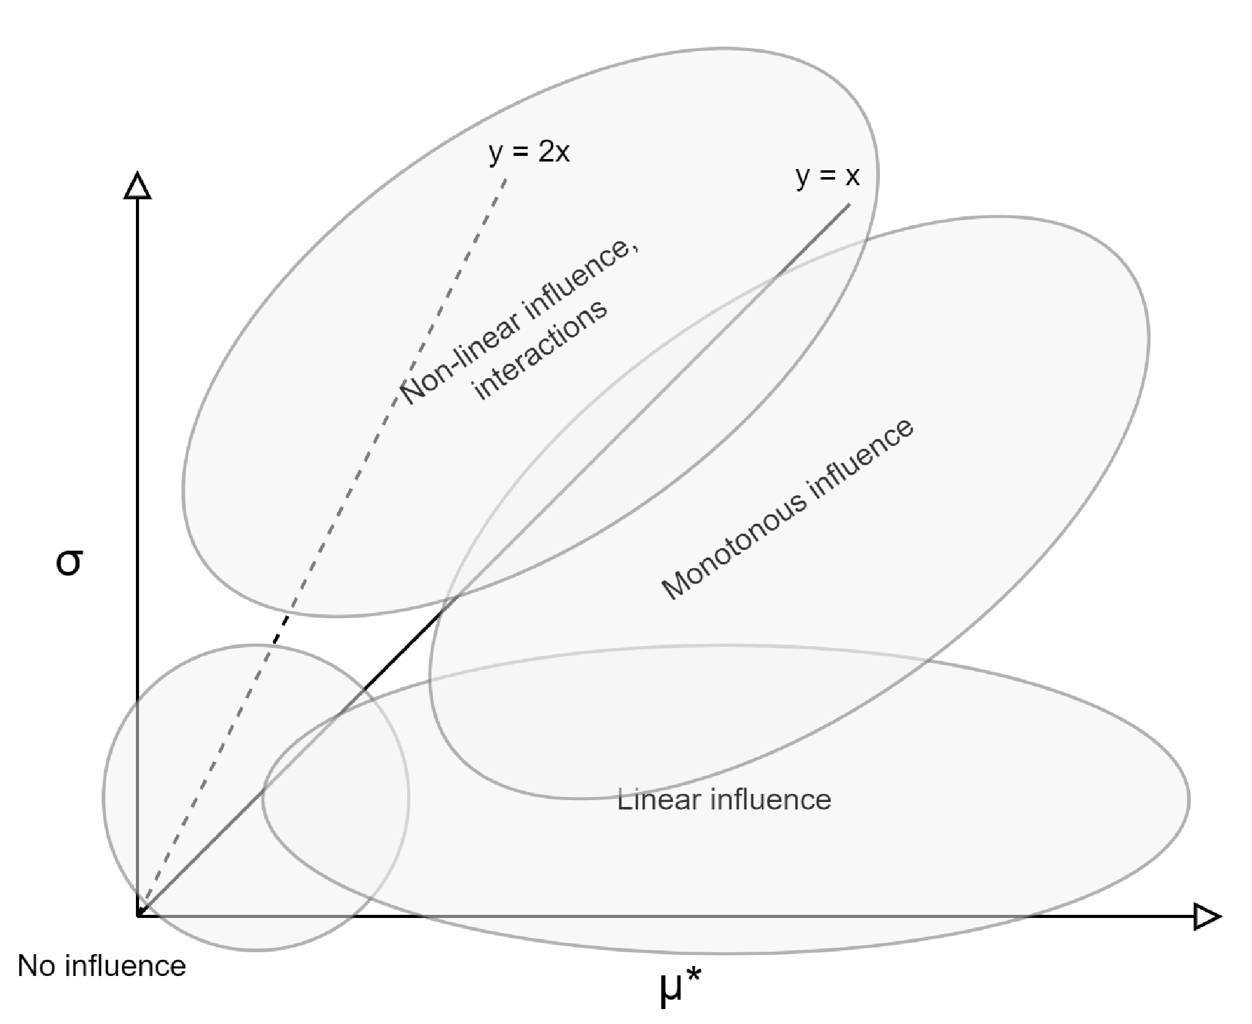
Adapted from l’AREP hypercube⁴⁰.
By design, the Morris screening method covers the whole input space (i.e. value ranges of all P_{j}). Accordingly, providing a suitable granularity (i.e. L and r values), the variation range of V over the N simulations is also a proxy of the total variance of the system. This means that, thanks to the standardization of the elementary effects, µ_{j}* can be seen as a proxy of the (relative) contribution of P_{j} to the variance of V, by construction. It remains relative in the sense that the actual value of µ_{j}* (e.g. 0.5) does not mean that P_{j} contributes to 50% of total variance (sum of the µ_{j}* gives between 1 and 2.5 with the present standardization). Nevertheless, the quantitative differences in-between (µ_{j}*; σ_{j}) points can be interpreted as the quantitative difference in the contribution of the parameters to the total variance of the results, in turn due to different sensitivity and/or different initial uncertainty on their value (Figure A4.2). L and r were selected accordingly, to ensure that individual trajectories are not too “local” in the input space (this is why dnP was selected close to 50%), and to select a number of trajectories higher than commonly reported (yet still relatively reduced to keep the computational advantage of the method). Under these conditions, the stability of the results obtained by the Morris method are also guaranteed³⁷; which was ensured by repeating the whole operation twice (the same distribution pattern was obtained). The related code was available in the research group (Matlab) and adapted to work with the present LCA model.
Figure SI2 – Sensitivity and uncertainty
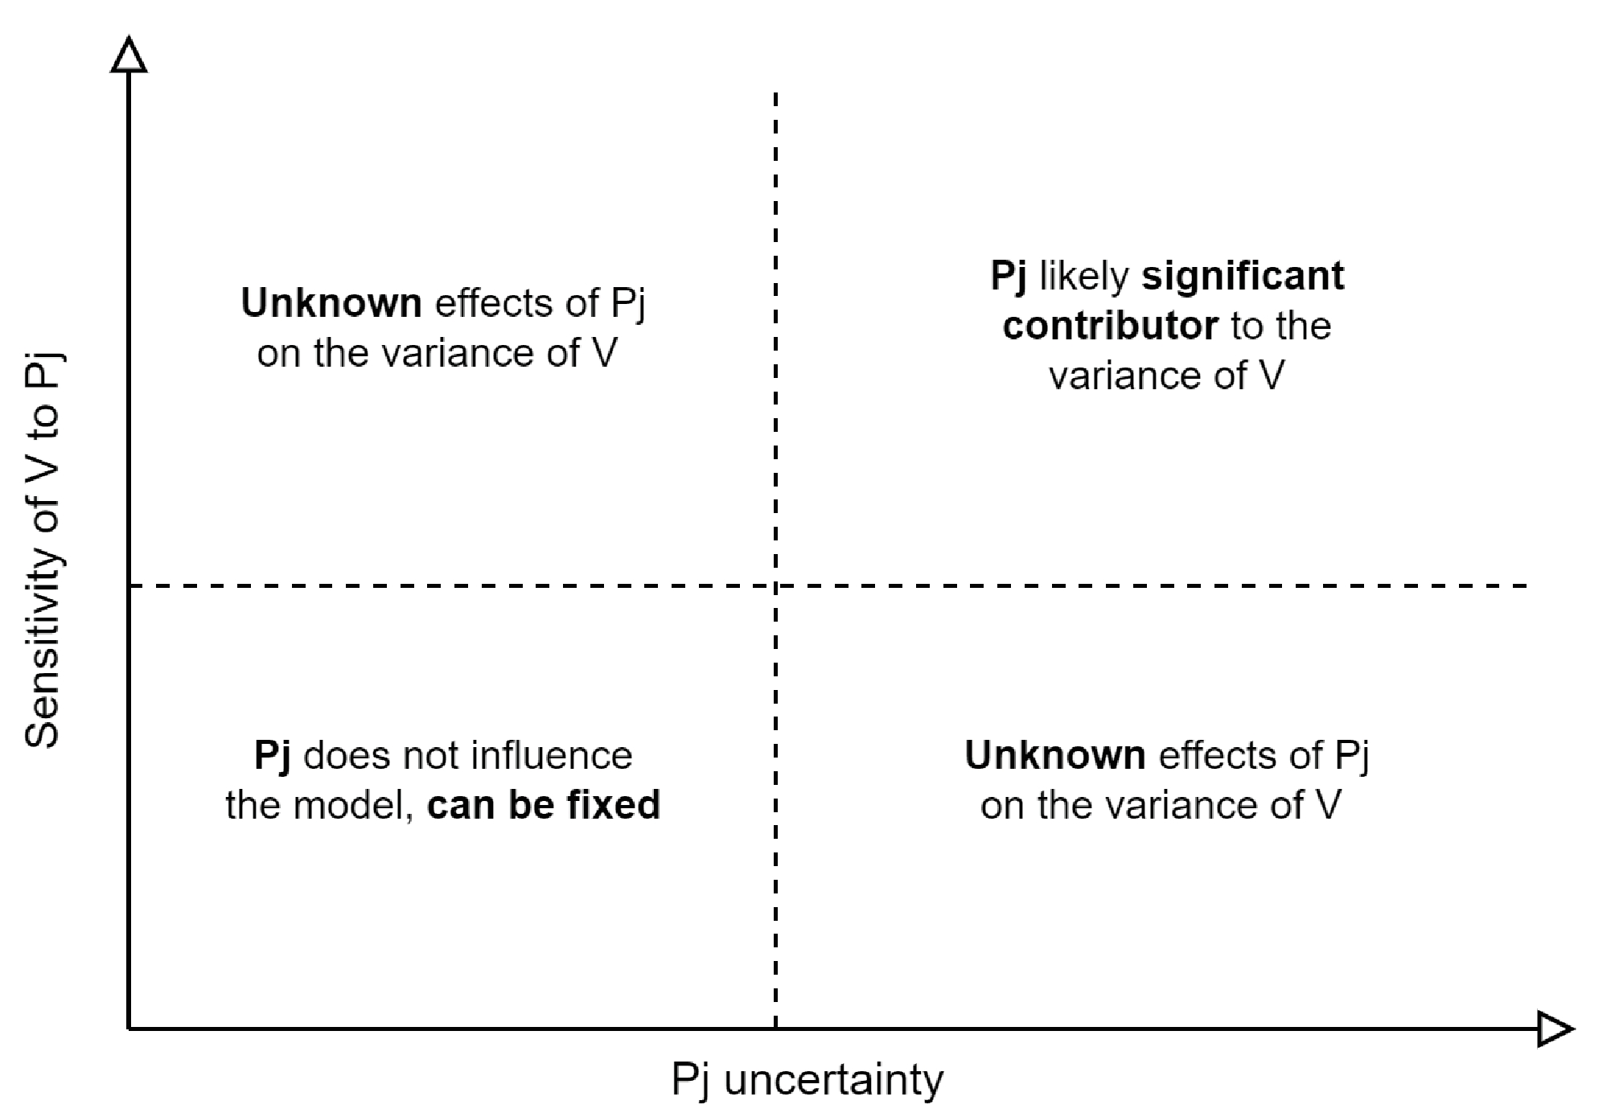
This figure illustrates the limitations to use sensibility analysis as a prescreening method (to reduce the dimension of the model) before assessing its variance. Indeed, removing a factor of the model (i.e. fixing it) requires both that (i) the model has a low sensitivity to this factor and (ii) this factor as a low uncertainty (bottom-left corner). Terminology in Table SI17.
This GSA procedure was applied to assess the influence of the 293 technology parameters on the LCA model. Accordingly, the (µ_{j}*; σ_{j}) scatter plots were elaborated for each of the 27 pathways and four impact categories, and are displayed and fully analyzed for the “ongoing food system trends” and “towards renewable energies” scenarios in the PhD thesis manuscript supporting the present analysis³⁴. The simulations were performed for all eleven representative input streams (i.e. case studies), to assess how these affect the way the technological parameters influence the LCA scores. Displayed on the same (µ_{j}*; σ_{j}) scatter plots, overlapping sensitivity value points across the input streams means that corresponding parameter influence the results the same way regardless of the characteristics of input streams (still true if points are clustered enough). On the other hand, if a parameter pops up in a (µ_{j}*; σ_{j}) plot only for one input stream, this mean that the way the parameter influences the LCA results is tightly linked with specific characteristics of input streams (e.g. ammoniacal nitrogen content).
The most sensitive parameters were displayed in the extended Table 1. Among these, the ten presenting the higher sensitivity ratios (across the four impact categories, focusing on waste-to-nutrition pathways) were retained to derive the Figure 3 of the main manuscript: (i) MOB yield, (ii) HOB yield, (iii) Methanation losses, (iv) AD methane production, (v) AD emissions reduction potential, (vi) cellulosic C₆ sugar yields, (vii) mycoproteins C₆ growth, (viii) SSF digestibility enhancement, (ix) proteins recovery in green pellets and (x) in green juice. Emission factors (EF) were not retained because considered as rather intrinsically unknown and pedoclimatic conditions-specifics than improvable in the future. This was done to illustrate how as few as ten key parameters influence overall results interpretation on future pathways ranking as well as the relevance of implementing waste-to-nutrition pathways. Further details available in Figure 3 caption and the Methods section.

Unravelling the parameters conditioning pathways ranking
Calculated for the same sets of input P^{i}; the LCA scores of the 27 waste valorization pathways can be compared one per one for each simulation. This enables to push forward classical pairwise discernibility analyses. A discernibility analysis consists in calculating the fraction of the simulations which complies with a specific condition. The following procedure was applied for each LCA scores associated with an individual (impact category; case study) combination, further referred to as V. Four impact categories and eleven feedstock case studies were assessed, yielding 44 individual LCA scores matrix V, each of size (8820; 27) because of the number of pathways assessed and simulations performed. First, for each V, the discernibility matrix ∆V was created with Equation 7. Resulting ∆V have 351 columns, representing all the pairwise pathways combinations. Nevertheless, not all are relevant nor compatible, as (feedstocks; pathways) combinations are stream-specific¹. The pairwise comparison matrices for each V are obtained by assessing the occurrence of positive and negative values for each column of ∆V (discernibility figures in the Chapter 4 of the PhD thesis manuscript³⁴).
Equation 7
$$∀ g,h ∈\left[1,27\right], g≠h,{∆V}_{N,gh}=V_{N,g}-V_{N,h}$$
Due to the volume of data to analyze, the statistical analysis was only performed for pairs of pathways interest for the goal of this study. It consists in identifying, if existing, sets of key parameters explaining the ranking between two pathways of interest (that is influencing the most the values of corresponding ∆V column). This was performed by comparing the descriptive statistics of each P_{j} (technological parameter) calculated over all the simulations (N) against the ones calculated over the reduced set of simulations complying with the condition ∆V_{gh} > 0 or ∆V_{gh} < 0 (N’<N). Due to the Morris screening design, the descriptive statistics of each P_{j} calculated over the simulations are uniformly distributed over their six values; the average P_{j} value is close to the middle of ${∆P}_{j}$. For each case, the relative change in average and standard deviation of all the P_{j} when calculated on N’ compared to N were established (Equation 8).
Equation 8
$∀ j ∈\left[1, 293\right], \overline{P_{j,r}}=\frac{\overline{P_{j,N'}}-\overline{P_{j,N}}}{\overline{P_{j,N}}}$ and $σ_{r}^{Pj}=\frac{σ_{N'}^{Pj}-{ σ}_{N}^{Pj}}{σ_{N}^{Pj}}$
$\overline{P_{j,N}}$ and $σ_{N}^{Pj}$respectively being the average and standard deviation of P_{j} calculated over the N=8820 simulations, N’ depending on the specific V and pathways couple studied.$\overline{P_{j,r}}$ and $σ_{r}^{Pj}$ represents respectively the relative change in average and standard deviation of P_{j} when calculated on the N’ samples instead of the whole sample (N).
For influent technological parameters (P_{j}), not only their average value over the subset of simulations is expected to be substantially modified compared to the whole set of simulations, but also their standard deviation is expected to narrow (the range of P_{j} values complying with the condition on ∆V_{gh} is reduced in the subset compared to the whole set). A cluster analysis was performed to identify if such key parameter exists among the 293, by visually displaying $\overline{P_{j,r}}$ against $σ_{r}^{Pj}$ (examples below).

Figure SI3 – Change in descriptive statistics, cluster analysis, example I.i
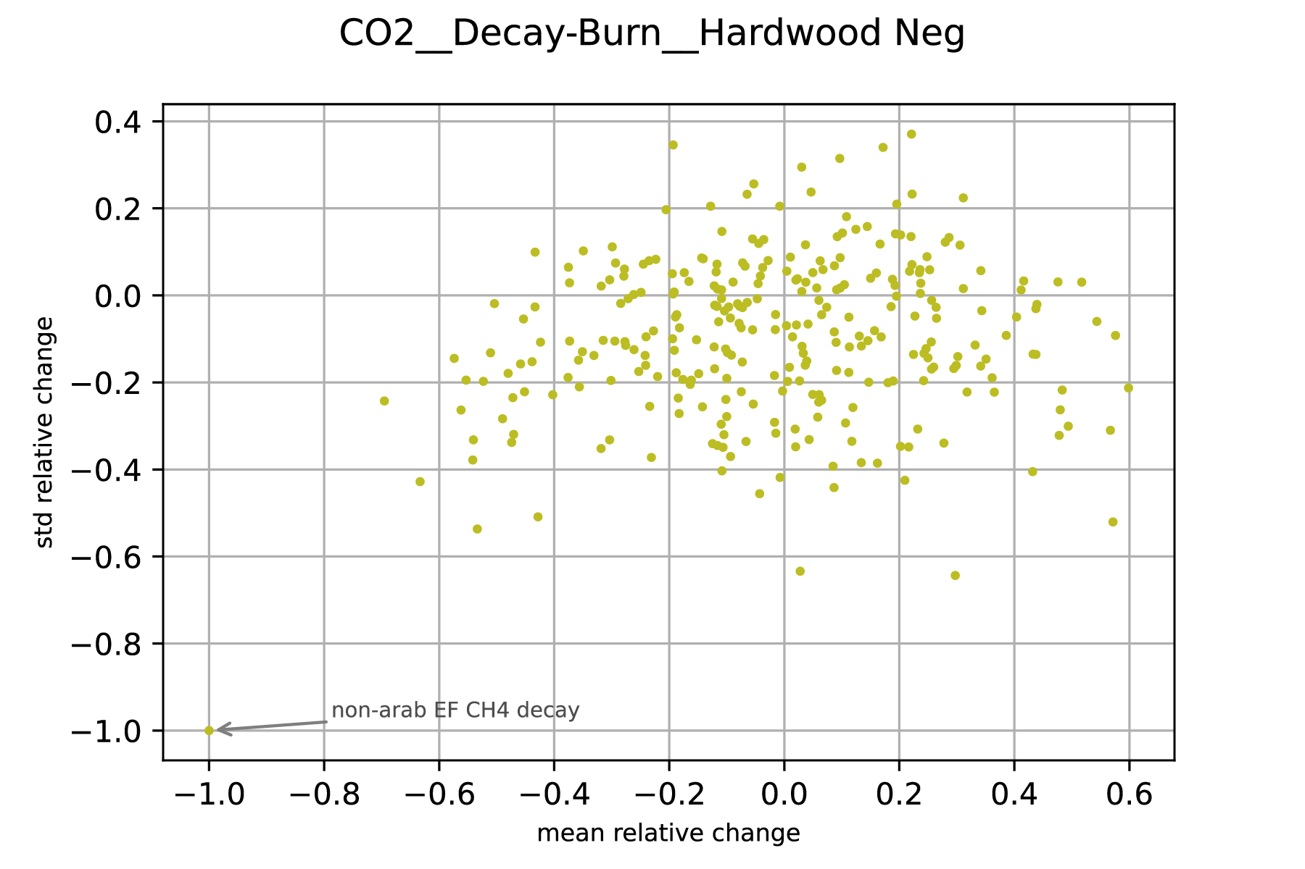
Illustration on the case of comparing “decay on land” pathway against “open-air burning” to manage hardwood residues, for climate change. The figure displays the change in descriptive statistics (293 technological parameters) between the whole set of simulations (no condition) and the subset of simulations complying with the statement “decay on land is better than open-air burning”. Important parameters are in the two bottom corners as their average changed and their standard deviation decreased in the subset compared to the whole set of simulations.
Figure SI4 – Change in descriptive statistics, cluster analysis, example I.ii
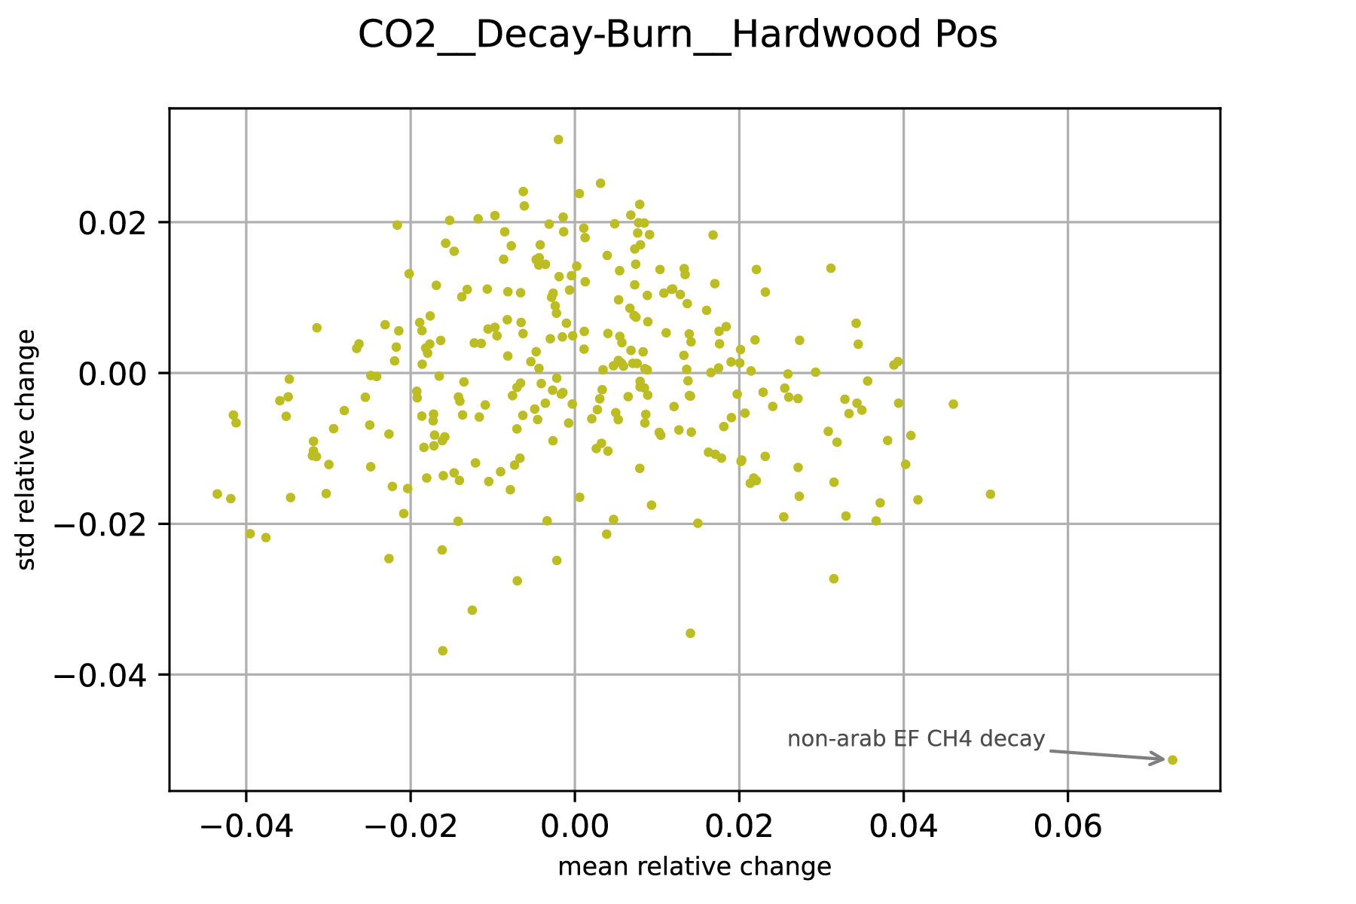
Illustration on the case of comparing “decay on land” pathway against “open-air burning” to manage hardwood residues, for climate change. The figure displays the change in descriptive statistics (293 technological parameters) between the whole set of simulations (no condition) and the subset of simulations complying with the statement “decay on land is worse than open-air burning”. Important parameters are in the two bottom corners as their average changed and their standard deviation decreased in the subset compared to the whole set of simulations.
Figure SI3 and Figure SI4 illustrate a case where one parameter clearly drives the relative ranking of two pathways. This does not mean that the ranking only depends on the single value of this specific parameter. It only indicates that finding a simple “sufficient condition” enabling one pathway to always outperform the other, most likely involve this parameter. This is further illustrated by the fact that the two different questions: what are the conditions enabling “pathway A better than pathway B” (Figure SI3) and “pathway A worse than pathway B” (Figure SI4) might not necessarily involve the same parameters (e.g. Figure SI7 and Figure SI8). Moreover, both questions might not be solved with a simple “sufficient condition” (Table SI18).
Table SI18 – Sufficient condition finding, illustrated on example I
Decay on land against open-air burning | Occurrence | CH₄ EF average (SD) | Occurrence if CH₄ EF ≤ 1% | Occurrence if CH₄ EF ≥ 6%
Total | 8820 | 5.6% (3.1%) | 1339 | 4118
Burning worse (A,i) | 598 (7%) | 1% (0%) | 598 (45%)
Burning better (A.ii) | 8222 (93%) | 6% (2.9%) |  | 4118 (100%)
Scenario “Towards renewable energies”, case of hardwood residues and climate change impact category. New average of the key parameter discriminating the two pathways being compared was calculated on the different subsets of simulations complying with a statement, and used to formulate threshold conditions on parameter’s value, which can result sufficient or not. Note: here, non-arable land CH₄ EF was considered as broad as 1-10%, which does not represent any national average but rather possible variation among local pedoclimatic conditions, discussions in companion work³.
Once the key parameters are found (resulting from the cluster analysis), their average over the subset of simulations can be used as threshold value to identify a “sufficient condition”. In the example of Table SI18, it is clear that over all the simulations complying with CH₄ EF ≥ 6%, burning was better than decay on land. On the other hand, a CH4 EF ≤ 1%, does not guarantee that burning is worse than decay on land: other parameters are involved. This procedure was developed individually for all the cases (pathways performance discrimination), and was not automated due to the different shape and number of parameters clusters and the differentiated relevance of responding to “A>B” and/or “A<B” among the pairwise comparisons. Example II (Figure SI5 and Table SI19) illustrates a case where a sufficient condition was found based on two parameters. Finally, example III (Figure SI6) illustrates a case where the cluster analysis was unsuccessful, meaning no simple “sufficient condition” performed on a small set of key parameters likely exist to explain the differences between alternative pathways.
Figure SI5 – Change in descriptive statistics, cluster analysis, example II
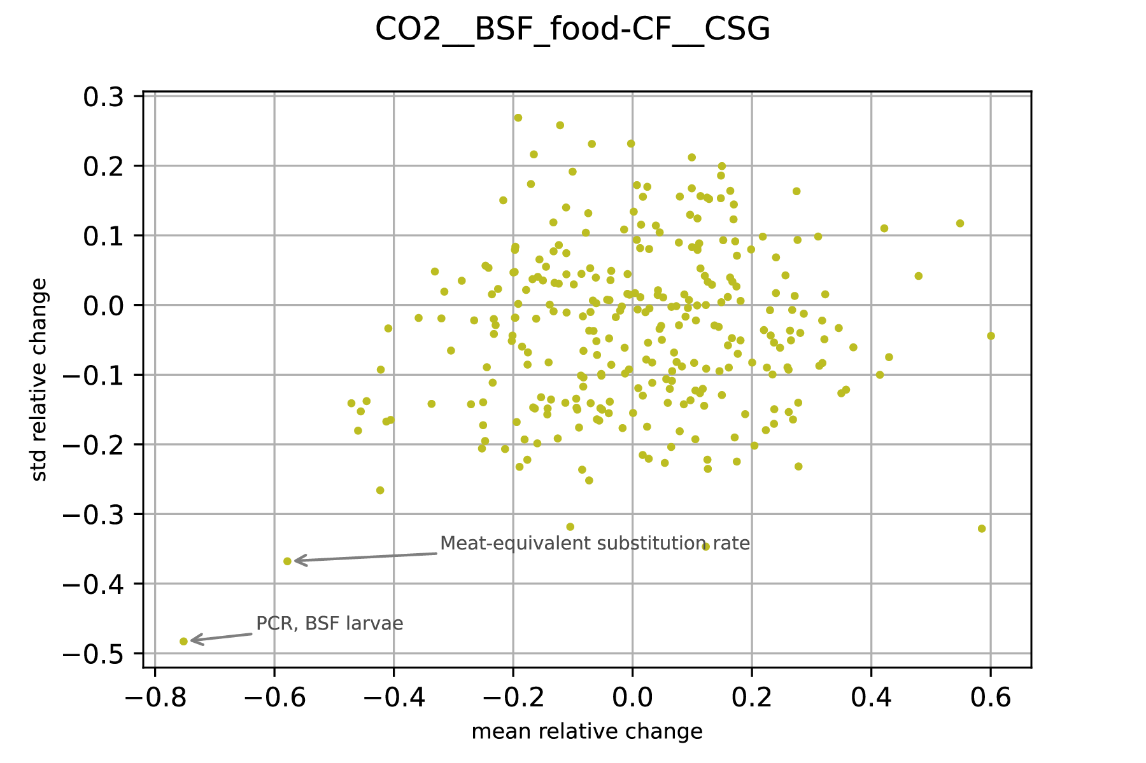
Illustration on the case of comparing “insect farming for food production” (BSF_food) pathway against “direct animal feeding” (CF) to manage corn spent grains, for climate change. The figure displays the change in descriptive statistics (293 technological parameters) between the whole set of simulations (no condition) and the subset of simulations complying with the statement “BSF_food is worse than CF”. Important parameters are in the two bottom corners as their average changed and their standard deviation decreased in the subset compared to the whole set of simulations.

Table SI19 – Sufficient condition finding, illustrated on example II
BSF_food against CF | Occurrence | PCR average (SD) | Meat-eq. average (SD) | Occurrence if PCR ≥ 30% & Meat-eq. ≥ 61%
Total | 8820 | 46% (11%) | 76% (16%) | 5579
BSF_food worse | 930 (11%) | 30% (6%) | 61% (10%) | 0 (0%)
Scenario “Towards renewable energies”, case corn spent grains and climate change impact category. New average of the key parameter discriminating the two pathways being compared was calculated on the different subsets of simulations complying with a statement, and used to formulate threshold conditions on parameter’s value, which can result sufficient or not.
Figure SI6 – Change in descriptive statistics, cluster analysis, example III
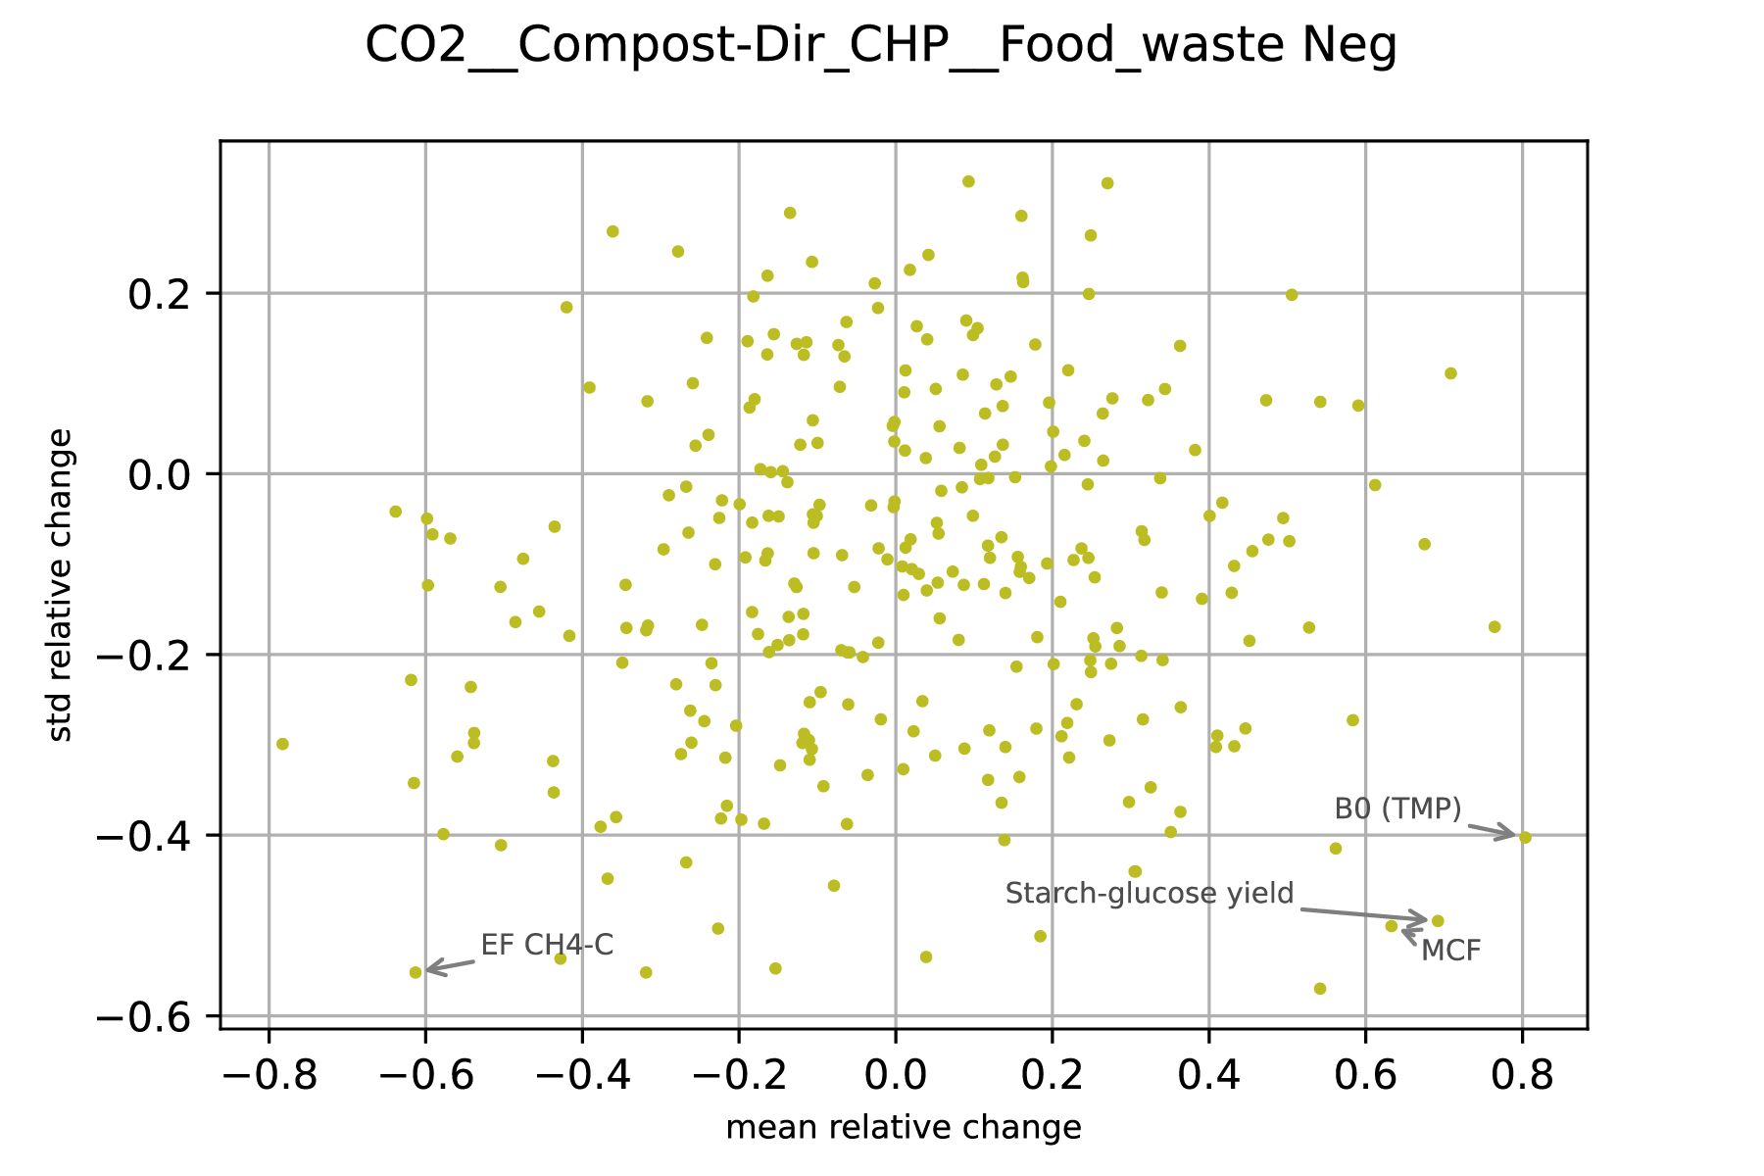
Illustration on the case of comparing “Composting” pathway against “incineration” (Dir_CHP) to manage household food waste, for climate change. The figure displays the change in descriptive statistics (293 technological parameters) between the whole set of simulations (no condition) and the subset of simulations complying with the statement “Composting is better than Dir_CHP”. Important parameters are in the two bottom corners as their average changed and their standard deviation decreased in the subset compared to the whole set of simulations.
The present “identification of sufficient conditions” procedure based on comparative statistics only serves if parameters are much more influent on the results than all the others. Deeper analysis would require an alternative screening procedure which continuously cover ${∆P}_{j}$ (here, discretized on six values) and likely involve more simulations to refine the screening granularity of the input space. In turn, this would enable to build alternative statistics-based method, such as correlation and regression. Not implementable here due to the OaT design, classifying the technology parameters according to their correlation with each column of $∆V$ could allow to build new indicators such as “contribution of the parameters to the difference between pathway A and pathway B”. Additionally, more advanced methods such as the principal component analysis or delta method can be performed for deeper understanding of the models and the results. Other limits and methodological improvement leverages are detailed in the PhD thesis manuscript³⁴. The future elaboration of a more comprehensive statistical analysis to refine the link between technological development and pathway ranking is made possible as the datasets and models are transparently provided.

Figure SI7 – Change in descriptive statistics, cluster analysis, example IV.i
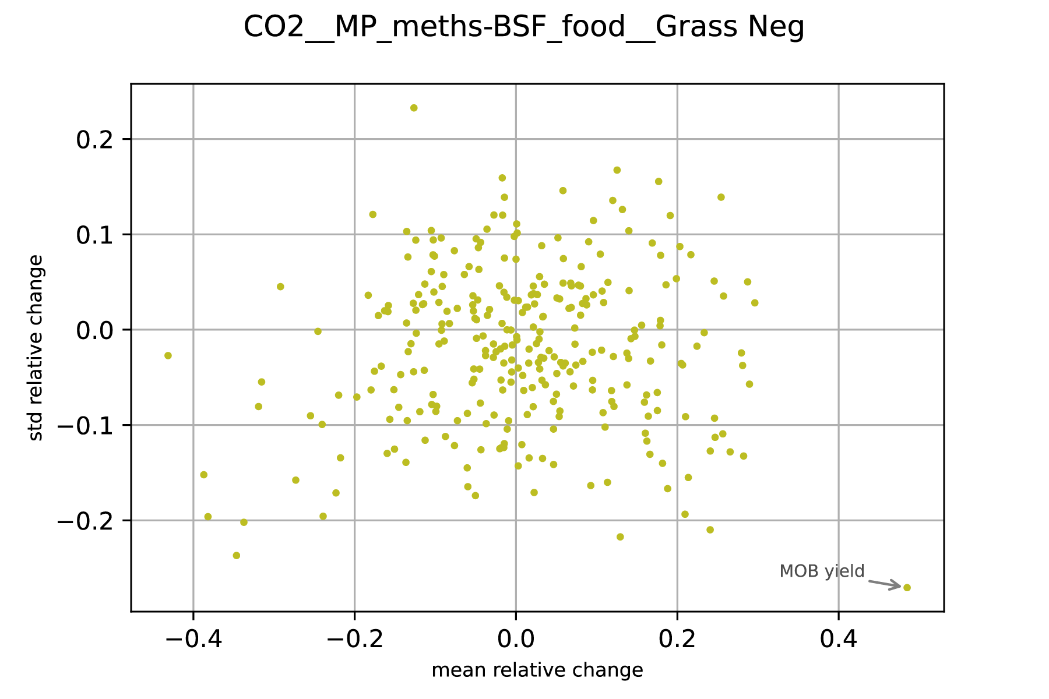
Illustration on the case of comparing “MP_meths” pathway against “BSF_food” to manage countryside management grass, for climate change. The figure displays the change in descriptive statistics (293 technological parameters) between the whole set of simulations (no condition) and the subset of simulations complying with the statement “MP_meths is better than BSF_food”. Important parameters are in the two bottom corners as their average changed and their standard deviation decreased in the subset compared to the whole set of simulations.
Figure SI8 – Change in descriptive statistics, cluster analysis, example IV.ii
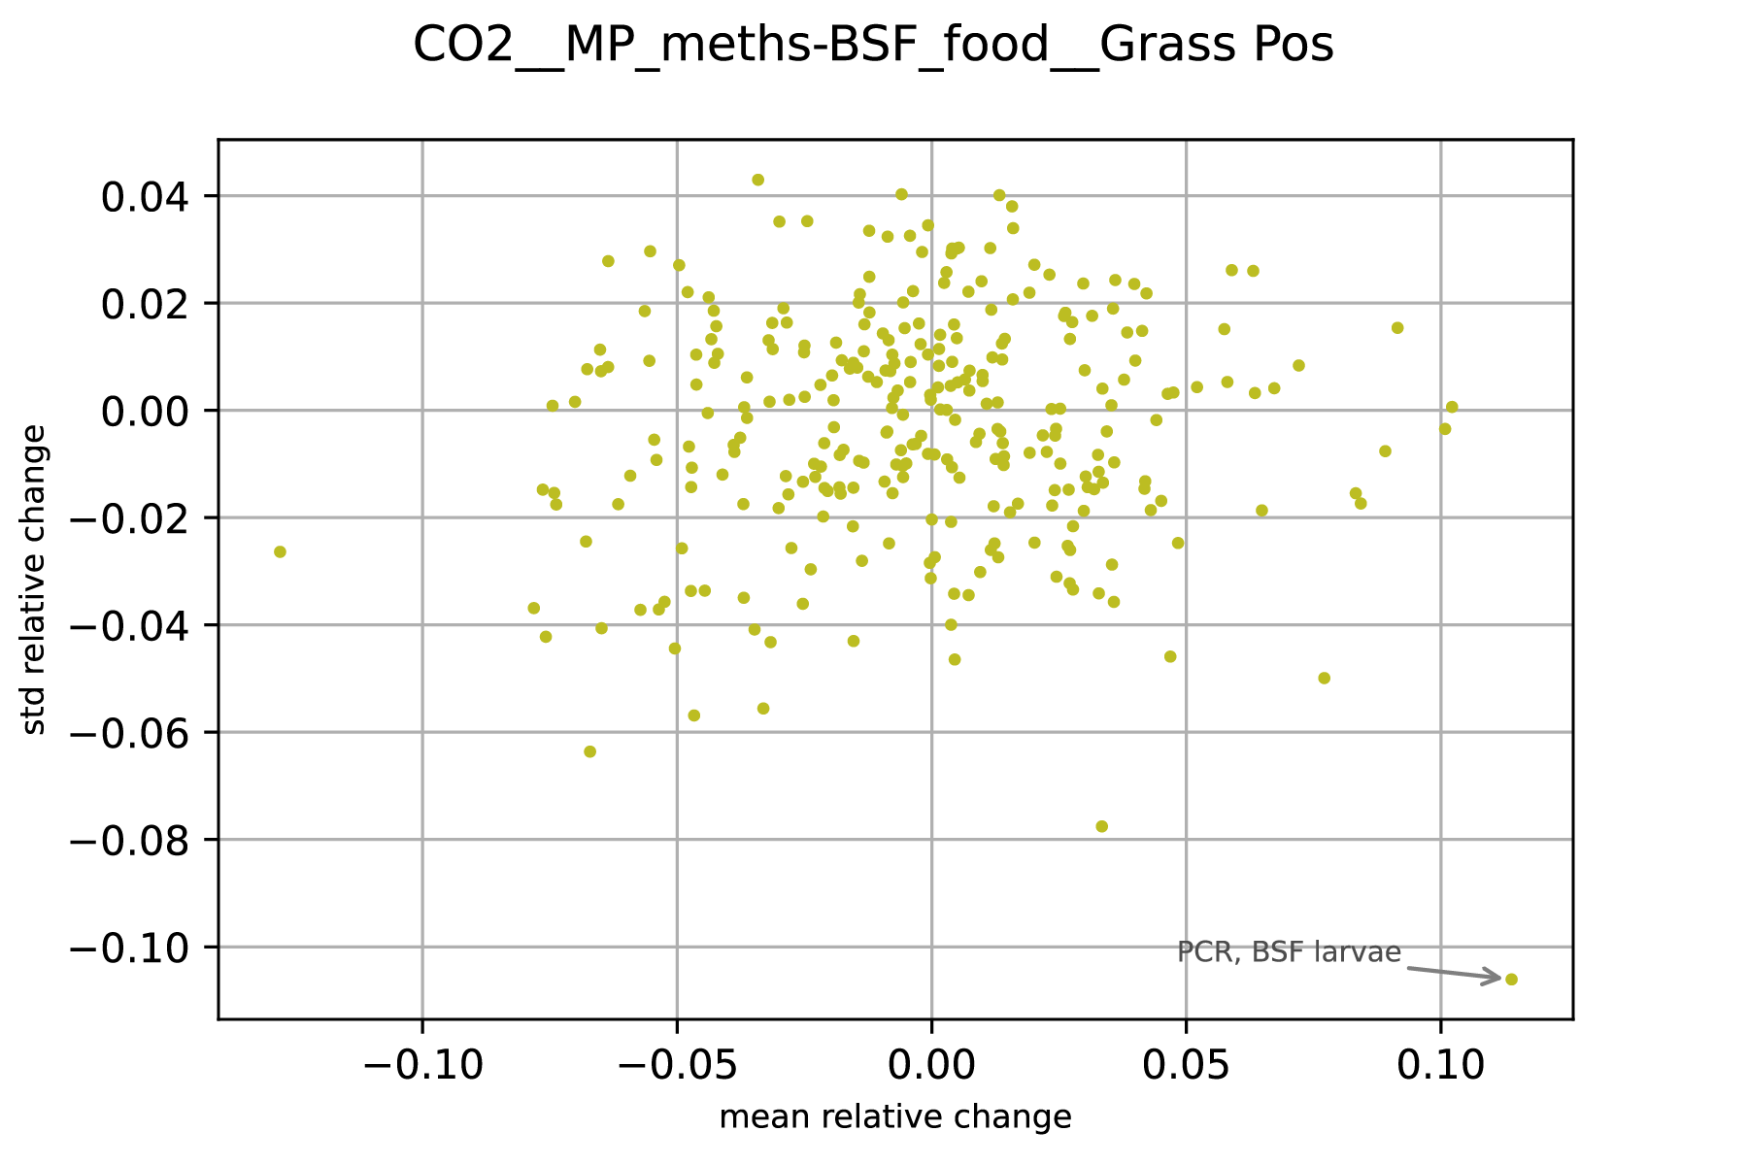
Illustration on the case of comparing “MP_meths” pathway against “BSF_food” to manage countryside management grass, for climate change. The figure displays the change in descriptive statistics (293 technological parameters) between the whole set of simulations (no condition) and the subset of simulations complying with the statement “MP_meths is worse than BSF_food”. Important parameters are in the two bottom corners as their average changed and their standard deviation decreased in the subset compared to the whole set of simulations.

Additional results
For a given residual stream, the ranking of alternative valorization pathways is determined by the net balance between the environmental impacts associated with the processing operations required (utilities and facilities) and the forecasted environmental credits associated with the services supplied, if existing (credits for substituting the conventional production of these services). In turn, the LCA scores and pathways ranking directly relate to their own waste-to-services conversion efficiencies and the relative LCA scores of the marginal suppliers of food, feed, energy and fertilizing services (the main ones associated with the waste valorization pathways assessed in this study). The latter directly relates to the future deployment context in which these pathways will be implemented, traduced here in terms of scenarios to screen contrasted future food and energy systems trajectories. This bioresources-pathways-services-impacts-scenarios nexus was fully detailed in the PhD thesis manuscript³⁴. It includes, among other, the LCA contribution analysis, the detailed sensitivity and discernibility analysis, and the one-at-the-time marginal suppliers perturbation analysis performed to design the scenario assessment of this work.
As the main manuscript was focusing on the main findings and particularly discuss the climate change impact categories, additional insights related to the other impact categories are further described. Please refer to Table 1 of the main manuscript for a description of each pathway and its acronym.

Additional notes for Figure 1
*: For lignocellulosic residues, in a scenario of ongoing transitions towards renewable energies and sustainable food systems, microbial proteins (MP) production should at least yield 3.0 g_{OM}.g_{H2}⁻¹ for MP pathways to outperform the Heat_ind pathway regarding land use. **: For lignocellulosic residues, in a scenario of ongoing transition towards renewable energies but maintaining or exacerbating the current impacts of food systems, MP pathways were identified as the best options to mitigate water use, except if mycoproteins production (Myco) achieves its best forecasted technological improvements fully substitutes meat production. ***: For nutrient-rich wastes, composting was found to always outperform anaerobic digestion (AD) pathways regarding marine eutrophication provided nitrates land leaching emissions factor remains below 7-8% of spread nitrogen. Preferred MP variant (among the six assessed) are scenario-, technological improvement- and impact category-dependent (see PhD thesis manuscript, Chapter 4)³⁴.

Additional comments for lignocellulosic streams valorization pathways ranking
Lignocellulosic residues are forecasted to play a key role in the decarbonation of energy systems, particularly when it comes to industrial heat production (through e.g. direct combustion in industrial furnaces; Heat_ind or gasification with grid injection; GA_grid). Naturally, there is much less GHG credits when substituting a 46 or 11 kgCO_{2-eq}.GJ⁻¹ heat sources, respectively estimated for the “towards renewable energies” and “high electrification” scenarios, than the 76 kgCO_{2-eq}.GJ⁻¹ of current natural-gas based heat supplies. This is why the relative performances of wood-to-proteins pathways compared to heat-producing pathways is affected by different energy scenarios (Figure 3 of the main manuscript). Notably, Myco and MP_syngas pathways’ GHG performances are slightly lower under a high electrification scenario (as these are net energy producers due to sensible heat and/or co-products recovery), while MP_meths and MP_shifts benefit from a decarbonized energy scenario (for being net energy consumers; Figure 3). Different marginal power supplies (ranging from 16 to 60 gCO₂-eq.kWh⁻¹ over the two scenarios) have overall limited effects on the model’s outcomes, which are only tractable for high power-consuming pathways (here, MP_meths and GA_grid for being based on electrolysis).
MP production from lignocellulosic residues was found as the best option to mitigate climate change under ongoing food systems trends (corresponds to ca. 4.5 kgCO₂-eq.kg_{DM}⁻¹ marginal protein feeds supplies) within a high electrification energy scenario, over more than 95% of the technological improvements combinations assessed (Figure 2). In this case, the best GHG emissions mitigating pathways become Myco_food (over ca. 40% of the combinations) and Heat_ind (50%). Moreover, the 10% of the technological combinations where MP was found as the best pathway always involved the most pessimistic improvements for technologies associated with Myco and Heat pathways. In other words, under ongoing food and energy systems trends, MP would need to bet on the failure of the R&D of both pathways to win the climate change mitigation prize. The threshold, in terms of climate scores of marginal feed production, over which wood-to-proteins pathways outperform wood-to-energy pathways (in occurrence over the span of future technological improvements) further increases with the climate score of marginal energy production. The previously described distribution of the best performing pathways under the high electrification energy scenario for a 2.5-3 kgCO₂-eq.kg_{DM}⁻¹ marginal protein feed supplies, would be achieved at 4.5 kgCO₂-eq.kg_{DM}⁻¹ under the “towards renewable energies” scenario (Figure 2). Under this energy scenario, at 2.5-3 kgCO₂-eq.kg_{DM}⁻¹ marginal protein feed supplies, Heat_ind pathway is the best option for climate change over ca. 80-95% of the future technological combinations assessed (range over the three lignocellulosic case studies: hardwood residues, sawmill waste and wheat straw). The reduced windows (i.e. the 5-20% of technological combinations) for Myco_food to outperform Heat_ind in this energy scenario implies this pathway successfully unlocks key technological challenges such as the scaled bioconversion of hemicellulosic (C₅) sugars by fungus, while this technological outbreak is not necessarily required under the high electrification energy scenario (Figure 1b).
Results were also contrasted for the rest of the impact categories, as the large savings induced by the substitution of marginal food and feed production regarding water use, land use and eutrophication do not always compensate for the relatively low conversion yield of wood-to-proteins pathways, ranging 50-350 kg_{DM}.t_{ww}⁻¹ (MP variants) and 40-70 kg_{DM}.t_{ww}⁻¹ (Myco variants). For example, the low land use impacts of nuclear energy (high electrification scenario) positions MP_meths as the best performing pathways for this impact category, regardless of future food systems scenarios. Indeed, MP_meths displays the best conversion yield wood-to-proteins conversion yield thanks to electrolysis assistance¹. Yet, the dominant position of MP_meths in terms of land use savings is not ensured under energy scenarios contemplating the use of (land-dependent) wood pellets and solar panels for energy production (towards renewable energies scenario). Indeed, nuclear-based power generates ca. 98% less land use impacts as a power mix based on renewable power. The same happens with industrial heat services the more wood pellets are removed from the marginal mix of suppliers. In this energy systems scenario, Heat_ind would always be the best option to manage lignocellulosic residues regarding land use impacts (Figure 1b), as it avoids the deployment of land-dependent bioenergy production. Trends are reversed for the water use impact category given the large impacts (ca. +300%) of nuclear power production compared to renewables. This means that, from a water use perspective, pathways avoiding energy production are favored within a high electrification energy scenario. For this impact category, the best valorization pathways were found to be GA_grid and MP_meths (which are the only ones involving electrolysis), provided at least 20% of co-produced oxygen is reused. This is due to the large water use benefits of avoiding conventional (cryogenic) oxygen production, as this requires as much as 80 L.kg_{O2}⁻¹ according to the background database. Yet, MP_meths becomes the clear winner in terms of water use if the marginal (substituted) feed supplies involve irrigated crops (here, corresponds to ongoing food systems trends or worst scenarios; extended figure 3).

Additional comments for nutrients-rich wastes valorization pathways ranking
The relative net climate benefits of MP variants shrinks when the climate scores of marginal feed protein supplies falls under ca. 4.0 kgCO₂-eq.kg_{DM}⁻¹ (Figure 2), trend observed for both contrasted energy scenarios assessed. Under the premises of a transition towards sustainable food systems, the preferred valorization pathway to deal with nutrient-rich wastes would oscillate between composting and energy-oriented anaerobic digestion, depending on the LCA scores of marginal energy supplies. Under the high electrification scenario, incentives to deploy anaerobic digestion for energy purposes decrease, and MP production should reach its best forecasted technological performances to evict composting from positioning as the best pathway (Figure 1c). Achieving such technological milestones would still not be enough if marginal industrial heat supplies are still loaded with more than 40 kgCO_{2-eq}.GJ⁻¹ (e.g. in the towards renewable energies scenario). In this case, AD_grid (anaerobic digestion with grid injection and biomethane valorization as industrial heat) would always be the best option to mitigate climate change, provided state-of-the-art facilities (Figure 1c). Else, the relative climate performances of AD and composting pathways are directly related to the contrasted nitrogen emission factors of digestate and compost, particularly for land spreading nitrous oxides. Notably, MP production on upgraded biomethane (MP_biometh) would always outperform the rest of the MP variants provided Methylococcus Capsulatus conversion yield achieves at least 0.9 g_{OM}.g_{CH4}⁻¹ and methanation losses are limited below 1% of input biogas (see PhD thesis manuscript)³⁴.

Additional comments for leafy residual streams valorization pathways ranking
Over most scenarios, the best valorization pathway for sugarbeet tops was found to follow the same trends as for the rest of edible residual streams (that is, BSF_food as the clear winner if insects substitute meat, else CF). Results only diverged for one specific scenario combining a best-case (sustainable) food system scenario while considering a pessimistic energy systems scenario (corresponding to EU average situation). In this case, diverting sugarbeet tops towards AD valorization or leaving it decay on soil would be the best management strategies, which is explained by the high moisture content (ca. 80%_{ww}) of vegetable tops undermining the competitiveness of drying processes under current impacts of energy systems.
Notably, across all scenarios, extracting a monogastric-grade protein concentrates from sugarbeet tops (GB pathways) almost always achieved worst environmental performances than its direct reuse as (ruminant-grade) feed, for all three GB variants assessed. A first exception was found for the water use impact category: the large benefits of avoiding concentrated feed services (through GB) compared to avoiding roughage feed (CF) compensate for the reduced GB conversion yields. This water use gap between the two feed services is explained by the fact that marginal roughage feed suppliers are mostly rainfed while some commodities of the marginal basket of concentrated feed services are being irrigated. Else, green biorefining sugarbeet tops would only outperform CF if specific enabling conditions align, particularly (i) achieving a proteins recovery yield (in concentrates) of at least 50% and betting on a failed energy systems transition (that is, whose marginal impacts would remain as high as EU average situation, meaning GB’s co-generated biomethane would fully substitute natural gas).
The conclusions slightly differ if considering a leafy residue with other characteristic (e.g. countryside management grass presenting ca. 9%_{DM} proteins, 50%_{OM} digestibility and 60%_{ww} moisture). For this stream, albeit BSF_food still positions among the best management options provided insects formulations do substitute meat (as for all edible residual streams), so do GB variants. Notably, CF is almost absent from the best options due to the low digestibility and low relevance of substituting roughage feed services. The winning GB variant oscillates between GB_rough and GB_myco depending on the scenarios and impact categories (see PhD thesis manuscript³⁴), while GB_AD was never found as the best option. Yet, again, GB pathways should achieve their best forecasted improvements (e.g. net increase in press pulp digestibility by 20%, among others) to outperform direct energy valorization or MP production from this residual grass stream. Although the performances of grass gasification are limited, as much as two to four times more concentrated feed services would be provided through MP production compared to GB pathways (respectively ca. 90-250 kg_{DM}.t_{DM}⁻¹ grass input and 50 kg_{DM}.t_{DM}⁻¹), meaning the worse future food systems scenarios, the more competitive the environmental benefits of grass-based MP production (mostly MP_meths or MP_shifts; as for lignocellulosic residues).

Additional comments for food waste valorization pathways ranking
MP production from food waste becomes the preferred option the worse the future food systems scenario (in terms of LCA scores achieved by marginal food and feed suppliers). Shifting towards sustainable food systems, recovering energy and fertilizers from food waste would become the favored options to mitigate climate change and eutrophication. In this case, thanks to (i) low food waste gasification performances (compared to e.g. lignocellulosic residues), (ii) biogas cleaning/detoxification requirements (e.g. desulfurization), direct incineration (Dir_CHP) was found more environmentally competitive than GA and AD pathways to manage food waste. Composting food waste was only found to outperform the benefits of Dir_CHP within a high electrification energy scenario, and provided the best composting emissions reduction practices are implemented. As a notable result, incinerating food waste yielded was found to generate less environmental impacts than composting and anaerobic digestion, under most scenarios.

Additional discussions
As illustrated with this work, quantifying the future environmental impacts of complex systems is based on large sets of assumptions, choices and data differing in terms of representativity. First, reporting these is fundamental to ensure the robustness and reliability of LCA results interpretation, but is still not systematically done in a transparent and tractable way, despite prescribed by existing LCA standards⁴¹. Moreover, albeit a standardized ‘one-fits-all’ format is hardly conceivable (LCA can be applied to multiple systems), structuring the way inventory and LCA scores data is provided, as done in other disciplines, can benefit the whole LCA community. Second, a framework to systematically account for land use change (LUC) impacts in prospective LCA is still missing. Ready-to-use LUC factors adopted in available LCI databases are not freely available for LCA analysts (preventing their wide adoption) and past and current initiatives are dispersed⁴². Yet, omitting LUC (particularly the so-called “indirect” effects) implies disregarding the finite aspect of arable land, and can lead to misleading conclusions (e.g. considering biomass as carbon neutral⁴³). Here, a generic LUC factor was used to screen the potential environmental performances of the marginal suppliers of land-dependent commodities, but it remains a questionable proxy. Nevertheless, it has the advantage to clearly highlight the role of marginally-responding yields in LUC impacts magnitude, and to stress the potential adverse effects of implementing commodity-specific ban with no additional intervention measures (i.e. ceteris paribus). As far as no consensus and common methodology is adopted, LUC impacts modeling and accounting in LCI background databases should be both transparent and controllable.

Additional figures
Visualizations complementing the main and extended figures of the main manuscript (rest of the case studies and impact categories) are available in the data repository.

References
1. Javourez, U., Tiruta-Barna, L. & Hamelin, L. Waste reintroduced in the kitchen: life cycles inventories of representative waste-to-nutrition pathways. Preprint at https://doi.org/10.21203/rs.3.rs-3671083/v2 (2023).
2. Javourez, U., Rosero Delgado, E. A. & Hamelin, L. Upgrading agrifood co-products via solid fermentation yields environmental benefits under specific conditions only. Nat Food 3, 911–920 (2022).
3. Javourez, U., Karan, S. K. & Hamelin, L. Setting the environmental performance threshold for diverting residual streams towards bioeconomy strategies. Preprint at https://doi.org/10.21203/rs.3.rs-3626167/v2 (2023).
4. RTE. Energy pathways to 2050 - Key results - Executive summary. 64 (2021).
5. European Commission. EU reference scenario 2020: energy, transport and GHG emissions: trends to 2050. (Publications Office of the European Union, 2021).
6. ADEME. Transition(s) 2050 - Choisir maintenant, Agir pour le climat - Rapport. (ADEME Editions, 2021).
7. Lorfing, D. et al. Design and performance of a new type of boiler using concentrated solar flux. Energy Convers. Manag 249, 114835 (2021).
8. Mayer, P. et al. Blue and green ammonia production: A techno-economic and life cycle assessment perspective. iScience 26, 107389 (2023).
9. OECD/FAO. OECD-FAO Agricultural Outlook 2022-2031. (OECD Publishing, 2022).
10. Searchinger, T., Waite, R., Hanson, C., Ranganathan, J. & Matthews, E. Creating a sustainable food future: A menu of solutions to feed nearly 10 billion people by 2050. Final Report. (World Resource Institute, 2018).
11. Schmidt, J. H. Life cycle assessment of five vegetable oils. J Clean Prod 87, 130–138 (2015).
12. Dalgaard, R. et al. LCA of soybean meal. Int J Life Cycle Assess 13, 240 (2007).
13. ecoinvent. ecoinvent databases. https://ecoinvent.org/ (2022).
14. Schmidt, J. & De Rosa, M. Certified palm oil reduces greenhouse gas emissions compared to non-certified. J Clean Prod 277, 124045 (2020).
15. INRAE. ECOALIM database. https://www6.inrae.fr/ecoalim_eng/ (2016).
16. European Commission, Joint Research Centre, Cucurachi, S., Steubing, B., & Siebler, F. Prospective LCA methodology for novel and emerging technologies for bio-based products: the Planet Bio project. (Publications Office of the European Union, 2022).
17. FAO. FAOSTAT. http://www.fao.org/faostat/en/ (2019).
18. Wilfart, A. et al. Réduire les impacts environnementaux des aliments pour les animaux d’élevage. INRA Prod. Anim. 31, 289–306 (2019).
19. Cameron, B. et al. Plant-based meat, eggs and dairy. (The Good Food Institute, 2019).
20. Howard, P. H. Cellular agriculture will reinforce power asymmetries in food systems. Nat Food 3, 798–800 (2022).
21. Alvaro, C. A virtue-ethical approach to cultured meat. Nat Food 3, 788–790 (2022).
22. Erkkola, M. et al. A slow road from meat dominance to more sustainable diets: An analysis of purchase preferences among Finnish loyalty-card holders. PLOS Sustainability and Transformation 1, e0000015 (2022).
23. Laisse, S. et al. L’efficience nette de conversion des aliments par les animaux d’élevage : une nouvelle approche pour évaluer la contribution de l’élevage à l’alimentation humaine. INRA Prod. Anim 31, 269–288 (2018).
24. U.S. DEPARTMENT OF AGRICULTURE. USDA.
25. Poore, J. & Nemecek, T. Reducing food’s environmental impacts through producers and consumers. Science 360, 987–992 (2018).
26. Mendoza Beltran, A. et al. Quantified Uncertainties in Comparative Life Cycle Assessment: What Can Be Concluded? Environ. Sci. Technol. 52, 2152–2161 (2018).
27. Baustert, P. M. Development of an uncertainty analysis framework for model-based consequential life cycle assessment. (Technische Universiteit Eindhoven, 2021).
28. Di Lullo, G., Gemechu, E., Oni, A. O. & Kumar, A. Extending sensitivity analysis using regression to effectively disseminate life cycle assessment results. Int J Life Cycle Assess 25, 222–239 (2020).
29. Cariboni, J., Gatelli, D., Liska, R. & Saltelli, A. The role of sensitivity analysis in ecological modelling. Ecological Modelling 203, 167–182 (2007).
30. Feng, K., Lu, Z. & Yang, C. Enhanced Morris method for global sensitivity analysis: good proxy of Sobol’ index. Struct Multidisc Optim 59, 373–387 (2019).
31. Jaxa-Rozen, M. & Kwakkel, J. Tree-based ensemble methods for sensitivity analysis of environmental models: A performance comparison with Sobol and Morris techniques. Environ Model Softw 107, 245–266 (2018).
32. Althaus, H.-J. et al. Overview and Methodology Data v2.0. 77 (2007).
33. Groen, E. A., Bokkers, E. A. M., Heijungs, R. & de Boer, I. J. M. Methods for global sensitivity analysis in life cycle assessment. Int J Life Cycle Assess 22, 1125–1137 (2017).
34. Javourez, U. Transforming residual biomass into food and feed, towards an LCA optimization platform. (INSA Toulouse, 2023).
35. Morris, M. D. Factorial Sampling Plans for Preliminary Computational Experiments. Technometrics 33, 161–174 (1991).
36. Méry, Y. Development of an integrated tool for Process Modelling and Life Cycle Assessment - Ecodesign of process plants and application to drinking water treatment. (Université de Toulouse, 2012).
37. Awad, M. Étude de modèles d’évaluation environnementale à travers l’identification de paramètres d’interactions. (Université Bretagne Loire, 2021).
38. Sin, G. & Gernaey, K. V. Improving the Morris method for sensitivity analysis by scaling the elementary effects. in 19th European Symposium on Computer Aided Process Engineering vol. 26 925–930 (Elsevier, 2009).
39. Campolongo, F., Cariboni, J. & Saltelli, A. An effective screening design for sensitivity analysis of large models. Environ Model Softw. 22, 1509–1518 (2007).
40. L’hypercube AREP. Analyse de sensibilité. https://lhypercube.arep.fr/methodes-numeriques/analyse-de-sensibilite/.
41. International Organization for Standardization. Environmental management: life cycle assessment; Principles and Framework. ISO (2006).
42. European Commission, COWI A/S, & Universiteit Utrecht. Environmental impact assessments of innovative bio-based product Task 1 of “Study on Support to R&I Policy in the Area of Bio-based Products and Services “. (2019).
43. Searchinger, T., James, O., Dumas, P., Kastner, T. & Wirsenius, S. EU climate plan sacrifices carbon storage and biodiversity for bioenergy. Nature 612, 27–30 (2022).

