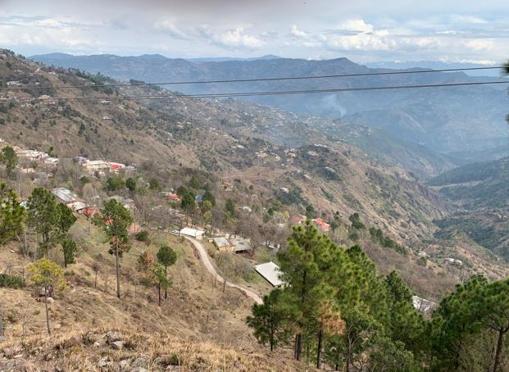
Fig S1 Panoramic view from S9 Aliyot, with Himalayan and Karakoram ranges in the Background.

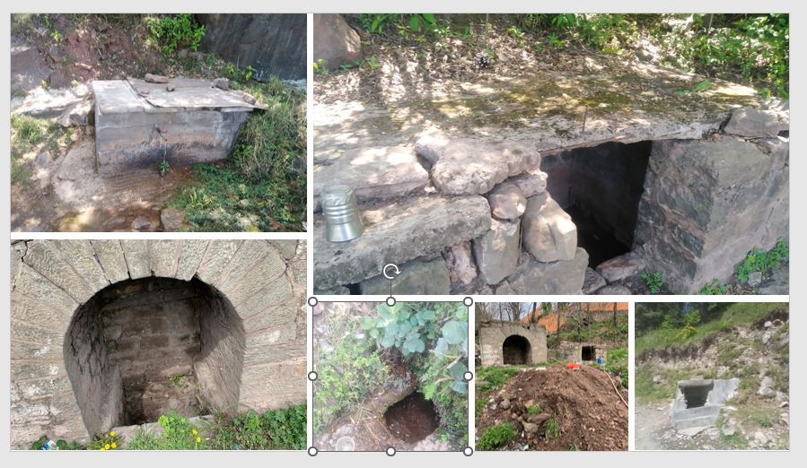
Fig S2 Some of the water sampling sites.
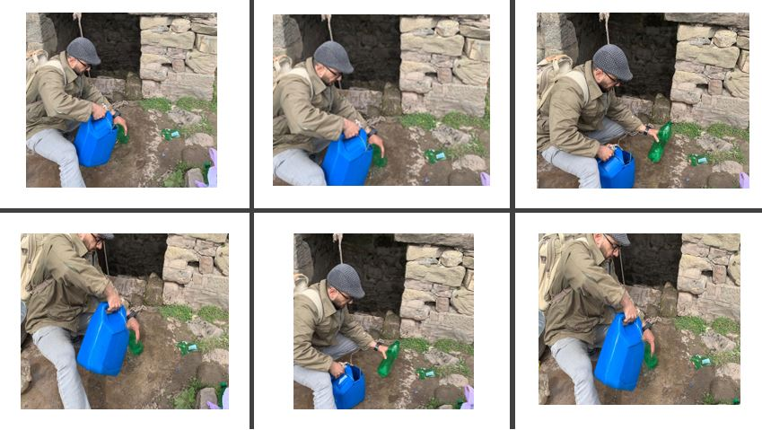
Fig S3 The author collecting the water samples from a Sikh-era spring at S12 phagwari which was dug in 1820s by the Sikh merchants.
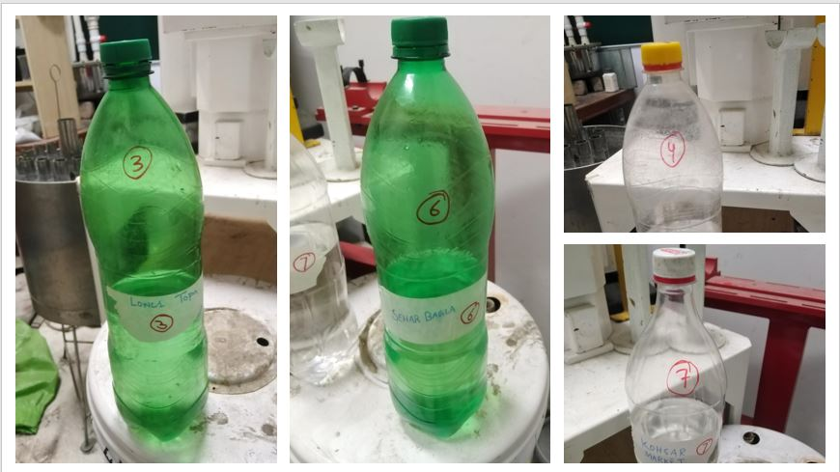
Fig S4 Bottled and labelled samples back at the Lab.

Table S1 Experimental conditions of ICP-OES
Parameter | Value
RF Power | 1150 W
Pump Rate | 50 rpm
Auxiliary Gas Flow | 0.5 L/min
Nebulizer Gas Flow | 0.5 L/min
Coolant Gas Flow | 12 L/min
Purge Gas Flow | Normal
Viewing Plasma Height | 14mm

Table S2 ADD parameters values.
Parameters | Adult | Child | Parameters | Adult | Child
R_{ING} (mg/day) | 100 | 200 | EF (days/year) | 180 | 180
R_{INH} (mg/cm²) | 20 | 20 | SA (cm²) | 2145 | 1150
ED (Years) | 24 | 6 | W (kg) | 70 | 15
PEF (m3/kg) | 1.3$×$10⁹ | 1.3$×$10⁹ | AT (days) | 8760 | 2190
ABF (As) | 0.03 | 0.03 | ABF (OM) | 0.001 | 0.001

Table S3 RFD and CSF values for the three exposure pathways.
Metals | RFD ING | RFD INH | RFD DER | CSF ING | CSF INH | CSF DER
Cu | 4.00$×$10⁻² | 4.02$×$10⁻² | 1.20$×$10⁻² | - | - | -
Pb | 3.50$×$10⁻³ | 3.25$×$10⁻³ | 5.25$×$10⁻⁴ | 0.0085 | - | 0.042
As | 3.00$×$10⁻⁴ | 3.00$×$10⁻⁴ | 1.23$×$10⁻⁴ | 1.5 | 1.5 | 1.5
Ni | 2.00$×$10⁻² | 2.06$×$10⁻² | 5.40$×$10⁻⁴ | - | 8.4 | -
Cr | 3.00$×$10⁻³ | 2.86$×$10⁻⁵ | 6.00$×$10⁻⁵ | 0.5 | - | 41
Mn | 1.40$×$10⁻¹ | 1.40$×$10⁻¹ | 1.80$×$10⁻³ | - | - | -
Ba | 7.00$×$10⁻² | 1.43$×$10⁻⁴ | 4.90$×$10⁻³ | - | - | -
Zn | 3.00$×$10⁻¹ | 3.00$×$10⁻¹ | 6.00$×$10⁻² | - | - | -
Li | - | - | - | - | - | -
Fe | 0.007 | - | 0.007 | - | - | -
Co | 3.00$×$10⁻⁴ | 5.71$×$10⁻⁶ | 1.60$×$10⁻² | - | 9.8 | -

Table S4: Water quality indices with permissible limits used in the study
S. No | Water quality assessment parameters | Values |  |  |  |  | References
1 | Sodium adsorption ratio (SAR) meq/L | < 10 | 10--18 | 18-26 | > 26 | - | (Alfaifi et al., 2021)
1 | Category | Excellent | Good | Doubtful | Unsuitable | -
2 | Salinity hazard (EC) µs/cm | < 250 | 250-750 | 750-2000 | 2000-3000 | > 3000 | (Raghunath, 1987)
2 | Category | Excellent | Good | Permissible | Doubtful | Unsuitable
3 | Sodium percentage (Na%) meq/L | < 20 | 20-40 | 40-60 | 40-80 | > 80 | (Xiao et al., 2019)
3 | Category | Excellent | Good | Permissible | Doubtful | Unsuitable
4 | Magnesium adsorption (MAR) meq/L | < 50 | > 50 | - | - | - | (Jehan et al., 2020)
4 | Category | Suitable | Unsuitable | - | - | -
5 | Kelly ratio (KR) meq/L | < 1 | > 1 | - | - | - | (Kelley, 1963)
5 | Category | Fit | Unfit | - | - | -

Table S5 Max allowed values for metals in water.
Agency | Metal | Max allowed value (mg/L)
PAK-EPA | Al | 0.2
PAK-EPA | Ba | 0.7
PAK-EPA | B | 0.3
PAK-EPA | Cr | 0.05
PAK-EPA | Ni | 0.02
USEPA | Fe | 0.3
PAK-EPA | Zn | 5
CANADA | Sr | 7
CANADA | Mg | 50
CANADA | Ca | 200

