Supplementary Information
Brown and beige adipose tissue regulate systemic metabolism to resist diet-induced obesity through metabolite signals in an inter-organ signaling axis
Anna Whitehead¹, Fynn N Krause², Amy Moran¹, Jason L Scragg,¹ Ben D McNally², Edward Boateng¹, Steven A Murfitt², Samuel Virtue³, John Wright¹, Amanda D.V. MacCannell¹, Jack Garnham¹, Graeme R Davies⁴, James Dodgson⁵, Jurgen E Schneider¹, Andrew J Murray⁶, Christopher Church⁴, Antonio Vidal-Puig³, Klaus K Witte¹, Julian L Griffin², Lee D Roberts^{1*}
1. School of Medicine, University of Leeds, Leeds LS2 9JT, UK.
2. Department of Biochemistry, University of Cambridge, Cambridge CB2 1GA, UK.
3. Institute of Metabolic Science, University of Cambridge, Cambridge CB2 0QQ, UK.
4. Bioscience Metabolism, Research and Early Development, Cardiovascular, Renal and Metabolism, BioPharmaceuticals R&D, AstraZeneca, Cambridge, UK
5. Phenotypic Screening and High Content Imaging, Antibody Discovery & Protein Engineering, R&D, AstraZeneca, Cambridge, UK
6. Department of Physiology, Development and Neuroscience, University of Cambridge, Cambridge CB2 3DY, U.K.

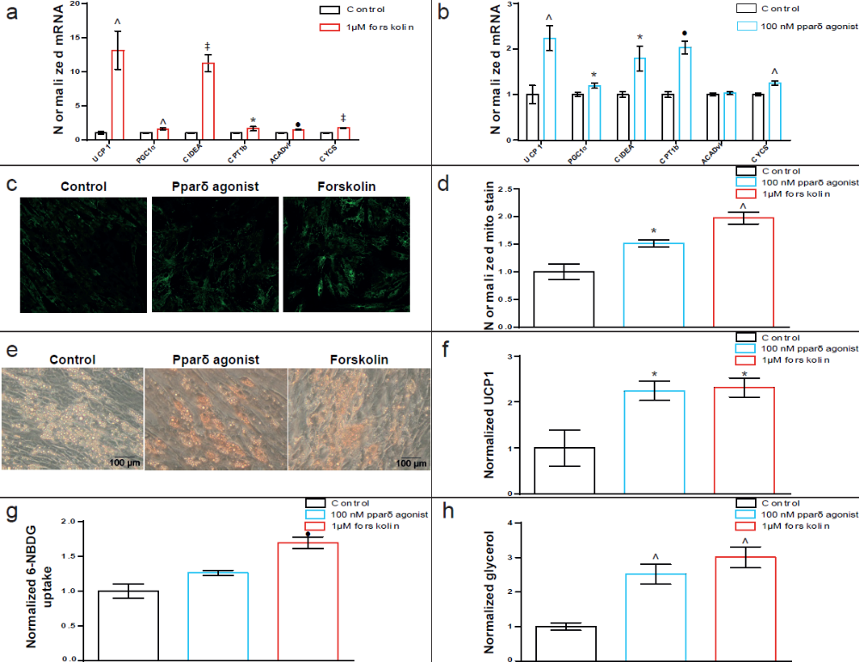
Supplementary Figure 1. Forskolin and PPARδ-agonism induce browning of human primary adipocytes
(a) Forskolin (1 μM) increases the expression of brown adipocyte-associated genes in primary human adipocytes. (b) PPARδ agonist GW0742 induces expression of brown adipocyte-associated genes in primary human adipocytes. (c) Mitotracker Green staining of mitochondria in human primary adipocytes treated with a PPARδ agonist or forskolin. (d) Forskolin and PPARδ agonism increase mitochondrial content of human primary adipocytes. (e) Immunohistochemical staining of UCP1 (red) in human primary adipocytes treated with forskolin or PPARδ agonist GW0742. (f) Forskolin and PPARδ agonism increase UCP1 protein content in human primary adipocytes. (g) Glucose uptake measured using fluorescent 6-NBDG in human primary adipocytes treated with forskolin or a PPARδ agoinst. (h) Extracellular glycerol as a measure of lipolysis analyzed using GC-MS from the media of forskolin and PPARδ agonist treated human primary adipocytes. ∗p ≤ 0.05, ^p ≤ 0.01, •p ≤ 0.001, ‡p ≤ 0.0001. Data are mean ± SEM of at least three biological replicates.
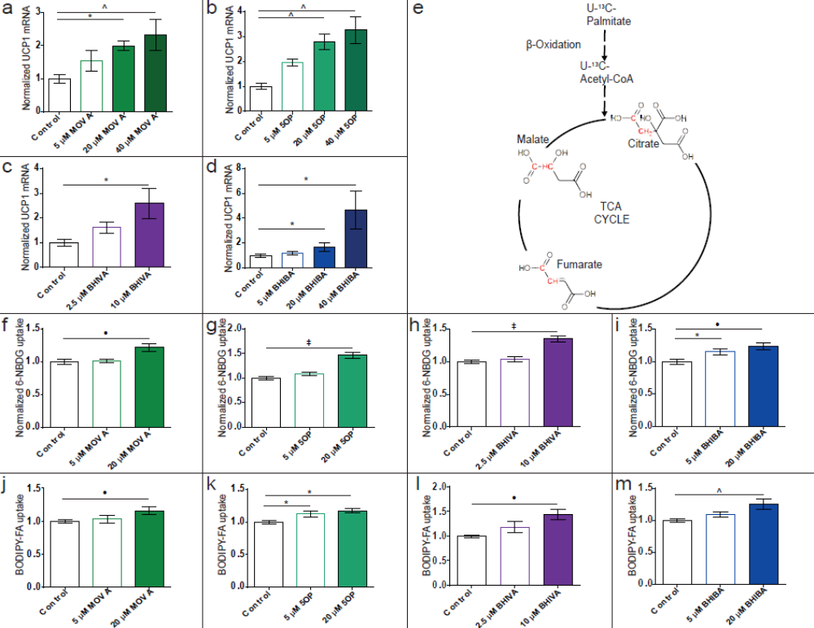
Supplementary Figure 2. Metabolites secreted from browning human primary adipocytes induce a brown adipocyte-like phenotype
UCP1 expression in primary human adipocytes treated with (a) MOVA (10 μM, 20 μM, 40 μM), (b) 5OP (10 μM, 20 μM, 40 μM), (c) BHIVA (5 μM, 10 μM) and (d) BHIBA (10 μM, 20 μM, 40 μM). (e) Schematic showing TCA cycle ¹³C-enrichment from ¹³C-palmitate metabolism in metabokine-treated human adipocytes. Red carbons represent ¹³C-labeling. Glucose uptake in (f) MOVA (5 and 20 μM), (g) 5OP (5 and 20 μM), (h) BHIVA (2.5 μM and 10 μM) and (k) BHIBA (5 and 20 μM)-treated human primary adipocytes. Fatty acid uptake in (j) MOVA (5 and 20 μM), (k) 5OP (5 and 20 μM), (l) BHIVA (2.5 μM and 10 μM) and (k) BHIBA (5 and 20 μM)-treated human primary adipocytes. ∗p ≤ 0.05, ^p ≤ 0.01, •p ≤ 0.001, ‡p ≤ 0.0001. Data are mean ± SEM of at least three biological replicates.
.
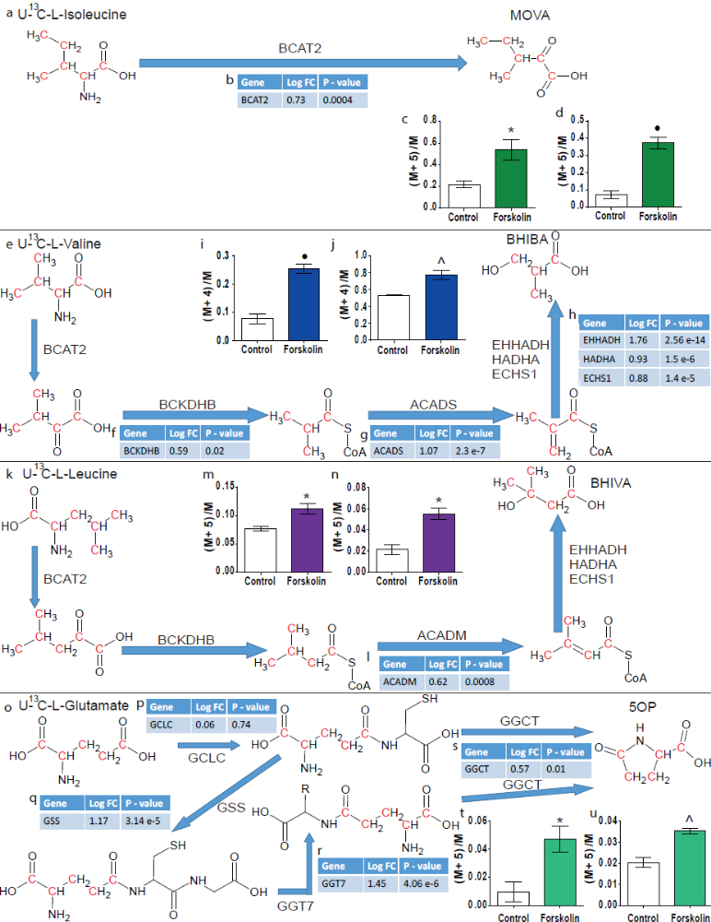
Supplementary Figure 3. ¹³C-isotope substrate tracing and RNAseq reveal mechanisms of MOVA, BHIBA, BHIVA and 5OP biosynthesis in browning human adipocytes
MOVA, BHIBA and BHIVA are generated through the degradation of the branched-chain
amino acids (BCAAs) isoleucine, valine and leucine. 5OP can be synthesized from glutamate. (a) Isoleucine metabolism to MOVA showing ¹³C-labeled substrates and products. (b) RNA-seq identifies increased expression of branched chain amino acid transaminase 2 (BCAT2), which catalyses the reaction producing MOVA, in forskolin-treated primary human adipocytes. (c) Intracellular adipocyte ¹³C-labeled MOVA and (d) extracellular ¹³C-labeled MOVA in conditioned media from forskolin-treated human primary adipocytes incubated with ¹³C-labeled isoleucine. (e) Valine metabolism to BHIBA showing ¹³C-labeled substrates and products. RNA-seq of forskolin-treated adipocytes identifies increased expression of BCAT2, (f) branched chain keto acid dehydrogenase E1 subunit beta (BCKDHB), (g) acyl-CoA dehydrogenase short chain (ACADS), and (h) Enoyl-Coenzyme A, Hydratase/3-Hydroxyacyl Coenzyme A Dehydrogenase (EHHADH), hydroxyacyl-CoA dehydrogenase (HADHA) and Enoyl-CoA Hydratase, Short Chain 1 (ECHS1), which catalyze the generation of BHIBA from valine. (i) Intracellular adipocyte ¹³C-labeled BHIBA and (j) extracellular ¹³C-labeled BHIBA in conditioned media from forskolin-treated human primary adipocytes incubated with ¹³C-labeled valine. (k) Leucine metabolism to BHIVA showing ¹³C-labeled substrates and products. RNA-seq of forskolin-treated adipocytes identifies increased expression of BCAT2, BCKDHB, (l) acyl-CoA dehydrogenase medium chain (ACADM), and EHHADH, HADHA and ECHS1, which catalyze the generation of BHIVA from valine. (m) Intracellular adipocyte ¹³C-labeled BHIVA and (n) extracellular ¹³C-labeled BHIVA in conditioned media from forskolin-treated human primary adipocytes incubated with ¹³C-labeled leucine. (o) Glutamate metabolism to 5OP showing ¹³C-labeled substrates and products. Expression of the 5OP biosynthetic enzymes (p) glutamate-cysteine ligase catalytic subunit (GCLC), (q) glutathione synthetase (GSS), (r) γ-glutamyltransferase 7 (GGT7) and (s) γ-glutamylcyclotransferase (GGCT) from RNA-seq data of forskolin-treated human primary adipocytes. (t) Intracellular adipocyte ¹³C-labeled 5OP and (u) extracellular ¹³C-labeled 5OP in conditioned media from forskolin-treated human primary adipocytes incubated with ¹³C-labeled glutamate. ∗p ≤ 0.05, ^p ≤ 0.01, •p ≤ 0.001. Data in bar charts are mean ± SEM of at least three biological replicates. Data in tables are Log fold-change (Log FC) of at least three biological replicates.

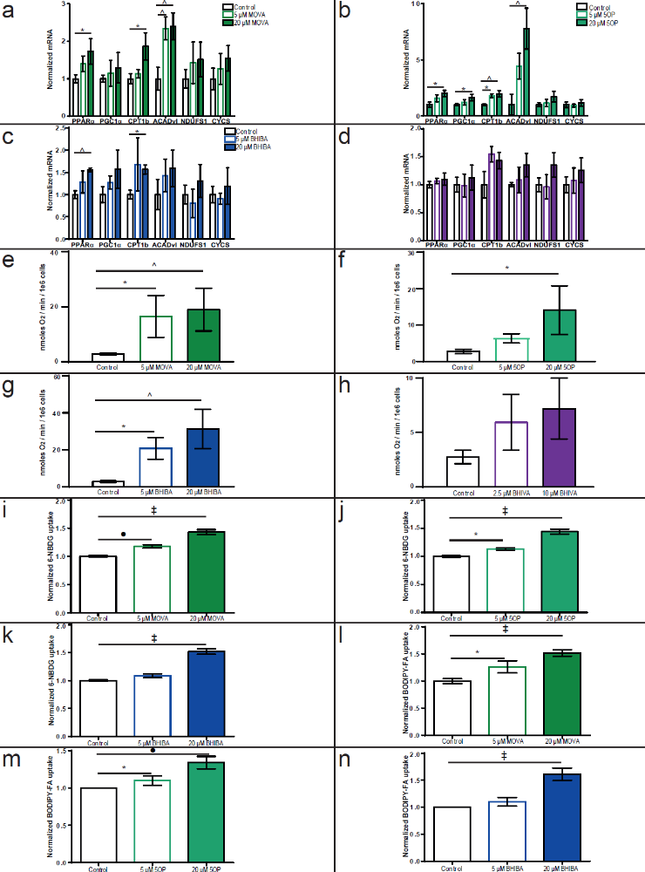
Supplementary Figure 4. MOVA, 5OP and BHIBA induce a dose responsive increase in oxidative energy metabolism in human primary skeletal myocytes
The expression of a mitochondrial and metabolic gene panel in human primary skeletal myocytes treated with (a) MOVA (5 μM, 20 μM), (b) 5OP (5 μM, 20 μM), (c) BHIBA (5 μM, 20 μM) and (d) BHIVA (2.5 μM, 10 μM). Basal oxygen consumption in human primary skeletal myocytes treated with (e) MOVA (5 and 20 μM), (f) 5OP (5 and 20 μM), (g) BHIBA (5 and 20 μM) and (h) BHIVA (2.5 μM, 10 μM). Glucose uptake in (i) MOVA (5 and 20 μM), (j) 5OP (5 and 20 μM), (k) BHIBA (5 and 20 μM)-treated human skeletal myocytes. Fatty acid uptake in (l) MOVA (5 and 20 μM), (m) 5OP (5 and 20 μM), (n) BHIBA (5 and 20 μM)-treated human skeletal myocytes. ∗p ≤ 0.05, ^p ≤ 0.01, •p ≤ 0.001, ‡p ≤ 0.0001. Data are mean ± SEM of at least three biological replicates.

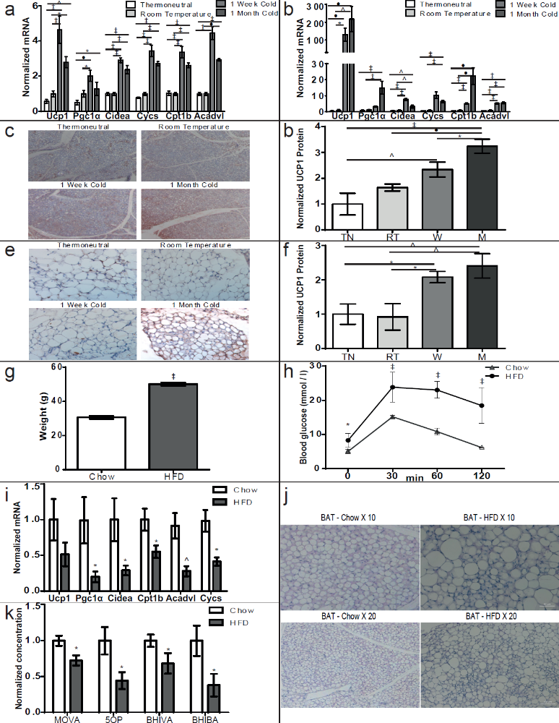
Supplementary Figure 5. Cold exposure induces a thermogenic phenotype and diet-induced obesity induces whitening to modulate metabokine concentrations in brown adipose tissue in mice
RT-qPCR analysis of brown adipocyte-associated and thermogenic genes in the (a) interscapular brown adipose tissue and (b) subcutaneous inguinal adipose tissue of mice housed at thermoneutrality (TN), room temperature (RT), 8˚C for 1 week (W) or 8˚C for 1 month (M). (c) Immunohistochemical staining of UCP1 protein (red) counterstained with hematoxylin in the brown adipose tissue of cold conditioned mice. (d) UCP1 protein is increased in the brown adipose tissue of cold conditioned mice. (e) Immunohistochemical staining of UCP1 protein (red) counter stained with hematoxylin in the subcutaneous adipose tissue of cold conditioned mice. (f) UCP1 protein is increased in the subcutaneous adipose tissue of cold conditioned mice. (g) Weights of mice receiving standard chow (Chow) or 60% fat diet (HFD) for 17 weeks. (h) Intraperitoneal glucose tolerance test in Chow and HFD-fed mice. (i) Reduced thermogenic gene expression, measured by RT-qPCR, in the BAT of HFD-fed mice compared to chow-fed mice. (j) Hematoxylin and eosin stained BAT from HFD-fed mice demonstrates whitening compared with BAT from chow-fed mice. (k) Concentrations of MOVA, 5OP, BHIVA and BHIBA, measured by GC-MS, are lower in BAT from HFD mice. ∗p ≤ 0.05, ^p ≤ 0.01, •p ≤ 0.001, ‡p ≤ 0.0001. Data are mean ± SEM of no less than five biological replicates.

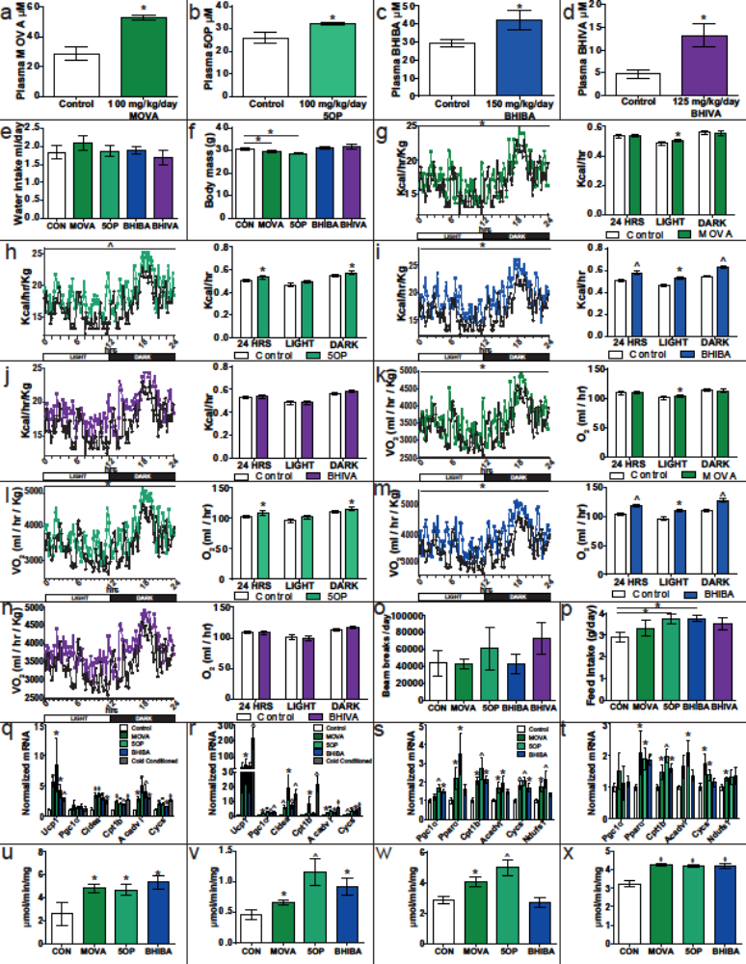
Supplementary Figure 6. Physiological concentrations of MOVA, 5OP and BHIBA increase systemic energy expenditure in vivo
(a - d) The plasma concentration of MOVA, 5OP, BHIBA and BHIVA in mice given 100 mg/kg/day MOVA, 100 mg/kg/day 5OP, 150 mg/kg/day BHIBA and 125 mg/kg/day BHIVA, respectively, in their drinking water compared to control mice. (e) Water intake in MOVA, 5OP, BHIBA and BHIVA-treated mice. (f) The weights of mice receiving MOVA, 5OP, BHIBA and BHIVA in their drinking water compared to untreated controls. Diurnal weight-normalized energy expenditure and average energy expenditure for 24 hour period, 12 hour dark phase (DARK) and 12 hour light phase (LIGHT) of (g) MOVA, (h) 5OP, (i) BHIBA and (j) BHIVA-treated mice. Diurnal weight-normalized oxygen consumption and average oxygen consumption for 24 hours, 12 hour dark phase (DARK) and 12 hour light phase (LIGHT) of (k) MOVA, (l) 5OP, (m) BHIBA and (n) BHIVA-treated mice. (o) Activity and (p) food consumption of MOVA, 5OP, BHIBA and BHIVA-treated mice. Thermogenic and brown adipocyte-associated gene expression in (q) brown adipose tissue (BAT) and (r) subcutaneous white adipose tissue (WAT) of MOVA, 5OP, BHIBA and BHIVA-treated mice. Expression of mitochondrial and metabolic genes in the (s) gastrocnemius and (t) soleus muscles of metabokine-treated mice. Metabokine treatment increases mitochondrial content in (u) BAT (v) subcutaneous WAT (w) gastrocnemius and (x) soleus muscle of mice, determined using a citrate synthase assay. ∗p ≤ 0.05, ^p ≤ 0.01, •p ≤ 0.001, ‡p ≤ 0.0001. Data are mean ± SEM of five biological replicates.
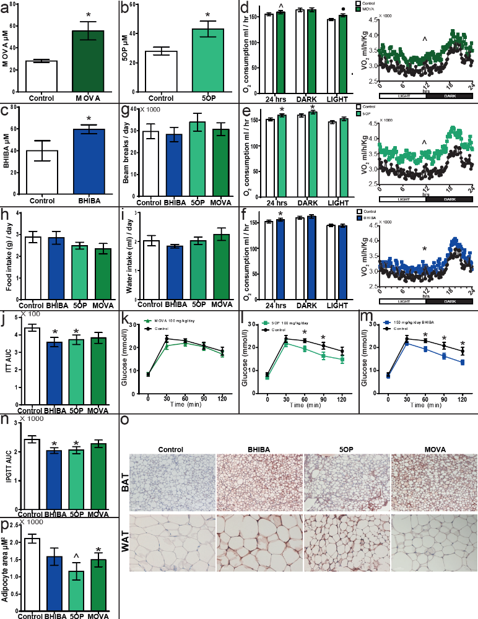
Supplementary Figure 7. The metabokines increase oxygen consumption, improve glucose tolerance and induce a phenotype and morphology consistent with browning in adipose tissue in obese mice
(a - c) The plasma concentration of MOVA, 5OP, and BHIBA in mice given 100 mg/kg/day MOVA, 100 mg/kg/day 5OP, or 150 mg/kg/day BHIBA, respectively, in their drinking water compared to control mice (n = 5). Analyzed by GC-MS. Diurnal weight normalized oxygen consumption and average oxygen consumption for 24 hour period, 12 hour dark phase (DARK) and 12 hour light phase (LIGHT) of (d) MOVA, (e) 5OP, and (f) BHIBA-treated mice fed a 60% fat diet (n = 8). (g) Daily activity (beam breaks), (h) food consumption and (i) water intake of mice treated with 100 mg/kg/day MOVA, 100 mg/kg/day 5OP or 150 mg/kg/day BHIBA. (j) Area under the curve (AUC) of intraperitoneal insulin tolerance tests of BHIBA, 5OP, or MOVA-treated mice (n = 10). Intraperitoneal glucose tolerance tests of (k) MOVA, (l) 5OP, and (m) BHIBA-treated mice. (n) AUC of intraperitoneal glucose tolerance tests of BHIBA, 5OP, or MOVA-treated mice (n = 10). (o) Immunohistochemical staining of Ucp1 protein (red) counterstained with hematoxylin in the brown adipose tissue (top panels) and inguinal subcutaneous adipose tissue (bottom panels) of BHIBA, 5OP and MOVA-treated mice. (p) Adipocyte area of the subcutaneous adipose tissue of BHIBA, 5OP, or MOVA-treated mice (n = 10). ∗p ≤ 0.05, ^p ≤ 0.01, •p ≤ 0.001, ‡p ≤ 0.0001. Data are mean ± SEM.

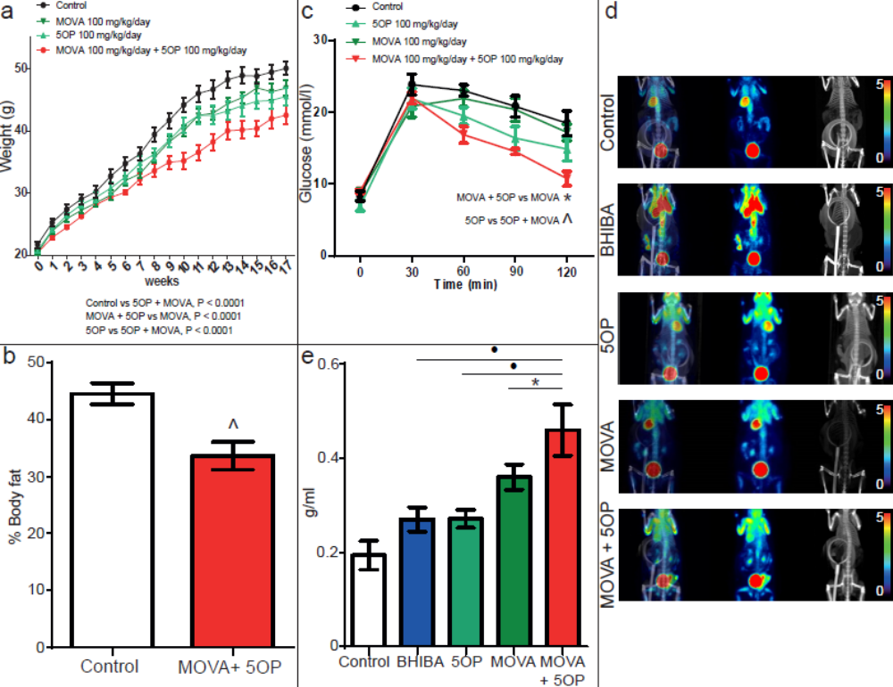
Supplementary Figure 8. The metabolite adipokines MOVA and 5OP have additive effects on body weight and glucose disposal in high fat diet-fed mice
(a) The reduction in weight gain in mice given a combination of MOVA and 5OP was greater than either MOVA or 5OP treatments. (b) Computed Tomography demonstrates that combined MOVA and 5OP treatment significantly reduces adiposity in mice. (c) Intraperitoneal glucose tolerance tests showed a greater improvement in glucose tolerance in the MOVA and 5OP combination-treated mice. (d) Positron emission tomography / computed tomography (PET/CT) ¹⁸F-FDG imaging of BHIBA, 5OP, MOVA and a combination of MOVA and 5OP-treated mice identifies enhanced glucose uptake of the combined treatment in vivo (n = 5). Scale bars are standardized uptake value (SUV). Right – CT, middle - PET, left – PET/CT co-registration. (e) PET/CT demonstrates that a combined MOVA and 5OP treatment significantly increases uptake of the glucose analogue ¹⁸F-FDG into the skeletal muscle of the hind limbs compared with either 5OP or MOVA treatment alone, expressed as standardized uptake values g/ml. ∗p ≤ 0.05, ^p ≤ 0.01, •p ≤ 0.001. Data are mean ± SEM of 5 biological replicates.

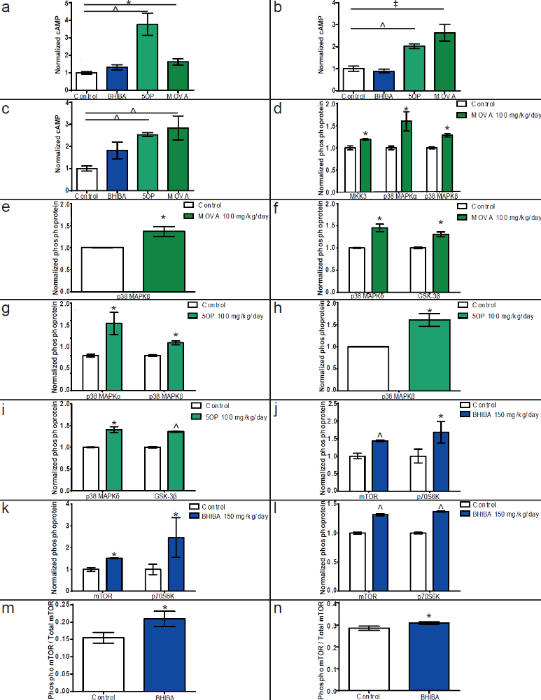
Supplementary Figure 9. MOVA and 5OP signal through cAMP-PKA-p38 MAPK and BHIBA via mTOR to regulate adipocyte and myocyte metabolic gene expression
Cyclic AMP concentrations in the (a) brown adipose tissue (BAT), (b) inguinal white adipose tissue (WAT) and (c) soleus skeletal muscle of mice treated with 100 mg/Kg/day MOVA, 100 mg/Kg/day 5OP or 125 mg/Kg/day BHIBA for 17 weeks. MOVA increased (d) brown adipose tissue (BAT) MKK3, p38 MAPKα and p38MAPKβ, (e) inguinal white adipose tissue (WAT) p38MAPKβ and (f) soleus p38 MAPKδ and GSK3β phosphorylation in mice. 5OP increased (g) BAT p38MAPKα and p38MAPKβ, and (h) inguinal WAT p38MAPKβ and (i) soleus p38MAPKδ and GSK3β phosphorylation in mice. BHIBA increased phosphorylation of mTOR and p70S6K in (j) BAT and (k) inguinal WAT and (l) soleus of mice. The phospho mTOR / total mTOR ratio in (m) BAT and (n) soleus skeletal muscle of 125 mg/Kg/day BHIBA treated mice. ∗p ≤ 0.05, ^p ≤ 0.01, •p ≤ 0.001, ‡p ≤ 0.0001. Data are mean ± SEM of no less than 3 biological replicates.

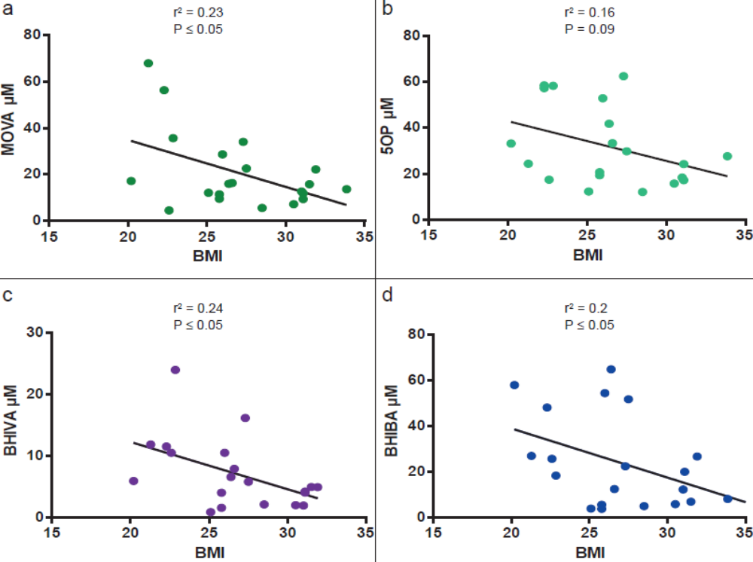
Supplementary Figure 10. Plasma concentrations of metabolite adipokines are inversely correlated with BMI in humans
(a - d) The inverse correlation of MOVA, 5OP, BHIVA and BHIBA plasma concentration to BMI in human volunteers, measured by GC-MS (n = 22).  Metabolite | Plasma Concentration (μM) | Reference
α-hydroxyisocaproic acid (HIC) | 0.25 ± 0.02 | Hoffer et al.¹
α-ketoisovaleric acid (AKV) | 11 ± 1.7  14 (0 – 28) | Geigy Scientific Tables, 8th Rev edition, pp. 165-177.  Hoffmann et al.²
α-hydroxyisovaleric acid (AHI) | 4.5 (2.9-6.2)  7.7 (0.0-19.0) | Geigy Scientific Tables, 8th Rev edition, pp. 165-177.  Hoffmann et al.²
3-methyl-2-oxovaleric acid (MOVA) | 22.7 +/- 4.6  18.0 (8.0-31.0) | Geigy Scientific Tables, 8th Rev edition, pp. 165-177.  Hoffmann et al.²
β-hydroxyisobutyric acid (BHIBA) | 21.0 +/- 2.0 | Avogaro et al³
β-hydroxyisovaleric acid (BHIVA) | ≤10 | Engelke et al.⁴
5-oxo-proline (5OP) | 19.5 ± 3.7 | Friesen et al.⁵

Supplementary Table 1. Physiological concentration of candidate metabokines in human plasma.

Target | Fold change | P-value
UCP1 | 20.754 | 0.06
LPL | 6.61 | 0.06
LEP | 5.985 | 0.02
CKMT2 | 4.028 | 0.06
FASN | 3.252 | 0.03
NPR1 | 3.185 | 0.04
SLC36A2 | 3.1 | 0.06
ADIPOQ | 3.04 | 0.03
CEBPA | 3.017 | 0.04
IL1B | 2.755 | 0.08
NR1H3 | 2.622 | 0.01
PNPLA2 | 2.559 | 0.06
FABP4 | 2.311 | 0.01
CKMT1B | 2.271 | 0.009
Perilipin 1 | 2.199 | 0.04
MLXIPL | 2.099 | 0.05
CPT1B | 2.065 | 0.09
GATM | 2.03 | 0.07
SLC27A1 | 1.908 | 0.02
SLC2A4 | 1.894 | 0.02
CD36 | 1.801 | 0.03
PGC1A | 1.738 | 0.01
SPARC | 1.655 | 0.001
Adipsin | 1.623 | 0.006
PRDM16 | 1.611 | 0.007
NPR3 | 1.539 | 0.04
PPARG | 1.49 | 0.05
INSR | 1.436 | 0.02
PPARA | 1.383 | 0.03
SREBF1 | 1.297 | 0.06
BMPR1A | 1.286 | 0.04
IGF1R | 1.258 | 0.03
ELOVL6 | 1.247 | 0.01
ATF2 | 1.234 | 0.03
CREB1 | 1.207 | 0.05
NRF1 | 1.158 | 0.03

Supplementary Table 2. Table of gene expression array data of key adipocyte and brown adipocyte-associated genes changed in immortalized human white preadipocytes isolated from neck fat and differentiation to adipocytes in the presence of 3-methyl-2-oxovaleric acid (MOVA) (20 μM) (Expression targets ordered by magnitude fold change, P ≤ 0.1).

Target | Fold change | P-value
UCP1 | 14.776 | 0.08
LEP | 5.731 | 0.02
CKMT1A/B | 4.695 | 0.05
CKMT2 | 4.205 | 0.05
NPR1 | 3.677 | 0.02
FABP4 | 3.468 | 0.06
FASN | 3.053 | 0.03
CEBPA | 2.919 | 0.04
ADIPOQ | 2.793 | 0.03
PNPLA2 | 2.606 | 0.06
NR1H3 | 2.477 | 0.01
MLXIPL | 2.447 | 0.03
Perilipin 1 | 2.371 | 0.03
Adipsin | 2.323 | 0.02
SLC27A1 | 2.09 | 0.02
CD36 | 2.054 | 0.07
SLC2A4 | 1.762 | 0.05
NPR3 | 1.629 | 0.03
INSR | 1.497 | 0.07
SPARC | 1.486 | 0.03
PPARG | 1.482 | 0.05
SREBF1 | 1.431 | 0.003
NRF1 | 1.4 | 0.03
ELOVL6 | 1.317 | 0.02
ATF2 | 1.297 | 0.05
CREB1 | 1.295 | 0.08
BMPR1A | 1.176 | 0.05

Supplementary Table 3. Table of gene expression array data of key adipocyte and brown adipocyte-associated genes changed in immortalized human white preadipocytes isolated from neck fat and differentiation to adipocytes in the presence of 5-oxo-proline (5OP) (20 μM) (Expression targets ordered by magnitude fold change, P ≤ 0.1).

Target | Fold change | P-value
LEP | 3.484 | 0.06
ADRB3 | 3.327 | 0.08
Adipsin | 2.204 | 0.01
PGC1A | 2.019 | 0.009
SLC27A1 | 1.747 | 0.004
MLXIPL | 1.599 | 0.08
INSR | 1.58 | 0.006
PRDM16 | 1.546 | 0.01
IGF1R | 1.493 | 0.004
NPR3 | 1.489 | 0.04
NRF1 | 1.476 | 0.002
SPARC | 1.473 | 0.01
CEBPA | 1.455 | 0.09
BMPR1A | 1.327 | 0.01
PPARG | 1.324 | 0.09
ATF2 | 1.292 | 0.01
TFAM | 1.291 | 0.08
CREB1 | 1.258 | 0.02
COL6A3 | 1.191 | 0.06
ELOVL6 | 1.106 | 0.07
NRF1 | 1.077 | 0.07
FOXC2 | 0.753 | 0.03
CIDEA | 0.119 | 0.09

Supplementary Table 4. Table of gene expression array data of key adipocyte and brown adipocyte-associated genes changed in immortalized human white preadipocytes isolated from neck fat and differentiation to adipocytes in the presence of β-hydroxyisobutyric acid (BHIBA) (20 μM) (Expression targets ordered by magnitude fold change, P ≤ 0.1).

Target | Fold change | P-value
UCP1 | 21.663 | 0.06
CKMT1A/B | 4.921 | 0.05
LPL | 4.712 | 0.09
CKMT2 | 3.214 | 0.09
FABP4 | 3.213 | 0.07
LEP | 2.862 | 0.09
SLC36A2 | 2.655 | 0.08
NPR1 | 2.622 | 0.07
IL1B | 2.599 | 0.09
CEBPA | 2.555 | 0.06
ADIPOQ | 2.438 | 0.06
NR1H3 | 2.392 | 0.02
PNPLA2 | 2.222 | 0.09
CD36 | 2.11 | 0.06
FASN | 2.085 | 0.09
Perilipin 1 | 1.995 | 0.05
MLXIPL | 1.954 | 0.06
CPT1B | 1.917 | 0.04
Adipsin | 1.884 | 0.007
SLC2A4 | 1.626 | 0.06
NPR3 | 1.596 | 0.02
SPARC | 1.551 | 0.002
PPARG | 1.455 | 0.06
INSR | 1.439 | 0.002
BMPR1A | 1.407 | 0.009
SREBF1 | 1.294 | 0.03
ELOVL6 | 1.244 | 0.007

Supplementary Table 5. Table of gene expression array data of key adipocyte and brown adipocyte-associated genes changed in immortalized human white preadipocytes isolated from neck fat and differentiation to adipocytes in the presence of β-hydroxyisovaleric acid (BHIVA) (10 μM) (Expression targets ordered by magnitude fold change, P ≤ 0.1).
Variant ID | Gene | SNP ID | p-Value | Effect | Trait | Data Set
6_80866657_T_G | BCKDHB | rs13220420 | 0.00000750 | -0.0210 | BMI | GIANT-UK Biobank GWAS Meta-analysis: males
6_80952806_A_G | BCKDHB | rs17506768 | 0.000149 | -0.0763 | BMI | GIANT GWAS: active men
6_81034583_G_A | BCKDHB | rs806848 | 0.000200 | -0.00970 | BMI | GIANT-UK Biobank GWAS Meta-analysis
6_81035173_A_G | BCKDHB | rs806845 | 0.000247 | -0.00950 | BMI | GIANT-UK Biobank GWAS Meta-analysis
6_81034730_A_G | BCKDHB | rs806847 | 0.000262 | -0.00950 | BMI | GIANT-UK Biobank GWAS Meta-analysis
6_80977740_G_T | BCKDHB | rs3805901 | 0.000300 | -0.00980 | BMI | GIANT UK Biobank GWAS
6_81036745_G_A | BCKDHB | rs1474790 | 0.000304 | -0.00940 | BMI | GIANT-UK Biobank GWAS Meta-analysis
6_81035737_C_A | BCKDHB | rs7747016 | 0.000307 | -0.00940 | BMI | GIANT-UK Biobank GWAS Meta-analysis
19_49299109_T_C | BCAT2 | rs73587808 | 0.000488 | 0.255 | BMI | GIANT-UK Biobank GWAS Meta-analysis: females
12_121167675_G_A | ACADS | rs12369156 | 0.000131 | -0.0222 | BMI | GIANT-UK Biobank GWAS Meta-analysis
12_121179939_C_T | ACADS | rs12825376 | 0.000137 | 0.0138 | BMI | GIANT-UK Biobank GWAS Meta-analysis: females
12_121177120_A_G | ACADS | rs566325901 | 0.000383 | 0.167 | BMI | GIANT-UK Biobank GWAS Meta-analysis
2_26472711_G_C | HADHA | rs559393527 | 0.0000341 | -0.124 | BMI | GIANT-UK Biobank GWAS Meta-analysis
2_26472712_A_T | HADHA | rs529693611 | 0.0000341 | -0.124 | BMI | GIANT-UK Biobank GWAS Meta-analysis
2_26472713_A_G | HADHA | rs548177580 | 0.0000371 | -0.123 | BMI | GIANT-UK Biobank GWAS Meta-analysis
2_26472714_T_C | HADHA | rs563090369 | 0.0000371 | -0.123 | BMI | GIANT-UK Biobank GWAS Meta-analysis
2_26479414_T_C | HADHA | rs397984129 | 0.000461 | -0.0873 | BMI | GIANT-UK Biobank GWAS Meta-analysis
20_33523155_G_T | GSS | rs2236270 | 3.60e-8 | 0.00980 | BMI | GIANT UK Biobank GWAS
20_33525407_G_A | GSS | rs7265992 | 8.40e-7 | -0.0113 | BMI | GIANT UK Biobank GWAS
20_33547633_T_G | GSS | rs6088662 | 0.0000250 | 0.00930 | BMI | GIANT UK Biobank GWAS
20_33545055_G_A | GSS | rs13041792 | 0.0000260 | 0.00930 | BMI | GIANT UK Biobank GWAS
20_33529766_T_G | GSS | rs2273684 | 0.0000280 | 0.00690 | BMI | GIANT UK Biobank GWAS
20_33542605_T_C | GSS | rs6088659 | 0.0000285 | 0.0328 | BMI | GIANT GWAS: men, Europeans, active + inactive individuals
20_33538214_G_A | GSS | rs35416056 | 0.0000326 | 0.0175 | BMI | GIANT-UK Biobank GWAS Meta-analysis
20_33522054_T_C | GSS | rs6087653 | 0.0000429 | 0.0250 | BMI | GIANT GWAS: men, active + inactive individuals
20_33540000_G_A | GSS | rs2025096 | 0.0000580 | 0.00890 | BMI | GIANT UK Biobank GWAS
20_33527838_A_G | GSS | rs6088655 | 0.0000679 | 0.0248 | BMI | GIANT GWAS: men, active + inactive individuals
20_33544075_C_G | GSS | rs3761144 | 0.0000719 | 0.0243 | BMI | GIANT GWAS: men, active + inactive individuals
7_30544048_C_T | GGCT | rs549124813 | 0.0000875 | 0.174 | BMI | GIANT-UK Biobank GWAS Meta-analysis: females
1_113504486_C_T | SLC16A1 | rs186286251 | 0.000471 | 0.296 | BMI | GIANT-UK Biobank GWAS Meta-analysis: males

Supplementary Table 6 Genetic variants in the metabokine biosynthetic genes associated with Body Mass Index in Genome Wide Association Study database in Genetic Investigation of ANthropometric Traits (GIANT) and UK Biobank Meta-analysis, including 795,640 subjects in the Type 2 Diabetes Knowledge Portal (http://www.type2diabetesgenetics.org/). P-value cut-off < 0.0005.

Volunteers | Age  (years) | % Male | Weight  (kg) | Mean body mass index
42 | 74.9 ± 1.3 | 78.6 | 84.5 ± 1.3 | 27.6 ± 0.7

Supplementary Table 7. Morphological parameters for human adipose biopsy volunteers. Data shown is Mean ± SEM.

 | MOVA | 5OP | BHIBA | BHIVA
Mouse Primary Adipocytes
Secretion during browning | ↑ | ↑ | ↑ | ↑
Induce brown adipocyte gene expression | ↑↑ | ↑↑ | ↑ | ↑
Human Primary Adipocytes
Secretion during browning | ↑ | ↑ | ↑ | ↑
Brown adipocyte gene expression | ↑ | ↑ | ↑ | ↑
Cellular respiration | ↑↑ | ↑↑ | ↑ | ↑
UCP1 Protein expression | ↑ | ↑ | ↑ | −
Relative fatty acid oxidation | ↑ | ↑ | ↑↑ | −
Glucose uptake | − | ↑ | ↑ | ↑
Fatty acid uptake | ↑ | ↑ | ↑ | ↑
Mouse C2C12 Myotubes
Metabolic gene expression | ↑↑ | ↑↑ | ↑ | ↑
Human Primary Skeletal Myotubes
Metabolic gene expression | ↑↑ | ↑↑ | ↑ | −
Cellular respiration | ↑ | ↑ | ↑ | −
Glucose uptake | ↑ | ↑ | −
Fatty acid uptake | ↑ | ↑ | ↑
High Fat Diet-fed C57Bl6 Mice
Weight gain | ↓↓ | ↓↓ | ↓ | −
Adiposity | ↓ | ↓ | −
Energy expenditure | ↑ | ↑ | ↑
Oxygen consumption | ↑ | ↑ | ↑
Insulin sensitivity | ↑ | ↑↑ | ↑↑ | −
Glucose tolerance | − | ↑ | ↑ | −
BAT Mitochondrial content | − | ↑ | ↑
Subcutaneous WAT Mitochondrial content | − | ↑ | ↑
Soleus mitochondrial content | ↑ | ↑ | ↑
Gastrocnemius mitochondrial content | ↑ | − | ↑
In vivo BAT glucose uptake | ↑ | − | ↑↑
In vivo hind limb glucose uptake | ↑ | ↑ | ↑
In vivo fore limb glucose uptake | ↑ | ↑ | −

Supplementary Table 8. Summary of the key metabolic effects of 3-methyl-2-oxovaleric acid (MOVA), 5-oxo-proline (5OP), β-hydroxyisobutyric acid (BHIBA) and β-hydroxyisovaleric acid (BHIVA) in mouse and human primary adipocytes, mouse and human skeletal myotubes and C57Bl6/J mice in vivo.

1 Hoffer, L. J., Taveroff, A., Robitaille, L., Mamer, O. A. & Reimer, M. L. Alpha-keto and alpha-hydroxy branched-chain acid interrelationships in normal humans. J Nutr 123, 1513-1521, doi:10.1093/jn/123.9.1513 (1993).
2 Hoffmann, G. F. et al. Physiology and pathophysiology of organic acids in cerebrospinal fluid. Journal of inherited metabolic disease 16, 648-669 (1993).
3 Avogaro, A. & Bier, D. M. Contribution of 3-hydroxyisobutyrate to the measurement of 3-hydroxybutyrate in human plasma: comparison of enzymatic and gas-liquid chromatography-mass spectrometry assays in normal and in diabetic subjects. J Lipid Res 30, 1811-1817 (1989).
4 Engelke, U. F. et al. NMR spectroscopic studies on the late onset form of 3-methylglutaconic aciduria type I and other defects in leucine metabolism. NMR in biomedicine 19, 271-278, doi:10.1002/nbm.1018 (2006).
5 Friesen, R. W., Novak, E. M., Hasman, D. & Innis, S. M. Relationship of dimethylglycine, choline, and betaine with oxoproline in plasma of pregnant women and their newborn infants. J Nutr 137, 2641-2646, doi:10.1093/jn/137.12.2641 (2007).

