Supplemental Material
List of Contents:
Table S1. Primers to amplify the target sequence
Table S2. Demographic characteristics, Al and Zn concentration in serum, and MoCA scores for workers in the different group
Table S3. Key targets of differential protein-protein interactions (PPI)
Table S4. PCR and WB verification experiment result
Fig. S1 Swimming speed for five consecutive days
Fig. S2 Schematic diagram of zinc finger domains of five DEPs

Table S1. Primers to amplify the target sequence
Target gene | Forward primers 5′–3′ | Reverse primers 5′–3′
Myl9 | CAGGGAACCCCCAACACC | CATTGGACGTAGCCCTCTGG
Rhoa | AGTCGTCGTCTTGAGCCTTG | ACCTCTGGGAACTGGTCCTT
Arhgef1 | AGACTGAAAGCCCTGAGCCTG | CCGCTTCACTTGGTTCTTGG
Egflam | CATCCATGTGAGGCACGACT | GCTTCTGTAATCGCTTTCTGGC
dsp | CTGGCAAAGGTAAGAAACCACT | CTGTTCTCCCGGGACAGTCT
GAPDH | CCATGGAGAAGGCTGGGG | CAAAGTTGTCATGGATGACC
R-miR-431 | GTCGTATCCAGTGCAGGGTCCGAGGT  ATTCGCACTGGATACGACTGCATG | GCGTGTCTTGCAGGCCGT
R-miR-182 | GTCGTATCCAGTGCAGGGTCCGAGGTAT  TCGCACTGGATACGACCGGTGT | GCGTTTGGCAATGGTAGAACTC
U6 | CTGCACTTATTTCAGAAGCAGAT | ATTTGTGCCATCCTTGCACC

Table S2 Demographic characteristics, Al and Zn concentration in serum, and MoCA scores for workers in the different group
Variables |  | Normal Group (MoCA≥ 26)（n=122） | MCI Group | P-Values
Variables |  | Normal Group (MoCA≥ 26)（n=122） | (MoCA < 26)（n=308） | P-Values
Age (years) |  | 42.52±6.50 | 43.67±7.63 | 0.048^{c}
Education level（n,%） | Primary school | 41(33.88%) | 154(49.84%) | <0.001ª
 | high school | 62(51.24%) | 139(44.98%)
 | undergraduate | 19(15.70%) | 15(4.85%)
Working years(years) |  | 21.53±7.27 | 22.87±8.71 | 0.054^{c}
History of illness（n,%） | Yes | 111(90.98%) | 52(16.88%) | <0.001ª
 | No | 11(9.02%) | 256(83.12%)
Smoking status n (%) | Yes | 108（88.53%） | 276（89.61%） | 0.743ª
 | No | 14（11.48%） | 32（10.39%）
Drinking status, n (%) | Yes | 74（60.66%） | 171（55.52%） | 0.332ª
 | No | 48（39.34%） | 137（44.48%）
exercise times per week(n) |  | 2.17±2.61 | 1.63±2.47 | 0.047^{b}
number of night shifts per week(n) |  | 1.31±0.93 | 1.35±0.90 | 0.751^{b}
serum Al concentrations (μg/L) |  | 15.87±10.37 | 17.82±13.45 | <0.001^{d}
serum Zn concentrations (μg/L) |  | 75.53±29.86 | 67.17±26.71 | 0.005^{b}
total score of MoCA |  | 26.94±1.01 | 22.01±2.86 | <0.001^{c}
 | score of executive/visuospatial abilities | 4.47±0.71 | 3.29±1.10 | <0.001^{c}
 | score of naming | 2.90±0.35 | 2.61±0.63 | <0.001^{c}
 | score of attention and calculation | 1.97±0.18 | 1.84±0.40 | <0.001^{c}
 | score of language | 1.09±0.59 | 0.68±0.65 | <0.001^{c}
 | score of abstract | 1.39±0.67 | 0.67±0.74 | <0.001^{b}
 | score of recall | 4.04±0.83 | 2.40±1.40 | <0.001^{c}
 | score of orientation | 5.87±0.36 | 5.63±0.62 | <0.001^{c}
Note: Continuous variables were presented as mean±SD. Categorical variables were presented as numbers (percentages). p-Values were derived from t-tests or Mann-Whitney U tests or Wilcoxon rank sum test according to the data distribution of continuous variables. Chi-square test were selected for the categorical variables. a: chi-square test; b= t-tests; c=Mann-Whitney U test; d= Wilcoxon rank sum test

Table S3. Key targets of differential protein-protein interactions (PPI)
name | Degree | BetweennessCentrality | ClosenessCentrality
Polr2e | 3.00 | 0.60 | 0.63
Rock1 | 3.00 | 0.70 | 0.63
Adcyap1 | 3.00 | 1.00 | 1.00
Ppa1 | 2.00 | 0.60 | 0.63
Polr2h | 2.00 | 0.00 | 0.45
Paf1 | 2.00 | 0.00 | 0.45
Sec24a | 2.00 | 0.40 | 0.50
Nckap1l | 2.00 | 1.00 | 1.00
Prex1 | 2.00 | 0.40 | 0.50
Arhgef1 | 2.00 | 0.60 | 0.63
Pltp | 2.00 | 1.00 | 1.00
Srcin1 | 1.00 | 0.00 | 0.42
Rnf31 | 1.00 | 0.00 | 1.00
Ripk2 | 1.00 | 0.00 | 1.00
Scrib | 1.00 | 0.00 | 0.36
Pip4k2a | 1.00 | 0.00 | 0.42
Pde7b | 1.00 | 0.00 | 1.00
Nt5c3a | 1.00 | 0.00 | 1.00
Galnt2 | 1.00 | 0.00 | 0.67
Specc1l | 1.00 | 0.00 | 1.00
Fkbp15 | 1.00 | 0.00 | 1.00
Ppp3r2 | 1.00 | 0.00 | 1.00
Dnah17 | 1.00 | 0.00 | 1.00
Utrn | 1.00 | 0.00 | 1.00
Dmd | 1.00 | 0.00 | 1.00
Cnih2 | 1.00 | 0.00 | 0.36
Mlc1 | 1.00 | 0.00 | 1.00
Clcn2 | 1.00 | 0.00 | 1.00
Cdc42ep1 | 1.00 | 0.00 | 0.67
Arpc5 | 1.00 | 0.00 | 0.67
Apoc1 | 1.00 | 0.00 | 0.67
Pdyn | 1.00 | 0.00 | 0.60
Trpv1 | 1.00 | 0.00 | 0.60
Slc18a2 | 1.00 | 0.00 | 0.60
Mms19 | 1.00 | 0.00 | 1.00
Abcb6 | 1.00 | 0.00 | 1.00
Wars2 | 1.00 | 0.00 | 1.00
Aars2 | 1.00 | 0.00 | 1.00

Table S4. PCR and WB verification experiment result
 | Control Group | High-dose Group | P Value
Myl9 | 1.66±0.18 | 1.12±0.22 | 0.003ª
Rhoa | 1.46±0.33 | 1.07±0.11 | 0.032^{b}
Arhgef1 | 0.95±0.10 | 1.03±0.26 | 1.000^{b}
Egflam | 1.13±0.36 | 1.13±0.48 | 0.988ª
dsp | 1.67±0.38 | 1.59±1.07 | 0.69^{b}
miR431 | 1.35±0.26 | 0.99±0.17 | 0.032ª
miR182 | 1.32±0.24 | 1.01±0.17 | 0.046ª
Rock1 | 0.74±0.11 | 0.42±0.16 | 0.006ª
DMD | 0.98±0.13 | 0.69±0.07 | 0.003ª
DHX57 | 0.42±0.12 | 0.22±0.13 | 0.040 ª
Sec24a | 0.82±0.22 | 0.63±0.19 | 0.187 ª
Note: a: t-test; b: Mann-Whitney U test. P < 0.05 indicates statistical significance.
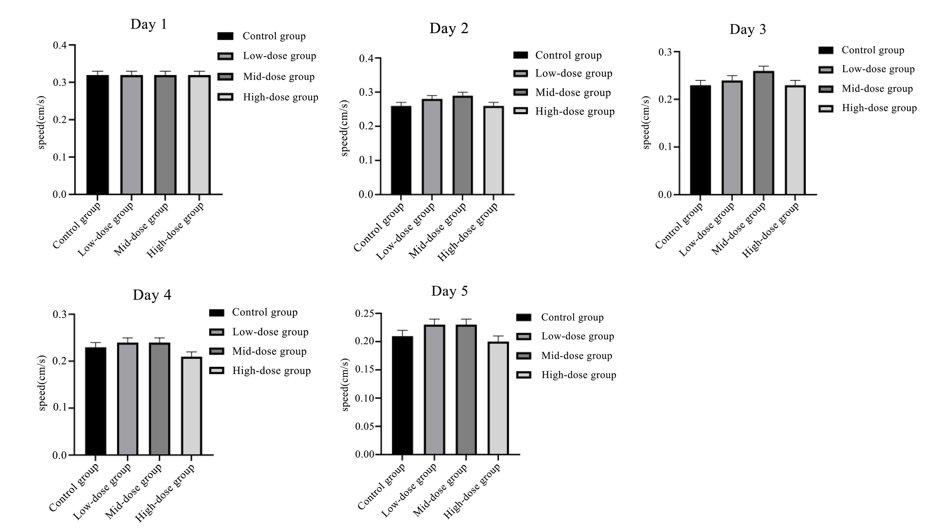

Fig. S1 Swimming speed for five consecutive days

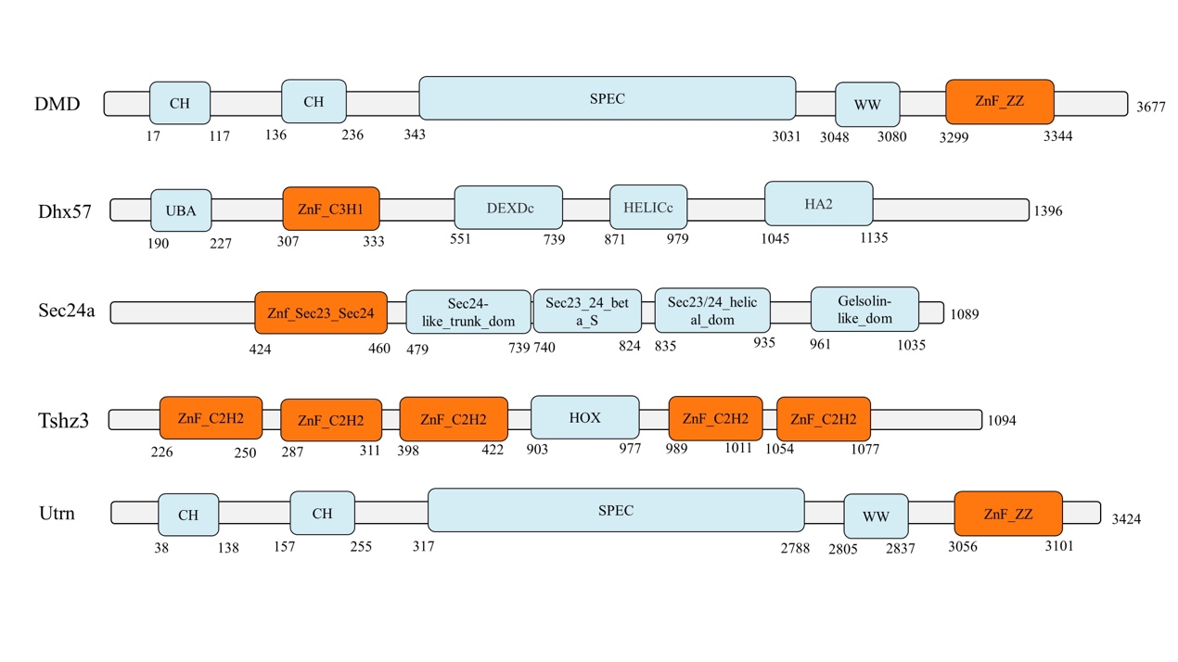
Fig. S2 Schematic diagram of zinc finger domains of five DEPs

