Supplementary Information

RBM14 enhances transcriptional activity of p23 regulating CXCL1 expression to induce EMT in lung cancer

Wen Zhang ^{1, 2#}, Yulin Peng^{1,2#}, Meirong Zhou^{1,2#}, Yilin Che¹, Junlin Chen^{1,2}, Wenhao Zhang^{1,2}, Chengjian He^{1,2}, Manman Tian^{1,2}, Xiangge Tian¹, Fei Yan¹, Yan Wang^{1,2}, Xiaokui Huo¹, Zhenlong Yu^{1,2*}, Xiaochi Ma^{1, 2*}
1. Second Affiliated Hospital, Dalian Medical University, Dalian 116000, China
2. Dalian Key Laboratory of Metabolic Target Characterization and Traditional Chinese Medicine Intervention, College (Institute) of Integrative Medicine, Dalian Medical University, Dalian 116044, China;

#These authors contributed equally.

Running title: p23 is a transcription factor of CXCL1 to promote tumor metastasis.

*Corresponding authors.
Zhenlong Yu, College of Pharmacy, Dalian Medical University, Tel: (+86)159-9863-6728, Email: qdyuzl871123@163.com;
Xiaochi Ma, Pharmaceutical Research Center, the Second Affiliated Hospital of Dalian Medical University, Tel: (+86) 0411-86110419, Fax: (+86)0411-86110419, Email: maxc1978@163.com.

Conflict of Interest
The authors declare no competing interests.

Table S1
The primer sequences were used
Prmers | Sequences
CXCL1 | AGGGAATTCACCCCAAGAAC
CXCL1 | TGGATTTGTCACTGTTCAGCA
RBM14 | GCAAAGAAGTGAAGGGCAAG
RBM14 | AAAGCCTGCTGGTAGTCGAA
p23 | TGCTTCTGCAAAGTGGTACG
p23 | GCTTGGAATCATTTGGATCA
E-Cadherin | TGCCCAGAAAATGAAAAAGG
E-Cadherin | GTGTATGTGGCAATGCGTTC
N-Cadherin | TTCCAACCTTCACCTTGACC
N-Cadherin | CCAGGTCTTGAGCAGTGACA
Vimentin | GAGAACTTTGCCGTTGAAGC
Vimentin | TCCAGCAGCTTCCTGTAGGT
CXCL8 | GTGCAGTTTTGCCAAGGAGT
CXCL8 | CTCTGCACCCAGTTTTCCTT
STC1 | TCAGCTGAAGTGGTTCGTTG
STC1 | GACGAATGCTTTTCCCTGAG
EIF4E3 | AAGACGTCGTCCAAGTCTGG
EIF4E3 | GTGTTTTCCACGTCCACCTT
F3 | GACCTCACCGACGAGATTGT
F3 | CCGAGGTTTGTCTCCAGGTA
MROH6 | GCCGTAACCAGCGTGTAAAT
MROH6 | CAAGCAGCAGATGTGGGTAG
S100A9 | TCATCAACACCTTCCACCAA
S100A9 | GTGTCCAGGTCCTCCATGAT
ANKRD22 | ATGCTGGCGTCGAAGTTAAT
ANKRD22 | TCCGTGCAATATCCAGTGAG
XYLT1 | TGTCTACGATGAGCCTGACG
XYLT1 | AAGCGGTCAGCAAGGAAGTA
PRODH | ACCACAGGTGCCTGGACTAC
PRODH | TCTGGTCACACATGCCTAGC
β-actin | AGAGCTACGAGCTGCCTGAC
β-actin | AGCACTGTGTTGGCGTACAG

Table S2
The sequences of EMSA probes were used
Probes | Sequences
E1 | TTCATGTTATACAGCCCTGGCTTCCACTGACGCTAACACTGG
E1 | CCAGTGTTAGCGTCAGTGGAAGCCAGGGCTGTATAACATGAA
E2 | ACTGGATTCAGCTTTTGACACTGATAATCTGTTGCCACCAAATGG
E2 | CCATTTGGTGGCAACAGATTATCAGTGTCAAAAGCTGAATCCAGT
E3 | AAATGGAAAACGTAAACAAGATATTCTAAGTGTGGTTAGAGAATATG
E3 | CATATTCTCTAACCACACTTAGAATATCTTGTTTACGTTTTCCATTT
E4 | AATATGCAACACAAGGAACAAGCAGAACATTCTTCTCTGGAATCTGA
E4 | TCAGATTCCAGAGAAGAATGTTCTGCTTGTTCCTTGTGTTGCATATT
E5 | ATCTGACATAATGGACTGTACTTTCACAGACAGCACTGATGTTAGAT
E5 | ATCTAACATCAGTGCTGTCTGTGAAAGTACAGTCCATTATGTCAGAT

Supplementary Figures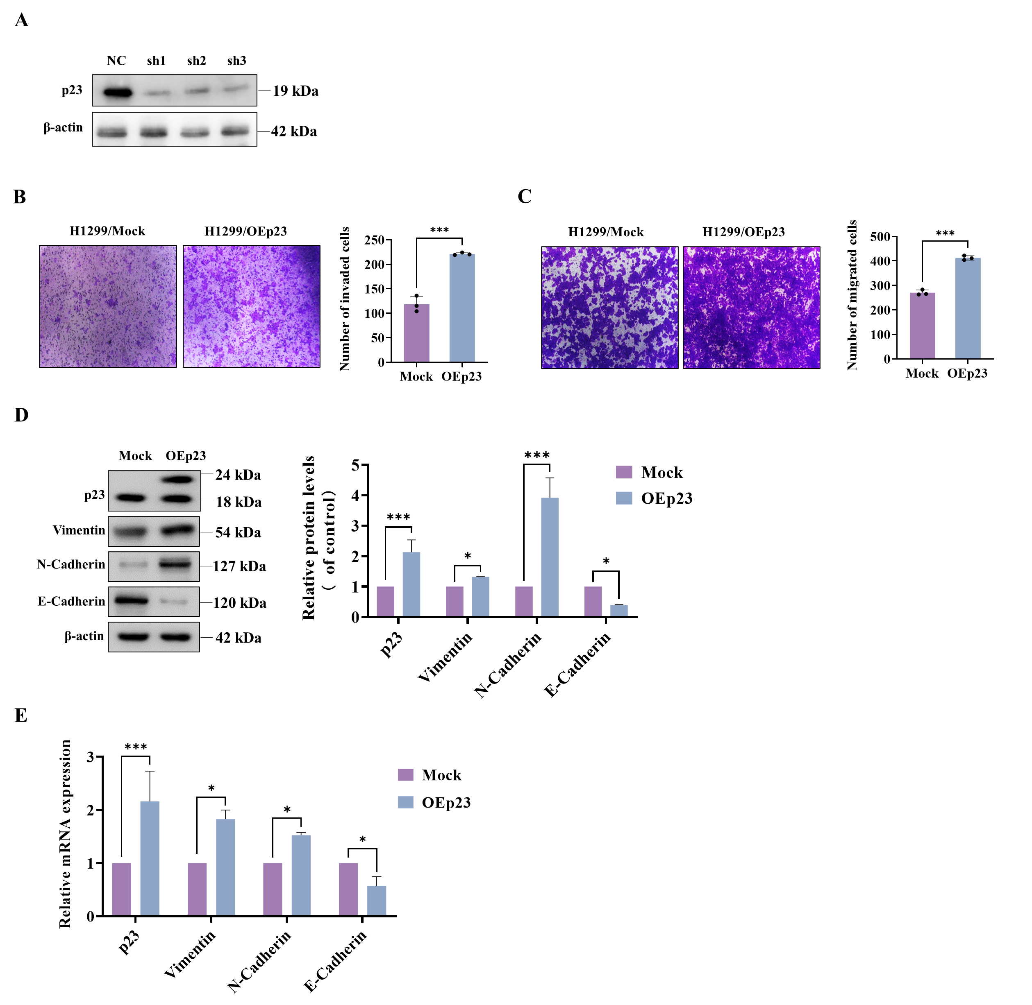
Figure S1. Verification of stable cell line and overexpression of p23 can inhibit the invasion and migration (EMT) of lung cancer cells. (A) The three si-RNA knock-down sequences of p23 can always inhibit the expression of endogenous p23. (B and C) Transwell invasion experiment (B) and migration experiment (C) were used to investigate the influence of p23-overexpression on the invasion and migration ability of H1299 cells; (D and E) Western blotting (D) and qPCR (E) were used to analyze the expression changes of invasion and migration proteins E-Cadherin, N-Cadherin and Vimentin after p23-overexpression.

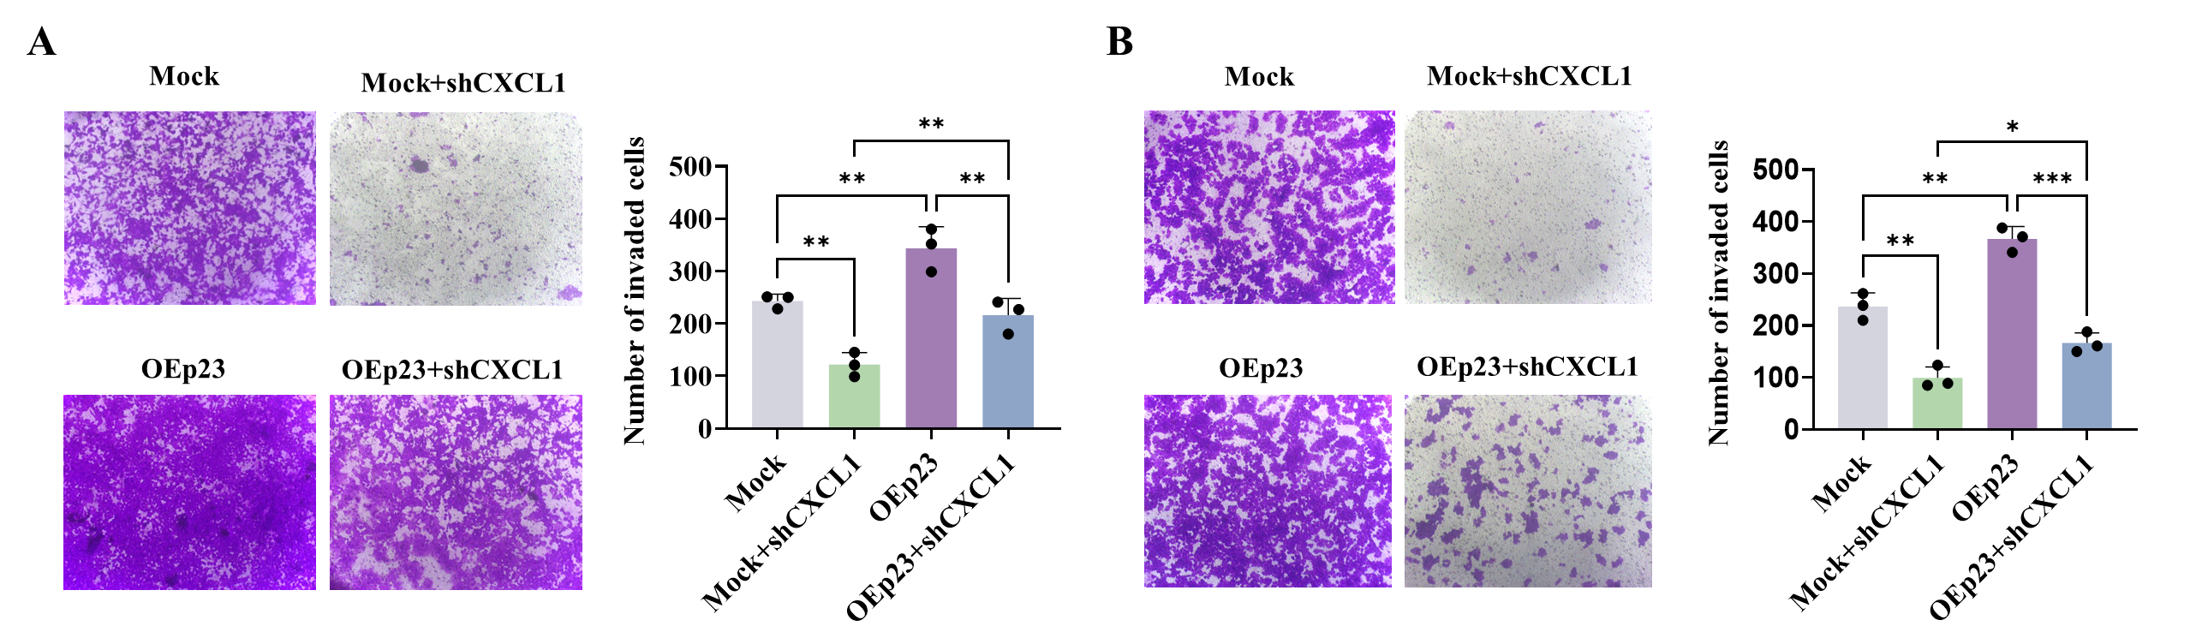 Figure S2. CXCL1 knockdown can reverse the invasion and migration of lung cancer cells caused by p23 overexpression. (A and B) Tranwell invasion experiment (A) and migration experiment (B) were used to investigate the influence of p23-overexpresssion and CXCL1-knockdown on the invasion and migration ability of H1299 cells.

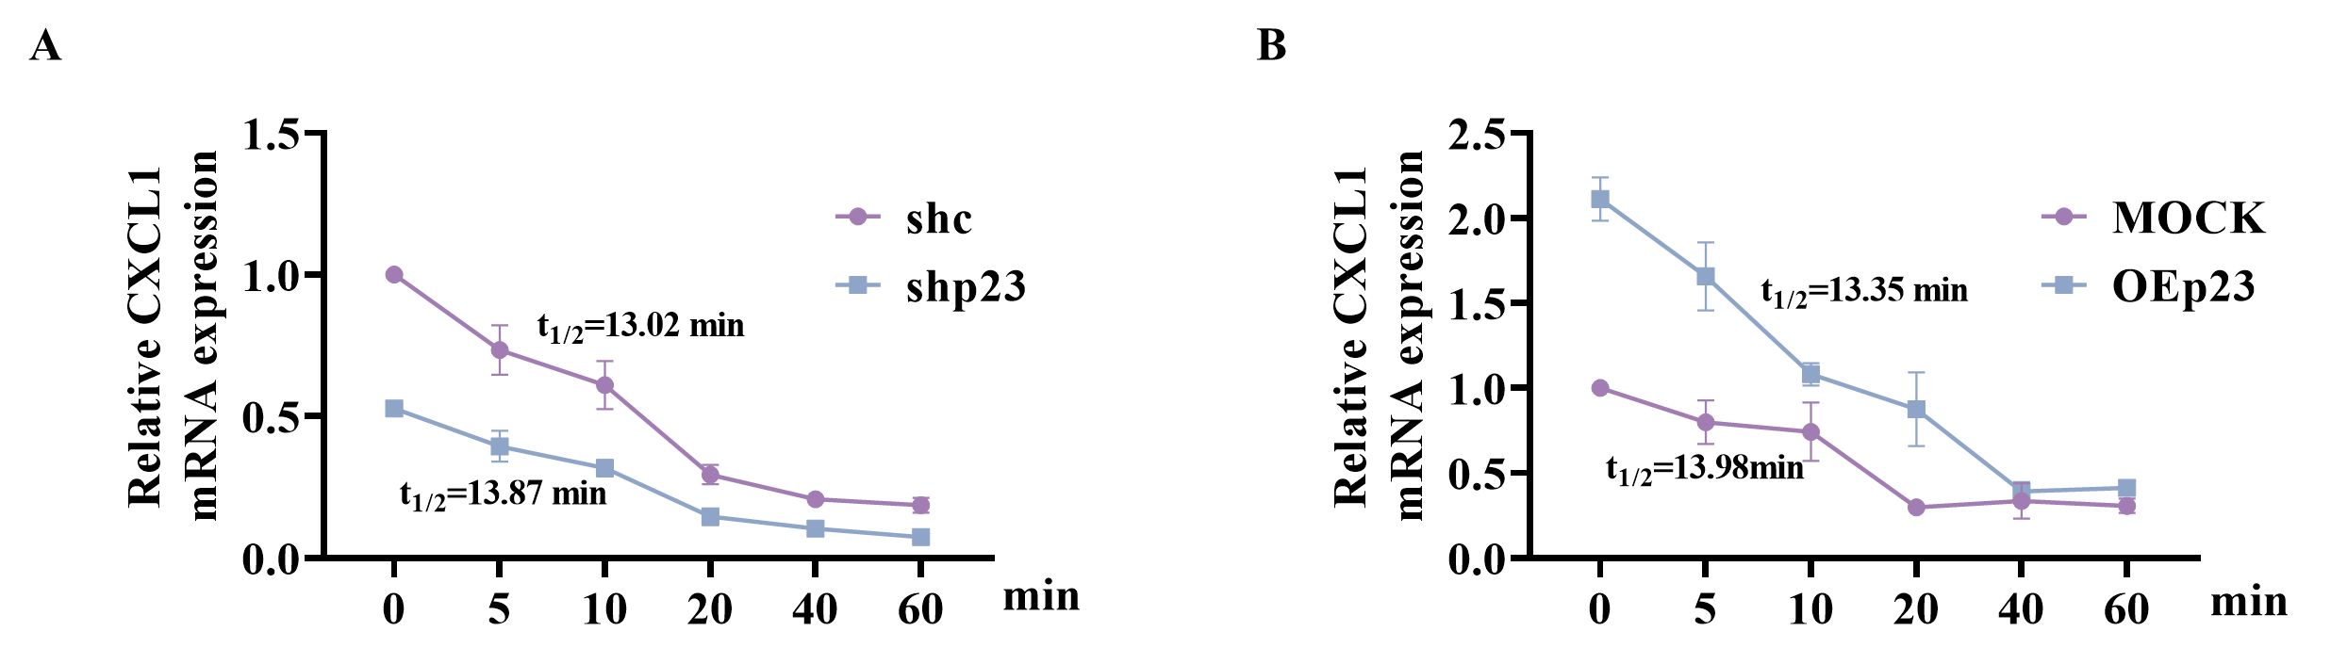
Figure S3. p23 has no any effects on the half-life of CXCL1. H1299/mock and H1299/p23-OE cells (A) or A549/Vec and A549/p23-KD cells (B) were treated with 20 μM of CHX for the indicated time, and then the expression of p23 and CXCL1 was analyzed by western blotting (C and D). A quantitative analysis of the data in A and B was also performed. Data are shown as means ± SD. P values were calculated using analysis of variance (ANOVA) followed by the least significant difference (LSD) test, and differences with P-values < 0.05 were statistically significant.

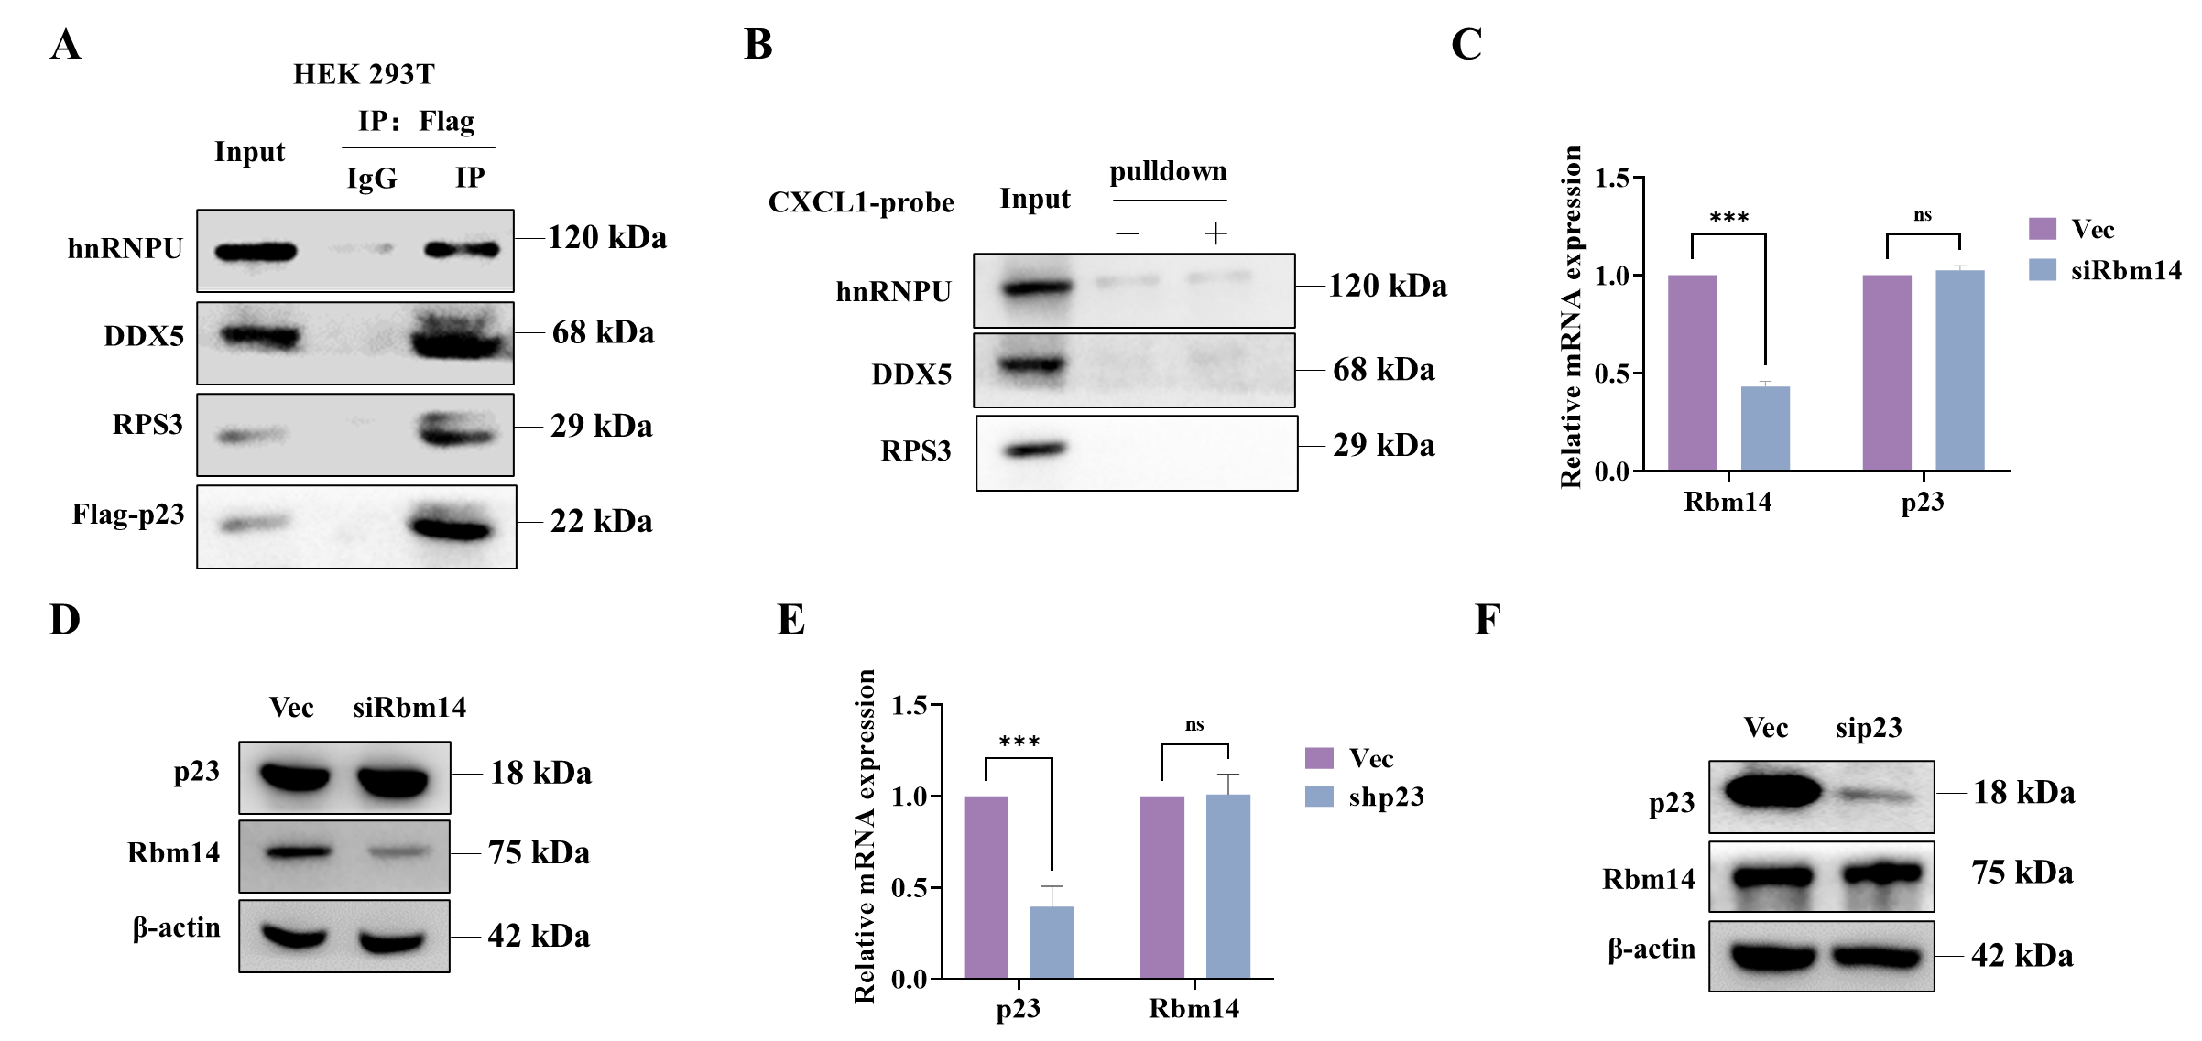
Figure S4. p23 and RBM14 do not affect each other's expression. (A) The interaction between p23 and several proteins with transcriptional activity was verified by co-IP. (B) The binding ability of several proteins with transcription activity to CXCL1 was verified by DNA pulldown agarose bead pull-down experiment. (C and D) Knocking down RBM14 in A549 cells did not affect the expression of p23 at mRNA (C) and protein level (D). (E and F) Knocking down p23 in A549 cells did not affect the expression of RBM14 at mRNA (E) and protein (F) level.

