Acute stress-related aberrant prefrontal based functional connectivity in high ruminators: An fNIRS study

Peng Lanxin¹, Long Jixin¹, Li Qian¹, Niu Lijing¹, Dai Haowei¹, Zhang Jiayuan¹, Chen Keyin¹, Huang Meiyan², Zhang Ruibin^{1,3}
¹ Laboratory of Cognitive Control and Brain Healthy, Department of Psychology, School of Public Health, Southern Medical University, Guangzhou, PRC China
² School of Biomedical Engineering, Southern Medical University, Guangzhou, PRC China
³ Department of Psychiatry, Zhujiang Hospital, Southern Medical University, Guangzhou, PRC China

# Correspondence and request for materials should be addressed to:
Huang Meiyan, School of Biomedical Engineering, Southern Medical University (e-mail: huangmeiyan16@163.com)

Zhang Ruibin, Department of Psychology, School of Public Health, Southern Medical University (e-mail: ruibinzhang@foxmail.com)

Sup Table 1. Demographic information and scale scores.
 | High rumination group  (n=28) |  |  | Low rumination group  (n=22) |  | t/χ² | p
Age | 21.35 (1.39) |  |  | 20.82(1.49) |  | 1.787 | >0.05
Gender (Male/Female) | 6/22 |  |  | 5/17 |  | 2.01 | 0.157
PHQ-9 | 10.1 | 2.722 |  | 7.50 | 4.897 | 2.456 | 0.0018
RRS | 57.07 | 5.156 |  | 26.59 | 2.702 | 25.113 | <0.001
PHQ-9, Patient Health Questionnaire-9; RRS, Ruminative Response Scale.

Sup Table 2. Channels of the used fNIRS probeset
and corresponding brain areas.
Brain Area | channel in left hemisphere | channel in right hemisphere
Middle frontal gyrus | 1, 2, 3, 4, 6 | 14, 15, 16, 17, 19
Inferior frontal gyrus | 5, 7 | 18, 20
Superior temporal gyrus | 8, 9 | 21, 22
Superior parietal lobule | 10, 11, 12, 13 | 23, 24, 25, 26

\

Sup Fig 1. The position of probes, channels and brain regions
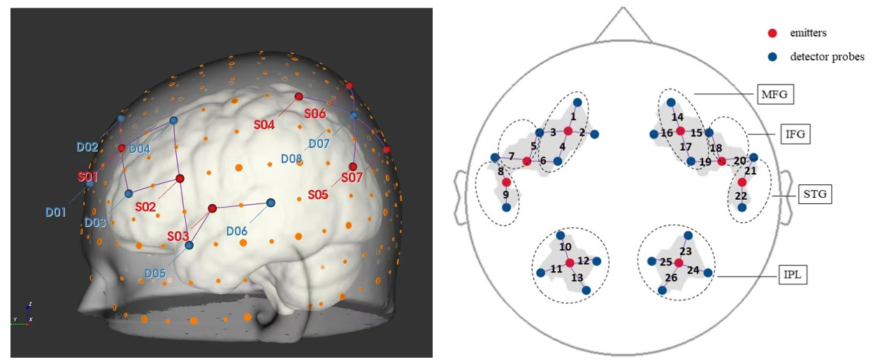
MFG, Middle frontal gyrus; IFG, Inferior frontal gyrus; STG, Superior temporal gyrus; SPL, Superior parietal lobule.

Sup Fig 2. Grouped-averaged variability of dynamic connectivity maps.
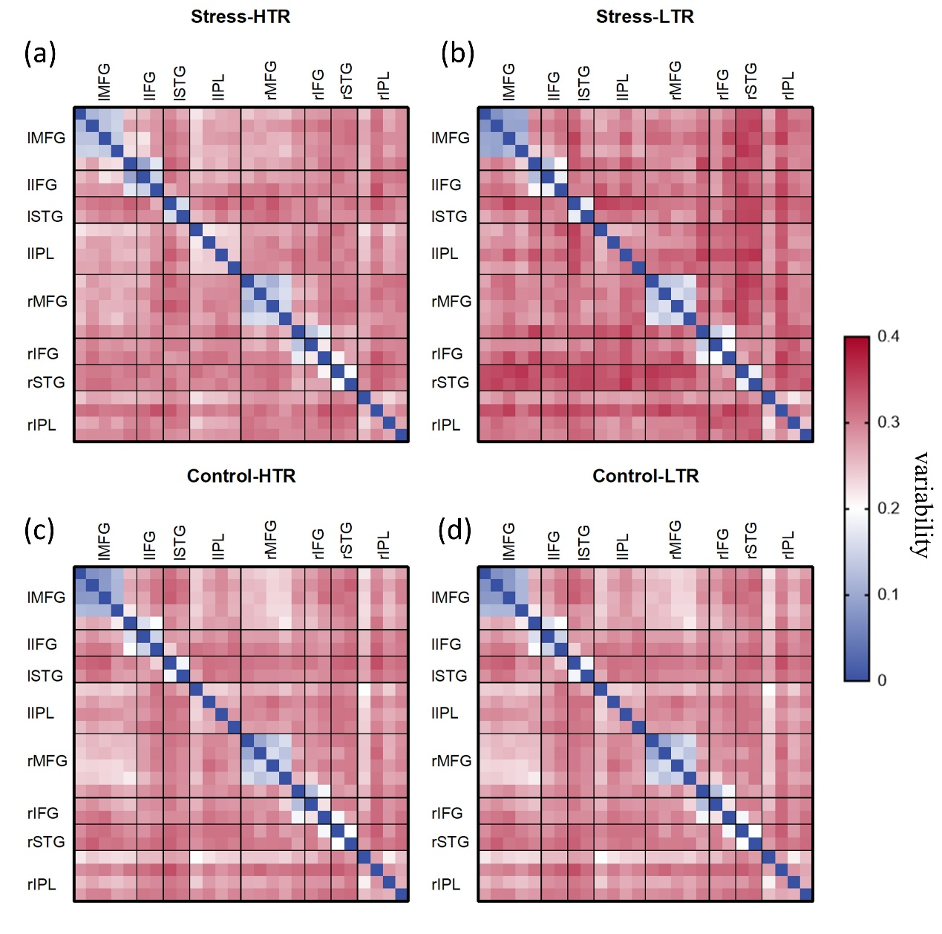(a) High trait rumination group under stress condition, (a) Low trait rumination group under stress condition, (c) High trait rumination group under control condition, (d) Low trait rumination group under control condition.

