Supplementary information

Normothermic ex vivo kidney perfusion preserves mitochondrial function and graft function after warm ischemia and is further enhanced by AP39

Masataka Kawamura, Catherine Parmentier, Samrat Ray, Sergi Clotet-Freixas, Sharon Leung, Rohan John, Laura Mazilescu, Emmanuel Nogueira, Yuki Noguchi, Toru Goto, Bhranavi Arulratnam, Sujani Ganesh, Tomas Tamang, Kaitlin Lees, Trevor Reichman, Ana C. Andreazza, Peter K. Kim, Ana Konvalinka, Markus Selzner, Lisa A. Robinson

1 Supplementary table

4 Supplementary figures

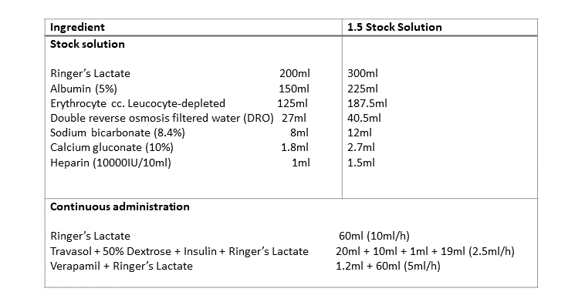
Supplementary table 1. Composition of perfusate and list of drugs administered continuously during warm perfusion.

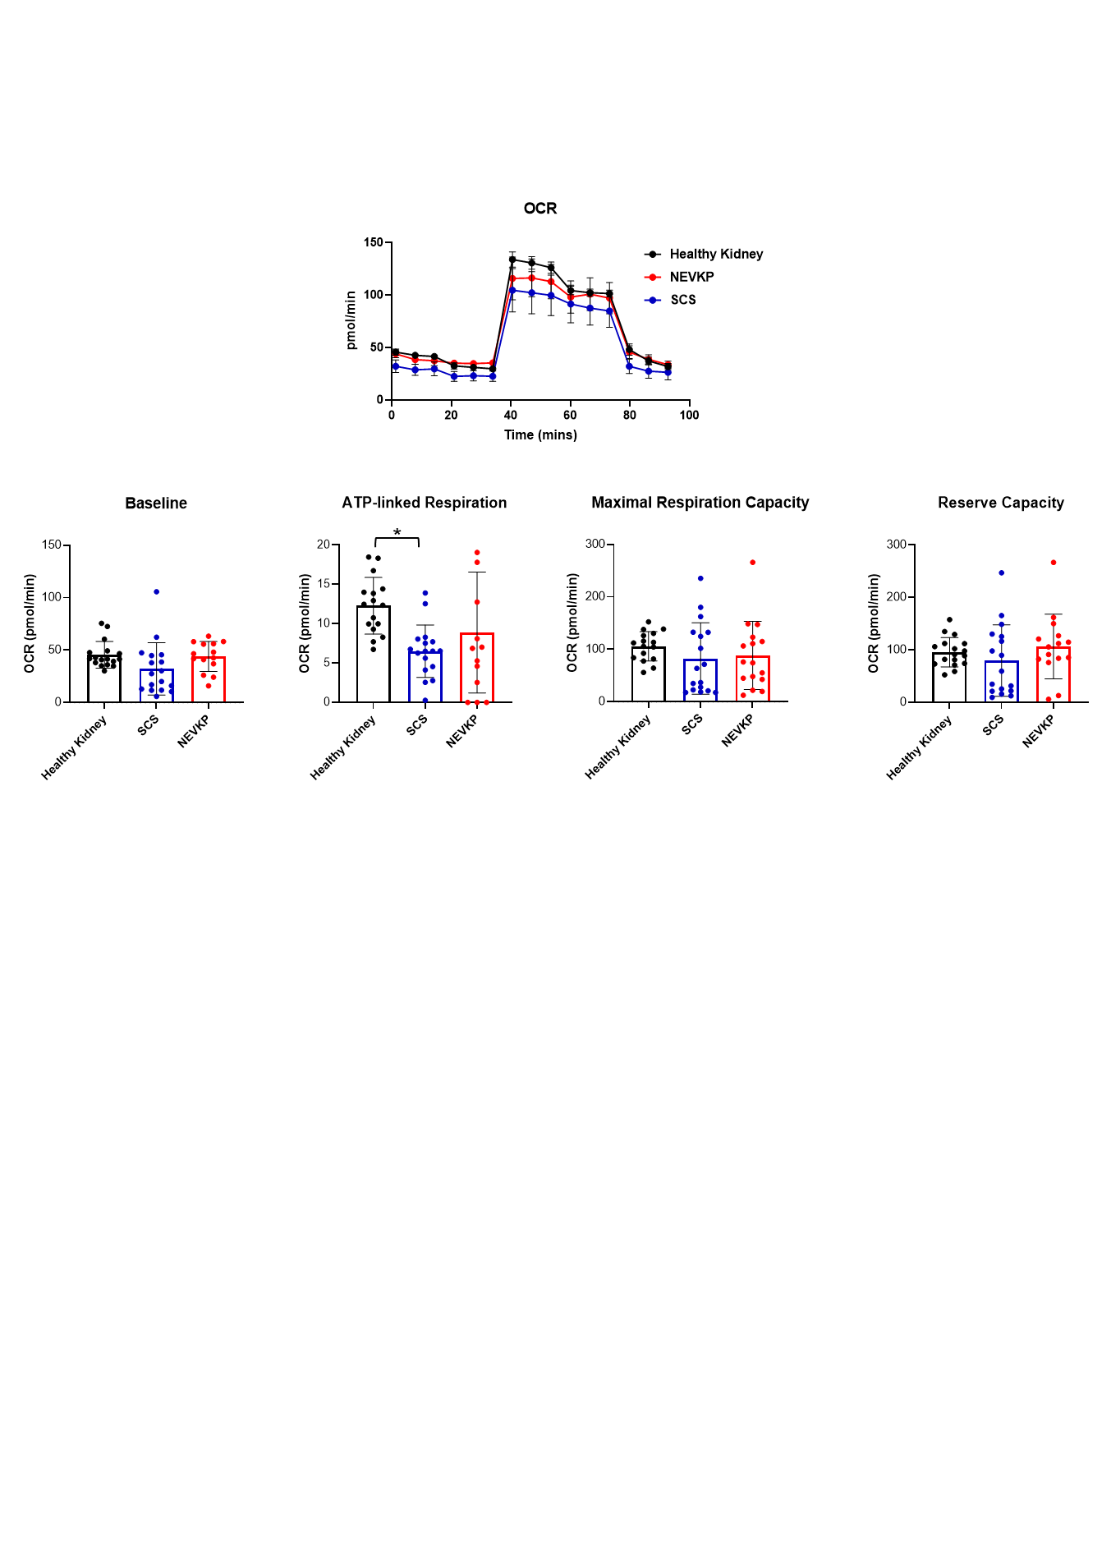Supplementary Figure S1. Comparison of mitochondrial metabolic capacity in the early post-transplant period.
Oxygen consumption rate in cells extracted from renal cortex tissue for analysis of mitochondrial respiration 30min after kidney transplantation. Changes from baseline to after metabolic stress. Differences in baseline oxygen consumption rates, calculated ATP-linked respiration, Maximal respiration capacity, and reserve capacity. Results are presented as means ± SD. *p<0.05.

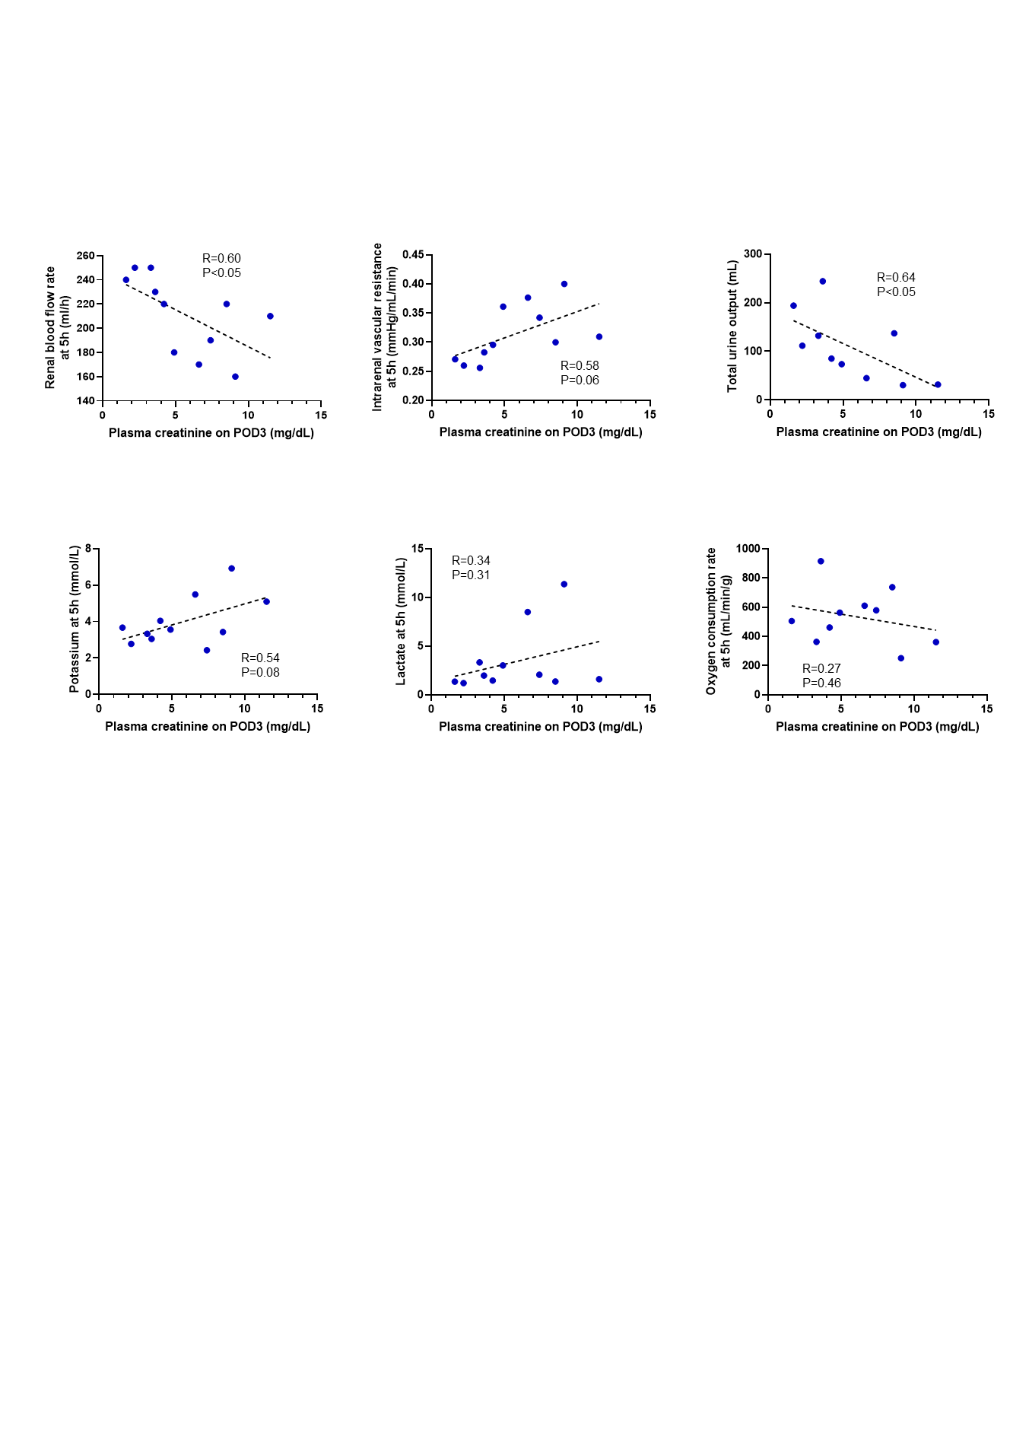
Supplementary Figure S2. Correlation between parameters during perfusion and graft function after transplantation.
Scatterplot between plasma creatinine levels on day 3 post-transplant and renal blood flow rate, intrarenal vascular resistance, potassium, lactate, oxygen consumption rate at 5 hours, and total urine output. R, Pearson's correlation coefficient.

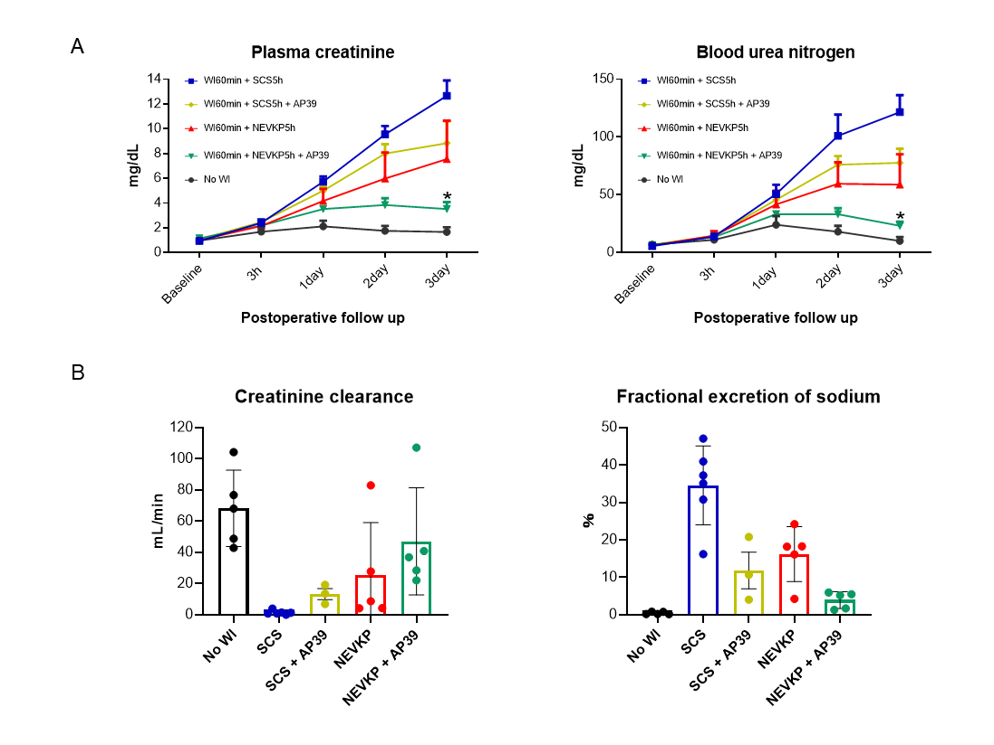

Supplementary Figure S3. Comparison of SCS plus AP39 with other groups.
Results of renal function trends. Plasma creatinine levels and urea nitrogen from preoperative to day 3. 24-hour urine storage test from day 2 to day 3. Creatinine clearance and fractional excretion of sodium. Results are presented as means ± SD. *p<0.05.

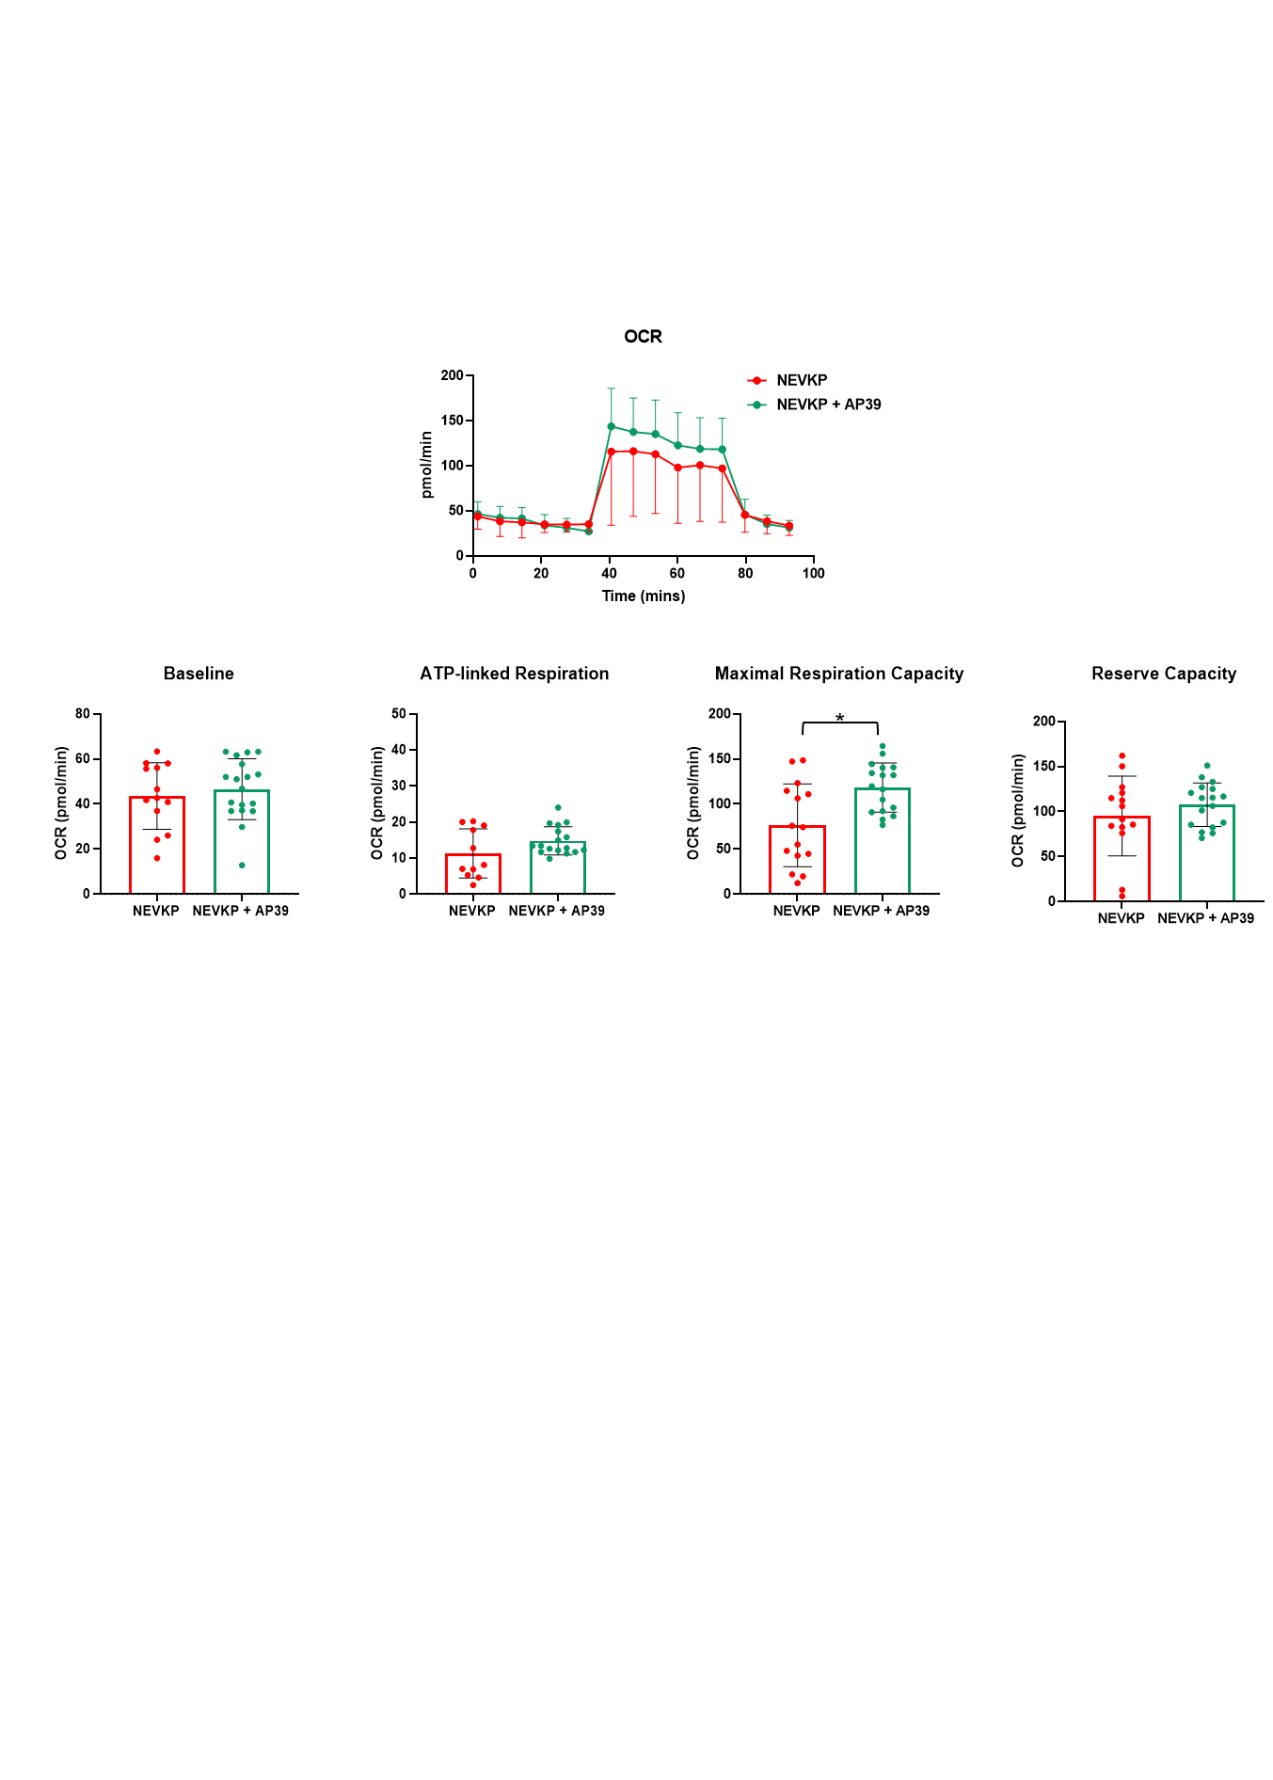
Supplementary Figure S4. Comparison of mitochondrial metabolic capacity in the early post-transplant period.
Oxygen consumption rate in cells extracted from renal cortex tissue for analysis of mitochondrial respiration 30min after kidney transplantation. Changes from baseline to after metabolic stress. Differences in baseline oxygen consumption rates, calculated ATP-linked respiration, Maximal respiration capacity, and reserve capacity. Results are presented as means ± SD. *p<0.05.

