Supplementary Figure 1. REViGO tree analysis of GO terms obtained with DAVID. Panel a shows BP terms associated with the 62 ID genes; Panel b shows BP terms associated with the 28 ARID genes; Panel c shows BP terms associated with the 25ADID genes; Panel d shows BP terms associated with the 9 XLID genes. DAVID, Database for Annotation Visualization, and Integrated Discovery; GO, Gene Ontology; BP, Biological Process; REViGO, Reduce + Visualize Gene Ontology.
a
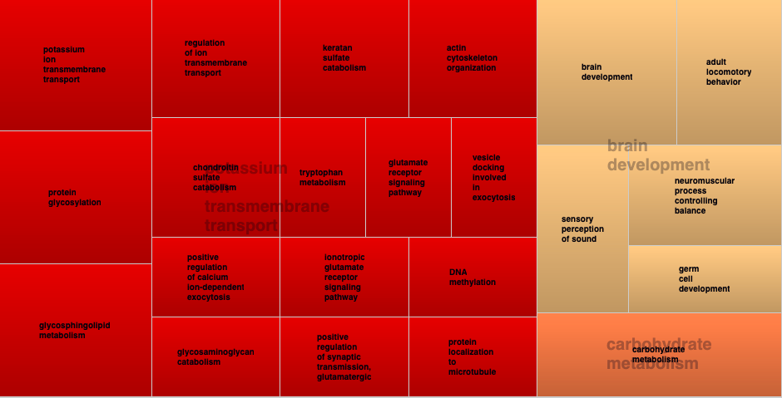

b
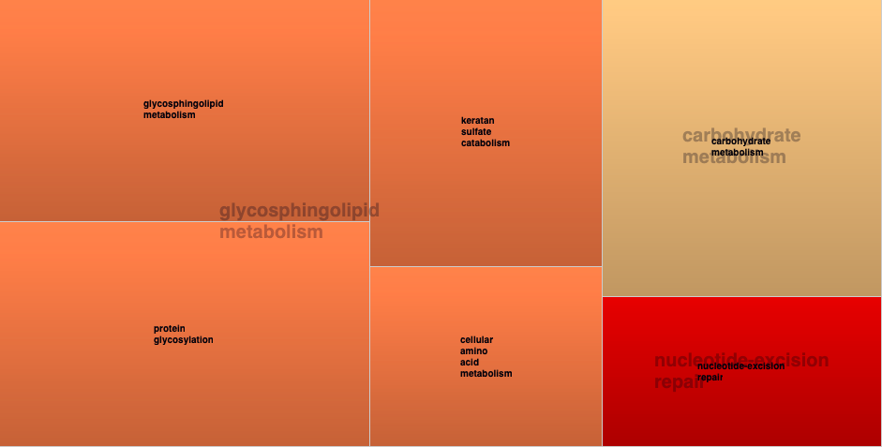

c
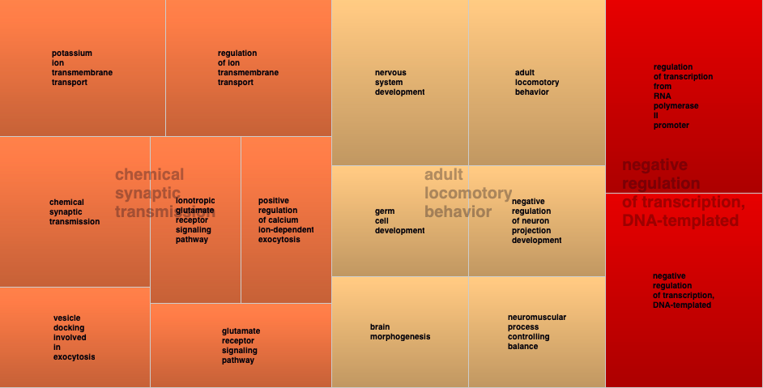
d
