Supplementary Figure 1. REViGO tree analysis of GO terms obtained with DAVID. Panel a shows BP terms associated with the 81 ID genes; Panel b shows BP terms associated with the 46 ARID genes; Panel c shows BP terms associated with the 26ADID genes; Panel d shows BP terms associated with the 13 XLID genes. DAVID, Database for Annotation Visualization, and Integrated Discovery; GO, Gene Ontology; BP, Biological Process; REViGO, Reduce + Visualize Gene Ontology.
a
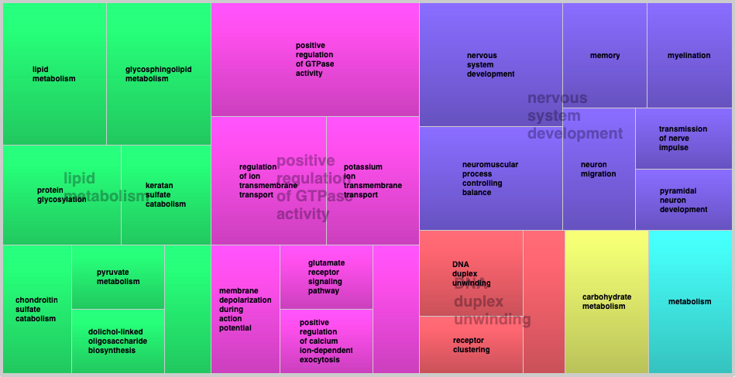
b
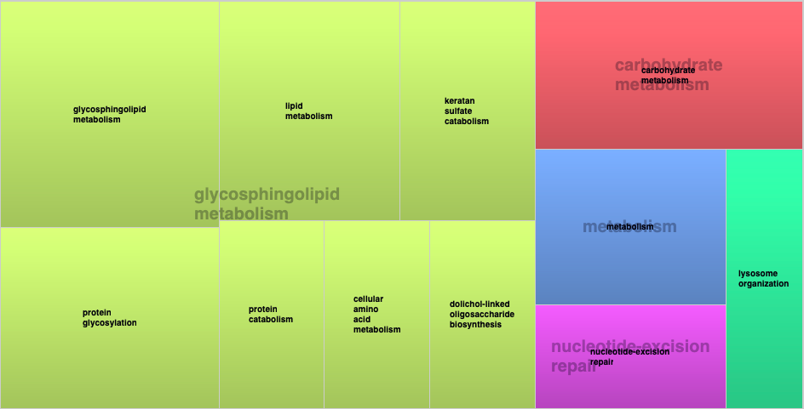
c
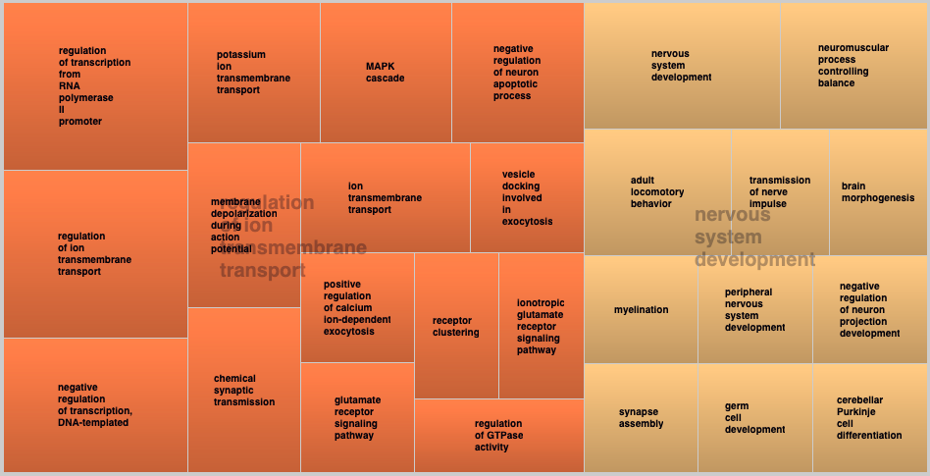
d
