Supplementary data
Table S1. Correlations (Pearson’s r) between environmental variables over the course of the study.
 | Temperature | Salinity | Dissolved Oxygen | Chlorophyll-a
Temperature | - | –0.034 | –0.650 | –0.300
Salinity | - | - | –0.025 | 0.120
Dissolved Oxygen | - | - | - | 0.600
Chlorophyll-a | - | - | - | -

Table S2. Model results examining the effect of environmental variables, their rates of change, and their interactions on the inter-individual variability of oyster behavior.
Terms | Estimate | Std. Error | df | t value | Pr (> |t|)
Intercept | 0.0530 | 0.0130 | 5 | 4.2 | 8.6 10³
DO | –0.0060 | 0.0006 | 31000 | –11.0 | < 0.001
T | –0.0050 | 0.0004 | 31000 | –11.0 | < 0.001
S | 0.0050 | 0.0005 | 30000 | 10.0 | < 0.001
∆DO | 0.0090 | 0.0004 | 31000 | 26.0 | < 0.001
∆Depth | 0.0020 | 0.0003 | 31000 | 6.3 | < 0.001
∆T | 0.0040 | 0.0004 | 31000 | 12.0 | < 0.001
∆S | 0.0004 | 0.0003 | 31000 | 1.5 | 0.130
DO × T | 0.0030 | 0.0003 | 31000 | 9.1 | < 0.001
DO × S | 0.0140 | 0.0006 | 31000 | 24.0 | < 0.001
T × S | 0.0090 | 0.0005 | 31000 | 18.0 | < 0.001
T × ∆DO | 0.0004 | 0.0004 | 31000 | 1.1 | 0.280
S × ∆DO | –0.0040 | 0.0004 | 31000 | –12.0 | < 0.001
DO × ∆DO | 0.0020 | 0.0004 | 31000 | 4.5 | <0.001
T × ∆Depth | –0.0009 | 0.0003 | 31000 | –2.8 | 0.005
S × ∆Depth | –0.0080 | 0.0003 | 31000 | –26.0 | < 0.001
DO × ∆Depth | –0.0030 | 0.0004 | 31000 | –7.2 | < 0.001
T × ∆T | –0.0005 | 0.0003 | 31000 | –1.9 | 0.060
S × ∆T | –0.0090 | 0.0004 | 31000 | –25.0 | < 0.001
DO × ∆T | –0.0006 | 0.0004 | 31000 | –1.5 | 0.140
T × ∆S | 0.0060 | 0.0004 | 31000 | 16.0 | < 0.001
DO × ∆S | –0.0040 | 0.0004 | 31000 | –8.0 | < 0.001
S × ∆S | 0.0050 | 0.0004 | 31000 | 13.0 | < 0.001

Table S3. Model results examining the effect of environmental variables, their rates of change, and their interactions on the rate of valve closure.
Terms | Estimate | Std. Error | z value | Pr (> |t|)
Intercept | –0.27000 | 0.120 | –2.200 | 0.0260
DO | 0.04200 | 0.027 | 1.600 | 0.1200
T | –0.03300 | 0.023 | –1.400 | 0.1500
S | 0.41000 | 0.015 | 28.000 | 0.0000
∆DO | –0.11000 | 0.019 | –5.700 | 0.0000
∆Depth | –0.00041 | 0.016 | –0.026 | 0.9800
∆T | 0.04200 | 0.019 | 2.300 | 0.0230
∆S | –0.11000 | 0.015 | –7.200 | 0.0000
DO × T | –0.14000 | 0.016 | –8.800 | 0.0000
DO × S | 0.01600 | 0.030 | 0.550 | 0.5800
T × S | –0.16000 | 0.027 | –6.100 | 0.0000
T × ∆DO | 0.00660 | 0.019 | 0.350 | 0.7300
S × ∆DO | –0.00570 | 0.020 | –0.280 | 0.7800
DO × ∆DO | –0.00350 | 0.021 | –0.160 | 0.8700
T × ∆Depth | 0.02800 | 0.016 | 1.700 | 0.0940
S × ∆Depth | 0.03100 | 0.017 | 1.800 | 0.0650
DO × ∆Depth | –0.05200 | 0.020 | –2.700 | 0.0077
T × ∆T | 0.03800 | 0.016 | 2.400 | 0.0150
S × ∆T | 0.03300 | 0.020 | 1.700 | 0.0990
DO × ∆T | 0.02800 | 0.024 | 1.200 | 0.2300
T × ∆S | 0.05000 | 0.023 | 2.200 | 0.0300
DO × ∆S | 0.07200 | 0.024 | 3.000 | 0.0031
S × ∆S | –0.12000 | 0.022 | –5.500 | 0.0000

Table S4. Model results examining the effect of environmental variables, their rates of change, and their interactions on the probability of an oyster being closed.
Terms | Estimate | Std. Error | z value | Pr (> |t|)
Intercept | –1.3000 | 0.260 | –4.900 | 8.0 10^{–7}
DO | –0.7300 | 0.130 | –5.700 | < 0.001
T | –0.9100 | 0.110 | –8.200 | < 0.001
S | 0.0760 | 0.078 | 0.980 | 3.3 10^{–1}
∆DO | 1.0000 | 0.090 | 11.000 | < 0.001
∆Depth | –0.1800 | 0.077 | –2.300 | 2.3 10^{–2}
∆T | 0.3200 | 0.083 | 3.800 | 1.2 10^{–4}
∆S | 0.0036 | 0.073 | 0.049 | 9.6 10^{–1}
DO × T | 0.4300 | 0.085 | 5.100 | 4.0 10^{–7}
DO × S | 1.9000 | 0.170 | 11.000 | < 0.001
T × S | 0.4800 | 0.130 | 3.700 | 2.4 10^{–4}
T × ∆DO | –0.0062 | 0.081 | –0.076 | 9.4 10^{–1}
S × ∆DO | –0.2800 | 0.110 | –2.600 | 9.5 10^{–3}
DO × ∆DO | –0.3000 | 0.110 | –2.700 | 6.2 10^{–3}
T × ∆Depth | 0.4600 | 0.085 | 5.400 | 1.0 10^{–7}
S × ∆Depth | –0.4000 | 0.087 | –4.600 | 3.8 10^{–6}
DO × ∆Depth | 0.3600 | 0.100 | 3.500 | 4.0 10^{–4}
T × ∆T | –0.2500 | 0.079 | –3.200 | 1.3 10^{–3}
S × ∆T | –0.5700 | 0.090 | –6.300 | < 0.001
DO × ∆T | –0.3500 | 0.120 | –3.000 | 3.1 10^{–3}
T × ∆S | –0.0270 | 0.120 | –0.230 | 8.2 10^{–1}
DO × ∆S | –0.9600 | 0.150 | –6.300 | < 0.001
S × ∆S | 0.6900 | 0.087 | 8.000 | < 0.001

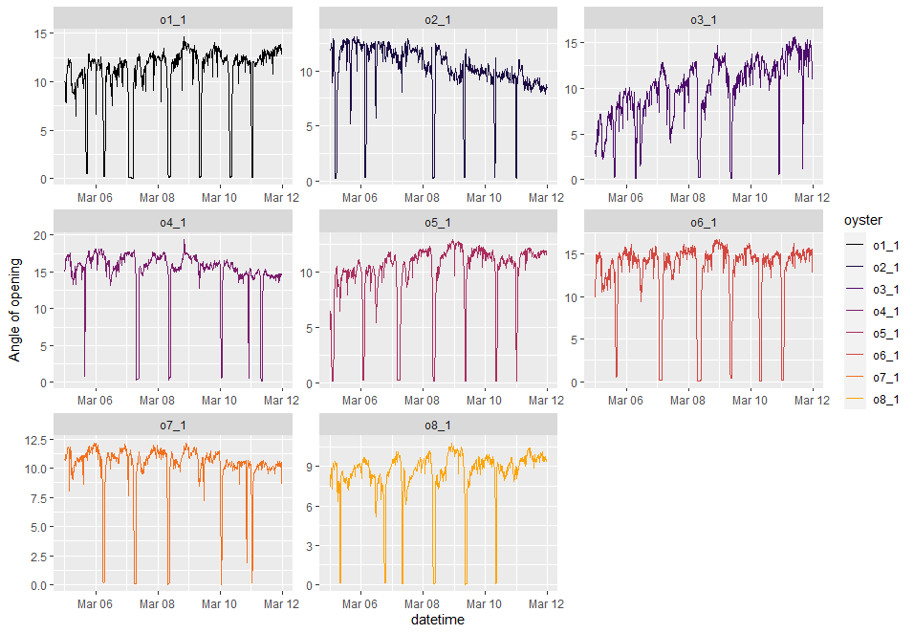
Figure S1. Sample of valve opening behavior monitoring presented as percentage of maximum opening of eight individual oysters (a–h) between 9 March and 26 April 2021.

