Micellar Curcumol for Maintenance Therapy of Ovarian Cancer
by activating the FOXO3a
Jing Wang ª†*, Bing Chen ^{b}†, Jiezhen Yang ^{c, d}†, Qin Tang ^{c}, Yan Zhong ª, Jiyu Du ^{c}, Sheng Wang ^{c}, Qiang Wu ^{c}, Yang Lu ^{b}*, Yonghong Song ^{b}*
a Department of Obstetrics & Gynecology, First Affiliated Hospital of Anhui Medical University, Hefei 230020, Anhui, P.R. China
b School of Chemistry and Chemical Engineering, Hefei University of Technology,
Hefei, Anhui 230009, P. R. China.
c Department of Pathology, School of basic medical sciences, School of pharmacy, Center for Scientific Research, Anhui Medical University, Hefei, Anhui 230032, P. R. China
d Department of Pathology, Zhongshan Hospital (Xiamen), Fudan University, Xiamen 361015, China

Materials and methods
Cell culture
SKOV3 and OVCAR3 cells were purchased from Procell (Wuhan, China) and cultured in McCoy’s 5A medium and RPMI 1640 medium containing 10% FBS and 1% penicillin and streptomycin (Gibco, USA) respectively, at 37℃, 5% CO₂. The media were replaced every other day and treated with micelle, micelle-loaded curcumol (MC), IGF-1, siRNA, or pCMV-FOXO3(human)-FLAG-Neo plasmids as indicated. Passage was performed when the cells grew to approximately 90% confluence.

Agents
Curcumol and DSPE-PEG2000 were purchased from Chengdu Alfa Biotechnology Co., Ltd. and Shanghai Ponsure Biotech, Inc., respectively. DiR, IGF-1, CCK-8, Annexin-V FITC and PI were obtained from UElandy (China), MedChemExpress (China), Beyotime (China), and from Bestbio (China). Antibodies for FOXO3a (12829S), H3 (4499T), AKT (pan) (4691), p-AKT (Ser437) (4060), PI3K (4249), PERK (5683), and ChIP assay kit (9003S) were obtained from Cell Signaling Technology (UK). Antibodies for p-FOXO3a (ab154786), p-AKT(T308) (ab278565), p-AKT(T450) (ab108266) were obtained from Abcam (UK), and the antibody for β-actin (66009-1g) was obtained from Proteintech (China).

Preparation and characterization of Micellar Curcumol (MC)
A mixture of Curcumol (2 mg) and DSPE-PEG (20 mg) was dissolved in acetonitrile (5 mL) and then evaporated to obtain a thin membrane on the inner surface of a round-bottom flask. Then the membrane was hydrated in 10 mL of distilled water at 60 °C for 30 min and filtered through a Millipore filter (0.45 μm) to afford a clear MC solution. Blank micellar solution was prepared when there was no drug added in accordance with the abovementioned procedure. The transmission electron microscope (TEM, Hitachi HT7700) was employed to observe the morphology of MC. In order to investigate its storage stability, the MC solution was stored at 4 °C for a period. At each time point, its particle size and zeta potential were measured using dynamic light scatter (ZS 90, Malvern).

Cell viability assay
SKOV3 cells and OVCAR3 were seeded into 96-well plates in sextuplicate and incubated with DSPE-PEG2000 or MC at different concentrations (0, 50, 100, and 200 μg/mL for DSPE-PEG2000, and 0, 15, 30, 60 and 120 μg/mL for MC) for 24 h or 48 h, respectively. Cell viability was measured according to the manufacturer’s instructions. The vehicle group was cells incubated with a culture medium containing 150 μg/mL blank micelle.

Apoptosis assay
SKOV3 cells and OVCAR3 were treated with MC at the indicated concentration for the indicated time. The cells were stained by Annexin-V FITC and PI, and further analyzed by flow cytometry (CytoFLEX, Beckman, America).

RNA interference
FOXO3a-specific siRNAs and a scrambled control siRNA (GenePharma Co. Shanghai, China; Supplementary Table 1 for sequences) were transfected into cells at 10 pmol using Lipofectamine 2000 (Invitrogen, USA) for 24 h. Protein lysates were prepared at 48 h after transfection and subjected to western blot analysis to confirm gene-specific silencing effects.

Western blotting assay
Cell lysates were prepared from different experiments. Aliquots of the lysates (5-10 μg proteins) were separated by 10% SDS-PAGE and transferred to PVDF membranes (Millipore, IPVH00010, USA). The membranes were first incubated with the primary antibodies, and then incubated with the secondary antibodies. β-actin was used as an internal control. Images were developed and captured using the ECL detection system (Biotanon, 4500SF, China). The iintensities of each band were quantified by Quantity-One software version 4.62 (Bio-Rad).

Plasmids and Transfections
SKOV3 cells were grown to a confluency of 50–70% in 6-well plates and transfected with 2mg of the pCMV-FLAG human FOXO3a expressing vector or the vacant pCDNA3.1-FLAG-C (MiaoLingPlasmid, China) by Lipofectamine 2000 (Invitrogen, USA). 24 h later, the transfected cells were used for CHIP analysis.

Chromatin immunoprecipitation (ChIP)
ChIP analysis was performed as described according to the manufacturer’s instructions. Briefly, SKOV3 cells (2.5*10⁶ cells) was transfected with the pCDNA3.1-Flag vector (Control) or Flag-tagged FOXO3a-WT for 6 h followed by 15 h recovery in culture medium, and then the SKOV3 cells were cross-linked by 37% formaldehyde for 10 min. The cells were then harvested and lysed with sodium dodecyl sulfate lysis buffer (1% sodium dodecyl sulfate, 10 Mm EDTA, 50 mM Tris-Cl, pH 8.1). For immunoprecipitation, 2 μg of either IgG, H3 or FOXO3a antibodies were added to the precleared samples. PCR was performed to amplify the FOXO3a-bound PERK promoter using 2 × Magic Green Taq SuperMix (Tolo Biotechnology, 21502, China) in a cycle procedure of 5 min at 95 °C, 30 s at 95 °C, 34 cycles of 30 s at 55 °C, 30 s at 72 °C, followed by 2% agarose gel electrophoresis for analysis. The primers designed to amplify a region –583 and –794 (bp) upstream of the PERK gene were forward 5’ TGCCTTGGCTGAACATTCCA3’ and reverse 5’TGTGACAATCCAGTCTGCCC3’. Human RPL30 Exon 3 Primers (CST 7014) were used as the positive control. All experiments were done in triplicates and results were normalized to the IgG antibody.

Real-time PCR analysis of FOXO3a, PERK, CHOP, Caspase mRNA
Total RNA was extracted using Trizol reagent (Vazyme Biotech, China) and reversely transcribed to complementary DNA using oligo(T)23VN primer (Generalbiol, China). Quantitative reverse transcription PCR was carried out using SYBR Green Master Mix (Vazyme Biotech, China) with gene-specific primers for FOXO3a, PERK, CHOP and Caspase3. Expression levels of glyceraldehyde-3-phosphate dehydrogenase (GAPDH) were also determined as an internal control. Primer sequences were listed in Supplementary Table 2.

Immunofluorescence and microscopy
Cells were fixed with cold methanol and incubated with anti-FOXO3a antibody in phosphate-buffered saline containing 1% bovine serum albumin. The secondary antibodies used were Alexa Fluor 488 goat anti-rabbit (Abcam, Cambridge, UK). Microscopy was performed using confocal microscopy (LSM880, ZEISS, Germany) and processed by ZEN Version 2.0.

Mouse xenograft model and IHC
Female BALB/C nude mice of SPF grade, weighing (17 ± 2) g, were purchased from Jiangsu Huachuang Sino Pharmaceutical Technology Co., Ltd (Qualification Certificate No: (Su)2020–0009). SKOV3 cells in the logarithmic growth phase were digested with trypsin and then terminated with a complete medium. After centrifugation, the cells were washed with PBS once, and then re-suspended in PBS. The cell count was adjusted to 1 × 10⁷ cells/mL. The nude mice were implanted with 0.2 mL SKOV3 cell suspension per mouse in the right fossa axillaris. Two weeks after the implantation, these tumor-bearing nude mice were randomly divided into two groups (n = 5):, the vehicle group and the MC group. Each group contained 5 mice and were intravenously injected in the tail twice with 2 mg/kg of the DSPE-PEG2000 or 2 mg/ kg of MC on day 14 and 21 post cell implantation. The tumor volume and body weight of the mice were examined every other day. The mice were sacrificed on day 7 after the last injection, and the tumors and major organs were collected. This study was approved by the experimental animal ethical committee of the Anhui Medical University (LLSC20210859).
Paraffin sections of the implanted ovarian tumors, collected from the different groups were de-paraffinized and rehydrated, and then were incubated overnight at 4°C with Ki-67 (1:400, Cell Signal), FOXO3a and p-FOXO3a antibodies (1:1000, Abcam). HRP-labeled goat anti-mouse/rabbit IgG polymer (PV-6000, ZSGB-Bio, China) was added, and the DAB substrate kit (ZLI-9018, ZSGB-Bio, China) was used for visualization. Ki-67 positive staining was observed in the nucleus, and p-FOXO3a positive staining was observed in the cytoplasm of the cancer cells.

Nuclear and Cytoplasmic Lysate Extraction
Nuclear and cytoplasmic extracts were prepared as previously described. The fractionation was done by using NE-PER nuclear and cytoplasmic extraction reagents (Beyotime) following the manufacturer’s protocol.

In vivo observation of fluorescence-MC distribution
To observe the MC distribution in vivo, two 6-week-old female BALB/c nude mice were implanted with 2–3 *10⁶ SKOV3 cells in the right fossa axillaris. Two weeks after the implantation, the tumor-bearing nude mice were intravenously injected in the tail with PBS or 2 mg/kg of DiR-labelled MC. Fluorescence images of the dorsal side of mice were taken with the Maestro in vivo fluorescence imaging system (Cambridge Research & Instrumentation, Inc.) at 1 h, 12 h, 24 h, and 48 h after injection. The mice were sacrificed under 2.5% isoflurane anesthesia post injection, and the tumors and major organs were collected for fluorescence imaging.

Reverse virtual screening and molecular docking
The potential molecular targets of curcumol were predicted and screened using Discovery Studio 2017 software. Considering that computer-simulated docking of the compound and different target proteins were similar, curcumol and AKT were taken as an example for describing the docking procedure. First, the ligand was prepared and the energy was minimized. Subsequently, the original ligand and water molecules were removed from the structure of the AKT protein, and then hydrogen atoms and the CHARMm force fields were added to complete the preparation of the protein. Next, the binding pocket, where the small molecule ligand bound to the target protein, was determined. Then, the CDOCKER program, a precise docking method to dock the target compound with the protein, was used. The results were mainly based on the analysis of docking postures and CDOCKER-INTERACTION-ENERGY scores. The higher the score was, the more likely curcumol bound to the target protein.

Statistical Analysis
All data were expressed as the mean ± SD. The differences were analyzed among groups using the one-way ANOVA by SPSS 15.0 statistical software. The results were considered to be significant when p<0.05.

Table S1 siRNA sequences
FOXO3a siRNA#749 | 5’-GCUGUCUCCAUGGACAAUATT-3’  5’-UAUUGUCCAUGGAGACAGCTT-3’
FOXO3a siRNA#1119 | 5’-UUCUCCGAACGUGUCACGUTT-3’  5’-ACGUGACACGUUCGGAGAATT-3
FOXO3a siRNA#1863 | 5’-GUGACAUGGAGUCCAUUAUTT-3’  5’-AUAAUGGACUCCAUGUCACTT-3’
Negative control (NC)siRNA | 5’-UUCUCCGAACGUGUCACGUTT-3’  5’-ACGUGACACGUUCGGAGAATT-3’

Table S2 qPCR primers
FOXO3a | F：5'-CGGACAAACGGCTCACTCT-3'
FOXO3a | R：5'-GGACCCGCATGAATCGACTAT-3'
PERK | F：5'-TGCCTTGGCTGAACATTCCA-3'
PERK | R：5'-TGTGACAATCCAGTCTGCCC-3'
GAPDH | F: 5'-CAGGAGGCATTGCTGATGAT-3'
GAPDH | R: 5'-GAAGGCTGGGGCTCATTT-3'
AKT | F: 5'-AGCGACGTGGCTATTGTGAAG-3'
AKT | R: 5'-GCCATCATTCTTGAGGAGGAAGT-3'
CHOP | F: 5'-GGAAACAGAGTGGTCATTCCC-3'
CHOP | R: 5'-CTGCTTGAGCCGTTCATTCTC-3'
Caspase3 | F: 5'-AGAGGGGATCGTTGTAGAAGTC-3'
Caspase3 | R: 5'-ACAGTCCAGTTCTGTACCACG-3'

Table S3. Reverse virtual screening was applied to validate the binding relationship between curcumol and the protein of PI3K-AKT-FOXO3a.The scoring represents the affinity of protein and curcumol.

Targets | Docking method | Scoring
PTEN | CDOCKER | 18.42
AKT | CDOCKER | 32.55
FOXO3a | CDOCKER | 24.83
EGFR | CDOCKER | 22.59
PDK1 | CDOCKER | 25.79
RECEPTOR TYROSINE KINASE | CDOCKER | 19.57
PIP3 | CDOCKER | 16.42
HER2 | CDOCKER | 12.76
PI3K | CDOCKER | 15.75
PIP2 | CDOCKER | 18.46

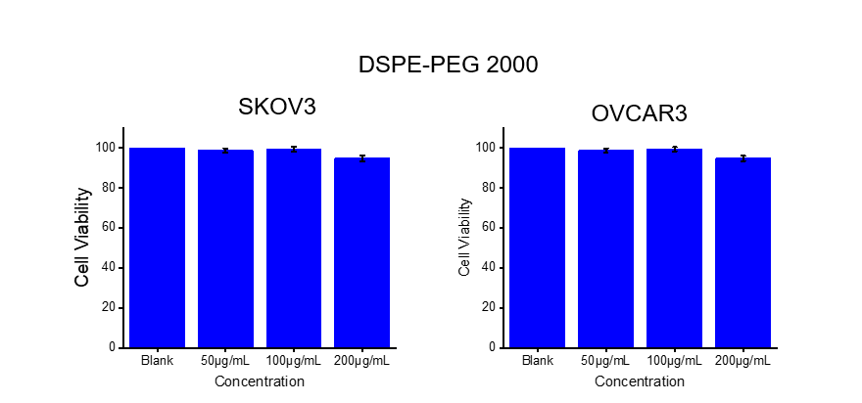
Fig. S1 Toxicity assay: SKOV3 or OVCAR3 were treated with DSPE-PEG 2000 (0, 50, 100, 200 μg/mL) for 24 h.

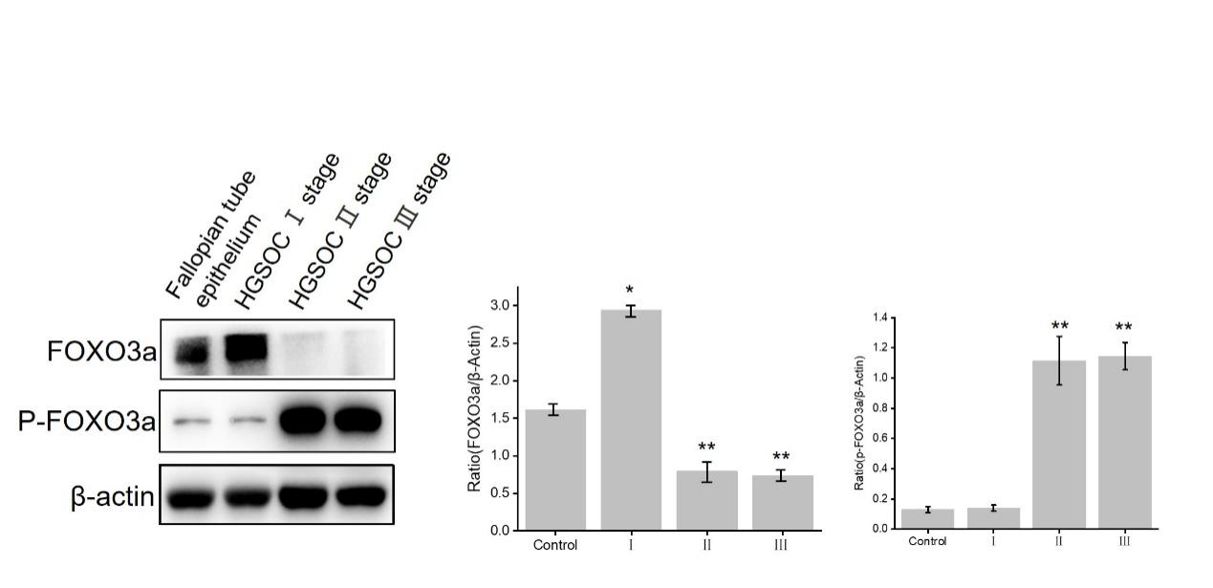
Fig. S2 The ovarian cancer tissue protein lysates of patients with ovarian cancer (Ⅰ, II, and Ⅲ stage of HGSOC) and the fallopian tubal epithelium (FTE) tissue protein lysates of patients with myoma of the uterus were analyzed by WB. WB was performed to determine the protein expression levels for FOXO3a (85 kDa), p-FOXO3a (S253) (95 kDa) and β-actin (45KD kDa). Compared with the FTE group, *p < 0.05, **p < 0.01.

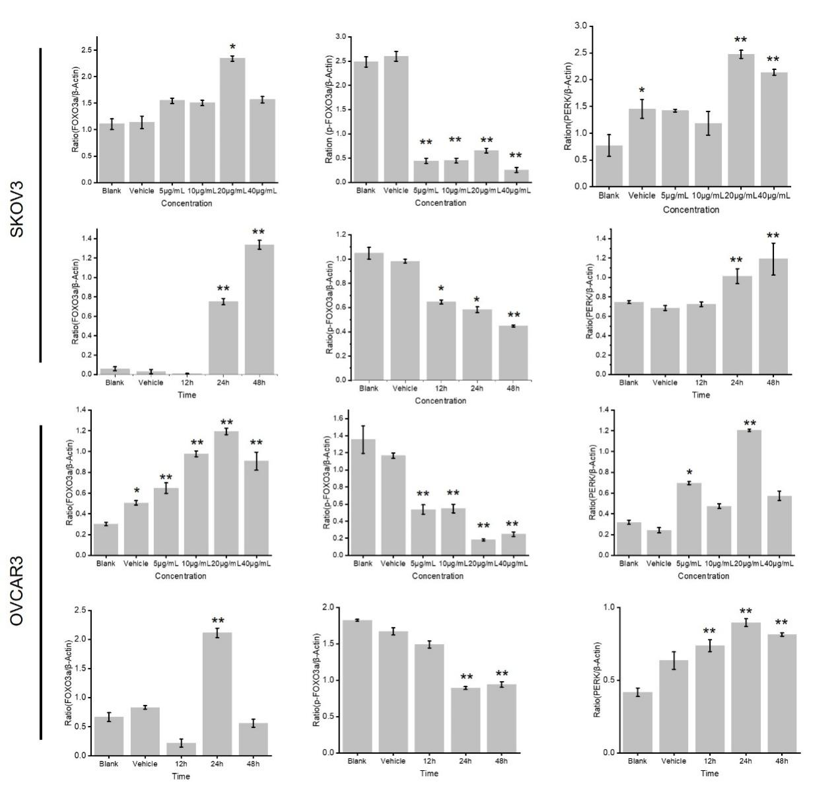
Fig.S3 Statistical charts for Fig.2C-D. Compared with blank and vehicle groups, *p < 0.05, **p < 0.01.

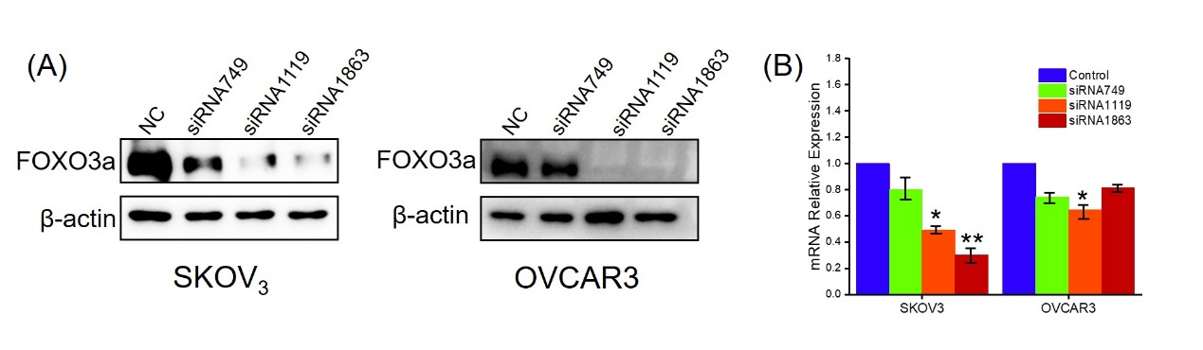
Fig. S4 SKOV3 and OVCAR3 cells were transfected with different siRNA (No. 749, 1119 and 1863). Expression levels of FOXO3a (85KD) protein levels (A) and mRNA (B) were investigated by WB and RT-PCR. β-actin (45KD) was used as a control for WB analysis. The data normalize with GAPDH RNA levels and represent the mean ± SEM (n=3; 2-tailed t-test). *p < 0.05, **p < 0.01. Representative RNA expression profiles of one of at least 3 independent experiments are shown.

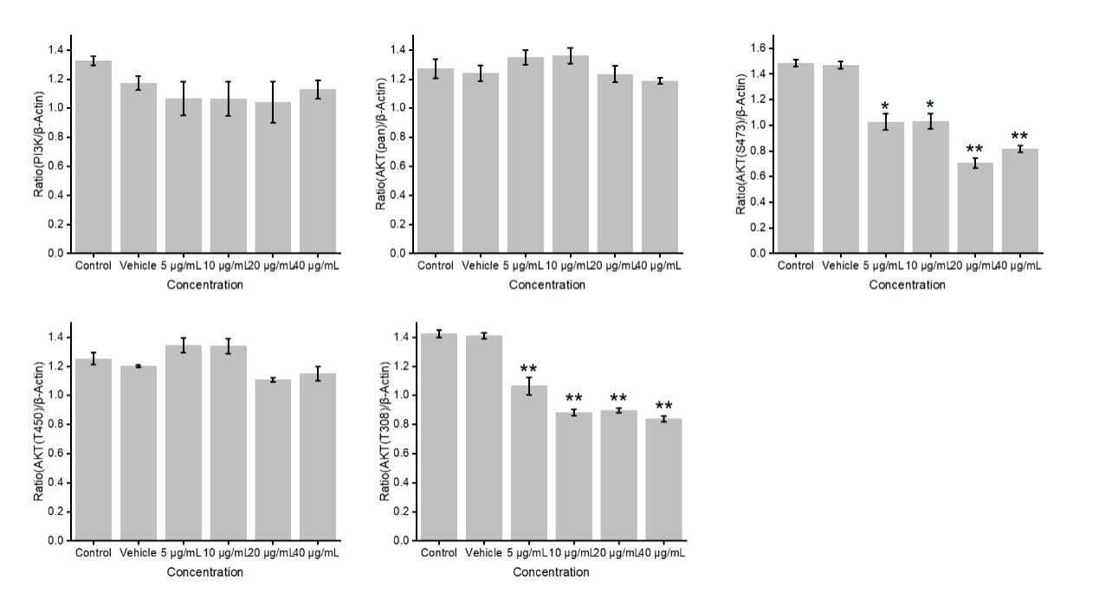

Fig.S5 Statistical charts for Fig.4D. Compared with blank and vehicle groups, *p < 0.05, **p < 0.01.

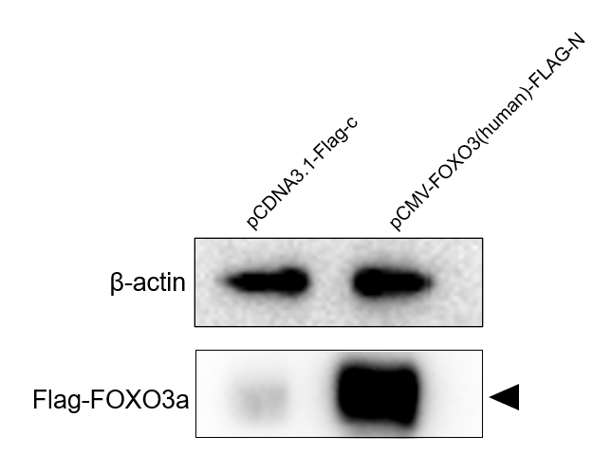
Fig.S6 SKOV3 cells were transfected with empty vector (pCDNA3.1-Flag-c) or FOXO3 expression vector (pCMV-FOXO3(human)-FLAG-N). The protein expression levels of FOXO3a(85KD) and β-actin (45KD) were analyzed by WB. Arrow represents FLAG-FOXO3a.

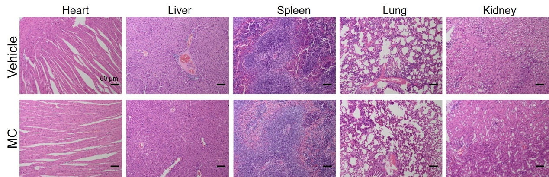
Fig. S7 H&E staining of heart, liver, spleen, lung, and kidney in two groups. Scale bar is 50 μm

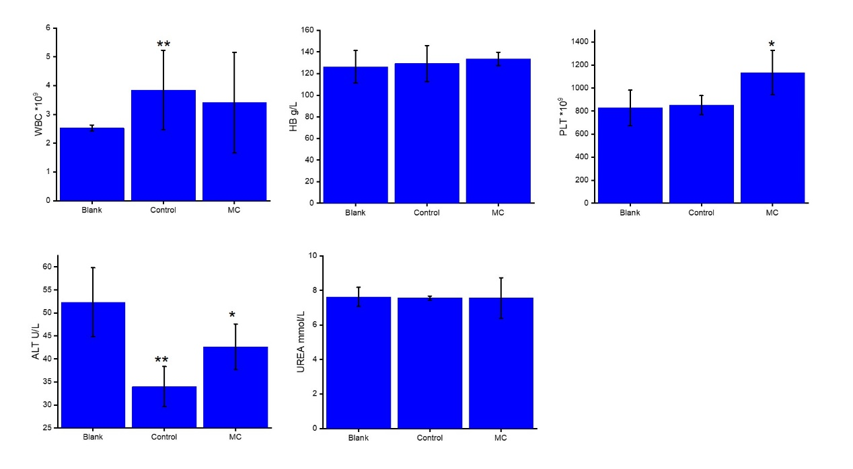
Fig.S8 Blood routine and biochemical indicators of the mice.

