Additional File 2. Inter and intra-observer variability indices.

- Jaccard conformity index (JCI)
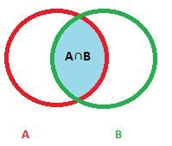 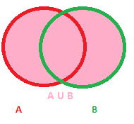$$JCI= \frac{A ∩B}{A ∪B}$$
- Geographical Miss Index (GMI) C) Kappa index
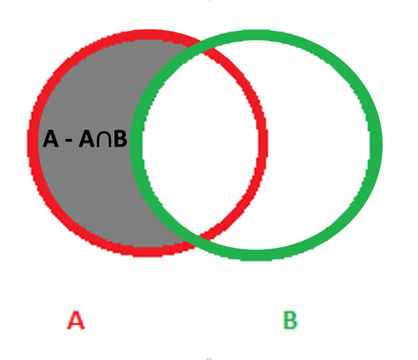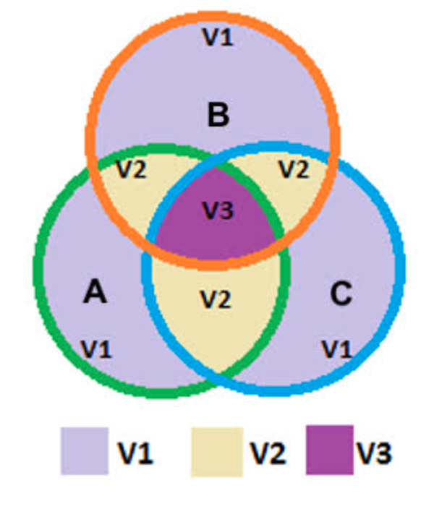
$GMI= \frac{A-(A∩B)}{A}$ Kappa index = $\frac{V2+3V3}{V1+2V2+3V3}$
A = volume of the gold standard, B = volume operator 1, C = volume of operator 2, V1 = volume delineated by one operator, V2 = common volume delineated by two operators, V3 = common volume delineated by all three observers, A ∩ B = volume of intersection of A and B, A ∪ B = volume of union of A and B.

- Intra-observer variability
$$∆v=100* \frac{(A ∪B- A∩B)}{A∩B}$$

$∆v$ ; delta volume, percentage differences between the two volumes of the same operator. A = first volume of one operator, B = second volume of the same operator, A ∩ B = volume of intersection of A and B, A ∪ B = volume of union of A and B.

