Additional File 1. Dose constraints for long-course CRT (1.8-2 Gy/fraction) from ESTRO ACROP guidelines 2020 (14)

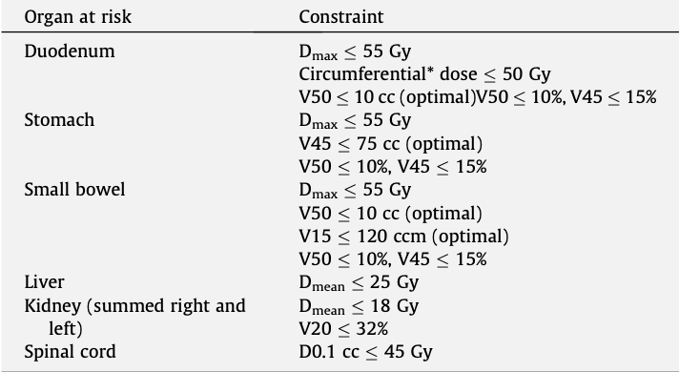
* Circumferential dose means that the dose not only at the adjacent side of the hollow organ wall next to the PTV but also at the opposite aspect of the wall, i.e. the dose is applied to the entire circumference of a segment of the hollow organ.

