Supplementary material - Efficacy and safety of enavogliflozin vs. dapagliflozin as add-on therapy in patients with type 2 diabetes mellitus based on renal function: A pooled analysis of two randomized controlled trials

Running title: Efficacy of enavogliflozin for type 2 diabetes

[author names]
Young Sang Lyu¹, Sangmo Hong², Si Eun Lee³, Bo Young Cho³, Cheol-Young Park⁴

[author affiliations]
¹Division of Endocrinology and Metabolism, Department of Internal Medicine, Chosun University Hospital, Gwangju, Republic of Korea.
²Division of Endocrinology, Department of Internal Medicine, Hanyang University Guri Hospital, 153 Gyeongchun-ro, Guri 11923, Korea.
³Daewoong Pharmaceutical Co., Ltd., Seoul, Republic of Korea.
⁴Department of Internal Medicine, Kangbuk Samsung Hospital, Sungkyunkwan University School of Medicine, Seoul, Republic of Korea.

Corresponding Author:
Cheol-Young Park
Division of Endocrinology and Metabolism, Department of Internal Medicine, Kangbuk Samsung Hospital, Sungkyunkwan University School of Medicine, 29 Saemunan-ro,
Jongno-gu, Seoul 03181, Korea
E-mail: cydoctor@chol.com

Supplementary Tables

Supplemental Table 1. Changed from baseline in glucose lowering efficacy based on renal function
 | Enavogliflozin 0.3 mg  (n=214) |  | Dapagliflozin 10 mg  (n=213)
 | Normal eGFR  (n=91) | Mildly reduced eGFR  (n=123) | Normal eGFR  (n=105) | Mildly reduced eGFR  (n=108)
HbA1c, %
Baseline | 7.81 (0.83) | 7.74 (0.77) | 7.78 (0.82) | 7.75 (0.75)
Week 24 | 7.00 (0.59) | 6.85 (0.55) | 6.88 (0.67) | 7.02 (0.67)
Change from baseline at week 24
LS mean (SE) | -0.84 (0.06) | -0.96 (0.05) | -0.95 (0.06) | -0.80 (0.06)
LS mean difference [95% Cl], p-value⁋ | 0.12 [-0.01, 0.26], p=0.0744 |  | -0.15 [-0.31, 0.00], p=0.0488
HbA1c, mmol/mol
Baseline | 61.90 (9.06) | 61.12 (8.39) | 61.55 (8.91) | 61.20 (8.18)
Week 24 | 53.02 (6.41) | 51.33 (6.01) | 51.75 (7.34) | 53.17 (7.36)
Change from baseline at week 24
LS mean (SE) | -9.16 (0.66) | -10.50 (0.55) | -10.42 (0.67) | -8.74 (0.66)
LS mean difference [95% Cl], p-value⁋ | 1.34 [-0.13, 2.82], p=0.0744 |  | -1.68 [-3.35, -0.01], p=0.0488
FPG, mg/dL
Baseline | 146.53 (29.00) | 138.67 (25.87) | 146.62 (30.70) | 141.94 (31.02)
Week 24 | 114.75 (18.28) | 112.19 (16.71) | 116.39 (18.93) | 118.15 (21.93)
Change from baseline at week 24
LS mean (SE) | -30.13 (1.86) | -29.85 (1.53) | -28.45 (2.06) | -25.81 (2.04)
LS mean difference [95% Cl], p-value⁋ | -0.28 [-4.54, 3.98], p=0.8969 |  | -2.65 [-7.85, 2.56], p=0.3177
Data are primarily based on the per-protocol set and presented as mean (standard deviation).
⁋Testing for difference between Normal eGFR group and Mild reduced eGFR group (ANCOVA with eGFR group as a factor, baseline value and stratification factors as covariates).
FPG, fasting plasma glucose; HbA1c, glycated hemoglobin.

Supplemental Table 2. UGCR Change from baseline at week 24 according to eGFR levels
eGFR level | Enavogliflozin 0.3 mg (n=213) |  | Dapagliflozin 10 mg (n=212)
eGFR level | n | Mean (SD) | n | Mean (SD)
60 ≤ eGFR ‹ 75 | 46 | 47.21 (18.36) | 39 | 40.13 (15.00)
75 ≤ eGFR ‹ 90 † | 77 | 58.25 (22.73) | 69 | 41.63 (18.98)
90 ≤ eGFR ‹ 105 † | 55 | 63.68 (22.24) | 57 | 40.75 (22.76)
105 ≤ eGFR ‹ 120 | 23 | 66.39 (20.74) | 24 | 50.98 (23.92)
120 ≤ eGFR | 12 | 76.52 (25.35) | 23 | 45.56 (31.06)
Data are primarily based on the per-protocol set and presented as mean (standard deviation).
†Testing for difference between Enavogliflozin and Dapagliflozin (ANCOVA with treatment group as a factor, baseline value and stratification factors as covariates). Statistical significance was assessed at a threshold of less than 0.01 to reduce false positives to adjustment for multiple comparisons.
eGFR, estimated glomerular filtration rate; N, number.

Supplemental Table 3. Summary of adverse events
 | Enavogliflozin 0.3 mg  (n=235) | Dapagliflozin 10 mg  (n=235)
TEAEs, n (%) | 53 (22.55) [75] | 54 (22.98) [80]
Serious TEAEs, n (%) | 3 (1.28) [3] | 7 (2.98) [8]
TEAEs leading to drug discontinuation | 0 | 1 (0.43) [1]
TEAEs leading to death | 0 | 0
TEAEs of special interest | 4 (1.70) [4] | 8 (3.40) [8]
Vaginal infection | 2 (0.85) [2] | 2 (0.85) [2]
Cystitis | 1 (0.43) [1] | 1 (0.43) [1]
Genital infection | 0 | 1 (0.43) [1]
Vulvovaginal candidiasis | 0 | 1 (0.43) [1]
Vulvovaginitis | 0 | 1 (0.43) [1]
Hypoglycaemia | 1 (0.43) [1] | 1 (0.43) [1]
Pollakiuria | 0 | 1 (0.43) [1]
ADRs, n (%) | 7 (2.98) [7] | 14 (5.96) [14]
Vaginal infection | 2 (0.85) [2] | 2 (0.85) [2]
Cystitis | 1 (0.43) [1] | 1 (0.43) [1]
Genital infection | 0 | 1 (0.43) [1]
Vulvovaginal candidiasis | 0 | 1 (0.43) [1]
Vulvovaginitis | 0 | 1 (0.43) [1]
Pruritus | 1 (0.43) [1] | 2 (0.85) [2]
Dyspepsia | 0 | 2 (0.85) [2]
Lethargy | 1 (0.43) [1] | 0
Somnolence | 1 (0.43) [1] | 0
Ocular discomfort | 0 | 1 (0.43) [1]
Blood pressure decreased | 1 (0.43) [1] | 0
Hypoglycaemia | 0 | 1 (0.43) [1]
Pollakiuria | 0 | 1 (0.43) [1]
Vulvovaginal pruritus | 0 | 1 (0.43) [1]
Data are number of subjects (%) [number of events]. Data were analyzed using the safety set.
ADR, adverse drug reaction; TEAE, treatment-emergent adverse event.

Supplementary Figure

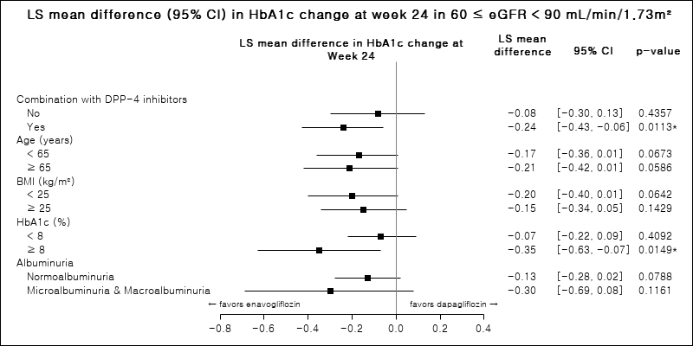
Supplemental Figure 1. Least-square mean difference (95% confidence interval) in the HbA1c level change at week 24 in patients with a mildly reduced kidney function, with an eGFR of ≥ 60 to < 90 mL/min/1.73 m² (Per-Protocol Set). BMI, body mass index; CI, confidence interval; DPP-4, dipeptidyl peptidase-4 inhibitors-4; eGFR, estimated glomerular filtration rate; LS, least square; OHA, oral antihyperglycemic agent.

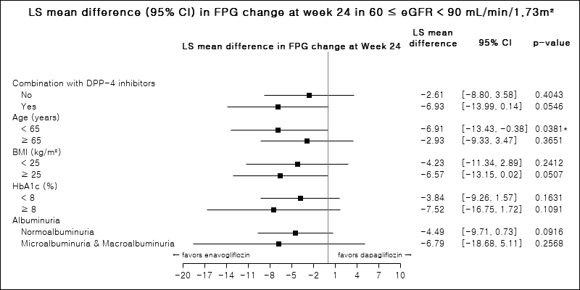
Supplemental Figure 2. Least-square mean difference (95% confidence interval) in the fasting plasma glucose level change at week 24 in patients with a mildly reduced kidney function, with an eGFR of ≥ 60 to < 90 mL/min/1.73 m² (Per-Protocol Set). BMI, body mass index; CI, confidence interval; DPP-4, dipeptidyl peptidase-4 inhibitors-4; eGFR, estimated glomerular filtration rate; FPG, fasting plasma glucose; HbA1c, LS, least square; OHA, oral antihyperglycemic agent.

