Supplementary Information

Earlier peak photosynthesis timing escalates global wildfires
Gengke Lai^{1,2†}, Jialing Li^{1,2†}, Jun Wang^{3†}, Chaoyang Wu^{3*}, Yongguang Zhang^{1,2,4,8*}, Constantin M. Zohner⁵, Josep Peñuelas^{6,7,8}
¹International Institute for Earth System Sciences, Jiangsu Center for Collaborative Innovation in Geographical Information Resource Development and Application, Nanjing University, Nanjing, Jiangsu 210023, China.
²Jiangsu Provincial Key Laboratory of Geographic Information Science and Technology, Key Laboratory for Land Satellite Remote Sensing Applications of Ministry of Natural Resources, School of Geography and Ocean Science, Nanjing University, Nanjing, Jiangsu 210023, China.
³The Key Laboratory of Land Surface Pattern and Simulation, Institute of Geographic Sciences and Natural Resources Research, Chinese Academy of Sciences, Beijing 100101, China.
⁴Huangshan National Park Ecosystem Field Scientific Observation and Research Station of the Ministry of Education, Nanjing, Jiangsu 210023, China.
⁵Department of Environmental Systems Science, Institute of Integrative Biology, ETH Zurich, Zurich 8092, Switzerland.
⁶CSIC, Global Ecology Unit CREAF-CSIC-UAB, Bellaterra, Barcelona 08193, Catalonia, Spain.
⁷CREAF, Cerdanyola del Valles, Barcelona 08193, Catalonia, Spain.
⁸Jiangsu International Joint Carbon Neutrality Laboratory, Nanjing University, Nanjing, Jiangsu 210023, China.

*Correspondence to:
Chaoyang Wu (wucy@igsnrr.ac.cn) and Yongguang Zhang (yongguang_zhang@nju.edu.cn) † These authors contributed equally

The supplement file includes:
Supplementary Figures 1 to 16
Tables S1 to S2
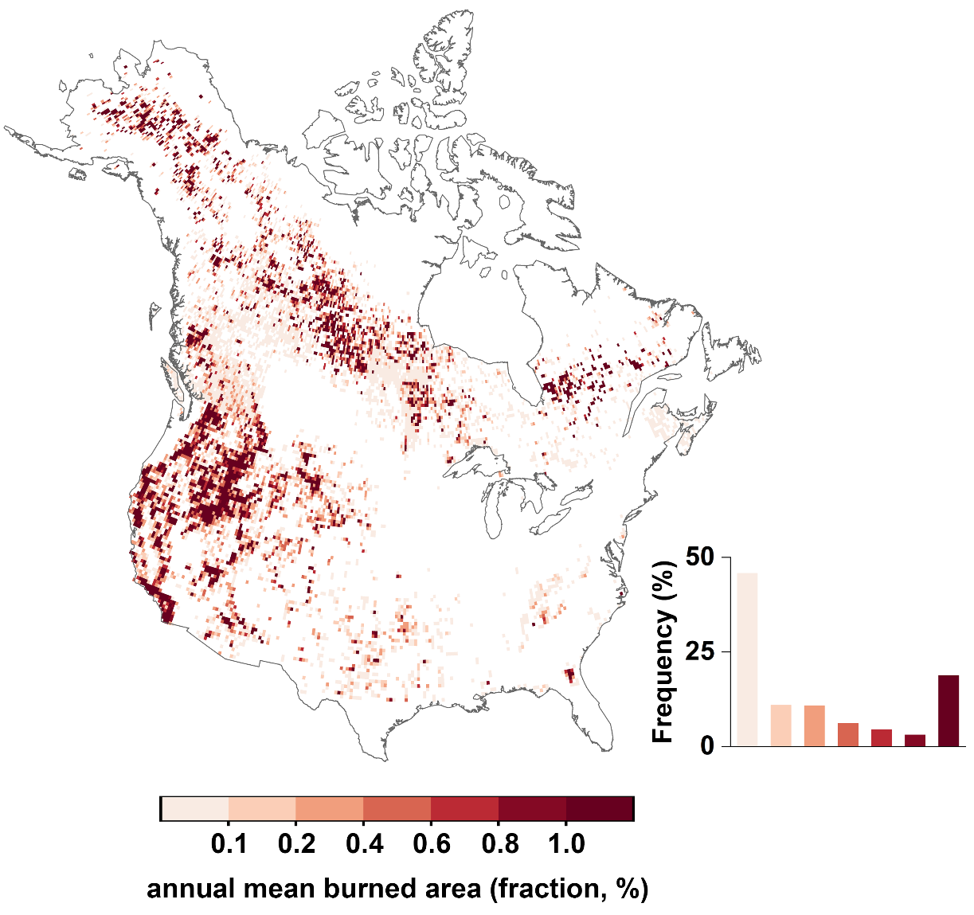
Supplementary Fig. 1 | Annual mean burned area after CSIF-derived peak photosynthesis timing (PPT) from 2002 to 2018 for fire perimeters data. Fire perimeters data include the National Burned Area Composite (NBAC) for Canada, and Monitoring Trends in Burn Severity (MTBS) for the US. Burned area was expressed as the fraction of a grid cell that burns at 0.25° resolution.

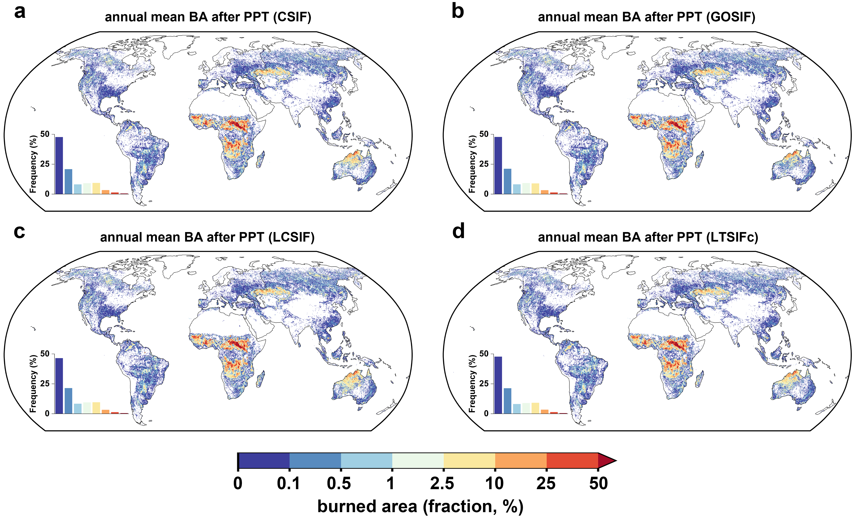
Supplementary Fig. 2 | Annual mean global burned area after peak photosynthesis timing (PPT) from 2002 to 2018. PPT was derived from CSIF (a), GOSIF (b), LCSIF (c), and LT_SIFc (d). Burned area was derived from MCD64A1 V6. Burned area was expressed as the fraction of a grid cell that burns at 0.25° resolution.

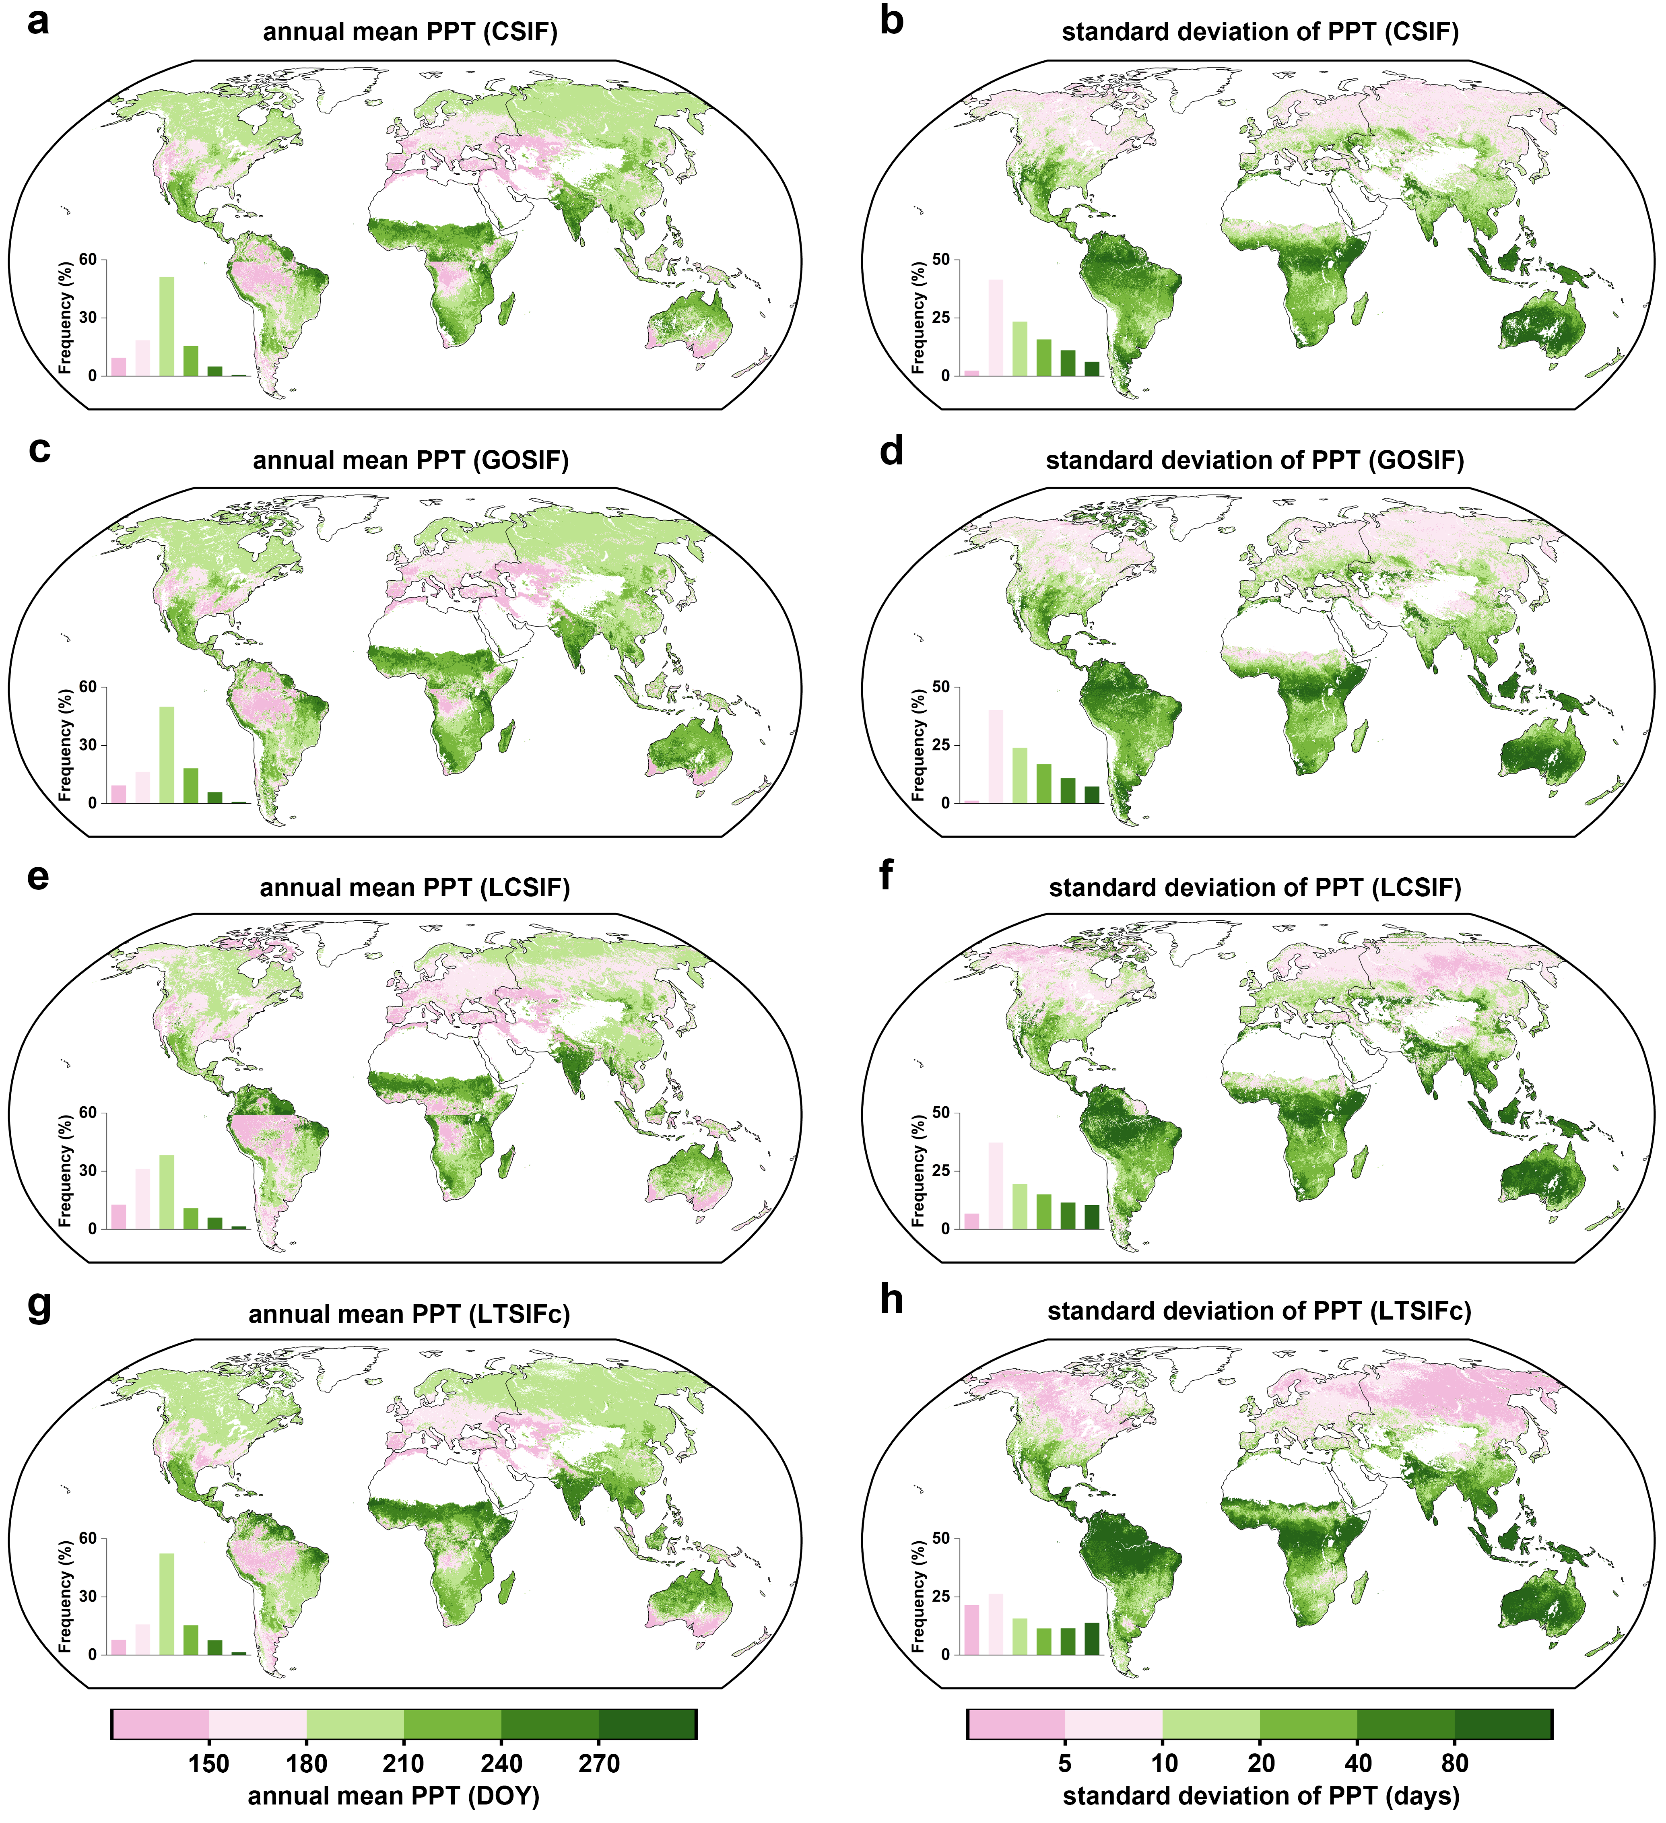
Supplementary Fig. 3 | Annual mean (left) and standard deviation (right) of global PPT over 2002–2018 for CSIF (a-b), GOSIF (c-d), LCSIF (e-f), and LT_SIFc (g-h).

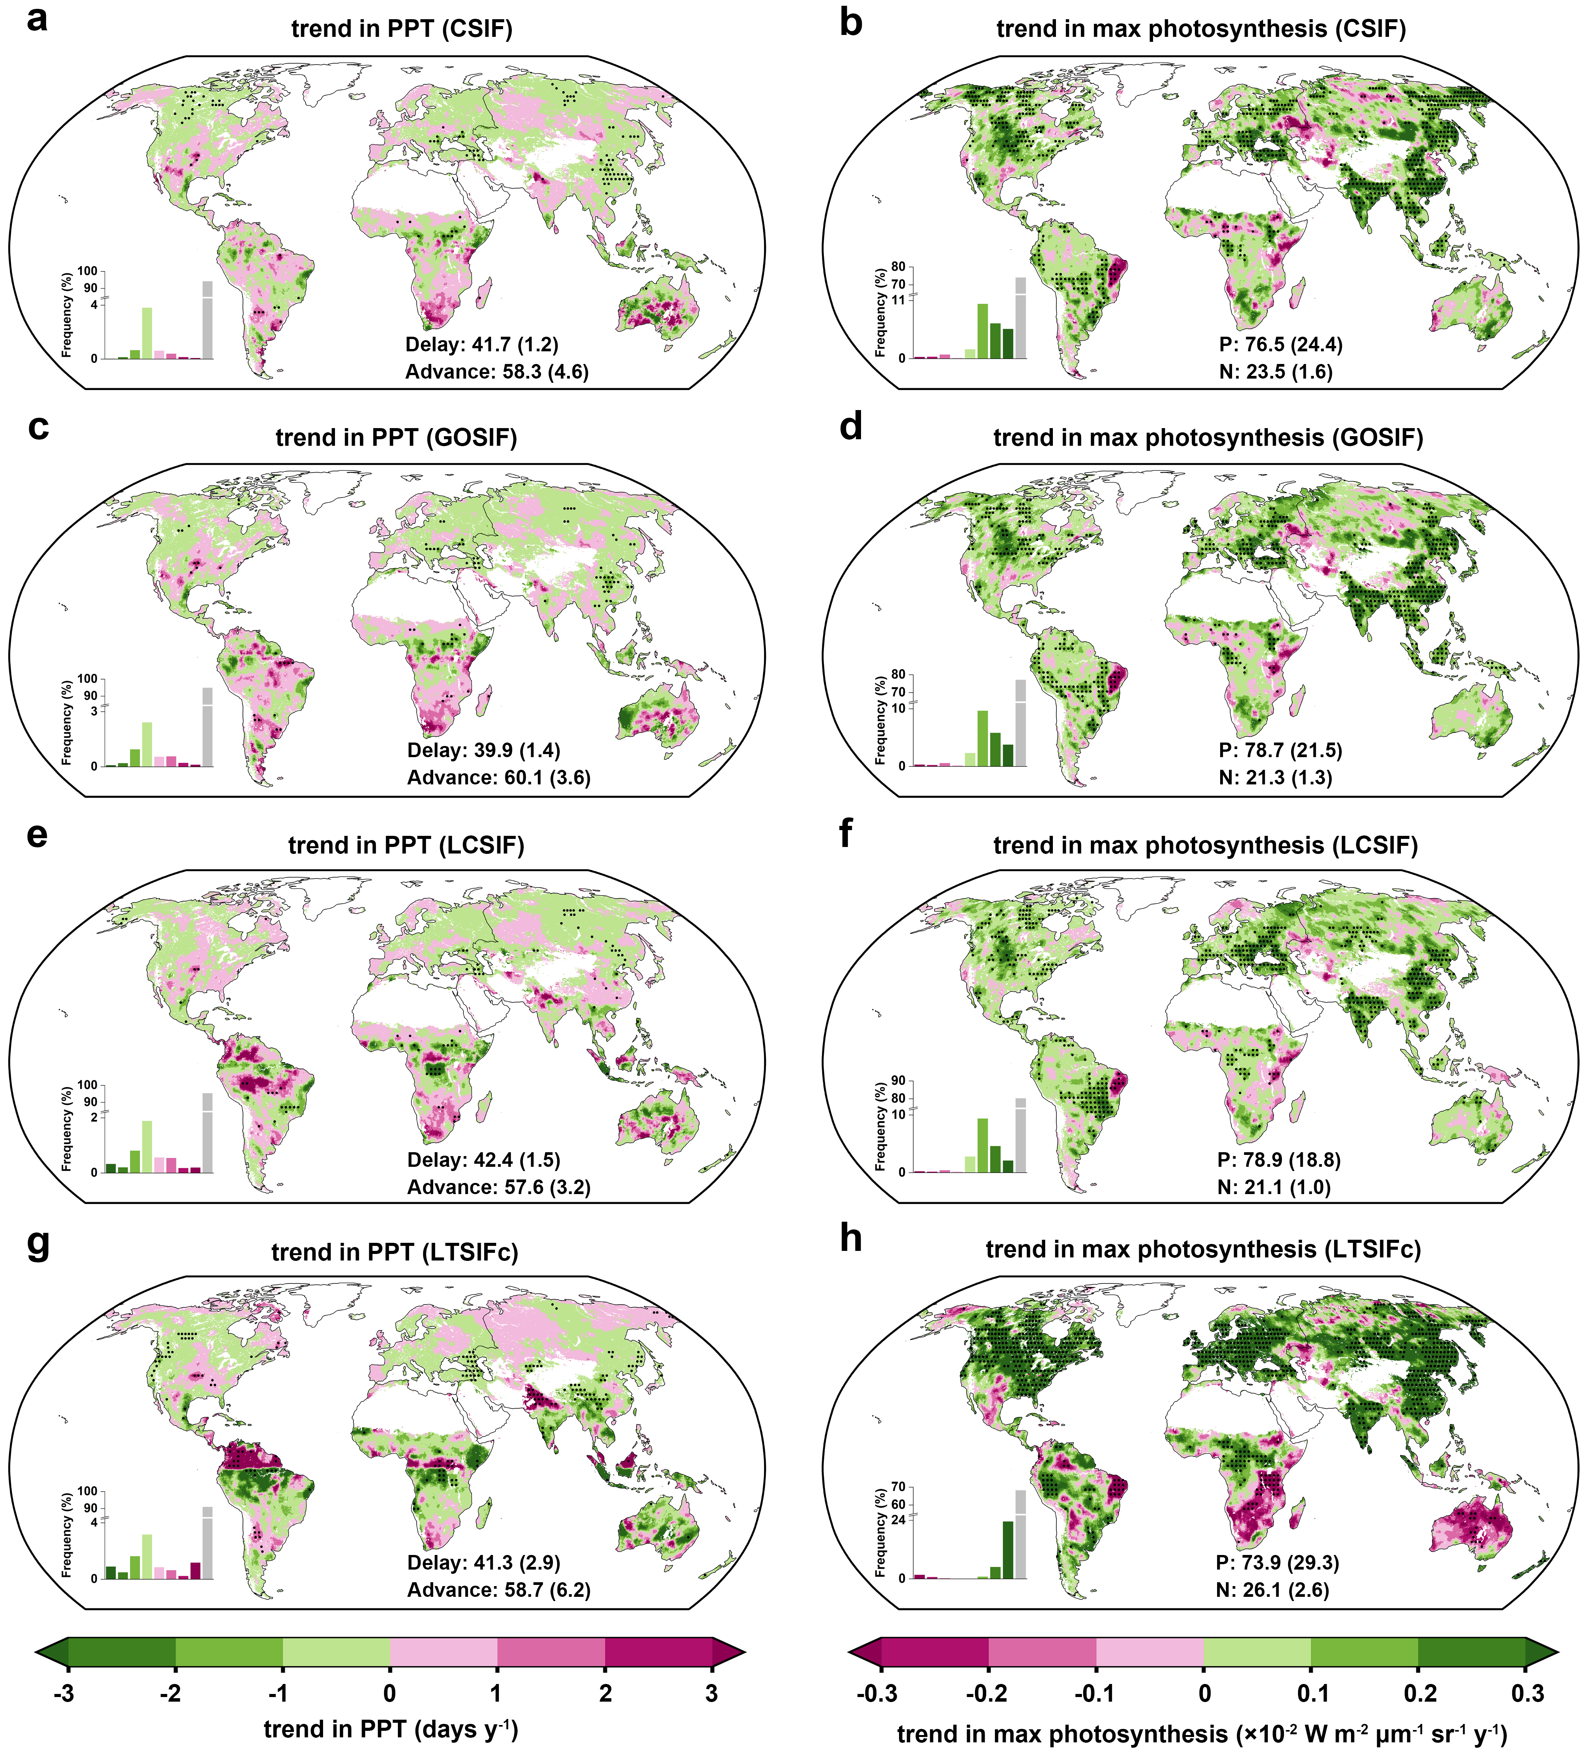
Supplementary Fig. 4 | Trends in peak photosynthesis timing (PPT; left) and maximum photosynthesis (SIF_{max}; right) over 2002-2018 for CSIF (a-b), GOSIF (c-d), LCSIF (e-f), and LT_SIFc (g-h). Labels in the left indicate the percentage of areas shown delayed and advanced PPT. P and N indicate the percentage of increased and decreased maximum photosynthesis, respectively. Black dots indicate regions with significant trends (p-value < 0.05).

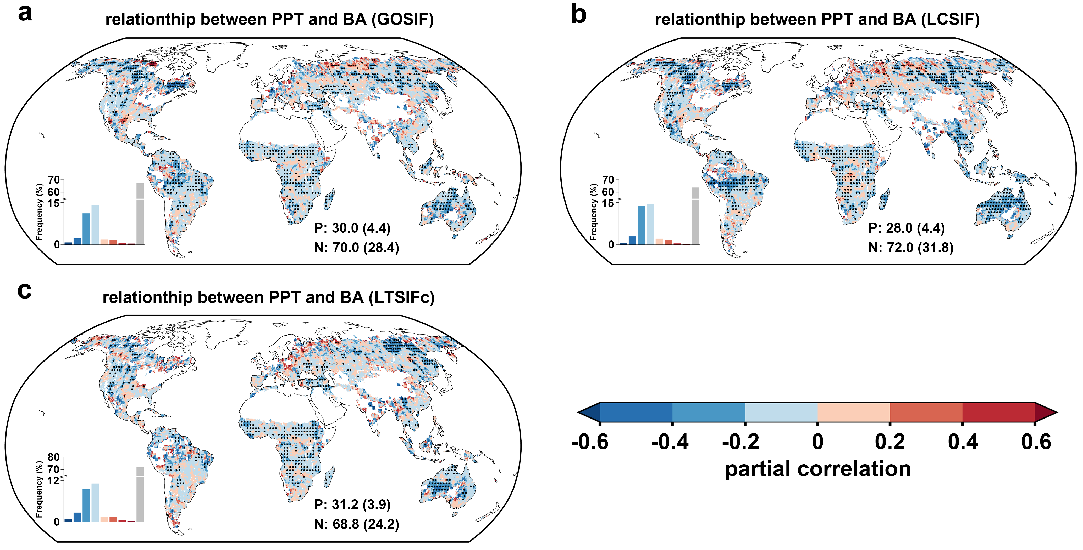
Supplementary Fig. 5 | Robustness of the relationship between peak photosynthesis timing (PPT) and subsequent burned area. PPT was derived from GOSIF (a), LCSIF (b), and LT_SIFc (c). P and N indicate the percentage of positive and negative correlation, respectively. Black dots indicate regions with significant partial correlations (p-value < 0.05).

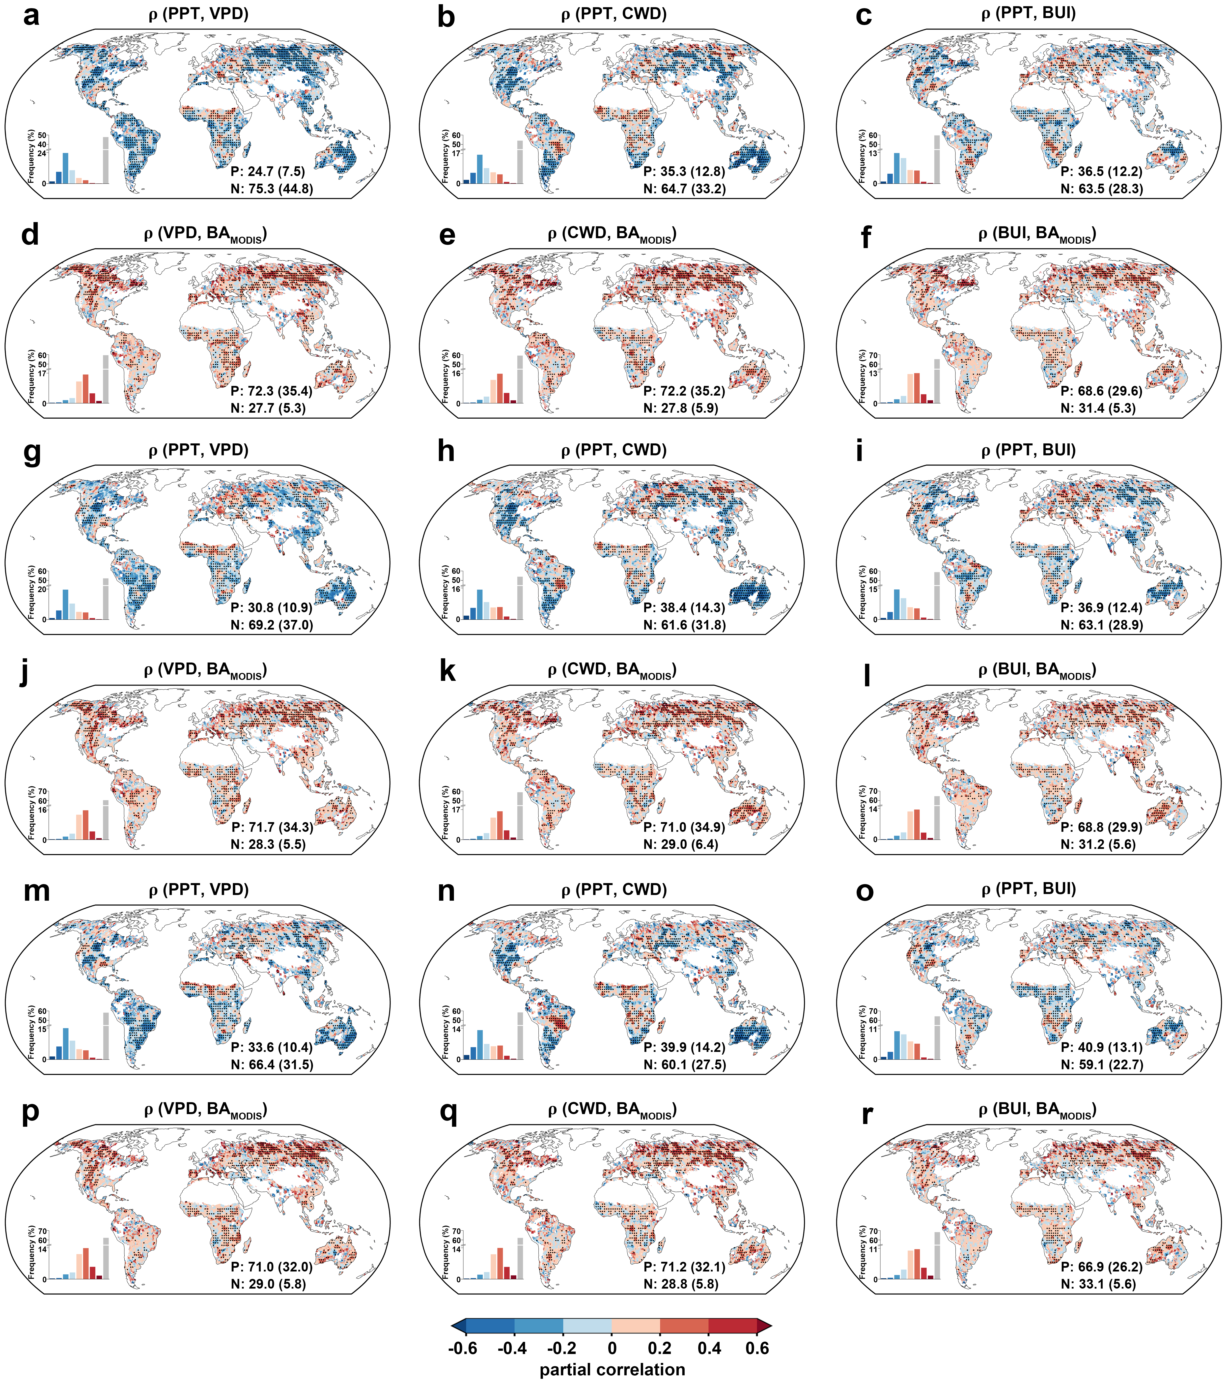
Supplementary Fig. 6 | Robustness of the underlying mechanisms linking peak photosynthesis timing (PPT) and burned area. PPT was derived from GOSIF (a-f), LCSIF (g-l), and LT_SIFc (m-r). Global patterns of partial correlations between PPT and factors (VPD, CWD, and BUI during the potential fire season after PPT), and then between factors and burned area. Black dots indicate regions with significant partial correlations (p-value < 0.05). P and N indicate the percentage of positive and negative correlations, respectively.

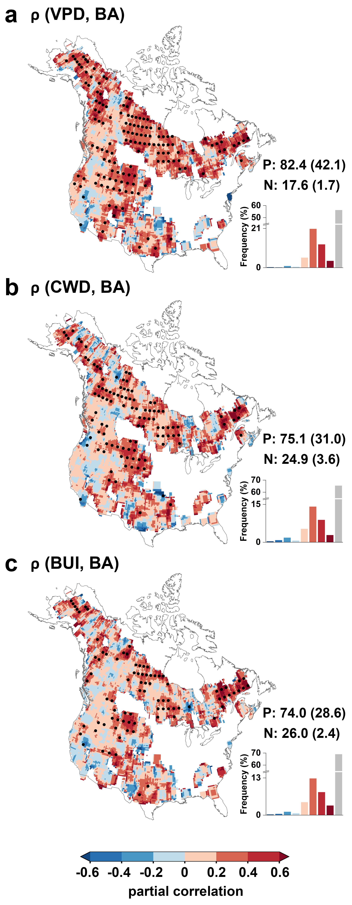
Supplementary Fig. 7 | Relationships between explainable factors and burned area (BA) for fire perimeters data. Partial correlations of VPD versus BA (a), CWD versus BA (b), and BUI versus BA (c). The explainable factors indicate the climate conditions during the potential fire season after CSIF-derived PPT. Black dots indicate regions with significant partial correlations (p-value < 0.05). P and N indicate the percentage of positive and negative correlations, respectively.
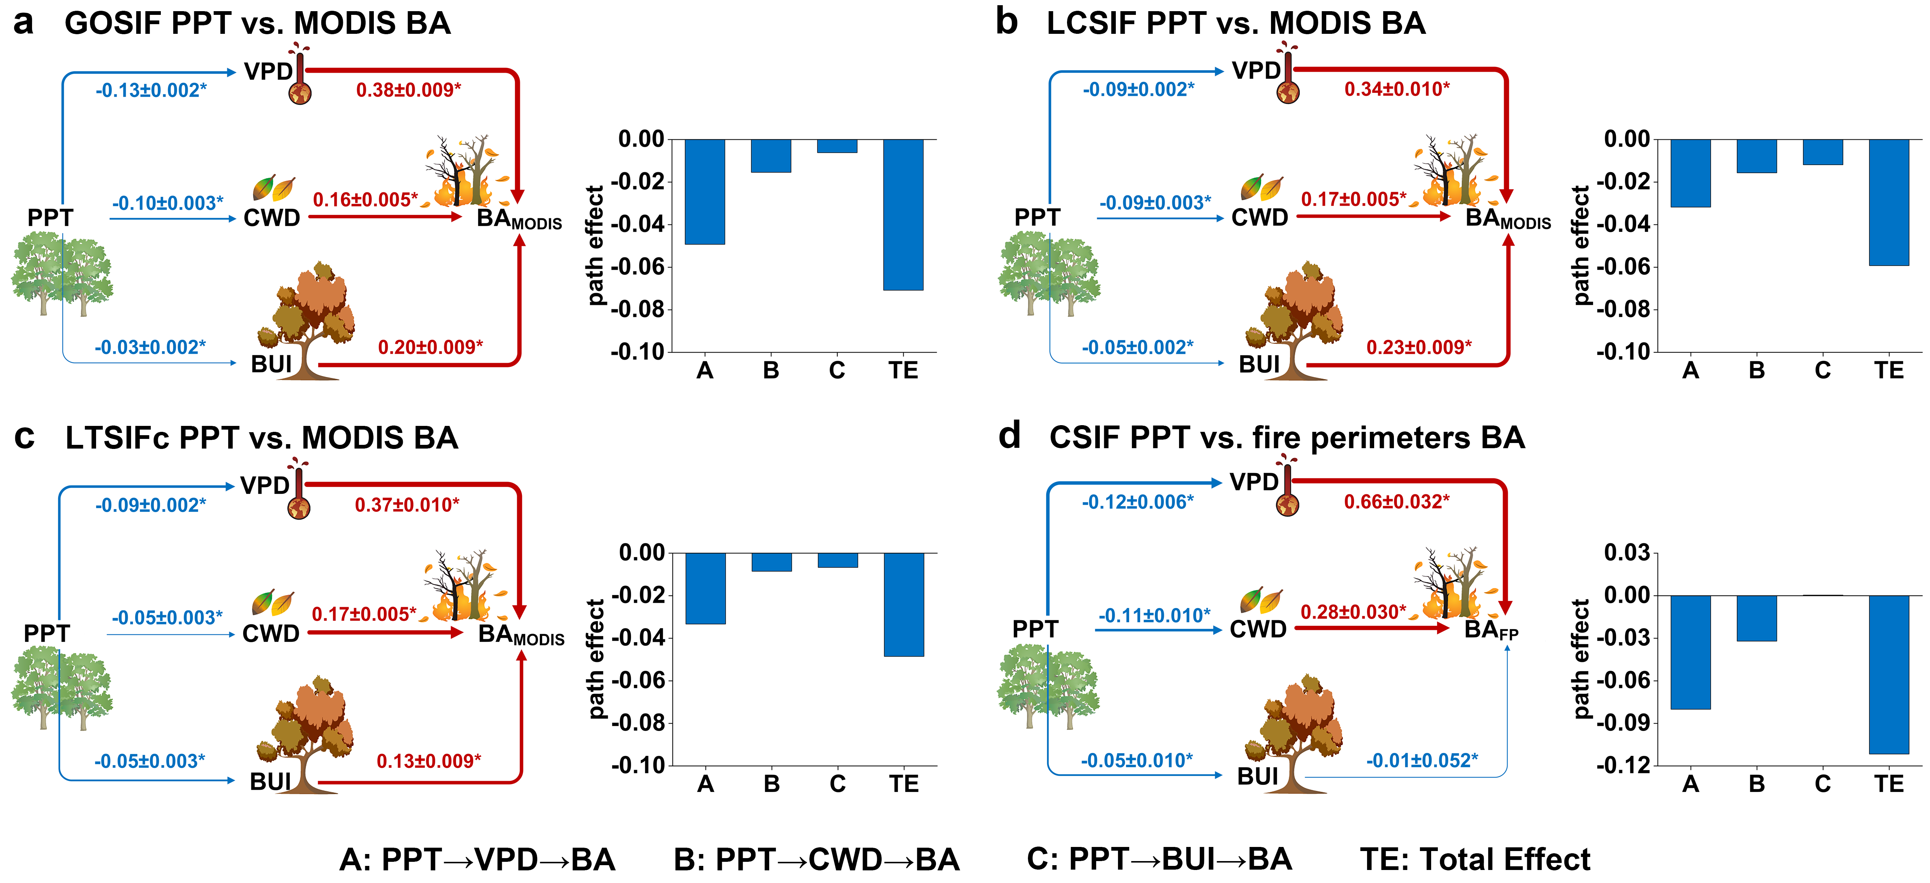
Supplementary Fig. 8 | Robustness of the underlying mechanisms linking peak photosynthesis timing (PPT) and subsequent burned area using structural equation model (SEM) for GOSIF (a), LCSIF (b), LT_SIFc (c), and fire perimeters (d). Path diagrams and path effects for the mechanisms are shown. The numbers in the path diagram represent the global means and 95% confidence intervals of standardized path coefficients, the asterisks indicate the path coefficients are significant (p-value < 0.05) and the colors (red and blue arrows represent positive and negative effects, respectively) and widths of the arrows represent the signs and magnitudes of the path coefficients, respectively. The color of bar represents positive (red) and negative (blue) path effect, respectively.

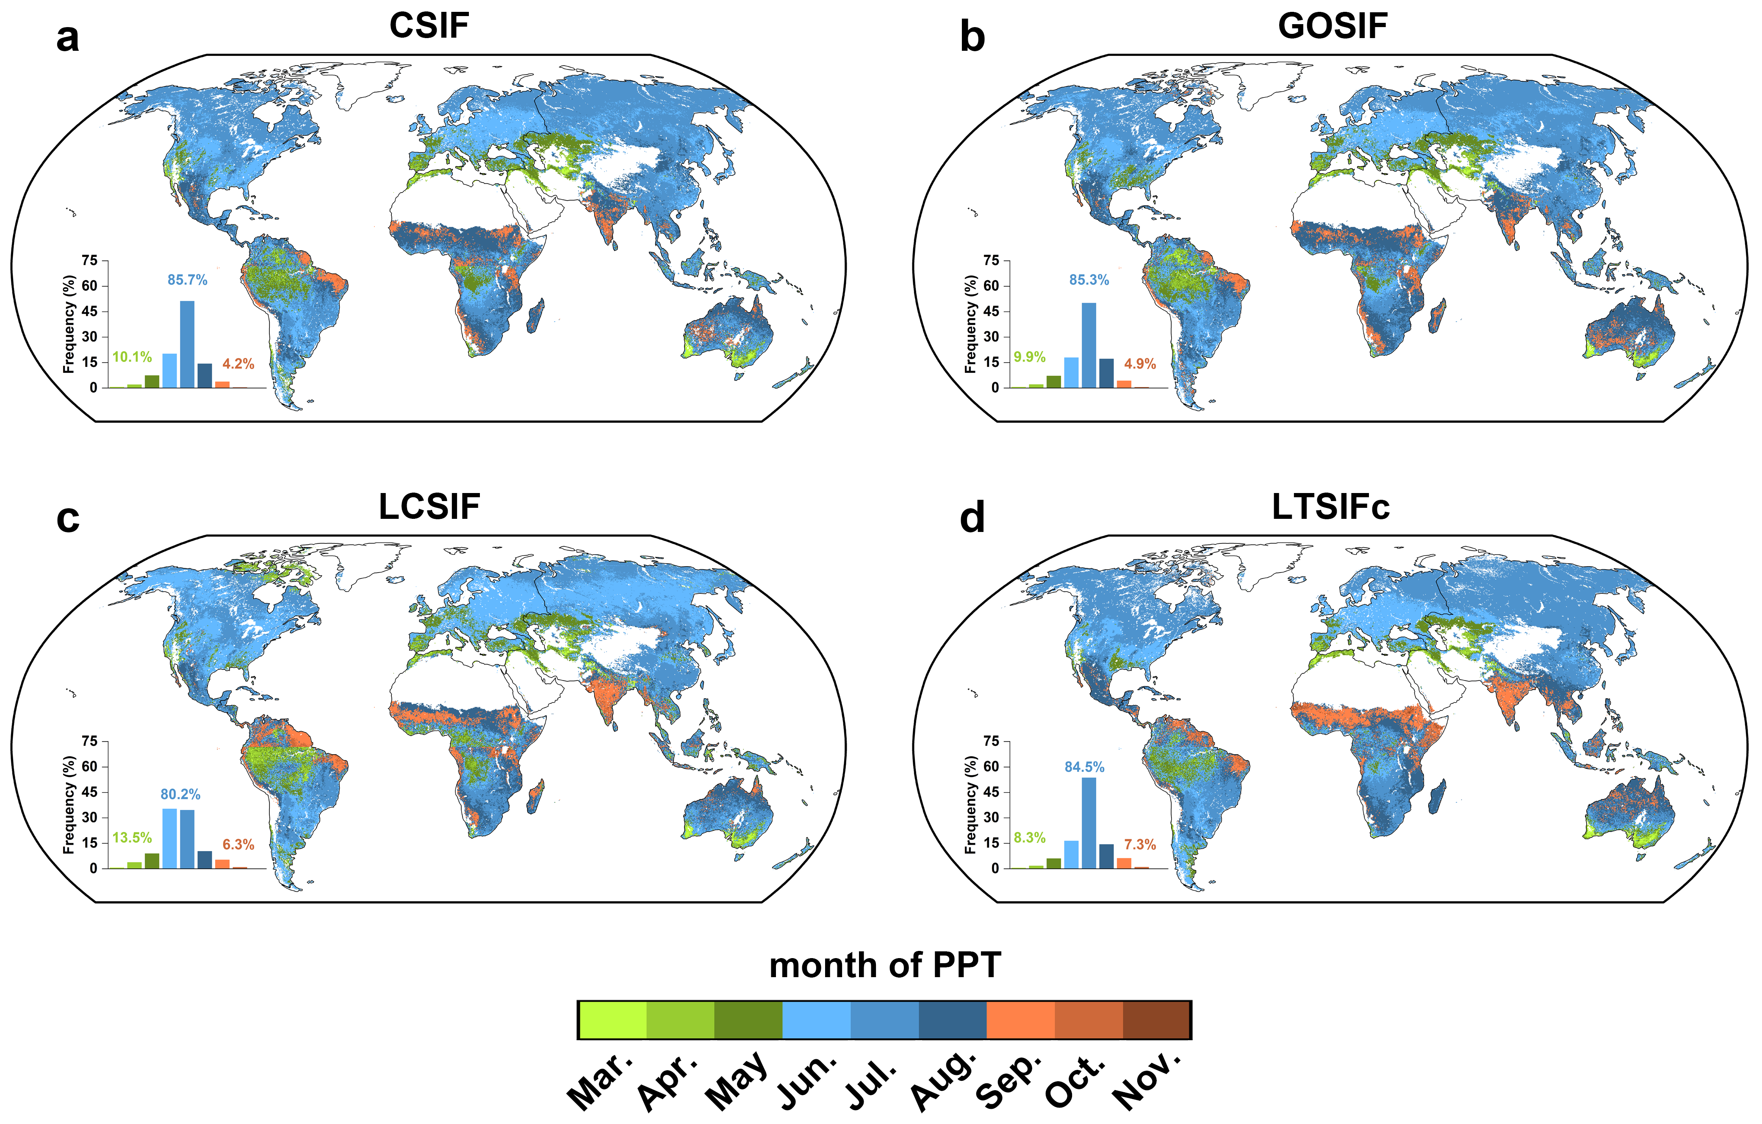
Supplementary Fig. 9 | The months of peak photosynthesis timing for CSIF (a), GOSIF (b), LCSIF (c), and LT_SIFc (d). The colored labels indicate the percentages of months in spring (green), summer (blue), and autumn (orange). It shows that for the majority of areas (> 80%), PPT occurs in summer.

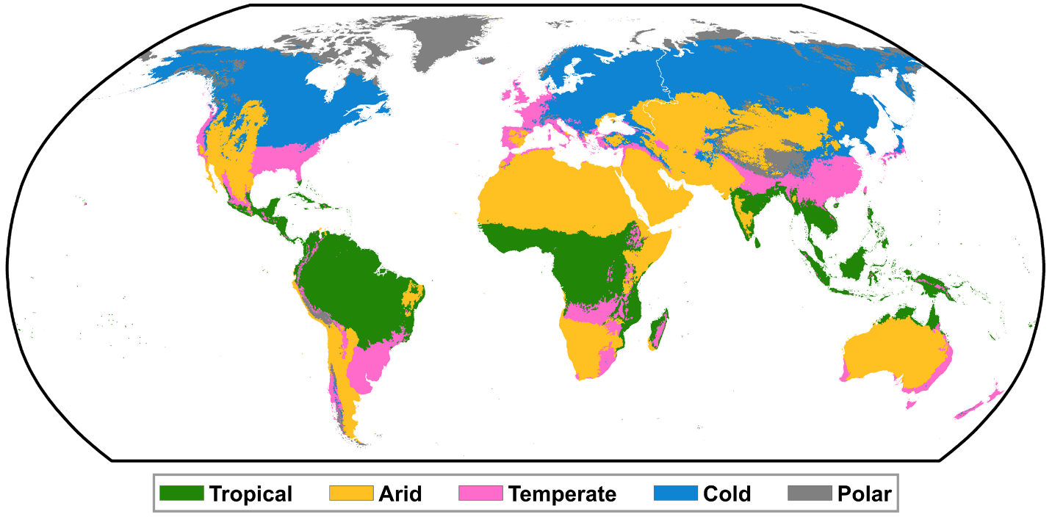
Supplementary Fig. 10 | Global map of tropical, arid, temperate, and cold regions derived from Köppen-Geiger climate classification map. Polar was excluded in our study.

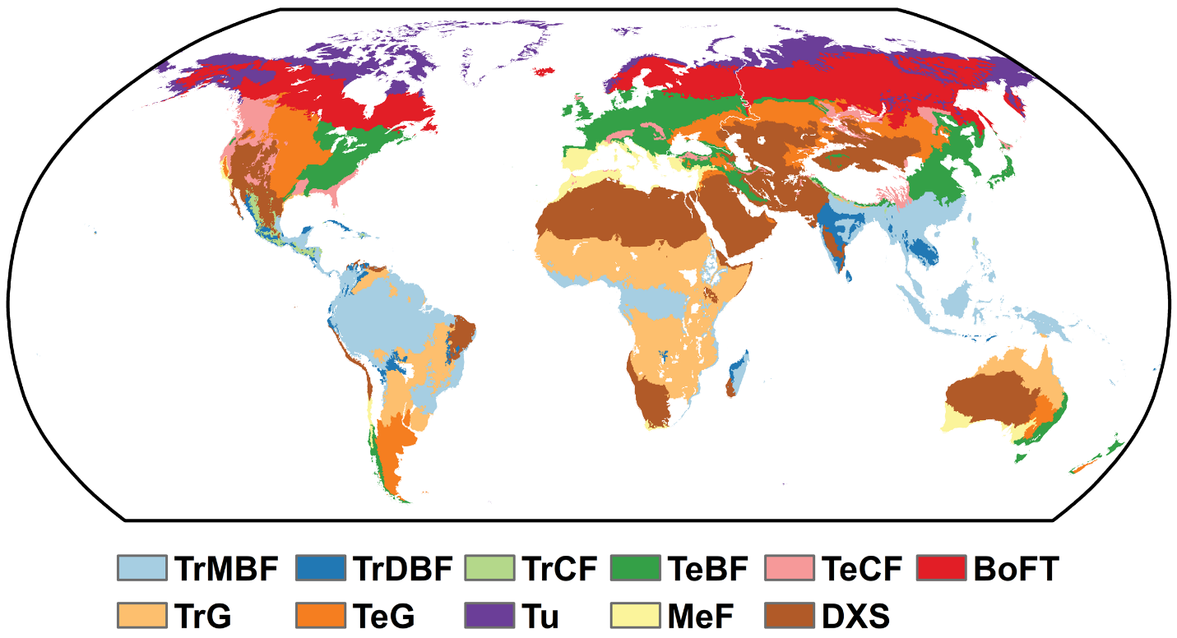
Supplementary Fig. 11 | Global map of biomes derived from the Terrestrial Ecoregions of the World. TrMBF: Tropical and Subtropical Moist Broadleaf Forests; TrDBF: Tropical and Subtropical Dry Broadleaf Forests; TrCF: Tropical and Subtropical Coniferous Forests; TeBF: Temperate Broadleaf and Mixed Forests; TeCF: Temperate Coniferous Forests; BoFT: Boreal Forests/Taiga; TrG: Tropical and Subtropical Grasslands, Savannas and Shrublands; TeG: Temperate Grasslands, Savannas and Shrublands; Tu: Tundra; MeF: Mediterranean Forests, Woodlands and Scrub; DXS: Deserts and Xeric Shrublands.

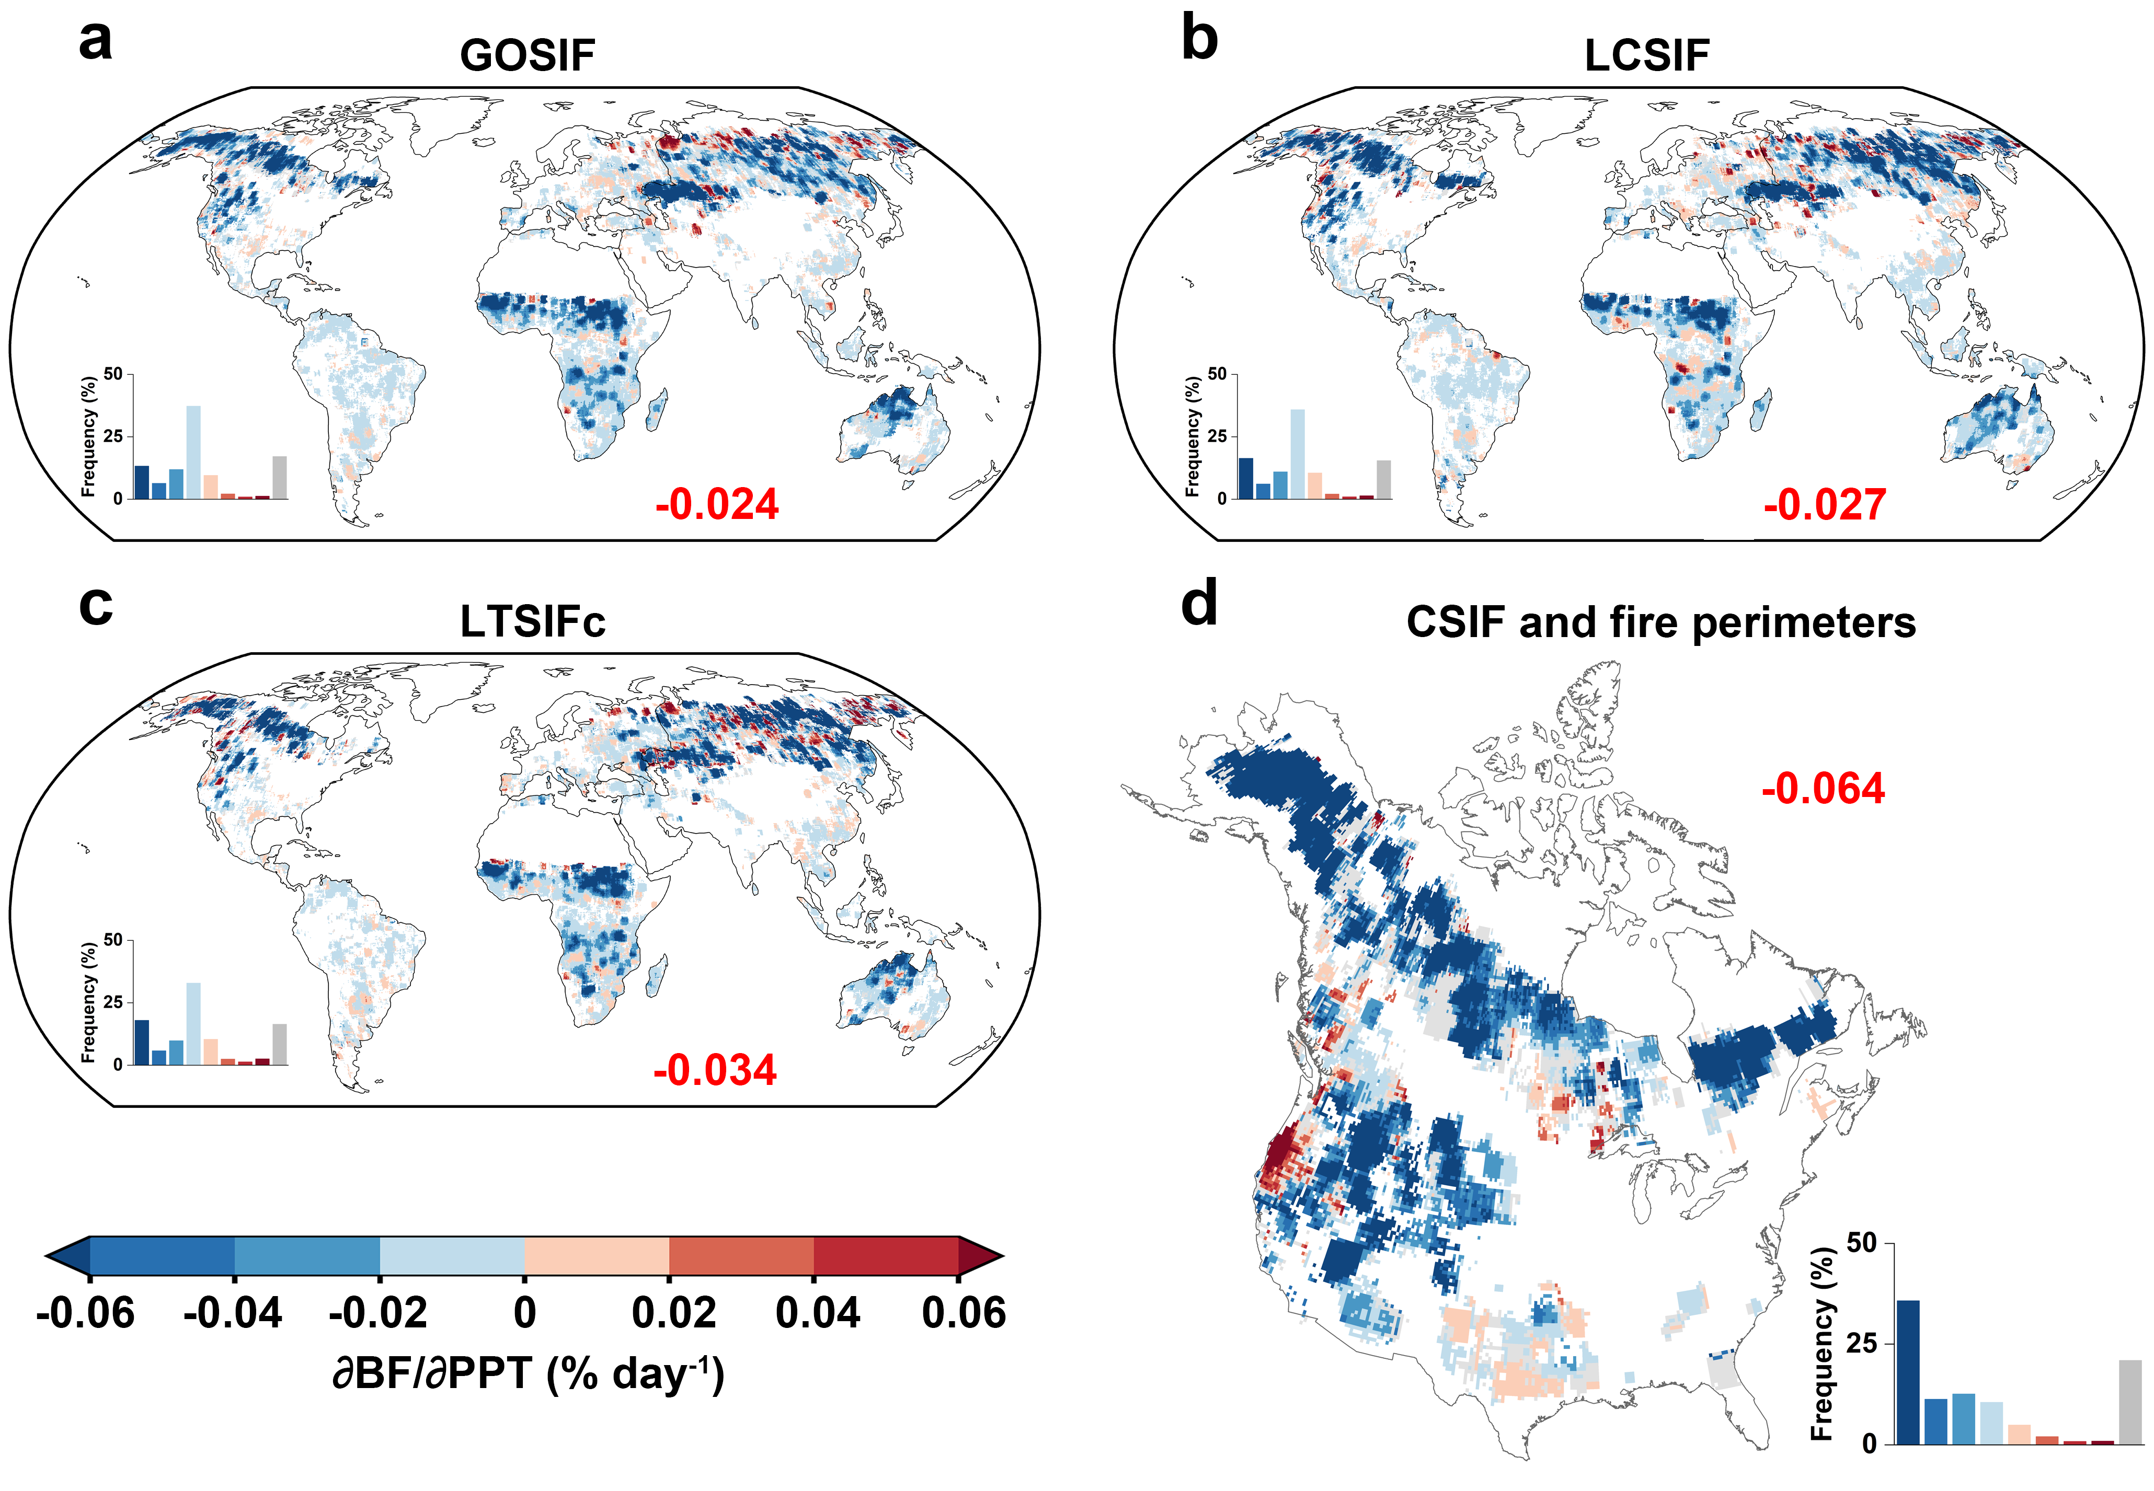
Supplementary Fig. 12 | Robustness of the sensitivity of burned area to peak photosynthesis timing (PPT) for GOSIF (a), LCSIF (b), LTSIFc (c), and fire perimeters (d) based on random forest and explainable machine learning (SHAP) methods. Gray area indicates the sensitivity is not statistically significant (p-value > 0.05). Red label indicates the area-weighted mean of global sensitivity.

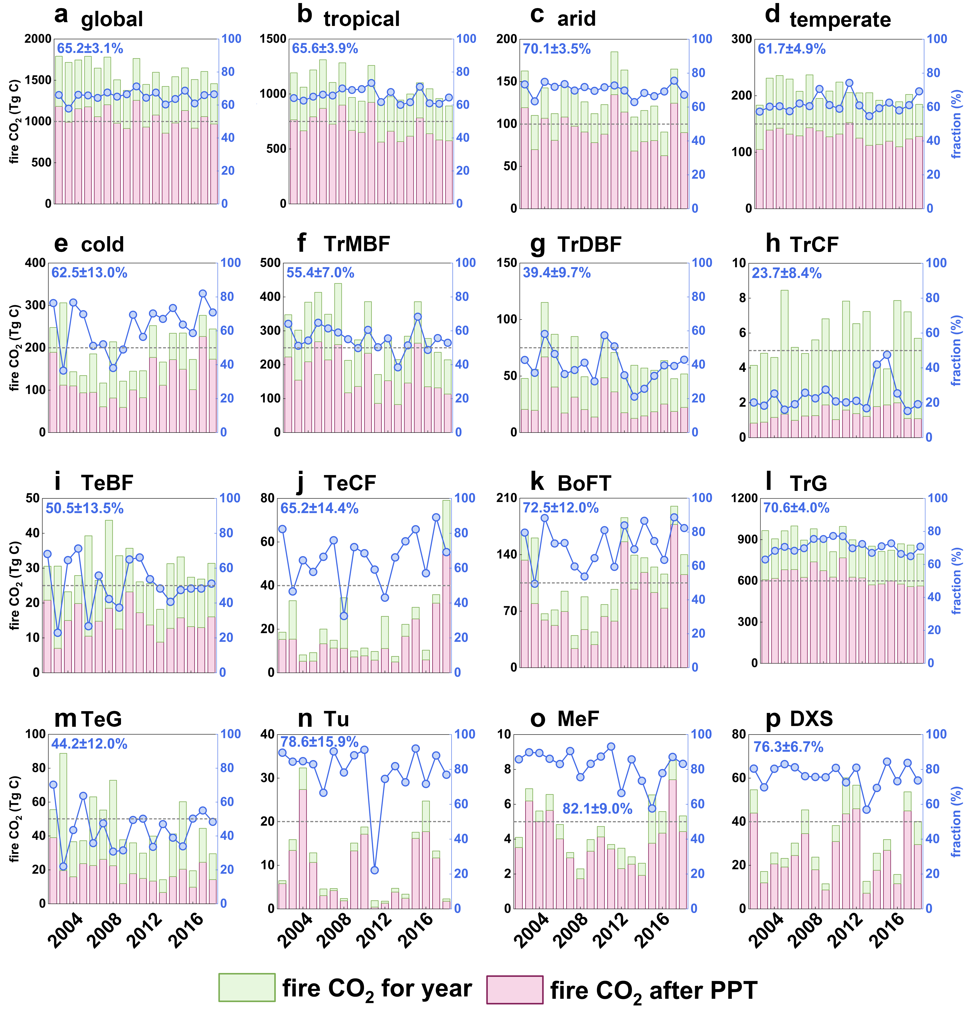
Supplementary Fig. 13 | Annual fractions (blue lines) of wildfire CO₂ emission after peak photosynthesis timing (PPT; pink bars) in relative to the annual total (green bars) for the globe, 4 climate zones, and 11 biomes based on CSIF-derived PPT and the global fire CO₂ emission dataset (Table S1). The blue label indicates the annual mean ± standard deviation of the fraction. The gray dotted line indicates the 50% fraction.

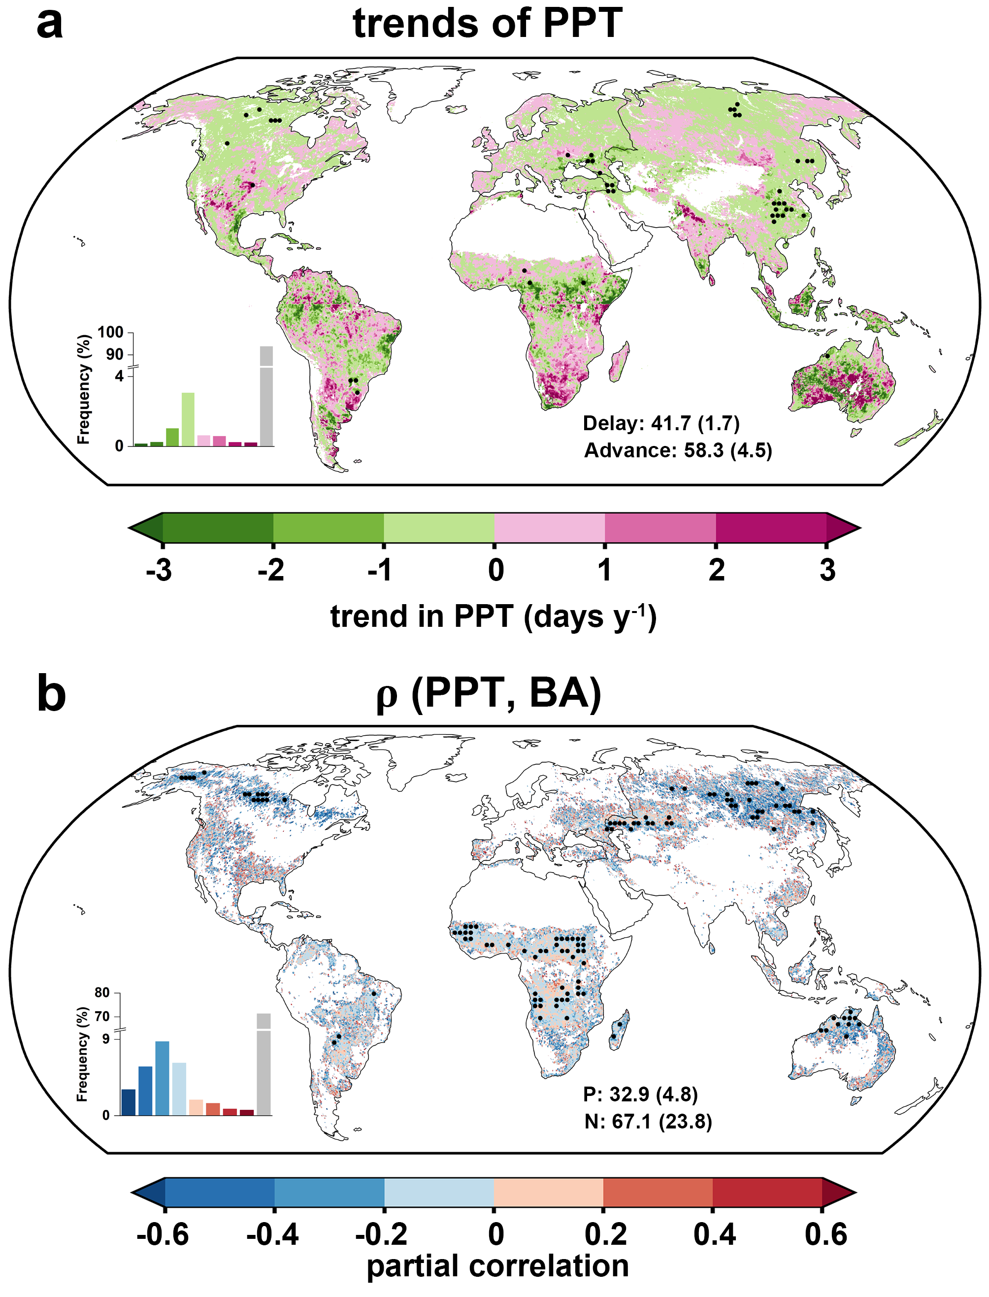
Supplementary Fig. 14 | Trend in peak photosynthesis timing (PPT) and partial correlation between PPT and the subsequent burned area at a 0.05° spatial scale. The black dots indicate regions with significant PPT trends and correlations (p-value < 0.05). The labels in a indicate the percentage of areas with delayed and advanced PPT, respectively. P and N indicate the percentage of positive and negative correlations, respectively. This analysis was based on CSIF-derived PPT and MODIS-derived global burned areas at a 0.05° spatial resolution.

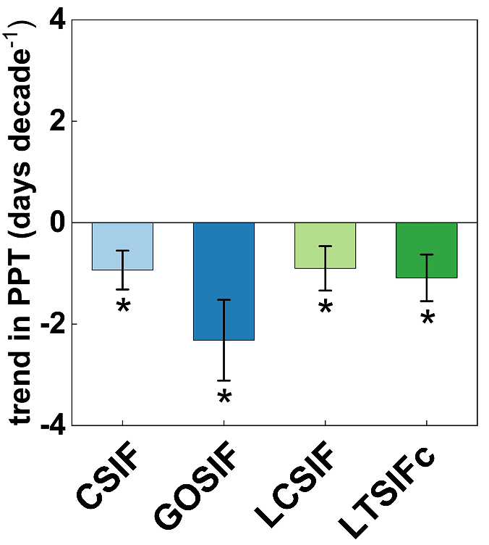
Supplementary Fig. 15 | Decadal trends in peak photosynthesis timing (PPT) over 2002-2018 derived from CSIF, GOSIF, LCSIF, and LT_SIFc for the northern ecosystems (>30°N). Bar and error bar indicate decadal trend and corresponding 95% confidence interval, respectively, based on linear regression (Methods). The asterisk denotes p-value < 0.05. We found that the trend of PPT in our study was consistent with previous studies that focused on the northern ecosystems, which demonstrates that our method used to calculate PPT is feasible and reasonable.

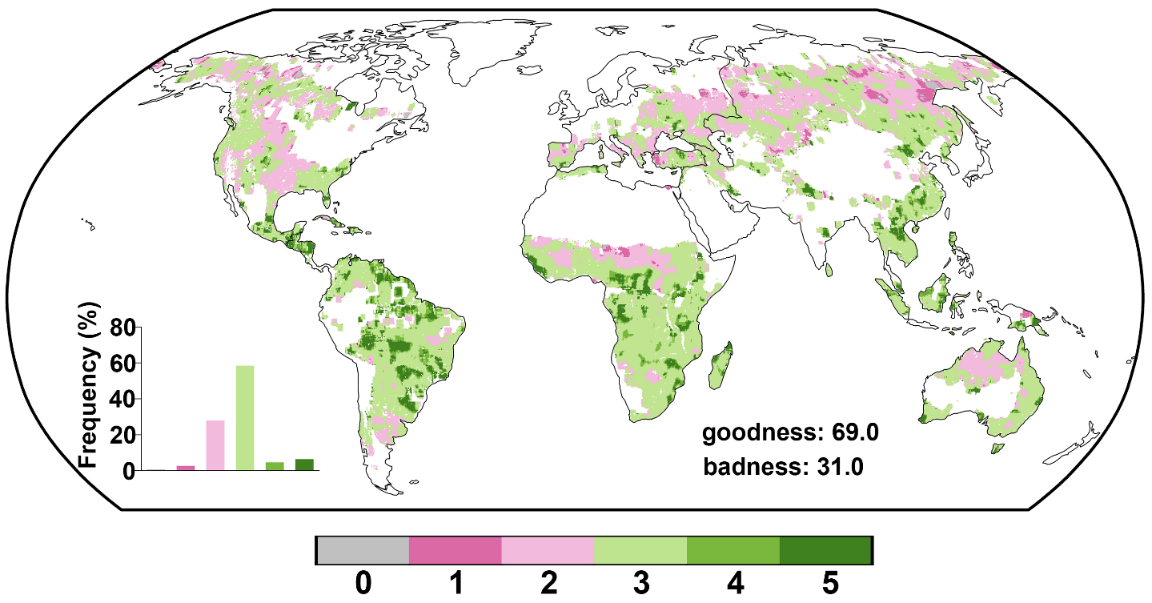
Supplementary Fig. 16 | Goodness of fit of the model using structural equation model (SEM) for CSIF-derived peak photosynthesis timing (PPT) and MODIS-derived burned area. We selected five metrics to evaluate the goodness of fitted model, i.e. GFI, CFI, RMSEA, NNFI, and SRMR. 0-5 indicate the number of criteria satisfied, and the model was considered reliable when three out of five criteria are met (green).

Table S1. Descriptions and access information of the datasets.
Variables | Datasets | Resolution | Periods | Data access
SIF | CSIF | 0.05°, 4-day | 2001-2018 | https://doi.org/10.17605/OSF.IO/8XQY6
SIF | GOSIF | 0.05°, 8-day | 2001-2018 | https://globalecology.unh.edu/data/GOSIF.html
SIF | LCSIF | 0.05°, bi-monthly | 2001-2018 | https://zenodo.org/records/7916879
SIF | LT_SIFc | 0.05°, monthly | 2001-2018 | https://doi.org/10.6084/m9.figshare.21546066.v1
NDVI | PKU GIMMS NDVI | 1/12°, half-monthly | 2001-2018 | https://zenodo.org/records/8253971
Fire activity | NBAC | shapefile | 2002-2018 | https://cwfis.cfs.nrcan.gc.ca/datamart
Fire activity | MTBS | shapefile | 2002-2018 | https://www.mtbs.gov/direct-download
Fire activity | MCD64A1 V6 | 500m, monthly | 2001-2018 | https://doi.org/10.5067/MODIS/MCD64A1.006
Climate variable | ERA5-Land monthly averaged reanalysis data (T, PRE, SM, Td, RAD) | 0.1°, monthly | 2001-2018 | https://cds.climate.copernicus.eu/cdsapp#!/dataset/reanalysis-era5-land-monthly-means?tab=overview
CWD | TerraClimate | 1/24°, monthly | 2001-2018 | https://www.climatologylab.org/terraclimate.html
BUI | Fire danger indices historical data | 0.25°, daily | 2001-2018 | https://cds.climate.copernicus.eu/cdsapp#!/dataset/cems-fire-historical?tab=overview
Land cover type | MCD12Q1 V6 IGBP classification | 500 m, yearly | 2001-2018 | https://doi.org/10.5067/MODIS/MCD12Q1.006
Climate classification | Köppen-Geiger climate classification | 0.083° | present-day (1980-2016) | http://www.gloh2o.org/koppen/
Biome | Terrestrial Ecoregions of the World | shapefile | -- | https://www.worldwildlife.org/publications/terrestrial-ecoregions-of-the-world
Global fire CO₂ emissions | GlobalFire CO₂ | 3.75°×1.9°, monthly | 2001-2018 | http://www.nesdc.org.cn/sdo/detail?id=618a22467e2817667e3c7d9e
SIF: solar-induced chlorophyll fluorescence; NDVI: normalized difference vegetation index; T: 2 m air temperature; PRE: total precipitation; SM: surface soil moisture content; Td: 2 m dewpoint temperature; RAD: surface solar radiation downwards; CWD: climatic water deficit; BUI: build up index. T and Td were used to calculate vapor pressure deficit (VPD) and relative humidity (RH).

Table S2. Summary of the FireMIP fire-vegetation models^{1,2} used in this study.
Model | Resolution | Period | Output
CLM³ | 2.5°×1.9°, monthly | 2001-2012 | GPP, BF
JSBACH-SPITFIRE⁴ | 1.875°×1.875°, monthly | 2001-2012 | GPP, BF
LPJ-GUESS-SPITFIRE⁵ | 0.5°×0.5°, monthly | 2001-2012 | GPP, BF
ORCHIDEE-SPITFIRE⁶ | 0.5°×0.5°, monthly | 2001-2012 | GPP BF
CTEM⁷ | 2.8125°×2.8125°, monthly | 2001-2012 | GPP, BF
JULES-INFERNO⁸ | 1.875°×1.245°, monthly | 2001-2012 | GPP, BF
LPJ-GUESS-SIMFIRE-BLAZE⁹ | 0.5°×0.5°, monthly | 2001-2012 | GPP, BF
GPP: gross primary productivity; BF: burned fraction, the fraction of burned area within a grid cell (%). Notably another two FireMIP models, LPJ-GUESS-GlobFIRM¹⁰ and MC2¹¹, were excluded in this study because they perform less well globally than other models in simulating global burned areas¹ and provide yearly burned area data.

References
1 Hantson, S. et al. Quantitative assessment of fire and vegetation properties in simulations with fire-enabled vegetation models from the Fire Model Intercomparison Project. Geoscientific Model Development 13, 3299-3318 (2020).
2 Hantson, S. et al. Model outputs: Quantitative assessment of fire and vegetation properties in historical simulations with fire-enabled vegetation models from the Fire Model Intercomparison Project [Data set]. Zenodo https://doi.org/10.5281/zenodo.3555562 (2019).
3 Li, F., Levis, S. & Ward, D. S. Quantifying the role of fire in the Earth system – Part 1: Improved global fire modeling in the Community Earth System Model (CESM1). Biogeosciences 10, 2293-2314 (2013).
4 Lasslop, G., Thonicke, K. & Kloster, S. SPITFIRE within the MPI Earth system model: Model development and evaluation. Journal of Advances in Modeling Earth Systems 6, 740-755 (2014).
5 Lehsten, V. et al. Estimating carbon emissions from African wildfires. Biogeosciences 6, 349-360 (2009).
6 Yue, C. et al. Modelling the role of fires in the terrestrial carbon balance by incorporating SPITFIRE into the global vegetation model ORCHIDEE – Part 1: simulating historical global burned area and fire regimes. Geoscientific Model Development 7, 2747-2767 (2014).
7 Melton, J. R. & Arora, V. K. Competition between plant functional types in the Canadian Terrestrial Ecosystem Model (CTEM) v. 2.0. Geoscientific Model Development 9, 323-361 (2016).
8 Mangeon, S. et al. INFERNO: a fire and emissions scheme for the UK Met Office's Unified Model. Geoscientific Model Development 9, 2685-2700 (2016).
9 Knorr, W., Jiang, L. & Arneth, A. Climate, CO2 and human population impacts on global wildfire emissions. Biogeosciences 13, 267-282 (2016).
10 Smith, B. et al. Implications of incorporating N cycling and N limitations on primary production in an individual-based dynamic vegetation model. Biogeosciences 11, 2027-2054 (2014).
11 Bachelet, D., Ferschweiler, K., Sheehan, T. J., Sleeter, B. M. & Zhu, Z. Projected carbon stocks in the conterminous USA with land use and variable fire regimes. Glob Chang Biol 21, 4548-4560 (2015).

