Method
The Random Intercept Cross-Lagged Panel Model (RI-CLPM) adopts a multilevel perspective to distinguish between intra-individual processes and inter-individual stable differences, allowing for the separation of within-individual effects from between-individual effects [1][2]. Traditional CLPMs assume that all individuals have the same baseline level. The RI-CLPM introduces random intercepts to allow for individual differences in baseline levels, aiding in the capture of heterogeneity between individuals. By separating individuals' stable characteristics (such as personal traits, long-term average levels, etc.) from time-specific measurements, RI-CLPM provides a more accurate estimation of causal relationships [3].
Calculation method:
Suppose there are two variables, X and Y, measured at T time points. For each individual i, the basic structure of the model is as follows:
Xit​=βX0​+βXX​Xi,t−1​+βXY​Yi,t−1​+μXi​+ϵXit​
Yit​=βY0​+βYX​Xi,t−1​+βYY​Yi,t−1​+μYi​+ϵYit​
Here, Xit andYit are the observed values of variables X and Y for individual i at time point t. βXX、βXY、βYX and βYYare parameters for cross-lagged effects, representing the influence of one variable at the previous time point on another variable at the current time point. ϵXit and ϵYit are random error terms. μXi and μYi are the random intercepts for individual i on variables X and Y, reflecting the individual's baseline level.
In this study, RI-CLPM analysis is employed to examine the direction and strength of the relationship between Community Service and Geriatric Depression. Four project packages representing domains were created as indicators of Community Service, with each package representing each domain defined in our measurement invariance. Random intercepts reflect the individual's average stable level in terms of Community Service, Psychological Resilience, and Geriatric Depression.

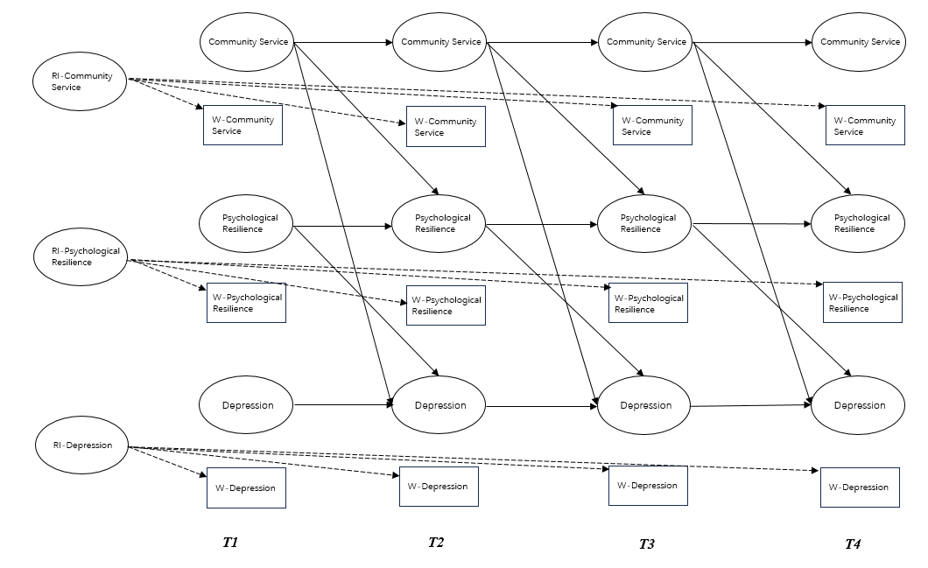
Figure 1 A depiction of the RI-CLPM including the relationships between Community Service, Geriatric Depression, and Psychological Resilience across the three waves. W represents within-person variable; T1 represents 2008; T2 represents 2011; T3 represents 2014; T4 represents 2018. The observed variables are represented in the squares. Of these observed variables, latent variables at both the between and within level were constructed. These latent variables are displayed as ovals. The three random intercepts (RI Community Service, RI Geriatric Depression, and RI Psychological Resilience) reflect the between-person variances. The nine latent within-person variables (WT1-WT4 Community Service, WT1-WT4 Geriatric Depression, and WT1-WT4 Psychological Resilience) reflect the within-person variances across 4 waves. The within-person paths are illustrated by the modeling structure between the nine latent within-person variables: 3 autoregressive paths between the latent factors of Within Community Service, 3 autoregressive paths between the latent factors of Within Geriatric Depression, and 3 autoregressive paths between the latent factors of Within Psychological Resilience; 3 cross-lagged paths from the latent factors of Within Community Service to Within Geriatric Depression and 3 cross-lagged paths from the latent factors of within Depressive to Within Community Service; 3 cross-lagged paths from the latent factors of Within Community Service to Within Psychological Resilience and 3 cross-lagged paths from the latent factors of Within Psychological Resilience to Within Community Service; 3 cross-lagged paths from the latent factors of Within Geriatric Depression to Within Psychological Resilience and 3 cross-lagged paths from the latent factors of Within Psychological Resilience to Within Geriatric Depression; correlations between Within Community Service, Within Geriatric Depression, and Within Psychological Resilience at Wave 1, and between the residual correlations of Within Community Service, Within Geriatric Depression, and W Psychological Resilience at Waves 2 and 3.

References
1. Hamaker EL, Kuiper RM, Grasman RPPP. A critique of the cross-lagged panel model. Psychol Methods. 2015;20(1):102–116. doi:10.1037/ a0038889
2.Hamaker, E. L., Kuiper, R. M., & Grasman, R. P. P. P. (2020). Three Extensions of the Random Intercept Cross-Lagged Panel Model. Structural Equation Modeling: A Multidisciplinary Journal, 27(5), 751-768.
3.Zyphur, M. J., Tay, L., & Voelkle, M. C. (2022). Power Analysis for the Random Intercept Cross-Lagged Panel Model Using the powRICLPM R-Package. Structural Equation Modeling: A Multidisciplinary Journal, 29(6), 925-939.

