Ultra-High Performance Organic Thermoelectric Generators through Interfacial Doping Gradients
Petsagkourakis I.^{1*}, Riera-Galindo S.¹, Ruoko T.-P.¹, Strakosas X.¹, Pavlopoulou E.², Liu X.¹, Braun S.¹ , Kim N.¹, Lienemann S.¹, Gueskine V.¹, Hadziioannou G.², Berggren M.^{1,3}, Fahlman M.¹, Fabiano S.¹, Tybrandt K.¹, Crispin X.^{1*}
¹Laboratory of Organic Electronics, Department of Science and Technology (ITN), Linköping University, SE-601 74 Norrköping, Sweden.

²Bordeaux INP, CNRS, Univ. Bordeaux, LCPO, UMR 5629, F-33600 Pessac, France
³Wallenberg Wood Science Center, Linköping University, Norrköping, Sweden
*corresponding authors

S1: Thermopower measurement schematic and measured raw data
The shadow masks for this measurement were designed following the guidelines provided by van Reenen & Kemerink on the effect of geometry on the thermoelectric performance, so that the measurements are as accurate as possible from a geometrical perspective¹. All devices had a cross section area of 100 nm by 1 cm. The temperature difference didn’t exceed 3 °C and was measured by two T-type thermocouples. We cross-checked the validity of our setup by measuring Ni and Au foils, following the approach used in Petsagkourakis et al.².
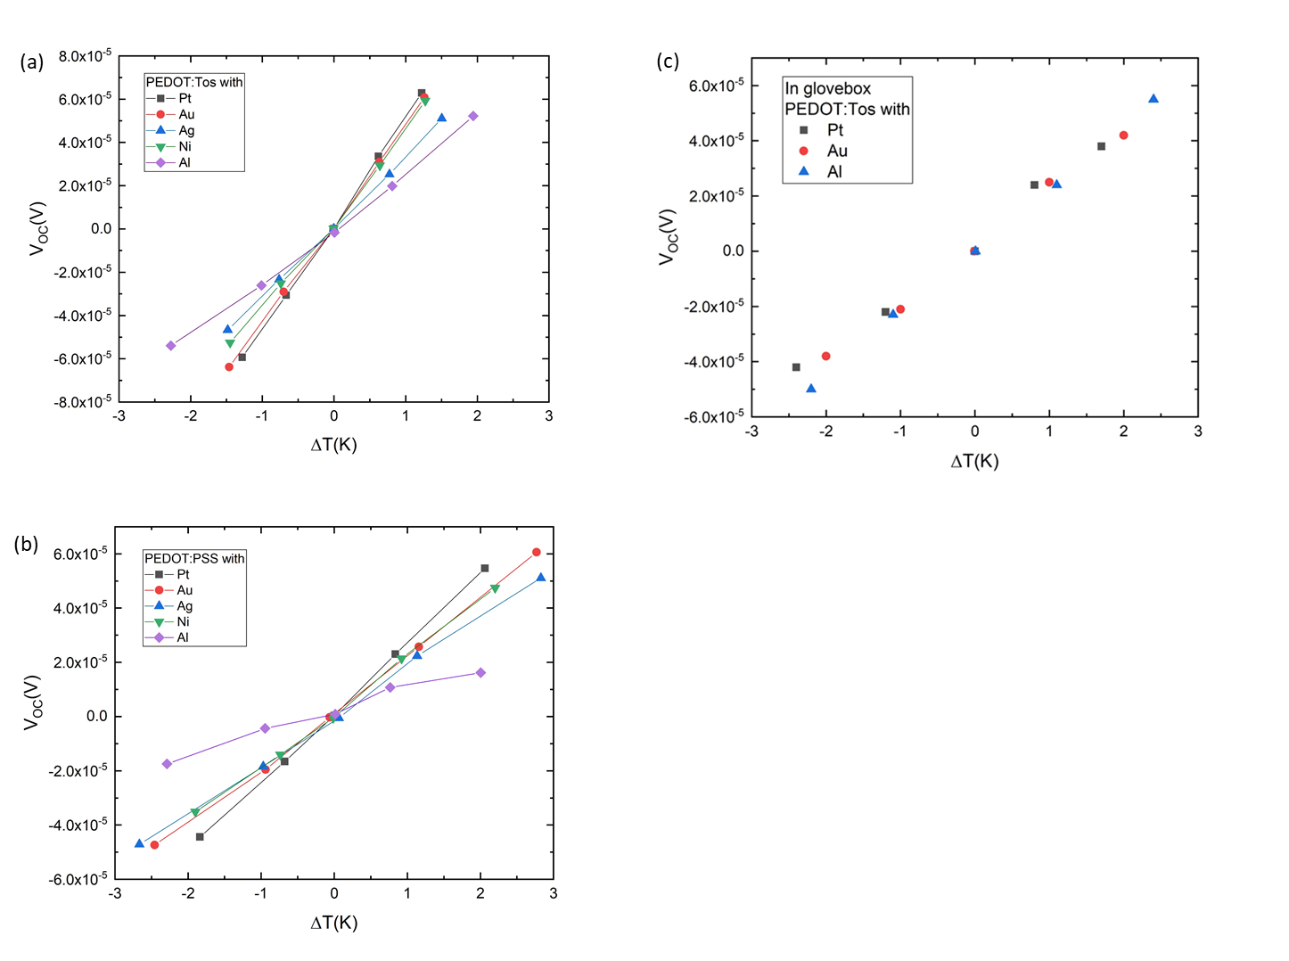
Figure S1.1 : The open circuit voltage V_{OC} plotted against the temperature difference ΔΤ for (a) PEDOT:Tos and (b) PEDOT:PSS under ambient conditions and (c) for PEDOT:Tos samples fabricated and measured inside a glovebox with various metals as the electrodes.

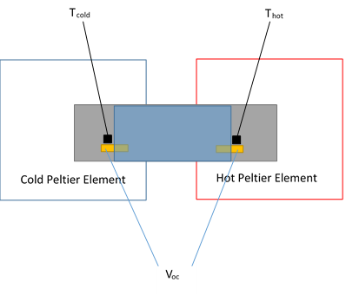
Figure S1.2: Schematic representation of the Seebeck coefficient and thermopower measurement. We put the sample on top of the hot (red) and cold (blue) peltier elements. The sample is on a glass slide (grey) that has the deposited metal (yellow) and polymer layers (transparent blue). The dimensions and positions of the gold electrodes follow the geometrical aspects of Reenen & Kemerink¹ for a trustworthy thermoelectric measurement, where the aspect ratios of the electrodes and the channel should be less than 1. The open circuit voltage was measured with a Keithley nanovoltmeter and the temperature was measured with thermocouples (black) that are attached on the sample with thermally conductive paste (black). We identified that the thermocouple readings were unaffected if the thermocouples were put in a slightly different place (as long as it followed the instructions provide by van Reenen & Kemerink¹. In order to cross-check the validity of the setup, Au and Ni foils were measured, such as in Petsagkourakis et al. ² Moreover, our reported values for PEDOT:PSS/Au, PEDOT:PSS/Ag and PEDOT:Tos/Au agree with other reported values in the literature²⁻⁵.

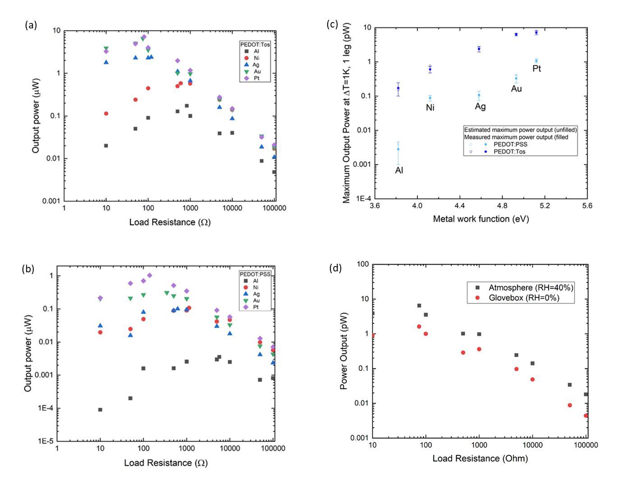
Figure S1.3 : (a),(b) The output power of the PEDOT systems vs the load resistance. (c) The maximum output power vs. the metal work function. (d) The measured output power vs load resistance for PEDOT:Tos/Pt inside and outside the glovebox.

S2: UPS spectra and Kelvin probe measurements of the bare metals
The UPS spectra were acquired with an UHV surface analysis system, consisting of an entry chamber (base pressure ~1×10⁻⁷ mbar), a preparation chamber (~1×10⁻⁸ mbar), and an analysis chamber (~2×10⁻¹⁰ mbar). Monochromatized HeI (hν = 21.22 eV) spectra were recorded with a in-lab designed and built photoelectron spectrometer, and were calibrated by using the Fermi edge and Au 4f_{7/2} peak position of an Ar⁺ ion sputter-cleaned gold foil. The UPS was performed with an error of ±0.05 eV.
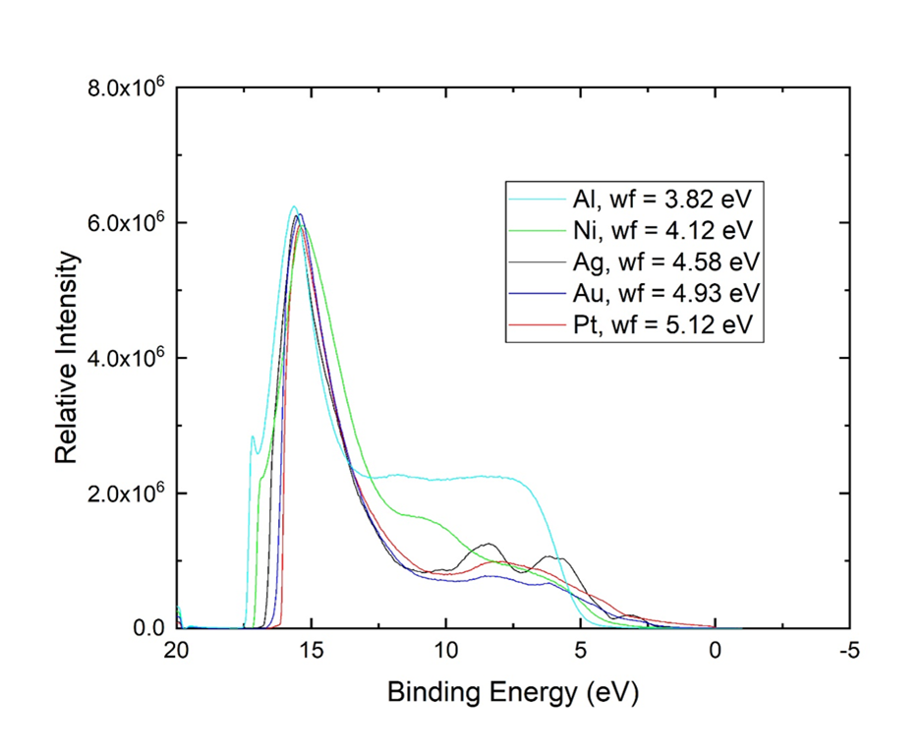
Figure S2.1: UPS spectra for the bare metal substrates
Ultraviolet photoelectron spectroscopy (UPS) was conducted for all of the metal samples. In Figure S2.1 are presented the UPS spectra for the bare metal substrates along with the extracted values of their work functions.
 | Metals : | Au |  | Ag |  | Al
step |  | CPD(V) | delta | CPD(V) | delta | CPD(V) | delta
1 | ambient | -0,490 |  | -0,318 |  | 0,823
2 | 7×10⁻5 mbar | -0,496 | -0,006 | -0,305 | 0,013 | 0,867 | 0,044
3 | 1.2×10⁻5 mbar | -0,509 | -0,013 | -0,303 | 0,002 | 0,889 | 0,022
4 | ambient | -0,454 | 0,055 | -0,331 | -0,028 | 0,910 | 0,021
Table S2.1 : Kelvin probe measurements for the various bare metals, cycling between air and vacuum. The CPD values are defined as the work function of the tip minus the work function of the sample, i.e., more negative values correspond to a higher work function. Delta shows the difference between the values in each step.

The CPD (contact potential difference) measurements were performed using a McAllister KP6500 digital Kelvin probe, which features a stain-less steel tip wiat a 2 mm diameter as the reference electrode. The accuracy of the system is 1 mV. The Kelvin Probe Measurements were performed for each sample in the following sequence: under ambient conditions, under high vacuum at 7×10⁻5 mbar and at 1.2×10⁻5 mbar and finally again under ambient conditions.

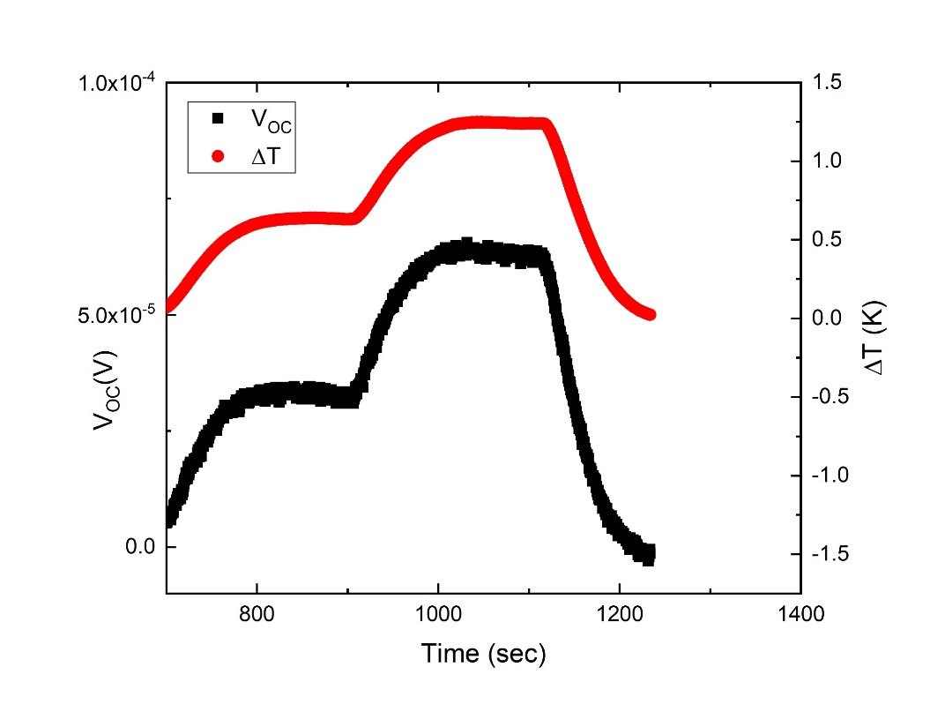
S3: Time dependence of the open voltage under a temperature gradient contribution.
PEDOT:Tos
Figure S3.1: The open circuit voltage and the temperature difference as a function of time, as recorded for the PEDOT:Tos/Pt sample.

S4: IRAS spectra and analysis
For the IRAS samples, the PEDOT films were transferred op top of glass slides covered with the various metals (~100 nm thick) with dimensions of 25x10 mm². The IRAS spectra were acquired using a Bruker Equinox 55 FTIR spectrophotometer.
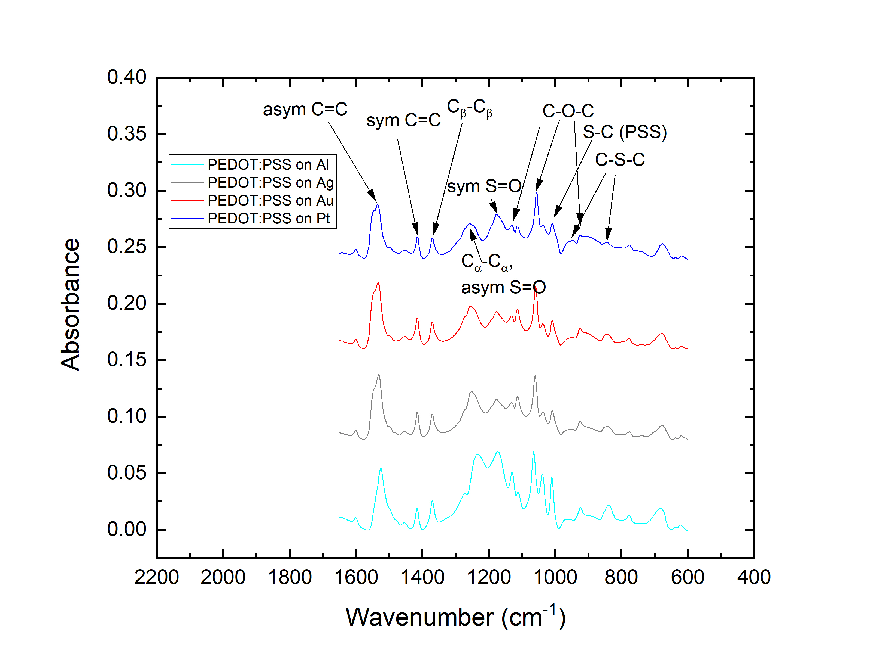
Figure S4.1: IRAS spectra of PEDOT:PSS of the same thickness on the various metals. The vibrational bands are depicted in the Figure and are also listed in Table S1.
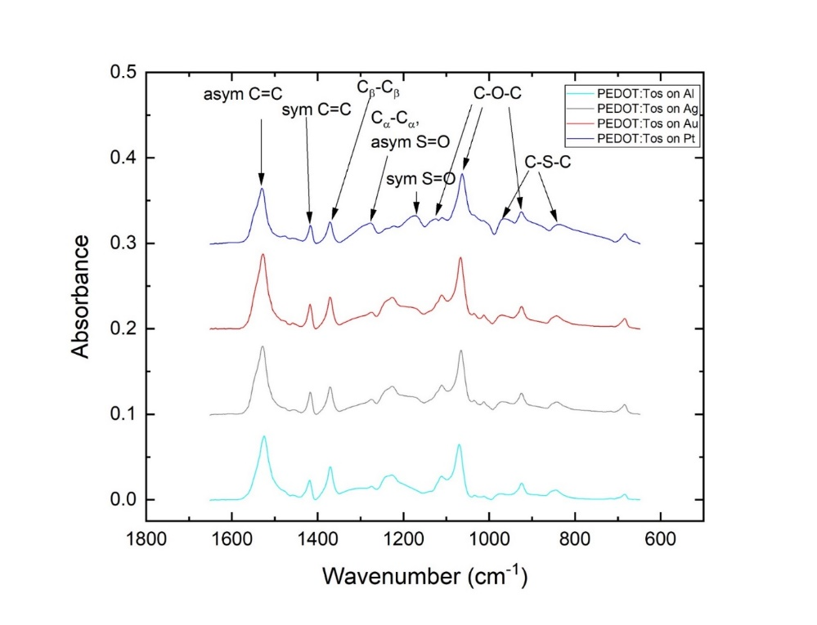
Figure S4.2: IRAS spectra of PEDOT:Tos films of the same thickness on the various metals. The vibrational bands are depicted in the Figure and are also listed in Table S1.
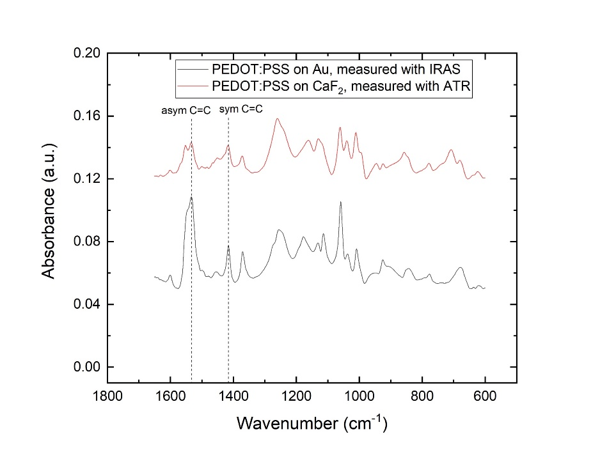
Figure S4.3 : The ATR-FTIR spectra for PEDOT:PSS on CaF₂ compared with the IRAS spectra of PEDOT:PSS/ Au.
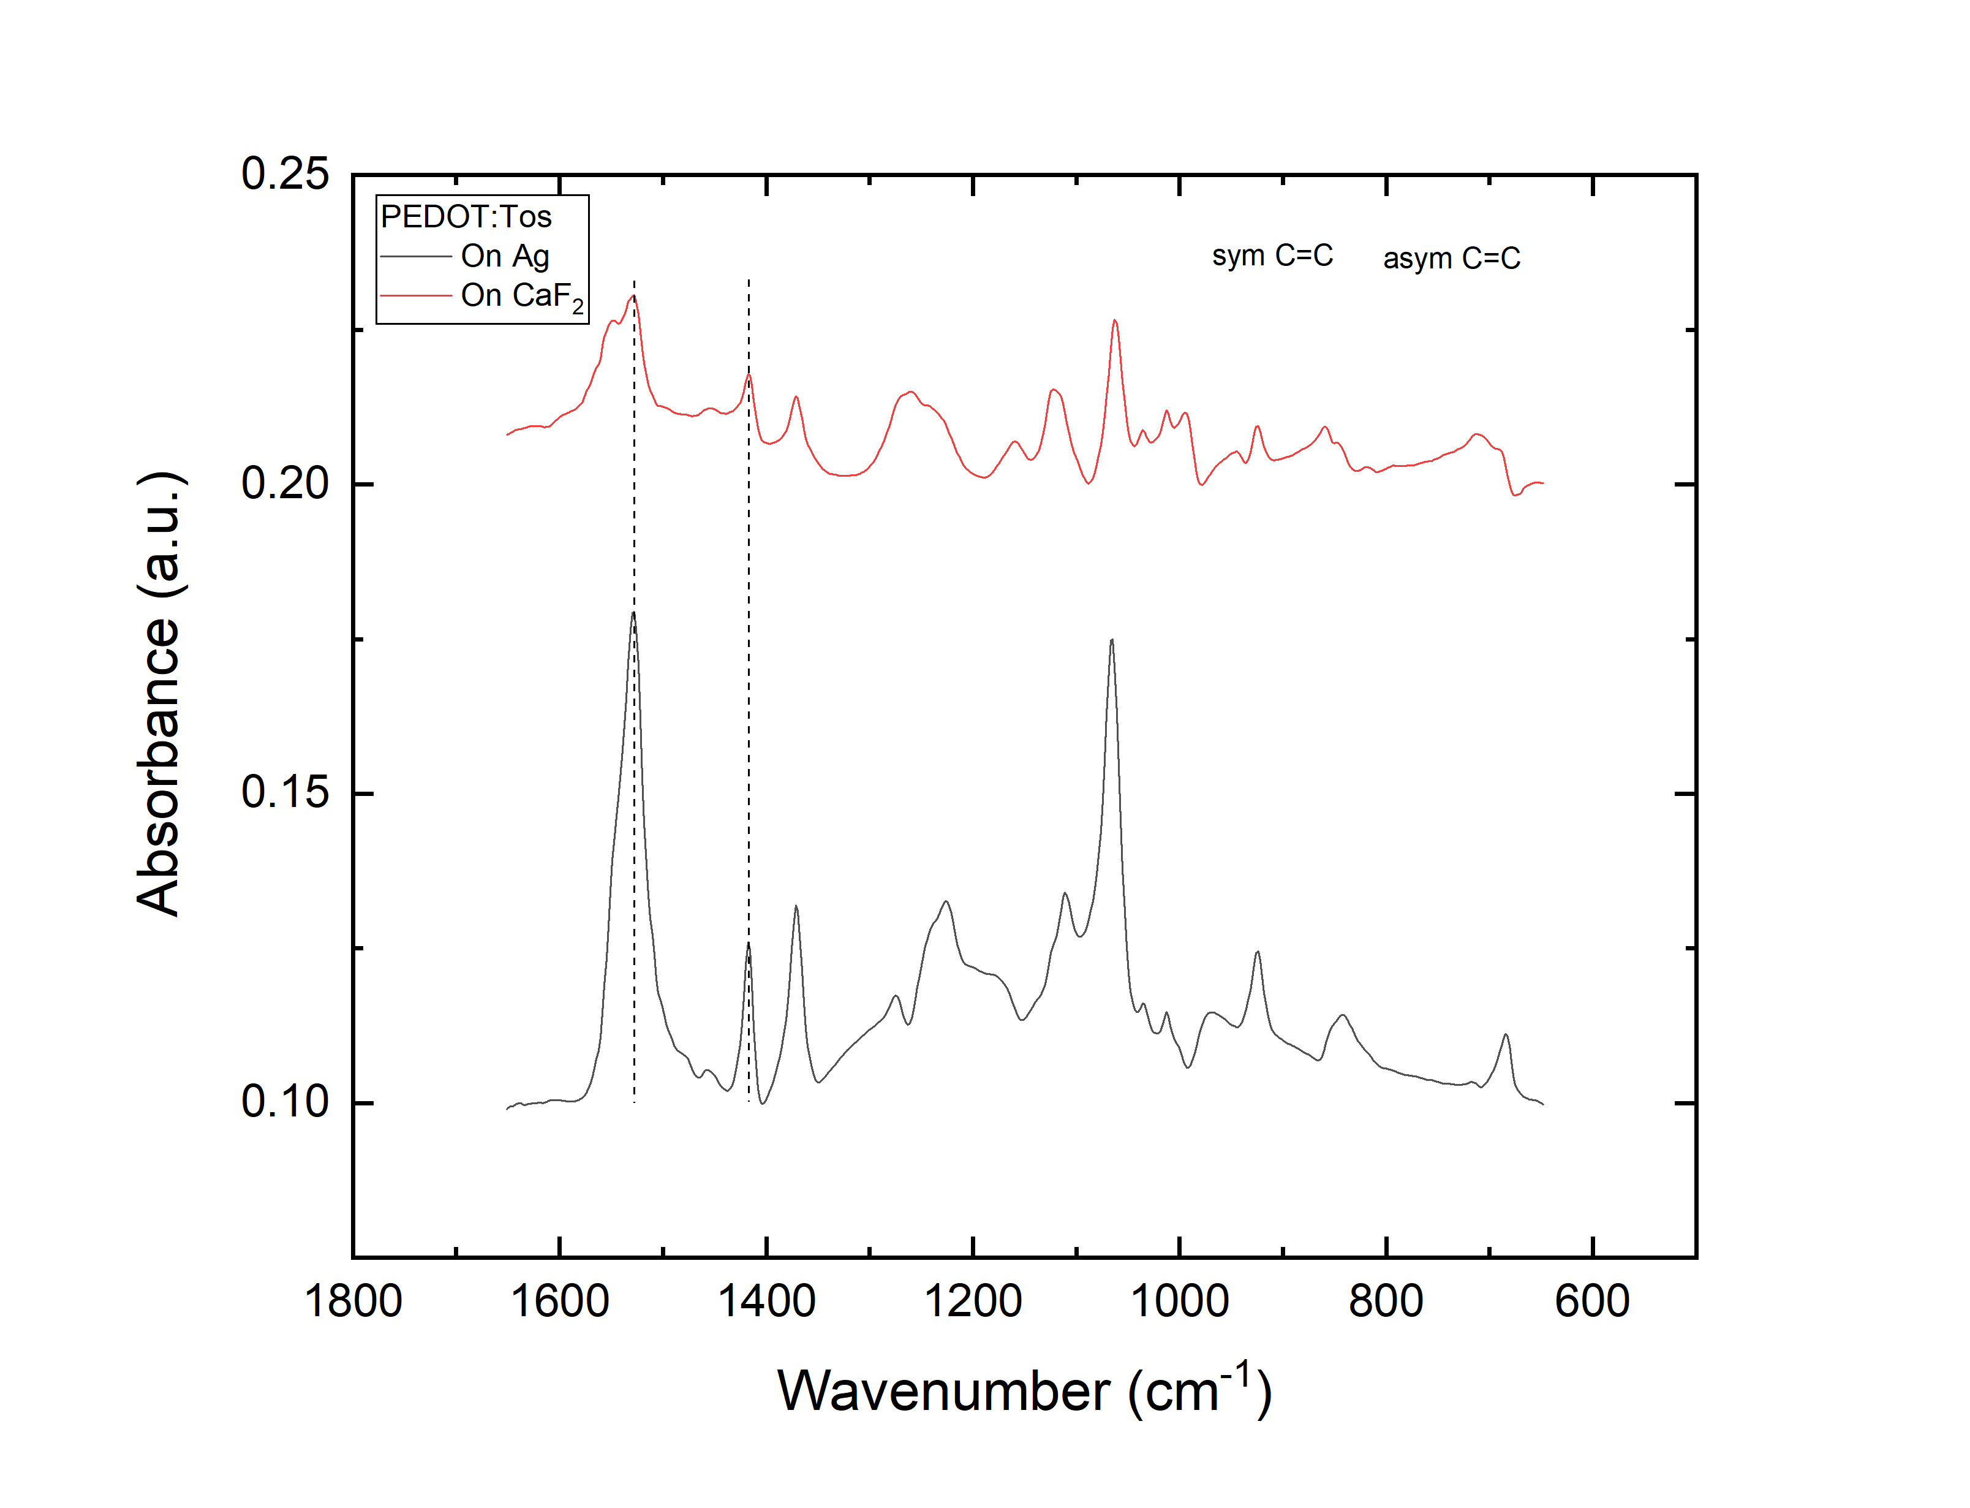
Figure S4.4 : The ATR-FTIR spectra for PEDOT:Tos on CaF₂ compared with the IRAS spectra of PEDOT:Tos/ Au.
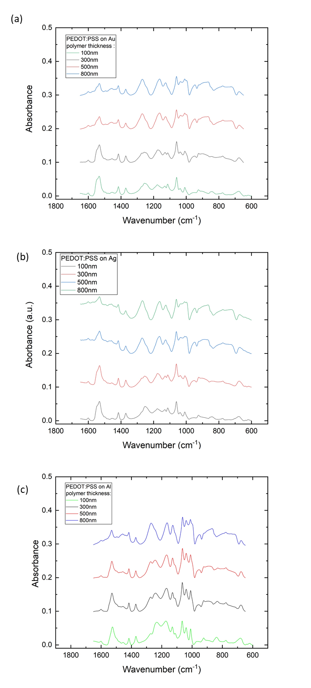
Figure S4.5: The IRAS spectra for different thickness PEDOT:PSS layers on (a) Au, (b) Ag, and (c) Al.

Table S4.1: FTIR peak maxima and chemical designations for PEDOT:PSS and PEDOT:Tos^{6,7}.
Peak maxima (cm⁻¹) | PEDOT:PSS | PEDOT:Tos
1525-1535 | Asymmetric C=C | Asymmetric C=C
1540-1550 | Asymmetric C=C doublet | Asymmetric C=C doublet
1412-1418 | Symmetric C=C | Symmetric C=C
1370 | C_{β}- C_{β} | C_{β}- C_{β}
1273 | C_{α}- C_{α} , asymmetric S=O | C_{α}- C_{α} , asymmetric S=O
1172 | Symmetric S=O | Symmetric S=O
1126, 1055, 922 | C-O-C | C-O-C
1026 | S-C (PSS) | --
955, 842 | C-S-C | C-S-C

S5: Original GIWAXS patterns
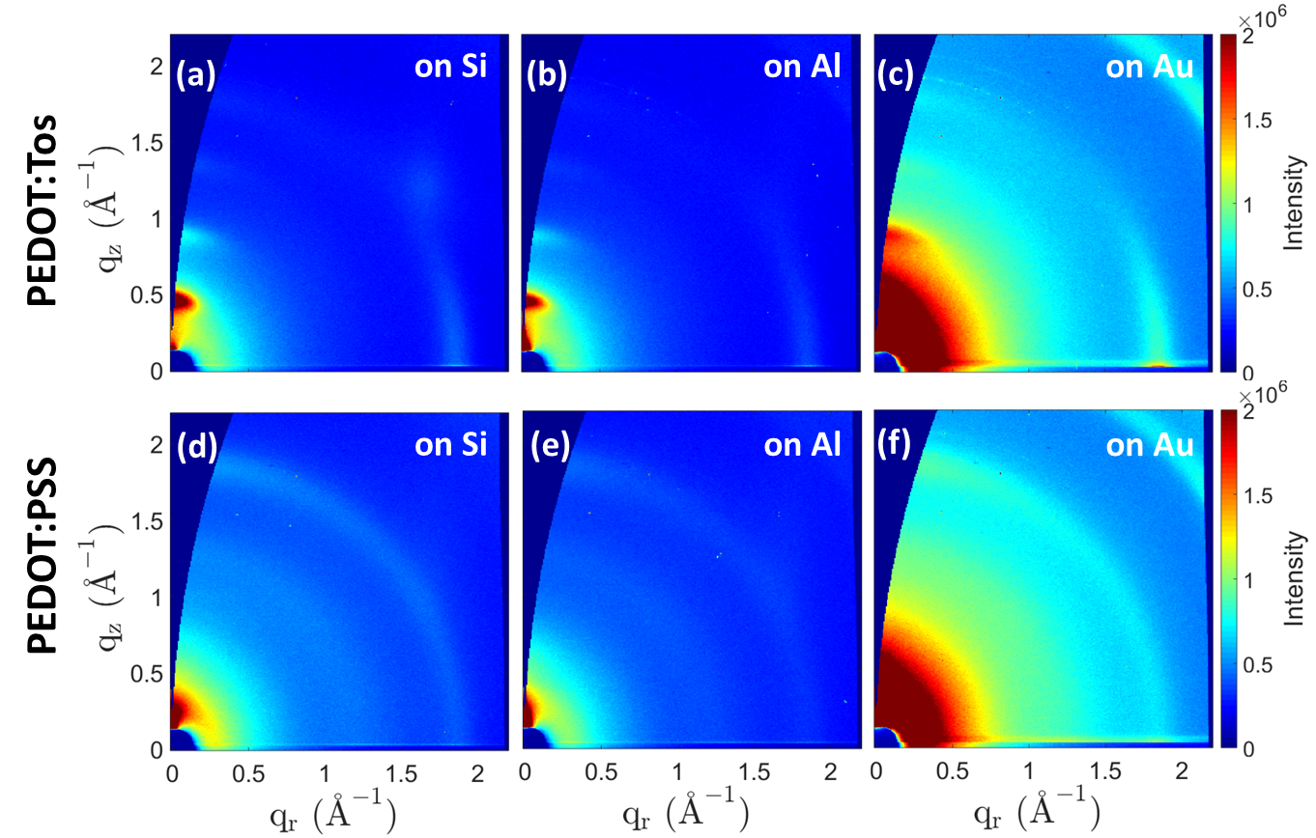
Figure S5.1 : The original 2D GIWAXS images for PEDOT:Tos (a)-(c) and PEDOT:PSS (d)-(f) on Si, Al, and Au before background subtraction.

Grazing incidence wide angle X-ray scattering (GIWAXS) experiments were performed at the NCD-SWEET beamline of the ALBA Synchrotron, located in Cerdanyola del Vallès, Spain. The wavelength of the X-rays was 0.9998 Å (12.4 keV), the sample to detector distance was 21.45 cm, and the angle of incidence was 0.16°. The diffracted intensity was recorded using a Rayonix LX255-HS detector, which consists of a pixel array of 960 × 2880 (H × V) and a pixel size of 88×88 μm². Data were normalized by the incident photon counts. Flat field, polarization, solid angle, and efficiency corrections were subsequently applied to the 2D GIWAXS images. The scattering vector q was defined with respect to the center of the incident beam and has a magnitude of q=(4π/λ)sin(θ), where 2θ is the Bragg reflection angle. The wedge-shaped corrected images are presented herein, with q_{r} and q_{z} being the in-plane and near out-of-plane scattering vectors, respectively, defined as follows: q_{x}=(2π/λ)(cos(2θ_{f})cos(α_{f})-cos(α_{i})), q_{y}=(2π/λ)(sin(2θ_{f})cos(α_{f})), q_{z} = (2π/λ)(sin(α_{f})+sin(α_{i})),$q_{r}^{2}=q_{x}^{2}+q_{y}^{2}$. α_{f} is the exit angle in the vertical direction and 2θ_{f} is the in-plane scattering angle⁸. Therefore, the scattering vector is calculated as follows, $q_{ }^{2}=q_{r}^{2}+q_{z}^{2}$. The 1D scattering patterns were obtained by performing a radial integration of the 2D images with respect to the incident beam.

S6 : Schematic on the impact of interfacial chemistry and stratification on the Seebeck coefficient
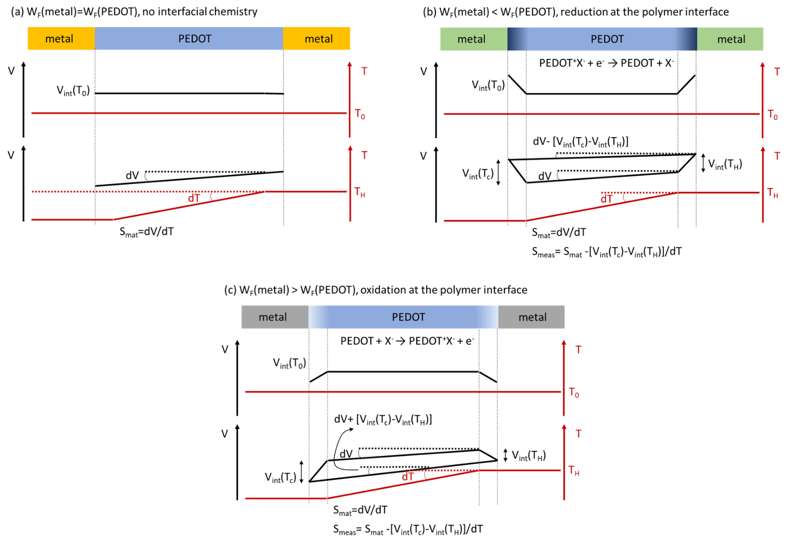
Figure S6.1 : A schematic representation on the effect of polymer/metal energetics on the measured Seebeck coefficient. (a) When PEDOT is in contact with a metal with equal work function, (b) with a lower work function metal, and (c) with a higher work function metal.

S7: Dissimilar contact device measurement and state-of-the-art on organic thermoelectric generator power densities.
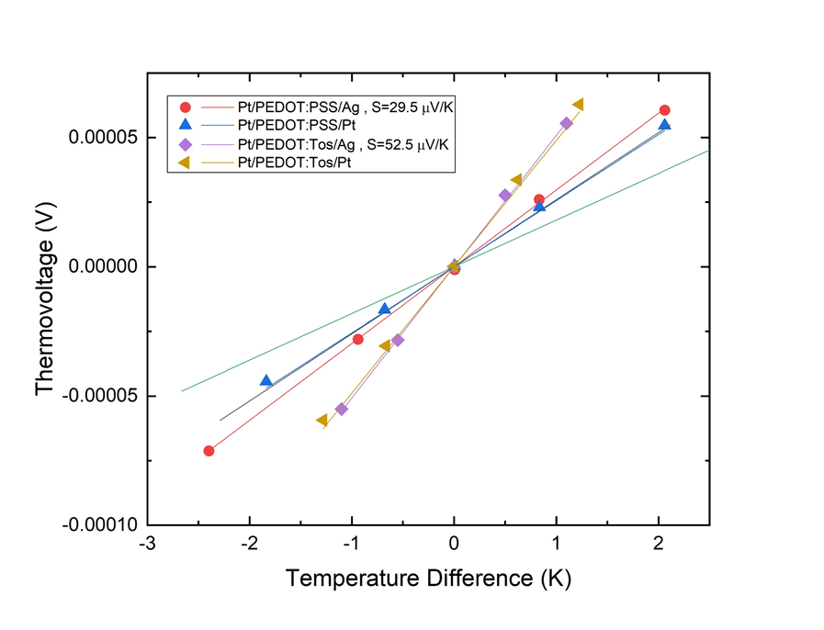
Figure S7.1 : The open circuit voltage (thermovoltage) plotted against the temperature difference for Pt/PEDOT:PSS/Ag, Pt/PEDOT:PSS/Pt, Pt/PEDOT:Tos/Ag, and Pt/PEDOT:Tos/Pt samples.

# in Figure 1a | Reference | Reported power (μW) | Reported ΔΤ (Κ) | Reported dimensions (cm) and cross-section area (cm²) | Calculated or reported power density at reported ΔΤ and cross-section area | Calculated power density at ΔΤ=30 °C
1 | ⁹ | -- | 30 | -- | 0.27 | 0.27
2 | ¹⁰ | 2.8 | 30 | -- | 2.8 | 2.8
3 | ⁴ | -- | -- | -- | 20 | 20
4 | ¹¹ | -- | 100 | -- | 1400 | 125
5 | ¹² | 388.7 | 75.2 | 0.46 | 830.5 | 132
6 | ¹³ | 0.108 | 80 | 0.01 | 10.8 | 1.52
7 | ¹⁴ | 200 | 50 | 1 | 200 | 72
8 | ¹⁵ | -- | 30 | -- | 0.7 | 0.7
9 | ¹⁶ | 37 | 50 | 1.54 | 24 | 8.64
10 | ¹⁷ | 0.0008 | 30 | 0.006 | 0.13 | 0.13
11 | ⁵ | -- | 30 | -- | 100 | 100
12 | ¹⁸ | -- | 12 | -- | 1 | 6.25
13 | ¹⁹ | -- | ~30 | -- | 6.8 | 6.8
14 | ²⁰ | -- | 100 | -- | 40 | 14.4
15 | ²¹ | 0.157 | 51.6 | -- | 75 | 25
16 | ²² | -- | 30 | -- | 3.4 | 3.4
Table S7.1 : The power density conversion for the various literature works used in Figure 5.

S8: Contact resistance device architecture
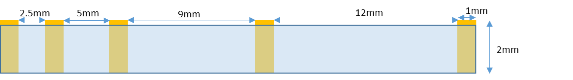
Figure S8.1 : The device architecture for the transmission line method. Yellow lines depict the electrodes and light-blue depicts PEDOT:PSS. For all systems the resistance of the single metal electrodes was 0.13 Ohm.

S9: Materials and Fabrication
3,4-ethylenedioxythiophene (EDOT), pyridine, dimethylsulfoxide (DMSO) , n-butanol, ethanol, acetone, isopropanol, sulfuric acid, and chloroplatinic acid were purchased from Sigma-Aldrich. Clevios CB54 and Clevios PH1000 were purchased from Heraus. Al, Ni, Cr, Ag, and Au were deposited with thermal evaporation on glass slides cleaned in an ultrasonic bath with acetone (5 min) and isopropanol (5 min). A ~5 nm layer of Cr was deposited prior to the deposition of Ag and Au for better adhesion to the glass slides. For all metals the deposition rates were 1 Å per second. Pt was electrodeposited on Au electrodes following the work of Strakosas et al.²³. A solution containing 5 mM chloroplatinic acid and 50 mM sulfuric acid was used for the Pt electrodeposition in a three electrode planar configuration. Ag/AgCl and a platinum mesh were used as the reference and counter electrodes, respectively. A probe with a positioner was used to contact the Au electrode that was used as a working electrode for the electrodeposition. A potentiostat was used to apply -0.2V to the working electrode vs. the reference electrode for 5 minutes.
PEDOT:PSS dispersions were formulated by mixing Clevios PH1000 with 5 v-% DMSO²⁴, followed by spin coating (1500 rpm, 30 s, 800 rpm/sec) and annealing at 100 °C to remove the solvents. A part of the metal contact was then cleaned from PEDOT with a laboratory scrub that was dipped in distilled water. The samples were further annealed at 100 °C for 5 min. PEDOT:Tos was polymerized with in-situ wet chemical oxidative polymerization with a procedure that is reported elsewhere³. The Clevios CB54 was diluted at 40 wt-% in iron tosylate with n-butanol and then pyridine and DMSO were both added at 3 v-% concentration. The oxidant solution with the additives was left stirring for 12 hours and then stored in a fridge overnight before use. EDOT was added in a ratio of 3.3 μl per 100 μl of oxidant/additive solution. The EDOT/oxidant/additive was stirred vigorously for 30 s followed by spincoating on the desired substrate (1500 rpm, 30 s, 800 rpm/s). Afterwards the films/substrate were annealed at 100 °C for 15 min to initiate the polymerization. The films were washed for 5 min each in a bathing sequence of n-butanol, n-butanol, ethanol in order to remove excess oxidant. Finally, the samples were dried with nitrogen. As this polymerization is aggressive towards metals such as Ag, the PEDOT:Tos samples were initially polymerized on top of a silicon wafer for all systems. During the washing treatment with n-butanol, the PEDOT films were delaminated with tweezers and transferred to the substrates with the metal contacts. Those samples were carefully dried with dry air. For the contact resistance measurements, two shadow masks were fabricated to extract the contact resistance with a 4-point probe approach and with the transmission line method. PEDOT:PSS was later deposited on those films similarly to the approach described earlier.
References
1 Reenen, S. v. & Kemerink, M. Correcting for contact geometry in Seebeck coefficient measurements of thin film devices. Organic Electronics 15, 2250-2255, doi:10.1016/j.orgel.2014.06.018 (2014).
2 Petsagkourakis, I. et al. Structurally-driven Enhancement of Thermoelectric Properties within Poly(3,4-ethylenedioxythiophene) thin Films. Scientific Reports 6, doi:10.1038/srep30501 (2016).
3 Petsagkourakis, I. et al. Correlating the Seebeck coefficient of thermoelectric polymer thin films to their charge transport mechanism. Organic Electronics 52, 335-341, doi:10.1016/j.orgel.2017.11.018 (2018).
4 Søndergaard, R. R., Hösel, M., Espinosa, N., Jørgensen, M. & Krebs, F. C. Practical evaluation of organic polymer thermoelectrics by large-area R2R processing on flexible substrates. Energy Science & Engineering 1, 81-88, doi:10.1002/ese3.8 (2013).
5 Li, Z. et al. A Free-Standing High-Output Power Density Thermoelectric Device Based on Structure-Ordered PEDOT:PSS. Advanced Electronic Materials 4, doi:10.1002/aelm.201700496 (2018).
6 Khan, Z. U. et al. Acido-basic control of the thermoelectric properties of poly(3,4-ethylenedioxythiophene)tosylate (PEDOT-Tos) thin films. J Mater Chem C Mater 3, 10616-10623, doi:10.1039/c5tc01952d (2015).
7 Mitraka, E. et al. Oxygen-induced doping on reduced PEDOT. J Mater Chem A Mater 5, 4404-4412, doi:10.1039/c6ta10521a (2017).
8 Renaud, G., Lazzari, R. & Leroy, F. Probing surface and interface morphology with Grazing Incidence Small Angle X-Ray Scattering. Surface Science Reports 64, 255-380, doi:https://doi.org/10.1016/j.surfrep.2009.07.002 (2009).
9 Bubnova, O. et al. Optimization of the thermoelectric figure of merit in the conducting polymer poly(3,4-ethylenedioxythiophene). Nat Mater 10, 429-433, doi:10.1038/nmat3012 (2011).
10 Sun, Y. et al. Organic thermoelectric materials and devices based on p- and n-type poly(metal 1,1,2,2-ethenetetrathiolate)s. Adv Mater 24, 932-937, doi:10.1002/adma.201104305 (2012).
11 Anno, H., Nishinaka, T., Hokazono, M., Oshima, N. & Toshima, N. Thermoelectric Power-Generation Characteristics of PEDOT:PSS Thin-Film Devices with Different Thicknesses on Polyimide Substrates. Journal of Electronic Materials 44, 2105-2112, doi:10.1007/s11664-015-3668-x (2015).
12 Du, Y. et al. Thermoelectric fabrics: toward power generating clothing. Sci Rep 5, 6411, doi:10.1038/srep06411 (2015).
13 Aranguren, P. et al. Optimized design for flexible polymer thermoelectric generators. Applied Thermal Engineering 102, 402-411, doi:https://doi.org/10.1016/j.applthermaleng.2016.03.037 (2016).
14 Lee, W. et al. Acidity-Controlled Conducting Polymer Films for Organic Thermoelectric Devices with Horizontal and Vertical Architectures. Scientific Reports 6, 33795, doi:10.1038/srep33795 (2016).
15 Ail, U. et al. Room temperature synthesis of transition metal silicide-conducting polymer micro-composites for thermoelectric applications. Synthetic Metals 225, 55-63, doi:https://doi.org/10.1016/j.synthmet.2017.01.007 (2017).
16 Mukaida, M., Wei, Q. & Ishida, T. Polymer thermoelectric devices prepared by thermal lamination. Synthetic Metals 225, 64-69, doi:https://doi.org/10.1016/j.synthmet.2016.11.016 (2017).
17 Taroni, P. J. et al. Toward Stretchable Self-Powered Sensors Based on the Thermoelectric Response of PEDOT:PSS/Polyurethane Blends. Advanced Functional Materials 28, 1704285, doi:10.1002/adfm.201704285 (2018).
18 Xu, S. et al. High-Performance PEDOT:PSS Flexible Thermoelectric Materials and Their Devices by Triple Post-Treatments. Chemistry of Materials 31, 5238-5244, doi:10.1021/acs.chemmater.9b01500 (2019).
19 Kee, S., Haque, M. A., Corzo, D., Alshareef, H. N. & Baran, D. Self‐Healing and Stretchable 3D‐Printed Organic Thermoelectrics. Advanced Functional Materials 29, doi:10.1002/adfm.201905426 (2019).
20 Mukaida, M., Kirihara, K. & Wei, Q. Enhanced Power Output in Polymer Thermoelectric Devices through Thermal and Electrical Impedance Matching. ACS Applied Energy Materials 2, 6973-6978, doi:10.1021/acsaem.9b01342 (2019).
21 Ni, D., Song, H., Chen, Y. & Cai, K. Free-standing highly conducting PEDOT films for flexible thermoelectric generator. Energy 170, 53-61, doi:https://doi.org/10.1016/j.energy.2018.12.124 (2019).
22 Kim, N. L., Samuel; Petsagkourakis, Ioannis; Mengistie, Desalegn Alemu; Kee, Seyoung; Ederth, Thomas; Gueskine, Viktor; Leclère, Philippe; Lazzaroni, Roberto; Crispin, Xavier; Tybrandt, Klas; . Elastic Conducting Polymer Composites in Thermoelectric Modules. Nature Communications (2020).
23 Strakosas, X. et al. Catalytically enhanced organic transistors for in vitro toxicology monitoring through hydrogel entrapment of enzymes. Journal of Applied Polymer Science 134, doi:10.1002/app.44483 (2017).
24 Kim, G. H., Shao, L., Zhang, K. & Pipe, K. P. Engineered doping of organic semiconductors for enhanced thermoelectric efficiency. Nat Mater 12, 719-723, doi:10.1038/nmat3635 (2013).

