Graphical Abstract

Insecticidal activity of isoborneol derivatives against Musca domestica adults and Culex quinquefasciatus larvae

Sujata V. Bhat,*¹ Manisha O. Gupta,¹ Roman Pavela,^{2,4} Chitra R.Kamath³
ª Laboratory for Advanced Research in Natural and Synthetic Chemistry KET’ V. G. Vaze College(Autonomous), Mulund (E), Mumbai 400081, India.
^{b} Crop Research Insttute, Drnovska 507, 161 06, Prague 6, Ruzyne, Czech Republic
^{c} K. J. Somaiya College of Arts and Science, Vidyavihar, Mumbai 400086, India.
^{d} Department of Plant Protection, Czech University of Life Sciences Prague, Kamycka 129, 165 00 Praha 6, Suchdol, Czech Republic.

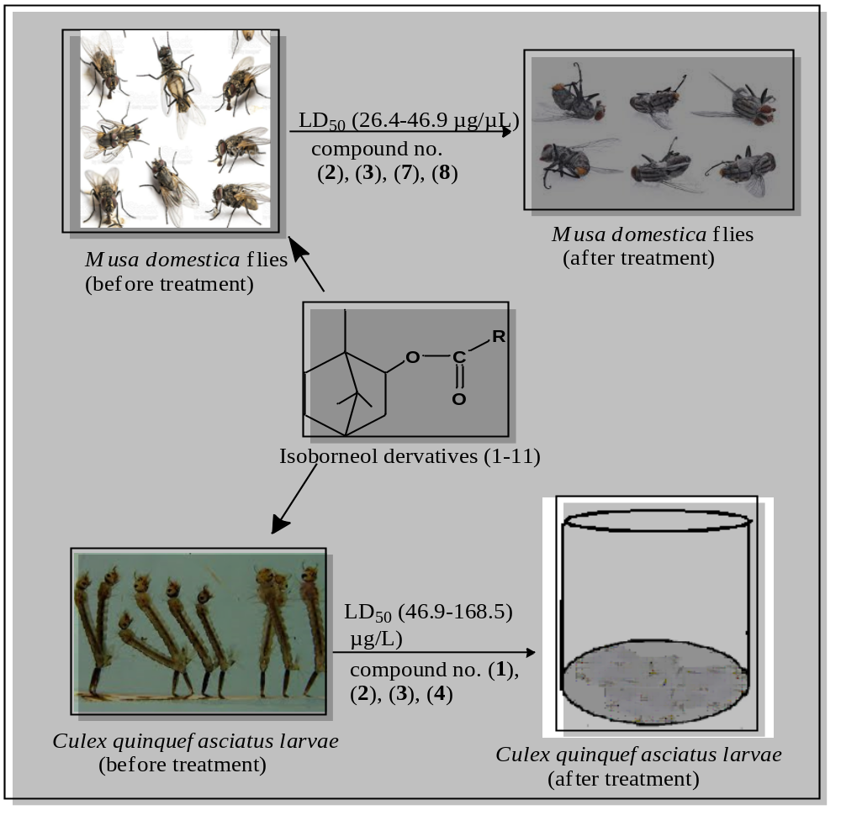

SUPPORTING INFORMATION
Sr. No. | Topic | Page No.
1. | ¹H NMR (500 MHz, CDCl₃) spectrum of 1 | S-7
2. | ¹³C NMR (125 MHz, CDCl₃) spectrum of 1 | S-7
3. | IR of compound 1 | S-8
4. | GCMS of compound 1 | S-8
5. | ¹H NMR (500 MHz, CDCl₃) spectrum of 2 | S-9
6. | ¹³C NMR (125 MHz, CDCl₃) spectrum of 2 | S-9
7. | IR of compound 2 | S-10
8. | GCMS of compound 2 | S-10
9. | ¹H NMR (500 MHz, CDCl₃) spectrum of 3 | S-11
10. | ¹³C NMR (125 MHz, CDCl₃) spectrum of 3 | S-11
11. | IR of compound 3 | S-12
12. | GCMS of compound 3 | S-12
13. | ¹H NMR (500 MHz, CDCl₃) spectrum of 4 | S-13
14. | ¹³C NMR (125 MHz, CDCl₃) spectrum of 4 | S-13
15. | IR of compound 4 | S-14
16. | GCMS of compound 4 | S-14
17. | ¹H NMR (500 MHz, CDCl₃) spectrum of 5 | S-15
18. | ¹³C NMR (125 MHz, CDCl₃) spectrum of 5 | S-15
19. | IR of compound 5 | S-16
20. | GCMS of compound 5 | S-16
21. | ¹H NMR (500 MHz, CDCl₃) spectrum of 6 | S-17
22. | ¹³C NMR (125 MHz, CDCl₃) spectrum of 6 | S-17
23. | IR of compound 6 | S-18
24. | GCMS of compound 6 | S-18
25. | ¹H NMR (500 MHz, CDCl₃) spectrum of 7 | S-19
26. | ¹³C NMR (125 MHz, CDCl₃) spectrum of 7 | S-19
27. | IR of compound 7 | S-20
29. | ¹H NMR (500 MHz, CDCl₃) spectrum of 8 | S-20
30. | ¹³C NMR (125 MHz, CDCl₃) spectrum of 8 | S-21
31. | IR of compound 8 | S-21
32. | ¹H NMR (500 MHz, CDCl₃) spectrum of 9 | S-22
33. | ¹³C NMR (125 MHz, CDCl₃) spectrum of 9 | S-22
34. | IR of compound 9 | S-23
35. | GCMS of compound 9 | S-23

Spectral Data:
(1,7,7-trimethylbicyclo[2.2.1]heptan-2-yl) ethyl fumarate (1)
Yield: 80 %, colorless oil.
IR (neat): ν_{max} 2956, 1725, 1644, 1456, 1391, 1369, 1298, 1259, 1153, 1051, 979 cm⁻¹.
GC (chiral) R_{t}: 30.56
¹H NMR (CDCl₃, 500 MHz): δ 0.78 (2 × s, 3H each), 0.93 (s, 3H), 0.99-1.14 (m, 1H),
1.25 (t, 3H) (J = 7.2 Hz), 1.46-1.54 (m, 1H), 1.62-1.81 (m, 4H), 4.18 (q, 2H) (J = 7.2
Hz), 4.70 (dd, 1H) (J = 7.2, 3.2 Hz), 6.70, 6.76 (2 × d, 1H each) (J = 15.6 Hz).
¹³C NMR (CDCl₃, 125 MHz): δ 11.4, 14.1, 19.9, 20.0, 26.9, 31.5, 38.4, 45.0, 46.9,
48.9, 61.3, 82.1, 133.1, 134.1, 164.4, 165.0.
GCMSm/z: 280.8 (M+), 235.1, 207.1, 152.9, 127.0, 93.0, 67.0, 44.0.

1,7,7-trimethylbicyclo [2.2.1] heptane-2-yl 3-methyl butanoate (2)
Yield: 88 %, pale yellow oil.
IR (neat): ν_{max} 2873, 1733, 1455, 1389, 1370, 1295, 1257, 1183, 1053, 1014 cm⁻¹.
GC (chiral) R_{t}: 22.92
¹H NMR(CDCl₃, 500 MHz): δ 0.83, 0.84 (2 × s, 3H each), 0.94, 0.95 (2 × d, 3H each) (J = 6.5Hz), 0.97 (s, 3H), 1.04-1.09 (m, 1H), 1.12-1.17 (m, 1H), 1.52-1.56 (m, 1H), 1.65-1.72 (m, 3H), 1.79-1.83 (m, 1H), 2.05-2.13 (m, 1H), 2.15 (dd, 2H) (J = 2.5,
1.0 Hz), 4.65 (dd, 1H) (J = 7.5, 3.5 Hz).
¹³C NMR (CDCl₃, 125 MHz): δ11.6, 20.3, 22.6, 25.9, 27.2, 33.9, 39.1, 44.1, 45.2, 47.1, 80.9, 172.8.
GCMS(m/z): 232.2 (M+), 197.1, 181.1, 153.1, 137.1, 121.1, 105.1, 85.1, 57.1, 48.1.

1,7,7-trimethylbicyclo[2.2.1]heptan-2-yl isobutyrate (3)
Yield: 90 %, pale yellow oil.
IR (neat): ν_{max} 2956, 1736, 1470, 1456, 1389, 1370, 1261, 1186, 1157, 1071, 1053, 1011, 973 cm⁻¹.
GC (chiral) R_{t}: 25.80
¹H NMR (CDCl₃, 500 MHz): δ 0.82 (s, 6H), 0.97 (s, 3H), 1.12 (d, 3H) (J = 7 Hz), 1.13 (d, 3H) (J = 7 Hz), 1.53-1.55 (m, 2H), 1.67-1.71 (m, 3H), 1.76-1.80 (m, 1H), 2.47-2.50 (m, 1H), 4.63 (dd, 1H) (J = 8.5, 3.5 Hz)
¹³C NMR (CDCl₃, 125 MHz): δ 11.5, 19.1, 20.2, 26.7, 27.2, 33.9, 34.5, 36.5, 38.9, 41.1, 45.2, 47.4, 80.6, 176.6.
GCMSm/z:224.0 (M⁺), 181.1, 136.1, 95.1, 71.1, 43.1.

1,7,7-Trimethylbicyclo[2.2.1]heptan-2-yl cyclohexanecarboxylate (4)
Yield: 85 %, colorless oil.
IR (neat): ν_{max} 2935, 1727, 1425, 1389, 1371, 1247, 1172, 1133, 1054, 1021, 758 cm⁻¹.
GC (chiral) R_{t}: 37.93.
¹H NMR (CDCl₃, 400 MHz): δ 0.76 (s, 6H), 0.92 (s, 3H), 0.95-1.13 (m, 2H), 1.14-1.28
(m, 3H), 1.29-1.41 (m, 2H), 1.42-1.52 (m, 1H), 1.53-1.62 (m, 2H), 1.63-1.71 (m, 4H),
1.79-1.89 (m, 2H), 2.12-2.31 (m, 1H), 4.58 (dd, 1H) (J = 8, 3.2 Hz).
¹³C NMR (CDCl₃, 100 MHz): δ10.4, 18.9, 19.1, 24.4, 24.8, 26.0, 27.8, 28.0, 28.1, 30.5, 36.3, 41.7, 44.0, 46.2, 47.6, 79.3, 174.5.
GCMS(m/z): 268.0 (M+), 243.1, 225.2, 202.1, 177.1, 155.1, 17.1, 105.1, 81.1, 63.0, 41.1.

1,7,7-Trimethylbicyclo[2.2.1]heptan-2-yl 2-(m-tolyl) acetate (5)
Yield: 83 %, colorless oil.
IR (neat): ν_{max} 2954, 1728, 1455, 1390, 1310, 1258, 1153, 1052, 1013, 747 cm⁻¹.
GC (chiral) R_{t}: 37.85
¹H NMR (CDCl₃, 400 MHz): δ 0.63 (s, 3H), 0.67 & 0.69 (2 × s, 3H each), 0.90-1.09 (m, 2H), 1.38-1.48 (m, 1H), 1.53-1.60 (m, 3H), 2.24 (s, 3H), 3.53 (s, 2H), 4.58 (dd, 1H) (J = 6.0 Hz, 3 Hz), 7.06 (m, 4H).
¹³C NMR (CDCl₃, 100 MHz): δ 11.2, 19.5, 19.6, 20.0, 27.0, 33.6, 38.7, 39.7, 44.9, 46.8, 48.6, 81.3, 126.0, 127.2, 130.2, 133.1, 133.6, 170.9.
GCMS(m/z): 286.1 (M+), 207.1, 162.9, 137.1, 105.0, 81.0, 62.9, 41.1.

1,7,7-Trimethylbicyclo[2.2.1]heptan-2-yl thiophene-2-carboxylate (6)
Yield: 85 %, colorless liquid
IR (neat): ν_{max} 2954, 1709, 1526, 1455, 1418, 1390, 1370, 1358, 1311, 1225, 1188, 1094, 1078, 1050, 1036, 1001, 965, 860, 848 cm⁻¹.
GC (chiral) R_{t}: 32.13.
¹H NMR (CDCl₃, 400 MHz): δ 0.86 (s, 3H), 0.91 (s, 3H), 1.09 (s, 3H), 1.17-1.23(m, 1H), 1.55-1.62 (m, 2H), 1.75-1.78 (m, 2H), 1.88 (m, 2H), 4.86 (t, 1H) (J = 6 Hz), 7.08 (t, 1H) (J = 4.4 Hz), 7.51 (d, 1H) (J = 4 Hz), 7.75 (d, 1H) (J = 4 Hz).
¹³C NMR (CDCl₃, 100 MHz): δ 11.6, 20.0, 20.6, 25.7, 33.7, 38.9, 45.1, 47.1, 49.1, 82.0, 127.8, 132.1, 133.0, 134.7, 161.8
GCMS(m/z): 264.1 (M+), 246.1, 221.1, 193.1, 175.0, 155.0, 136.1, 111.0, 93.1, 67.1, 41.1.

(4-Methoxyphenyl)(1,7,7-trimethylbicyclo[2.2.1]heptan-2-yl)sulfane (7)
Yield: 84 %, white solid.
Mp.: 81-83 °C.
IR(CHCl₃): ν_{max}2963, 1591, 1570, 1491, 1460, 1440, 1388, 172, 1284, 1245, 1216, 1172, 1103, 1032, 873, 757 cm⁻¹.
GC (chiral) R_{t}: 39.39.
¹H NMR (CDCl₃, 500 MHz): δ1.01 (s, 3H), 1.20 (s, 3H), 1.29 (s, 3H), 1.61-1.79 (m, 4H), 1.92-2.00 (m, 2H), 2.53 (d, 1H) (J = 7 Hz), 3.80 (s, 3H), 6.83 (d, 2H) (J = 9 Hz), 7.41 (d, 2H) (J = 8.5 Hz).
¹³C NMR (CDCl₃, 125 MHz): δ14.3, 22.5, 24.0, 24.1, 27.9, 35.7, 49.2, 51.8, 55.4, 58.9, 61.9, 114.0, 114. 5, 125.2, 132.8, 139.5, 160.2.

Methyl 2-((1,7,7-trimethylbicyclo[2.2.1]heptan-2-yl)thio)acetate (8)
Yield: 72 %, white liquid.
IR(neat): ν_{max}2953, 1736, 1435, 1389, 1374, 1275, 1129, 1105, 1013, 931 cm⁻¹.
GC (chiral) R_{t}: 38.87.
¹H NMR (CDCl₃, 400 MHz): δ0.92 (s, 3H), 0.93 (s, 3H), 1.13 (s, 3H), 1.50-1.59 (m, 4H), 2.01-2.28 (m, 3H), 2.75 (dd, 1H) (J = 6 Hz, 3.2 Hz), 3.17 (s, 2H), 3.65 (s, 3H).
¹³C NMR (CDCl₃, 100 MHz): δ13.7, 20.1, 20.4, 21.8, 31.8, 32.6, 35.8, 44.2, 49.5, 52.4, 54.7, 59.2, 171.7.

2-(2,4-dichloro phenoxy)-1,7,7-trimethylbicyclo[2.2.1]heptane(9)
Yield: 80 %, pale-yellow liquid.
IR (neat): ν_{max} 2954, 1587, 1479, 1390, 1373, 1313, 1285, 1263, 1245, 1215, 1187,
1102, 1063, 1007, 972, 802 cm⁻¹.
GC (chiral) R_{t}: 33.2
¹H NMR (CDCl₃, 400 MHz): δ 0.91 (s, 3H), 0.97 (s, 3H), 1.03 (s, 3H), 1.65-1.79 (m, 2H), 1.79-1.81 (m, 1H), 1.82-1.83 (m, 2H), 2.27-2.28 (m, 2H), 4.04 (t, 1H) (J = 6.5 Hz), 6.77 (d, 1H) (J = 9.2 Hz), 7.18 (d, 1H) (J = 9.2 Hz), 7.33 (s, 1H).
¹³C NMR (CDCl₃, 100 MHz): δ 11.9, 20.3, 20.4, 27.7, 34.1, 39.6, 45.4, 48.4, 51.0, 85.9, 114.3, 116.7, 124.8, 127.3, 130.1, 152.5
GCMS(m/z): 298.1 (M+), 269.1, 243.1, 215.0, 187.9, 161.9, 137.1, 109.1, 81.1, 62.0, 41.1.

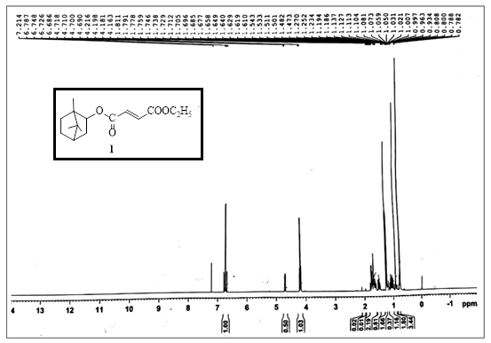
¹H NMR (500 MHz, CDCl₃) spectrum of 1
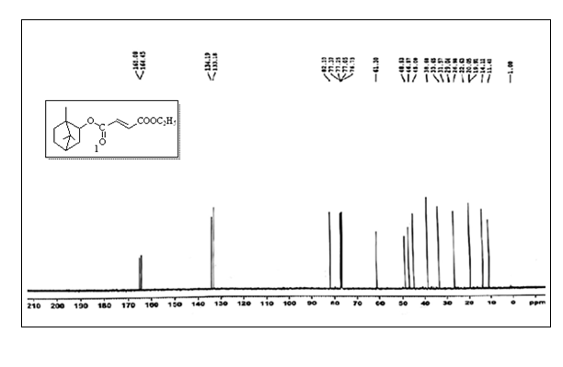
¹³C NMR (125 MHz, CDCl₃) spectrum of 1
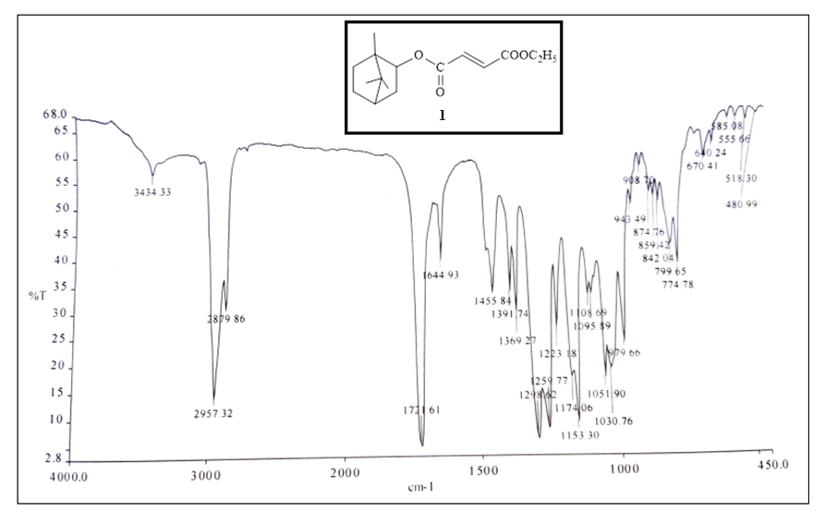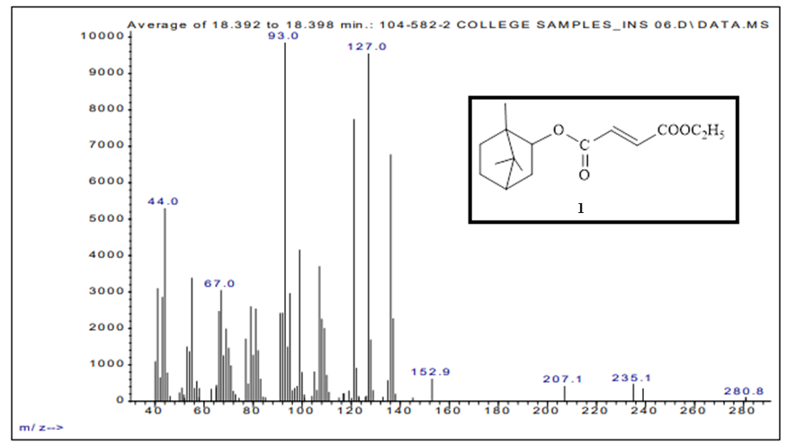
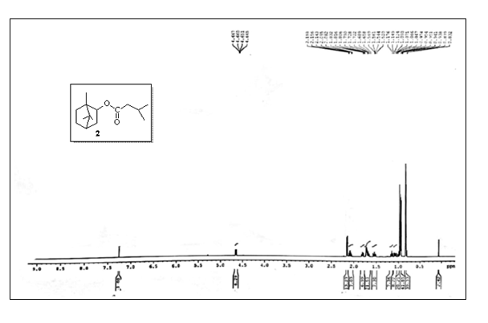
¹H NMR (500 MHz, CDCl₃) spectrum of 2
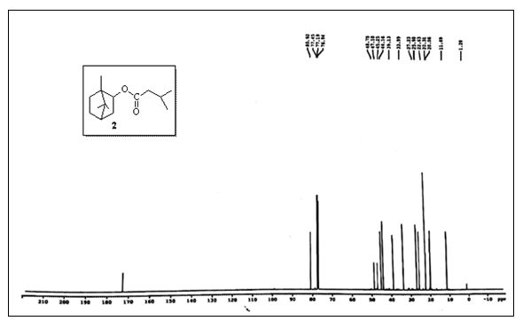
¹³C NMR (500 MHz, CDCl₃) spectrum of 2
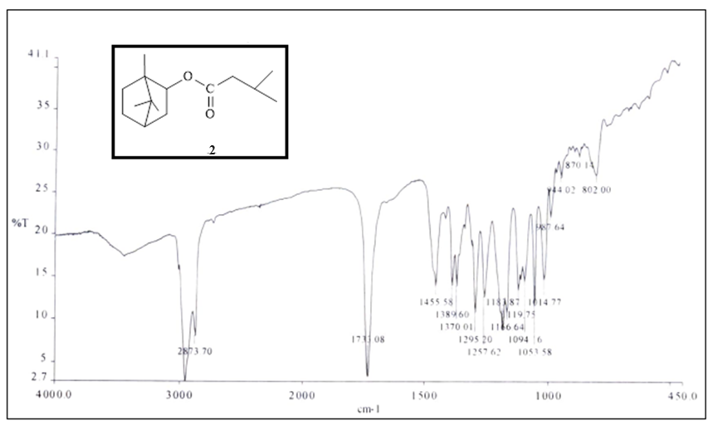
IR of compound 2
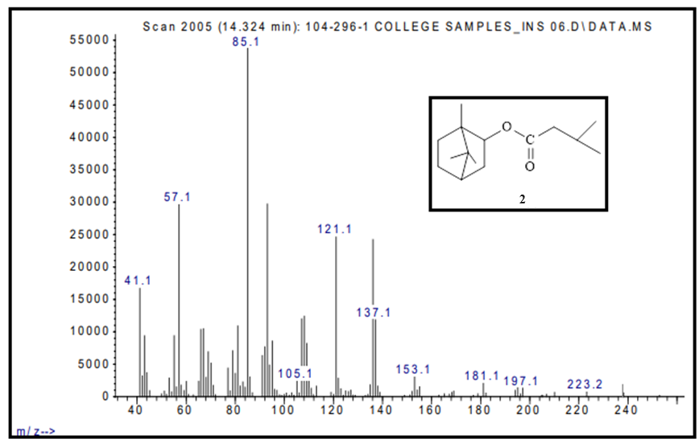
GCMS of compound 2
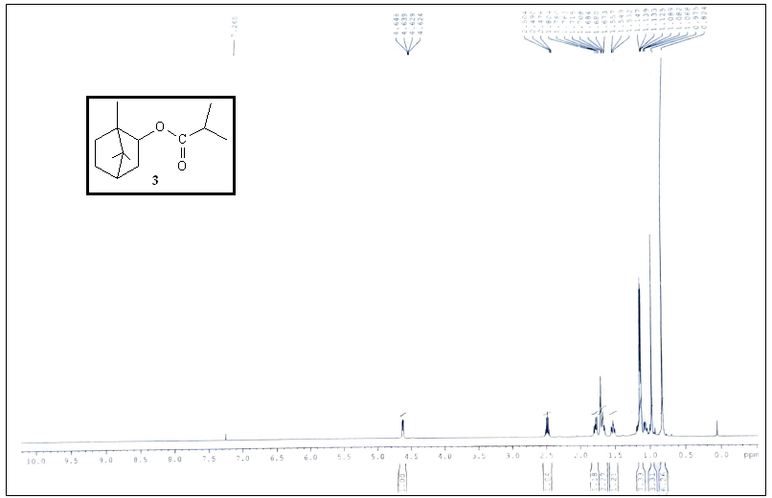
¹H NMR (500 MHz, CDCl₃) spectrum of 3
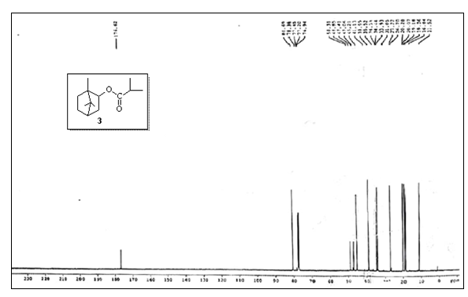
¹³C NMR (500 MHz, CDCl₃) spectrum of 3
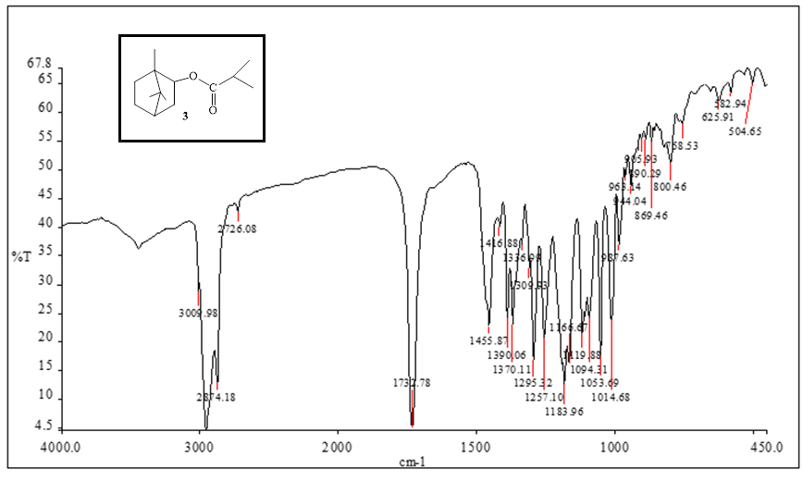
IR of compound 3
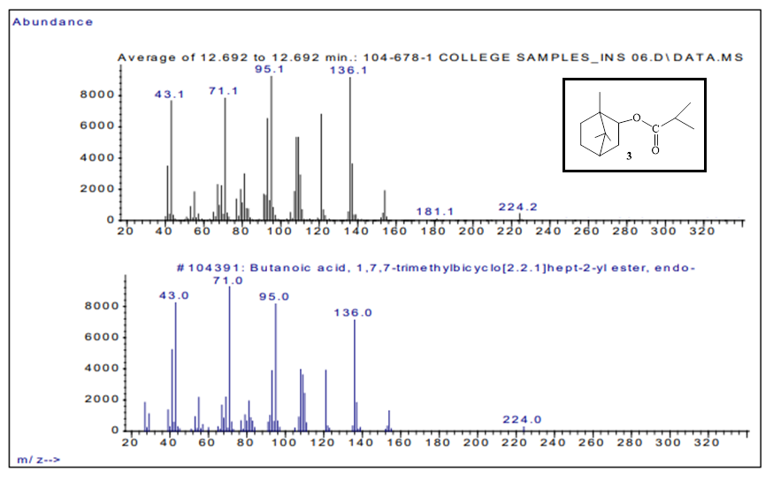
GCMS of compound 3
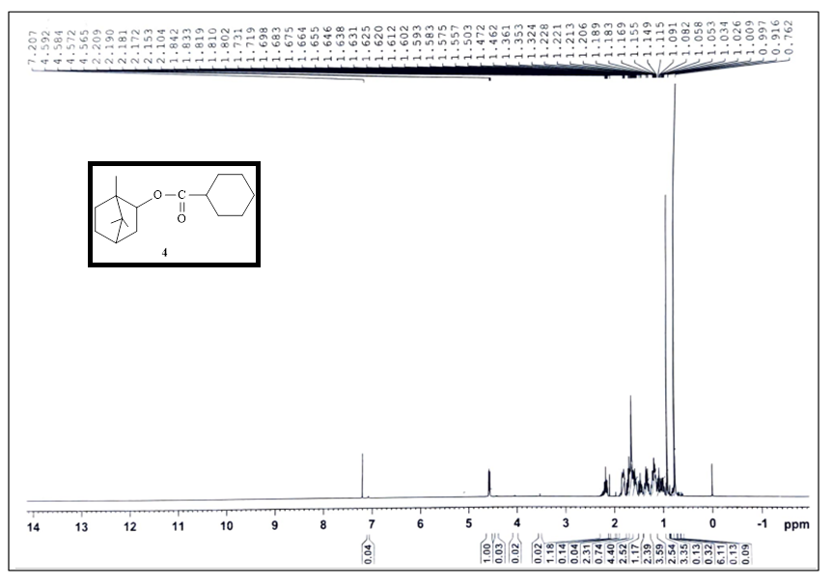
¹H NMR (500 MHz, CDCl₃) spectrum of 4
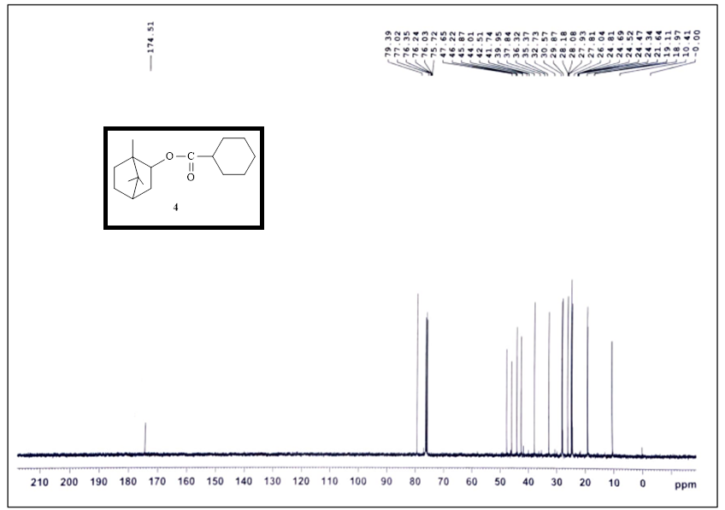
¹³C NMR (125 MHz, CDCl₃) spectrum of 4
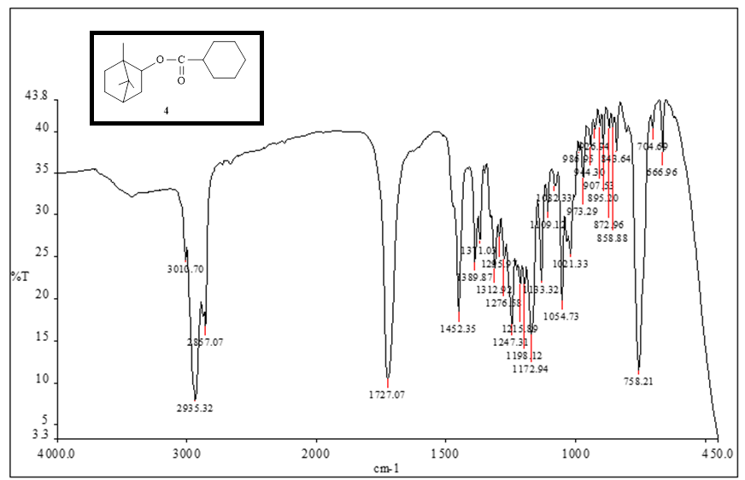
IR of compound 4
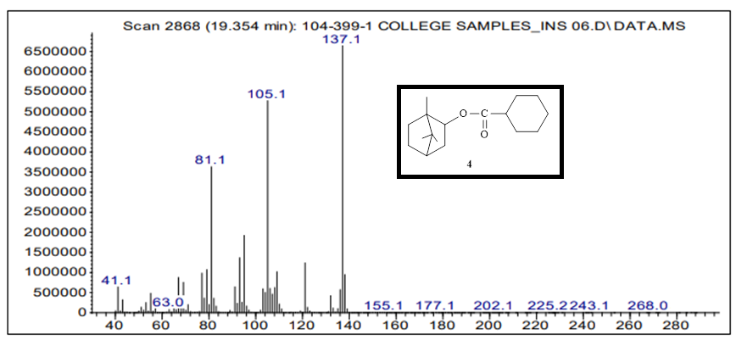
GCMS of compound 4
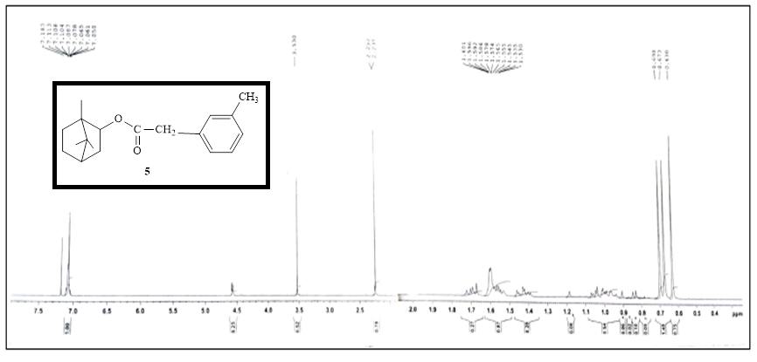
¹H NMR (500 MHz, CDCl₃) spectrum of 5
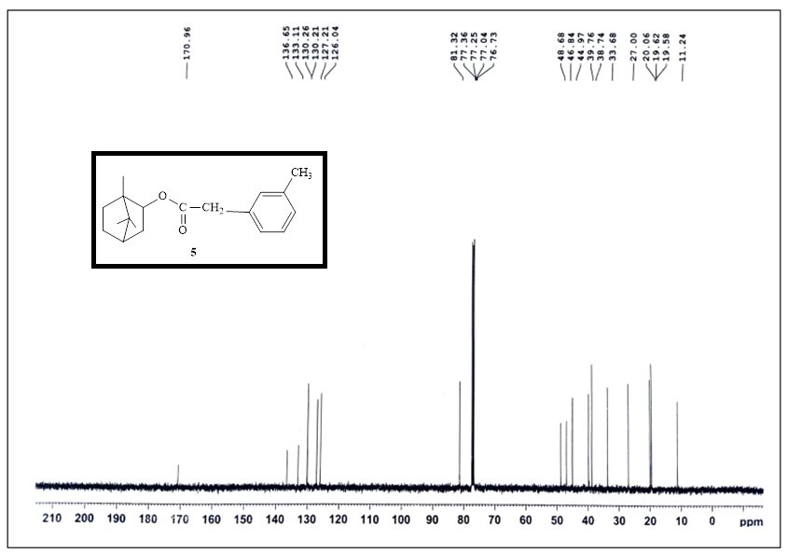
¹³C NMR (125 MHz, CDCl₃) spectrum of 5

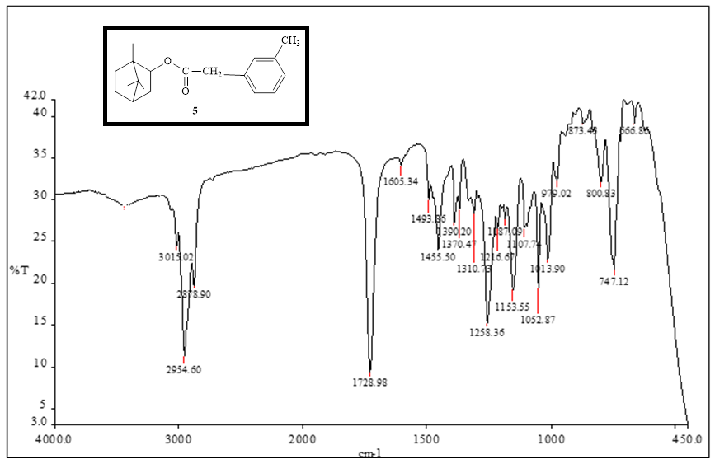
IR of compound 5
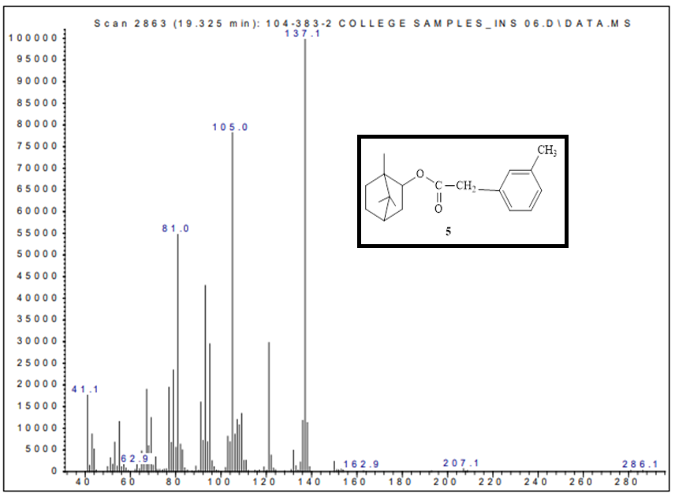
GCMS of compound 5
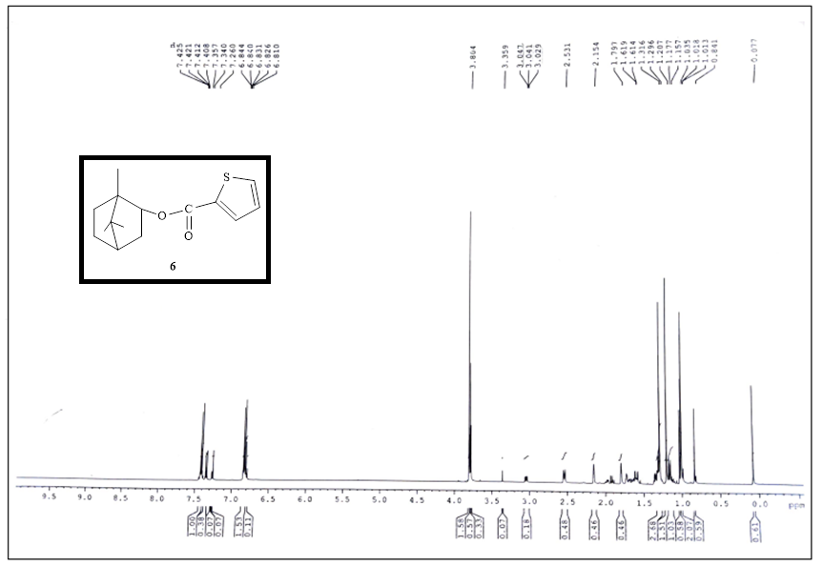
¹H NMR (500 MHz, CDCl₃) spectrum of 6
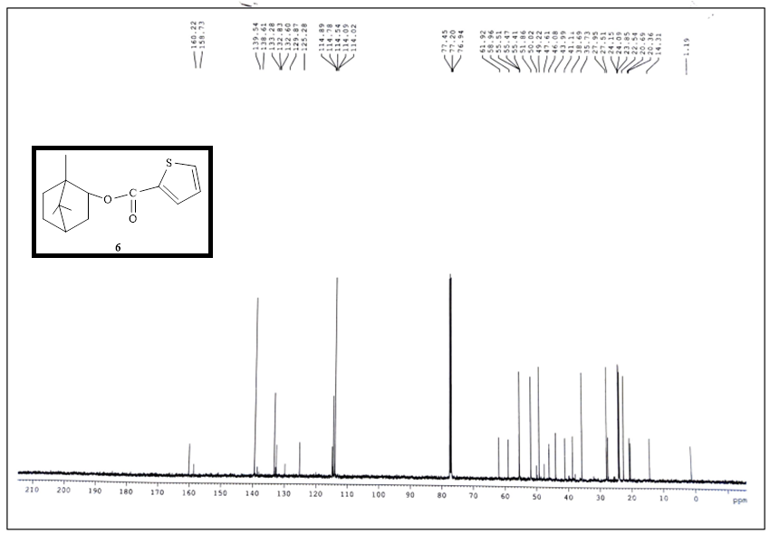
¹³C NMR (500 MHz, CDCl₃) spectrum of 6
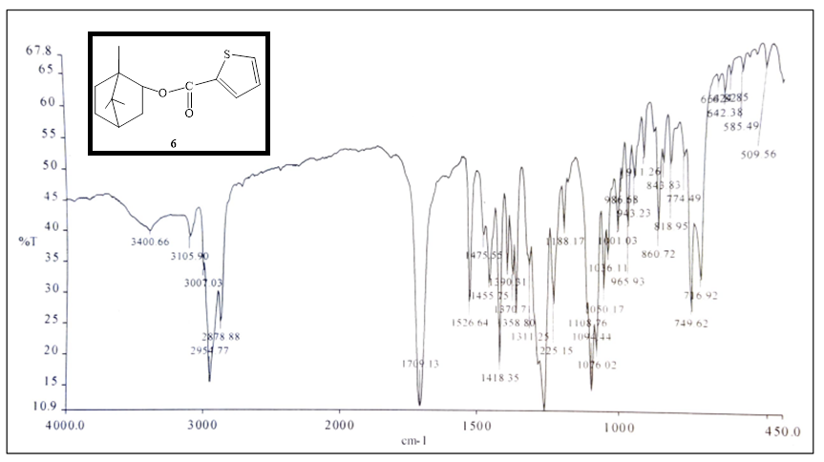
IR of compound 6

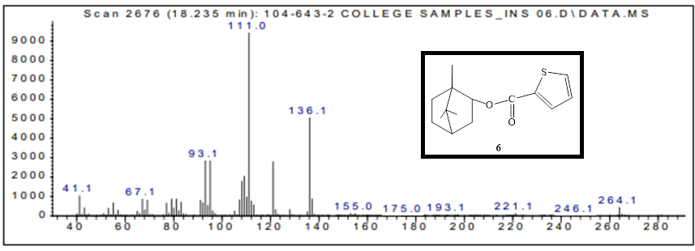
GCMS of compound 6

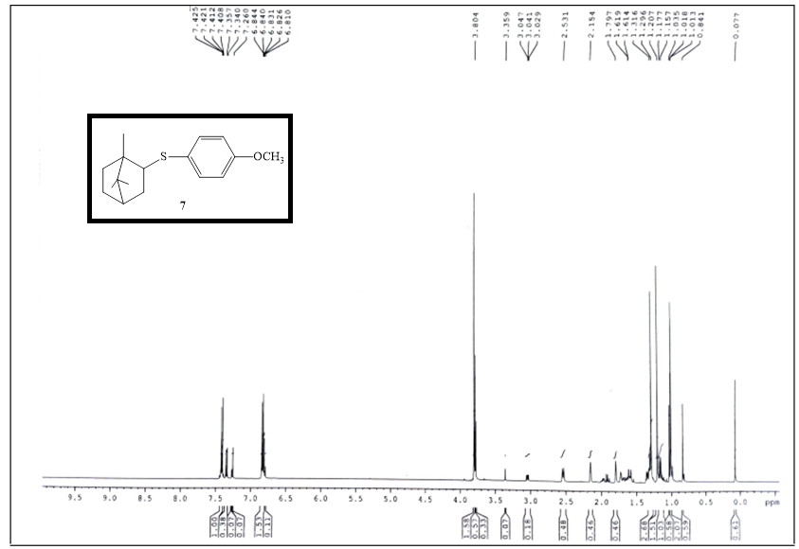
¹H NMR (500 MHz, CDCl₃) spectrum of 7
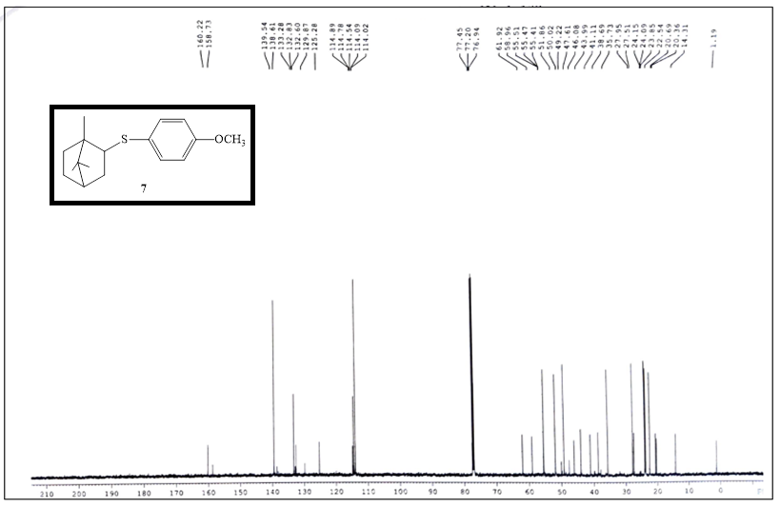
¹³C NMR (125 MHz, CDCl₃) spectrum of 7
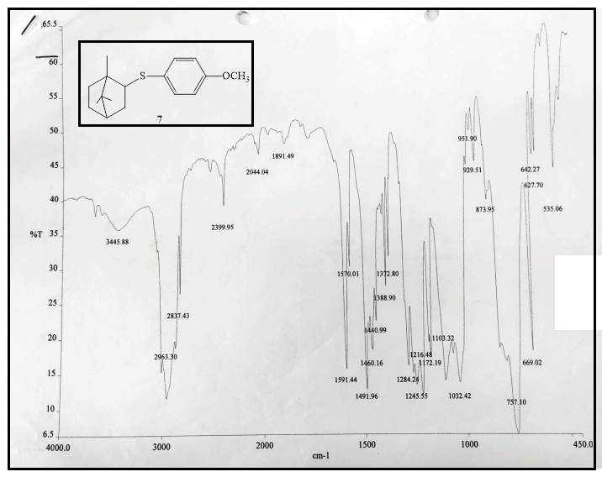
IR of compound 7
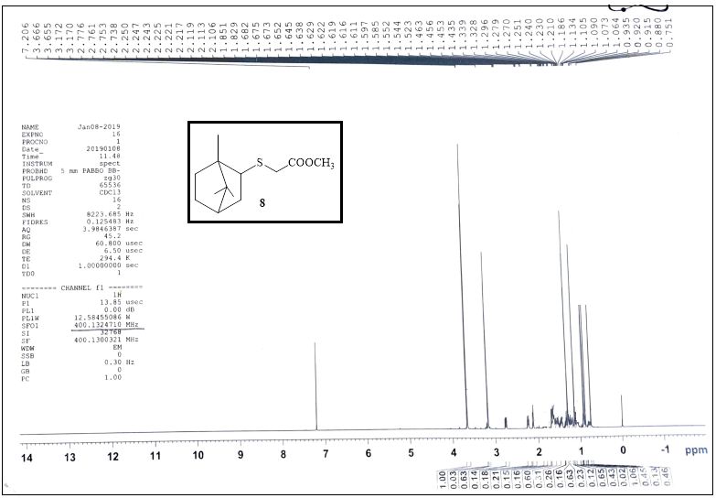
¹H NMR (500 MHz, CDCl₃) spectrum of 8
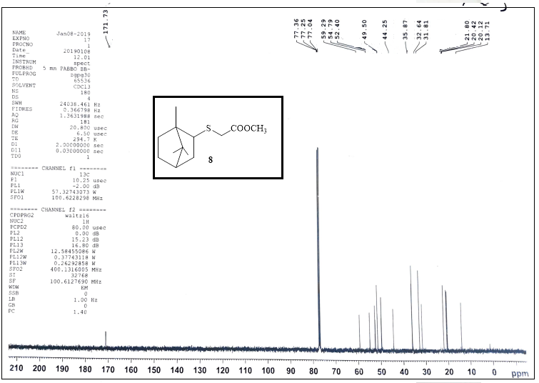
¹³C NMR (500 MHz, CDCl₃) spectrum of 8
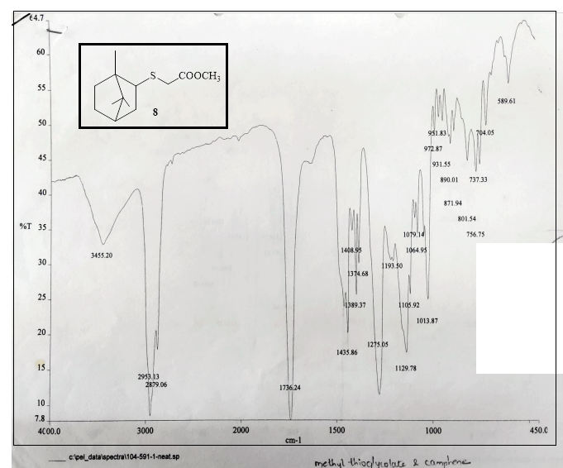
IR of compound 8

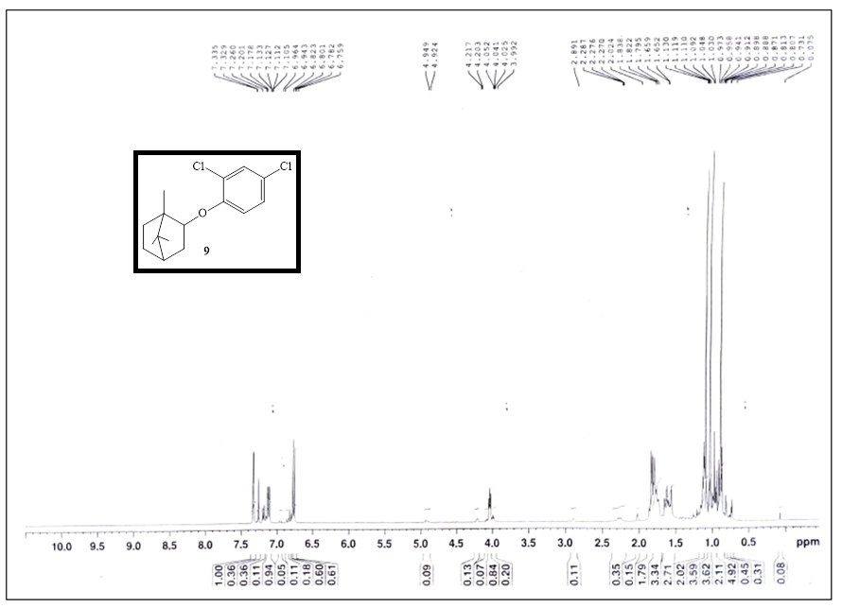
¹H NMR (500 MHz, CDCl₃) spectrum of 9
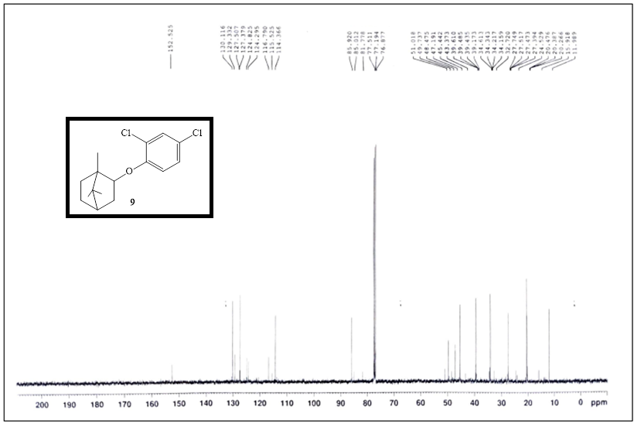
¹³C NMR (500 MHz, CDCl₃) spectrum of 9
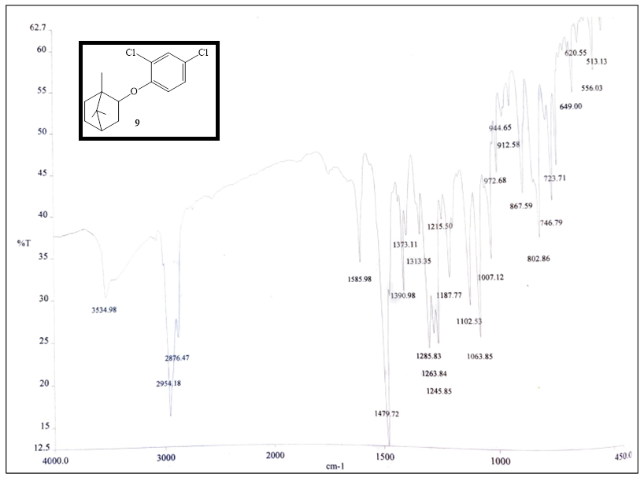
IR of compound 9
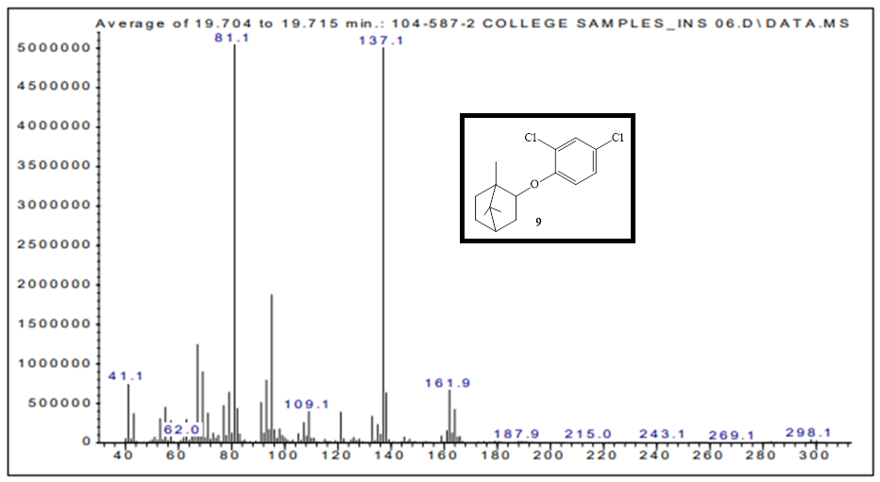
GCMS of compound 9

