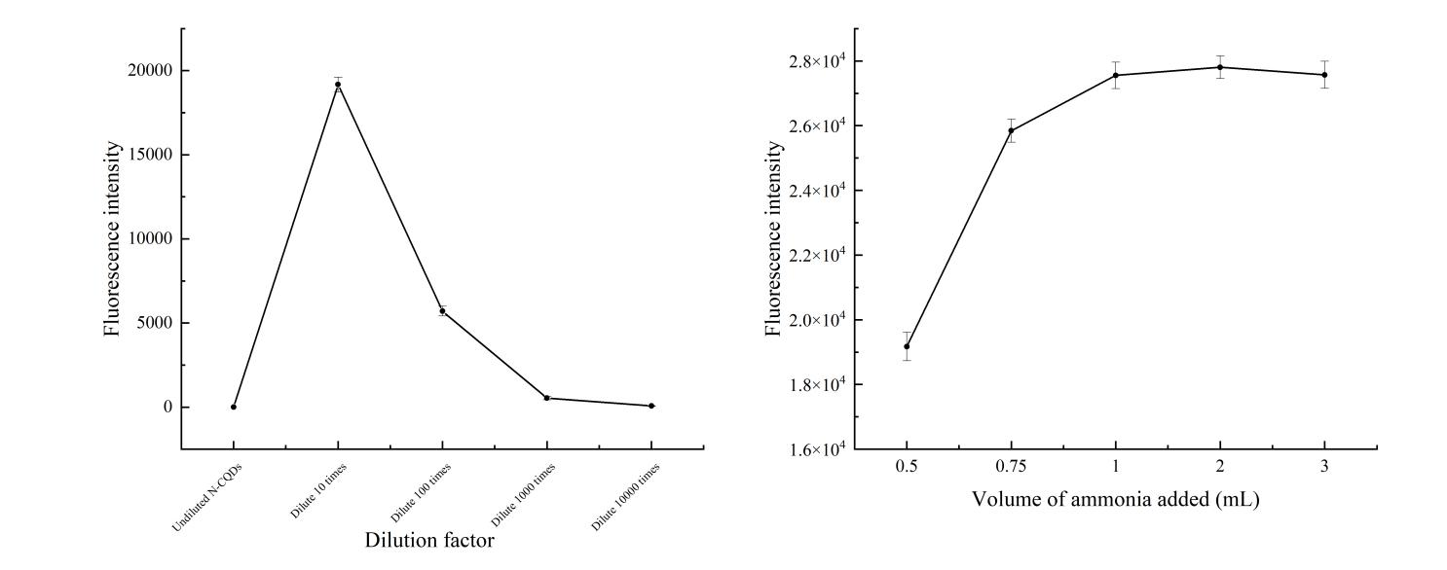
Suppl. Fig. 1 Effect of dilution (left) and ammonia addition (right) on the fluorescence intensity of N-CQDs

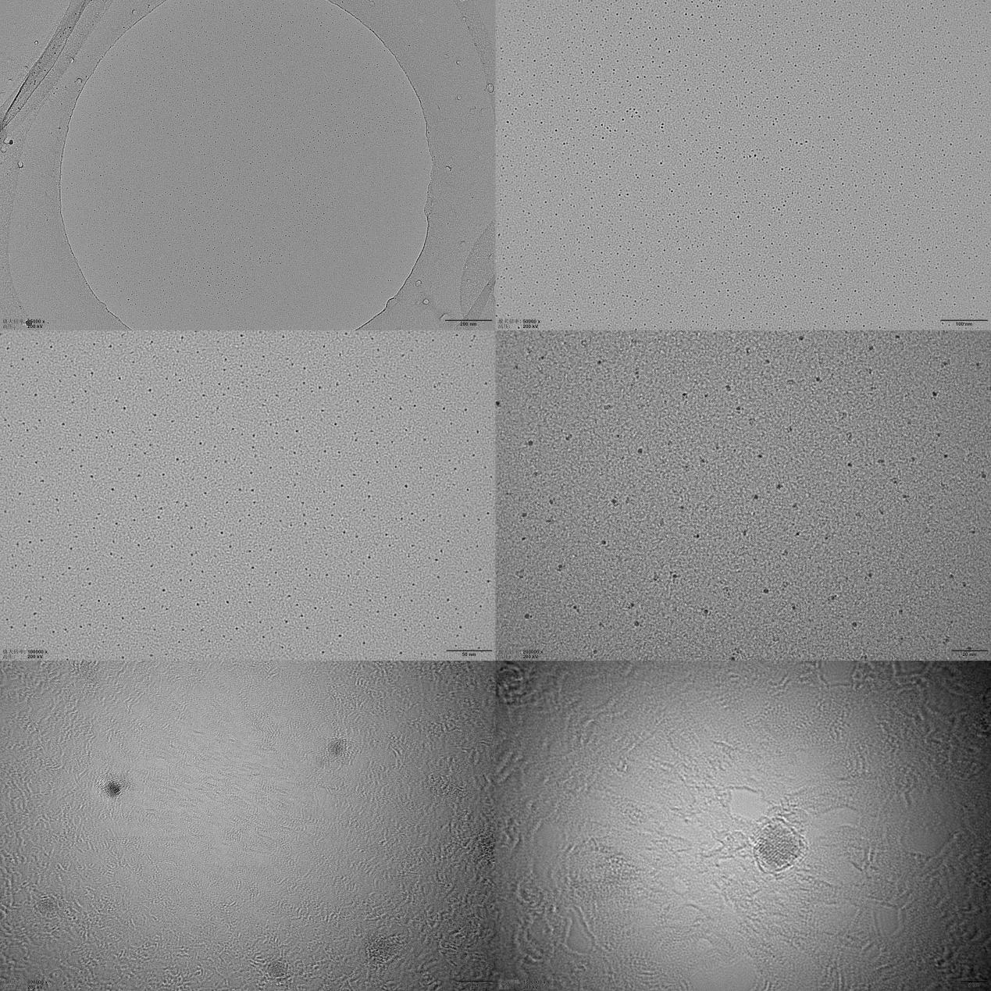
Suppl. Fig. 2 Transmission electron micrograph of N-CQDs

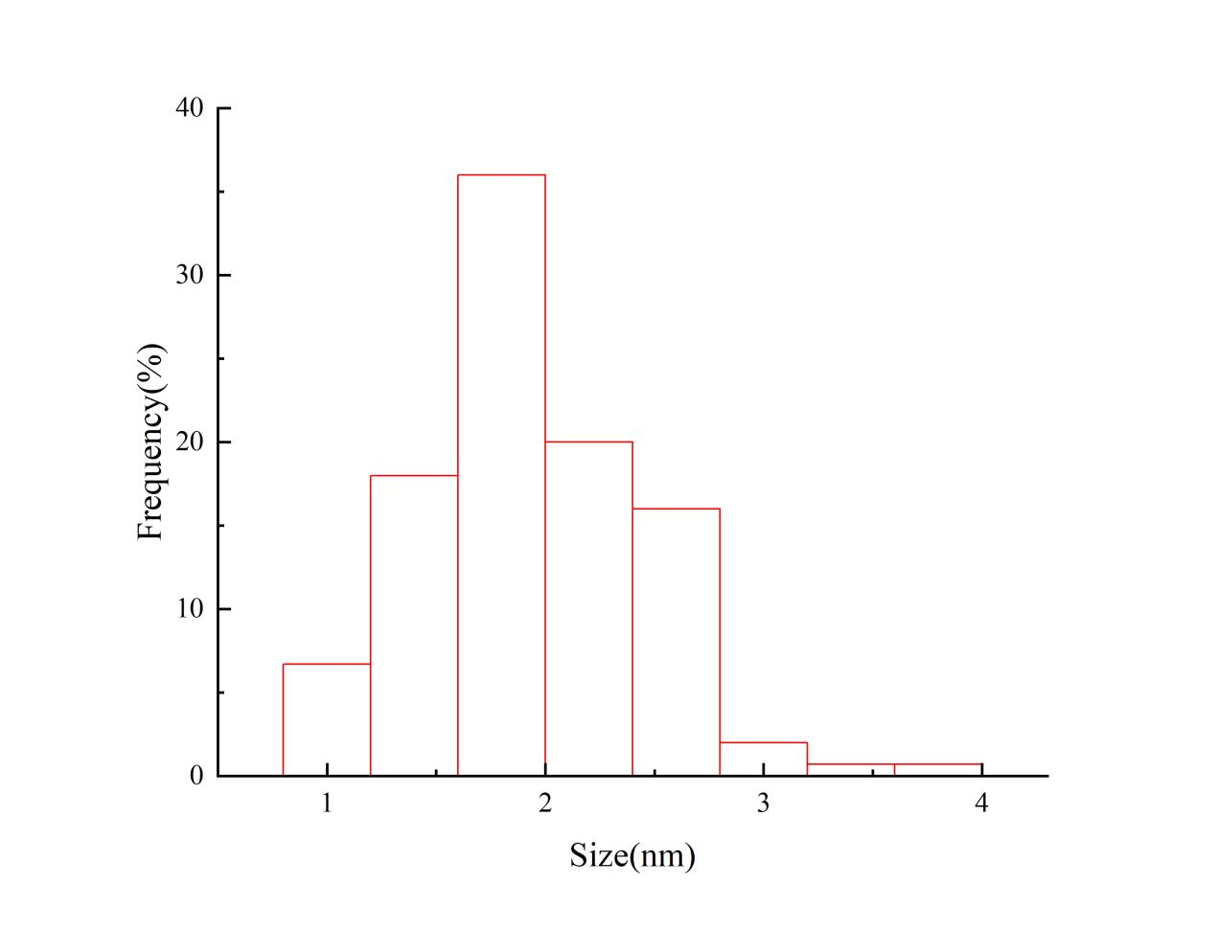
Suppl. Fig. 3 Particle size distribution of N-CQDs

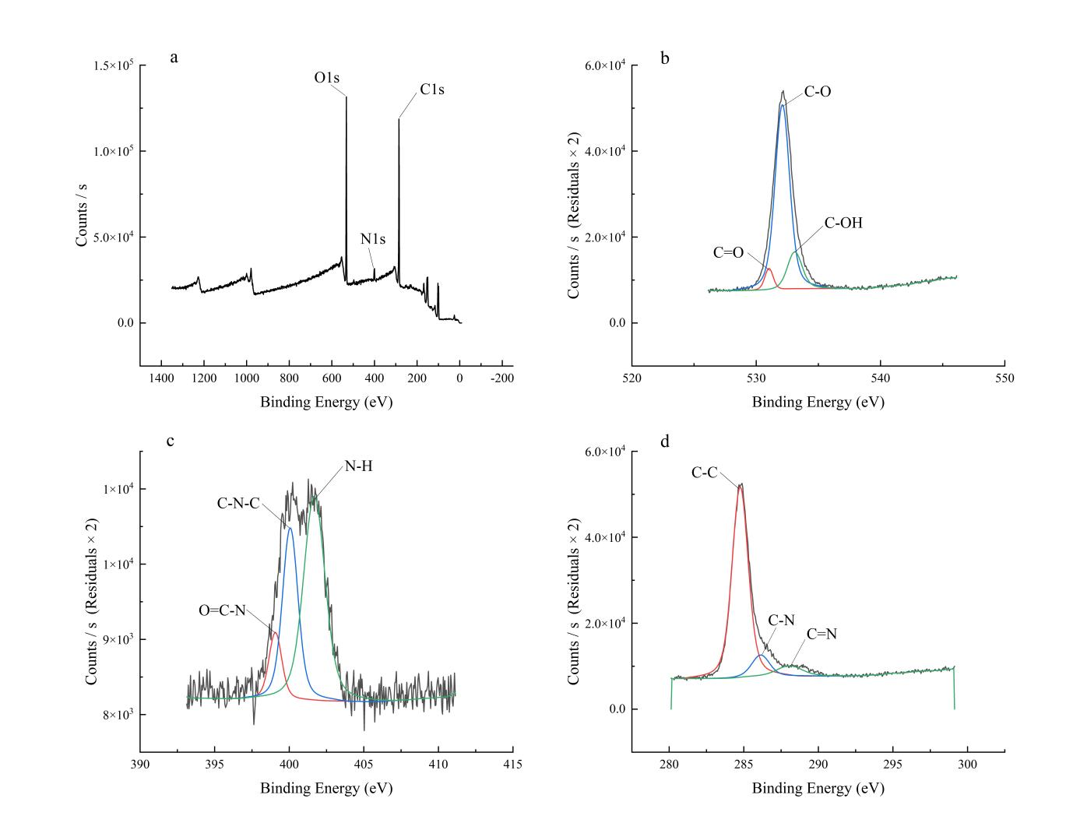
Suppl. Fig. 4 X-ray photoelectron spectrometer of N-CQDs

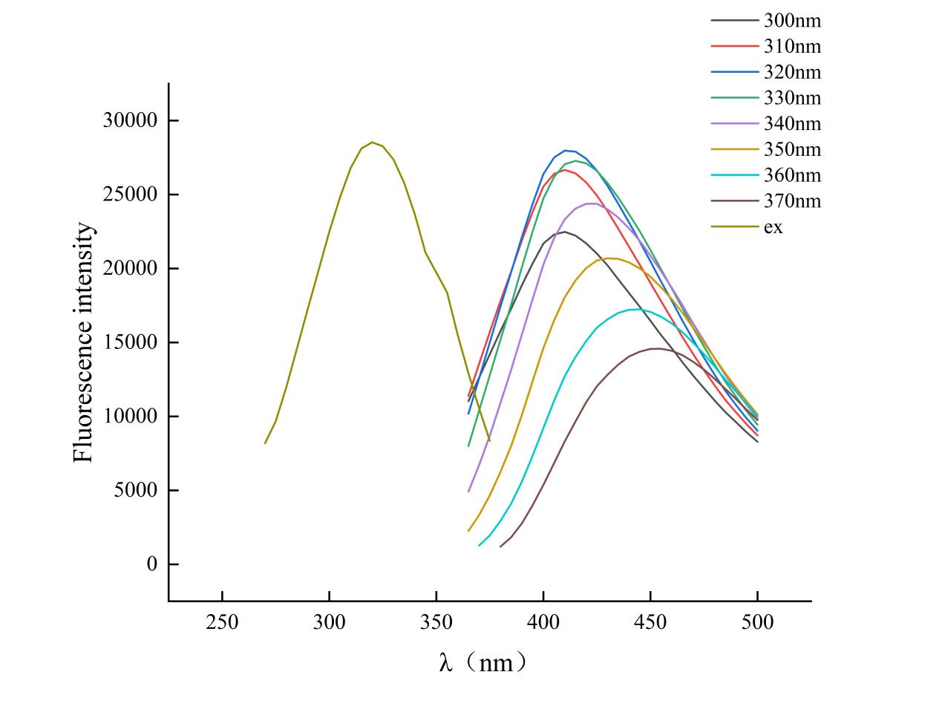
Suppl. Fig. 5 Fluorescence spectrogram of N-CQDs

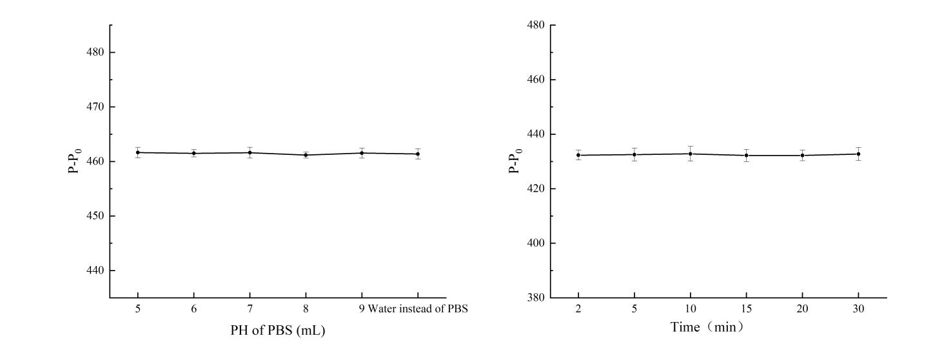
Suppl. Fig. 6 Effect of addition of supplemental solution (left) and resting time (right) on the change of fluorescence intensity of N-CQDs

Suppl.Table 1 Fluorescence intensity of N-CQDs after different storage times
Days | Fluorescence intensity of N-CQDs
1 | 27953.3±22.55
3 | 27884.3±75.20
5 | 27878.4±19.42
10 | 27664.8±7.41
15 | 27579.6±13.70
20 | 27155.97±34.69
25 | 26615.2±31.58
30 | 26031.27±30.59

