Preparation of NiFeCoMnCr Hydroxide on Nickel Foam by Corrosion Method and its Enhanced Electrochemical Performance in Oxygen Evolution Reaction
Hyein Lee, Han Minho, Noh Heejin, Taekyung Yu*
Department of Chemical Engineering, College of Engineering, Integrated Engineering Major, Kyung Hee University, Yongin 17140, Korea.
* Corresponding Author: tkyu@khu.ac.kr (T. Y.)

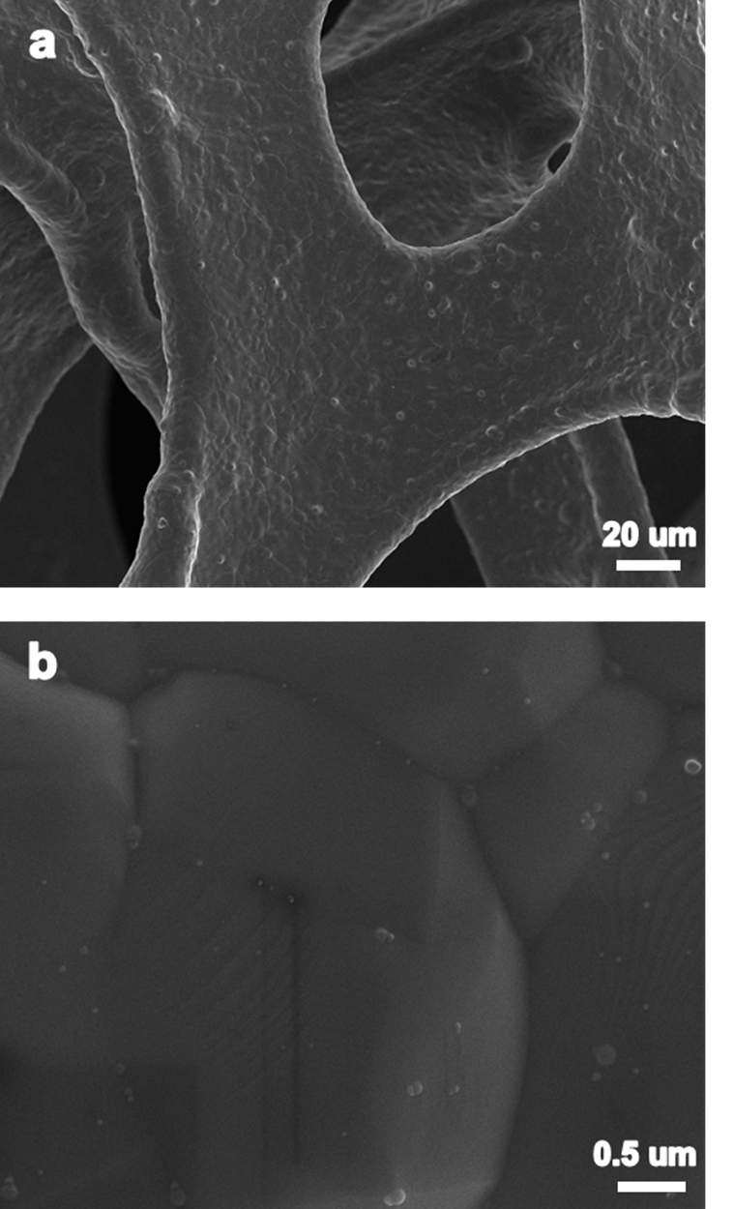
Figure S1. a) Typical and b) high-resolution SEM images of bare Ni foam.

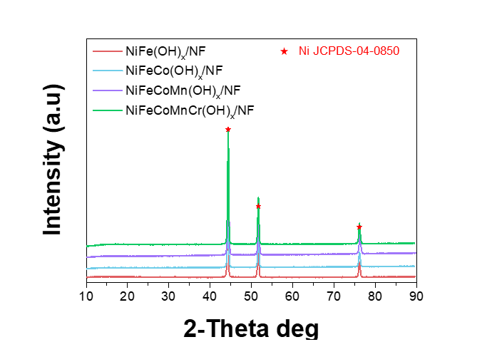
Figure S3. XRD patterns of the synthesized samples.
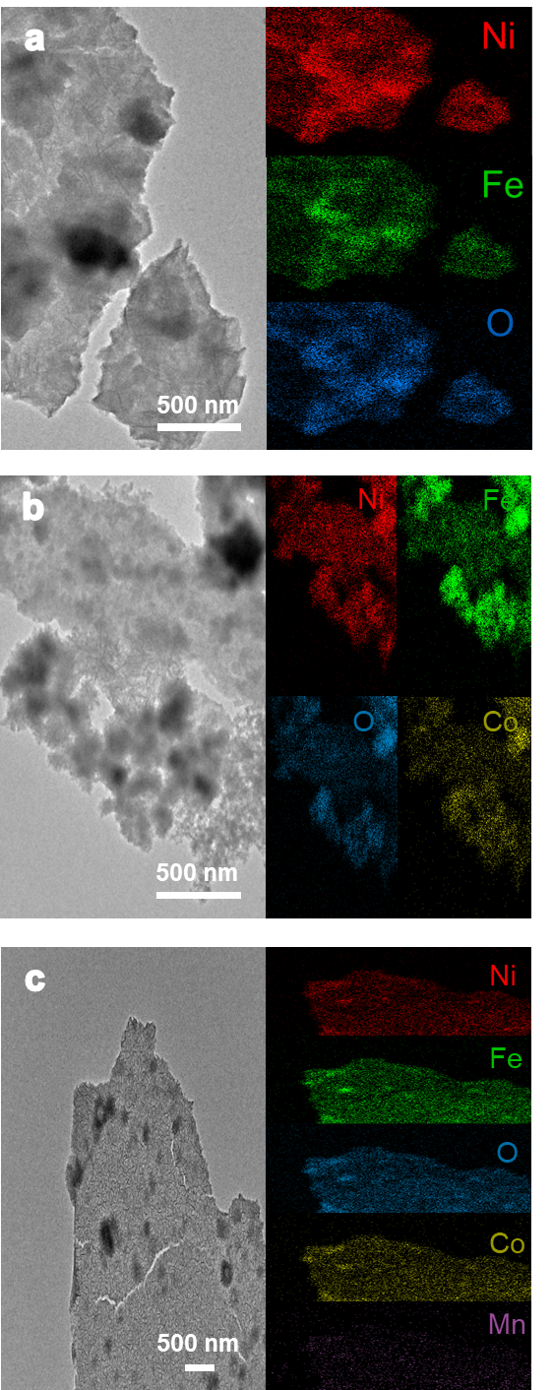
Figure S4. TEM and EDX elemental mapping images of the a) NiFe(OH)x/NF, b) NiFeCo(OH)x/NF, and c) NiFeCoMn(OH)x/NF.

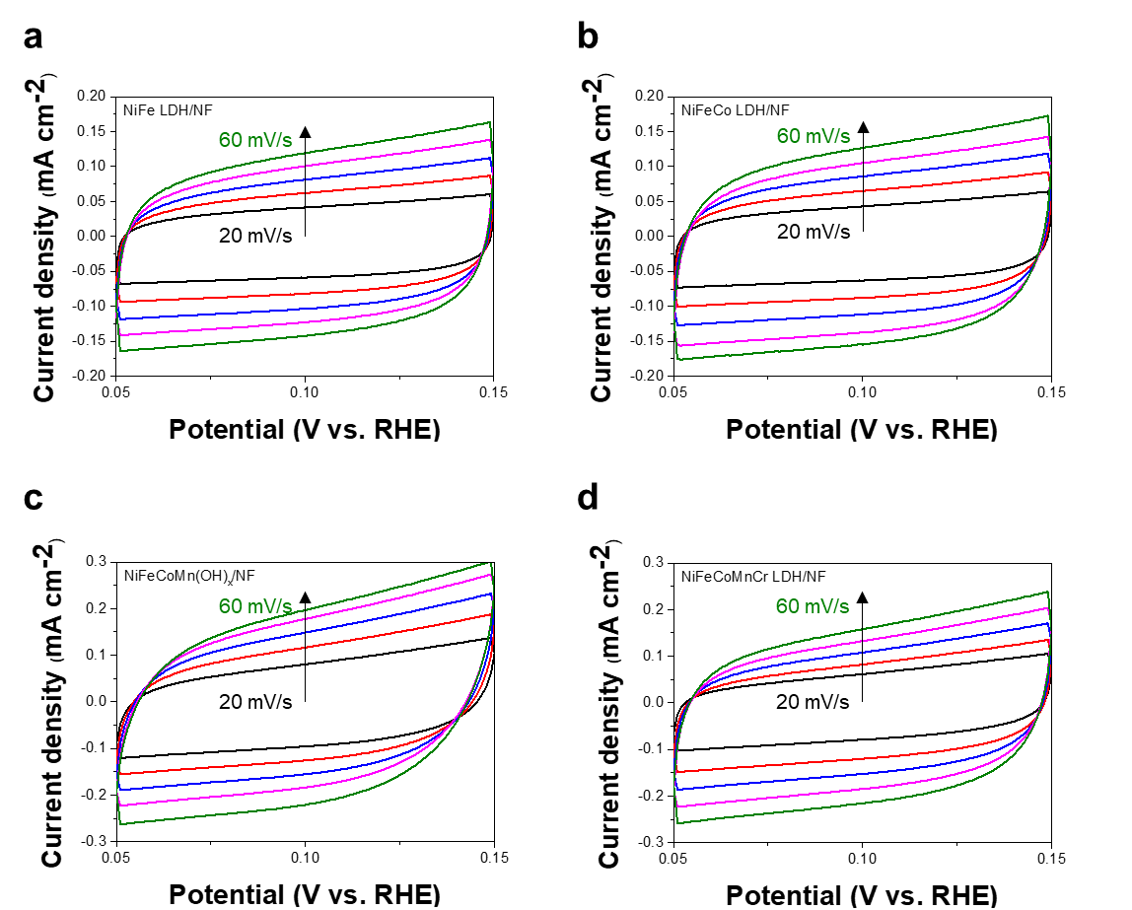
Figure S5. Cyclic voltammetry curves of the a) NiFe(OH)_{x}/NF, b) NiFeCo(OH)_{x}/NF, C) NiFeCoMn(OH)_{x}/NF, and d) NiFeCoMnCr(OH)_{x}/NF in non-faradaic regions.

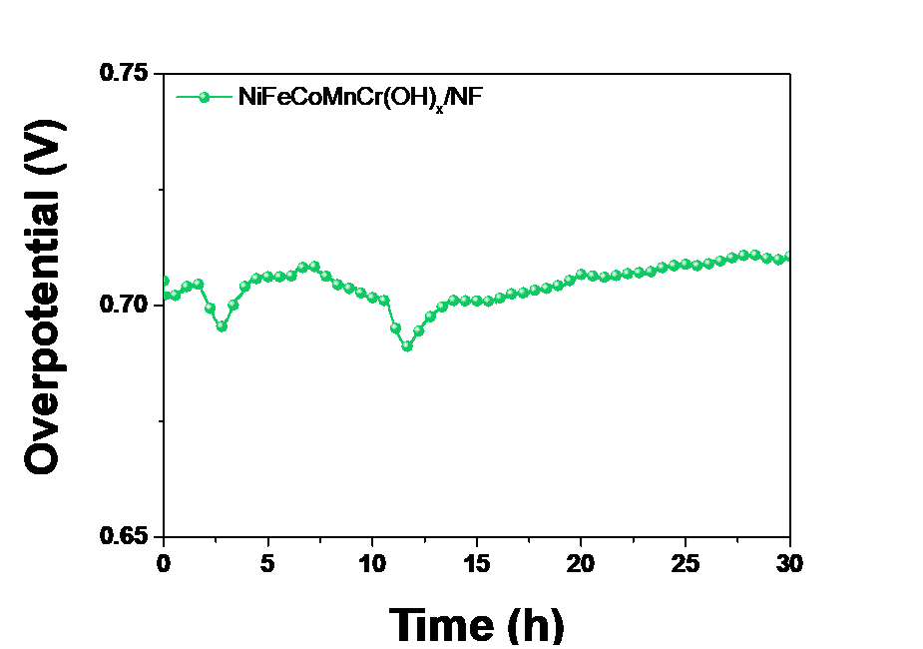
Figure S6. Chronopotentiometric response of the NiFeCoMnCr(OH)x/NF at current density of 100 mA/cm2 for 30 h.

Table S1. Redox potential table
Electrode pair | Potential [V]
Fe³⁺/Fe²⁺ | 0.771
Ni²⁺/Ni | -0.257
Co²⁺/Co | -0.280
Mn²⁺/Mn | -1.18
Cr³⁺/Cr | -0.744
O₂/OH⁻ | 0.401

Table S2. Molar ratio of synthesized samples
 | Fe | Co | Mn | Cr
NiFe(OH)_{x} /NF | 1
NiFeCo(OH)_{x}/NF | 1 | 0.8
NiFeCoMn(OH)x/NF | 1 | 0.83 | 0.5
NiFeCoMnCr(OH)_{x} /NF | 1 | 0.88 | 0.75 | 1

