Diffusion Model-based Probabilistic Downscaling for 180-year East Asian Climate Reconstruction
Supplementary Information
Authors: Fenghua Ling^{1,2†}, Zeyu Lu^{3,4†}, Jing-Jia Luo^{1*}, Lei Bai^{3*}, Swadhin K. Behera², Dachao Jin¹, Baoxiang Pan⁵, Huidong Jiang^{6,7} and Toshio Yamagata^{1,2}

Affiliations:
¹Institute for Climate and Application Research (ICAR)/CIC-FEMD/KLME/ILCEC, Nanjing University of Information Science and Technology, Nanjing, China
²Application Laboratory, Japan Agency for Marine-Earth Science and Technology, Yokohama, Japan
³Shanghai AI Laboratory, Shanghai, China
⁴Shanghai Jiao Tong University
⁵Institute of Atmospheric Physics, Chinese Academy of Sciences, Beijing 100029, China
⁶RIKEN Center for Advanced Intelligent Project, Tokyo, Japan
⁷Department of Computer Science, Tokyo Institute of Technology, Tokyo, Japan

†Equal Contributions,
*Corresponding to jjluo@nuist.edu.cn, bailei@pjlab.org.cn

Including:
Supplementary Table 1.
Supplementary Fig.1.
Supplementary Fig. 2.
Supplementary Fig. 3.
Supplementary Fig. 4.
Supplementary Fig. 5.
Supplementary Fig. 6.
Supplementary Fig. 7.
Supplementary Fig. 8.
Supplementary Fig. 9.

Supplementary Table 1. List of the datasets that the deep learning model (DPDM and deterministic model) used

 | ERA5 | ERA5-LAND | ETOPO
Variable | Air temperature at 2 meters high (T2m), Total Precipitation (TP)  Surface Pressure (SP), U-Wind at 10 meters high(U10m),  V-Wind at 10 meters high (V10m) |  | Etopo1
Resolution | Spatial: 1° | Spatial: 0.1°
Resolution | Time length:1961-2021
Region | East Asia  (15°-55°N, 65°-135°E)
Dataset split | 90% of 6-hourly data for training and 10% for validation during 1961-2015  monthly data for testing during 2016-2021

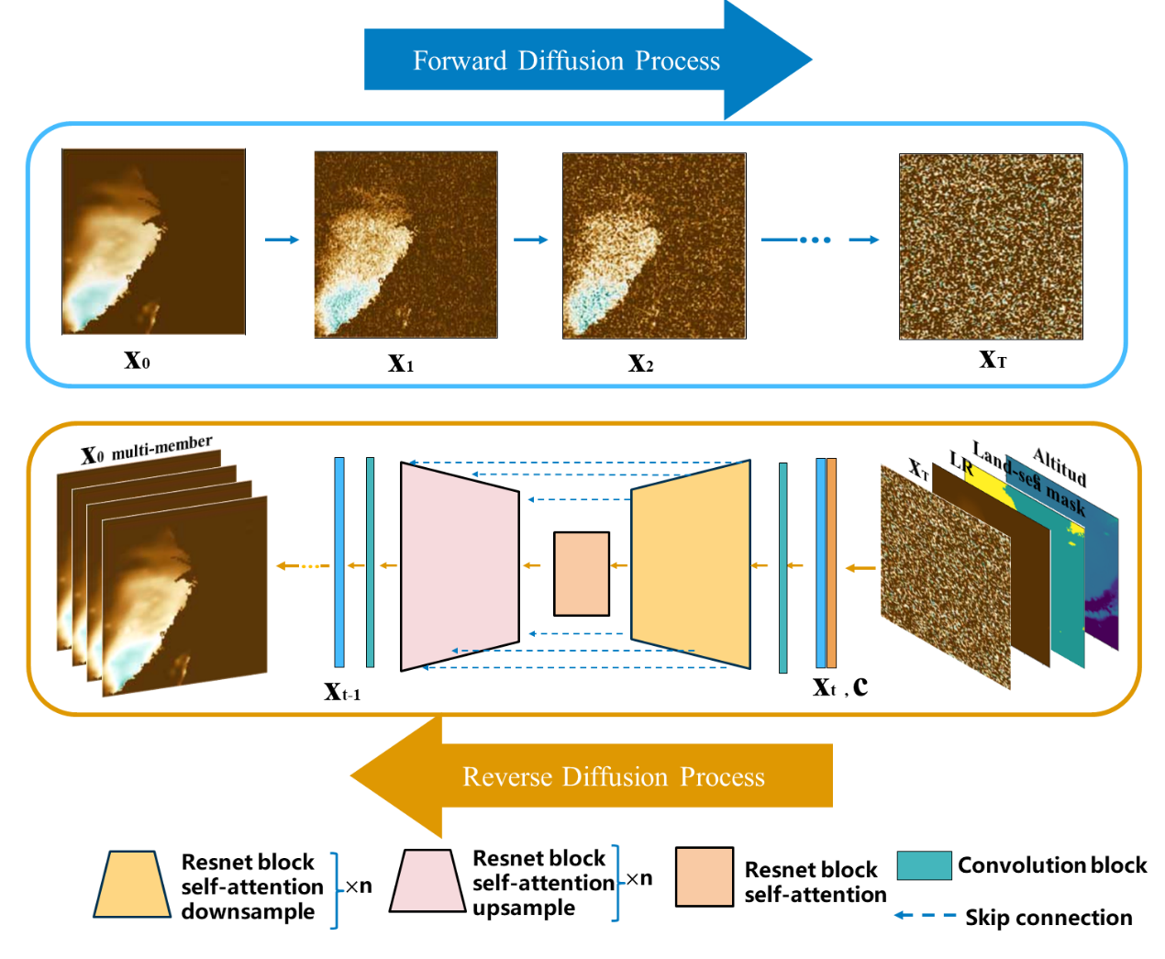
Supplementary Figure 1. The structure of the Diffusion Probabilistic Downscaling Model (DPDM). The DPDM contains two parts, a forward diffusion noise adding process and a reverse denoising process. In the denoising process, low-resolution data, geography, land-sea mask information are provided as input. The denoising model adopts the U-net architecture, and both upsampling and downsampling use similar residual modules and self-attention modules.

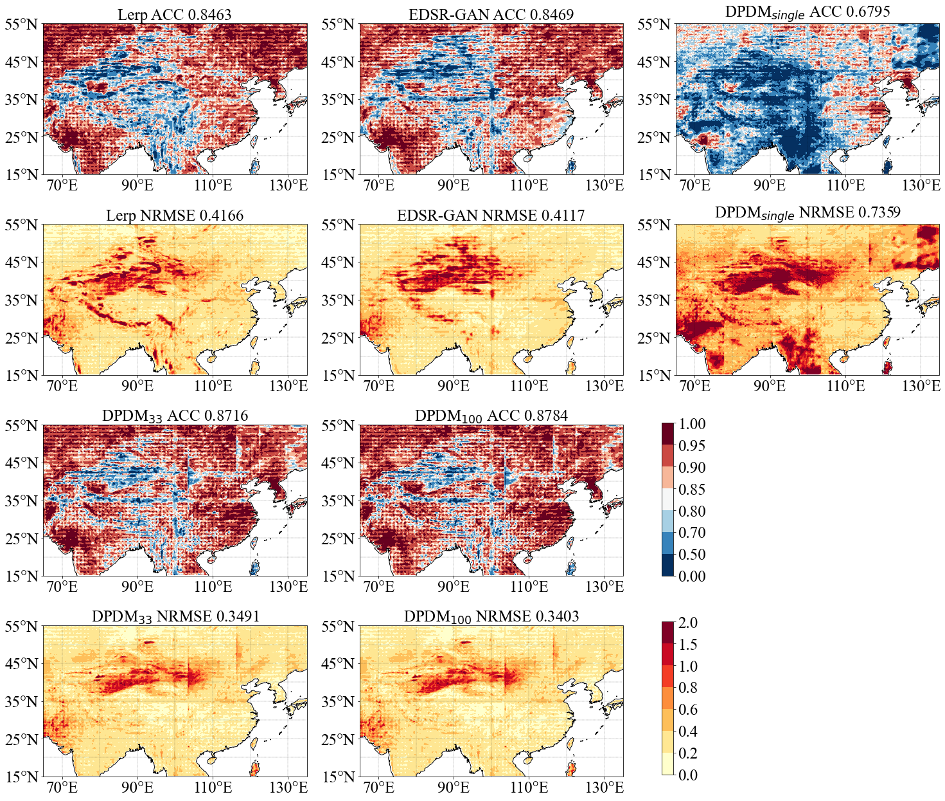
Supplementary Figure 2. Comparison of total precipitation downscaling results from different methods. The skills of anomaly correlation coefficients (ACC) and normalized root mean square error (NRMSE) in reproducing precipitation over East Asia based on the downscaling results of the Lerp, EDSR-GAN, DPDM with single member, DPDM with 33 members and DPDM with 100 members, respectively.

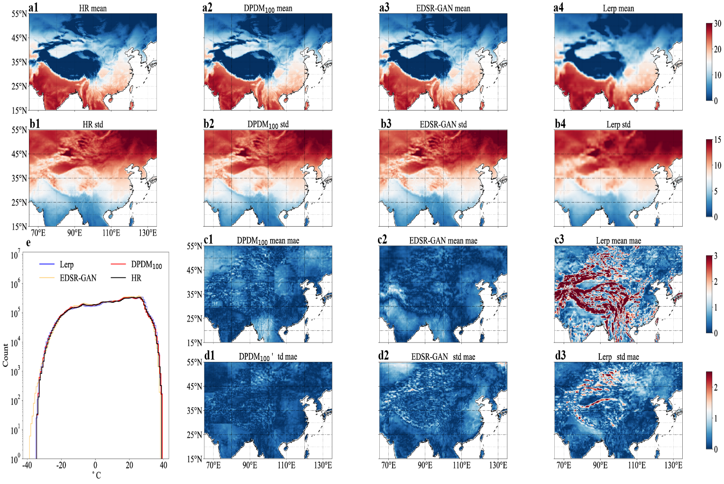
Supplementary Figure 3. The downscaling results for climatological mean temperature at 2 meters high (T2m) and its standard deviation based on different methods. (a) Observed and downscaled climatological mean T2m during 2016-2021 based on the three different methods. (b) As in (a), but for the standard deviation of monthly T2m. (c) Bias of the downscaling results relative to the true high-resolution T2m based on the different methods. (d) As in (c), but for the bias in its standard deviation. (e) T2m distribution histograms based on the high-resolution (black curve), EDSR-GAN (yellow curve), DPDM with 100 members (red curve) and Lerp (blue curve).

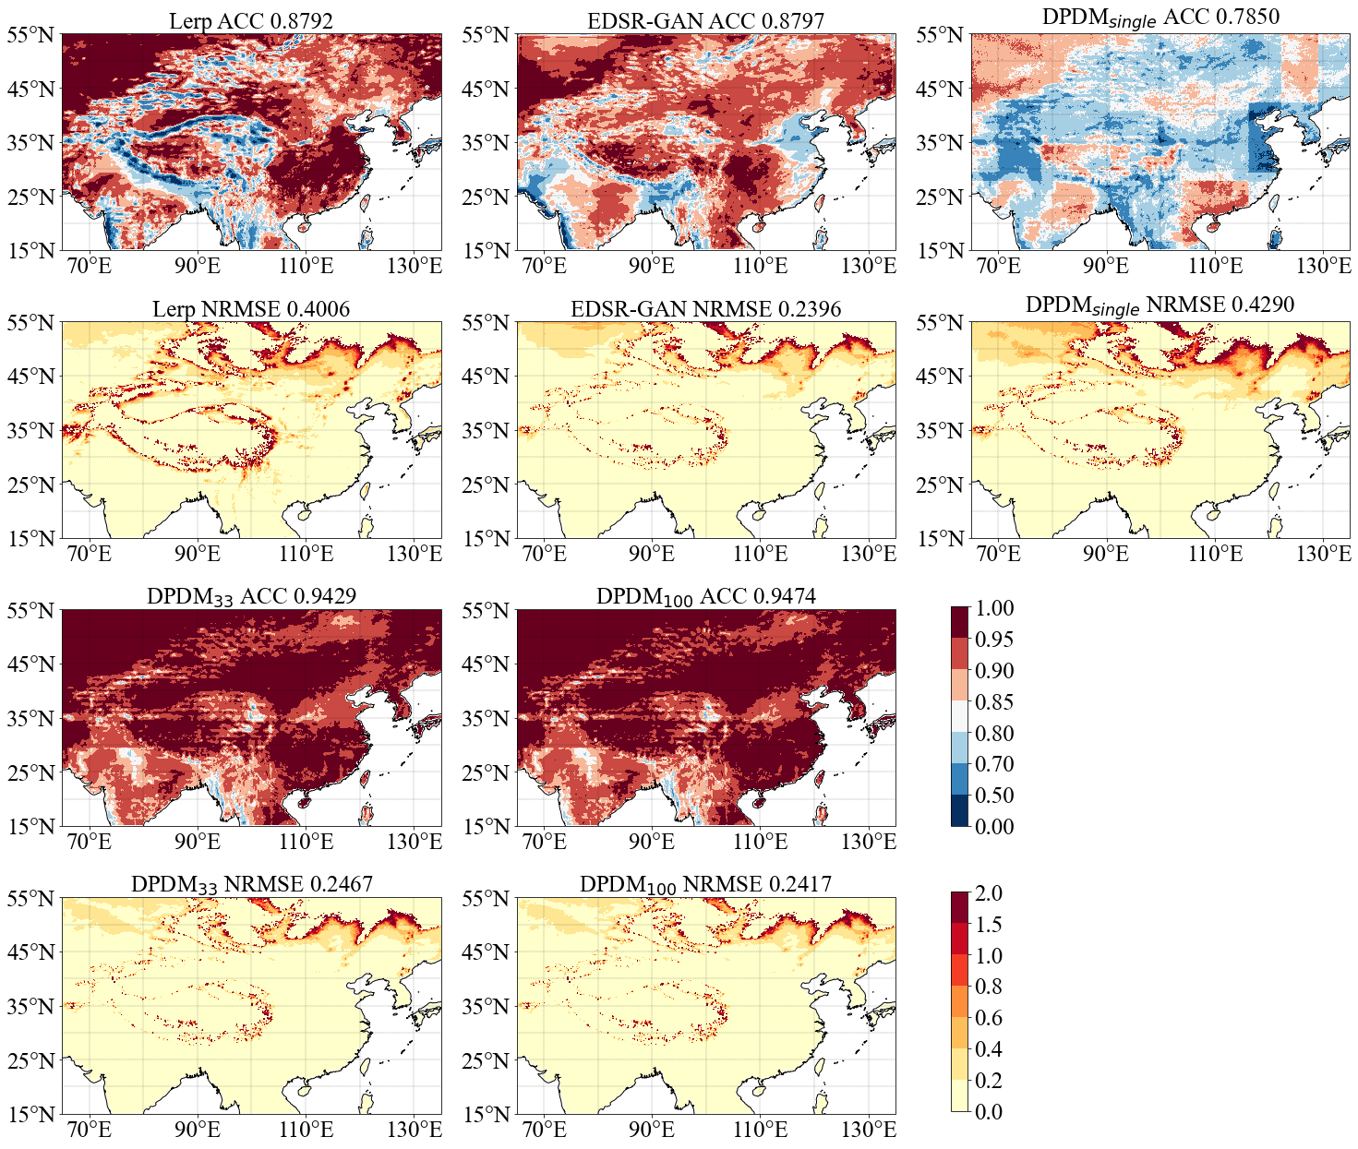
Supplementary Figure 4. Comparison of T2m downscaling results from different methods. As in Supplementary Fig. 2, but for the downscaling results of T2m.

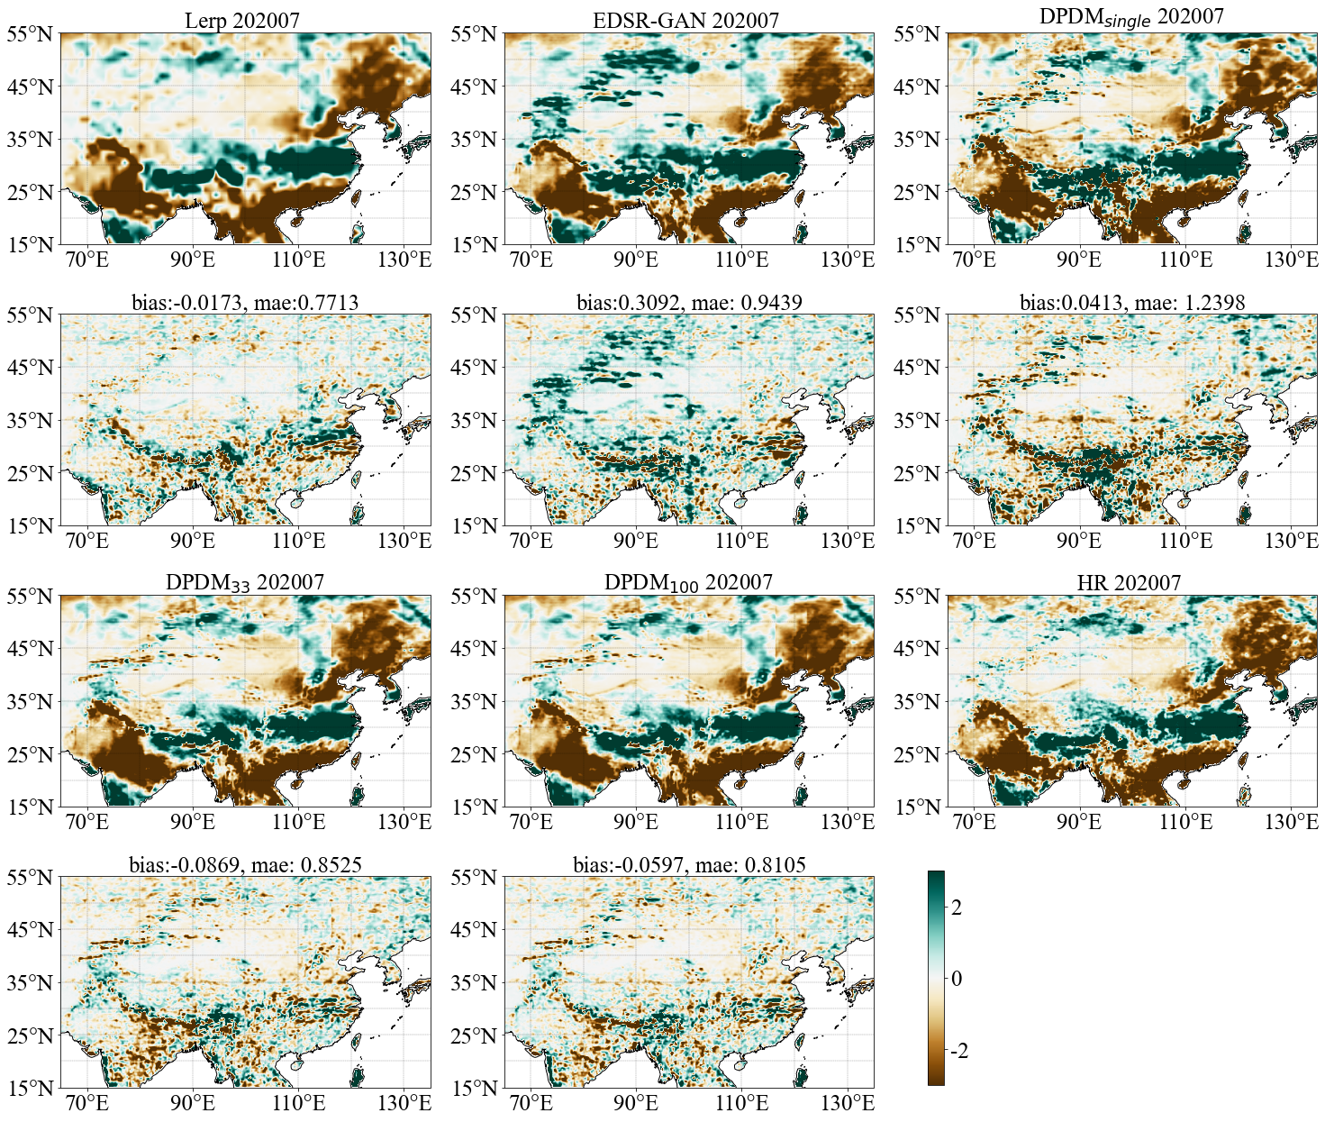
Supplementary Figure 5 The anomaly of total precipitation in different downscaling methods. The anomaly of total precipitation in July 2020 produced by the different downscaling methods. The spatially averaged bias and mean absolute error (mae) are shown in top of the panel.

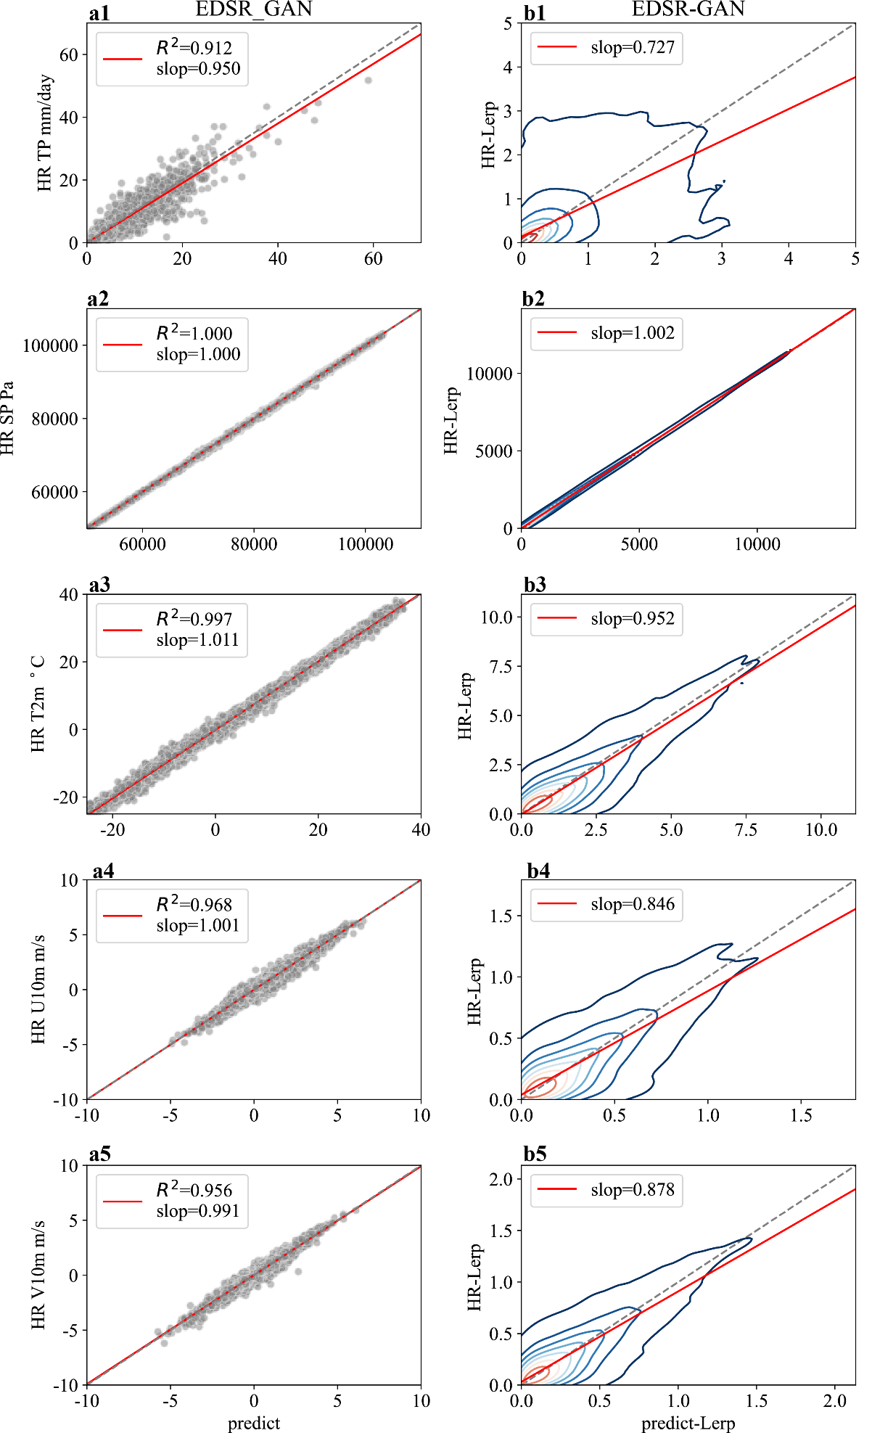
Supplementary Figure 6. Evaluation of R squared (R²) and blurriness for EDSR-GAN results in different variable. (a1-a5) Scatter plots between the high-resolution observations and the downscaling results with the EDSR-GAN. The red line represents the fitting line, and slope and R² are shown in the legend. (b1-b5) Two-dimensional kernel density estimation of EDSR-GAN to assess the blurriness of downscaling results. The x axis represents the absolute difference between the downscaling outputs and the Lerp, and the y axis represents the absolute difference between the high-resolution observations and the Lerp. The black dashed diagonal line represents the identity relation.

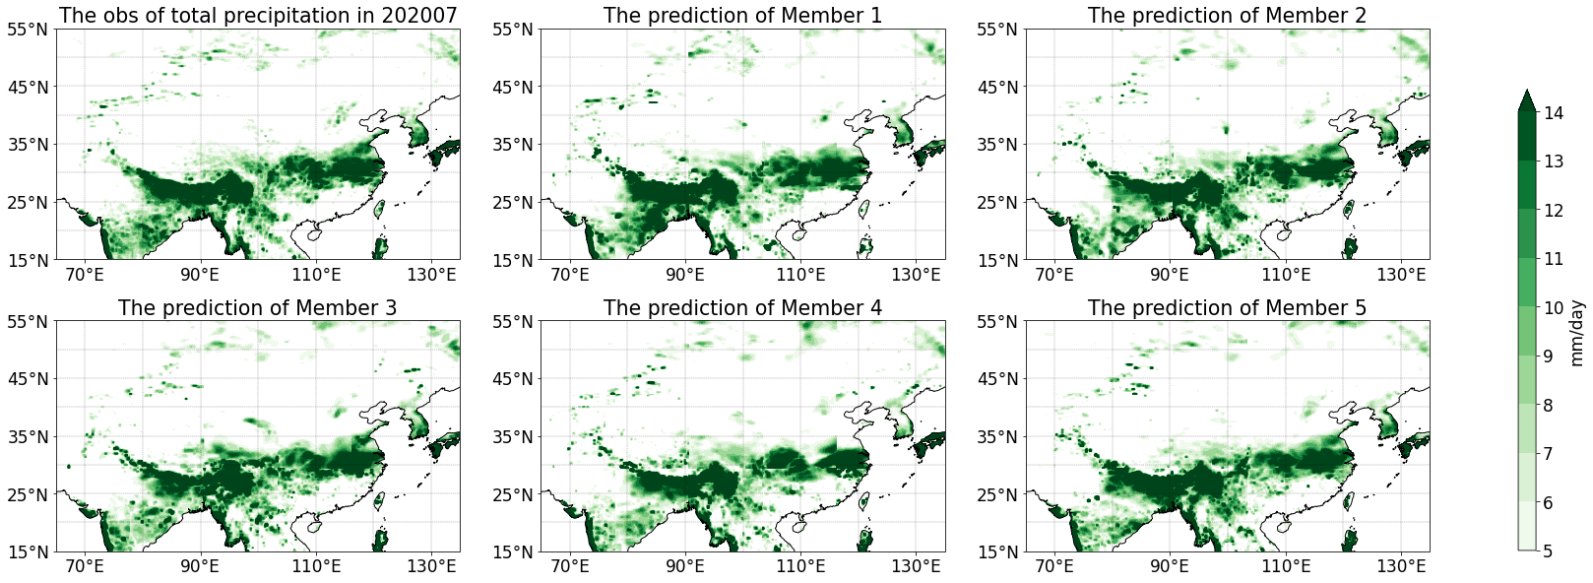
Supplementary Figure 7. The total precipitation in different members of DPDM.

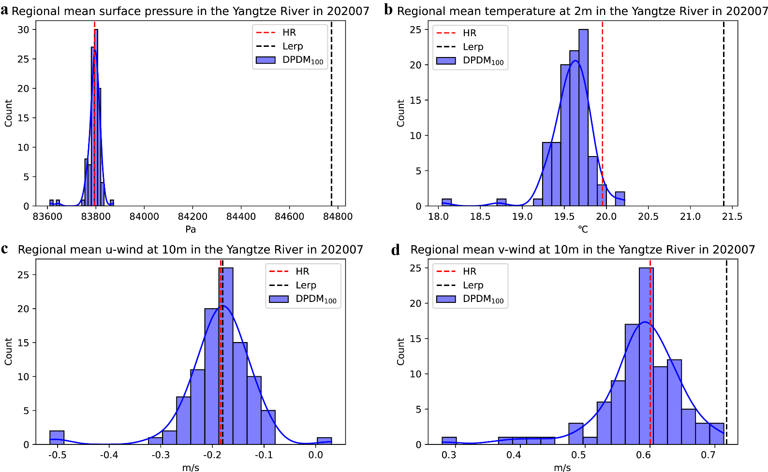
Supplementary Figure 8. Comparison of regional average results for different elements of DPDM. (a) Regional mean surface pressure from different members of DPDM in the Yangtze River Basin (24°-35°N, 90°-123°E) in July 2020. The red line represents the real high-resolution result, the black dashed line indicates the linear interpolation, the blue line denotes the probability density distribution of the 100 members and the blue line denotes its fitting curve. (b-d) As in (a), but for the downscaling of temperature at 2 meters high and winds at 10 meters high, respectively.

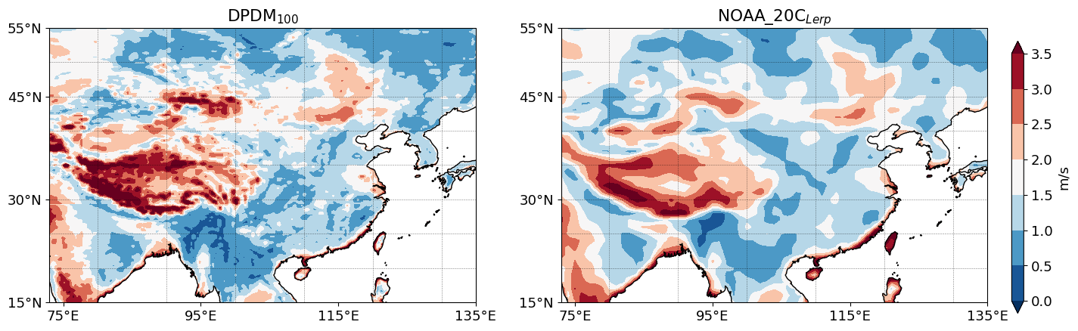
Supplementary Figure 9. Climatology of wind speed from the different datasets from 1836 to 2015.

