Table S.1 Clinicopathologic features of patients in the study cohort and the TCGA cohort
Clinicopathological features | The study cohort（N=87） | The TCGA cohort(N=84) | P value
Gender
Male | 31 | 21
Female | 56 | 63 | 0.131
Age（years）
≤Median | 51 | 42
＞Median | 36 | 42 | 0.258
Smoke
Smoking | 42 | 47
Non-Smoking | 44 | 37 | 0.353
T classification
T1-2 | 23 | 36
T3 | 64 | 48 | 0.024
TNM
Ⅰ+Ⅱ | 47 | 51
Ⅲ+Ⅳ | 40 | 33 | 0.376
TLS
TLS+ | 58 | 44
TLS- | 29 | 40 | 0.057

Table S.2 The correlation between average TLS density and clinicopathologic features in study cohort (N=87)
Clinicopathological features | Average TLS density-Low (N=43) | Average TLS density-High (N=43) | P value
Gender
Male | 15 | 16
Female | 28 | 28 | 0.885
Age(years)
≤63 | 25 | 25
＞63 | 18 | 19 | 0.901
Smoke
Smoking | 18 | 24
Non-Smoking | 24 | 20 | 0.278
Drink
Drinking | 16 | 18
Non-Drinking | 26 | 26 | 0.790
T classification
T1-2 | 13 | 10
T3 | 30 | 34 | 0.427
Node metastasis
Positive | 22 | 28
Negative | 21 | 26 | 0.946
TNM
Ⅰ+Ⅱ | 21 | 26
Ⅲ+Ⅳ | 22 | 18 | 0.337
Death
Yes | 27 | 22
No | 16 | 22 | 0.229

Table S.3 The correlation between Maximal TLS diameter and clinicopathologic features in study cohort (N=87)
Clinicopathological features | Maximal TLS diameter-Low  (N=29) | Maximal TLS diameter-High （N=29） | P value
Gender
Male | 10 | 10
Female | 19 | 19 | 1
Age(years)
≤63 | 17 | 18
＞63 | 12 | 11 | 0.788
Smoke
Smoking | 15 | 15
Non-Smoking | 14 | 13 | 0.889
Drink
Drinking | 13 | 10
Non-Drinking | 16 | 18 | 0.483
T classification
T1-2 | 5 | 11
T3 | 24 | 18 | 0.078
Node metastasis
Positive | 16 | 9
Negative | 13 | 20 | 0.465
TNM
Ⅰ+Ⅱ | 13 | 20
Ⅲ+Ⅳ | 16 | 9 | 0.063
Death
Yes | 18 | 10
No | 11 | 19 | 0.036

Table S.4 The correlation between pTLS diameter and clinicopathologic features in study cohort (N=87)
Clinicopathological features | pTLS density-Low(N=43) | pTLS density-High（N=44） | P value
Gender
Male | 15 | 16
Female | 28 | 28 | 0.885
Age(years)
≤63 | 24 | 26
＞63 | 19 | 18 | 0.757
Smoke
Smoking | 17 | 25
Non-Smoking | 25 | 19 | 0.130
Drink
Drinking | 17 | 17
Non-Drinking | 25 | 27 | 0.862
T classification
T1-2 | 11 | 12
T3 | 32 | 32 | 0.858
Node metastasis
Positive | 21 | 18
Negative | 22 | 26 | 0.457
TNM
Ⅰ+Ⅱ | 21 | 26
Ⅲ+Ⅳ | 22 | 18 | 0.337
Death
Yes | 28 | 21
No | 15 | 23 | 0.102

Table S.5 The correlation between TLS and clinicopathologic features in TCGA cohort (N=84)
Clinicopathological features | TLS+(N=44) | TLS-（N=40） | P值
Gender
Male | 10 | 11
Female | 34 | 29 | 0.614
Age(years)
≤57.6 | 26 | 16
＞57.6 | 18 | 24 | 0.081
Smoke
Smoking | 26 | 21
Non-Smoking | 18 | 19 | 0.543
T classification
T1-2 | 21 | 15
T3 | 23 | 25 | 0.344
Node metastasis
Positive | 22 | 17
Negative | 22 | 23 | 0.491
TNM
Ⅰ+Ⅱ | 25 | 26
Ⅲ+Ⅳ | 19 | 14 | 0.443
Death
Yes | 14 | 13
No | 30 | 27 | 0.947

FigS.1 Multivariate Cox analysis of overall survival be performed according to the average density of TLS（a）；the peritumoral density of TLS（b）； the maximal diameter of TLS（c）in study cohort. (Abbreviations: TLS, tertiary lymphoid structures；pTLS，peritumoral tertiary lymphoid structures )

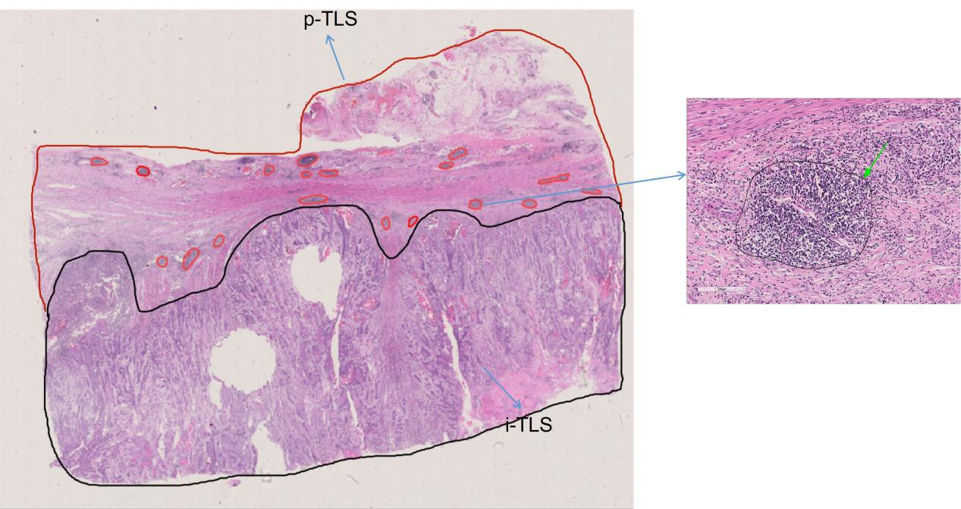
FigS 2 Representative HE images of peritumoral patients

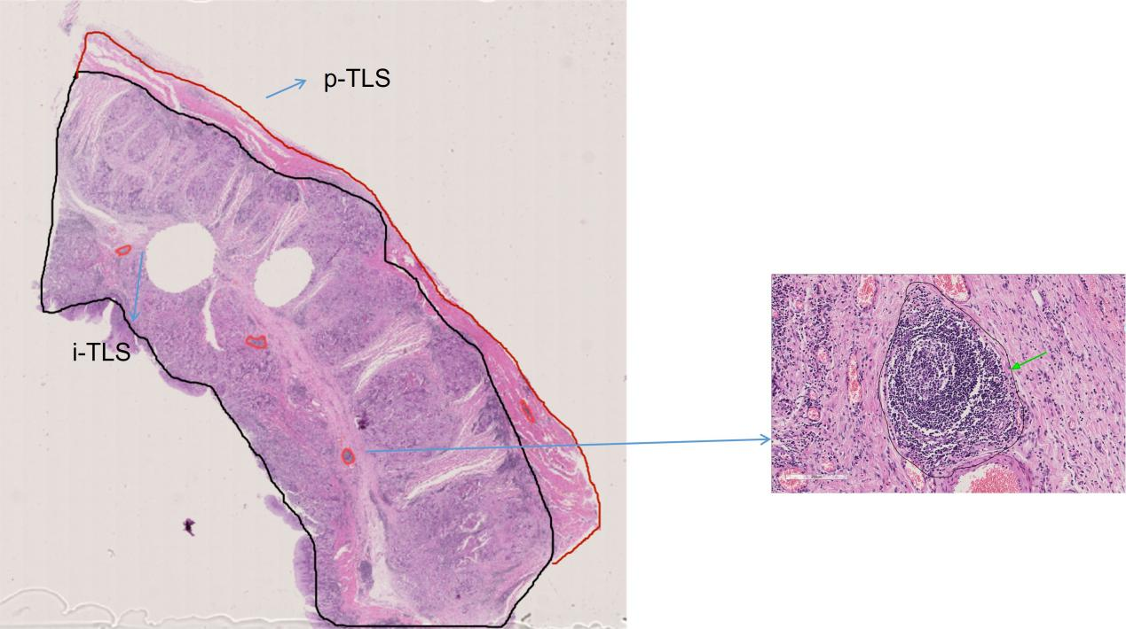
FigS 3 Representative HE images of intratumoral patients

Table S.6 According to the results of HE staining, ESCC patients were divided into TLS+and TLS- groups，which were obtained from the TCGA repository
TLS | ID
NO | TCGA.LN.A9FO.01
NO | TCGA.L5.A43H.01
NO | TCGA.IG.A50L.01
NO | TCGA.IG.A5B8.01
NO | TCGA.IG.A3Y9.01
YES | TCGA.Z6.A9VB.01
YES | TCGA.VR.A8ET.01
NO | TCGA.Z6.A8JE.01
NO | TCGA.IG.A3YB.01
YES | TCGA.Z6.AAPN.01
NO | TCGA.V5.A7RC.01
YES | TCGA.Z6.A8JD.01
NO | TCGA.JY.A6FE.01
NO | TCGA.L5.A43J.01
NO | TCGA.LN.A5U5.01
YES | TCGA.IG.A8O2.01
YES | TCGA.Q9.A6FU.01
NO | TCGA.LN.A49K.01
NO | TCGA.KH.A6WC.01
YES | TCGA.VR.A8EW.01
YES | TCGA.VR.AA7D.01
YES | TCGA.IG.A6QS.01
NO | TCGA.LN.A49L.01
NO | TCGA.LN.A7HV.01
NO | TCGA.L7.A56G.01
YES | TCGA.VR.AA7B.01
YES | TCGA.LN.A4A9.01
NO | TCGA.LN.A7HW.01
NO | TCGA.LN.A7HY.01
YES | TCGA.LN.A9FP.01
NO | TCGA.IG.A97I.01
YES | TCGA.LN.A7HX.01
NO | TCGA.LN.A9FR.01
YES | TCGA.LN.A4MQ.01
NO | TCGA.LN.A49P.01
NO | TCGA.LN.A5U6.01
YES | TCGA.LN.A8HZ.01
NO | TCGA.LN.A49N.01
YES | TCGA.VR.A8ER.01
NO | TCGA.LN.A49Y.01
NO | TCGA.LN.A4A2.01
NO | TCGA.LN.A4A1.01
NO | TCGA.LN.A4A4.01
YES | TCGA.LN.A49X.01
NO | TCGA.LN.A49M.01
YES | TCGA.LN.A4A3.01
YES | TCGA.IG.A625.01
NO | TCGA.LN.A9FQ.01
YES | TCGA.LN.A4A6.01
NO | TCGA.LN.A49S.01
NO | TCGA.LN.A7HZ.01
NO | TCGA.LN.A8I1.01
NO | TCGA.LN.A4MR.01
YES | TCGA.LN.A49W.01
NO | TCGA.LN.A8I0.01
YES | TCGA.LN.A49R.01
NO | TCGA.LN.A49O.01
YES | TCGA.XP.A8T8.01
NO | TCGA.IG.A97H.01
NO | TCGA.V5.AASV.01
YES | TCGA.LN.A49U.01
YES | TCGA.LN.A4A8.01
NO | TCGA.VR.AA7I.01
YES | TCGA.IG.A51D.01
YES | TCGA.VR.AA4G.01
NO | TCGA.VR.A8EZ.01
NO | TCGA.VR.A8EU.01
YES | TCGA.IG.A4P3.01
YES | TCGA.IG.A3YC.01
YES | TCGA.S8.A6BW.01
YES | TCGA.IG.A3YA.01
YES | TCGA.LN.A4A5.01
YES | TCGA.IG.A5S3.01
YES | TCGA.JY.A93F.01
YES | TCGA.XP.A8T6.01
YES | TCGA.LN.A5U7.01
YES | TCGA.VR.A8EO.01
YES | TCGA.VR.A8EP.01
YES | TCGA.VR.A8EX.01
YES | TCGA.IG.A3I8.01
YES | TCGA.VR.A8EY.01
YES | TCGA.IG.A3QL.01
YES | TCGA.L5.A4OM.01
YES | TCGA.JY.A6FD.01

