Supporting information

Chiral Terahertz Control via Curvature and Regioselective-Enhanced Reconfigurable Metasurfaces

Juyong Gwak¹, Hyojin Kang¹, Young-Mi Kim¹, Gyuseok Lee², Huu-Quang Nguyen³, Ki-Jae Jeong⁴, Hee Jun Shin⁶, Yujin Choi², Youngjin Cho², Mahendra Goddati¹, Hongxia Chen⁵, Gyeongsik Ok^{2*}, Jaebeom Lee^{1,3*}

¹Department of Chemical Engineering and Applied Chemistry, Chungnam National University, Daejeon, 34134, Republic of Korea
²Research Group of Food Safety and Distribution, Korea Food Research Institute, Wanju, 55365, Republic of Korea
³Department of Chemistry, Chungnam National University, Daejeon, 34134, Republic of Korea
⁴CAS Key Laboratory for Nanosystem and Hierarchical Fabrication, CAS Center for Excellence in Nanoscience, National Center for Nanoscience and Technology, Beijing 100190, China
⁵School of Life Sciences, Shanghai University, Shanghai 200444, PR China
⁶ Pohang Accelerator Laboratory, POSTECH, 80, Jigokro-127-beongil, Nam-gu, Pohang, Gyeongbuk 37673, Republic of Korea
*Corresponding authors: G. Ok, gsok@kfri.re.kr: J. Lee, nanoleelab@cnu.ac.kr

Table of Contents

Supplementary Figures
Fig S1-1 | The correlation between light chirality and skew angle using previous report 1.
Fig S1-2 | The correlation between light chirality and skew angle using previous report 2.
Fig S1-3 | Schematic representation of THz-time domain spectroscopy (TDS) system.
Fig S1-4 | The geometric sturcture of split ring metamaterials (SRMs).
Fig S1-5 | Schematic diagram of light passing through SRMs with curvature
Fig S1-6 | Schematic diagrm of two bending patterns
Fig S2-1 | Images of magnetic force microscopy (MFM).
Fig S2-2 | Simulation of Non-Magnetized Ni-Pattern with Magnetic Properties.
Fig S3-1 | A one-step solvothermal synthesis to obtain Au@Fe_{x}O_{y} MagPlas NWs.
Fig S3-2 | SQUID of MagPlas NPs and NRs.
Fig S3-3 | The absorbance spectra of MagPlas and hollow NPs.
Fig S3-4 | The size profiles of MagPlas and hollow NPs, and NRs measured by TEM images.
Fig S3-5 | Regioselective assembly of Ag@Fe₃O₄ NPs on Ni-metasurface depending on magnetization time.
Fig S3-6 | Regioselective assembly of Au@Fe_{x}O_{y} NRs on the magnetized Ni-metasurface (magnetic field direction is Y axis) depending on the concentration of NRs.
Fig S3-7 | THz-time domain spectroscopy spectra of MagPlas (Ag@Fe₃O₄) and hollow@Fe₃O₄ NPs, and Au@Fe₃O₄ NRs on Ni-metasurface at 0.1 mg/ml.
Fig S3-8 | Regioselectivie assembly of MagPlas NPs/NRs (Ag@Fe₃O₄ /Au@Fe₃O₄) on Ni-metasurface depending on the concentration of NPs/NRs.
Fig S3-9 | Finite element method (FEM) simulation on the effect of regioselective NP assembly on the Ni metasurface:
Fig S3-10 | Finite element method (FEM) simulation on the effect of regioselective NP assembly on the Ni metasurface.
Fig S4-1 | Circular polarized THz-time domain spectroscopy spectra of (a) Ag@Fe₃O₄ NPs, (b) hollow NPs, and (c) Au@Fe₃O₄ NRs metasurface with 45˚ (LH) and -45˚ (RH).
Fig S5-1 | THz transmittance-time variation across the Ag@Fe₃O₄ NPs regioselective (a) LH and (b) RH metasurface depending on the wiregrid polarizer rotation angle (θ_{rot}) when the azimuthal angle of the linearly polarized incident wave θ_{in} = 0°.
Fig S5-2 | THz transmittance-time variation across the Hollow NPs regioselective (a) LH and (b) RH metasurface depending on the wiregrid polarizer rotation angle (θ_{rot}) when the azimuthal angle of the linearly polarized incident wave θ_{in} = 0°.
Fig S5-3 | THz transmittance-time variation across the Au@Fe₃O₄ NRs regioselective (a) LH and (b) RH metasurface depending on the wiregrid polarizer rotation angle (θ_{rot}) when the azimuthal angle of the linearly polarized incident wave θ_{in} = 0°.
Fig S5-4 | THz transmittance variation of regioselective (Ag@Fe₃O₄) LH and RH chiral metasurface depending on the wiregrid polarizer rotation angle (θ_{rot} = -4, -2, 0, 2, 4°), when the azimuthal angle of the linearly polarized incident wave θ_{in} = 0°.
Fig S5-5 | THz transmittance variation of regioselective (hollow NPs) LH and RH chiral metasurface depending on the wiregrid polarizer rotation angle (θ_{rot}= -6°, -4°, -2°, 0°, 2°, 4°,6°), when the azimuthal angle of the linearly polarized incident wave θ_{in} = 0°.
Fig S5-6 | THz transmittance variation of regioselective (Au@Fe₃O₄ NRs) LH and RH chiral metasurface depending on the wiregrid polarizer rotation angle (θ_{rot}= -6°, -4°, -2°, 0°, 2°, 4°,6°), when the azimuthal angle of the linearly polarized incident wave θ_{in} = 0°.

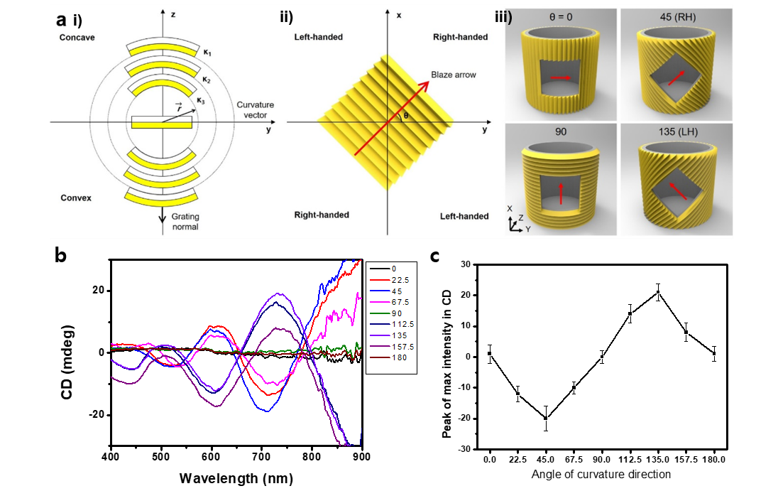
Fig S1-1 | The correlation between light chirality and skew angle using previous report 1. Reproduced with permission.¹ Copyright 2022 American Chemical Society.

The study aimed to understand how curvature influences chirality on a patterned surface. The direction of curvature was defined by the tangent vector (T), which varied with the skew angle (θ) - the angle between the pattern direction (P) and T. When P was parallel or at a right angle to T (θ = 0° or 90°), the surface remained achiral. For 0° < θ < 90° or 180° < θ < 270°, it exhibited right-handed chirality, while for 90° < θ < 180° or 270° < θ < 360°, it showed left-handed chirality. The curvature and pattern size affected the intensity and number of circular dichroism (CD) peaks. The chiroptical properties were closely related to P, T, and θ. This perspective extends to other 2D nanomaterials, where induced curvature can lead to chirality. Biaxial buckling-induced chiral surfaces combine two symmetry-breaking actions, and metasurface with pattern can modulate chiroptical properties, influencing both intensity and spectrum sign (handedness).

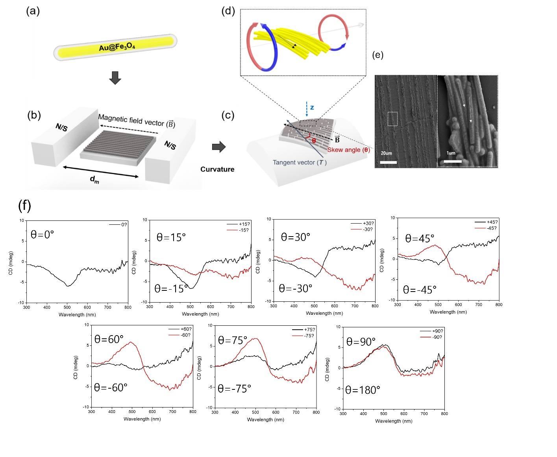Fig S1-2 | The correlation between light chirality and skew angle using previous report 2. Reproduced with permission.² Copyright 2022 Wiley.
The study aimed to understand how curvature influences chirality plasmonic magnetic nanowires (NWs) metasurface. The study investigated the self-assembly of magnetic nanowires (NWs) in an aqueous solvent (Fig S1-3a~c). Linearly aligned NWs with skew angles induced enhanced asymmetric interaction from light-matter interaction (Fig S1-3d). The CD spectra of NW arrays were affected by various skew angles (Fig S1-3f). At a 45° skew angle, the experiment reveals the most pronounced asymmetry in the interaction. This indicates that this specific orientation has a particularly significant impact on the observed asymmetric behavior.
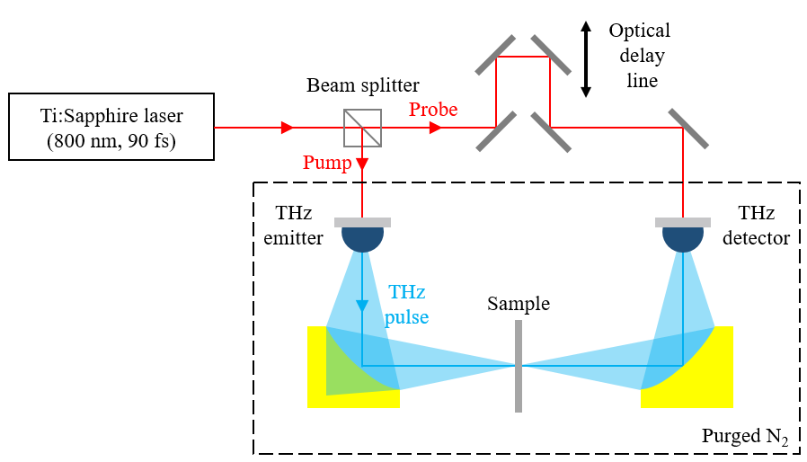
Fig S1-3 | Schematic representation of THz-time domain spectroscopy (TDS) system.
In the experiments, a commercial THz-TDS system (TPS-3000, Teraview Inc., Cambridge, UK) was utilized. Briefly, the Ni-metasurface sample with/without coating of MagPlas NPs/NRs were placed between the two off-axis parabolic mirrors. The transmitted THz pulses through the Ni-metasurface samples were detected by a photoconductive antenna (PCA) gated by a probe beam. The phase of the probe beam is modulated by the delay stage, and the waveform of the THz pulse was detected by a time-domain sweep of the THz pulse at the PCA detector.³ The environment of experiments was enclosed in a chamber and purged with nitrogen (N₂) to eliminate the THz absorption by water vapor in air at 25 ºC.

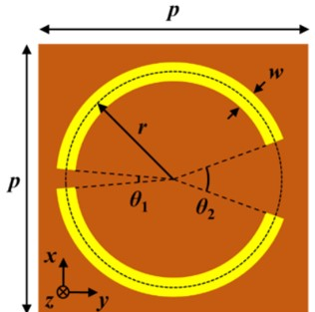
Fig S1-4 | The geometric sturcture of split ring metamaterials (SRMs).

In this simulation we used the commericial FDTD software(Lumerical FDTD Solutions, Ansys, Canada) to simulate changing the chirality from curvatured SRMs. The objective is to observe how the introduction of curvature affects the chiral properties of the metasurface. The provided information pertains to a single split ring structure (Fig S1-4a). As depicted in Fig. S2a, the unit cell of the metal pattern is an asymmetric double C-shaped resonator, where the design parameters are a period (p), a central radius (r), a pattern line-width (w ) and gap angles (θ₁, θ₂), respectively.
The used dimensions of the design parameters are as follows: p = 58μm, r = 0.8 * p/2 = 23.2μm, w = 4μm, and angles (θ₁, θ₂) of 10° and 40°, respectively. Accordingly, inner radius = r - w/2 = 21.2μm, outer radius = r + w/2= 25.2μm. As a z axis parameters, gap patterned metal thickness = 200nm of Gold (Au) on Titanium (Ti) as an adhesion layer, and PI (Polyimide) thickness = 120μm. Usually, the metal layer plays a crucial role in the electromagnetic response of the split ring structure. This configuration defines a split ring metamaterial structure. The period of pattern determine the overall size and shape of the structure. As shown, the inner and outer radii are calculated based on the split ring pattern line-width (w), which is 4μm in this case. The PI layer likely serves as a substrate or support material for the split ring structure. Further, the refractive index of the PI substrate was assumed with a constant of complex refractive index $n_{PI}$ = 1.8 + i0.026, and that of gold was the Perfect Conductor (PC) model. Overall, this configuration is designed to exhibit specific electromagnetic properties, which can be attributed to the dimensions and materials specified for the split ring structure and its surrounding layers.
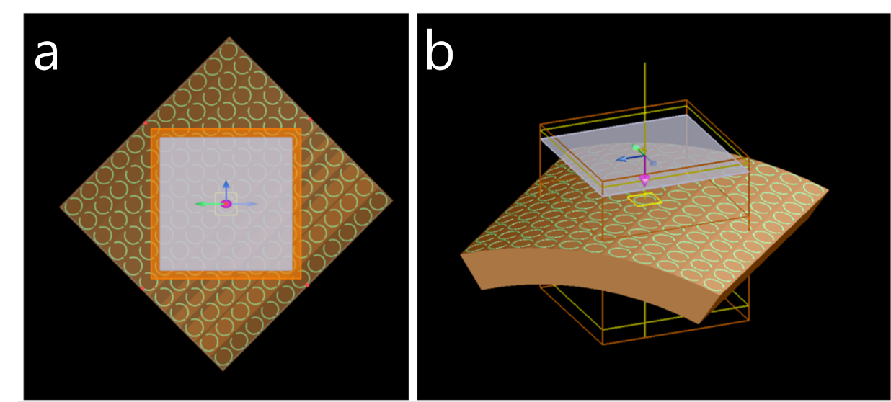
Fig S1-5 | Schematic diagram of light passing through SRMs with curvature: (c) top view, (b) perspective view.
Additionally, the metasurface is exposed to circularly polarized terahertz (THz) radiation to analyze the alterations induced by this interaction (Fig S1-5a and b). Circular dichroism (CD) is quantified by the equation CD = |TR - TL|, wherein TR and TL denote the transmittance of the device when subjected to right- and left-circularly polarized plane waves, respectively. Additionally, the phase for Ex (electric field component in the x-direction) is characterized by a positive kz as follows phase (E_{x}) = +kz, while the phase for Ey (electric field component in the y-direction) is represented by +kz + π/2 as follows phase (E_{y}) = +kz+ π/2.
For FDTD simuations of CD in 3D structure, we used perfectly matched layer (PML) boundary conditions in the all x-y-z directions. First, the two dimensioanlly arrayed unit cell of patterns (11×11) on PI substrate are bended with 5 degrees of bending angle. It means that each patterns are sucessively added with bending the angle (φ) between patterns by 5 degrees, as shown Fig S3, where the curvature radius R is calculated with follwing equation:
R=L/(π- (π/2–φ)*2) (1)
For instance, φ = 5 degree, p=58μm, then R= 58μm/(0.174533) =332μm.
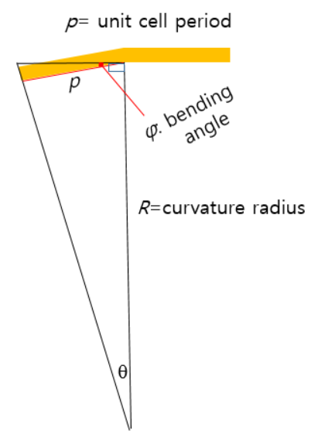
Fig S1-6 | Schematic diagrm of two bending patterns
Next, bended array patterns on PI substrate are rotated 45 degrees about z-axis colockwise. Finally, the FDTD unit cell (mesh span) is defined as 6 times of pattern unit cell period(348 μm ×348 μm). The simulation setup involves creating 300 frequency points from 400 GHz to 1900 GHz, along with initializing matrices tr and ref for storing transmission and reflection data. Subsequently, simulations are run for each specified shift value. The metasurface is configured to bend in both LH (45) and RH (135), and the phase is adjusted accordingly. The results, including transmission and reflection coefficients, are recorded for further analysis. The obtained data is then saved into text files, with each file containing frequency, reflection, and transmission values. This allows for comprehensive post-processing and data interpretation. Overall, this simulation provides a systematic investigation of the influence of curvature on the chirality of the split ring metasurface, offering valuable insights for potential applications in terahertz wave manipulation.
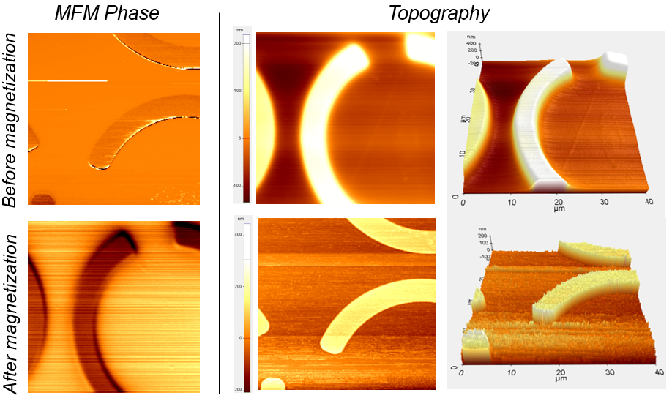
Fig S2-1 | Images of magnetic force microscopy (MFM). Ni pattern was magnetized by external magnet and compared by MFM phase and its topography.

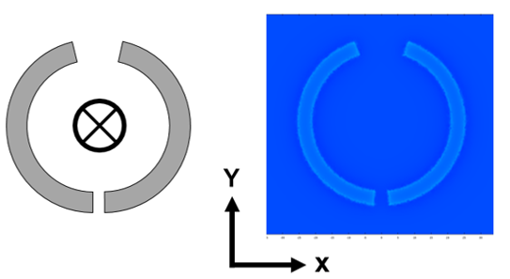
Fig S2-2 | Simulation of Non-Magnetized Ni-Pattern with Magnetic Properties.

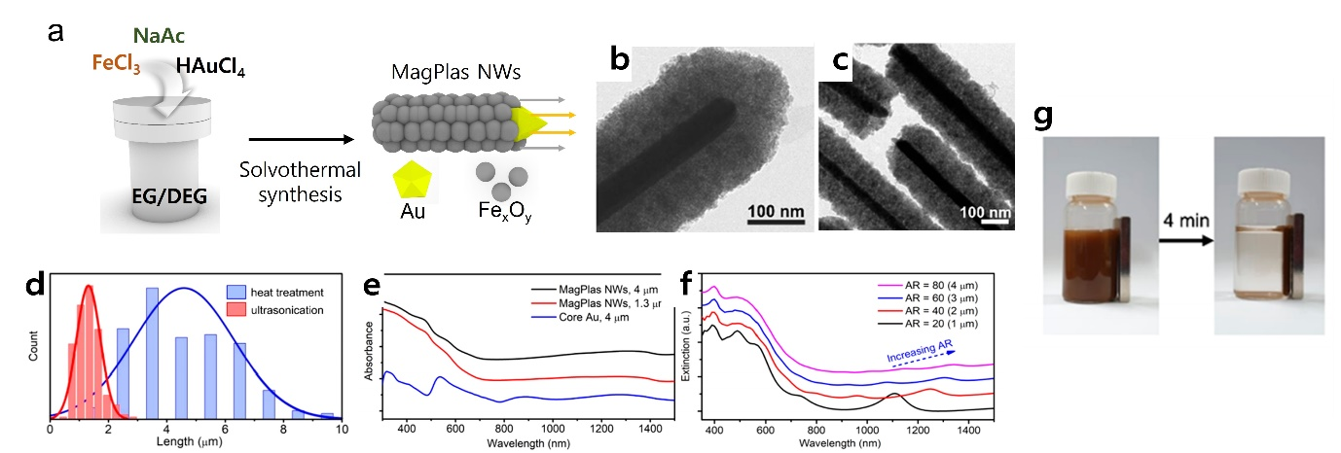
Fig S3-1 | A one-step solvothermal synthesis to obtain Au@Fe_{x}O_{y} MagPlas NWs. Reproduced with permission.⁴ Copyright 2022 American Chemical Society.
The study employed a one-pot solvothermal synthesis technique to fabricate Au@Fe_{x}O_{y} MagPlas NWs (Fig S3-1a). This process entailed dissolving iron and gold precursors, along with sodium acetate, in a mixture of polyols (ethylene glycol and diethylene glycol) and subjecting the solution to controlled heating within a sealed flask, maintaining temperatures between 150 to 240 °C for a maximum of 16 hours. The resulting product, a black powder, underwent purification using ethanol and DI water, followed by collection with a magnet to remove any residual substances. To enhance the dispersibility of MagPlas NWs in polar solvents, the surface of iron oxide was treated with citric acid. The synthesized MagPlas NWs exhibited an average diameter of 226 ± 25 nm and a length of 4.2 ± 1.6 μm, with an internal core aspect ratio (AR_{core}) of 82 ± 31, and a total aspect ratio encompassing the Fe_{x}O_{y} shell (AR_{total}) of 18.6 ± 7.1 (Fig S3-1b). Employing sonication, as opposed to mechanical stirring during stabilization, yielded MagPlas NWs with reduced aspect ratios, referred to as "sonicated MagPlas NWs". These displayed sharper ends due to mechanical breakage during the ultrasonication process (Fig S3-1c). The length of sonicated MagPlas NWs averaged at 1.3 ± 0.4 μm, with an unaltered diameter, resulting in decreased AR_{core} and AR_{total} values of 25.4 ± 7.8 and 5.8 ± 1.8, respectively (Fig S3-1d). Optical properties were examined using UV-vis-NIR extinction spectra. The NWs exhibited prominent extinction peaks below 400 nm, along with peaks at 470 and 530-560 nm (Fig S3e). These corresponded to the characteristic UV-vis extinction pattern of Fe_{x}O_{y} and the transverse mode plasmon resonance of the Au core, respectively. Longer NWs displayed a shift in longitudinal SPR modes towards higher wavelengths due to an increased aspect ratio (Fig S3-1f). However, the intensity of sub-1500 nm peaks diminished in longer NWs, accounting for the absence of absorption peaks in the NIR region. The aspect-ratio-dependent optical properties were validated through in-silico optical simulation (Please refer to the paper for more details). Fig S3-1g demonstrates magnetic separation where the synthesized product was easily collected from an aqueous suspension after a few minutes using a permanent magnet. Manipulation of NW length provided a means to tailor the SPR effect for specific applications.

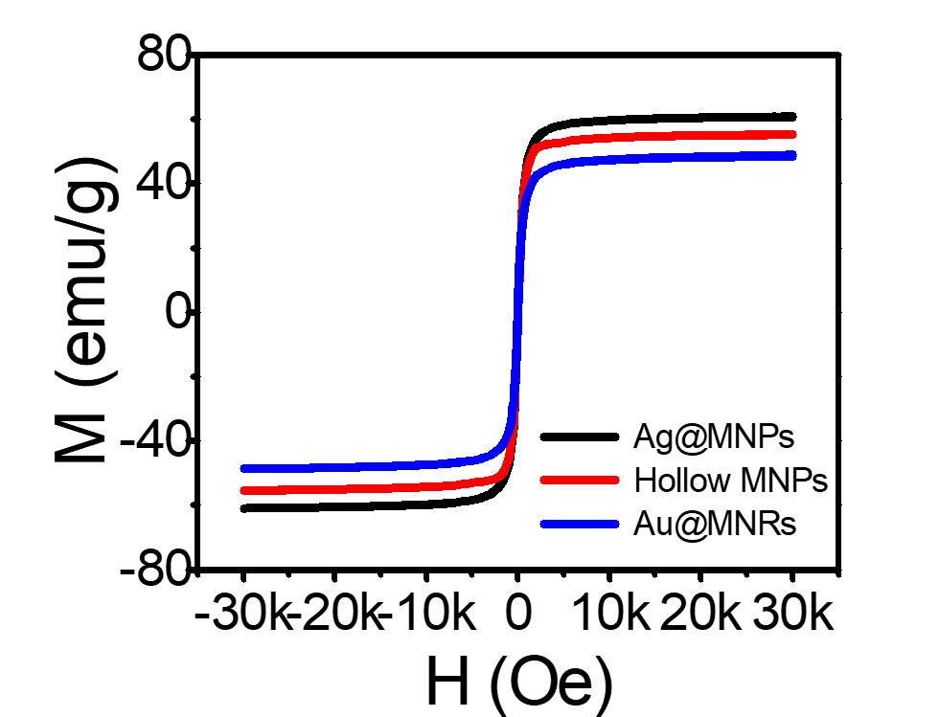
Fig S3-2 | SQUID of MagPlas NPs and NRs.
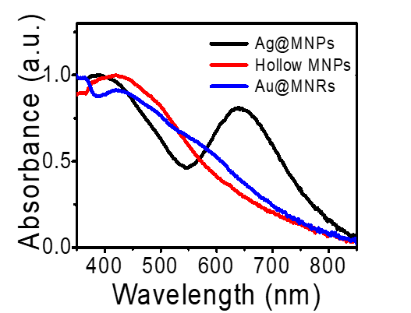
Fig S3-3 | The absorbance spectra of MagPlas and hollow NPs.
The remarkable peak around 650 nm of Ag@Fe₃O₄ NP is correspondent on the dipole mode of localized surface plasmon resonance. The intensity of the peak is attenuated as increasing the etching time of the Ag-core, indicating the core-shell NPs become hollow structures after over 72 h reduction. At the near 400 nm wavelength, the scattering peak of Fe₃O₄ shell did not change during the etching treatment. Short wavelength shift may be related to the slight change of refractive index surrounding the Ag-core from porous Fe₃O₄ to deionized water. Indeed, most plasmonic band was disappeared after the etching process. Meanwhile, Au@Fe₃O₄ NRs show two typical spectra for longitudinal plasmonic absorption at the peak wavelength of 570 nm and light scattering in the vicinity of 1,000 nm even though strong water absorption was overlapped.
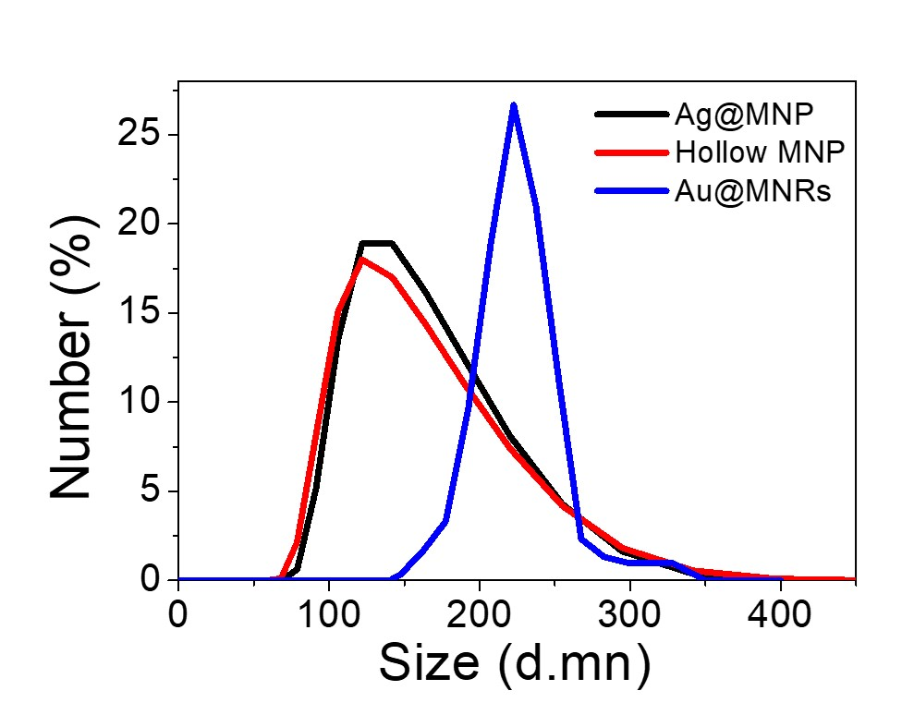
Fig S3-4 | The size profiles of MagPlas and hollow NPs, and NRs measured by TEM images.
It shows the size distribution profiles of MagPlas and hollow NPs, and NRs measured by their TEM images, where >100 particles were measured. It clearly shows that hollow NPs mostly kept their diameter even after the etching process. The localized surface plasmon resonances of the as-synthesized plasmonic materials are highly dependent on the refractive index of the surrounding medium and generally shift toward the longer wavelengths as the index is increased.⁴

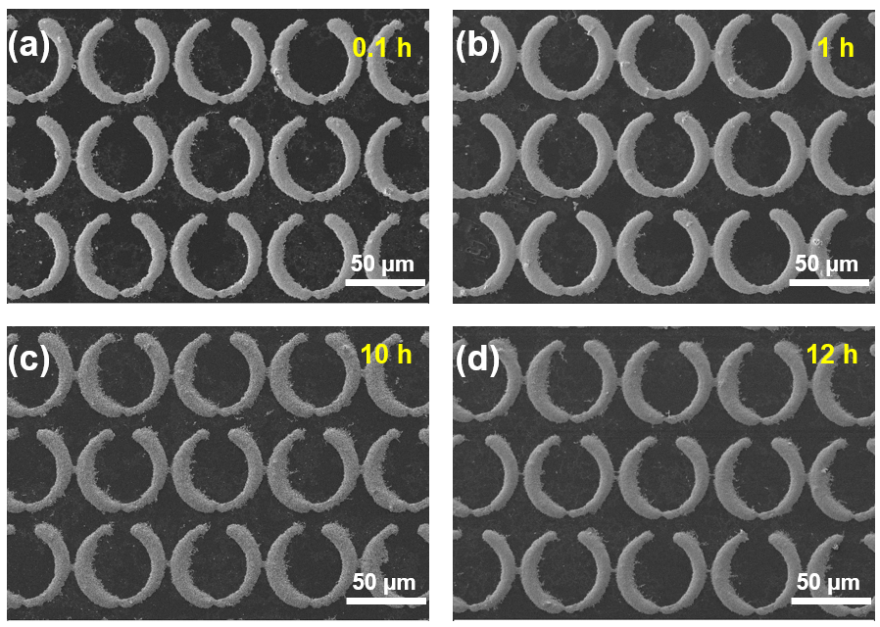
Fig S3-5 | Regioselective assembly of Ag@Fe₃O₄ NPs on Ni-metasurface depending on magnetization time. (a~d) images applied same magnetization field direction (X axis). Each was magnetized for (a) 0.1 h, (b) 1 h, (c) 10 h, and (d) 12 h.

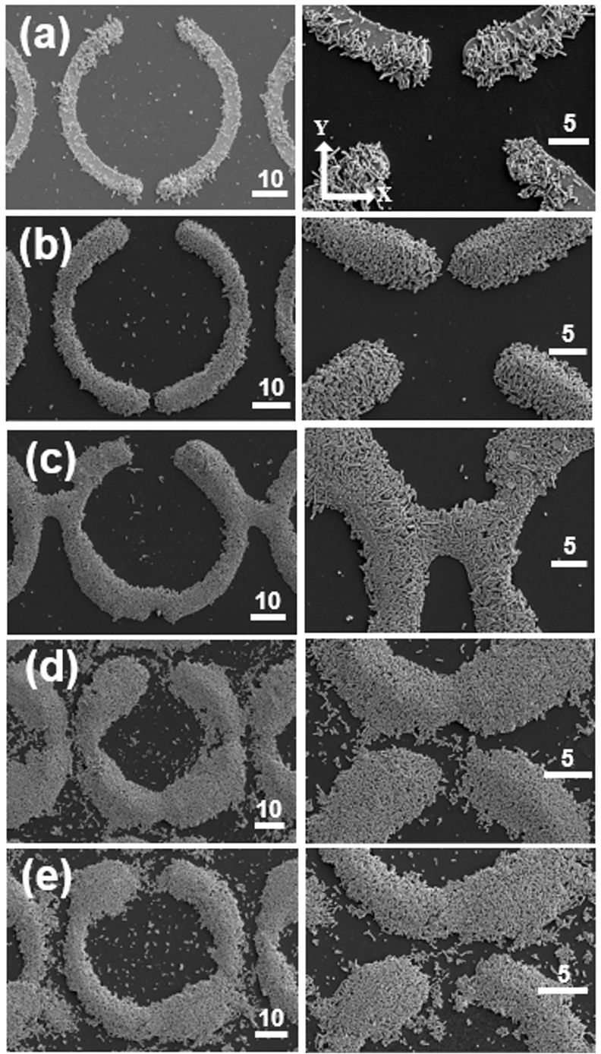
Fig S3-6 | Regioselective assembly of Au@Fe_{x}O_{y} NRs on the magnetized Ni-metasurface (magnetic field direction is Y axis) depending on the concentration of NRs. (a) 0.1 mg mL⁻¹, (b) 0.3 mg mL⁻¹ , (c) 0.5 mg mL⁻¹ , (d) 0.8 mg mL⁻¹ , and (e) 1 mg mL⁻¹ of Au@Fe_{x}O_{y} NRs were used.

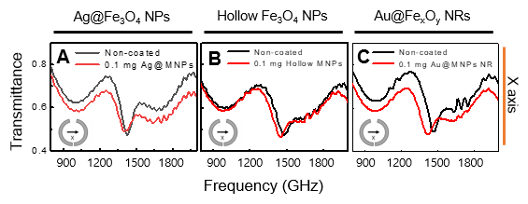
Fig S3-7 | THz-time domain spectroscopy spectra of MagPlas (Ag@Fe₃O₄) and hollow@Fe₃O₄ NPs, and Au@Fe₃O₄ NRs on Ni-metasurface at 0.1 mg/ml.
Au@Fe₃O₄ NRs are deposited with the same amount of the optical density as the NPs, where the transmittance was adjusted to be an equal intensity by the amount of MagPlas NP and NR. In the NR-deposited metasurfaces, a remarkable peak shift was observed, i.e., 46 GHz from 1268 to 1222 GHz. The large shift at the same optical density of NR may be explained from two plasmonic resonance modes through the longitudinal and transverse direction of NRs.
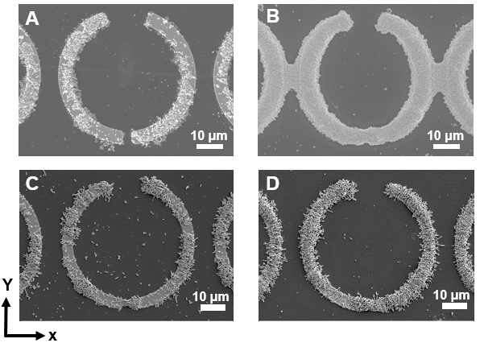
Fig S3-8 | Regioselectivie assembly of MagPlas NPs/NRs (Ag@Fe₃O₄ /Au@Fe₃O₄) on Ni-metasurface depending on the concentration of NPs/NRs. (a) used 0.1 mg⋅mL⁻¹ of Ag@Fe₃O₄ NPs, (b) used 1 mg⋅mL⁻¹ of Ag@Fe₃O₄ NPs, (c) used 0.1 mg⋅mL⁻¹ of Au@Fe₃O₄ NRs, and (d) used 0.3 mg⋅mL⁻¹ of Au@Fe₃O₄ NRs. Direction of magnetization was set to x-axis (a,b) and x-axis (c,d).

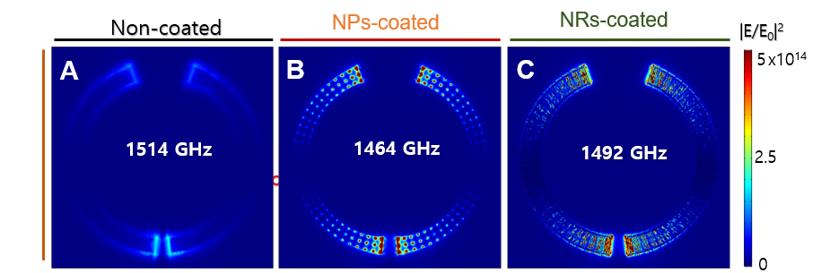Fig S3-9 | Finite element method (FEM) simulation on the effect of regioselective NP assembly on the Ni metasurface: Calculated electric field enhancement of the terahertz near-field irradiation in response to (A) uncoated and fully coated metasurfaces, using (B) Ag@Fe₃O₄ NP and (C) Au@Fe₃O₄ NR.

To reveal the origin of peak shift in the presence of NPs/NRs on the Ni-magnetized metasurface, finite element method (FEM) computational simulations of the terahertz near-field irradiation on the metasurfaces were performed using COMSOL Multiphysics software (Version 5.2a with incorporated Wave Optics Module). The electric field enhancement and the calculated THz-TDS spectra in transmittance, according to the coating mode and the NPs type (Ag@Fe₃O₄ NPs, Au@Fe₃O₄ NRs) were visualized in Fig S3-8. The calculation results demonstrated that the Ni - split ring metasurface exhibits a peak absorption at 1400 ~ 1500 GHz as well as a broaden absorption band at below 1300 GHz, similar to the experimental results. The assembly of MagPlas NPs/NRs on the Ni split-rings caused bathochromic shifts of the peak absorption, due to the local field enhancement and resonance of NPs/NRs.
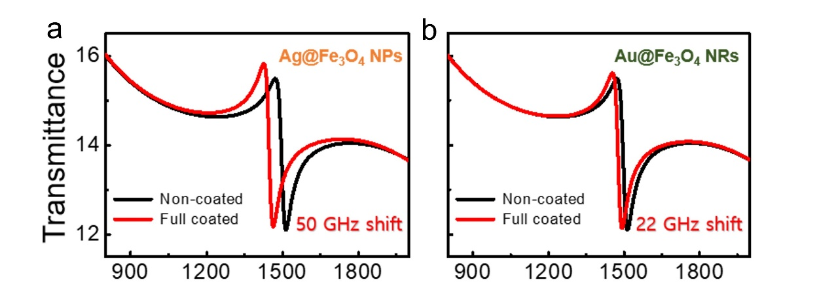
Fig S3-10 | Finite element method (FEM) simulation on the effect of regioselective NP assembly on the Ni metasurface: Calculated THz-TDS spectra of (a) Ag@Fe₃O₄ NP and (b) Au@Fe₃O₄ NR.
The field enhancement factor at the hotspots in the presence of NPs/NRs reached as high as 10⁶ with a -50 GHz shift in case of NPs (Fig S3-9a), and 10⁷ with a -22 GHz shift in case of NRs assembled on the Ni-based metasurface (Fig S3-9b). The extension of the shifting instances could be attributed to the expanding conductive geometry, as some of the local field enhancements were observed over nickel pattern exterior. Therefore, the simulation results indicated that the assembly geometry and morphology of magnetic NP assembled on the Ni metasurfaces is crucial to modulate the distinctive absorption characteristics toward THz wave. These unique strategies could be used to reconfigurable chiral metasurfaces.

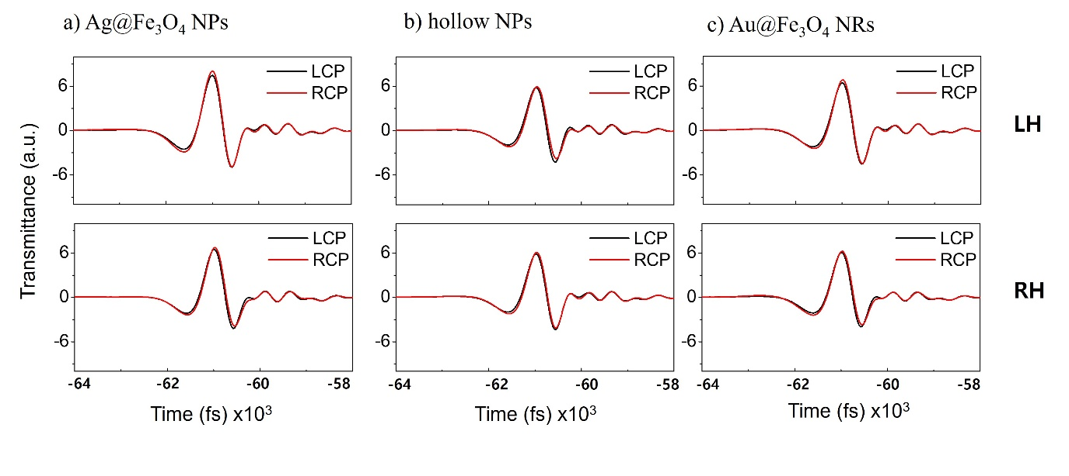
Fig S4-1 | Circular polarized THz-time domain spectroscopy spectra of (a) Ag@Fe₃O₄ NPs, (b) hollow NPs, and (c) Au@Fe₃O₄ NRs metasurface with 45˚ (LH) and -45˚ (RH).

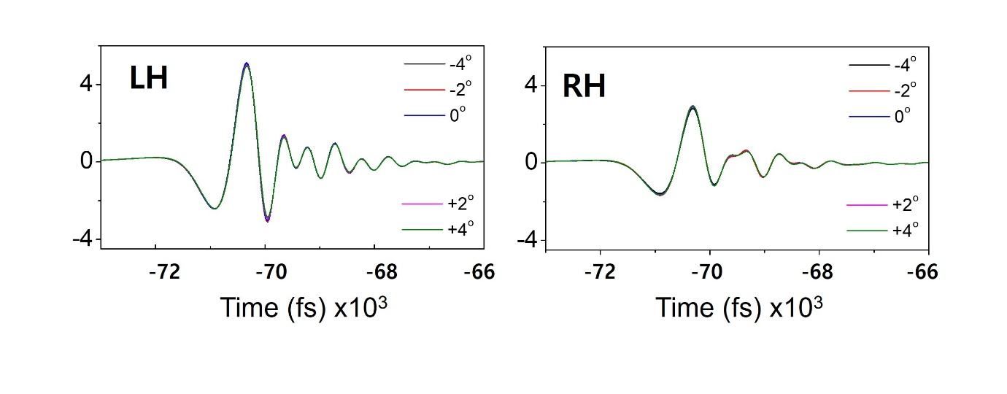
Fig S5-1 | THz transmittance-time variation across the Ag@Fe₃O₄ NPs regioselective (a) LH and (b) RH metasurface depending on the wiregrid polarizer rotation angle (θ_{rot}), when the azimuthal angle of the linearly polarized incident wave θ_{in} = 0°.

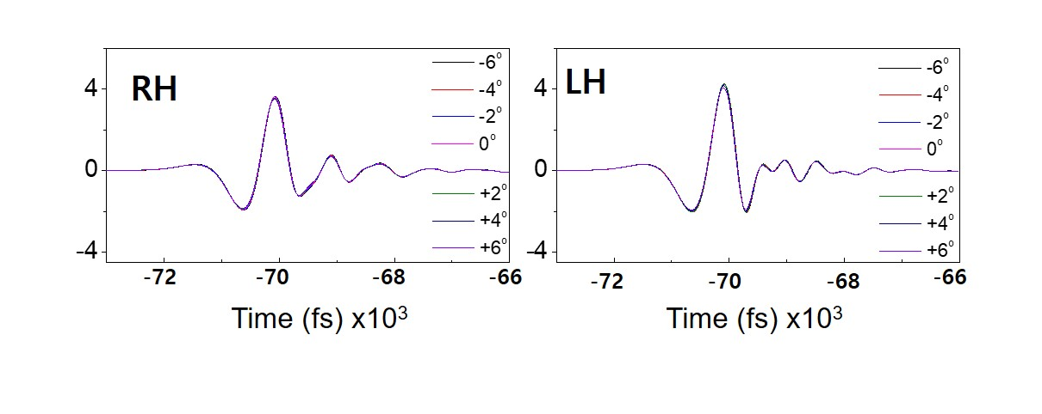Fig S5-2 | THz transmittance-time variation across the Hollow NPs regioselective (a) LH and (b) RH metasurface depending on the wiregrid polarizer rotation angle (θ_{rot}), when the azimuthal angle of the linearly polarized incident wave θ_{in} = 0°.
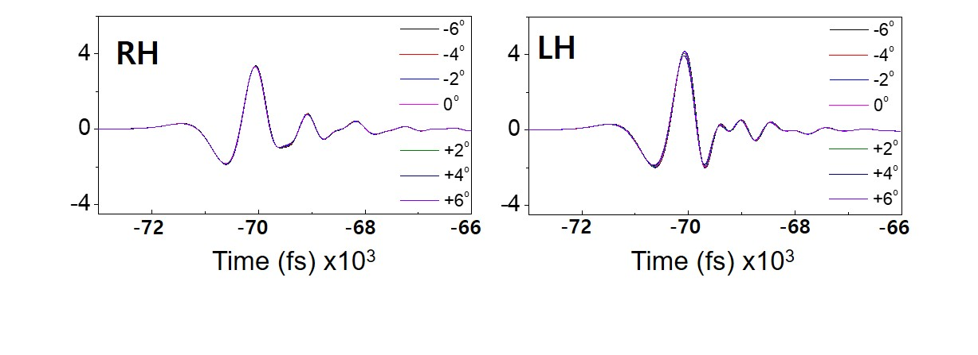
Fig S5-3 | THz transmittance-time variation across the Au@Fe₃O₄ NRs regioselective (a) LH and (b) RH metasurface depending on the wiregrid polarizer rotation angle (θ_{rot}), when the azimuthal angle of the linearly polarized incident wave θ_{in} = 0°.

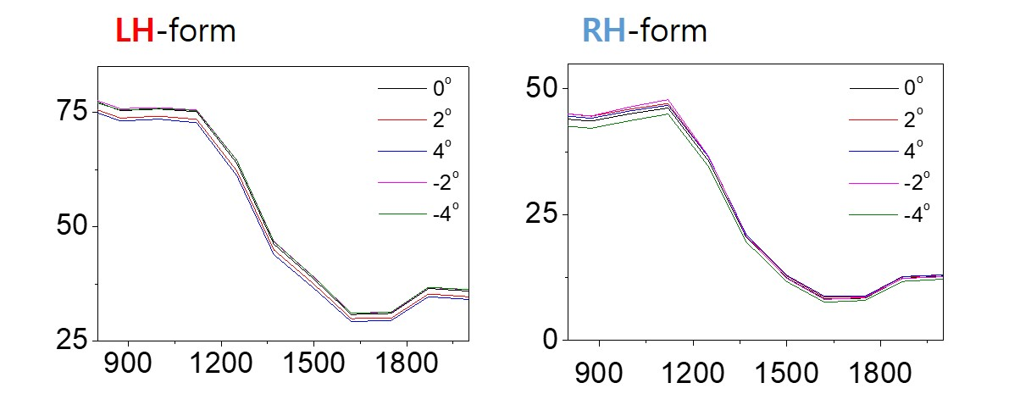
Fig S5-4 | THz transmittance variation of regioselective (Ag@Fe₃O₄) LH and RH chiral metasurface depending on the wiregrid polarizer rotation angle (θ_{rot} = -4, -2, 0, 2, 4°), when the azimuthal angle of the linearly polarized incident wave θ_{in} = 0°.
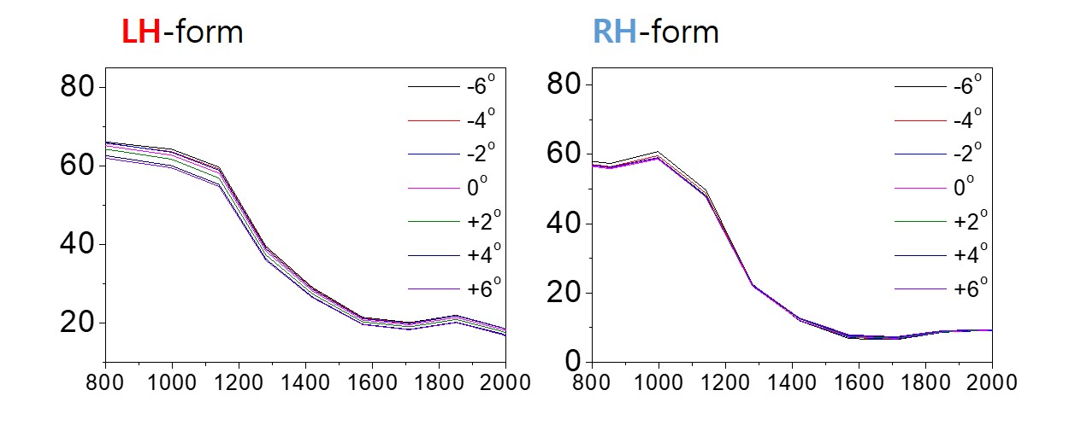
Fig S5-5 | THz transmittance variation of regioselective (hollow NPs) LH and RH chiral metasurface depending on the wiregrid polarizer rotation angle (θ_{rot}= -6°, -4°, -2°, 0°, 2°, 4°,6°), when the azimuthal angle of the linearly polarized incident wave θ_{in} = 0°.
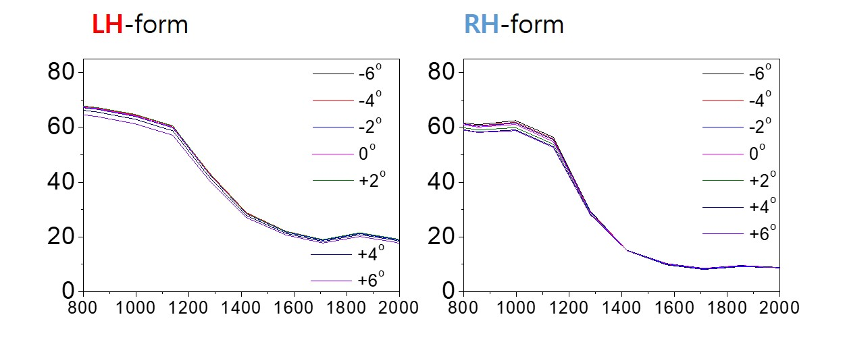
Fig S5-6 | THz transmittance variation of regioselective (Au@Fe₃O₄ NRs) LH and RH chiral metasurface depending on the wiregrid polarizer rotation angle (θ_{rot}= -6°, -4°, -2°, 0°, 2°, 4°,6°), when the azimuthal angle of the linearly polarized incident wave θ_{in} = 0°.

1 Jeong, K.-J. et al. Chirality of Fingerprints: Pattern-and Curvature-Induced Emerging Chiroptical Properties of Elastomeric Grating Meta-Skin. ACS nano 16, 6103-6110 (2022).
2 Gwak, J. et al. Reconfigurable Metasurface of Magnetoplasmonic Microbundle Array for Chiral Signal Enhancing. Advanced Optical Materials 11, 2202104 (2023).
3 Shin, H. J., Choi, S.-W. & Ok, G. Qualitative identification of food materials by complex refractive index mapping in the terahertz range. Food chemistry 245, 282-288 (2018).
4 Chen, H. et al. Shape-dependent refractive index sensitivities of gold nanocrystals with the same plasmon resonance wavelength. The Journal of Physical Chemistry C 113, 17691-17697 (2009).

