Additional details on methodology, study sites and findings

Section 1: Details on methodology and sites
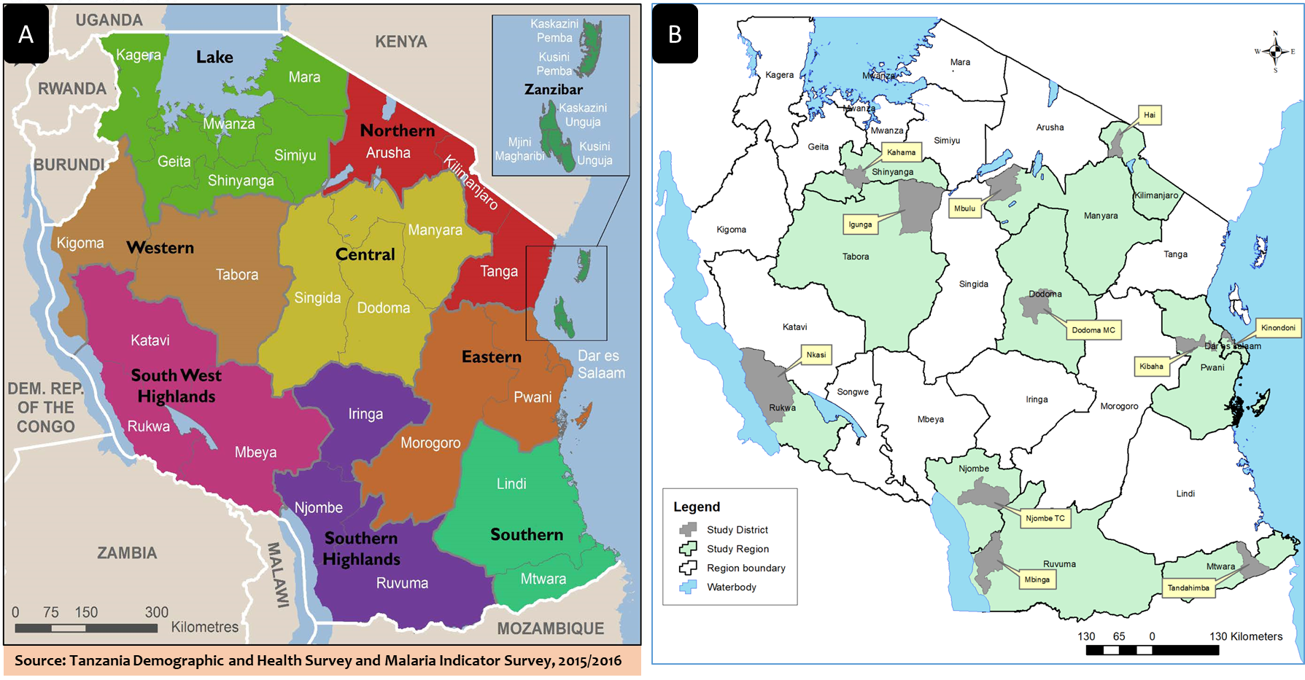
Figure S1.1: Map of Tanzania indicating geographical zones (A) and regions and districts involved in data quality assessment study (B)
To facilitate sampling of study sites, the country was categorized into eight geographical zones (Figure S1.1 – Panel A). A multistage sampling technique was used to randomly select 1-2 regions from each zone which were believed to be representative considering zone size. One district was then randomly selected from each region using computer generated random number. Districts (and regions) selected were Hai (Kilimanjaro) Dodoma Urban (Dodoma), Mbulu (Manyara), Kinondoni (Dar es Salaam), Kibaha (Pwani), Tandahimba (Mtwara), Kahama (Shinyanga), Igunga (Tabora), Nkasi (Rukwa), Njombe Urban (Njombe) and Mbinga (Ruvuma) (Figure S1.1 – Panel B).
Table S1.1: Number of visited health facilities by districts and service area
Service area
District | HF visited | OPD | ANC | PNC | PITC | LND | FP | IPD
Dodoma | 11 | 11 | 11 | 7 | 9 | 6 | 8 | 3
Hai | 10 | 10 | 10 | 10 | 9 | 10 | 10 | 4
Igunga | 10 | 10 | 9 | 9 | 7 | 8 | 7 | 5
Kahama | 10 | 10 | 9 | 9 | 9 | 9 | 8 | 4
Kibaha | 8 | 8 | 7 | 5 | 6 | 5 | 6 | 1
Kinondoni | 18 | 17 | 16 | 18 | 14 | 8 | 13 | 3
Mbinga | 10 | 10 | 10 | 10 | 9 | 10 | 7 | 5
Mbulu | 8 | 8 | 8 | 8 | 6 | 8 | 7 | 3
Njombe | 10 | 10 | 9 | 10 | 10 | 10 | 7 | 6
Nkasi | 10 | 10 | 10 | 10 | 6 | 10 | 7 | 5
Tandahimba | 10 | 10 | 9 | 9 | 9 | 9 | 8 | 4
Total | 115 | 114 | 108 | 105 | 94 | 93 | 88 | 43

List of facilities per district (registered and functional) were obtained from the Health Facility Registry (http://moh.go.tz/hfrportal). With such selection a minimum number of facilities per district was 8. Due to a large number of private facilities in Kinondoni district, additional private hospital and two private health centres were added.

Figure S1.2: Maps of study districts indicating distribution of visited health facilities by level and ownership
Dodoma
Hai
Igunga

Kahama
Kibaha
Kinondoni

Mbinga
Mbulu
Njombe
Nkasi

Tandahimba

Section 2: Additional information on tools, forms and procedures used during data collection, management and analysis

Selection of Service areas and Indicators for assessment:
The Tanzania Health Management Information System (HMIS) is structured via department units that provide specific service of which each require recording, compilation and preparation of reports. These service areas vary in facilities, based on the level and readiness. Prior to the assessment exercise, a pilot study which mainly involved the core research team and health facility workers was conducted. During the pilot study, all HMIS tools (registers, tally-sheets and report forms) used for data collection, compiling and reporting for all service areas available at the health facilities were reviewed and discussed thoroughly. The discussion focused on the collecting health workers’ opinions and experiences on the data processes, i.e. clarity on variables needed to be collected, processes used for data compilation, summarization and preparation of reports. The team also reviewed all the indicators in the report forms and discussed with facility staff on their opinions on number of indicators for each service, clarity and variation with respect to time required to compile its data, level of difficulty, chances of errors, sensitive, etc.
Following these discussions each of the facility involved in the pilot was asked to suggest few service areas that could represent assessment of HMIS data quality and utilization of tools. The choice of areas was supposed to cover services that address most more clients’ needs, require more time to delivery service, require more time to register, and with more complex tools, and cover disease programs. Once the service was picked the team and staff jointly identified, discussed and agree on the indicators from the report forms that would be appropriate for assessment The final list of the service area and indicators selected is shown in Table S2.1.

Table S2.1: Indicators assessed for each service area during data quality assessment study
Service Area | Age categories (in years) | Indicators
OPD | <5 and ≥5 | Anaemia, Mild/ Moderate
OPD | <5 and ≥5 | Anaemia, Severe
OPD | <5 and ≥5 | Confirmed malaria blood slide (BS) positive
OPD | <5 and ≥5 | Confirmed malaria mRDT positive
OPD | <5 and ≥5 | Clinical Malaria (Not Tested)
IPD | <5 and ≥5 | Anaemia, Mild/ Moderate
IPD | <5 and ≥5 | Anaemia, Severe
IPD | <5 and ≥5 | Confirmed malaria blood slide (BS/mRDT) positive
IPD | <5 and ≥5 | Clinical Malaria (Not Tested)
ANC and ANC (PMTCT) | <20 and ≥20 | 2a: Less than 12 weeks of pregnancy (Umri wa mimba chini ya wiki 12)
ANC and ANC (PMTCT) | <20 and ≥20 | 2b: Twelve or more weeks of pregnancy (Umri wa mimba wiki 12 au Zaidi)
ANC and ANC (PMTCT) | <20 and ≥20 | 3: Pregnant mothers received TT2 vaccine (Wajawazito waliopata chanjo ya TT2)
ANC and ANC (PMTCT) | <20 and ≥20 | 6c: Pregnant mothers tested malaria positive (Waliopima Malaria positive)
ANC and ANC (PMTCT) | <20 and ≥20 | 6d: Pregnant mothers received IPT2 (Waliopewa IPT2)
ANC and ANC (PMTCT) | <20 and ≥20 | 5c: Pregnant mothers received first test of HIV at the clinic (Wajawazito Waliopima VVU kipimo cha kwanza kliniki)
ANC and ANC (PMTCT) | <20 and ≥20 | 5d: Pregnant mothers tested positive for HIV during first test (Wajawazito Waliokutwa na VVU (positive) kipimo cha kwanza)
ANC and ANC (PMTCT) | <20 and ≥20 | 5p: Pregnant mothers < 25 years received first HIV test (Wajawazito waliopima VVU kipimo cha kwanza walio chini ya umri wa miaka 25)
PNC and PNC (PMTCT) | <20 and ≥20 | 1a: Delivered mothers attended clinic within 48 hours (Waliohudhuria Ndani ya saa 48)
PNC and PNC (PMTCT) | <20 and ≥20 | 1b: Delivered mothers attended clinic between 3-7 days (Waliohudhuria kati ya siku ya 3-7)
PNC and PNC (PMTCT) | <20 and ≥20 | 2. Delivered mothers completed all the visits (48hours/3-7 days, 8-28 days, 29-42 days) (Waliomaliza mahudhurio yote (saa 48/siku 3-7, siku 8-28, siku 29-42))
PNC and PNC (PMTCT) | <20 and ≥20 | 3. Delivered mothers diagnosed with severe anaemia (Hb < 8.5 g/dl) (Wenye upungufu mkubwa wa damu (Hb < 8.5 g/dl))
PNC and PNC (PMTCT) | <20 and ≥20 | 4. Delivered mothers acquired mental illness (Waliopata matatizo ya akili)
PNC and PNC (PMTCT) | <20 and ≥20 | 10d. HIV positive mothers choose exclusive breast feeding (EBF) (Wenye VVU waliochagua kunyonyesha maziwa ya mama pekee (EBF))
LnD | <20 and ≥20 | 2a. Delivered at health facility (Waliojifungulia katika kituo cha kutolea huduma za afya)
LnD | <20 and ≥20 | 2e. Delivered with skilled health personnel (Waliozalishwa na watoa huduma wenye ujuzi)
FP | 10-14, 15-19, 20-24 and ≥25 | 1a. Number of clients for Injection method (Idadi ya Wateja wa Sindano)
FP | 10-14, 15-19, 20-24 and ≥25 | 2a. Number of clients receiving pills at health facility (Idadi ya wateja wa Vidonge Kituoni)
FP | 10-14, 15-19, 20-24 and ≥25 | 6a. Inserting Inter-uterine device at health facility (Kuweka Kitanzi – kituoni)
FP | 10-14, 15-19, 20-24 and ≥25 | 6c. Removing inter-uterine device at health facility (Kuondoa Kitanzi – kituoni)
FP | 10-14, 15-19, 20-24 and ≥25 | 11a. Those screened for breast cancer (Waliochunguzwa Titi)
FP | 10-14, 15-19, 20-24 and ≥25 | 11c. Those screened for cervical cancer (Waliochunguzwa Shingo ya mfuko wa kizazi)
PITC | ≤14, 15-24, 25-49 and ≥50 | Number of new clients (Idadi ya wateja wapya (MP))
PITC | ≤14, 15-24, 25-49 and ≥50 | Number of new clients tested positive for HIV (Idadi ya wateja wapya waliopimwa na wakapatika na VVU)
PITC | ≤14, 15-24, 25-49 and ≥50 | Number of clients returned for counselling after testing and received the test results (Idadi ya wateja waliorudi na kupewa ushauri nasaha baada ya kipimo na kupewa majibu ya VVU (HM))
Texts in Italics represent the Indicator name translated from Kiswahili version used in the HMIS tools.
OPD=Outpatient department; IPD=Inpatient department; ANC=Antenatal care; FP=Family Planning; PNC=Post-natal care; LND=Labour and Delivery; PITC=Provider-Initiated Testing and Counselling; mRDT= Malaria rapid diagnostic test; IPT=Intermittent preventive therapy or intermittent preventive treatment; TT= tetanus toxoid; PMTCT= Prevention of mother-to-child transmission
The age category for the indicators followed the grouping used for reporting by HMIS tools. Based on HMIS experts’ opinions’ and, health workers from pilot facilities and data generated during pilot exercise, we included the indicators which were easy to collect, difficult to understand, difficult to compile, and took time to compile.

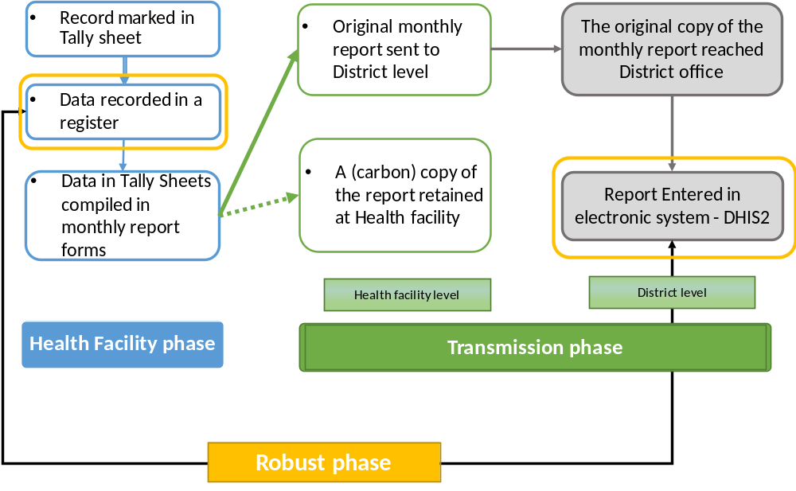
Figure S2.1: The routine health management information system data journey used to categorize data management system. DHIS2 = District Health Information System Version-2

Data journey and processes: Patient data are recorded in registers at the time a client is been attended. The records are compiled at the end of each month to make a report, done in duplicate and separately for each service unit. Tally-sheets, designed for each service unit with the same structure as the reported indicators, are used daily to track each record. The original month report is submitted to the district office. Used registers, tally-sheets and carbon copies of reports are kept/stored at the facility. The reports submitted to the district office are filed and organized and the data later entered in the electronic system for further analysis and use (Figure S2.1).

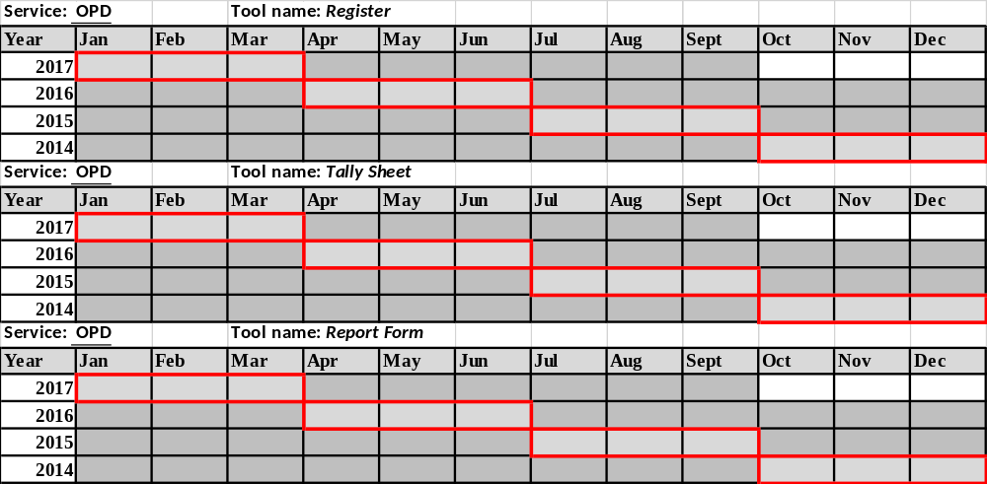
Figure S2.2: Checklist at Health Facility level for Data Verification Assessment. The months marked in red represent the quarters in a year where detailed data review was performed.

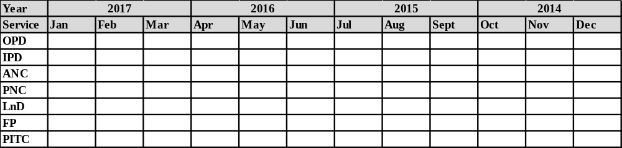
Figure S2.3: Checklist at District level for Data Verification Assessment

The checklists were used to mark available registers, tally-sheets and summary report forms for all service areas, then later summarized to calculate availability rates. Taking all services offered and all HFs, in each month assessed, a total of 645 register-months, 551 tally-sheets-months and 645 monthly reports were expected to be available. For the 45 months assessed (January 2014-September 2017) we expected a total of 29,025, 24,795, and 29,025 register-months, tally-sheets-months and report-form-months, respectively.
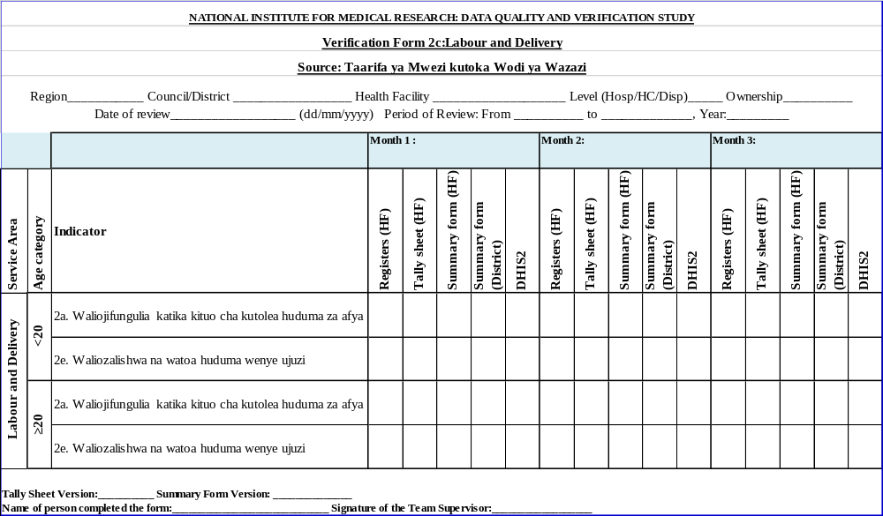
Figure S2.4: Sample of verification form used to compare data from different source during data quality assessment exercise

Before data entry, data collection forms were organized, sorted and provided with unique identification numbers. All entries were checked for immediate errors such as names of HFs, names of districts/regions, etc., and corrected immediately. Quality check was done by comparing a random pick of 10% of entered data with the one in the original forms.

Table S2.2: Difference ratios to measure data variation at different phase of assessment
Phase | Difference measure | Difference ratio (base source in bold) | Description
Health facility (HF) phase | Diff1 | Tally sheet/HF Register | Compared data recounted from register and those marked in a tally sheet
Health facility (HF) phase | Diff2 | HF Summary report at facility /HF Register | Compared data recounted from register and the summary recorded in a monthly report
Transmission phase | Diff3 | HF Summary report at District /HF Summary report at facility | Compared data in the original monthly report obtained at district office and those in a copy retained at HF
Transmission phase | Diff4 | DHIS2 /HF Summary report at facility | Compared data between the copy of a monthly report retained at HF and those entered in electronic system (DHIS2)
Transmission phase | Diff5 | DHIS2 /HF Summary report at District | Compared data in the original monthly report submitted at district and those entered in electronic system
Robust phase | Diff6 | DHIS2 / HF Register | Comparing data recounted from registers with totals entered in DHIS2

Six difference ratio (DR) indices, Diff1-6, were calculated and assessed, and grouped considering three phases of the data journey, i.e. from the point a record is entered in a register at the facility to the point it reaches the DHIS2 (Table S2.2). The first phase focuses on data activities occurring at facility: recording, tallying, report compilation and preparation, referred as the “health facility phase” and includes: Diff 1 – comparing data recounted from register and those marked in a tally sheet; and Diff 2 – comparing data recounted from register and the summary recorded in a monthly report found at facility. The second phase focused on a stage when data is transferred from one level to another, facility to district or district office files to DHIS2 and accounts for all the revisions and corrections that might happen during this period. This is referred as the “transmission phase” and includes: Diff 3– comparing data in the original (submitted to the district) and in the copy (retained at the facility) monthly report; Diff 4 – comparing records in the copy of a monthly report and in DHIS2; and, Diff 5 - comparing data in the original monthly report and those entered in the DHIS2. The third phase referred as the “robust phase” includes: Diff 6 - comparing data recounted from registers with totals entered in DHIS2. Diff 6 masks all quality issues that may arise at the facility or during transmission and compare the two extreme ends of the data journey.

At the facility level, each service area has its own register, tally sheet (not available for PITC) and report form. Therefore, for the availability assessment, for each service area, we expected to observe a total of 45 months with records in the registers, 45 used tally-sheets (matching each month and 45 monthly reports to cover the period under review (January 2014 to September 2017). At district level, we expected to observe a total of 12 report forms for each service area (reviewed quarters: October-December 2014; July-September 2015; April-June 2016; and January-March 2017).
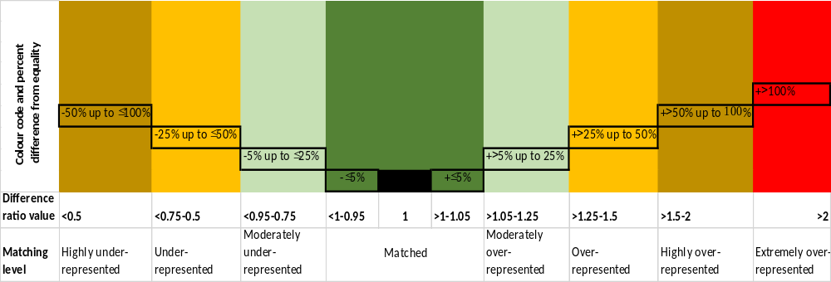
Figure S2.5: Colour code scheme used to compare data accuracy between different tools

Section 3: Additional findings on availability rates and data accuracy by different attributes

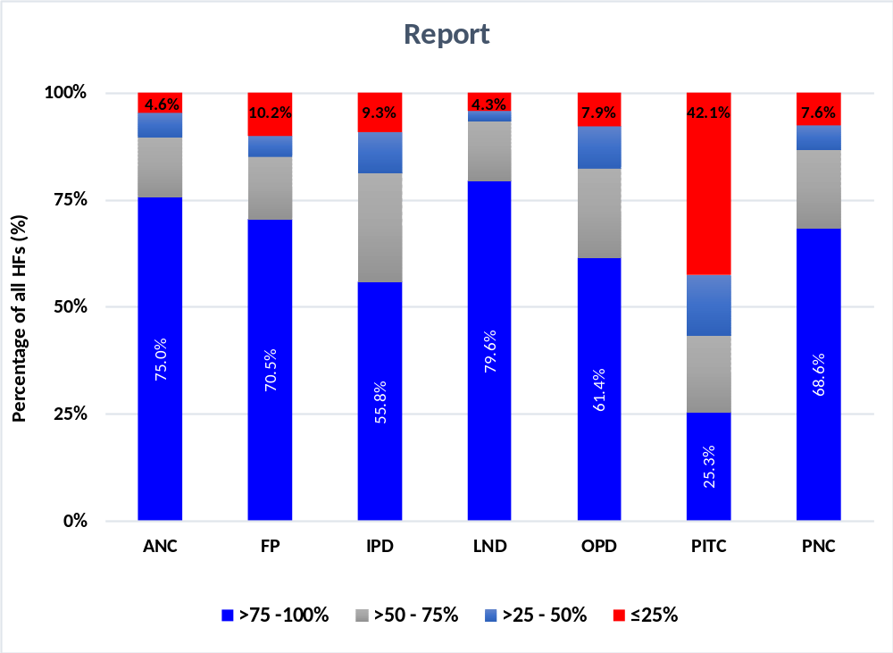
Figure S3.1: Report forms availability rates by service area categorized into very high, high, average, and low windows. Percentages were calculated condition on the HFs providing the service

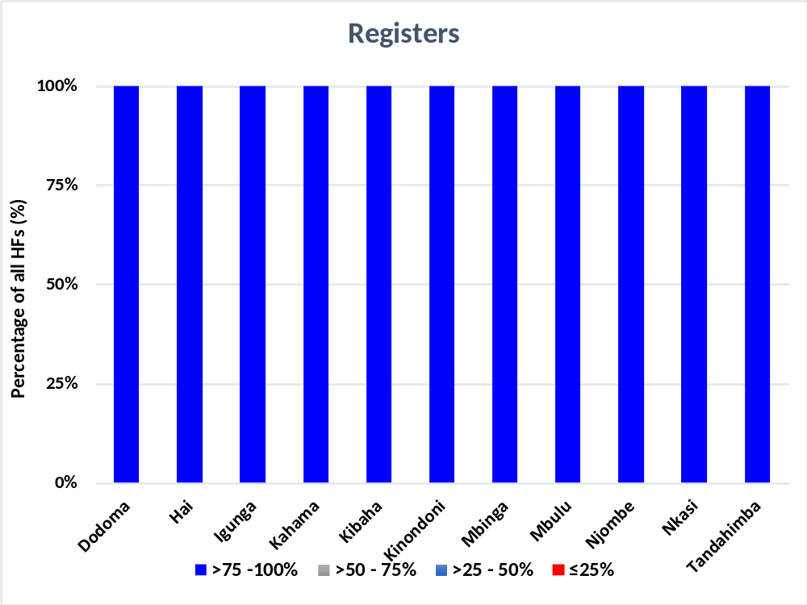
Figure S3.2: Registers availability levels by district categorized into very high, high, average, and low windows

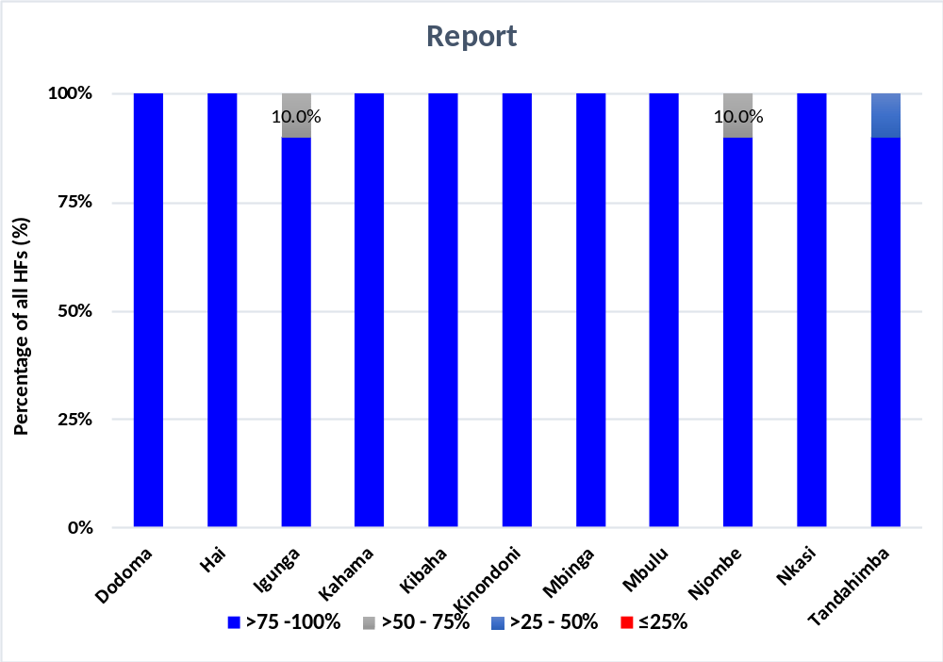
Figure S3.3: Report-forms availability levels by district categorized into very high, high, average, and low windows.

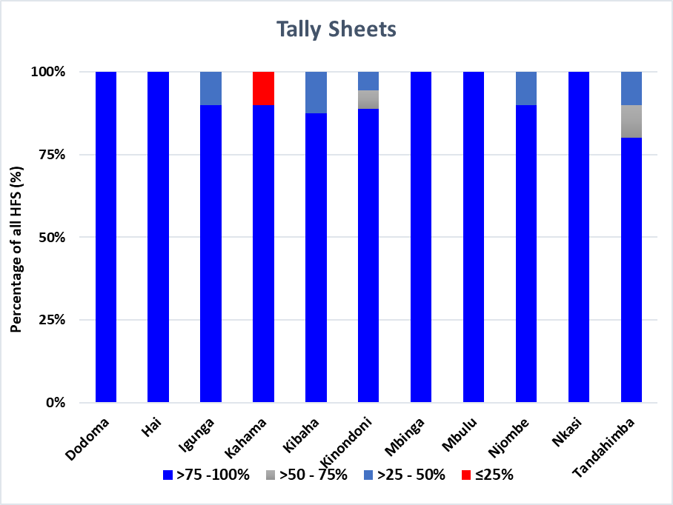
Figure S3.4: Tally-sheets availability levels by district categorized into very high, high, average, and low windows

Matching availability of reports at district level and HF
We matched availability of reports at district level and HF by service area for each of the four quarters included in the 12-month detailed review period. Results in Figure S3.5 indicate higher availability of reports at the HF level than at the district level (p<0.0001). This means copies of the reports were seen at HFs but not found at district office. This differed by service-area with the reproductive health unit reports (PNC, LnD, ANC) presenting best performance, PITC reports difficult to find at both levels but worse at district office, and IPD reports often missing at district offices. We also observed significant matched variation for hospitals and private facilities reports with less reports found at district office (p<0.0001) which could imply paper reports not submitted.

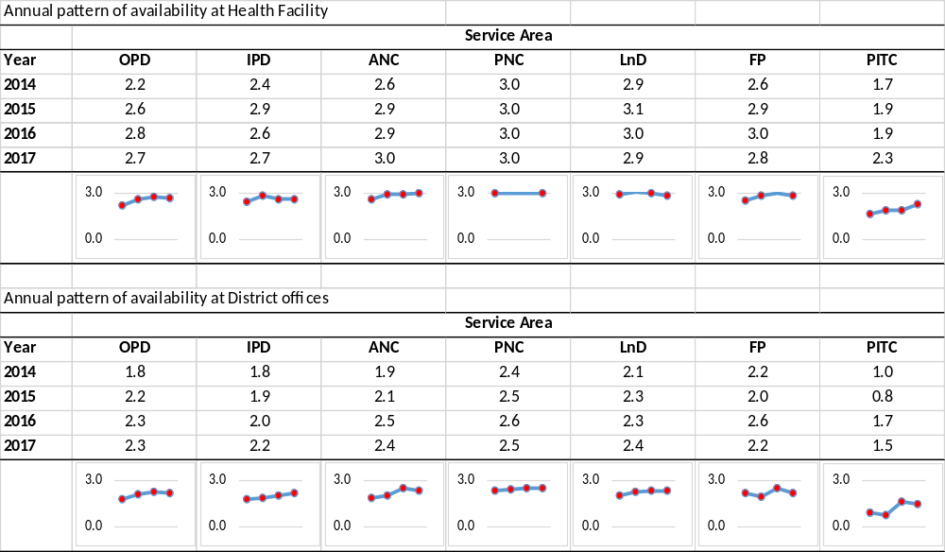
Figure S3.5: Trend of report-forms availability matching presence at district office and at HF by service area over years

These findings add evidence on either challenges in transmission of reports, differences in program reporting practices and weakness in the filing system at the district office. There was no standard filing system of the received HF reports existing which hindered assessing if the report was received or not.

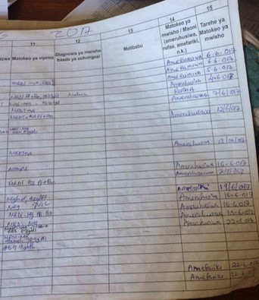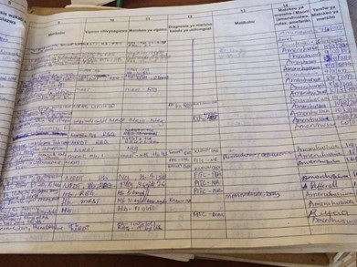
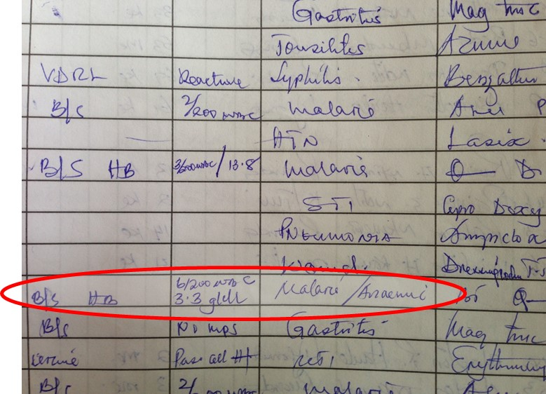
Figure S3.6: Missing information – in the attached sheet no diagnosis was filled for the entire column, or wrong diagnosis filled (anaemia instead of severe anaemia) however, laboratory results including positive mRDTs, Hb tests are found. In this case, (it was reported that) the person doing the counting for the report would base on the laboratory results to count if it was malaria or anaemia cases or categorize to the severity levels of anaemia as required in the report form.

This type of malpractice was common and was found to be among the sources of poor reports and low accuracy

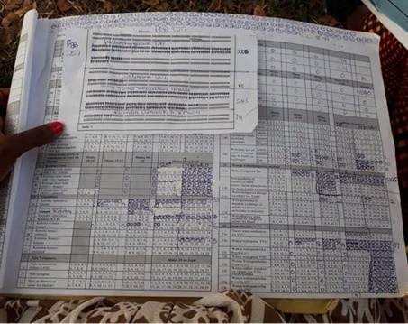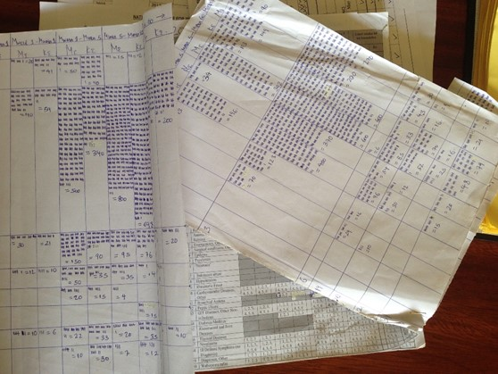
Figure S3.7: Utilization of Tally sheets at Health facilities – due to a large number of clients and few spaces allocated in the tally sheets, health workers had to innovate mechanisms to capture all cases by either improvise “circles” on the sides of the sheet or attach a separate sheet.

This approach is praised and has solved issues of data accuracy, however, it is found difficult to track what belongs to what when a different personnel is involved in making reports and make health workers see tally sheets as complicated tool to use.

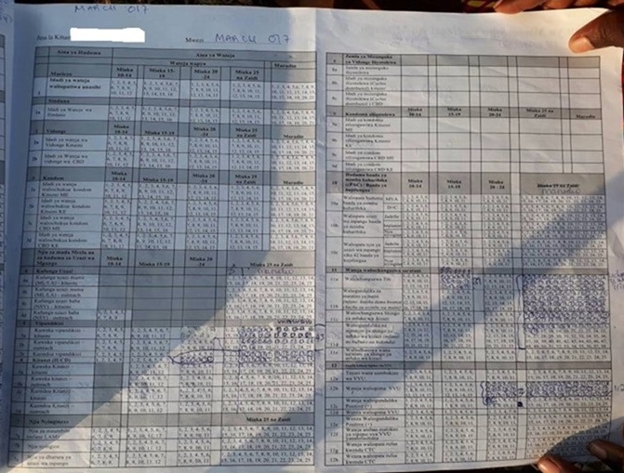
Figure S3.8: Few spaces in the tally sheets – health workers stop marking cases once all available numbers have been used – and “just” add the total at the end of month by counting back from the registers.

The challenge of this approach is that it is time consuming, makes the tally sheets seem redundant and results to accuracy problems.

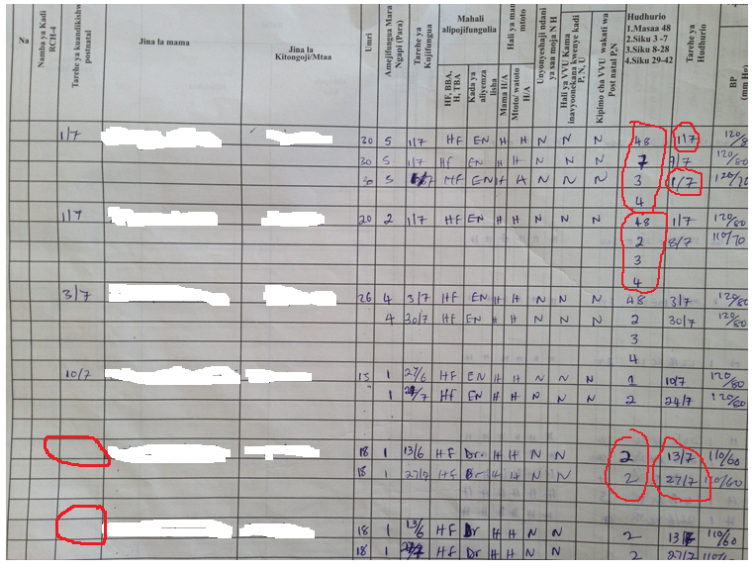
Figure S3.9: An extract from Postnatal register indicating low understanding on recording. Such poor recording practice were linked to double/wrong counting which resulted to low accuracy

Figure S3.10: An extract from a Labour and Delivery tally sheet indicating inconsistency in recording. Clients where indicated to deliver at health facility as marked in the tally sheet (purple mark), however, almost none where marked of who assisted in delivery (yellow mark). This practice resulted to inaccuracy during reporting.

Additional data accuracy results

Table S3.1: Data Accuracy by indicators
Service area | Indicator | Health facility phase |  | Transmission phase |  |  | Robust
Service area | Indicator | Diff 1  Tally vs. Registers | Diff 2  Report (HF) vs. Registers | Diff 3  Report (District) vs. Report (HF) | Diff 4  DHIS2 vs. Report (HF) | Diff 5  DHIS2 vs. Report (District) | Diff 6 DHIS2 vs. Registers
ANC | 2a: Less than 12 weeks of pregnancy (Umri wa mimba chini ya wiki 12) | 1.45 | 1.55 | 0.97 | 1.05 | 1.11 | 1.54
ANC | 2b: Twelve or more weeks of pregnancy (Umri wa mimba wiki 12 au Zaidi) | 1.08 | 1.14 | 1.05 | 1.10 | 1.07 | 1.18
ANC | 3: Pregnant mothers received TT2 vaccine (Wajawazito waliopata chanjo ya TT2) | 2.42 | 3.71 | 1.02 | 1.03 | 1.02 | 3.65
ANC | 6c: Pregnant mothers tested malaria positive (Waliopima Malaria positive) | 1.11 | 1.24 | 0.96 | 0.95 | 0.98 | 1.15
ANC | 6d: Pregnant mothers received IPT2 (Waliopewa IPT2) | 2.18 | 3.09 | 1.03 | 1.09 | 1.06 | 3.20
ANC | 5c: Pregnant mothers received first test of HIV at the clinic (Wajawazito Waliopima VVU kipimo cha kwanza kliniki) | 1.34 | 1.56 | 1.06 | 1.09 | 1.03 | 1.61
ANC | 5d: Pregnant mothers tested positive for HIV during first test (Wajawazito Waliokutwa na VVU (positive) kipimo cha kwanza) | 0.77 | 0.97 | 1.00 | 0.95 | 0.95 | 0.98
ANC | 5p: Pregnant mothers < 25 years received first HIV test (Wajawazito waliopima VVU kipimo cha kwanza walio chini ya umri wa miaka 25) | 0.31 | 0.91 | 0.99 | 0.14 | 0.16 | 0.03
FP | 1a. Number of clients for Injection method (Idadi ya Wateja wa Sindano) | 0.88 | 0.96 | 1.00 | 1.13 | 1.10 | 1.04
FP | 2a. Number of clients receiving pills at health facility (Idadi ya wateja wa Vidonge Kituoni) | 0.72 | 1.03 | 0.95 | 1.01 | 1.06 | 1.03
FP | 6a. Inserting Inter-uterine device at health facility (Kuweka Kitanzi – kituoni) | 1.08 | 1.23 | 0.98 | 0.83 | 0.88 | 1.03
FP | 6c. Removing inter-uterine device at health facility (Kuondoa Kitanzi – kituoni) | 0.74 | 0.70 | 0.93 | 0.80 | 0.82 | 0.62
FP | 11a. Those screened for breast cancer (Waliochunguzwa Titi) | 0.84 | 1.34 | 0.98 | 1.04 | 1.05 | 1.40
FP | 11c. Those screened for cervical cancer (Waliochunguzwa Shingo ya mfuko wa kizazi) | 0.53 | 0.99 | 0.93 | 0.97 | 1.02 | 1.11
IPD | Anaemia, Mild/ Moderate | 0.93 | 1.88 | 1.35 | 1.25 | 1.01 | 2.19
IPD | Anaemia, Severe | 2.38 | 3.81 | 1.29 | 1.26 | 1.00 | 4.47
IPD | Confirmed malaria blood slide (BS/mRDT) positive | 1.93 | 3.15 | 1.39 | 1.26 | 1.03 | 3.02
IPD | Clinical Malaria (Not Tested) | 1.36 | 2.50 | 0.98 | 0.88 | 1.23 | 2.33
LND | 2a. Delivered at health facility (Waliojifungulia katika kituo cha kutolea huduma za afya) | 1.04 | 1.08 | 1.31 | 1.24 | 1.03 | 1.11
LND | 2e. Delivered with skilled health personnel (Waliozalishwa na watoa huduma wenye ujuzi) | 1.49 | 1.78 | 1.08 | 1.02 | 1.01 | 1.75
OPD | Anaemia, Mild/ Moderate | 1.22 | 6.03 | 1.01 | 0.92 | 0.98 | 4.83
OPD | Anaemia, Severe | 1.49 | 3.94 | 0.87 | 0.79 | 0.93 | 5.55
OPD | Confirmed malaria blood slide (BS) positive | 1.52 | 3.92 | 1.54 | 1.39 | 1.09 | 4.44
OPD | Confirmed malaria mRDT positive | 1.48 | 3.30 | 1.00 | 1.03 | 1.06 | 4.62
OPD | Clinical Malaria (Not Tested) | 0.95 | 3.30 | 1.09 | 0.96 | 0.91 | 4.01
PITC | Number of new clients (Idadi ya wateja wapya (MP)) |  | 2.25 | 1.36 | 1.47 | 1.16 | 3.07
PITC | Number of new clients tested positive for HIV (Idadi ya wateja wapya waliopimwa na wakapatika na VVU) |  | 1.15 | 0.94 | 0.95 | 0.92 | 1.45
PITC | Number of clients returned for counselling after testing and received the test results (Idadi ya wateja waliorudi na kupewa ushauri nasaha baada ya kipimo na kupewa majibu ya VVU (HM)) |  | 1.51 | 1.09 | 0.98 | 1.04 | 1.81
PNC | 1a: Delivered mothers attended clinic within 48 hours (Waliohudhuria Ndani ya saa 48) | 1.30 | 3.09 | 1.01 | 1.02 | 1.00 | 2.62
PNC | 1b: Delivered mothers attended clinic between 3-7 days (Waliohudhuria kati ya siku ya 3-7) | 1.23 | 1.36 | 1.00 | 1.10 | 1.04 | 1.41
PNC | 2. Delivered mothers completed all the visits (48hours/3-7 days, 8-28 days, 29-42 days) (Waliomaliza mahudhurio yote (saa 48/siku 3-7, siku 8-28, siku 29-42)) | 1.61 | 2.34 | 0.98 | 1.05 | 1.09 | 2.34
PNC | 3. Delivered mothers diagnosed with severe anaemia (Hb < 8.5 g/dl) (Wenye upungufu mkubwa wa damu (Hb < 8.5 g/dl)) | 0.99 | 0.18 | 0.78 | 0.75 | 0.87 | 0.10
PNC | 4. Delivered mothers acquired mental illness (Waliopata matatizo ya akili) | 0.02 | 0.01 | 0.43 | 0.43 | 0.44 | 0.02
PNC | 10d. HIV positive mothers choose exclusive breast feeding (EBF) (Wenye VVU waliochagua kunyonyesha maziwa ya mama pekee (EBF)) | 0.80 | 1.30 | 1.02 | 0.95 | 0.80 | 0.93

Table S3.2: Data Accuracy by specific facilities combining all services within each district
District |  |  | Health facility phase |  | Transmission phase |  |  |  | Robust phase
District | HF Level | HF Ownership | Diff 1  Tally vs. Registers | Diff 2  Report (HF) vs. Registers | Diff 3  Report (District) vs. Report (HF) | Diff 4  DHIS2 vs. Report (HF) | Diff 5  DHIS2 vs. Report (District) | Diff 6 DHIS2 vs. Registers
Dodoma | Dispensary1 | Public | 0.45 | 1.07 | 1.02 | 0.97 | 0.89 | 0.95
Dodoma | Dispensary2 | Public | 2.64 | 2.21 | 0.89 | 0.87 | 0.89 | 2.11
Dodoma | Dispensary3 | Public | 3.07 | 2.28 | 1.04 | 0.85 | 0.76 | 1.78
Dodoma | Dispensary4 | Private | 0.84 | 0.90 | 1.00 | 0.40 | 0.44 | 0.34
Dodoma | Dispensary5 | FBO | 1.20 | 1.48 | 1.10 | 1.01 | 0.98 | 1.34
Dodoma | Dispensary6 | FBO | 1.55 | 1.35 | 1.01 | 1.02 | 0.92 | 1.41
Dodoma | Health Centre1 | Private | 0.99 | 1.73 | 1.19 | 0.94 | 0.91 | 1.83
Dodoma | Health Centre2 | Public | 1.16 | 1.35 | 1.00 | 0.98 | 0.95 | 1.13
Dodoma | Health Centre3 | Public | 3.09 | 2.61 | 0.98 | 1.00 | 0.96 | 3.63
Dodoma | Health Centre4 | FBO | 1.10 | 1.88 | 1.02 | 1.00 | 0.93 | 1.77
Dodoma | Hospital | Public | 0.89 | 4.11 | 0.96 | 1.28 |  | 4.44
Hai | Dispensary1 | Public | 0.75 | 0.81 | 1.00 | 0.99 | 0.98 | 0.73
Hai | Dispensary2 | FBO | 1.09 | 1.30 | 1.02 | 1.06 | 1.03 | 1.37
Hai | Dispensary3 | FBO | 1.70 | 1.50 | 0.98 | 0.95 | 0.95 | 1.45
Hai | Dispensary4 | Public | 0.46 | 0.50 | 1.00 | 1.03 | 1.00 | 0.63
Hai | Dispensary5 | Public | 0.71 | 0.94 | 1.05 | 0.95 | 0.94 | 0.86
Hai | Dispensary6 | Private | 1.04 | 1.36 | 1.00 | 1.07 | 1.11 | 1.08
Hai | Health Centre1 | Public | 1.62 | 1.96 | 0.96 | 0.99 | 0.95 | 1.56
Hai | Health Centre2 | Public | 1.15 | 1.82 | 0.86 | 0.87 | 1.12 | 1.45
Hai | Health Centre3 | Private | 0.82 | 1.21 | 0.96 | 0.89 | 0.94 | 1.01
Hai | Hospital | Public | 1.26 | 2.68 | 1.64 | 1.61 | 1.13 | 2.40
Igunga | Dispensary1 | FBO | 1.06 | 1.02 | 1.03 | 1.00 | 0.98 | 0.98
Igunga | Dispensary2 | Private | 0.86 | 0.98 | 0.94 | 0.93 | 0.93 | 0.88
Igunga | Dispensary3 | Public | 1.40 | 1.34 | 1.02 | 1.01 | 0.97 | 1.29
Igunga | Dispensary4 | FBO | 1.76 | 1.61 | 0.94 | 0.94 | 0.99 | 1.38
Igunga | Dispensary5 | Private | 0.21 | 0.69 | 0.97
Igunga | Dispensary6 | Public | 1.14 | 1.13 | 0.96 | 1.06 | 1.05 | 1.21
Igunga | Health Centre1 | Public | 0.98 | 1.29 | 0.93 | 1.22 | 1.21 | 1.53
Igunga | Health Centre2 | Public | 1.34 | 1.25 | 1.05 | 1.00 | 0.91 | 1.32
Igunga | Health Centre3 | FBO | 1.60 | 1.62 | 1.00 | 0.99 | 1.20 | 1.41
Igunga | Hospital | Public | 0.81 | 4.34 | 1.93 | 2.31 | 1.22 | 4.71
Kahama | Dispensary1 | Private | 1.36 | 4.26 | 0.90 | 0.85 | 1.02 | 3.60
Kahama | Dispensary2 | Private | 0.93 | 1.74 | 1.00 | 1.03 | 1.03 | 1.63
Kahama | Dispensary3 | Public | 1.69 | 2.00 | 1.03 | 1.02 | 1.02 | 1.71
Kahama | Dispensary4 | Public | 1.50 | 1.47 | 1.45 | 1.38 | 0.97 | 1.46
Kahama | Dispensary5 | Public | 1.17 | 1.15 | 0.95 | 0.97 | 0.99 | 1.03
Kahama | Dispensary6 | FBO | 1.16 | 1.82 | 2.15 | 1.75 | 0.96 | 1.26
Kahama | Health Centre1 | Private | 1.13 | 1.16 | 1.00 | 0.97 | 1.02 | 1.09
Kahama | Health Centre2 | FBO | 0.83 | 1.40 | 0.95 | 0.97 | 0.98 | 1.24
Kahama | Health Centre3 | Public | 1.04 | 1.95 | 1.17 | 1.06 | 1.02 | 1.12
Kahama | Hospital | Public | 2.44 | 6.44 | 1.17 | 1.14 | 1.28 | 7.93
Kibaha | Dispensary1 | Public | 0.83 | 1.13 | 0.92 | 0.90 | 0.98 | 1.02
Kibaha | Dispensary2 | Public | 1.05 | 1.27 | 1.01 | 1.10 | 1.09 | 1.41
Kibaha | Dispensary3 | Public | 1.38 | 0.99 | 0.94 | 0.91 | 0.98 | 0.93
Kibaha | Dispensary4 | Public | 1.08 | 1.06 | 0.98 | 0.96 | 0.99 | 1.01
Kibaha | Dispensary5 | Private | 2.08 | 3.06 | 1.13 | 1.24 | 1.08 | 3.10
Kibaha | Dispensary6 | FBO | 1.58 | 1.59 | 0.98 | 0.89 | 0.96 | 1.55
Kibaha | Health Centre1 | Public | 1.20 | 2.71 | 0.99 | 1.00 | 1.07 | 7.11
Kibaha | Health Centre2 | Public | 0.92 | 3.08 | 0.99 | 0.95 | 0.93 | 2.70
Kinondoni | Dispensary1 | FBO | 2.23 | 2.68 | 0.99 | 0.99 | 0.93 | 2.21
Kinondoni | Dispensary2 | Private | 1.17 | 1.37 | 1.12 | 1.05 | 0.98 | 1.59
Kinondoni | Dispensary3 | FBO | 1.07 | 5.24 | 1.61 | 1.44 | 1.12 | 6.80
Kinondoni | Dispensary4 | Public | 0.96 | 1.87 | 1.02 | 1.62 | 1.09 | 1.85
Kinondoni | Dispensary5 | Public | 0.79 | 1.82 | 1.12 | 1.00 | 1.10 | 3.60
Kinondoni | Dispensary6 | Private | 1.72 | 1.93 | 0.96 | 0.94 | 1.05 | 1.74
Kinondoni | Dispensary7 | Public | 1.13 | 1.64 | 1.14 | 1.08 | 1.06 | 1.33
Kinondoni | Dispensary8 | Private | 0.98 | 1.12 | 0.97 | 0.92 | 0.94 | 1.11
Kinondoni | Dispensary9 | Public | 0.40 | 0.88 | 1.00 | 0.98 | 0.98 | 0.90
Kinondoni | Dispensary10 | Public | 0.65 | 1.39 | 1.04 | 1.46 | 0.67 | 1.15
Kinondoni | Dispensary11 | Private | 1.20 | 7.68 | 1.12 | 0.79 | 0.85 | 1.36
Kinondoni | Health Centre1 | Public | 1.97 | 3.97 | 1.30 | 1.10 | 1.10 | 4.95
Kinondoni | Health Centre2 | Private | 0.84 | 2.25 | 1.17 | 1.14 | 0.99 | 2.66
Kinondoni | Health Centre3 | Private | 1.34 | 3.48 | 0.96 | 0.82 | 0.88 | 2.78
Kinondoni | Health Centre4 | Private | 0.79 | 2.94 | 1.11 | 0.85 | 0.97 | 2.43
Kinondoni | Health Centre5 | Public | 2.88 | 7.52 | 1.09 | 1.31 | 0.96 | 8.91
Kinondoni | Hospital1 | Public | 0.36 | 1.95 | 1.01 | 1.24 | 1.24 | 2.53
Kinondoni | Hospital2 | Private | 1.52 | 11.43 | 1.15 | 0.94 | 0.99 | 12.19
Mbinga | Dispensary1 | Public | 1.22 | 1.60 | 0.98 | 0.94 | 0.94 | 1.23
Mbinga | Dispensary2 | Public | 0.81 | 0.76 | 0.96 | 0.96 | 0.97 | 0.73
Mbinga | Dispensary3 | Public | 0.86 | 0.89 | 0.99 | 0.95 | 0.97 | 0.87
Mbinga | Dispensary4 | FBO | 1.09 | 1.54 | 1.01 | 0.89 | 0.91 | 1.28
Mbinga | Dispensary5 | Public | 1.34 | 1.45 | 0.99 | 0.95 | 0.96 | 1.29
Mbinga | Dispensary6 | Public | 1.01 | 1.00 | 1.00 | 0.98 | 1.05 | 0.94
Mbinga | Health Centre1 | FBO | 1.41 | 1.94 | 1.09 | 0.96 | 0.91 | 1.71
Mbinga | Health Centre2 | Public | 0.73 | 1.18 | 0.99 | 0.96 | 0.94 | 1.07
Mbinga | Health Centre3 | Public | 1.10 | 1.38 | 0.98 | 0.95 | 0.92 | 1.22
Mbinga | Hospital | FBO | 0.93 | 1.01 | 1.02 | 0.96 | 0.93 | 1.34
Mbulu | Dispensary1 | FBO | 1.21 | 1.05 | 0.99 | 0.93 | 0.96 | 0.95
Mbulu | Dispensary2 | Public | 0.86 | 1.34 | 0.99 | 0.94 | 0.95 | 0.87
Mbulu | Dispensary3 | FBO | 1.31 | 1.46 | 0.99 | 0.93 | 0.94 | 1.17
Mbulu | Dispensary4 | Public | 0.80 | 0.93 | 0.92 | 1.01 | 1.05 | 0.88
Mbulu | Dispensary5 | Public | 0.80 | 0.68 | 0.97 | 0.94 | 0.93 | 0.81
Mbulu | Health Centre1 | FBO | 0.97 | 1.23 | 0.98 | 0.93 | 0.94 | 1.05
Mbulu | Health Centre2 | FBO | 1.11 | 1.05 | 0.98 | 0.91 | 0.96 | 1.17
Mbulu | Hospital | FBO | 4.90 | 7.67 | 1.05 | 1.08 | 1.00 | 7.42
Njombe | Dispensary1 | FBO | 1.03 | 0.98 | 0.96 | 0.88 | 0.87 | 0.99
Njombe | Dispensary2 | Private | 0.99 | 1.09 | 0.92 | 0.89 | 0.94 | 1.00
Njombe | Dispensary3 | Public | 0.96 | 1.03 | 1.01 | 0.97 | 0.96 | 1.00
Njombe | Dispensary4 | Public | 1.16 | 1.14 | 1.02 | 0.97 | 0.96 | 1.02
Njombe | Dispensary5 | Public | 1.43 | 1.32 | 0.97 | 0.95 | 0.92 | 1.09
Njombe | Health Centre1 | Private | 1.51 | 1.24 | 0.87 | 0.83 | 1.03 | 0.46
Njombe | Health Centre2 | Public | 1.38 | 1.51 | 1.03 | 0.97 | 1.02 | 1.56
Njombe | Health Centre3 | FBO | 0.92 | 0.93 | 0.99 | 0.90 | 0.95 | 0.85
Njombe | Health Centre4 | FBO | 1.28 | 1.38 | 1.01 | 0.91 | 0.95 | 1.11
Njombe | Hospital | Public | 1.26 | 1.91 | 1.03 | 1.15 | 1.12 | 0.83
Nkasi | Dispensary1 | Public | 1.00 | 0.98 | 0.97 | 1.57 | 1.59 | 1.26
Nkasi | Dispensary2 | FBO | 1.00 | 1.41 | 0.95 | 1.09 | 1.18 | 1.42
Nkasi | Dispensary3 | Public | 0.92 | 1.19 | 0.97 | 1.04 | 1.24 | 1.33
Nkasi | Dispensary4 | Public | 0.96 | 1.05 | 2.13 | 1.66 | 1.81 | 1.72
Nkasi | Dispensary5 | FBO | 1.37 | 1.29 | 0.97 | 1.16 | 1.57 | 1.52
Nkasi | Health Centre1 | FBO | 1.96 | 2.57 | 0.96 | 1.15 | 1.01 | 2.06
Nkasi | Health Centre2 | Public | 2.45 | 2.83 | 0.97 | 1.52 | 1.49 | 3.05
Nkasi | Health Centre3 | FBO | 1.44 | 1.47 | 0.99 | 1.11 | 1.12 | 1.69
Nkasi | Health Centre4 | Public | 1.31 | 1.43 | 1.44 | 1.02 | 1.06 | 1.34
Nkasi | Hospital | FBO | 2.04 | 2.94 | 0.99 | 1.39 | 1.42 | 2.56
Tandahimba | Dispensary1 | Private | 0.57 | 1.53 | 1.10 | 1.42 | 1.34 | 1.27
Tandahimba | Dispensary2 | Public | 0.60 | 1.33 | 1.00 | 0.98 | 0.96 | 1.09
Tandahimba | Dispensary3 | Public | 2.26 | 1.93 | 0.99 | 0.97 | 1.00 | 1.64
Tandahimba | Dispensary4 | Public | 1.02 | 1.15 | 0.99 | 0.93 | 0.95 | 1.06
Tandahimba | Dispensary5 | Public | 0.84 | 0.98 | 1.00 | 0.96 | 0.97 | 0.90
Tandahimba | Dispensary6 | Public | 0.84 | 1.00 | 0.99 | 0.96 | 0.97 | 0.92
Tandahimba | Health Centre1 | FBO | 1.56 | 1.69 | 1.42 | 1.00 | 1.04 | 1.63
Tandahimba | Health Centre2 | Public | 1.48 | 2.35 | 0.99 | 0.96 | 0.96 | 2.46
Tandahimba | Health Centre3 | Public | 0.82 | 2.12 | 0.98 | 0.97 | 0.97 | 2.08
Tandahimba | Hospital | Public | 2.17 | 4.19 | 1.09 | 1.08 | 1.03 | 3.42
Key
≥0.95-1.05 | Matched | >1.05-1.25 | Moderately over-represented
<0.95-0.75 | Moderately under-represented | >1.25-1.5 | Over-represented
<0.75-0.5 | Under-represented | >1.5-2 | Highly over-represented
<0.5 | Highly under-represented | >2 | Extremely over-represented
FBO= Faith-based Organization
