Supplementary Information File

Binding affinity optimization and structural evaluation of designed antibodies against PD-1 and PD-L1 as critical immune checkpoints involved in cancer treatment ‬‬‬‬‬‬‬‬‬‬‬‬‬‬‬‬‬‬‬‬‬‬‬‬‬‬‬‬‬‬‬‬‬‬‬‬‬‬‬‬‬‬‬‬‬‬‬‬‬‬‬‬‬‬‬‬‬‬‬‬‬‬‬‬‬‬‬‬‬‬‬‬‬‬‬‬‬‬‬‬‬‬‬‬‬‬‬‬‬‬‬‬‬‬‬‬‬‬‬‬‬‬‬‬‬‬‬‬‬‬‬‬‬‬‬‬‬‬‬‬‬‬‬‬‬‬‬‬‬‬‬‬‬‬‬‬‬‬‬‬‬‬‬‬‬‬‬‬‬‬‬‬‬‬‬‬‬‬‬‬‬‬‬‬‬

Sarah Abdolmaleki¹, Mazdak Ganjalikhani hakemi^{2,3}, Mohamad Reza Ganjalikhany¹*

¹ Department of Cell and Molecular Biology & Microbiology, University of Isfahan, Isfahan, Iran
² Regenerative and Restorative Medicine Research Center (REMER), Research Institute for Health Sciences and Technologies (SABITA), Istanbul Medipol University, Istanbul, Turkey
³ Department of Immunology, faculty of Medicine, Isfahan University of Medical Sciences, Isfahan, Iran

* Corresponding author
Email: m.ganjalikhany@sci.ui.ac.ir

Supplementary contents:
Figure S1: Redesigned CDR sequences for nivolumab in complex with PD-1 (control-5wt9).
Figure S2. Redesigned CDR sequences for toripalimab in complex with PD-1 (control-6jbt).
Figure S3. Redesigned CDR sequences for MW11-H317 in complex with PD-1 (control-6jjp).
Figure S4. Redesigned CDR sequences for MAB059C in complex with PD-1 (control-6k0y).
Figure S5. Redesigned CDR sequences for sasanlimab in complex with PD-1 (control-6xkr).
Figure S6. Redesigned CDR sequences for tislelizumab in complex with PD-1 (control-7cgw).
Figure S7. Redesigned CDR sequences for BMS936559 in complex with PD-L1 (control-5ggt).
Figure S8. Redesigned CDR sequences for avelumab in complex with PD-L1 (control-5grj).
Figure S9. Redesigned CDR sequences for durvalumab in complex with PD-L1 (control-5xj4).
Figure S10. Redesigned CDR sequences for atezolizumab in complex with PD-L1 (control-5xxy).
Figure S11. RMSD graphs for control-5wt9 (nivolumab-PD-1) complex during 50 ns of MD simulation.
Figure S12. The RMSF graphs of PD-1 and antibodies during 50 ns of MD simulation (control-5wt9).
Figure S13. RMSD graphs for control-6jbt (toripalimab_PD-1) during 50 ns of MD simulation.
Figure S14. The RMSF graphs of PD-1 and antibodies during 50 ns of MD simulation (control-6jbt).
Figure S15. RMSD graphs for control-6jjp (MW11-H317_PD-1) complex during 50 ns of MD simulation.
Figure S16. The RMSF graphs of PD-1 and antibodies during 50 ns of MD simulation (control-6jjp).
Figure S17. RMSD graphs for control-6k0y(MAB059C_PD-1) complex during 50 ns of MD simulation.
Figure S18. The RMSF graphs of PD-1 and antibodies during 50 ns of MD simulation (control-6k0y).
Figure S19. RMSD graphs for control-6xkr (sasanlimab_PD-1) complex during 50 ns of MD simulation.
Figure S20. The RMSF graphs of PD-1 and antibodies during 50 ns of MD simulation (control-6xkr).
Figure S21. RMSD graphs for control-7cgw (tislelizumab_PD-1) complex during 50 ns of MD simulation.
Figure S22. The RMSF graphs of PD-1 and antibodies during 50 ns of MD simulation (control-7cgw).
Figure S23. RMSD graphs for control-5ggt (BMS936559_PD-L1) complex during 50 ns of MD simulation.
Figure S24. The RMSF graphs of PD-1 and antibodies during 50 ns of MD simulation (control-5ggt).
Figure S25. RMSD graphs for control-5grj (avelumab_PD-L1) complex during 50 ns of MD simulation.
Figure S226. The RMSF graphs of PD-1 and antibodies during 50 ns of MD simulation (control-5grj).
Figure S27. RMSD graphs for control-5xj4 (durvalumab_PD-L1) complex during 50 ns of MD simulation.
Figure S28. The RMSF graphs of PD-1 and antibodies during 50 ns of MD simulation (control-5xj4).
Figure S29. RMSD graphs for control-5xxy (atezolizumab_PD-L1) complex during 50 ns of MD simulation.
Figure S30. The RMSF graphs of PD-1 and antibodies during 50 ns of MD simulation (control-5xxy).
Figure S31. Contact patterns of complexes during 50 ns of MD simulation.
Figure S32. Contact patterns of complexes during 50 ns of MD simulation.
Figure S33. Contact patterns of complexes during 50 ns of MD simulation.
Figure S34. Contact patterns of complexes during 50 ns of MD simulation.
Figure S35. Contact patterns of complexes during 50 ns of MD simulation.
Figure S36. Contact patterns of complexes during 50 ns of MD simulation.
Figure S37. Contact patterns of complexes during 50 ns of MD simulation.
Figure S38. Contact patterns of complexes during 50 ns of MD simulation.
Figure S39. Contact patterns of complexes during 50 ns of MD simulation.
Figure S40. Contact patterns of complexes during 50 ns of MD simulation.
Figure S41. 2D interaction maps of heavy and light chains of antibodies in complex with PD-1 (control-5wt9).
Figure S42. 2D interaction maps of heavy and light chains of antibodies in complex with PD-1 (control-6jbt).
Figure S43. 2D interaction maps of heavy and light chains of antibodies in complex with PD-1 (control-6jjp).
Figure S44. 2D interaction maps of heavy and light chains of antibodies in complex with PD-1 (control-6k0y).
Figure S45. 2D interaction maps of heavy and light chains of antibodies in complex with PD-1 (control-6xkr).
Figure S46. 2D interaction maps of heavy and light chains of antibodies in complex with PD-1 (control-7cgw).
Figure S47. 2D interaction maps of heavy and light chains of antibodies in complex with PD-L1 (control-5ggt).
Figure S48. 2D interaction maps of heavy and light chains of antibodies in complex with PD-L1 (control-5grj).
Figure S49. 2D interaction maps of heavy and light chains of antibodies in complex with PD-L1 (control-5xj4).
Figure S50. 2D interaction maps of heavy and light chains of antibodies in complex with PD-L1 (control-5xxy).
Figure S51. Binding free energy decomposition of the residues in the control and designed complexes (control-5wt9).
Figure S52. Binding free energy decomposition of the residues in the control and designed complexes (control-6jbt).
Figure S53. Binding free energy decomposition of the residues in the control and designed complexes (control-6jjp).
Figure S54. Binding free energy decomposition of the residues in the control and designed complexes (control-6k0y).
Figure S55. Binding free energy decomposition of the residues in the control and designed complexes (control-6xkr).
Figure S56. Binding free energy decomposition of the residues in the control and designed complexes (control-7cgw).
Figure S57. Binding free energy decomposition of the residues in the control and designed complexes (control-5ggt).
Figure S58. Binding free energy decomposition of the residues in the control and designed complexes (control-5grj).
Figure S59. Binding free energy decomposition of the residues in the control and designed complexes (control-5xj4).
Figure S60. Binding free energy decomposition of the residues in the control and designed complexes (control-5xxy).
Figure S61. Analysis of conformational changes within PD-1 loops in the design-9886 complex.
Figure S62. Analysis of conformational changes within PD-1 loops in the design-9609 complex.
Figure S63. Analysis of conformational changes within PD-1 loops in the design-7357 complex.
Figure S64. Analysis of conformational changes within PD-1 loops in the design-3128 complex.
Figure S65. Analysis of conformational changes within PD-1 loops in the design-8773 complex.
Figure S66. Analysis of conformational changes within PD-1 loops in the design-1223 complex.
Figure S67. RMSD graphs for PD-1 with and without loops during 50 ns of MD simulation (control-5ggs).
Figure S68. RMSD graphs for PD-1 with and without loops during 50 ns of MD simulation (control-5wt9).
Figure S69. RMSD graphs for PD-1 with and without loops during 50 ns of MD simulation (control-6jbt).
Figure S70. RMSD graphs for PD-1 with and without loops during 50 ns of MD simulation (control-6jjp).
Figure S71. RMSD graphs for PD-1 with and without loops during 50 ns of MD simulation (control-6k0y).
Figure S72. RMSD graphs for PD-1 with and without loops during 50 ns of MD simulation (control-6xkr).
Figure S73. RMSD graphs for PD-1 with and without loops during 50 ns of MD simulation (control-7cgw).
Table S1. The interface characteristics of the antibody-PD-1 and antibody-PD-L1 complexes were calculated by RosettaInterfaceAnalyzer.
Table S2. MMPBSA binding energies (kcal·mol ⁻¹) for control and design complexes.
Video S1. Conformational changes of PD-1 loops upon binding to design-3753 (binding site 1).
Video S2. Conformational changes of PD-1 loops upon binding to design-9886 (binding site 2).
Video S3. Conformational changes of PD-1 loops upon binding to design-9609 (binding site 3).
Video S4. Conformational changes of PD-1 loops upon binding to design-7357 (binding site 4).
Video S5. Conformational changes of PD-1 loops upon binding to design-3128 (binding site 5).
Video S6. Conformational changes of PD-1 loops upon binding to design-8773 (binding site 6).
Video S7. Conformational changes of PD-1 loops upon binding to design-1223 (binding site 7).

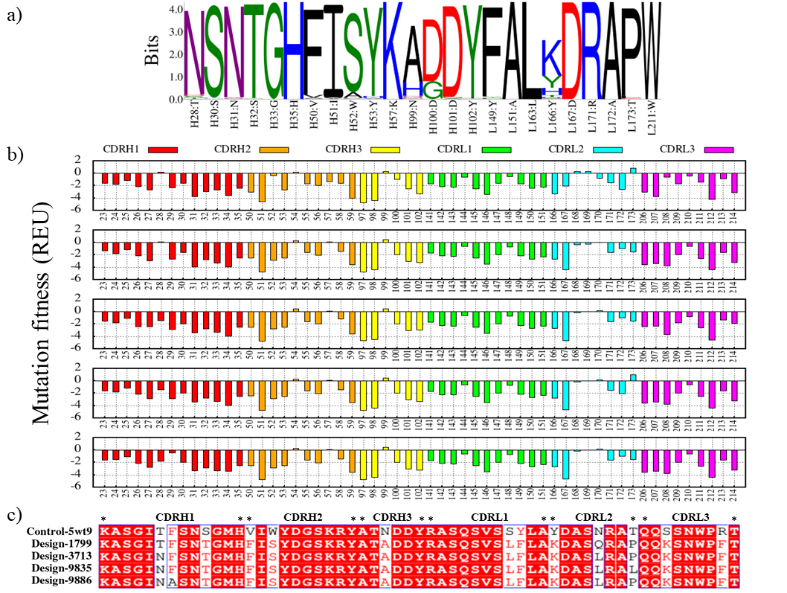
Figure S1. Redesigned CDR sequences for nivolumab in complex with PD-1 (control-5wt9). (a) The sequence logo in the 10000 designs. (b) Mutational fitness analysis of each residue in nivolumab CDR sequences. Mutational energy shown as a function of individual mutations; a more negative energy score is preferred. The CDRH1, CDRH2, CDRH3, CDRL1, CDRL2, and CDRL3 were colored in red, orange, yellow, green, cyan, and magenta, respectively. (c) Alignment of CDR sequences in the control-5wt9 and design groups.

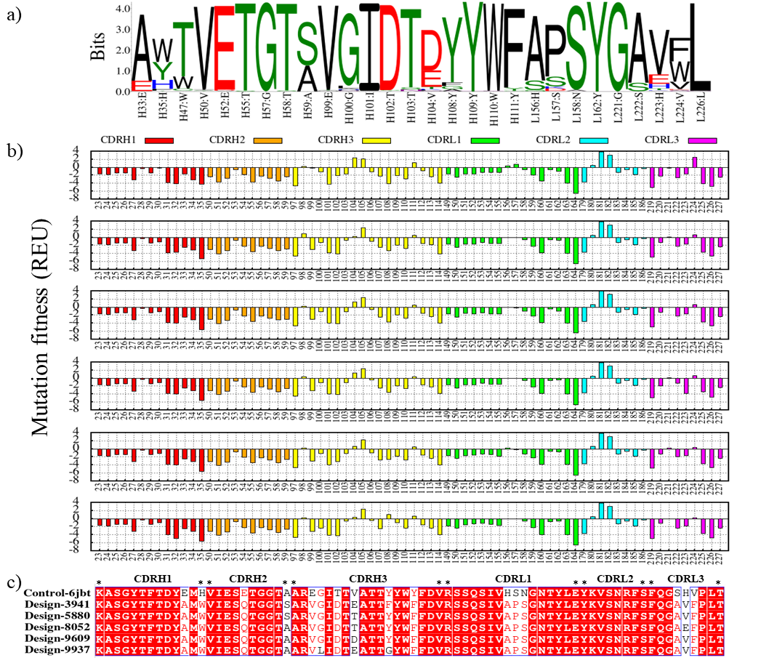
Figure S2. Redesigned CDR sequences for toripalimab in complex with PD-1 (control-6jbt). (a) The sequence logo in the 10,000 designs. (b) Mutational fitness analysis of each residue in toripalimab CDR sequences. Mutational energy shown as a function of individual mutations; a more negative energy score is preferred. The CDRH1, CDRH2, CDRH3, CDRL1, CDRL2, and CDRL3 were colored in red, orange, yellow, green, cyan, and magenta, respectively. (c) Alignment of CDR sequences in the control-6jbt and design groups.

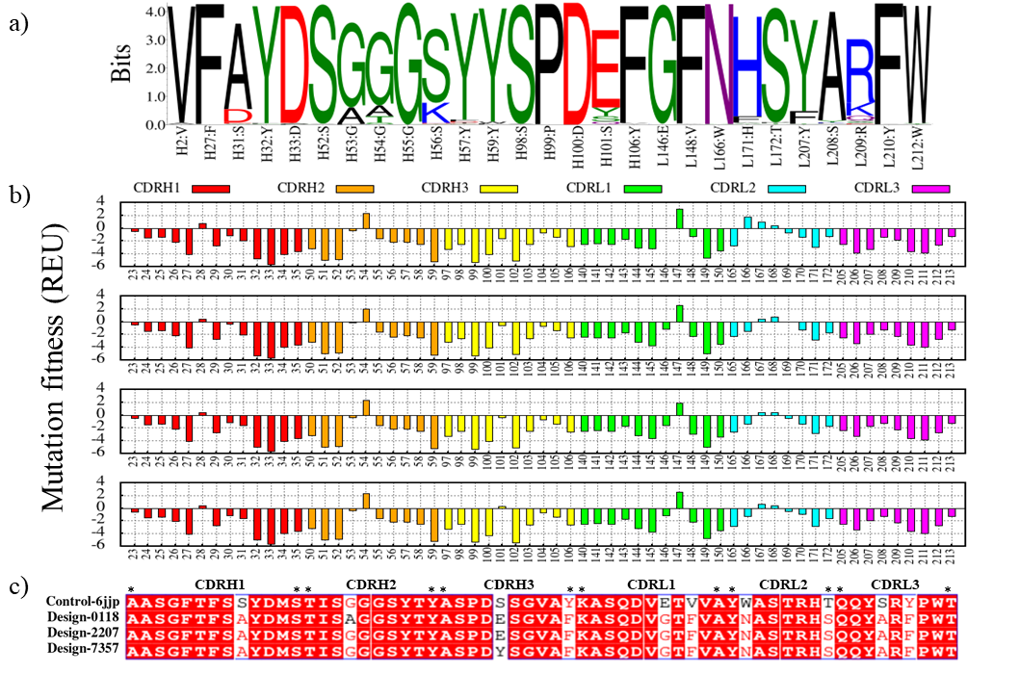
Figure S3. Redesigned CDR sequences for MW11-H317 in complex with PD-1 (control-6jjp). (a) The sequence logo in the 10,000 designs. (b) Mutational fitness analysis of each residue in MW11-H317 CDR sequences. Mutational energy shown as a function of individual mutations; a more negative energy score is preferred. The CDRH1, CDRH2, CDRH3, CDRL1, CDRL2, and CDRL3 were colored in red, orange, yellow, green, cyan, and magenta, respectively. (c) Alignment of CDR sequences in the control-6jjp and design groups.

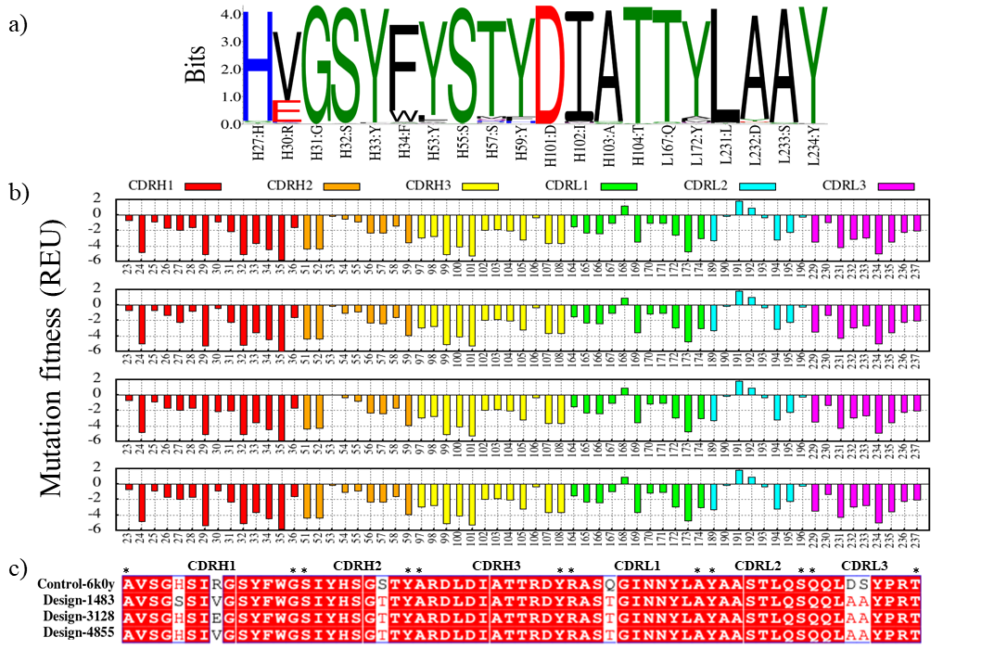
Figure S4. Redesigned CDR sequences for MAB059C in complex with PD-1 (control-6k0y). (a) The sequence logo in the 10,000 designs. (b) Mutational fitness analysis of each residue in MAB059C CDR sequences. Mutational energy shown as a function of individual mutations; a more negative energy score is preferred. The CDRH1, CDRH2, CDRH3, CDRL1, CDRL2, and CDRL3 were colored in red, orange, yellow, green, cyan, and magenta, respectively. (c) Alignment of CDR sequences in the control-6k0y and design groups.

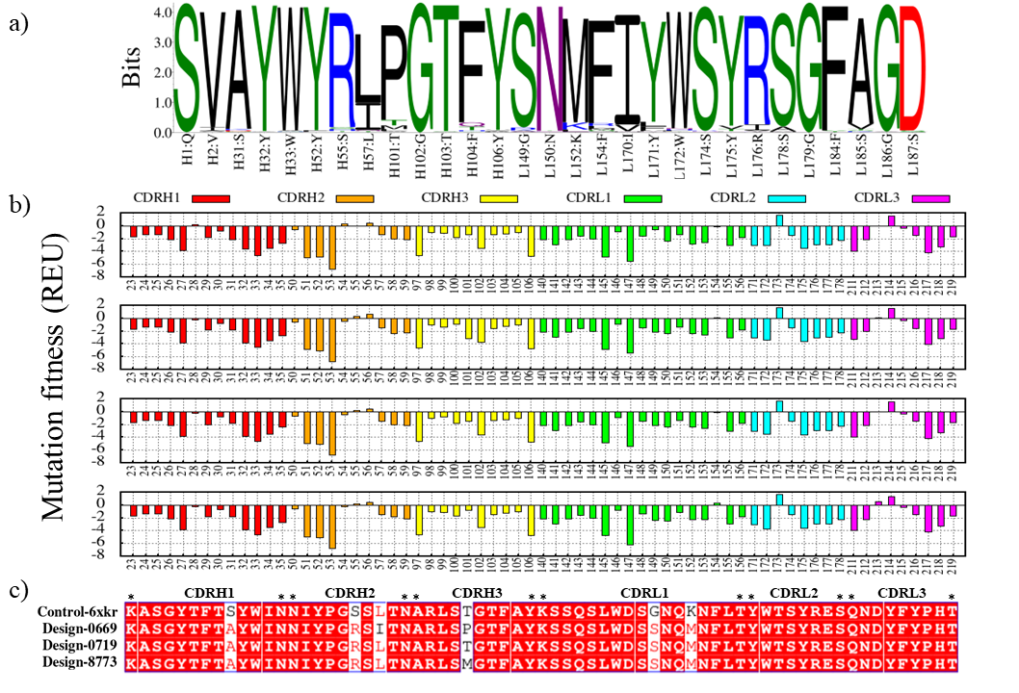
Figure S5. Redesigned CDR sequences for sasanlimab in complex with PD-1 (control-6xkr). (a) The sequence logo in the 10,000 designs. (b) Mutational fitness analysis of each residue in sasanlimab CDR sequences. Mutational energy shown as a function of individual mutations; a more negative energy score is preferred. The CDRH1, CDRH2, CDRH3, CDRL1, CDRL2, and CDRL3 were colored in red, orange, yellow, green, cyan, and magenta, respectively. (c) Alignment of CDR sequences in the control-6xkr and design groups.
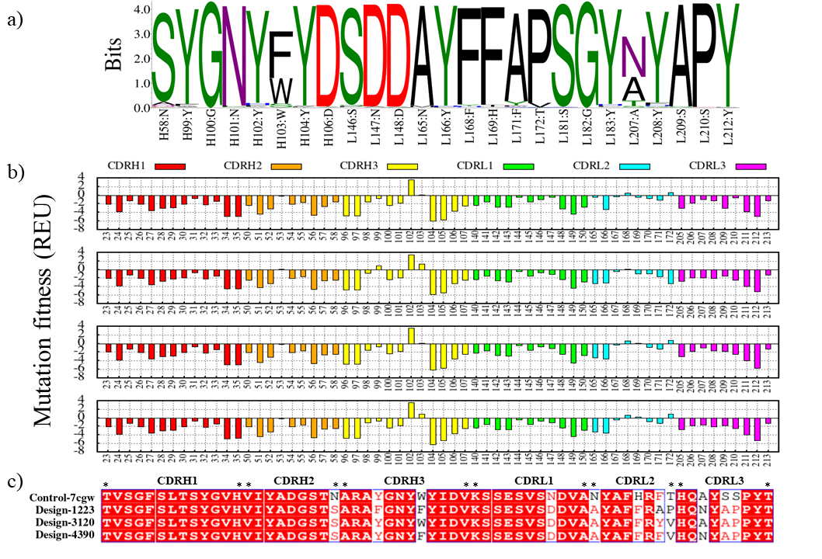
Figure S6. Redesigned CDR sequences for tislelizumab in complex with PD-1 (control-7cgw). (a) The sequence logo in the 10,000 designs. (b) Mutational fitness analysis of each residue in tislelizumab CDR sequences. Mutational energy shown as a function of individual mutations; a more negative energy score is preferred. The CDRH1, CDRH2, CDRH3, CDRL1, CDRL2, and CDRL3 were colored in red, orange, yellow, green, cyan, and magenta, respectively. (c) Alignment of CDR sequences in the control-7cgw and design groups.

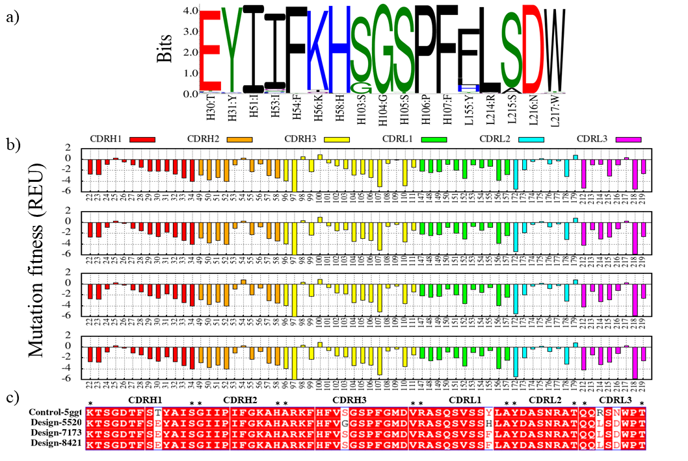
Figure S7. Redesigned CDR sequences for BMS936559 in complex with PD-1 (control-5ggt). (a) The sequence logo in the 10,000 designs. (b) Mutational fitness analysis of each residue in BMS936559 CDR sequences. Mutational energy shown as a function of individual mutations; a more negative energy score is preferred. The CDRH1, CDRH2, CDRH3, CDRL1, CDRL2, and CDRL3 were colored in red, orange, yellow, green, cyan, and magenta, respectively. (c) Alignment of CDR sequences in the control-5ggt and design groups.

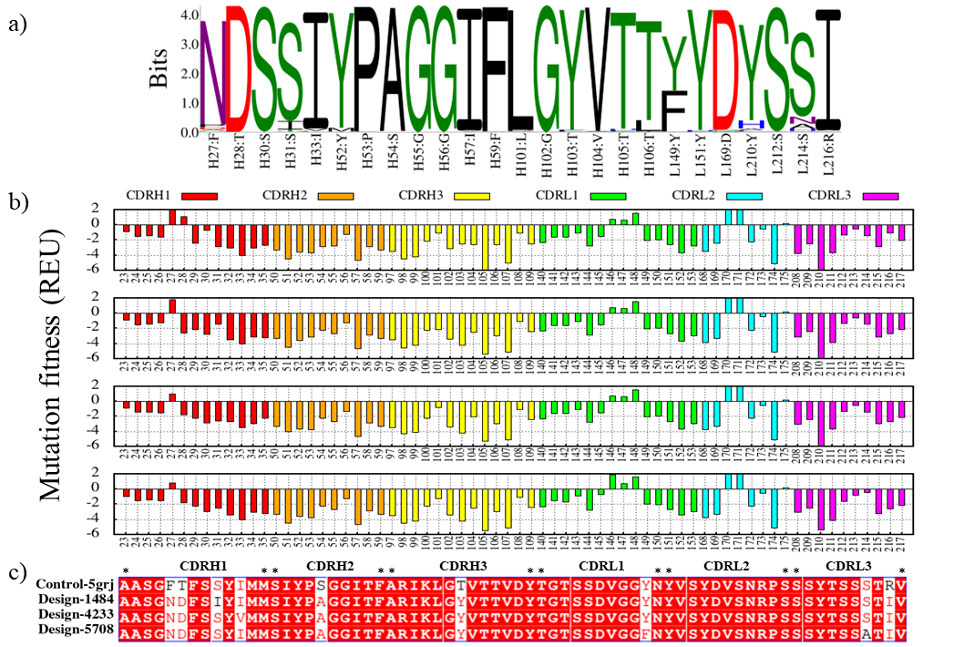
Figure S8. Redesigned CDR sequences for avelumab in complex with PD-1 (control-5grj). (a) The sequence logo in the 10,000 designs. (b) Mutational fitness analysis of each residue in avelumab CDR sequences. Mutational energy shown as a function of individual mutations; a more negative energy score is preferred. The CDRH1, CDRH2, CDRH3, CDRL1, CDRL2, and CDRL3 were colored in red, orange, yellow, green, cyan, and magenta, respectively. (c) Alignment of CDR sequences in the control-5grj and design groups.
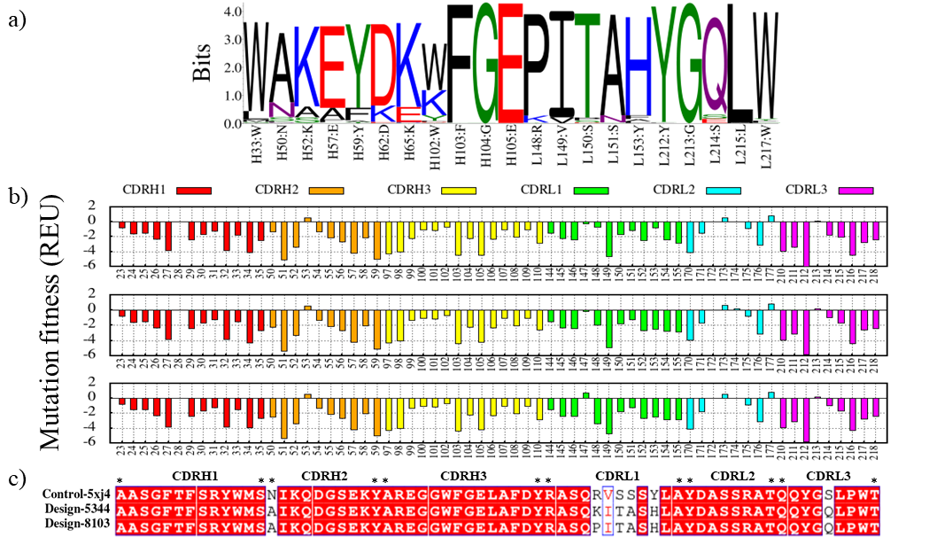
Figure S9. Redesigned CDR sequences for durvalumab in complex with PD-1 (control-5xj4). (a) The sequence logo in the 10,000 designs. (b) Mutational fitness analysis of each residue in durvalumab CDR sequences. Mutational energy shown as a function of individual mutations; a more negative energy score is preferred. The CDRH1, CDRH2, CDRH3, CDRL1, CDRL2, and CDRL3 were colored in red, orange, yellow, green, cyan, and magenta, respectively. (c) Alignment of CDR sequences in the control-5xj4 and design groups.

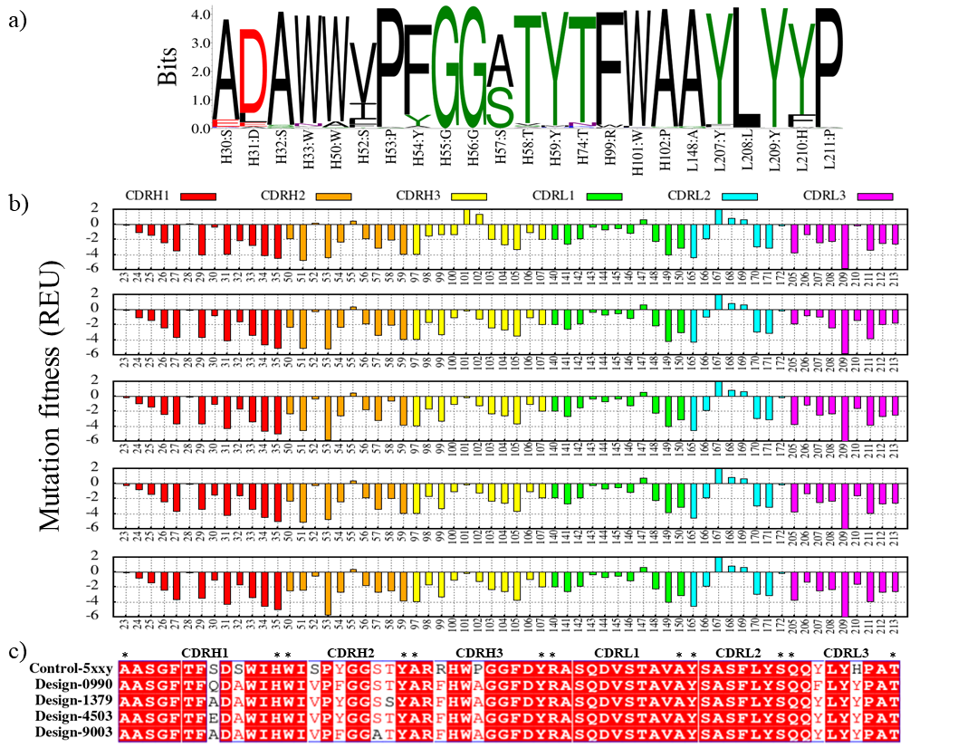
Figure S10. Redesigned CDR sequences for atezolizumab in complex with PD-1 (control-5xxy). (a) The sequence logo in the 10,000 designs. (b) Mutational fitness analysis of each residue in atezolizumab CDR sequences. Mutational energy shown as a function of individual mutations; a more negative energy score is preferred. The CDRH1, CDRH2, CDRH3, CDRL1, CDRL2, and CDRL3 were colored in red, orange, yellow, green, cyan, and magenta, respectively. (c) Alignment of CDR sequences in the control-5xxy and design groups.

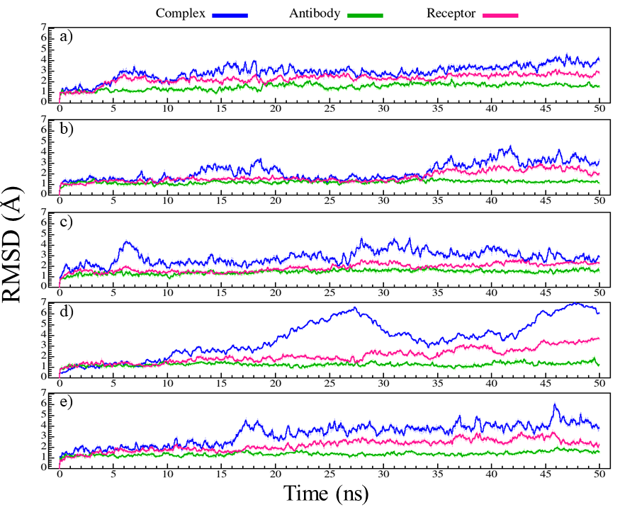
Figure S11. RMSD graphs for complex (blue), antibody (green), and PD-1 (magenta) during 50 ns of MD simulation. (a) control-5wt9 (nivolumab-PD-1). (b) design-1799. (c) design-3713. (d) design-9835. (e) design-9886.

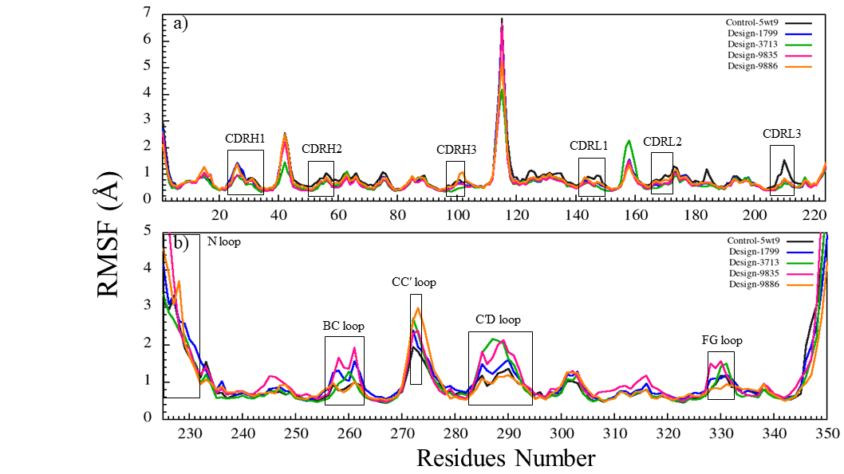
Figure S12. The RMSF graphs of PD-1 and antibodies during 50 ns of MD simulation. RMSF graphs of PD-1 for control-5wt9 (nivolumab-PD-1, dark gray), design-1799 (blue), design-3713 (green), design-9835 (magenta), and design-9886 (orange). (a) Comparison of RMSF graphs of antibodies bound to PD-1. (b) Comparison of RMSF graphs of PD-1 when bound to antibodies.
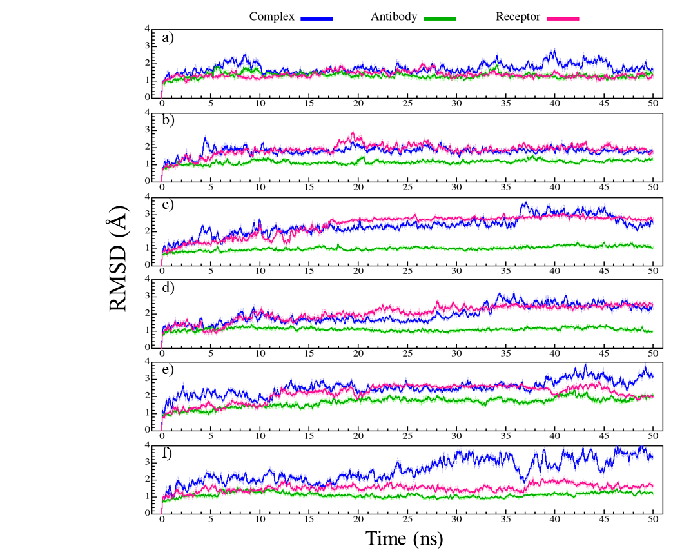
Figure S13. RMSD graphs for complex (blue), antibody (green), and PD-1 (magenta) during 50 ns of MD simulation. (a) control-6jbt (toripalimab-PD-1). (b) design-3941. (c) design-5880. (d) design-8052. (e) design-9609. (f) design-9937.
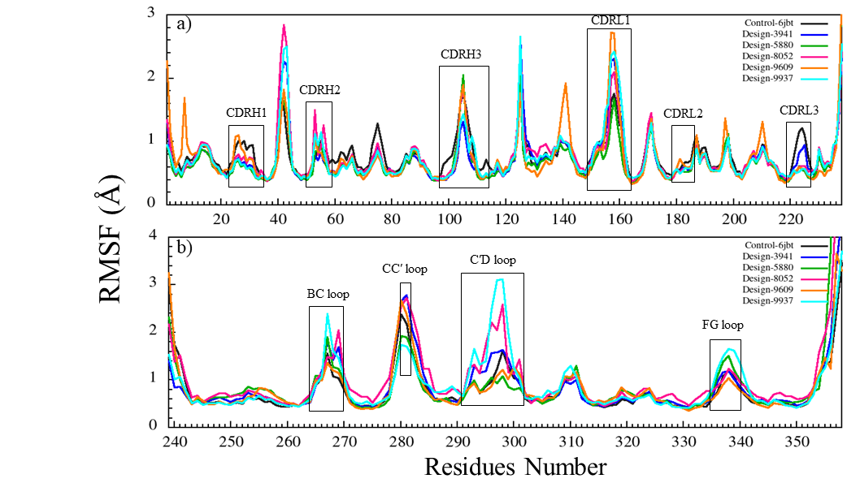
Figure S14. The RMSF graphs of PD-1 and antibodies during 50 ns of MD simulation. RMSF graphs of PD-1 for control-6jbt (toripalimab-PD-1, dark gray), design-3941 (blue), design-5880 (green), design-8052 (magenta), design-9609 (orange), and design-9937 (cyan). (a) Comparison of RMSF graphs of antibodies bound to PD-1. (b) Comparison of RMSF graphs of PD-1 when bound to antibodies.

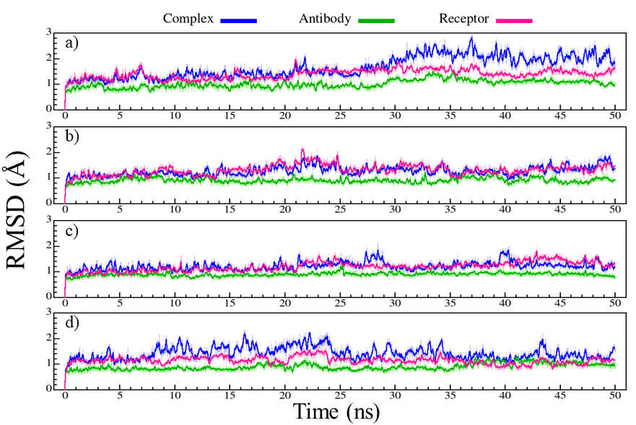
Figure S15. RMSD graphs for complex (blue), antibody (green), and PD-1 (magenta) during 50 ns of MD simulation. (a) control-6jjp (MW11-h317-PD-1). (b) design-0118. (c) design-2207. (d) design-7357.

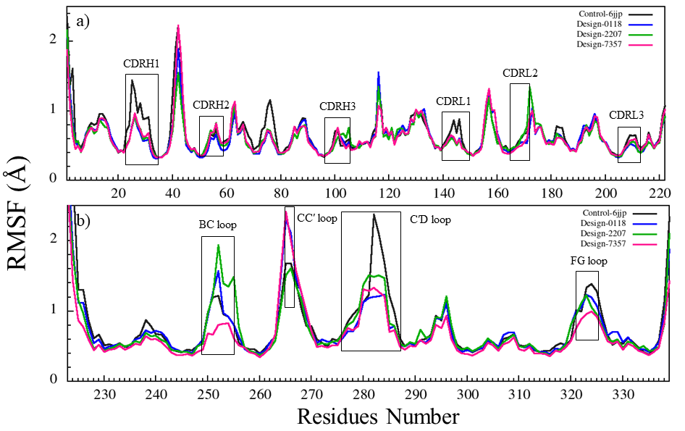
Figure S16. The RMSF graphs of PD-1 and antibodies during 50 ns of MD simulation. RMSF graphs of PD-1 for control-6jjp (MW11-h317-PD-1, dark gray), design-0118 (blue), design-2207 (green), design-7357 (magenta). (a) Comparison of RMSF graphs of antibodies bound to PD-1. (b) Comparison of RMSF graphs of PD-1 when bound to antibodies.
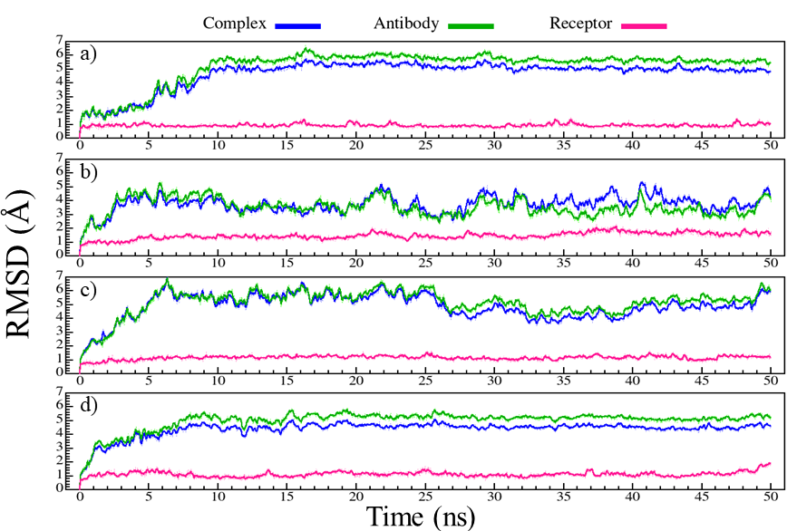

Figure S17. RMSD graphs for complex (blue), antibody (green), and PD-1 (magenta) during 50 ns of MD simulation. (a) control-6k0y (mAb059c-PD-1). (b) design-1483. (c) design-3128. (d) design-4855.
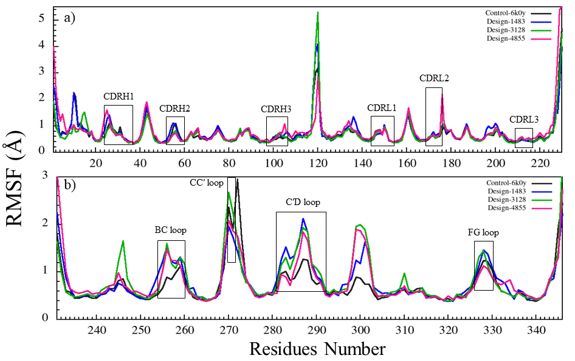
Figure S18. The RMSF graphs of PD-1 and antibodies during 50 ns of MD simulation. RMSF graphs of PD-1 for control-6k0y (mAb059c-PD-1, dark gray), design-1483 (blue), design-3128 (green), design-4855 (magenta). (a) Comparison of RMSF graphs of antibodies bound to PD-1. (b) Comparison of RMSF graphs of PD-1 when bound to antibodies.
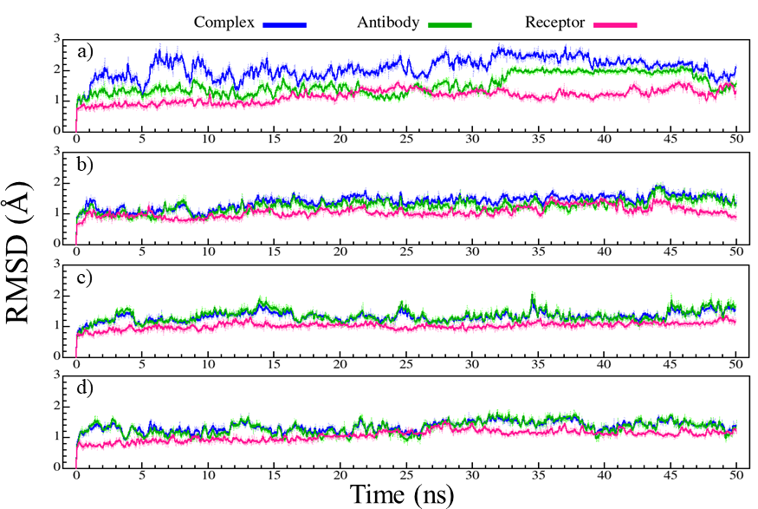
Figure S19. RMSD graphs for complex (blue), antibody (green), and PD-1 (magenta) during 50 ns of MD simulation. (a) control-6xkr (sasanlimab-PD-1). (b) design-0669. (c) design-0719. (d) design-8773.
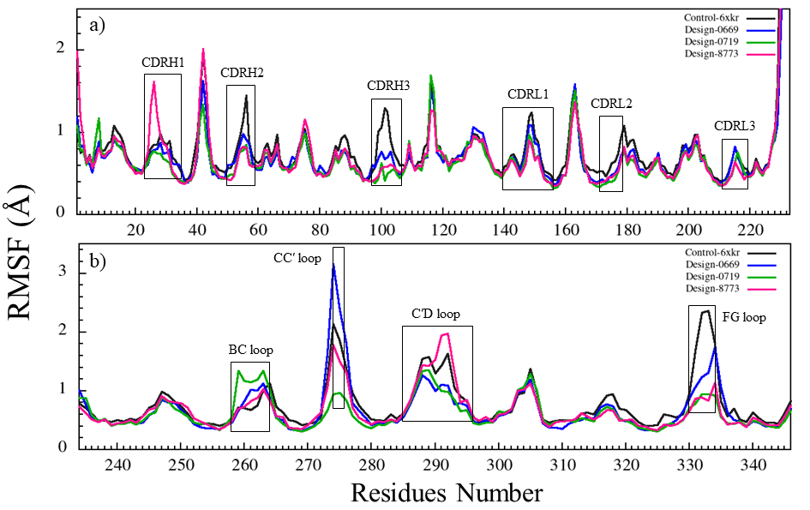
Figure S20. The RMSF graphs of PD-1 and antibodies during 50 ns of MD simulation. RMSF graphs of PD-1 for control-6xkr (sasanlimaPD-1, dark gray), design-0669 (blue), design-0719 (green), design-8773 (magenta). (a) Comparison of RMSF graphs of antibodies bound to PD-1. (b) Comparison of RMSF graphs of PD-1 when bound to antibodies.
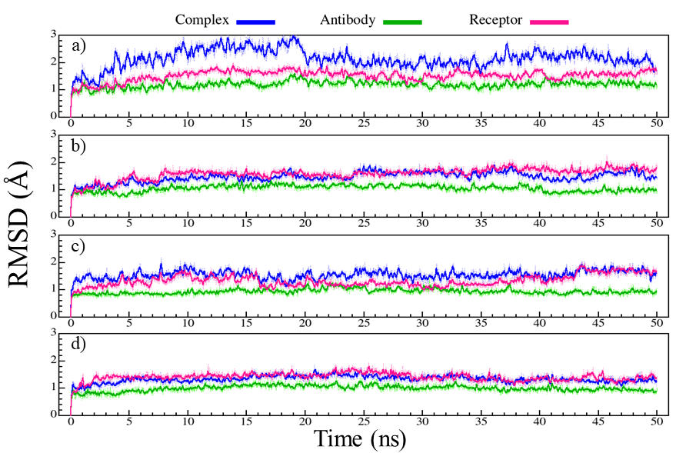
Figure S21. RMSD graphs for complex (blue), antibody (green), and PD-1 (magenta) during 50 ns of MD simulation. (a) control-7cgw (tislelizumab-PD-1). (b) design-1223. (c) design-3120. (d) design-4390.
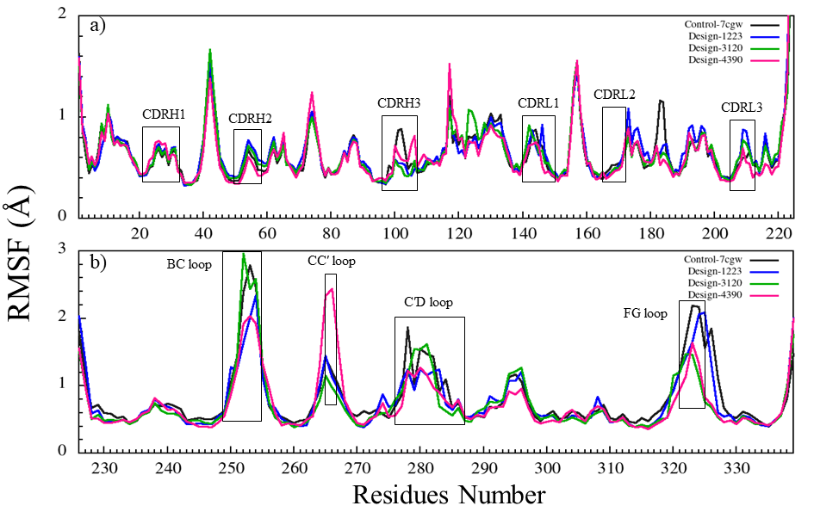
Figure S22. The RMSF graphs of PD-1 and antibodies during 50 ns of MD simulation. RMSF graphs of PD-1 for control-7cgw (tislelizumab-PD-1, dark gray), design-1223 (blue), design-3120 (green), design-4390 (magenta). (b) Comparison of RMSF graphs of PD-1 when bound to antibodies.

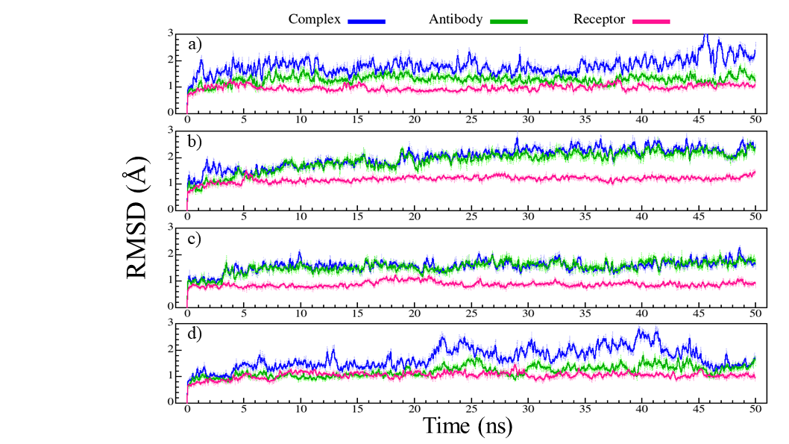
Figure S23. RMSD graphs for complex (blue), antibody (green), and PD-1 (magenta) during 50 ns of MD simulation. (a) control-5ggt (BMS-936559-PD-L1). (b) design-5520. (c) design-7173. (d) design-8421.
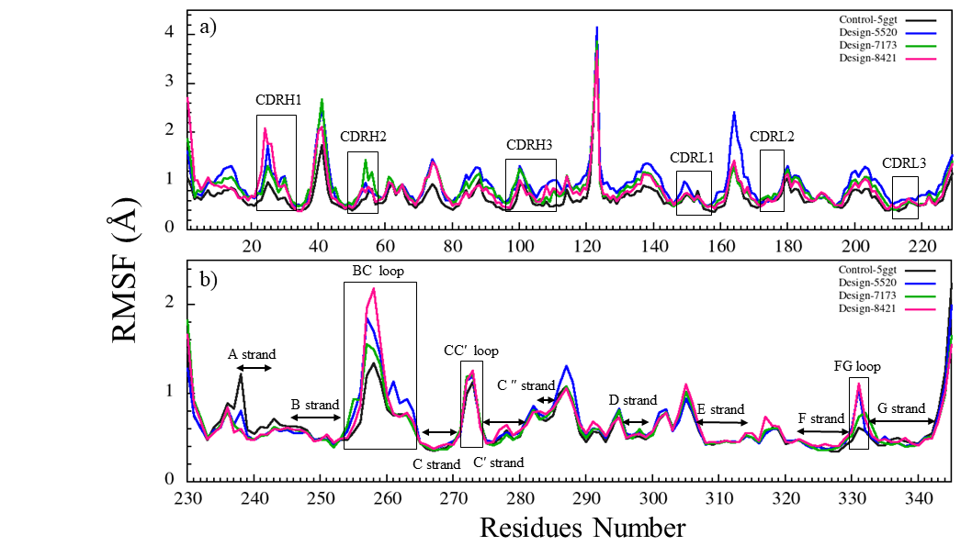
Figure S24. The RMSF graphs of PD-1 and antibodies during 50 ns of MD simulation. RMSF graphs of PD-1 for control-5ggt (BMS-936559-PD-L1, dark gray), design-5520 (blue), design-7173 (green), design-8421 (magenta). (b) Comparison of RMSF graphs of PD-1 when bound to antibodies.
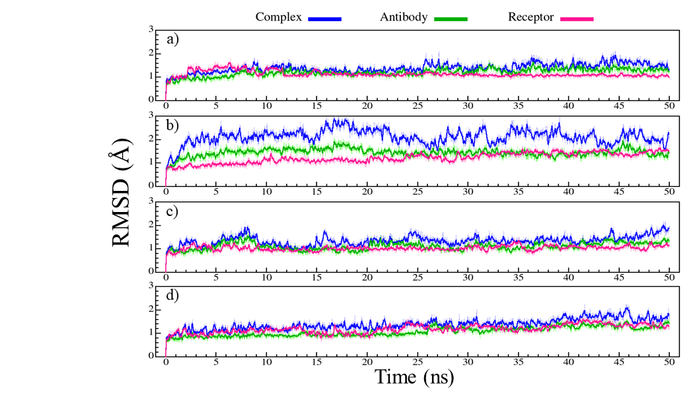
Figure S25. RMSD graphs for complex (blue), antibody (green), and PD-1 (magenta) during 50 ns of MD simulation. (a) control-5grj (avelumab-PD-L1). (b) design-1484. (c) design-4233. (d) design-5708.
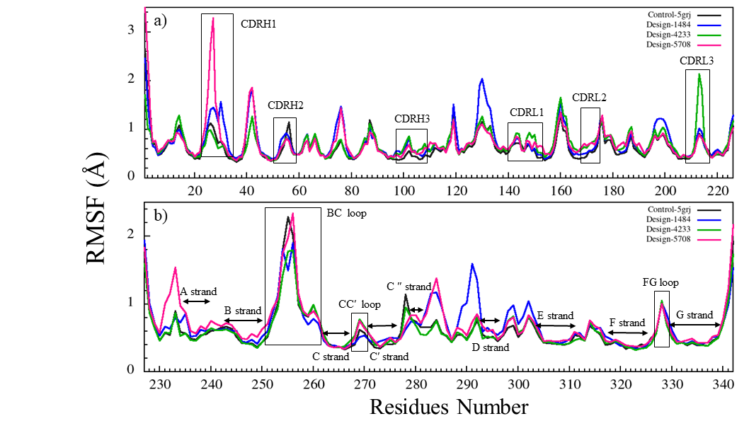
Figure S26. The RMSF graphs of PD-1 and antibodies during 50 ns of MD simulation. RMSF graphs of PD-1 for control-5grj (avelumab-PD-L1, dark gray), design-1484 (blue), design-4233 (green), design-5708 (magenta). (b) Comparison of RMSF graphs of PD-1 when bound to antibodies.
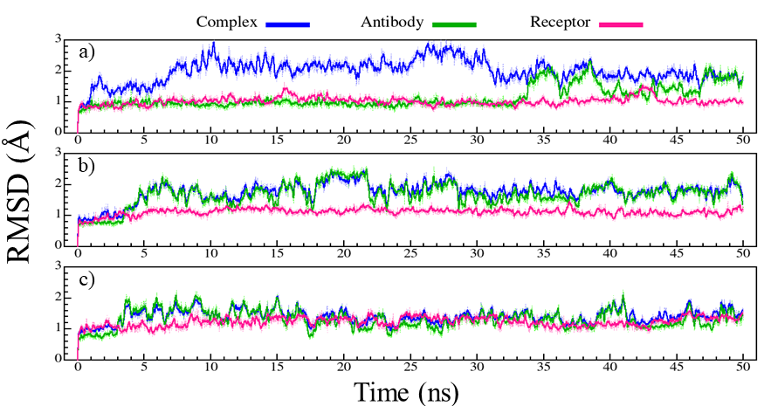
Figure S27. RMSD graphs for complex (blue), antibody (green), and PD-1 (magenta) during 50 ns of MD simulation. (a) control-5xj4 (durvalumab-PD-L1). (b) design-5344. (c) design-8103.
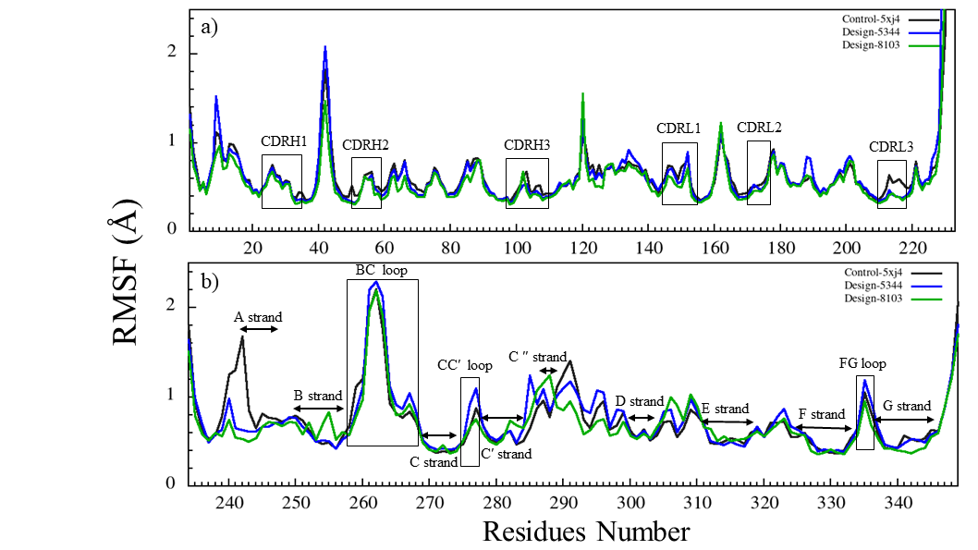
Figure S28. The RMSF graphs of PD-1 and antibodies during 50 ns of MD simulation. RMSF graphs of PD-1 for control-5xj4 (durvalumab-PD-L1, dark gray), design-5344 (blue), design-8103 (green). (b) Comparison of RMSF graphs of PD-1 when bound to antibodies.
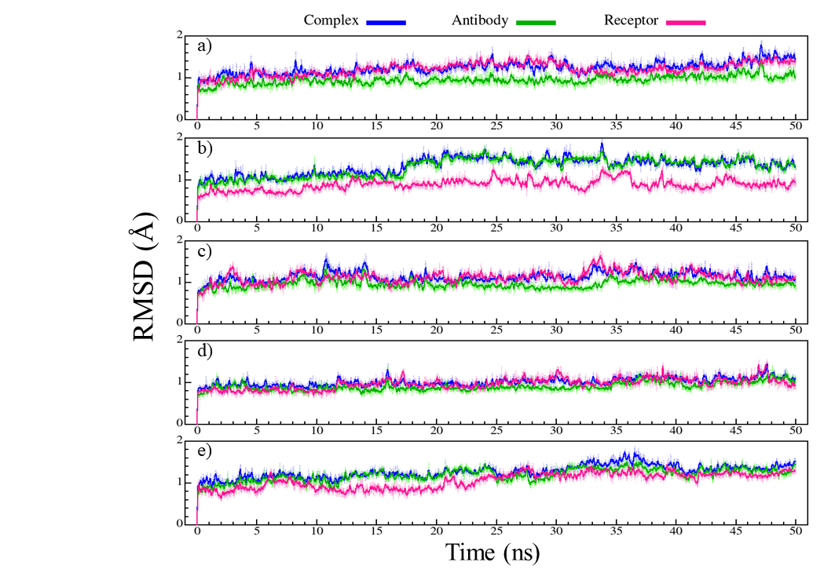
Figure S29. RMSD graphs for complex (blue), antibody (green), and PD-1 (magenta) during 50 ns of MD simulation. (a) control-5xxy (atezolizumab-PD-L1). (b) design-0990. (c) design-1379. (d) design-4503. (e) design-9003.
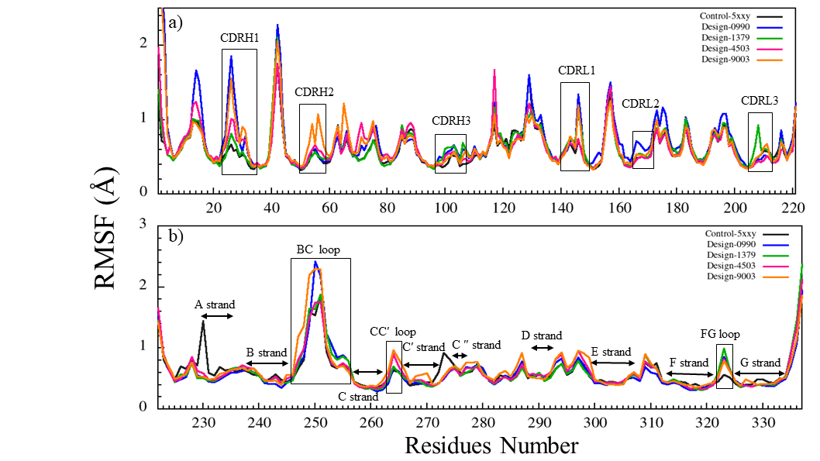
Figure S30. The RMSF graphs of PD-1 and antibodies during 50 ns of MD simulation. RMSF graphs of PD-1 for control-5xxy (atezolizumab-PD-L1, dark gray), design-0990 (blue), design-1379 (green), design-4503 (magenta), and design-9003 (orange). (b) Comparison of RMSF graphs of PD-1 when bound to antibodies.

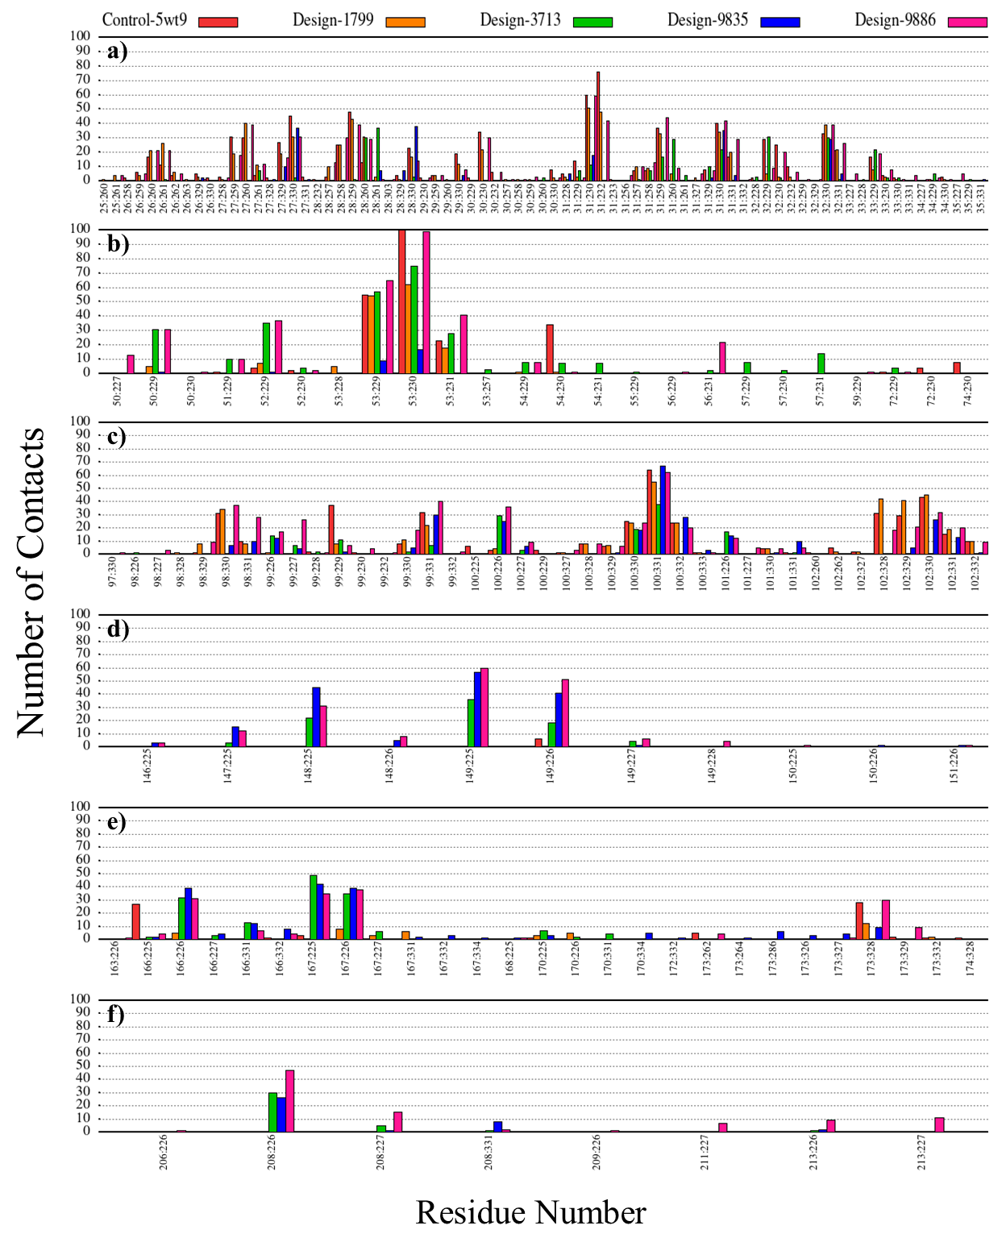
Figure S31. Contact patterns of complexes during 50 ns of MD simulation. Number of contacts for residues in (a) CDRH1, (b) CDRH2, (c) CDRH3, (d) CDRL1, (e) CDRL2, and (f) CDRL3. Control-5wt9 (nivolumab-PD-1, red), design-1799-PD-1 (orange), design-3713-PD-1 (green), design-9835-PD-1 (blue), and design-9886-PD-1 (magenta). The x-axis shows pairwise residue interactions of the antibody- receptor complex.
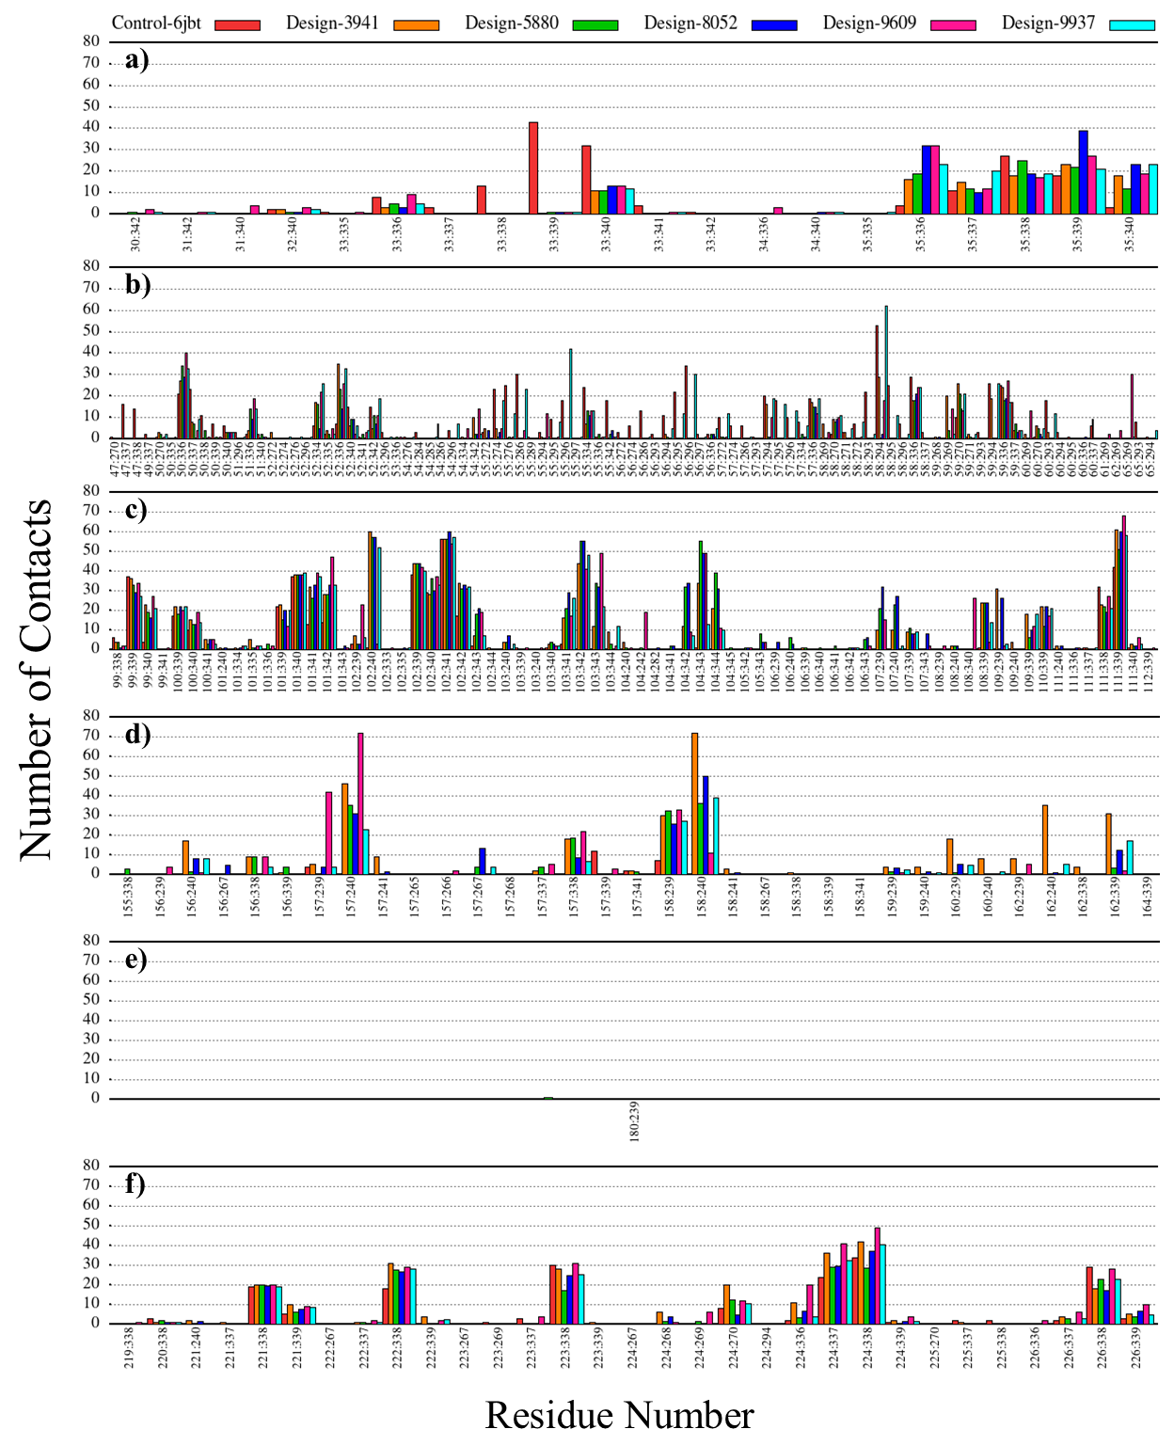
Figure S32. Contact patterns of complexes during 50 ns of MD simulation. Number of contacts for residues in (a) CDRH1, (b) CDRH2, (c) CDRH3, (d) CDRL1, (e) CDRL2, and (f) CDRL3. Control-6jbt (toripalimab-PD-1, red), design-3941-PD-1 (orange), design-5880-PD-1 (green), design-8052-PD-1 (blue), design-9609-PD-1 (magenta), and design-9937-PD-1 (cyan). The x-axis shows pairwise residue interactions of the antibody- receptor complex.
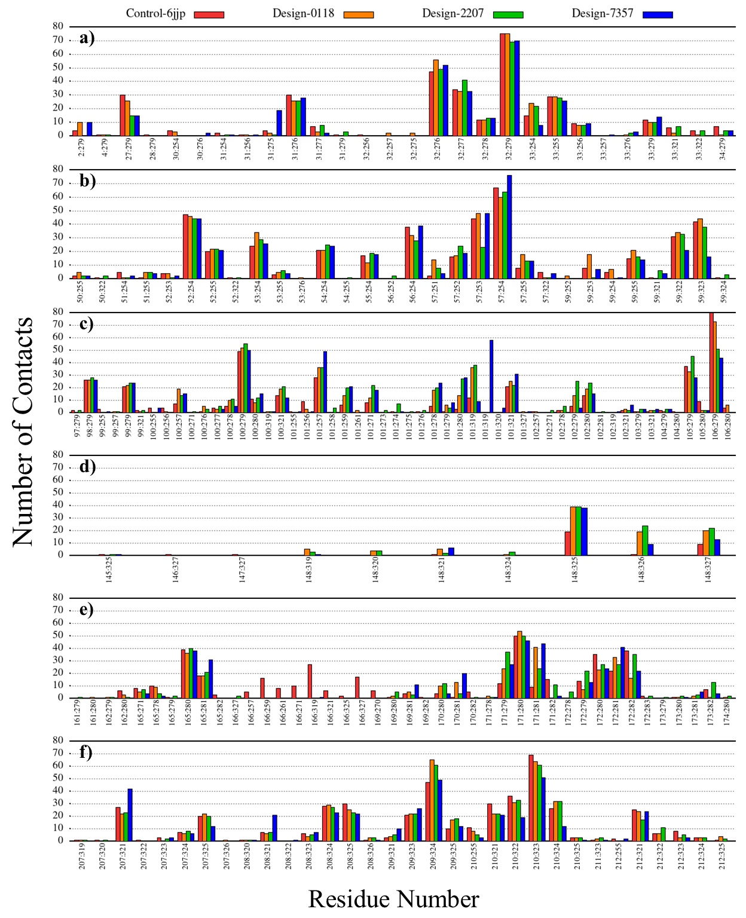
Figure S33. Contact patterns of complexes during 50 ns of MD simulation. Number of contacts for residues in (a) CDRH1, (b) CDRH2, (c) CDRH3, (d) CDRL1, (e) CDRL2, and (f) CDRL3. Control-6jjp (MW11-h317-PD-1, red), design-0118-PD-1 (orange), design-2207-PD-1 (green), and design-7357-PD-1 (blue). The X-axis shows residue-residue contacts of the antibody- receptor. The x-axis shows pairwise residue interactions of the antibody- receptor complex.
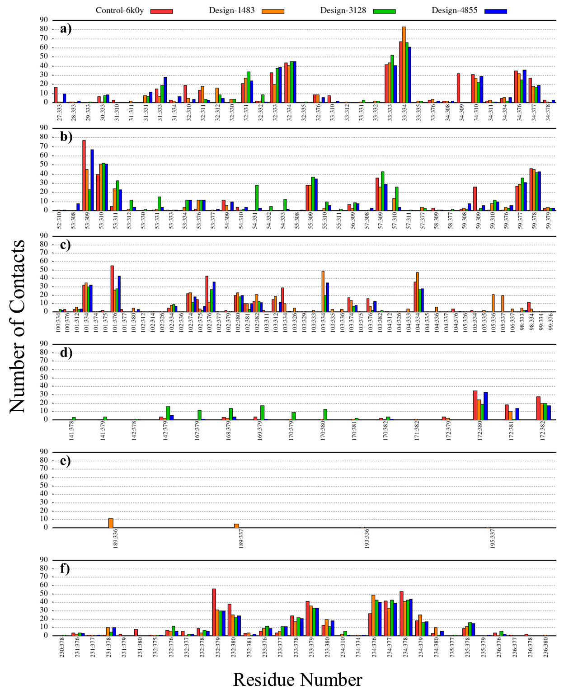
Figure S34. Contact patterns of complexes during 50 ns of MD simulation. Number of contacts for residues in (a) CDRH1, (b) CDRH2, (c) CDRH3, (d) CDRL1, (e) CDRL2, and (f) CDRL3. Control-6k0y (mAb059c-PD-1, red), design-1483-PD-1 (orange), design-3128-PD-1 (green), and design-4855-PD-1 (blue). The x-axis shows pairwise residue interactions of the antibody- receptor complex.
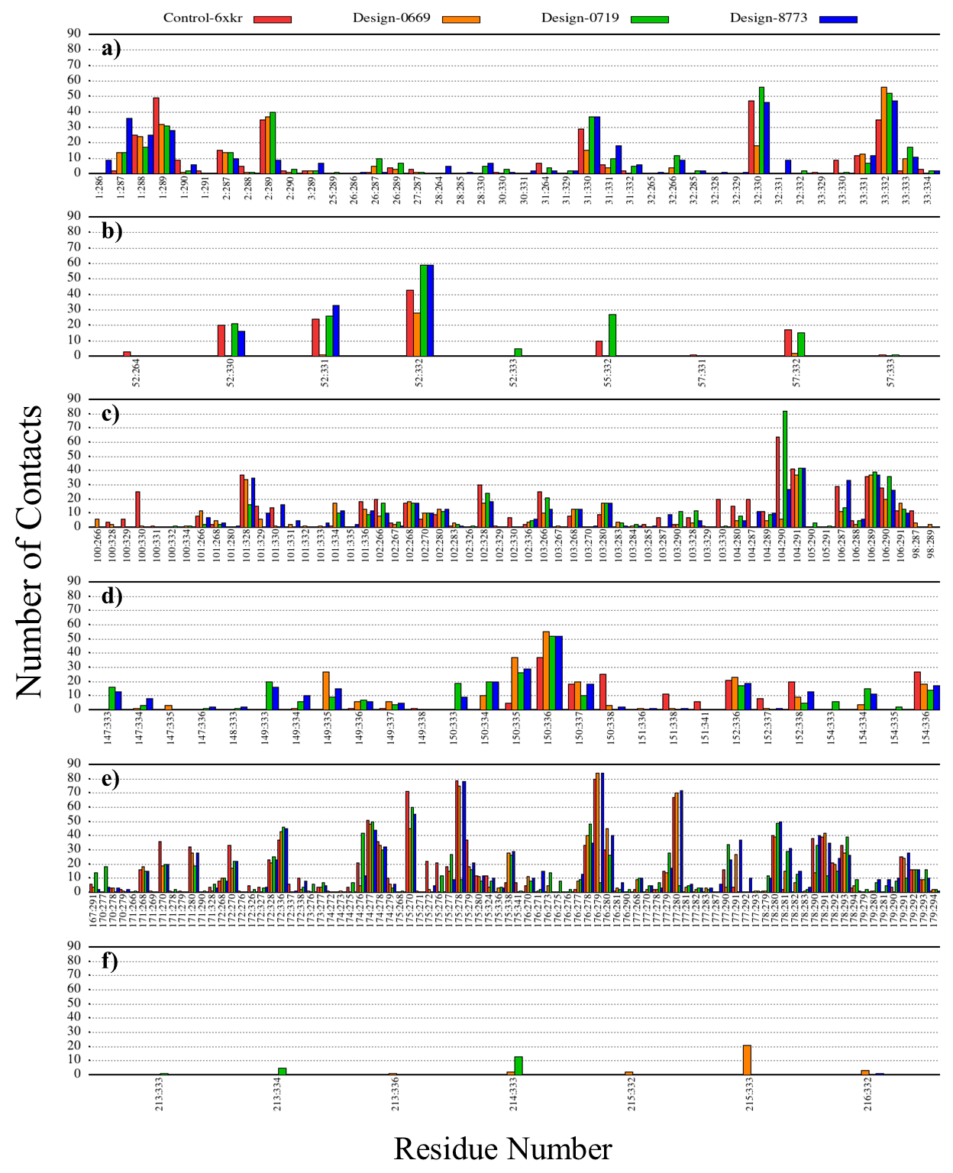
Figure S35. Contact patterns of complexes during 50 ns of MD simulation. Number of contacts for residues in (a) CDRH1, (b) CDRH2, (c) CDRH3, (d) CDRL1, (e) CDRL2, and (f) CDRL3. Control-6xkr (sasanlimab-PD-1, red), design-0619-PD-1 (orange), design-0719-PD-1 (green), and design-8773-PD-1 (blue). The x-axis shows pairwise residue interactions of the antibody- receptor complex.
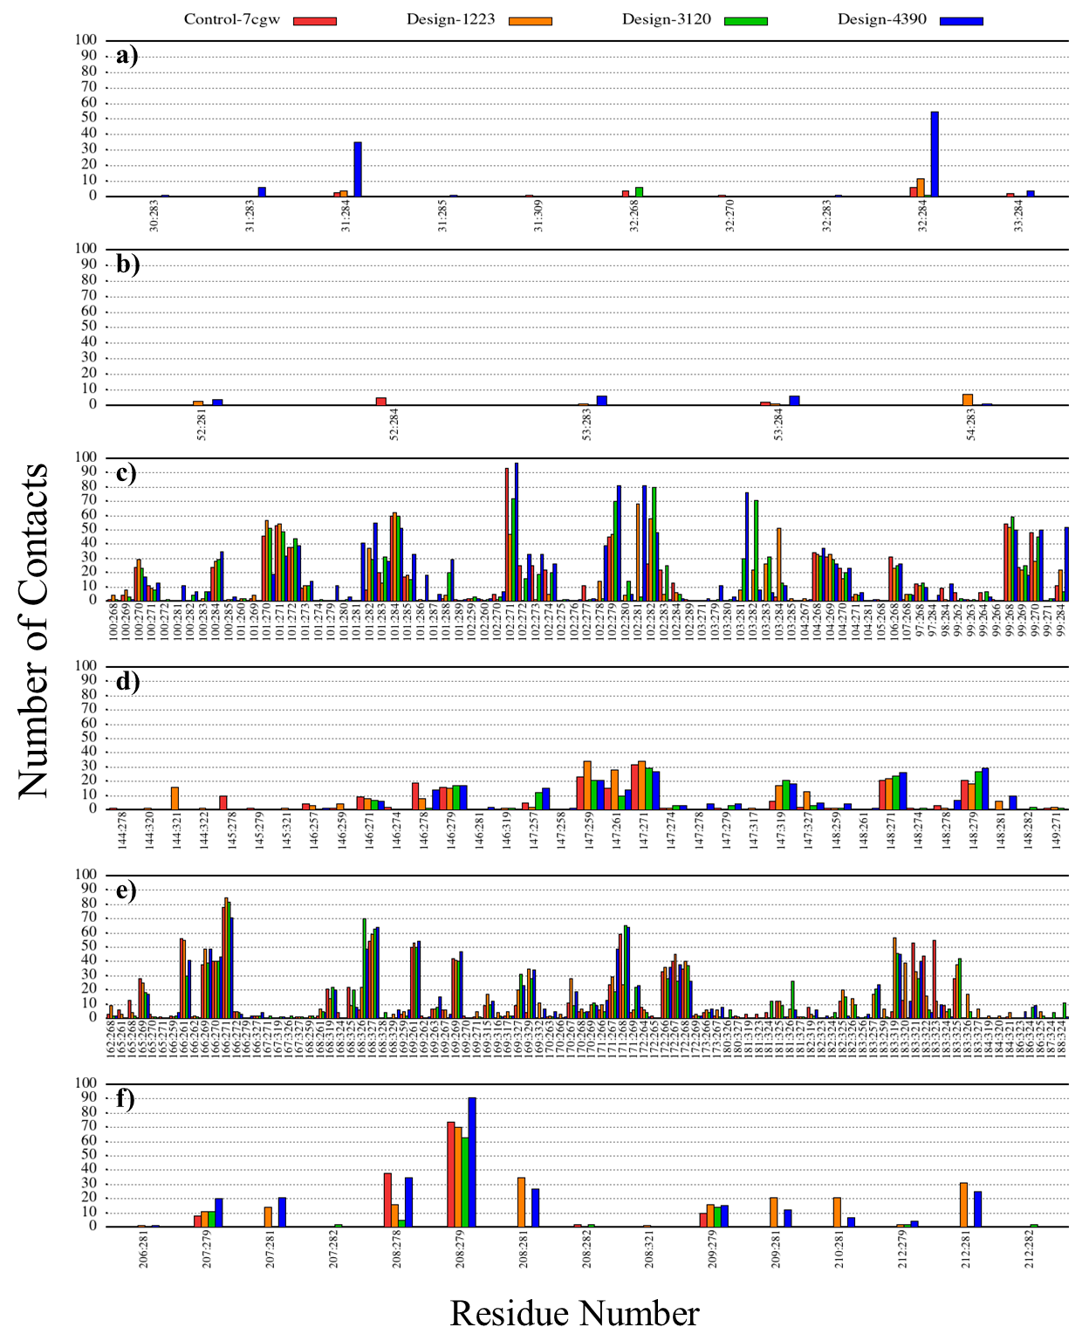
Figure S36. Contact patterns of complexes during 50 ns of MD simulation. Number of contacts for residues in (a) CDRH1, (b) CDRH2, (c) CDRH3, (d) CDRL1, (e) CDRL2, and (f) CDRL3. Control-7cgw (tislelizumab-PD-1, red), design-1223-PD-1 (orange), design-3120-PD-1 (green), and design-4390-PD-1 (blue). The x-axis shows pairwise residue interactions of the antibody- receptor complex.
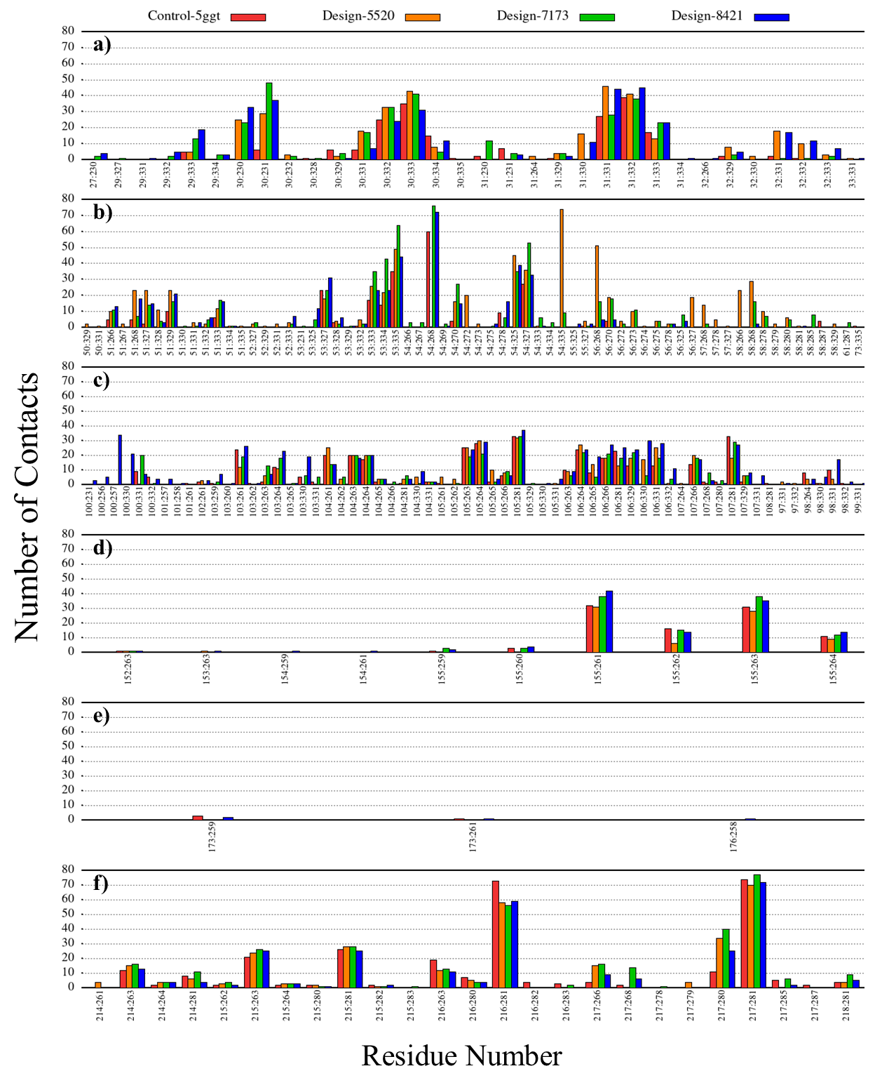
Figure S37. Contact patterns of complexes during 50 ns of MD simulation. Number of contacts for residues in (a) CDRH1, (b) CDRH2, (c) CDRH3, (d) CDRL1, (e) CDRL2, and (f) CDRL3. Control-5ggt (BMS-936559-PD-L1, red), design-5520-PD-L1 (orange), design-7173-PD-L1 (green), and design-8421-PD-L1 (blue). The x-axis shows pairwise residue interactions of the antibody- receptor complex.
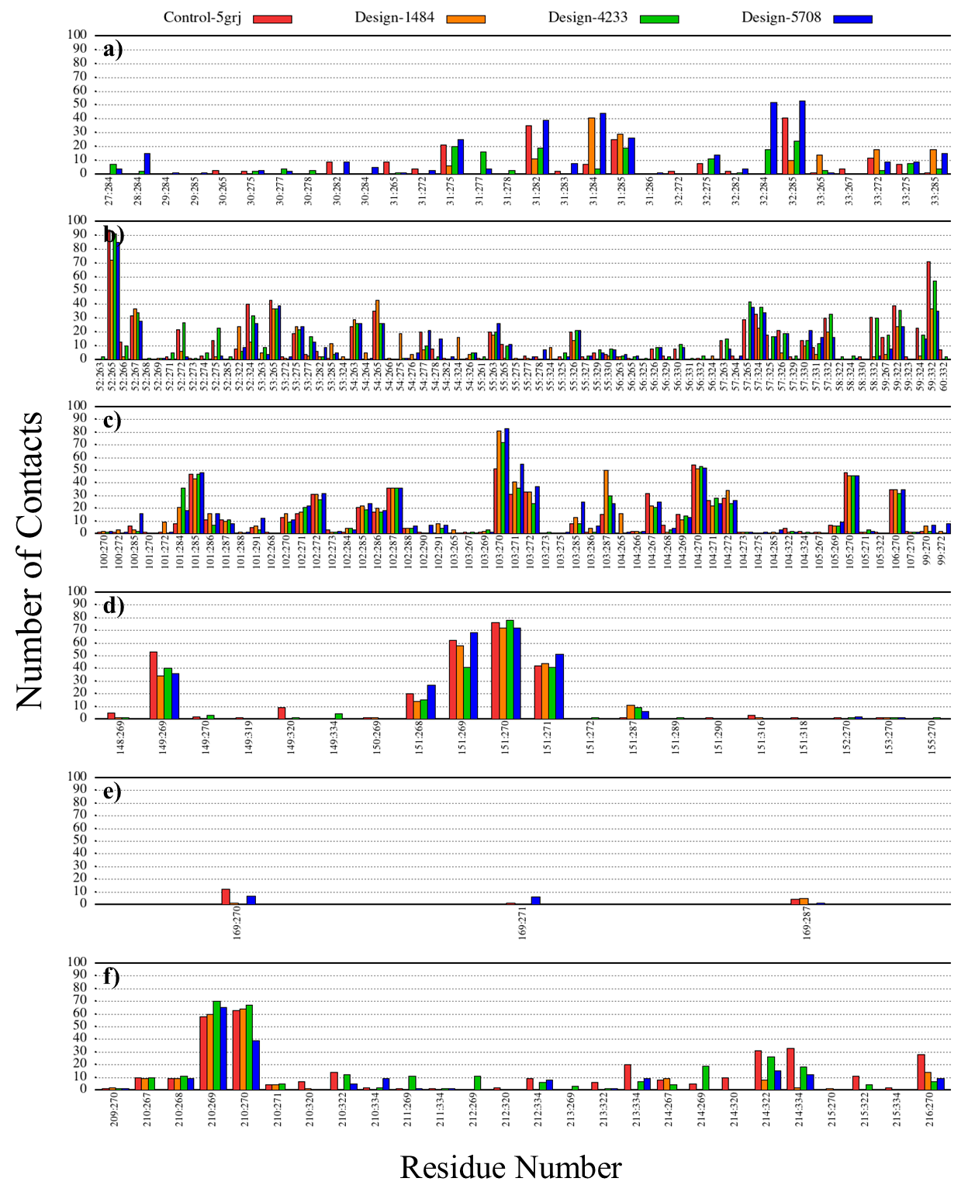
Figure S38. Contact patterns of complexes during 50 ns of MD simulation. Number of contacts for residues in (a) CDRH1, (b) CDRH2, (c) CDRH3, (d) CDRL1, (e) CDRL2, and (f) CDRL3. Control-5jrg (avelumab-PD-L1, red), design-1484-PD-L1 (orange), design-4233-PD-L1 (green), and design-5708-PD-L1 (blue). The x-axis shows pairwise residue interactions of the antibody- receptor complex.
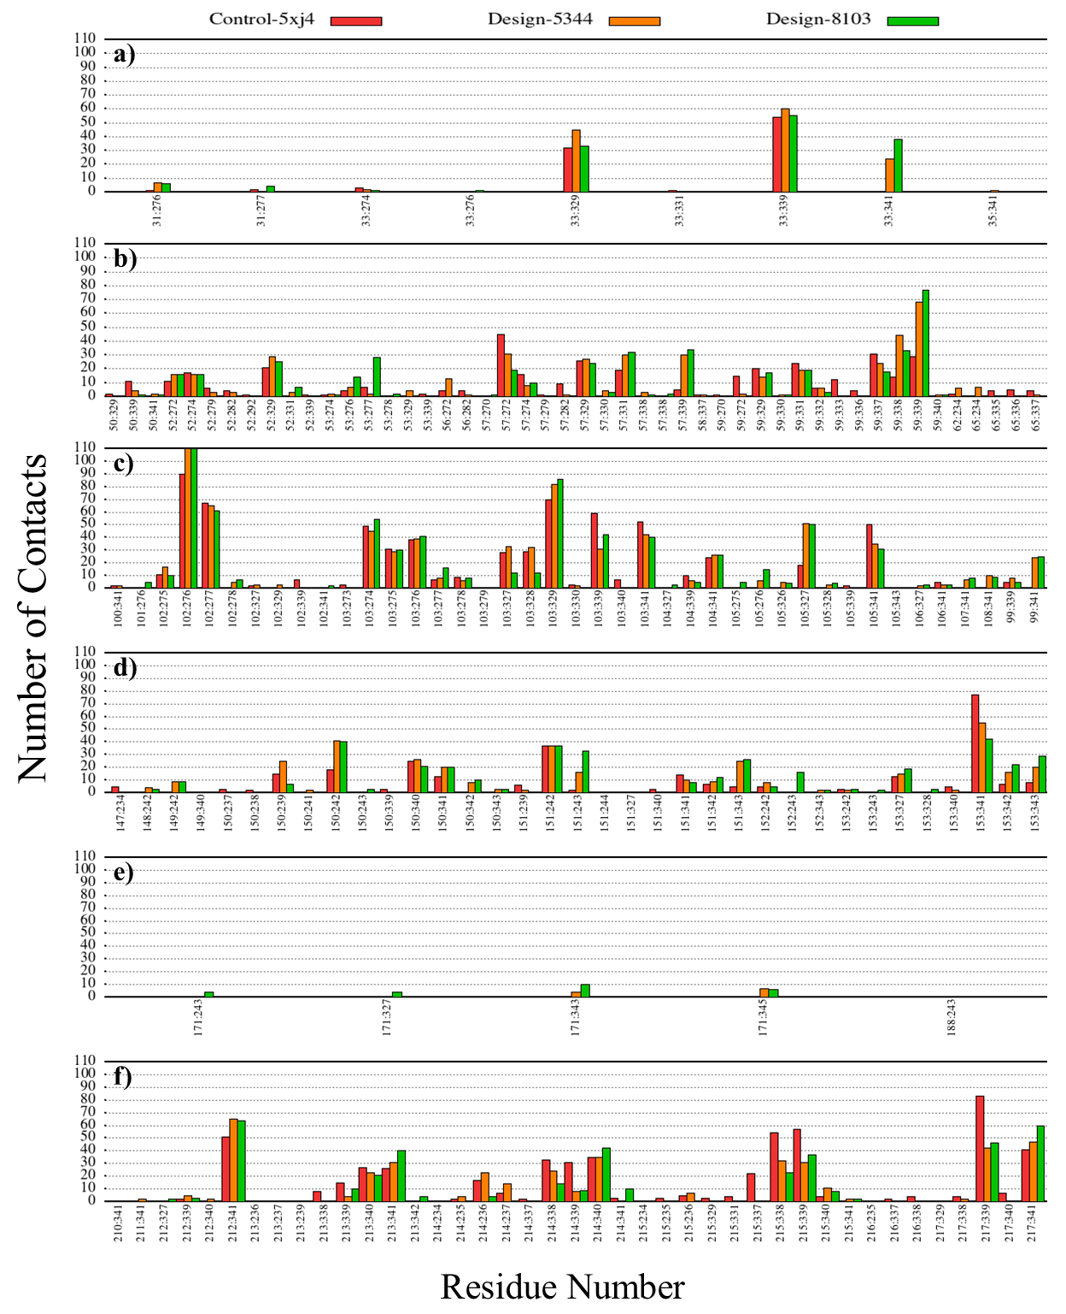
Figure S39. Contact patterns of complexes during 50 ns of MD simulation. Number of contacts for residues in (a) CDRH1, (b) CDRH2, (c) CDRH3, (d) CDRL1, (e) CDRL2, and (f) CDRL3. Control-5xj4 (durvalumab-PD-L1, red), design-5344-PD-L1 (orange), and design-8103-PD-L1 (green). The x-axis shows pairwise residue interactions of the antibody- receptor complex.
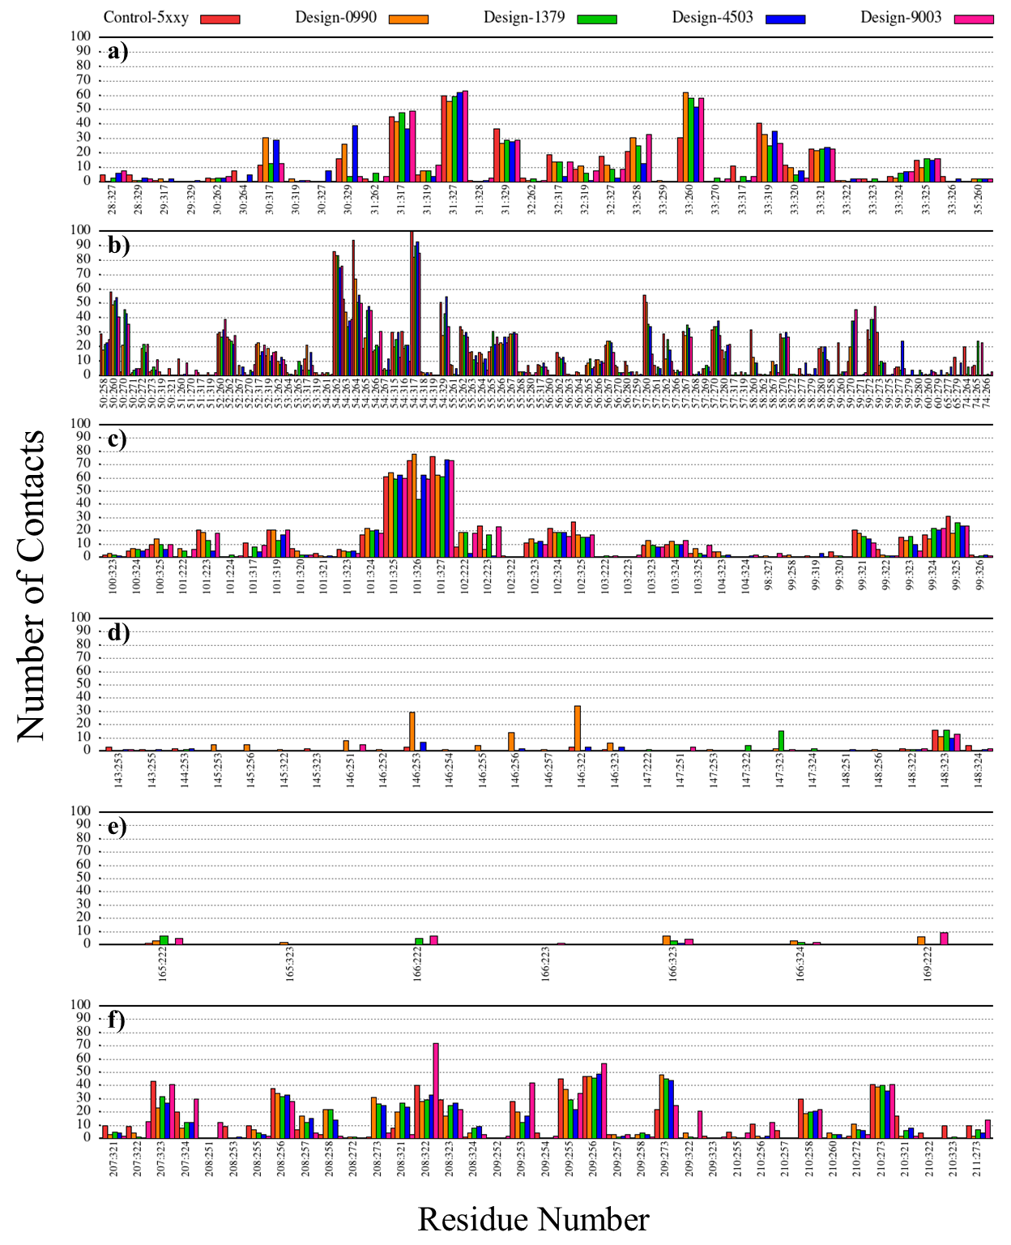
Figure S40. Contact patterns of complexes during 50 ns of MD simulation. Number of contacts for residues in (a) CDRH1, (b) CDRH2, (c) CDRH3, (d) CDRL1, (e) CDRL2, and (f) CDRL3. Control-5xxy (atezolizumab-PD-L1, red), design-0990-PD-L1 (orange), design-1379-PD-L1 (green), design-4503-PD-L1 (blue), and design-9003-PD-L1 (magenta). The x-axis shows pairwise residue interactions of the antibody- receptor complex.

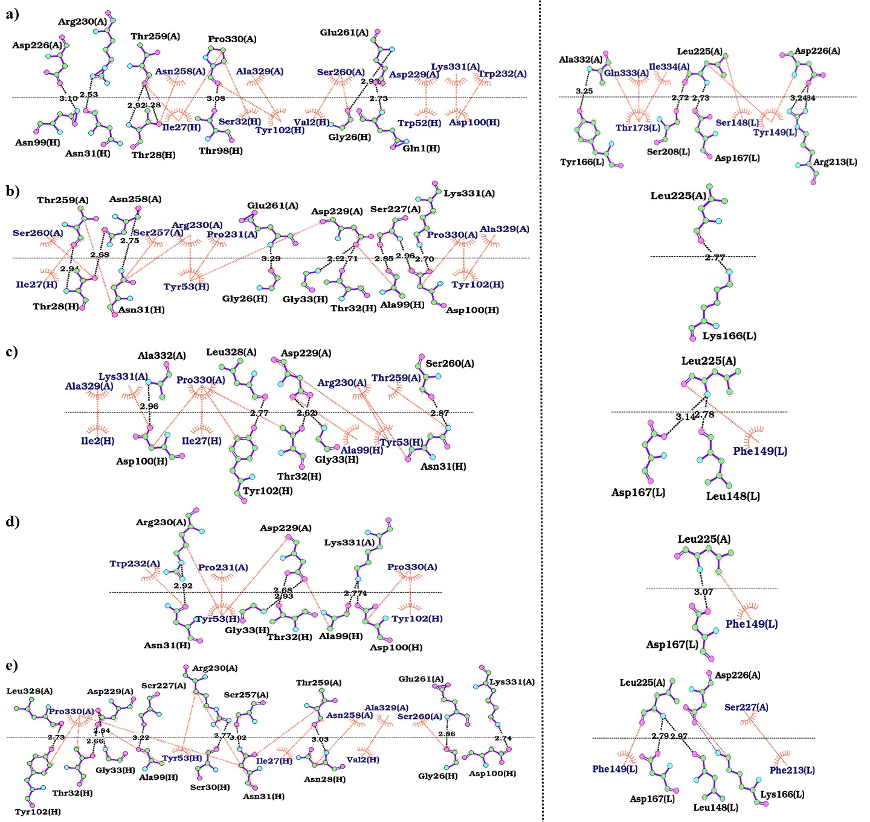
Figure S41. 2D interaction maps of heavy (left) and light (right) chains of antibodies in complex with PD-1. The interactions between the antibody chains and PD-1 in (a) control-5wt9 (nivolumab-PD-1), (b) design-1799, (c) design-3713, (d) design-9835, (e) and design-9886 were analyzed using LigPlot⁺. The hydrogen bonds, hydrophobic interactions and salt-bridges are colored in orange, black and blue lines, respectively. The PD-1 and light and heavy chains of the antibody are labeled A, H, and L, respectively.
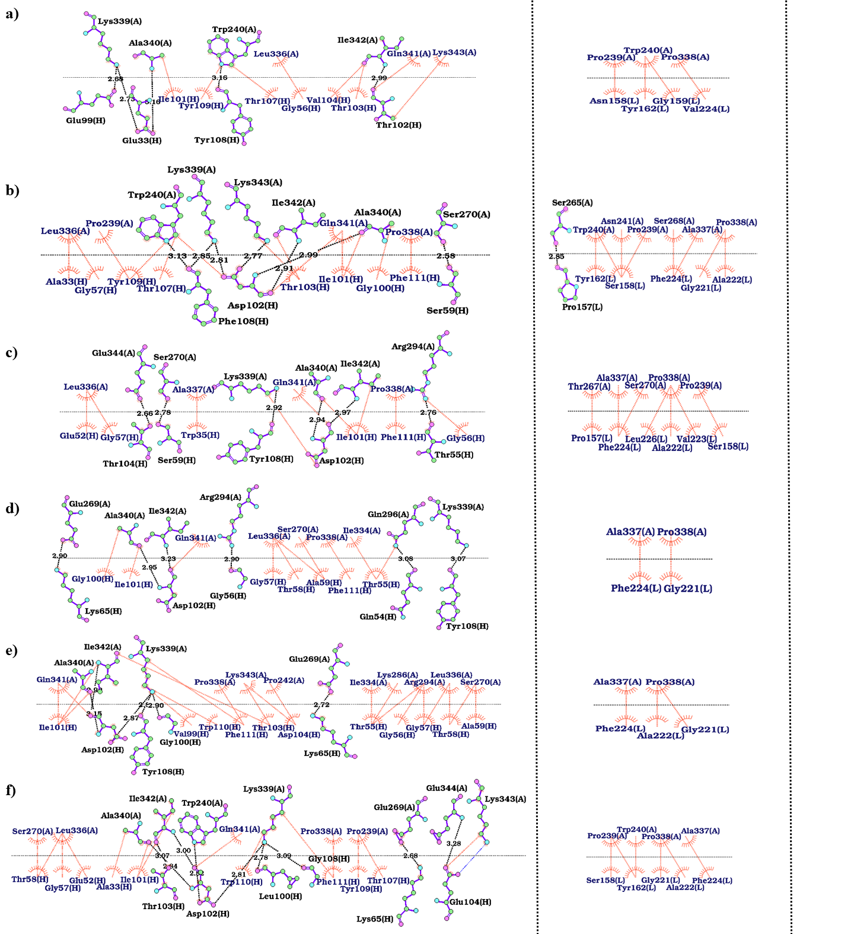
Figure S42. 2D interaction maps of heavy (left) and light (right) chains of antibodies in complex with PD-1. The interactions between the antibody chains and PD-1 in (a) control-6jbt (toripalimab-PD-1), (b) design-3941, (c) design-5880, (d) design-8052, (e) and design-9609, (f) and design-9937 were analyzed using LigPlot⁺. The hydrogen bonds, hydrophobic interactions and salt-bridges are colored in orange, black and blue lines, respectively. The PD-1 and light and heavy chains of the antibody are labeled A, H, and L, respectively.
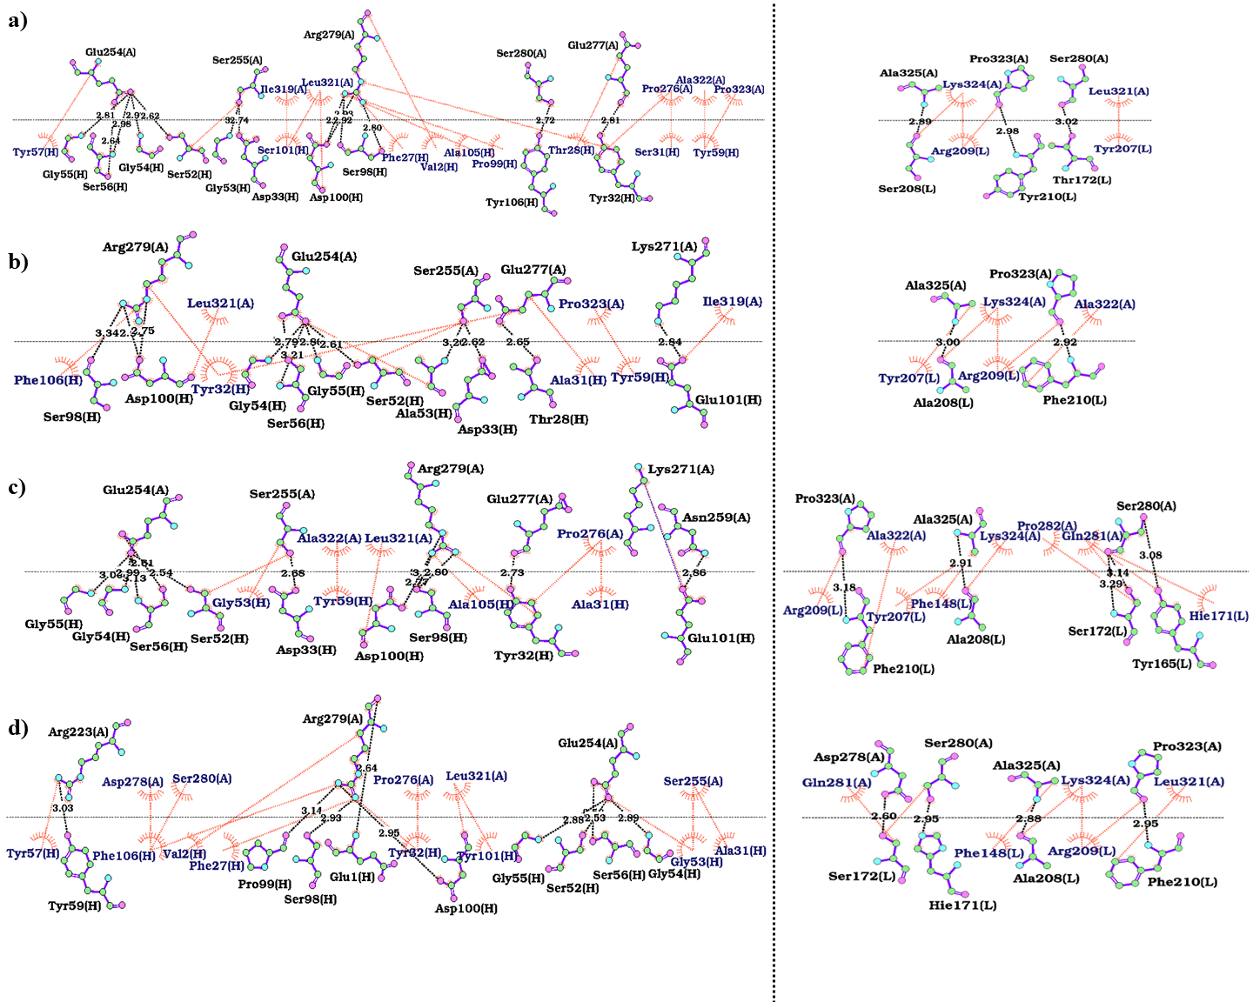
Figure S43. 2D interaction maps of heavy (left) and light (right) chains of antibodies in complex with PD-1. The interactions between the antibody chains and PD-1 in (a) control-6jjp (MW11-h317-PD-1), (b) design-0118, (c) design-2207, and (d) design-7357 were analyzed using LigPlot⁺. The hydrogen bonds and hydrophobic interactions are colored in orange and black, respectively. The PD-1 and light and heavy chains of the antibody are labeled A, H, and L, respectively.
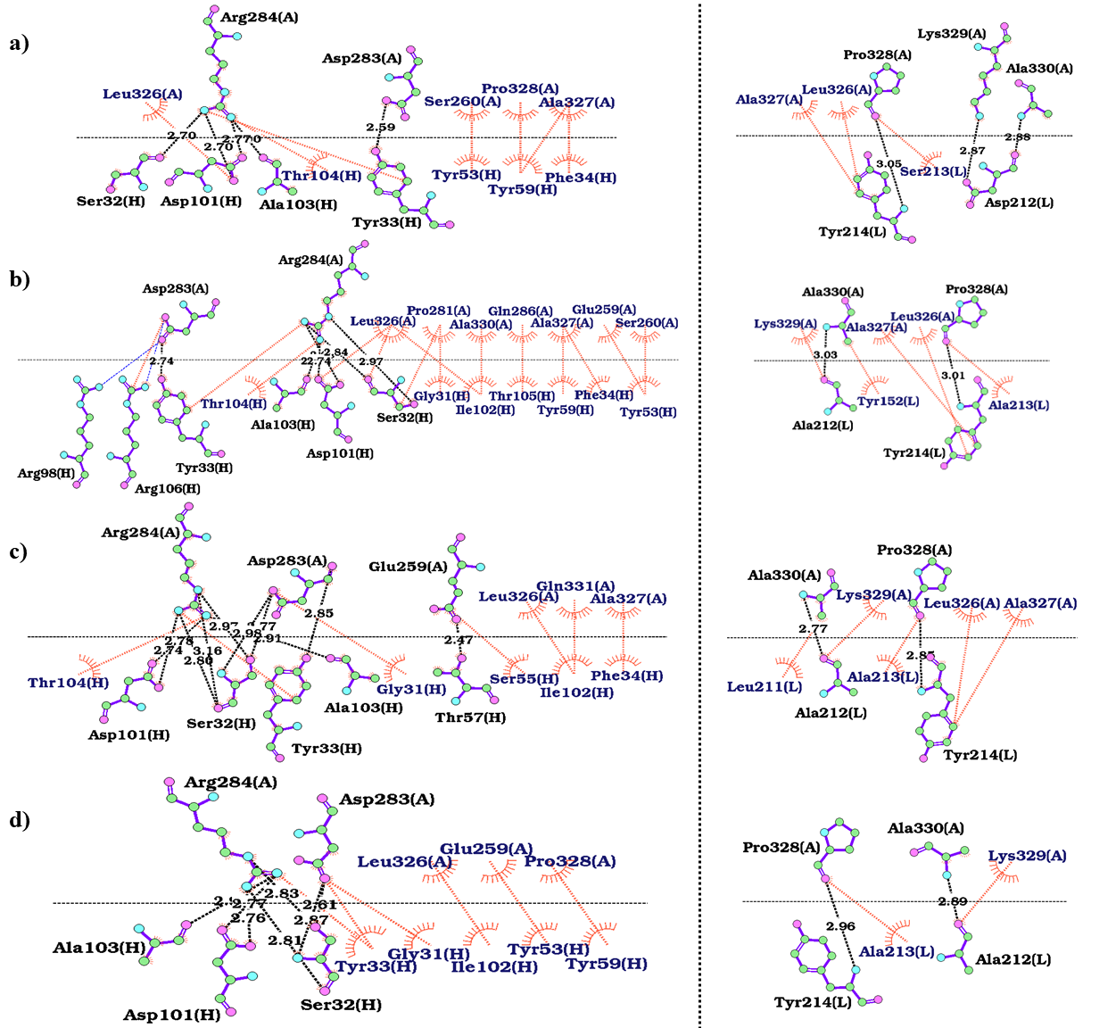
Figure S44. 2D interaction maps of heavy (left) and light (right) chains of antibodies in complex with PD-1. The interactions between the antibody chains and PD-1 in (a) control-6k0y (mAb059c-PD-1), (b) design-1483, (c) design-3128, and (d) design-4855 were analyzed using LigPlot⁺. The hydrogen bonds, hydrophobic interactions and salt-bridges are colored in orange, black and blue lines, respectively. The PD-1 and light and heavy chains of the antibody are labeled A, H, and L, respectively.
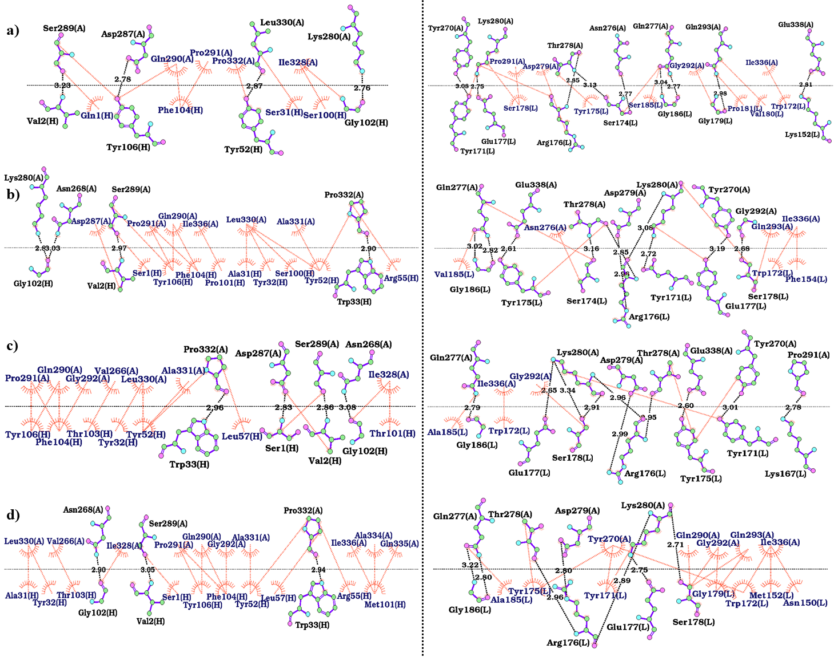
Figure S45. 2D interaction maps of heavy (left) and light (right) chains of antibodies in complex with PD-1. The interactions between the antibody chains and PD-1 in (a) control-6xkr (sasanlimab-PD-1), (b) design-0669, (c) design-0719, and (d) design-8773 were analyzed using LigPlot⁺. The hydrogen bonds and hydrophobic interactions are colored in orange and black lines, respectively. The PD-1 and light and heavy chains of the antibody are labeled A, H, and L, respectively.
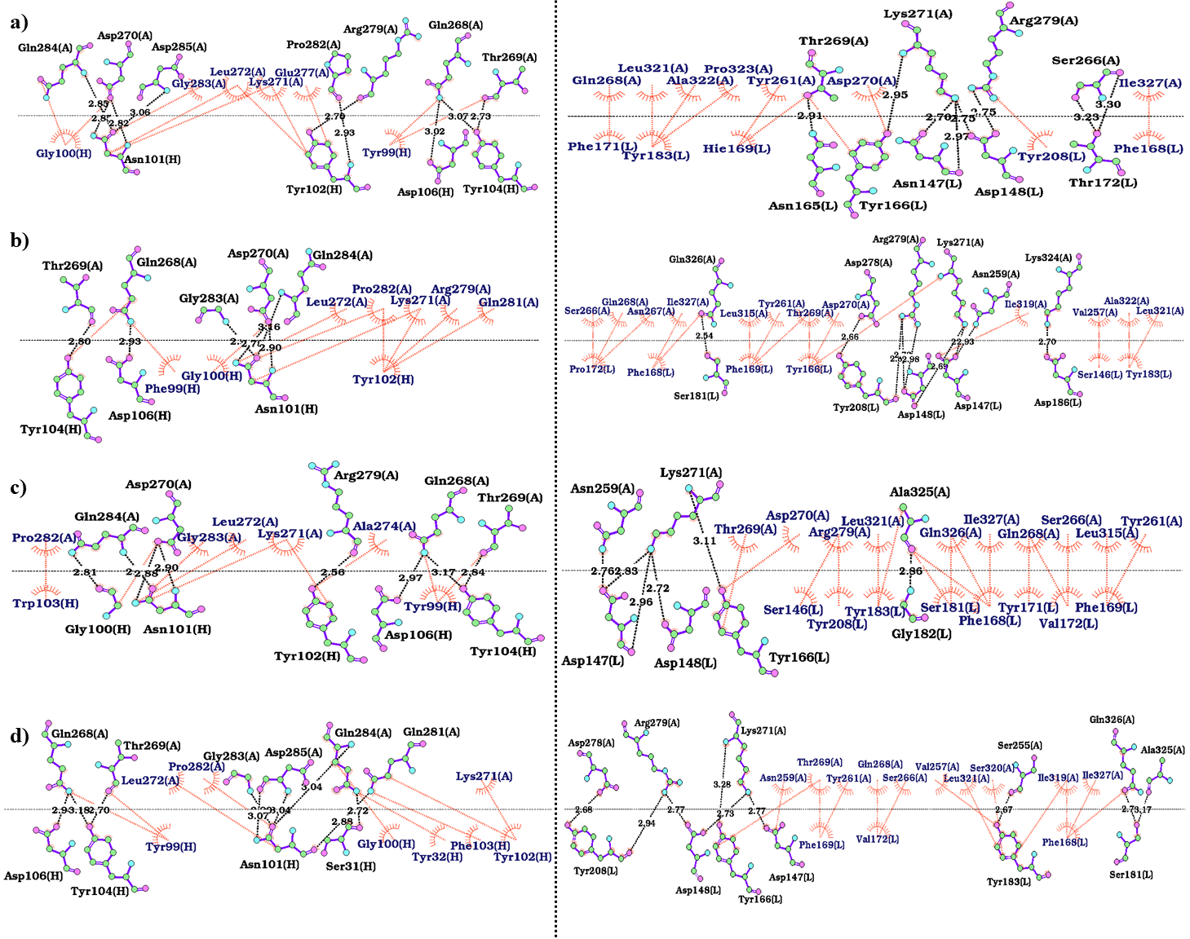
Figure S46. 2D interaction maps of heavy (left) and light (right) chains of antibodies in complex with PD-1. The interactions between the antibody chains and PD-1 in (a) control-7cgw (tislelizumab-PD-1), (b) design-1223, (c) design-3120, and (d) design-4390 were analyzed using LigPlot⁺. The hydrogen bonds and hydrophobic interactions are colored in orange and black lines, respectively. The PD-1 and light and heavy chains of the antibody are labeled A, H, and L, respectively.
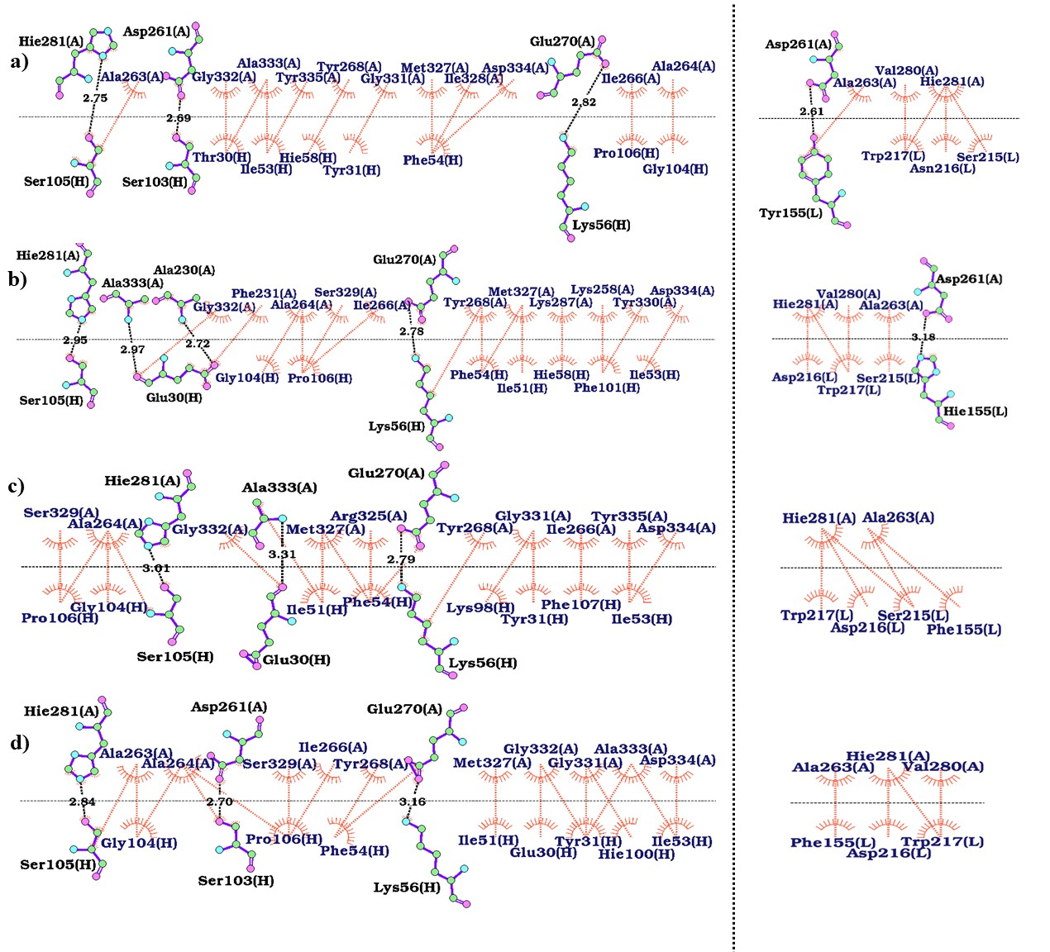
Figure S47. 2D interaction maps of heavy (left) and light (right) chains of antibodies in complex with PD-L1. The interactions between the antibody chains and PD-1 in (a) control-5ggt (BMS-936559-PD-1), (b) design-5520, (c) design-7173, and (d) design-8421 were analyzed using LigPlot⁺. The hydrogen bonds and hydrophobic interactions are colored in orange and black lines, respectively. The PD-1 and light and heavy chains of the antibody are labeled A, H, and L, respectively.
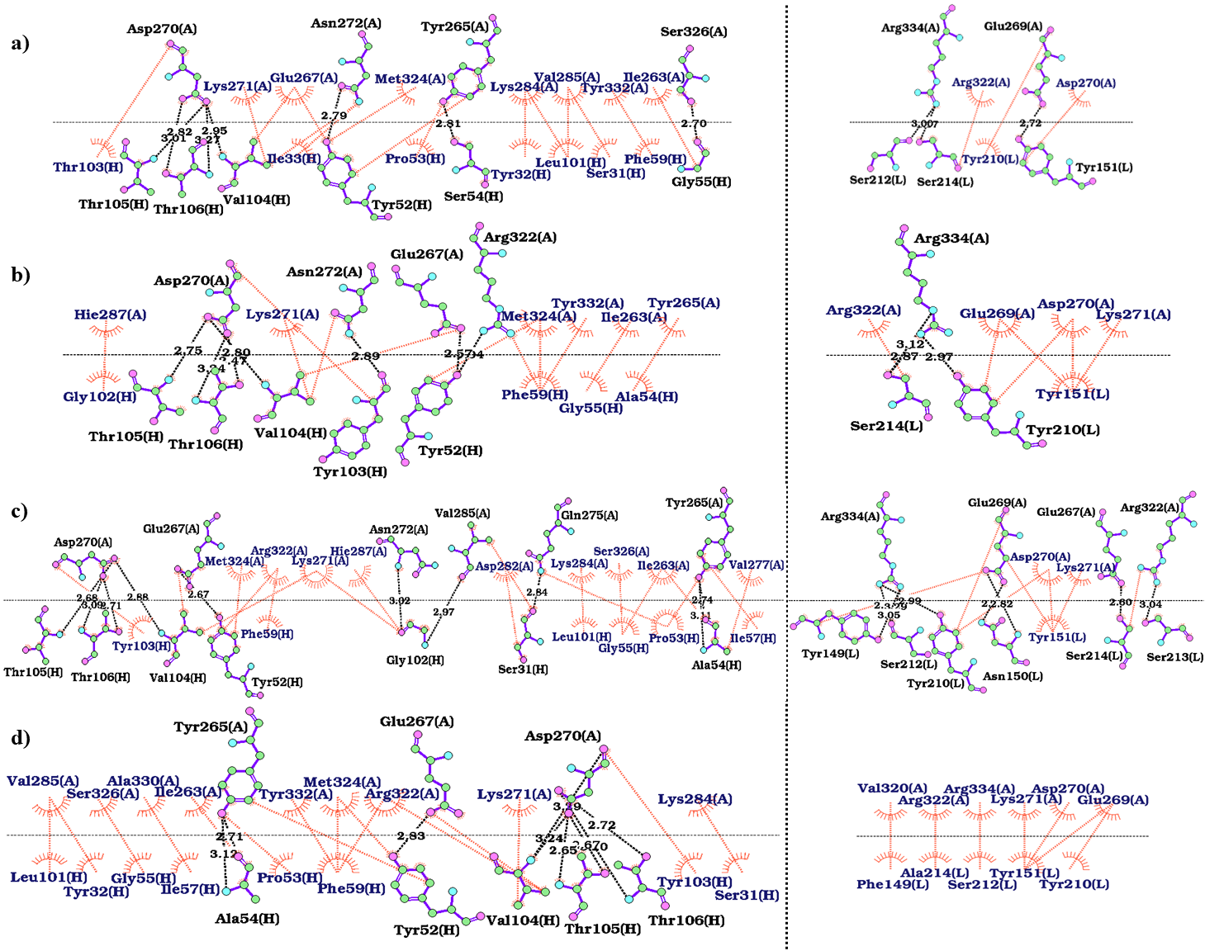
Figure S48. 2D interaction maps of heavy (left) and light (right) chains of antibodies in complex with PD-L1. The interactions between the antibody chains and PD-1 in (a) control-5grj (avelumab-PD-L1), (b) design-1484, (c) design-4233, and (d) design-5708 were analyzed using LigPlot⁺. The hydrogen bonds and hydrophobic interactions are colored in orange and black lines, respectively. The PD-1 and light and heavy chains of the antibody are labeled A, H, and L, respectively.

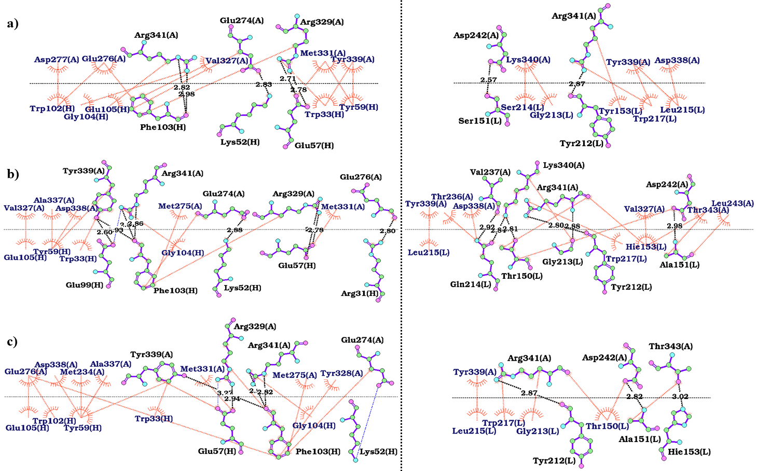
Figure S49. 2D interaction maps of heavy (left) and light (right) chains of antibodies in complex with PD-L1. The interactions between the antibody chains and PD-1 in (a) control-5xj4 (durvalumab-PD-L1), (b) design-5344, and (c) design-8103 were analyzed using LigPlot⁺. The hydrogen bond, hydrophobic, and salt-bridge interactions are colored by the tomato, black, and blue lines, respectively. The PD-1 and light and heavy chains of the antibody are labeled A, H, and L, respectively.

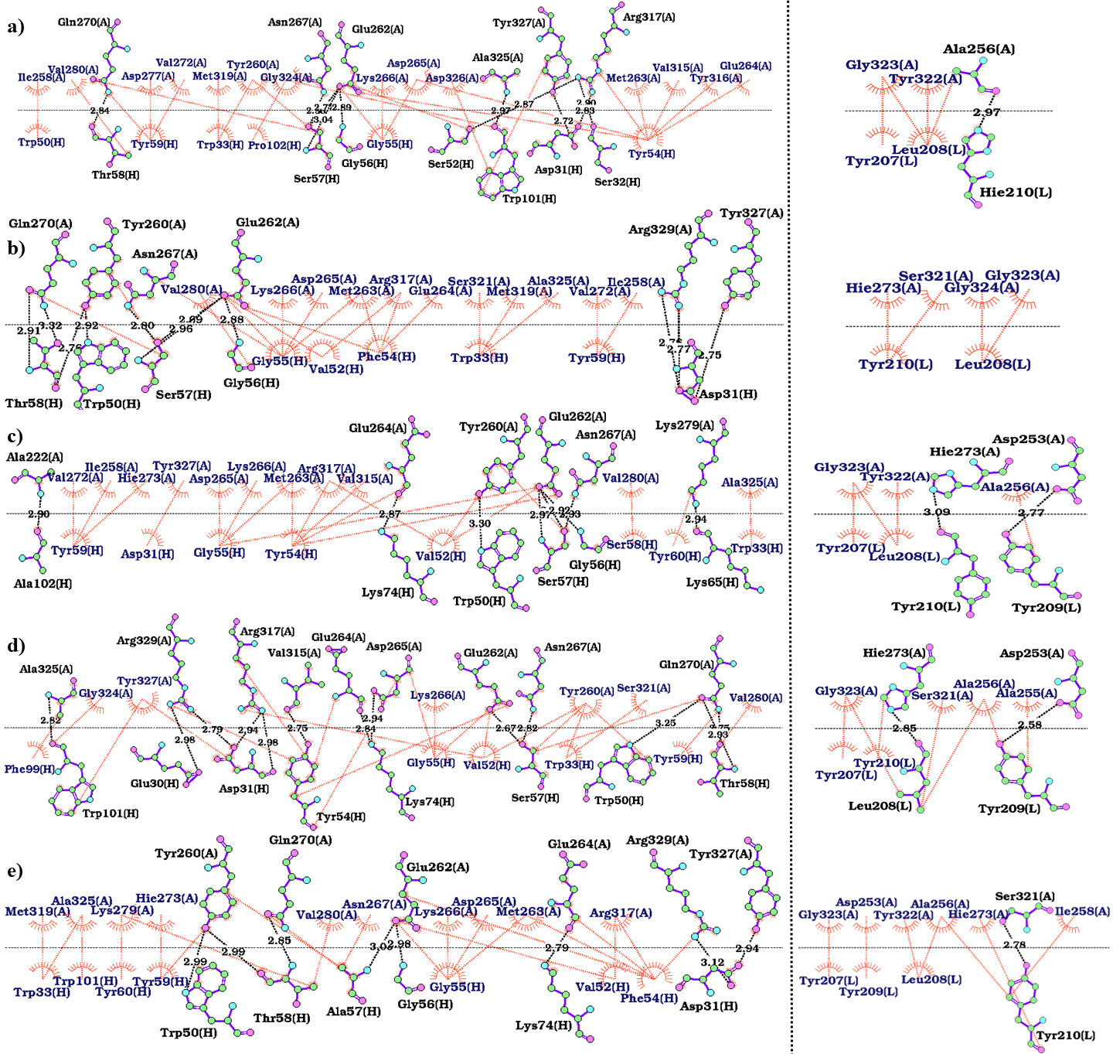
Figure S50. 2D interaction maps of heavy (left) and light (right) chains of antibodies in complex with PD-L1. The interactions between the antibody chains and PD-1 in (a) control-5xxy (atezolizumab-PD-L1), (b) design-0990, (c) design-1379, (d) design-4503, and (e) design-9003 were analyzed using LigPlot⁺. The hydrogen bonds and hydrophobic interactions are colored in orange and black, respectively. The PD-1 and light and heavy chains of the antibody are labeled A, H, and L, respectively.

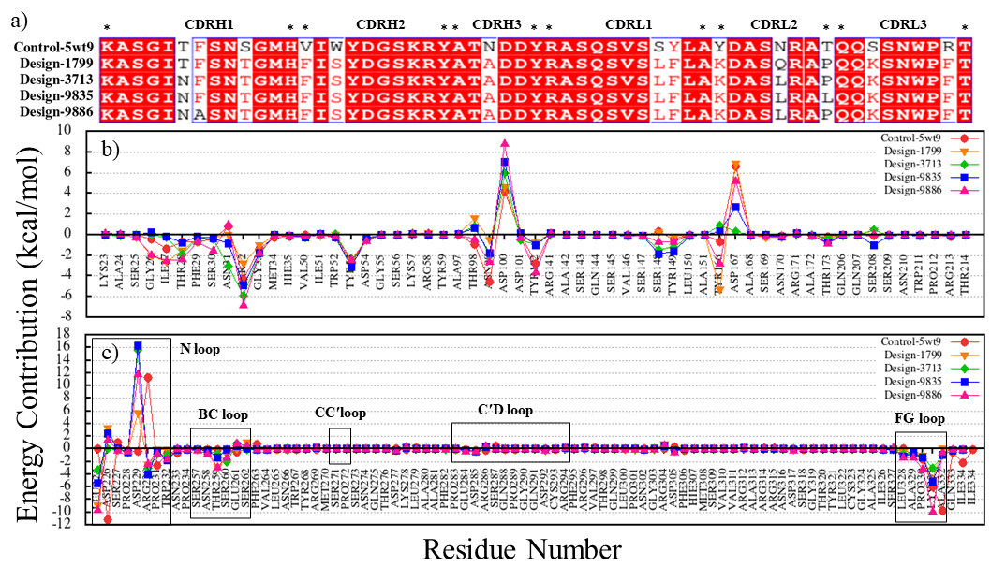
Figure S51. Binding free energy decomposition of the residues in the control and designed complexes. (a) Alignment of CDR sequences in the control-5wt9 (nivolumab-PD-1) and design groups. (b) Energy contribution values of PD-1 residues from MM-PBSA. (c) Energy contribution values of CDR residues from MM-PBSA. The graphs show the binding free energy for each residue in control-5wt9 (red), design-1799 (orange), design-3713 (green), design-9835 (blue), and design-9886 (magenta).
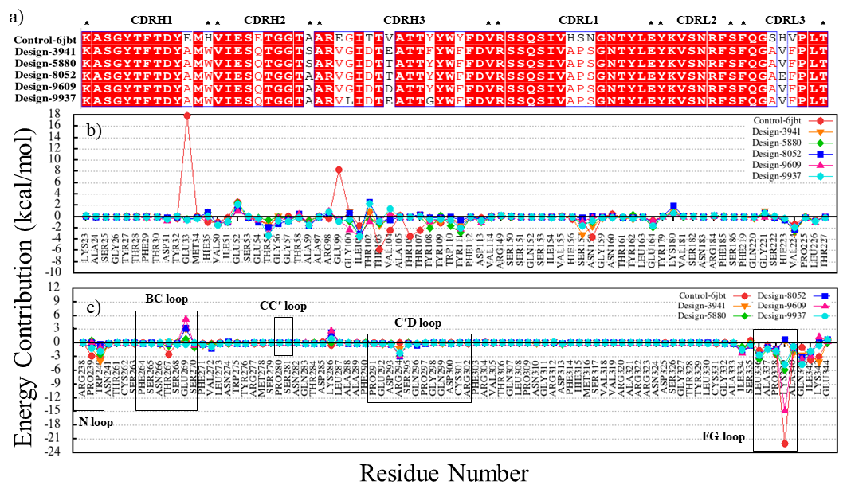
Figure S52. Binding free energy decomposition of the residues in the control and designed complexes. (a) Alignment of CDR sequences in the control-6jbt (toripalimab-PD-1) and design groups. (b) Energy contribution values of PD-1 residues from MM-PBSA. (c) Energy contribution values of CDR residues from MM-PBSA. The graphs show the binding free energy for each residue in control-6jbt (red), design-3941 (orange), design-5880 (green), design-8052 (blue), design-9609 (magenta), and design-9937 (cyan).

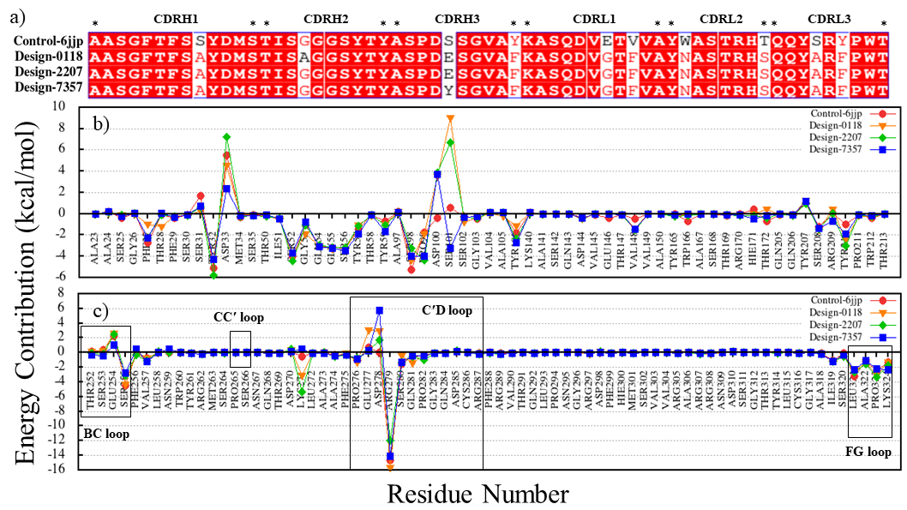
Figure S53. Binding free energy decomposition of the residues in the control and designed complexes. (a) Alignment of CDR sequences in the control-6jjp (MW11-h317-PD-1) and design groups. (b) Energy contribution values of PD-1 residues from MM-PBSA. (c) Energy contribution values of CDR residues from MM-PBSA. The graphs show the binding free energy for each residue in control-6jjp (red), design-0118 (orange), design-2207 (green), and design-7357 (blue).
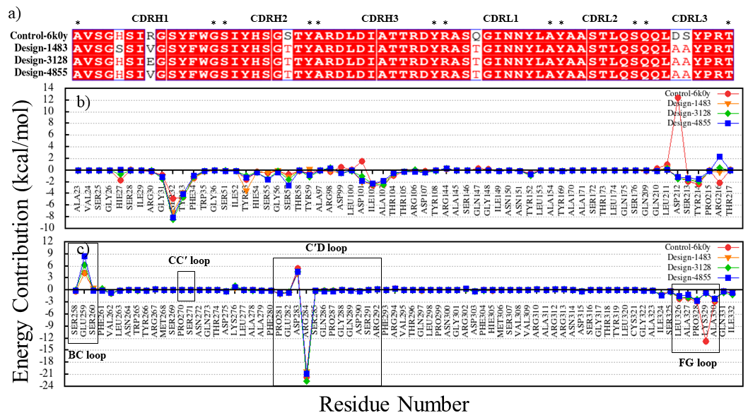
Figure S54. Binding free energy decomposition of the residues in the control and designed complexes. (a) Alignment of CDR sequences in the control-6k0y (mAb059c-PD-1) and design groups. (b) Energy contribution values of PD-1 residues from MM-PBSA. (c) Energy contribution values of CDR residues from MM-PBSA. The graphs show the binding free energy for each residue in control-6k0y (red), design-1483 (orange), design-3128 (green), and design-4855 (blue).
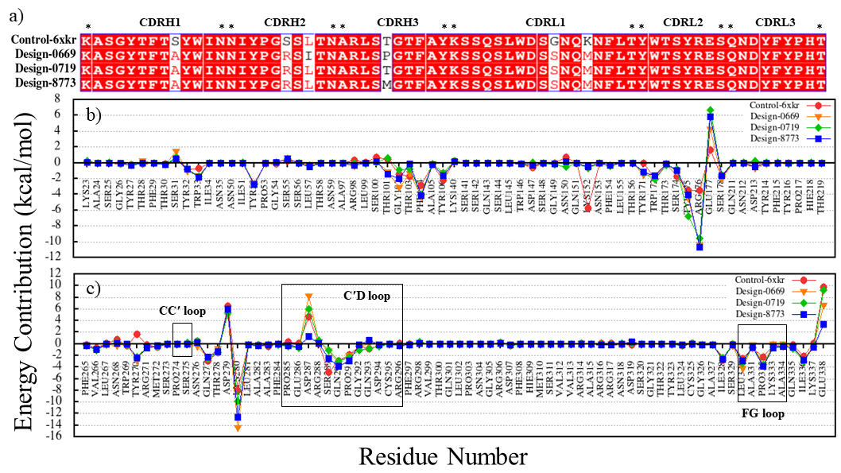
Figure S55. Binding free energy decomposition of the residues in the control and designed complexes. (a) Alignment of CDR sequences in the control-6xkr (sasanlimab-PD-1) and design groups. (b) Energy contribution values of PD-1 residues from MM-PBSA. (c) Energy contribution values of CDR residues from MM-PBSA. The graphs show the binding free energy for each residue in control-6xkr (red), design-0669 (orange), design-0719 (green), and design-8773 (blue).
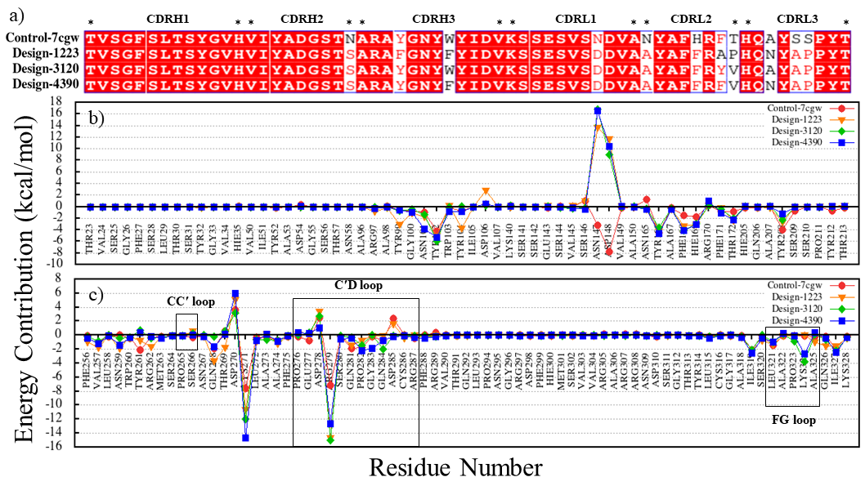
Figure S56. Binding free energy decomposition of the residues in the control and designed complexes. (a) Alignment of CDR sequences in the control-7cgw (tislelizumab-PD-1) and design groups. (b) Energy contribution values of PD-1 residues from MM-PBSA. (c) Energy contribution values of CDR residues from MM-PBSA. The graphs show the binding free energy for each residue in control-7cgw (red), design-1223 (orange), design-3120 (green), and design-4390 (blue).
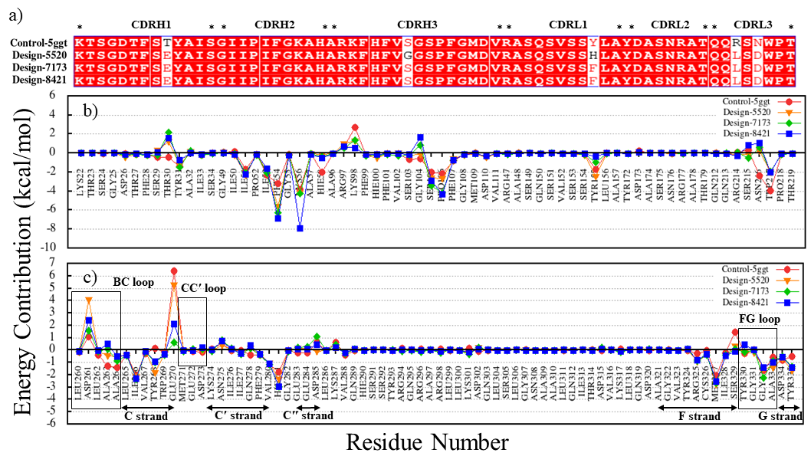
Figure S57. Binding free energy decomposition of the residues in the control and designed complexes. (a) Alignment of CDR sequences in the control-5ggt (BMS-936559-PD-1) and design groups. (b) Energy contribution values of PD-L1 residues from MM-PBSA. (c) Energy contribution values of CDR residues from MM-PBSA. The graphs show the binding free energy for each residue in control-5ggt (red), design-5520 (orange), design-7173 (green), and design-8421 (blue).
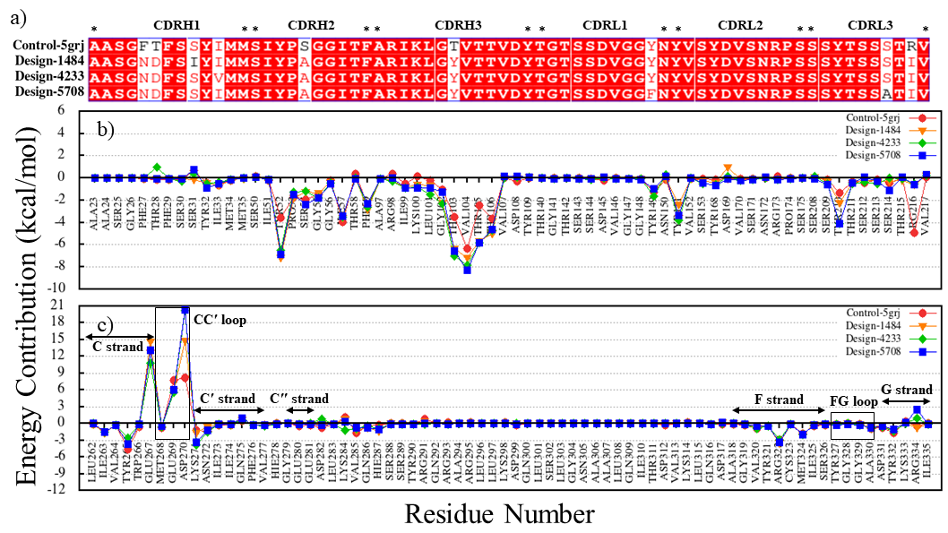
Figure S58. Binding free energy decomposition of the residues in the control and designed complexes. (a) Alignment of CDR sequences in the control-5grj (avelumab-PD-L1) and design groups. (b) Energy contribution values of PD-L1 residues from MM-PBSA. (c) Energy contribution values of CDR residues from MM-PBSA. The graphs show the binding free energy for each residue in control-5grj (red), design-1484 (orange), design-4233 (green), and design-5708 (blue).

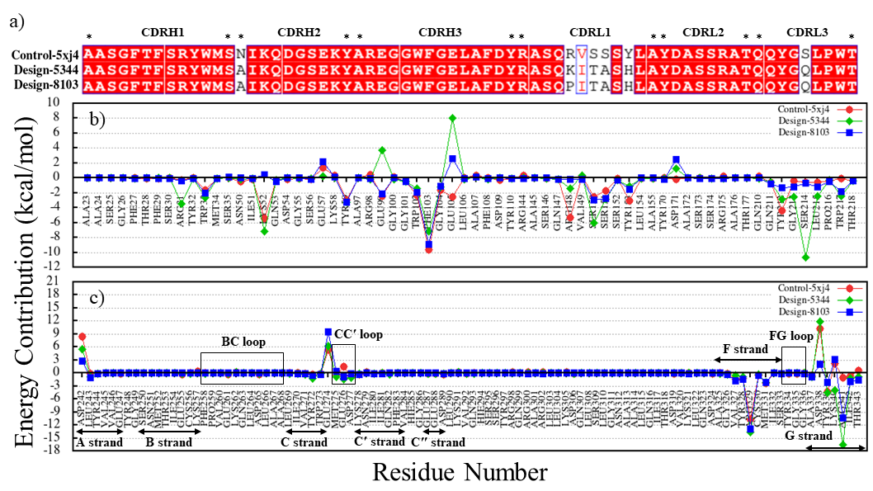
Figure S59. Binding free energy decomposition of the residues in the control and designed complexes. (a) Alignment of CDR sequences in the control-5xj4 (durvalumab-PD-L1) and design groups. (b) Energy contribution values of PD-L1 residues from MM-PBSA. (c) Energy contribution values of CDR residues from MM-PBSA. The graphs show the binding free energy for each residue in control-5xj4 (red), design-5344 (green), and design-8103 (blue).
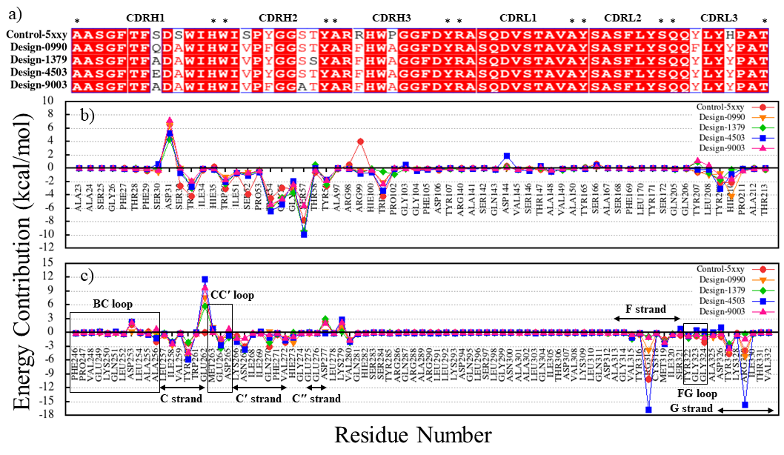
Figure S60. Binding free energy decomposition of the residues in the control and designed complexes. (a) Alignment of CDR sequences in the control-5xxy (atezolizumab-PD-L1) and design groups. (b) Energy contribution values of PD-L1 residues from MM-PBSA. (c) Energy contribution values of CDR residues from MM-PBSA. The graphs show the binding free energy for each residue in control-5xxy (red), design-0990 (orange), design-1379 (green), design-4503 (blue), and design-9003 (magenta).
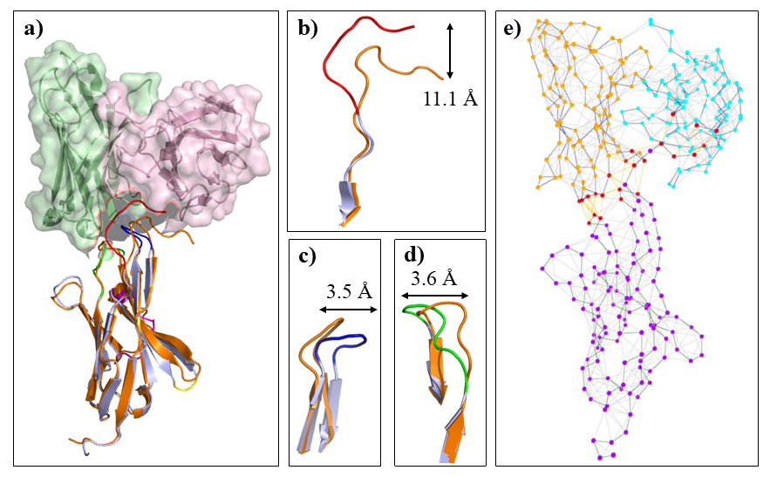
Figure S61. Analysis of conformational changes within PD-1 loops in complex with design-9886. (a) Comparison of conformational changes in the PD-1 loops upon binding to design-9886 and PD-L1. The heavy chain, light chain, PD-1 in complex with design-9886, and PD-1 in complex with PD-L1 are colored pale green, light pink, light blue, and orange, respectively. The FG, BC, and N loops of PD-1 in complex with design-9886 are colored in blue, green, and red, respectively. (b) The N loop of PD-1 shifted 11.1 Å upon binding to design-9886. (c) The FG loop of PD-1 shifted 3.5 Å upon binding to design-9886. (d) The BC loop of PD-1 shifted 3.6 Å upon binding to design-9886. (e) Interaction network between PD-1 loops and the design-9886. The amino acids in the heavy chain, light chain and PD-1 are colored as cyan, gold, and violet nodes, respectively. Red nodes represent the amino acids which are participate in PD-1 interaction.
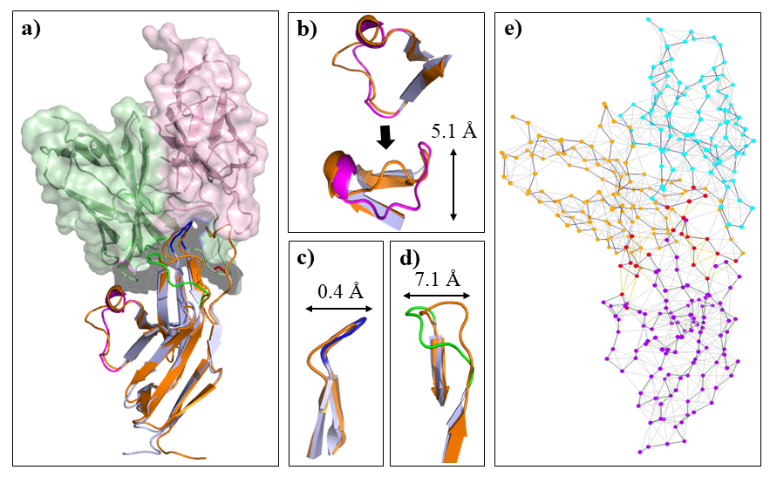
Figure S62. Analysis of conformational changes within PD-1 loops in the design-9609 complex. (a) Comparison of conformational changes in the PD-1 loops upon binding to design-9609 and PD-L1. The heavy chain, light chain, PD-1 in complex with design-9609, and PD-1 in complex with PD-L1 are colored pale green, light pink, light blue, and orange, respectively. The FG, BC, and N loops of PD-1 in complex with design-9609 are colored in blue, green, and red, respectively. (b) The C′D loop of PD-1 shifted 5.1 Å upon binding to design-9609. (c) The FG loop of PD-1 shifted 0.4 Å upon binding to design-9609. (d) The BC loop of PD-1 shifted 7.1 Å upon binding to design-9609. (e) Interaction network between PD-1 loops and the design-9609. The amino acids in the heavy chain, light chain and PD-1 are colored as cyan, gold, and violet nodes, respectively. Red nodes represent the amino acids which are participate in PD-1 interaction.
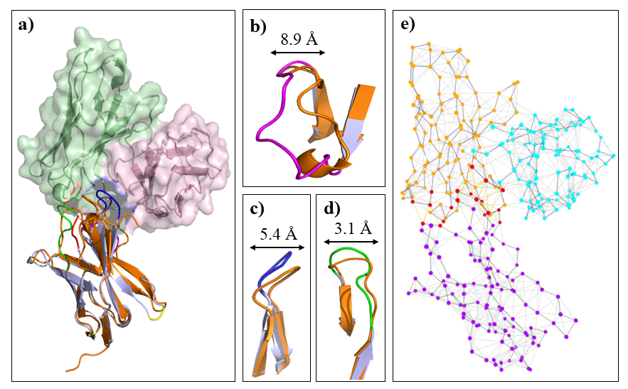
Figure S63. Analysis of conformational changes within PD-1 loops in complex with design-7357. (a) Comparison of conformational changes in the PD-1 loops upon binding to design-7357 and PD-L1. The heavy chain, light chain, PD-1 in complex with design-7357, and PD-1 in complex with PD-L1 are colored pale green, light pink, light blue, and orange, respectively. The C′D, FG, and BC loops of PD-1 in complex with design-7357 are colored in magenta, blue, and green, respectively. (b) The C′D loop of PD-1 shifted 8.9 Å in the groove which was formed by the CDR loops of design-7357. (c) The FG loop of PD-1 shifted 5.4 Å upon the binding to design-7357. (d) The BC loop of PD-1 shifted 3.1 Å upon the binding to design-7357. (e) Interaction network between PD-1 loops and the design-7357. The amino acids in the heavy chain, light chain and PD-1 are colored as cyan, gold, and violet nodes, respectively. Red nodes represent the amino acids which are participate in PD-1 interaction.
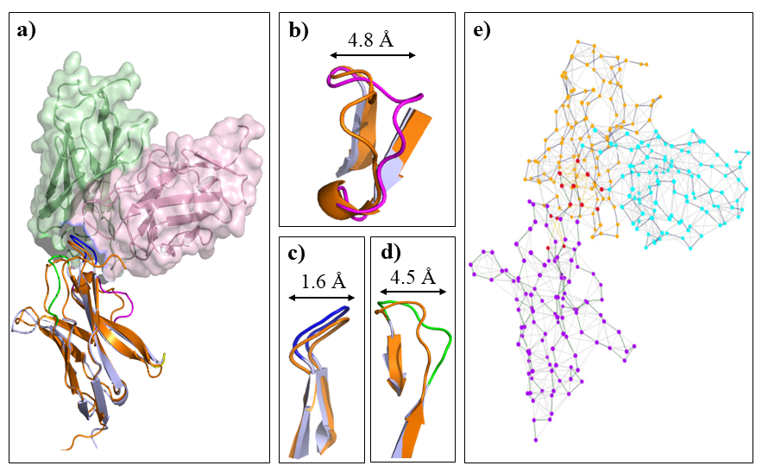
Figure S64. Analysis of conformational changes within PD-1 loops in complex with design-3128. (a) Comparison of conformational changes in the PD-1 loops upon binding to design-3128 and PD-L1. The heavy chain, light chain, PD-1 in complex with design-3128, and PD-1 in complex with PD-L1 are colored pale green, light pink, light blue, and orange, respectively. The FG, BC, and N loops of PD-1 in complex with design-3128 are colored in blue, green, and red, respectively. (b) The C′D loop of PD-1 shifted 4.8 Å upon binding to design-3128. (c) The FG loop of PD-1 shifted 1.6 Å upon binding to design-3128. (d) The BC loop of PD-1 shifted 4.5 Å upon binding to design-3128. (e) Interaction network between PD-1 loops and the design-3128. The amino acids in the heavy chain, light chain and PD-1 are colored as cyan, gold, and violet nodes, respectively. Red nodes represent the amino acids which are participate in PD-1 interaction.
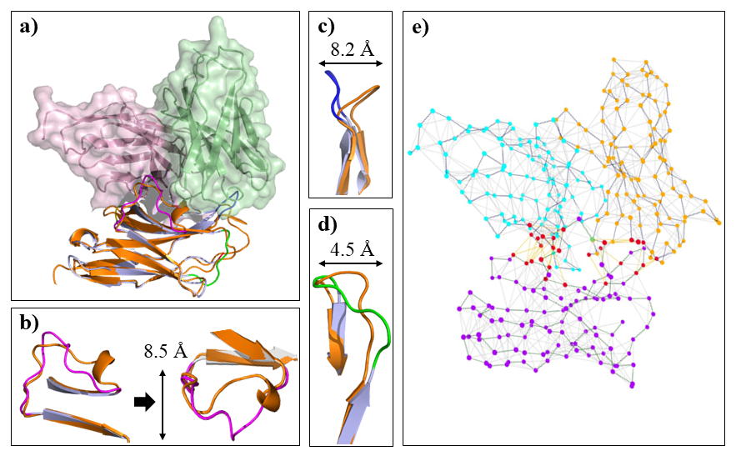
Figure S65. Analysis of conformational changes within PD-1 loops in complex with design-8773. (a) Comparison of conformational changes in the PD-1 loops upon binding to design-8773 and PD-L1. The heavy chain, light chain, PD-1 in complex with design-8773, and PD-1 in complex with PD-L1 are colored pale green, light pink, light blue, and orange, respectively. The C′D, FG, and BC loops of PD-1 in complex with design-8773 are colored in magenta, blue, and green, respectively. (b) The C′D loop of PD-1 shifted 8.5 Å in the groove which was formed by the CDR loops of design-8773. (c) The FG loop of PD-1 shifted 8.2 Å upon binding to design-8773. (d) The BC loop of PD-1 shifted 4.5 Å upon binding to design-8773. (e) Interaction network between PD-1 loops and the design-8773. The amino acids in the heavy chain, light chain and PD-1 are colored as cyan, gold, and violet nodes, respectively. Red nodes represent the amino acids which are participate in PD-1 interaction.
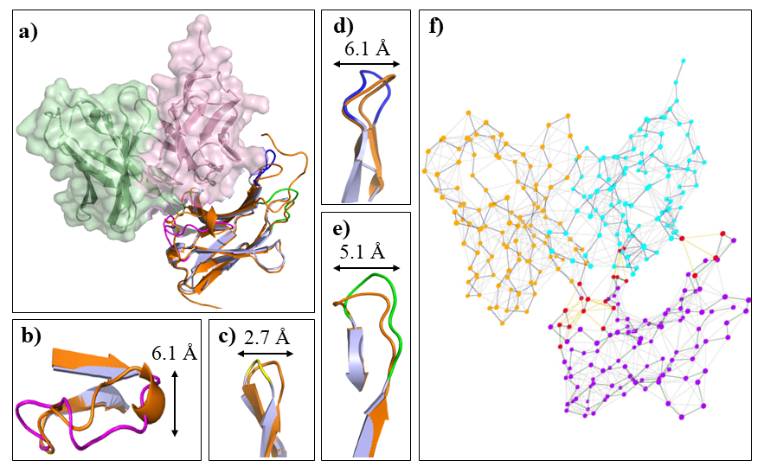
Figure S66. Analysis of conformational changes within PD-1 loops in complex with design-1223. (a) Comparison of conformational changes in the PD-1 loops upon binding to design-1223 and PD-L1. The heavy chain, light chain, PD-1 in complex with design-1223, and PD-1 in complex with PD-L1 are colored pale green, light pink, light blue, and orange, respectively. The FG, BC, and N loops of PD-1 in complex with design-1223 are colored in blue, green, and red, respectively. (b) The C′D loop of PD-1 shifted 6.1 Å upon binding to design-1223. (c) The CC′ loop of PD-1 shifted 2.7 Å upon binding to design-1223. (d) The FG loop of PD-1 shifted 6.1 Å upon binding to design-1223. (e) The BC loop of PD-1 shifted 5.1 Å upon the binding to design-1223. (f) Interaction network between PD-1 loops and the design-1223. The amino acids in the heavy chain, light chain and PD-1 are colored as cyan, gold, and violet nodes, respectively. Red nodes represent the amino acids which are participate in PD-1 interaction.
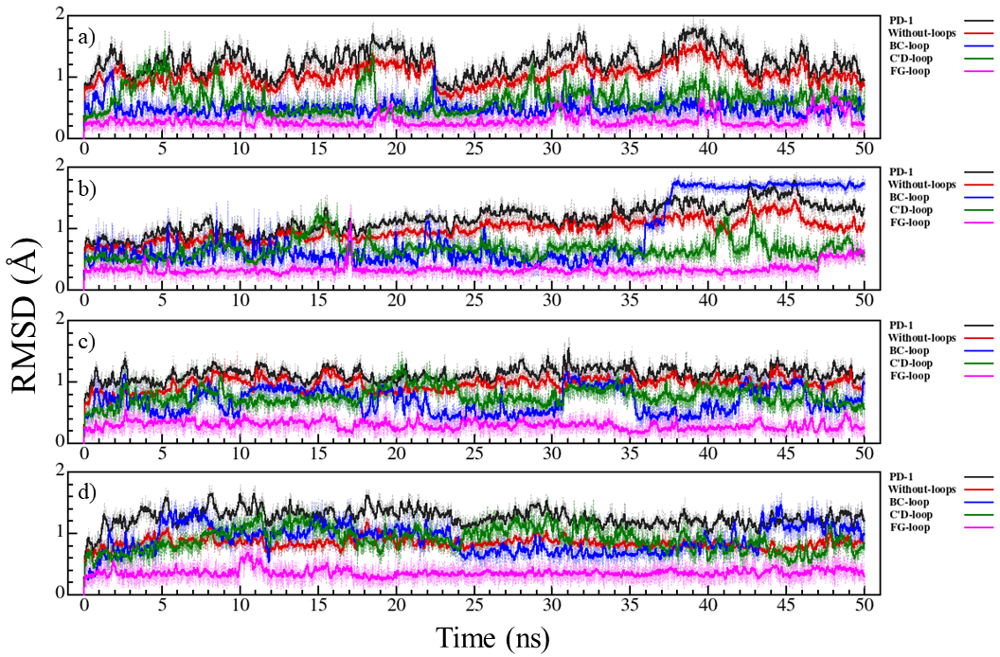
Figure S67. RMSD graphs for PD-1 with and without loops during 50 ns of MD simulation. PD-1 (black), PD-1 without BC, C′D and FG loops (red), BC loop (blue), C′D loop (green), and FG loop (magenta). (a) control-5ggs (pembrolizumab-PD-1), (b) design-1022, (c) design-3753, (d) design-6013.
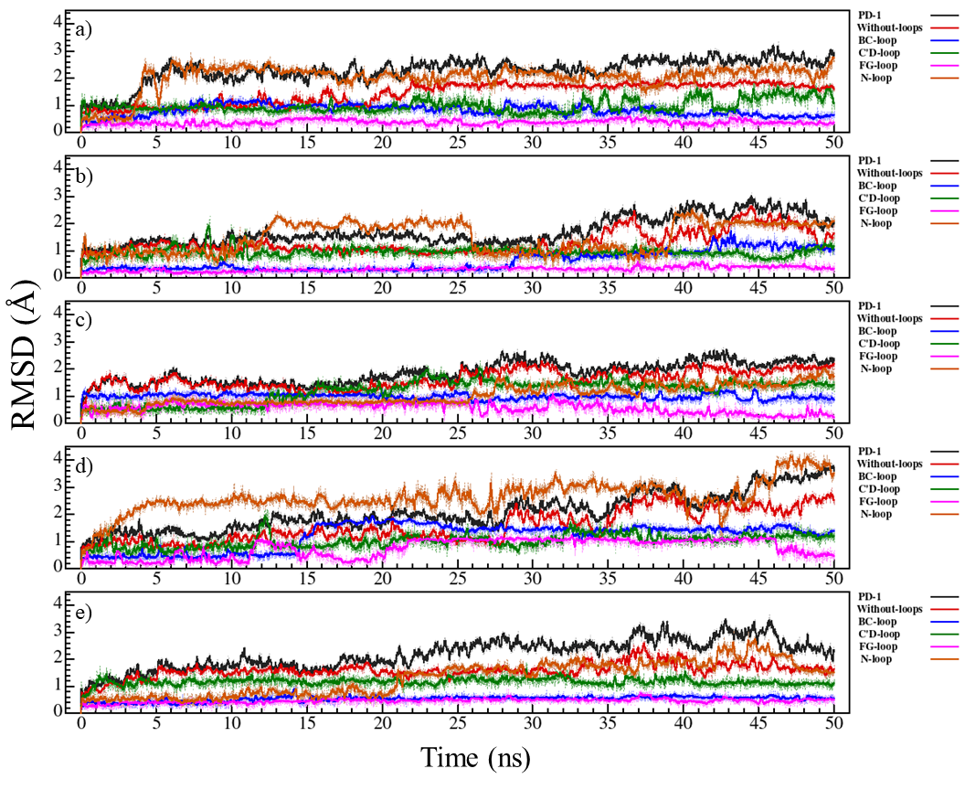
Figure S68. RMSD graphs for PD-1 with and without loops during 50 ns of MD simulation. PD-1 (black), PD-1 without BC, C′D and FG loops (red), BC loop (blue), C′D loop (green), FG loop (magenta), and N loop (orange). (a) control-5wt9 (nivolumab-PD-1). (b) design-1799. (c) design-3713. (d) design-9835. (e) design-9886.
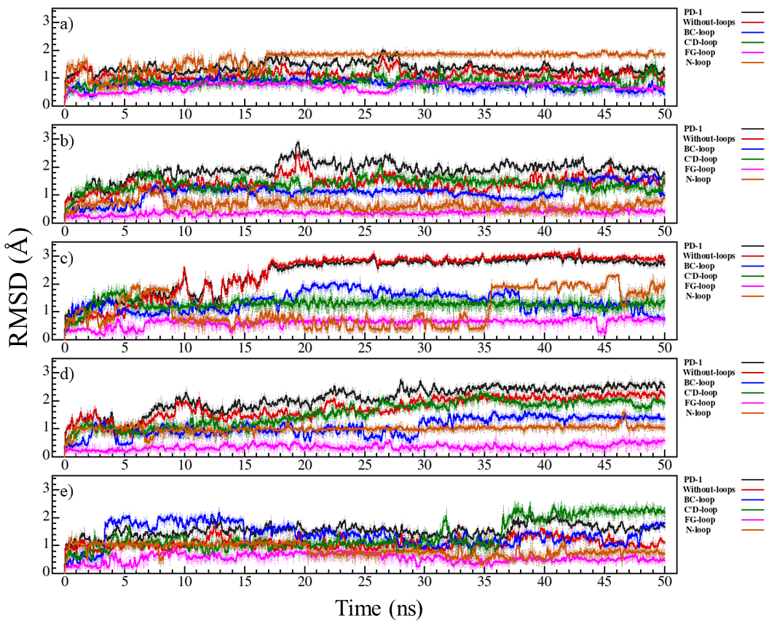
Figure S69. RMSD graphs for PD-1 with and without loops during 50 ns of MD simulation. PD-1 (black), PD-1 without BC, C′D and FG loops (red), BC loop (blue), C′D loop (green), FG loop (magenta), and N loop (orange). (a) control-6jbt (toripalimab-PD-1). (b) design-3941. (c) design-5880. (d) design-8052. (e) design-9609. (f) design-9937.

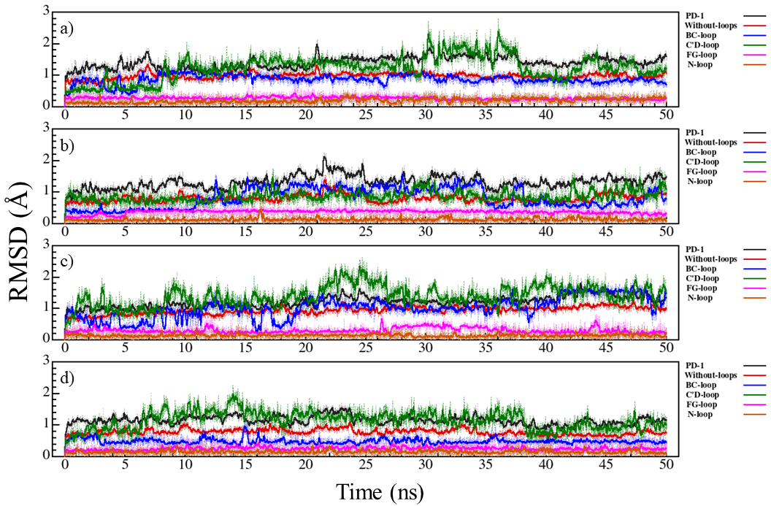
Figure S70. RMSD graphs for PD-1 with and without loops during 50 ns of MD simulation. PD-1 (black), PD-1 without BC, C′D and FG loops (red), BC loop (blue), C′D loop (green), FG loop (magenta), and N loop (orange). (a) control-6jjp (MW11-h317-PD-1). (b) design-0118. (c) design-2207. (d) design-7357.
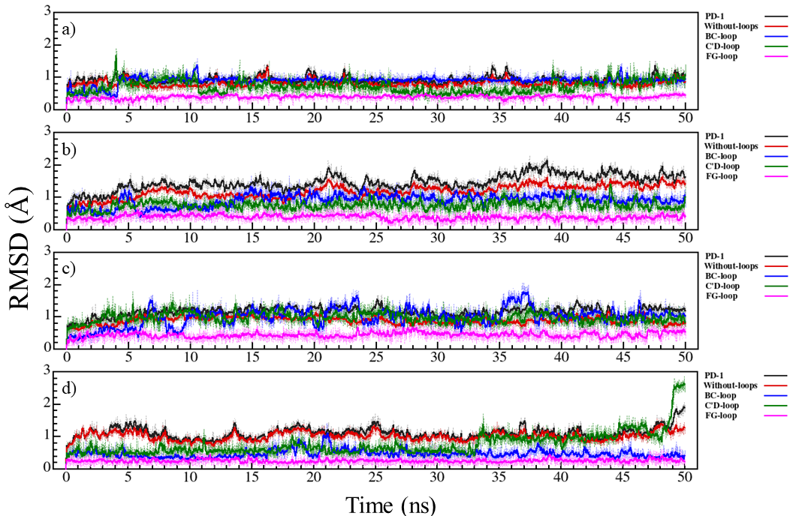
Figure S71. Figure S69. RMSD graphs for PD-1 with and without loops during 50 ns of MD simulation. PD-1 (black), PD-1 without BC, C′D and FG loops (red), BC loop (blue), C′D loop (green), and FG loop (magenta). (a) control-6k0y (mAb059c-PD-1). (b) design-1483. (c) design-3128. (d) design-4855.

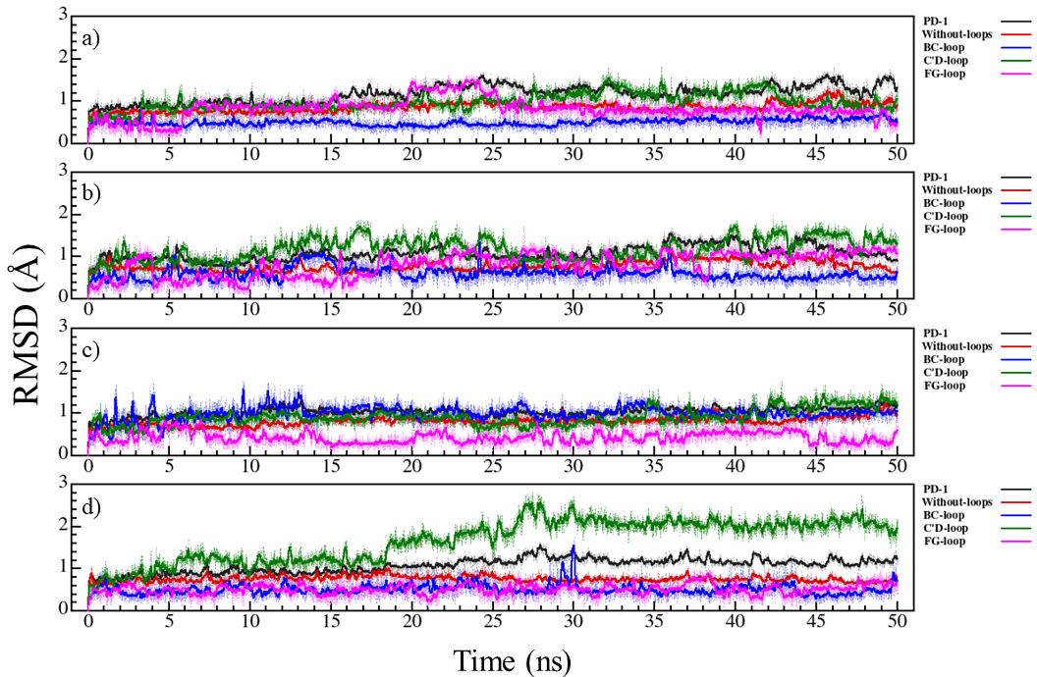
Figure S72. RMSD graphs for PD-1 with and without loops during 50 ns of MD simulation. PD-1 (black), PD-1 without BC, C′D and FG loops (red), BC loop (blue), C′D loop (green), and FG loop (magenta). (a) control-6xkr (sasanlimab-PD-1). (b) design-0669. (c) design-0719. (d) design-8773.
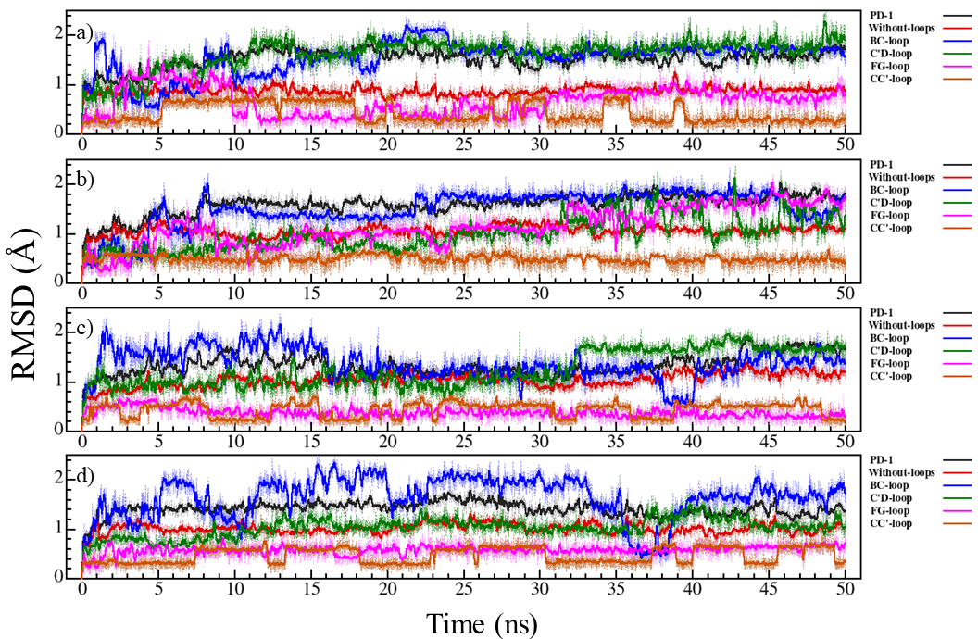
Figure S73. RMSD graphs for PD-1 with and without loops during 50 ns of MD simulation. PD-1 (black), PD-1 without BC, C′D and FG loops (red), BC loop (blue), C′D loop (green), FG loop (magenta), and N loop (orange). (a) control-7cgw (tislelizumab-PD-1). (b) design-1223. (c) design-3120. (d) design-4390.

Table S1. The interface characteristics of the antibody-PD-1 and antibody-PD-L1 complexes were calculated by RosettaInterfaceAnalyzer.
 | total-scoreª | dG^{b} | dG/dSASA^{c} | hbond-int^{d} | delta_unsathbonds^{e} | dSASA-int^{f} | dSASA-hphobic^{g} | dSASA-polar^{h}
Control-5ggs | -1040.69 | -58.1373 | -2.64502 | 15 | 9 | 2198 | 1135.5 | 1062.49
Design-1022 | -1043.942 | -59.0409 | -2.71164 | 13 | 9 | 2177.32 | 1170.32 | 1007
Design-3753 | -1043.040 | -58.1324 | -2.66747 | 13 | 8 | 2179.31 | 1180.94 | 998.373
Design-6013 | -1041.094 | -58.2503 | -2.64393 | 13 | 10 | 2203.17 | 1164.21 | 1038.96
Control-5wt9 | -1119.788 | -39.0138 | -2.66536 | 9 | 8 | 1463.73 | 675.79 | 787.942
Design-1799 | -1133.746 | -45.1498 | -3.16364 | 11 | 5 | 1427.15 | 732.8 | 694.347
Design-3713 | -1121.099 | -44.8084 | -3.16877 | 10 | 3 | 1414.06 | 735.352 | 678.71
Design-9835 | -1134.952 | -46.0289 | -3.11045 | 10 | 3 | 1479.82 | 797.372 | 682.445
Design-9886 | -1130.743 | -44.466 | -3.11819 | 10 | 3 | 1426.02 | 787.373 | 638.65
Control-6jbt | -1104.923 | -32.4556 | -1.8182 | 7 | 9 | 1785.03 | 936.909 | 848.125
Design-3941 | -1108.093 | -38.9062 | -2.2862 | 7 | 12 | 1701.79 | 983.39 | 718.395
Design-5880 | -1108.444 | -40.1905 | -2.38676 | 7 | 10 | 1683.89 | 1022.22 | 661.667
Design-8052 | -1110.318 | -39.1618 | -2.31964 | 6 | 8 | 1688.27 | 1042.02 | 646.256
Design-9609 | -1112.326 | -39.0501 | -2.29341 | 6 | 10 | 1702.71 | 1008.42 | 694.291
Design-9937 | -1109.745 | -39.5147 | -2.31911 | 6 | 8 | 1703.87 | 986.161 | 717.712
Control-6jjp | -1116.095 | -47.8669 | -2.79844 | 10 | 11 | 1710.48 | 947.926 | 762.556
Design-118 | -1121.091 | -50.4086 | -2.84142 | 11 | 8 | 1774.06 | 996.561 | 777.503
Design-2207 | -1123.070 | -51.0697 | -2.89695 | 11 | 9 | 1762.88 | 993.332 | 769.548
Design-7357 | -1121.386 | -52.1637 | -2.85052 | 11 | 9 | 1829.97 | 1070.67 | 759.305
Control-6k0y | -1252.773 | -54.92 | -3.9211 | 11 | 5 | 1400.63 | 706.092 | 694.534
Design-1483 | -1251.103 | -54.4094 | -4.13902 | 11 | 5 | 1314.55 | 687.242 | 627.308
Design-3128 | -1253.999 | -54.8652 | -4.06571 | 11 | 5 | 1349.46 | 684.556 | 664.905
Design-4855 | -1254.022 | -55.2639 | -4.09788 | 11 | 5 | 1348.6 | 686.414 | 662.182
Control-6xkr | -1077.740 | -67.5875 | -3.24925 | 16 | 7 | 2080.1 | 1052.78 | 1027.31
Design-669 | -1081.302 | -69.0659 | -3.28492 | 16 | 7 | 2102.52 | 1085.12 | 1017.4
Design-719 | -1078.978 | -69.296 | -3.32382 | 16 | 7 | 2084.83 | 1065.65 | 1019.18
Design-8773 | -1079.368 | -69.9914 | -3.35814 | 16 | 7 | 2084.23 | 1080.86 | 1003.38
Control-7cgw | -1033.152 | -54.758 | -2.77503 | 12 | 11 | 1973.24 | 947.405 | 1025.83
Design-1223 | -1035.597 | -59.3066 | -3.00043 | 12 | 7 | 1976.6 | 1100.43 | 876.175
Design-3120 | -1042.956 | -59.8174 | -2.98492 | 12 | 6 | 2003.99 | 1041.48 | 962.507
Design-4390 | -1039.282 | -60.2057 | -3.01044 | 12 | 6 | 1999.9 | 1054.51 | 945.389
Control-5ggt | -1086.287 | -42.1543 | -2.98478 | 5 | 7 | 1412.31 | 867.236 | 545.07
Design-5520 | -1087.590 | -42.2487 | -3.0444 | 6 | 7 | 1387.75 | 868.125 | 519.625
Design-7173 | -1087.662 | -43.5579 | -3.05941 | 5 | 7 | 1423.74 | 899.251 | 524.486
Design-8421 | -1088.247 | -43.1905 | -3.0554 | 5 | 7 | 1413.58 | 888.097 | 525.482
Control-5grj | -1063.568 | -63.3364 | -3.57195 | 16 | 8 | 1773.16 | 888.481 | 884.68
Design-1484 | -1073.040 | -65.1081 | -3.63706 | 14 | 7 | 1790.13 | 932.251 | 857.878
Design-4233 | -1070.431 | -64.7461 | -3.63957 | 15 | 7 | 1778.95 | 902.368 | 876.583
Design-5708 | -1072.605 | -66.1955 | -3.80789 | 15 | 7 | 1738.38 | 920.325 | 818.053
Control-5xj4 | -1139.166 | -39.6586 | -2.53517 | 11 | 6 | 1564.34 | 800.353 | 763.983
Design-5344 | -1139.001 | -40.3788 | -2.51883 | 11 | 6 | 1603.08 | 870.151 | 732.928
Design-8103 | -1140.133 | -40.2086 | -2.631 | 11 | 6 | 1528.26 | 842.694 | 685.571
Control-5xxy | -1005.265 | -64.6807 | -3.35811 | 12 | 22 | 1926.11 | 1116.05 | 810.061
Design-990 | -1009.838 | -66.1703 | -3.50152 | 11 | 17 | 1889.76 | 1197.65 | 692.108
Design-1379 | -1009.386 | -67.3249 | -3.46849 | 12 | 15 | 1941.04 | 1166.88 | 774.161
Design-4503 | -1009.991 | -69.1986 | -3.42916 | 13 | 17 | 2017.95 | 1167.6 | 850.352
Design-9003 | -1013.426 | -68.4729 | -3.61223 | 11 | 17 | 1895.59 | 1232.51 | 663.077

ªtotal-score: The score of the entire complex
^{b}dG: The binding energy
^{c}dG/dSASA: The binding density
^{d}hbonds_int: Total cross-interface hydrogen bonds
^{e}delta_unsathbonds: The number of buried unsatisfied hydrogen bonds at the interface
^{f}dSASA_int: The solvent accessible area buried at the interface
^{g}dSASA-hydrophobic: The amount of change in the hydrophobic part of dSASA
^{h}dSASA-polar: The change in the polar part of dSASA

Table S2. MMPBSA binding free energies (kcal·mol ⁻¹) for control and design complexes.
 | ∆G_bindingª | EN_polar | EPB^{b} | EEL^{c} | VDWAALS^{d}
PD-1-PD-L1 | -36.3006 ± 0.6670 | -12.2053 | 368.5067 | -294.6720 | -97.9300
Control-5ggs | -63.5046 ± 1.0689 | -13.1622 | 211.3707 | -141.6487 | -120.0644
Design-1022 | -71.8580 ± 0.8023 | -11.9187 | 210.7278 | -158.6573 | -112.0099
Design-3753 | -84.5037 ± 0.9835 | -12.5994 | 228.9138 | -178.7286 | -122.0894
Design-6013 | -76.0652 ± 1.0441 | -13.2310 | 275.1449 | -217.5797 | -120.3994
Control-5wt9 | -45.9166 ± 0.6162 | -8.3022 | 220.2949 | -188.1658 | -69.7435
Design-1799 | -28.9920 ± 0.6232 | -7.3594 | 185.1880 | -156.0977 | -50.7228
Design-3713 | -25.2546 ± 0.7286 | -6.5267 | 164.5513 | -130.0838 | -53.1953
Design-9835 | -23.4566 ± 0.7279 | -7.0713 | 180.8681 | -142.7150 | -54.5383
Design-9886 | -53.3361 ± 0.7075 | -8.1761 | 229.8903 | -203.2274 | -71.8229
Control-6jbt | -57.2988 ± 1.2210 | -9.6246 | 377.5447 | -347.7800 | -77.4389
Design-3941 | -57.4944 ± 0.9084 | -9.9253 | 300.8474 | -260.9954 | -87.4211
Design-5880 | -59.9833 ± 0.7305 | -8.8057 | 196.3309 | -170.5891 | -76.9193
Design-8052 | -38.2312 ± 0.7049 | -8.9574 | 274.9222 | -203.0716 | -74.1244
Design-9609 | -66.2888 ± 0.6987 | -9.2896 | 317.9428 | -290.8447 | -84.0974
Design-9937 | -56.8644 ± 1.1921 | -9.9594 | 281.1409 | -241.9234 | -86.1225
Control-6jjp | -78.3314 ± 0.6077 | -10.3637 | 275.9774 | -266.9189 | -77.0262
Design-118 | -67.6653 ± 0.6881 | -10.4243 | 304.8807 | -290.7395 | -71.3823
Design-2207 | -76.4657 ± 0.8719 | -10.4272 | 304.6621 | -291.6020 | -79.0986
Design-7357 | -80.0839 ± 0.9019 | -11.1178 | 256.1507 | -243.8937 | -81.2231
Control-6k0y | -62.1815 ± 0.6120 | -7.5072 | 210.2384 | -204.7890 | -60.1236
Design-1483 | -65.2533 ± 0.4896 | -6.9540 | 61.6082 | -60.0528 | -59.8574
Design-3128 | -67.7862 ± 0.5036 | -7.5754 | 59.2986 | -61.0846 | -58.4248
Design-4855 | -59.3813 ± 0.4697 | -7.5641 | 85.7730 | -86.7508 | -50.8394
Control-6xkr | -67.5520± 0.6288 | -12.7660 | 244.3635 | -192.8176 | -106.3320
Design-669 | -86.5503 ± 0.7275 | -13.2291 | 302.7844 | -263.3775 | -112.7281
Design-719 | -74.4536 ± 0.6898 | -12.9840 | 313.8567 | -266.3762 | -108.9501
Design-8773 | -87.8527 ± 0.7346 | -12.8635 | 248.5621 | -208.0094 | -115.5420
Control-7cgw | -69.1484 ± 0.9933 | -10.6475 | 198.8348 | -169.6457 | -87.6900
Design-1223 | -66.3825 ± 0.8905 | -12.0646 | 348.8838 | -296.5649 | -106.6369
Design-3120 | -50.7525 ± 0.7756 | -10.4295 | 301.9074 | -253.4811 | -88.7493
Design-4390 | -59.0010 ± 0.9997 | -11.5392 | 334.6023 | -277.5610 | -104.5030
Control-5ggt | -43.6594 ± 0.6323 | -8.7001 | 179.5114 | -135.5261 | -78.9446
Design-5520 | -46.0070 ± 0.8771 | -8.2333 | 145.7664 | -102.8552 | -80.6350
Design-7173 | -53.5563 ± 0.6880 | -9.6456 | 169.3057 | -120.2914 | -92.9250
Design-8421 | -48.6919 ± 0.8411 | -8.4332 | 162.0082 | -125.4270 | -76.8399
Control-5grj | -52.9111 ± 0.9894 | -10.3188 | 291.5815 | -239.0225 | -95.1512
Design-1484 | -57.0060 ± 0.6449 | -10.4273 | 253.1840 | -206.5268 | -93.2359
Design-4233 | -60.6421 ± 0.5616 | -9.6380 | 259.7454 | -218.7672 | -91.9822
Design-5708 | -55.4120 ± 0.5494 | -9.7065 | 238.7751 | -196.6032 | -87.8774
Control-5xj4 | -53.3737 ± 0.6736 | -8.9439 | 281.6083 | -250.1673 | -75.8707
Design-5344 | -91.9746 ± 0.7648 | -9.8335 | 389.1429 | -380.0630 | -91.2210
Design-8103 | -62.9899 ± 1.1393 | -8.8248 | 268.4529 | -233.3424 | -89.2759
Control-5xxy | -92.8574 ± 1.2213 | -11.3072 | 225.6802 | -194.1754 | -113.0550
Design-990 | -75.8208 ± 1.0071 | -9.5161 | 185.0168 | -156.5105 | -94.8111
Design-1379 | -68.1533 ± 0.7771 | -10.9205 | 221.7871 | -173.7705 | -105.2493
Design-4503 | -97.6586 ± 0.9169 | -11.7572 | 288.2266 | -257.4467 | -116.6812
Design-9003 | -51.6839 ± 0.8393 | -10.5893 | 251.9205 | -191.5943 | -101.4202

ªDELTA G binding: final estimated binding free energy (kcal/mol)
^{b}EPB: The electrostatic contribution to the solvation free energy calculated by PB
^{c}EEL: electrostatic energy as calculated by the MM force field.
^{d}VDWAALS: van der Waals contribution from MM.

