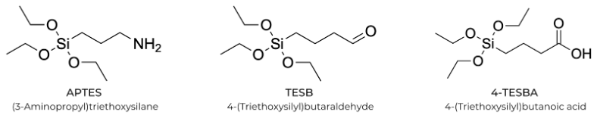
Figure S1. Structures of the silicon-based functionalizing agents (3-aminopropyl)triethoxysilane (APTES), triethoxysilylbutyraldehyde (TESB), and 4-triethoxysilylbutanoic acid (4-TESBA).

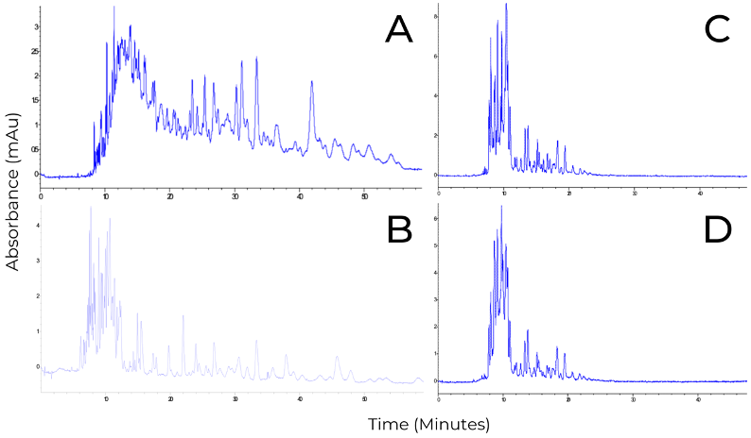
Figure S2. Effect of denaturation conditions of BSA on the digestion via pepsin CEP for 4 hours at a 1:0.1 enzyme:substrate ratio (mass:mass). (A) Classical denaturation conditions employing urea, DTT, and IDA. (B) Acidic denaturation employing formic acid (0.44% v/v, pH 2.0). Separations were performed at +15 kV using phosphate buffer (50 mM, pH 2.5) with detection at 200 nm for A, and formic acid (0.44% v/v, pH 2.0) for B. Effect of denaturation conditions of BSA on the digestion via pepsin CEP for 4 hours using 26 μL of BSA for a 1:0.1 enzyme:substrate ratio (mass:mass). (C) Thermal denaturation. (D) Thermal and acidic denaturation employing phosphate buffer (50 mM, pH 2.0). Separations were performed at +15 kV using phosphate buffer (50 mM, pH 2.5) with detection at 200 nm.

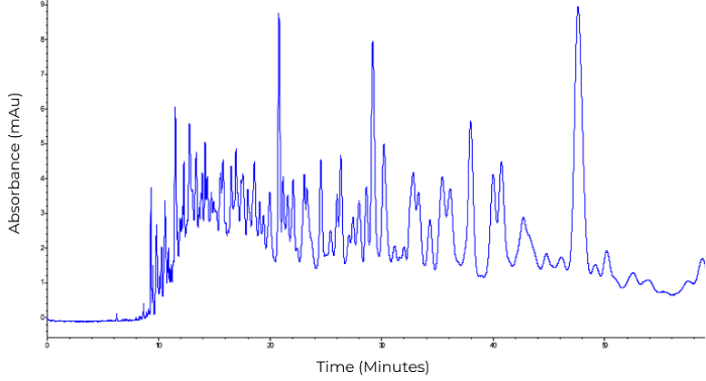
Figure S3. CE-UV peptide map of in-solution digestion of denatured BSA (7.01 μg/μL) at an enzyme-to-substrate of 1:0.1 (mass:mass). Separations were performed at +15 kV using phosphate buffer (50 mM, pH 2.5) with detection at 200 nm.

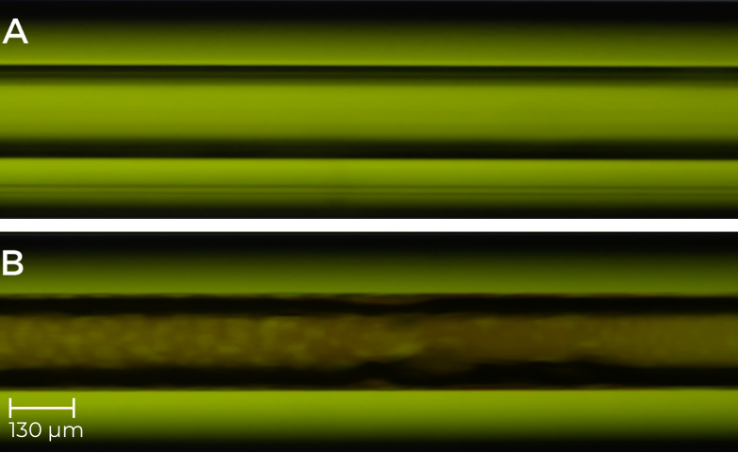
Figure S4. Light microscope images taken of the capillary at 40× magnification. (A) Bare 100 μm inner diameter fused silica capillary prior to immobilization. (B) 4-TESBA functionalized capillary with pepsin in phosphate buffer (50 mM, pH 2.0), immobilized within. Imaged 15 cm from the capillary inlet.

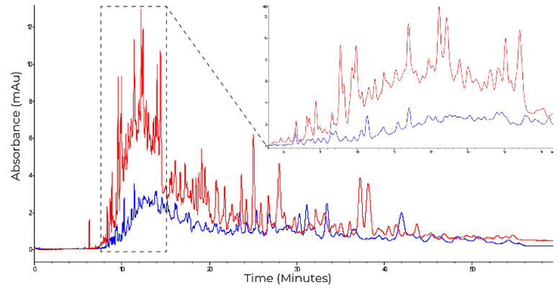
Figure S5. Peptide map of digestion of denatured BSA using the phosphate buffer CEP at a 1:0.1 enzyme-to-substrate ratio (blue) and the pepsin phosphate buffer OT-IMER flowing substrate for 240 minutes at 50 mbar (red). The phosphate buffer OT-IMER has a sequence coverage of 31% by LC-MS/MS analysis, compared to 36% for the off-line digestion. The CEP only used 20 μL of BSA while approximately 942 μL of BSA passed through the IMER over the 240 minute flow, hence the discrepancy in peak height. Only Separations were performed at +15 kV using phosphate buffer (50 mM, pH 2.5) with detection at 200 nm.

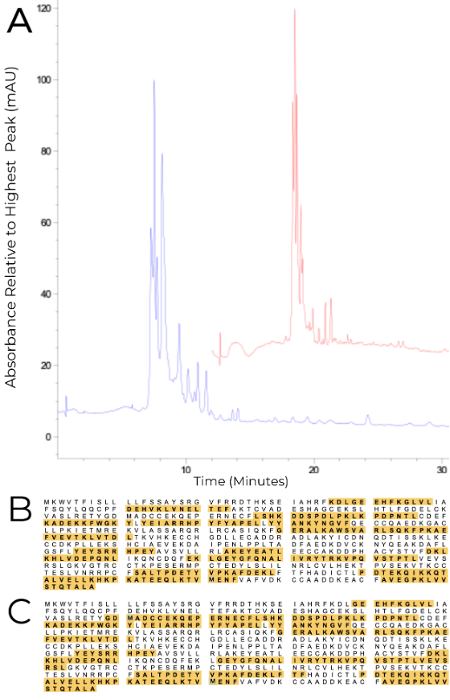
Figure S6. (A) The first digestion in blue and the tenth digestion in red. BSA sequence coverage from the LC-MS/MS analysis on the digest from the pepsin IMER. (B) Digest #1, 40% BSA sequence coverage. (C) Digest #10, 40% BSA sequence coverage. Separations were performed at +15 kV using formic acid (0.44% v/v, pH 2.0) with detection at 200 nm.

Table S1. Peptides identified by LC-MS/MS analysis of the pepsin phosphate buffer CEP digestion of BSA. Masses are reported in Daltons. Sites with missed cleavages are indicated in the sequence column.
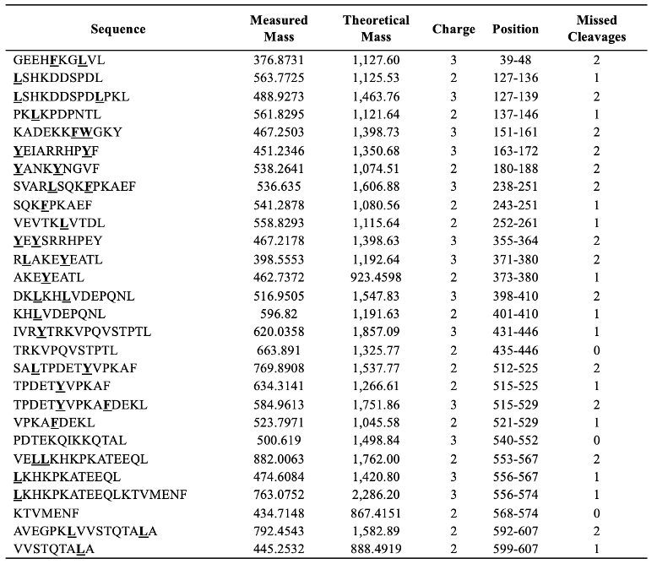

Table S2. Peptides identified by LC-MS/MS analysis of the pepsin phosphate buffer IMER digestion of BSA. Masses are reported in Daltons. Sites with missed cleavages are indicated in the sequence column.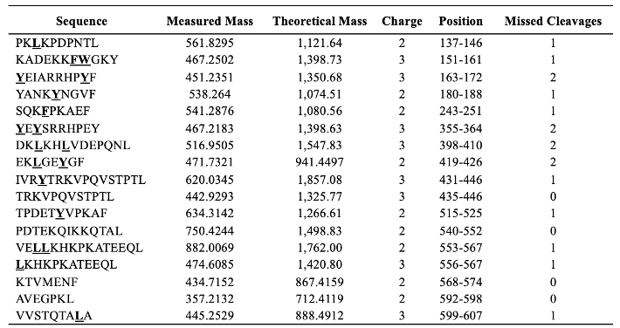

Table S3. Peptides identified by LC-MS/MS analysis of the first of ten BSA digestions by the same pepsin formic acid IMER within two hours. Masses are reported in Daltons. Sites with missed cleavages are indicated in the sequence column.
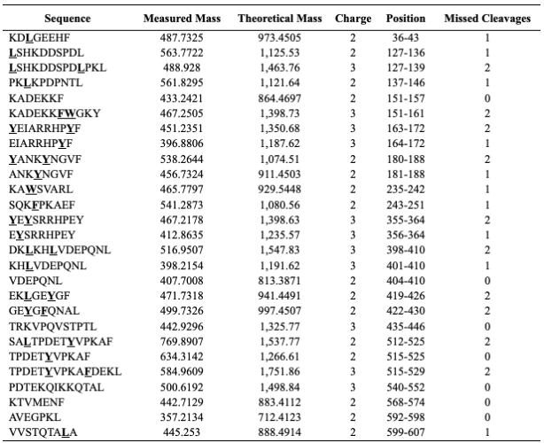

Table S4. Peptides identified by LC-MS/MS analysis of the tenth of ten BSA digestions by the same pepsin formic acid IMER within two hours. Masses are reported in Daltons. Sites with missed cleavages are indicated in the sequence column.
